Metropolitan Area Networks (MANs)
A Metropolitan Area Network (MAN) is one of a number of types of networks (see also LAN and WAN). A MAN is a relatively new class of network, it serves a role similar to an ISP, but for corporate users with large LANs. There are three important features which discriminate MANs from LANs or WANs:
- The network size falls intermediate between LANs and WANs. A MAN typically covers an area of between 5 and 50 km diameter. Many MANs cover an area the size of a city, although in some cases MANs may be as small as a group of buildings or as large as the North of Scotland.
- A MAN (like a WAN) is not generally owned by a single organisation. The MAN, its communications links and equipment are generally owned by either a consortium of users or by a single network provider who sells the service to the users. This level of service provided to each user must therefore be negotiated with the MAN operator, and some performance guarantees are normally specified.
- A MAN often acts as a high speed network to allow sharing of regional resources (similar to a large LAN). It is also frequently used to provide a shared connection to other networks using a link to a WAN.
A typical use of MANs to provide shared access to a wide area network is shown in the figure below:
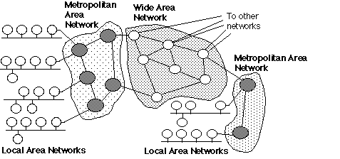
Use of MANs to provide regional networks which share the cost of access to a WAN

Gorry Fairhurst - email:G.Fairhurst@eng.abdn.ac.uk - Date: 01/10/2001 EG3557

