The process of translating the mRNA data (nucleotide chain) into Proteins (Amino-acid chains).
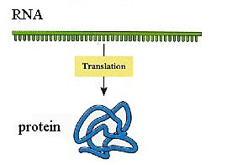

- The mRNA is binding to the Ribosome’s small unit (mRNA binding site).
- A tRNA with bound methionine (amino-acid that binds to a tRNA, that has the UAC anti-codon, which is complementary to the start codon AUG ) is sliding over the mRNA, from it’s “cap”, until it finds the 1st AUG sequence, and stops there.
- The Ribosome’s large subunit is attaching to the tRNA, locating it in its P-site.
- A tRNA (with bound amino-acid) will enter the A-site, in condition that it has anti-codon that is complementary to the next codon on the mRNA .
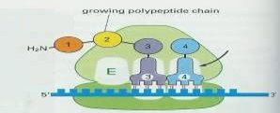
- Enzymes will create a peptide bond between the A-site amino-acid and the P-site peptide chain (or only methionine) .
- The large subunit slides over the mRNA to a distance of 3 nucleotides, so the A-site will now be parallel to a new codon, the tRNA from A-site will move to P-site, and the tRNA from P-site will move to E-site (and exit from the Ribosome).
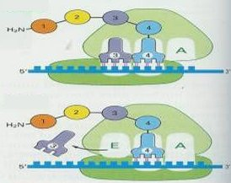
- Steps 4 to 6 will repeat until a stop-codon is met. In this case, a tRNA without amino-acid will enter the A-site, and decompose the whole system.
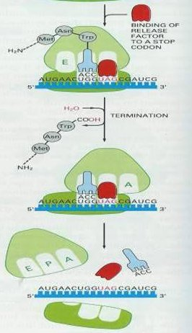
- The mRNA will either continue to another Ribosome (to create another protein), or will be destroyed by enzymes.
