Before a cell is divided, it’s DNA is being replicated, according to the semi-conservative model.
- “Replication forks” are opened between the 2 DNA strands (at many places simultaneously).
- Two “Primer” stones are added :
One is added to the base of the fork (meeting one strand) → added at every round.
One is added to the edge of the fork in the counter-strand → added only in the 1st round.
- The DNA Polymeraze enzyme is working in direction “ 3’ to 5’ “, starting from the “primer” at each strand. It is creating new chains of nucleotides, that are complementary to each strand (adding A bases in parallel to T, and C in parallel to G ).
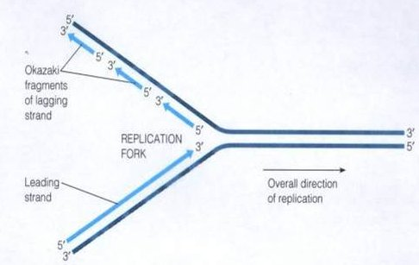
- The fork is opening a bit wider, and the process returns to step (2) until both strands are fully duplicated.
- The “primer” stones are removed. It creates a gap in the Telomeres (DNA edges).
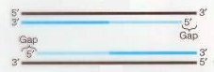
- The Telomeraze enzyme completes that gap.
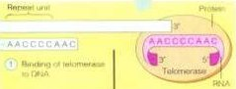
- This process produces two DNA molecules out of one !
