Images | URL | Design Element | Comments
 | www.nenos.com/ artistas/artistas.htm | Color | Color is used to highlight the women. The color orange is used as the primary contrasting color.
 | http://www.indmix.com/pictures/05/feb/0225054.html | Color | The color of the shirts of the people in this picture brings unity to the background of the photo.
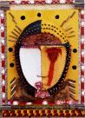 | www.libanvision.com/ kz-art-africain.htm | Shapes | The face is designed by different shapes that makes the unique mask.
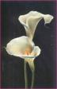 | www.art-posters.net/ flowersart2.html | Color | The black background sets the tone for the white lily’s, making them stand out.
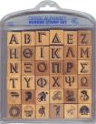 | www.bunchoffun.com/ 22009_-_Greek_-_75dpi.jpg | Lines | The repetition if the lines are consistent and makes the observer concentrate on the alphabets embedded between them. Most of the alphabets have distinct lines with the exception of those with curves.

