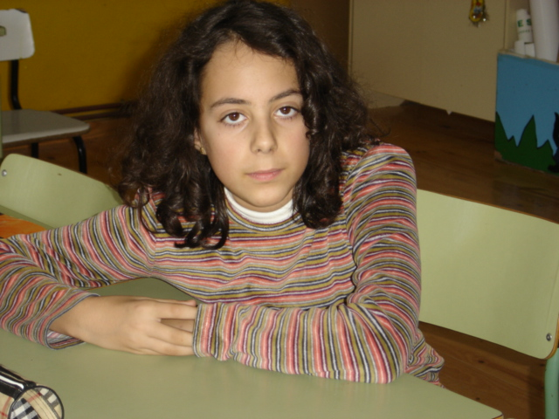

Hello!
My name’s Cristina.
I’m eleven years old.
I’m live in the north of Spain.
I have got a brother.
I have got one cat , a lot of birds and a lot of rabbits.
My favourite singer is Madonna.
My favourite film is Harry Potter.
My favourite colour is blue.
My favourite animal is a cat and parrot.
My favourite food is hamburger,
chips , meat , spaghetti , cola and pizza.
I don’t like vegetables.

Best wishes!

