HARPER/HUTZEL/KARMANOS/RIM CRASH CART LOCATIONS
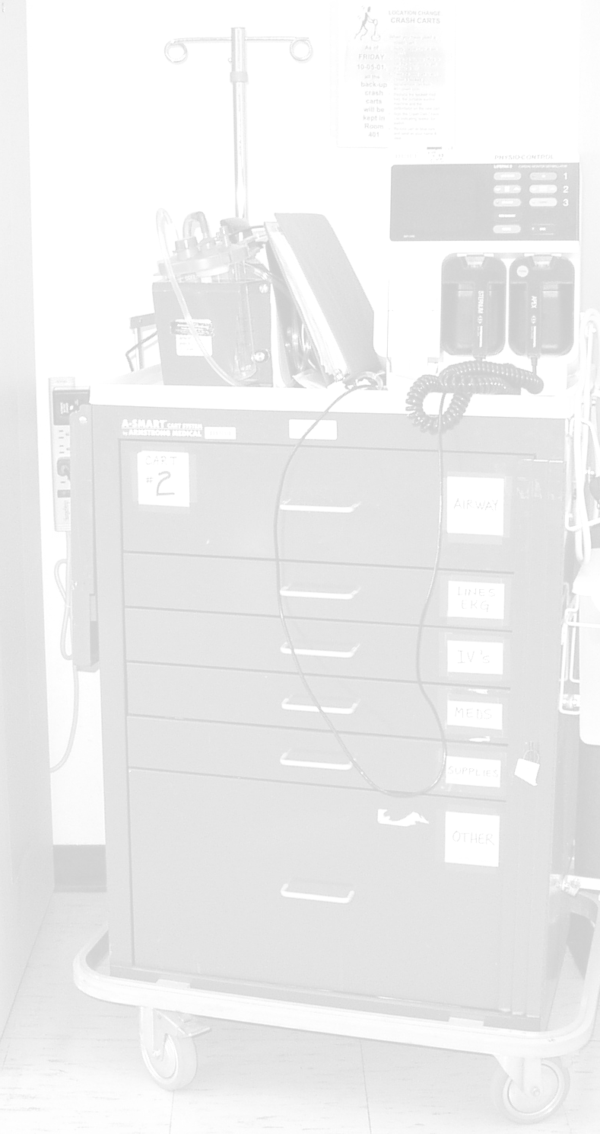
Floor | Location
10WN | Main hall alcove | Next to room 10435
10WS | Room 10435 | Back hall
2BC (PCN/SCN) | Room 1 | Opposite desk (code pink)
2BNS | Hall | Opposite desk
2WN | Main hall alcove | Between 2222 & 2223
2WS | Main hall alcove | Next to RN conference room
3BN | Inside med room | Opposite desk
3BS | Inside med room | Opposite desk
3WS | Maternal special care | Opposite desk (code pink)
4ICU | Hall | Opposite room 4503
4WS | Main hall alcove | Between pantry & clean utility
5BS | Main hall alcove | Next to equipment room
5ICU | Hall | Opposite room 5508
5WN | Main hall alcove | Between 5227 & 5228
5WS | Hall opposite desk | Between 5431 & 5432
6B | Main hall alcove | Next to room 6722
6ICU | Hall | Opposite room 6508
8MICU | Hall | Opposite room 8502
8WN | Main hall alcove | Between 8201 & 8202
8WS | Back hall alcove | Between 8429 & 8435
9ICU | Hall | Opposite room 9508
9WN | Room 9231 | Clean utility opposite desk
9WS | Hall opposite desk | Between 9431 & 9432
Hemodialysis | Hall | Next to room 8
Wertz Clinic | Between clinics E & F | Door has punch-code lock
RIM3 | Behind desk | Next to RN conference room
RIM4 | Behind desk | Next to manager’s office
RIM7 | Clean utility room | Room 724
Updated Feb 2006

