Date ____________________

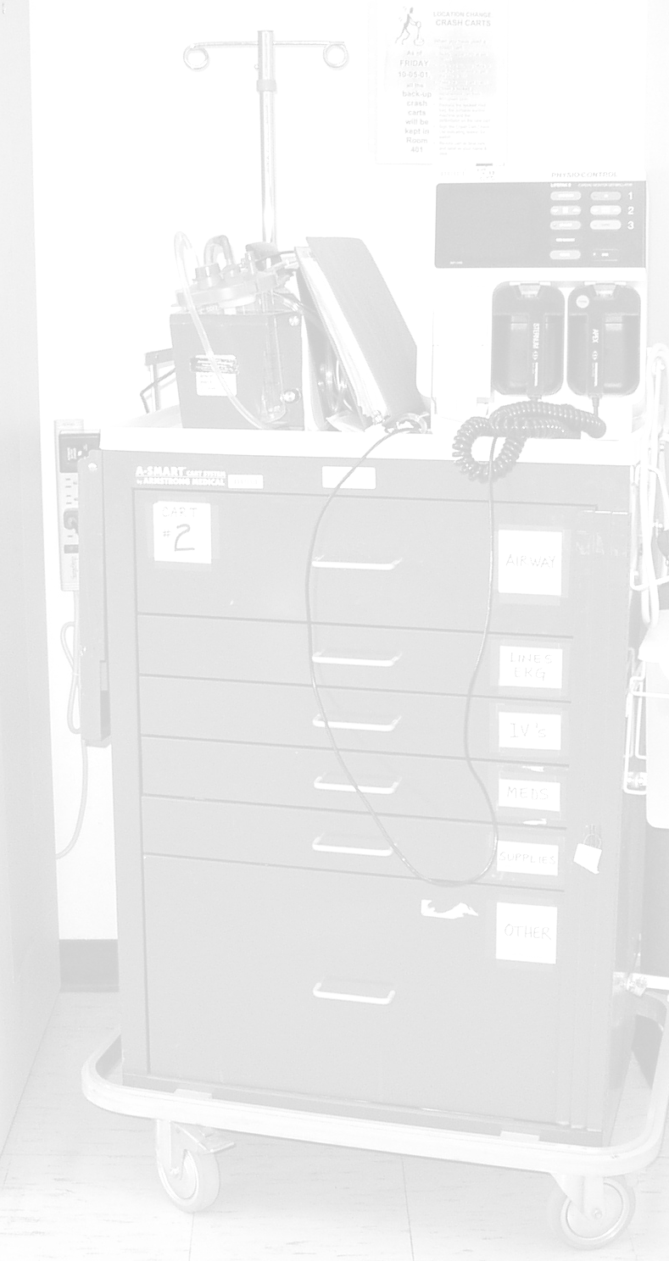  Questions | Circle the Most Appropriate Choice
- How long did it take you to complete the course? | 2-2.5 hours | 2.5-3 hours | 3-3.5 hours | 3.5-4 hours | >4 hours
- Will the course help you participate more fully in a code blue emergency? | Definitely | Almost Certainly | Probably | Possibly | Not at All
- Was the level of presentation appropriate? | Definitely | Almost Certainly | Probably | Possibly | Not at All
- How did you find the choice of instructional material? | Absolutely Relevant | Very Relevant | Mostly Relevant | Slightly Relevant | Not Relevant
- How was the presentation of the course material? | Too Difficult | Moderately Difficult | Appropriate | Relatively Easy | Too Easy
- Would you recommend this course to coworkers? | Definitely | Almost Certainly | Probably | Possibly | Not at All
- How long have you been a pharmacist? | ≤1 year | 2-3 years | 4-5 years | 6-15 years | >15 years
- What part of the unit(s) of instruction did you find most effective? Why?
- What part of the unit(s) of instruction would you recommend to change? To what?
- What additional areas would you like covered on the practical exam?

Questions | Circle the Most Appropriate Choice
- How did you find the method of instruction? | Extremely Effective | Very Effective |  | Mostly Effective | Slightly Effective | Not Effective
- Do you find the Cmap format an effective way for learning and review? | Extremely Effective | Very Effective |  | Mostly Effective | Slightly Effective | Not Effective
- Would you prefer to study the material independently (video instead of live lecture)? | Yes No |  | Why or why not?
- Comments:

