SYRINGE ASSEMBLY

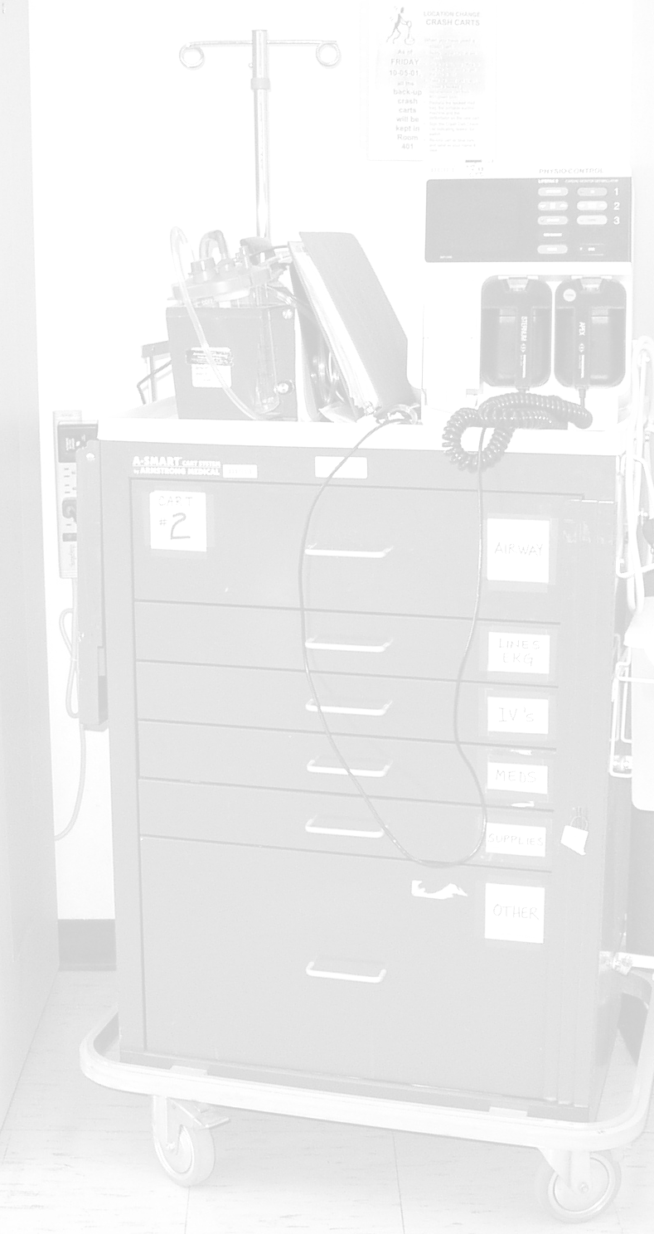
Knowing how to assemble a pre-filled syringe is an integral part of any code blue emergency. Pre-filled syringes in the medication tray are atropine, dextrose, lidocaine, epinephrine, calcium chloride, naloxone, and sodium bicarbonate. The easy-to-follow steps are listed below.

- Open the syringe box from the side indicated | 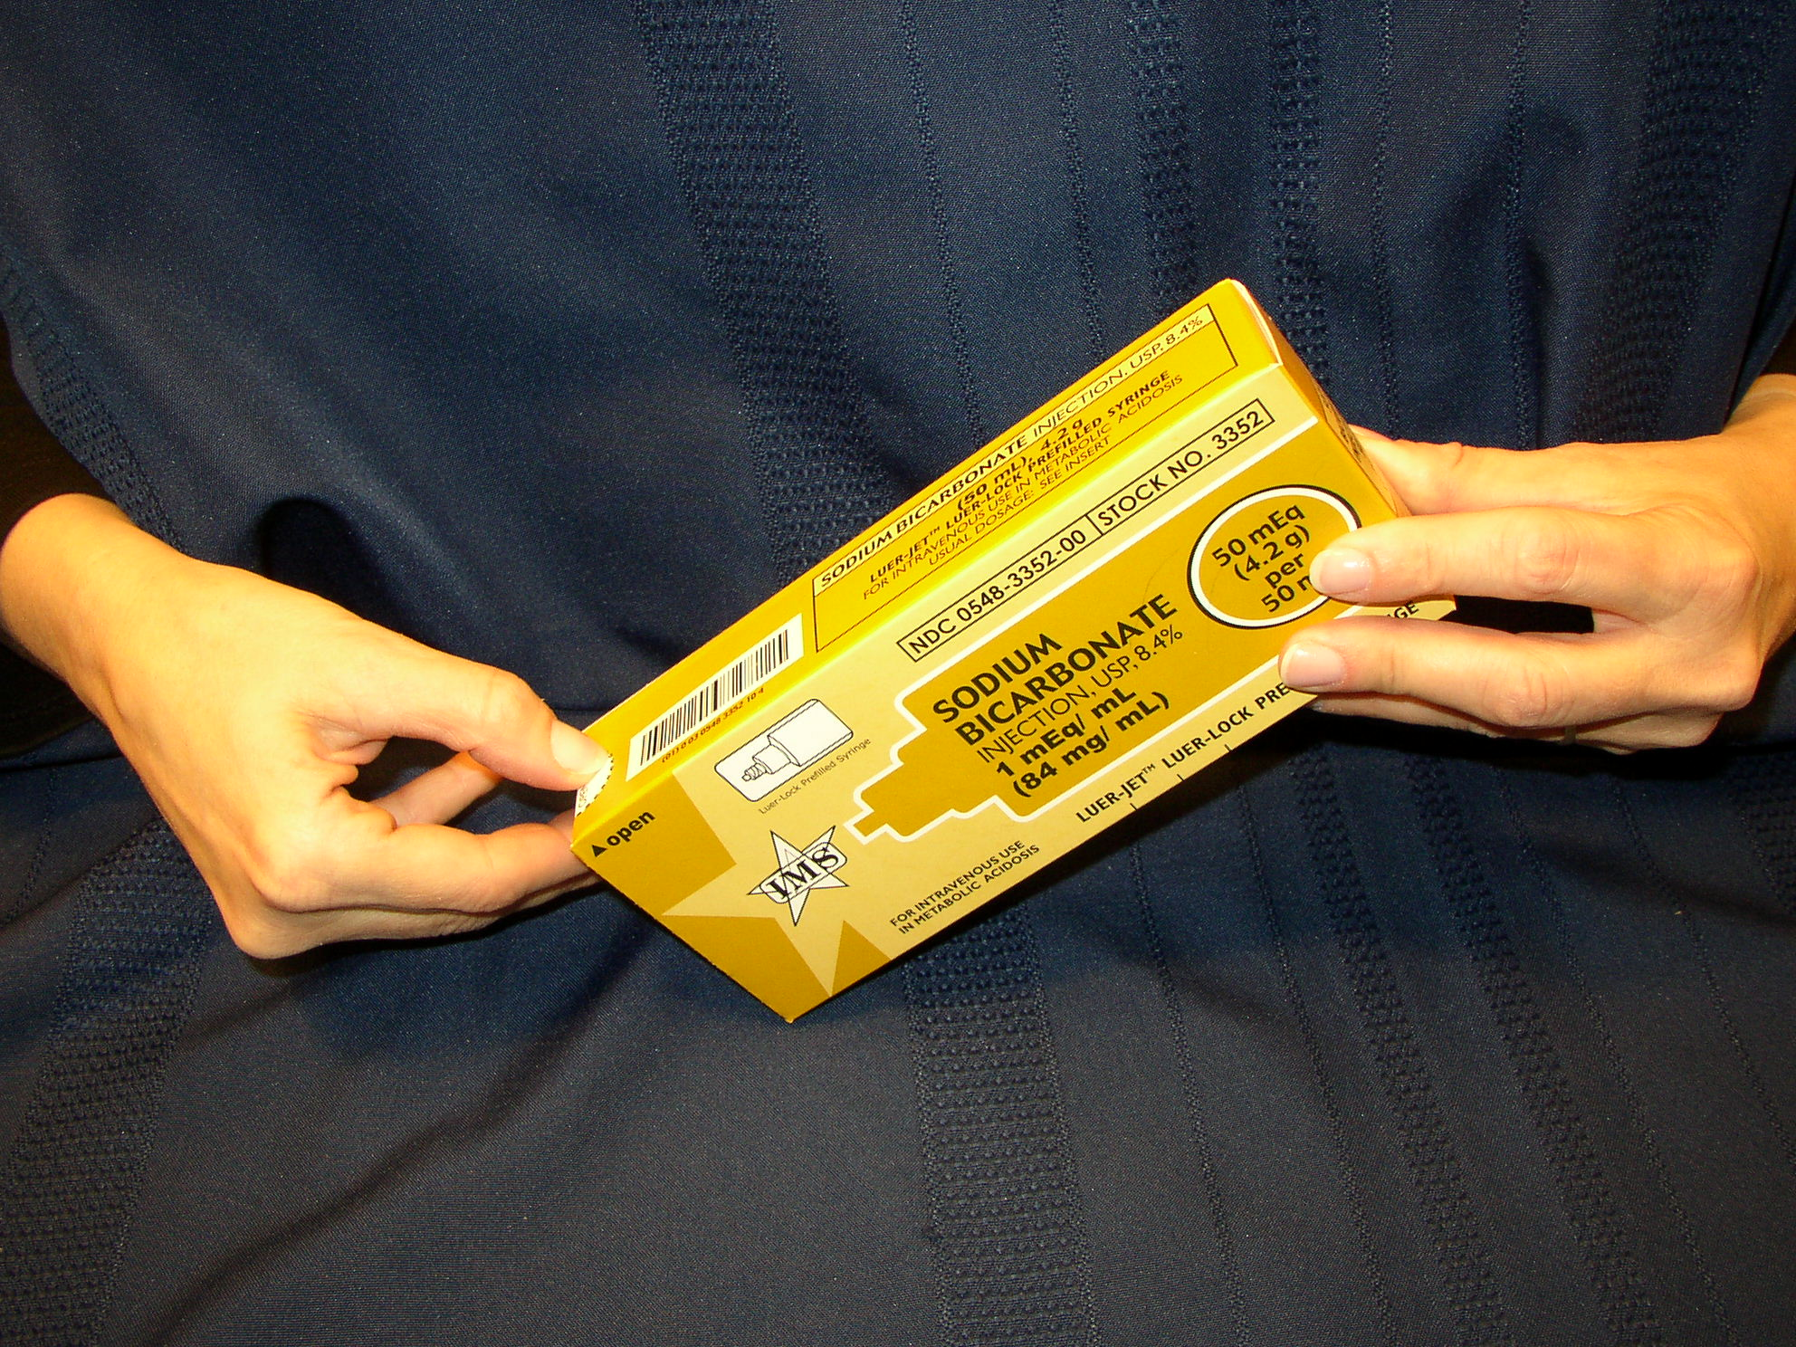
- So that the two parts fall out into your hand, then | 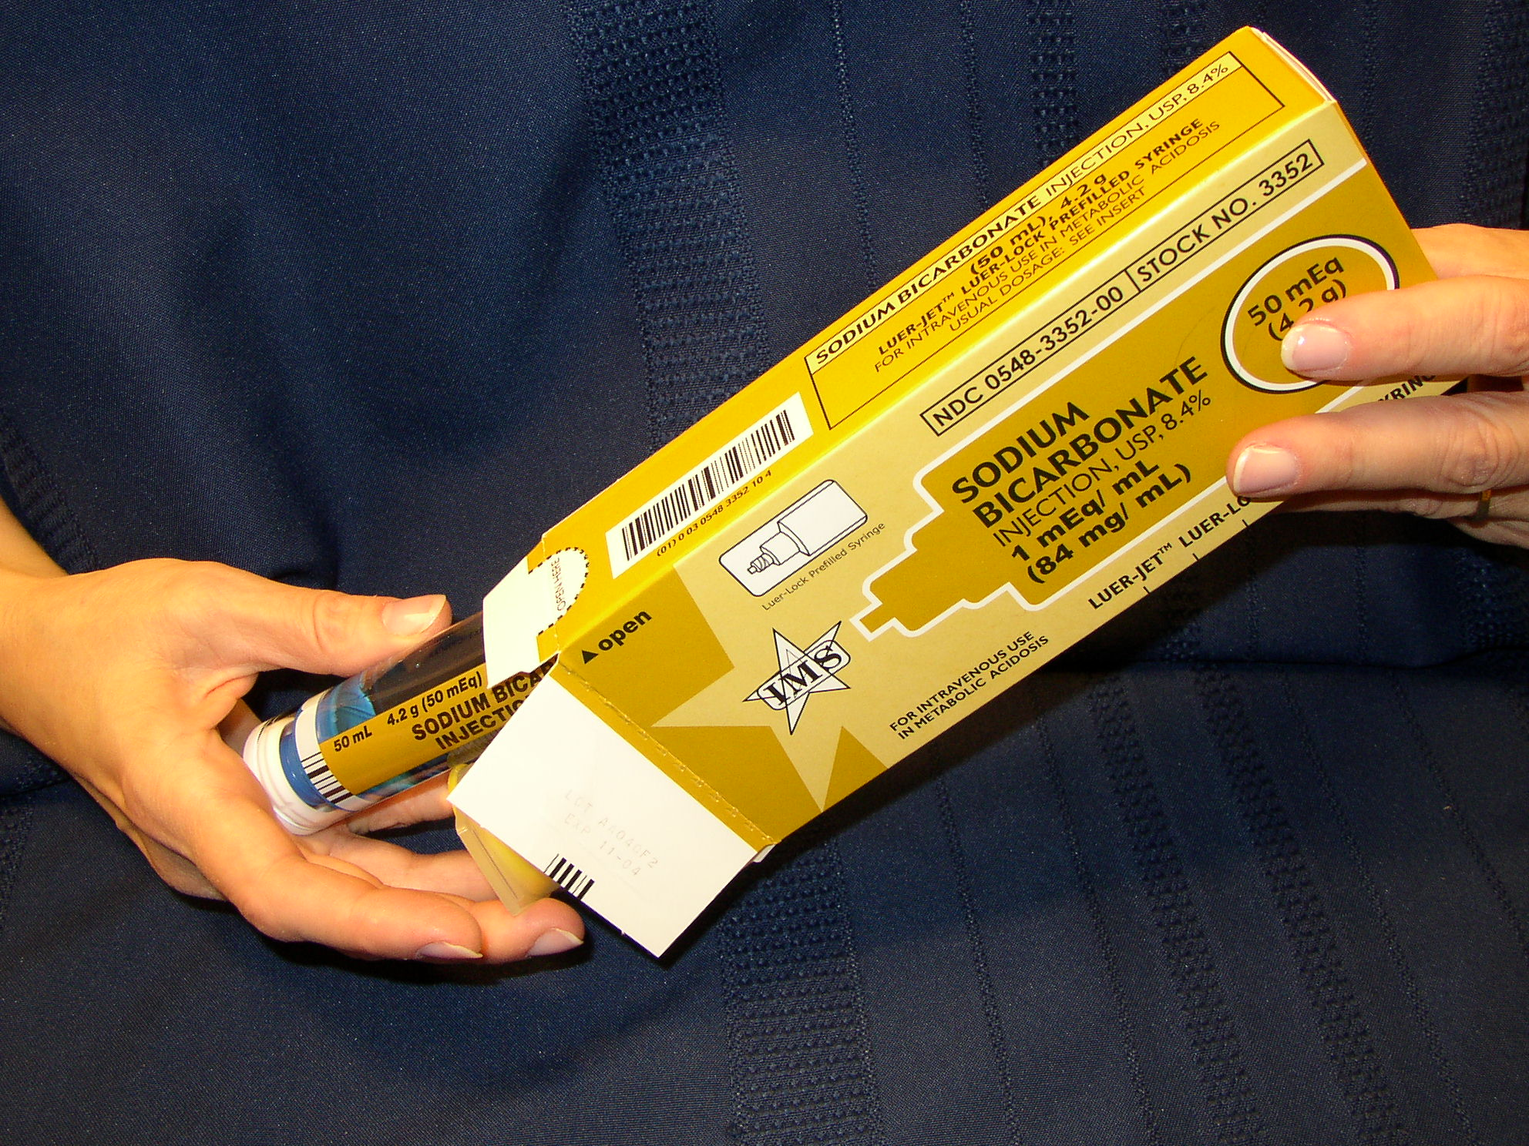
- Flip off the plastic end-caps and | 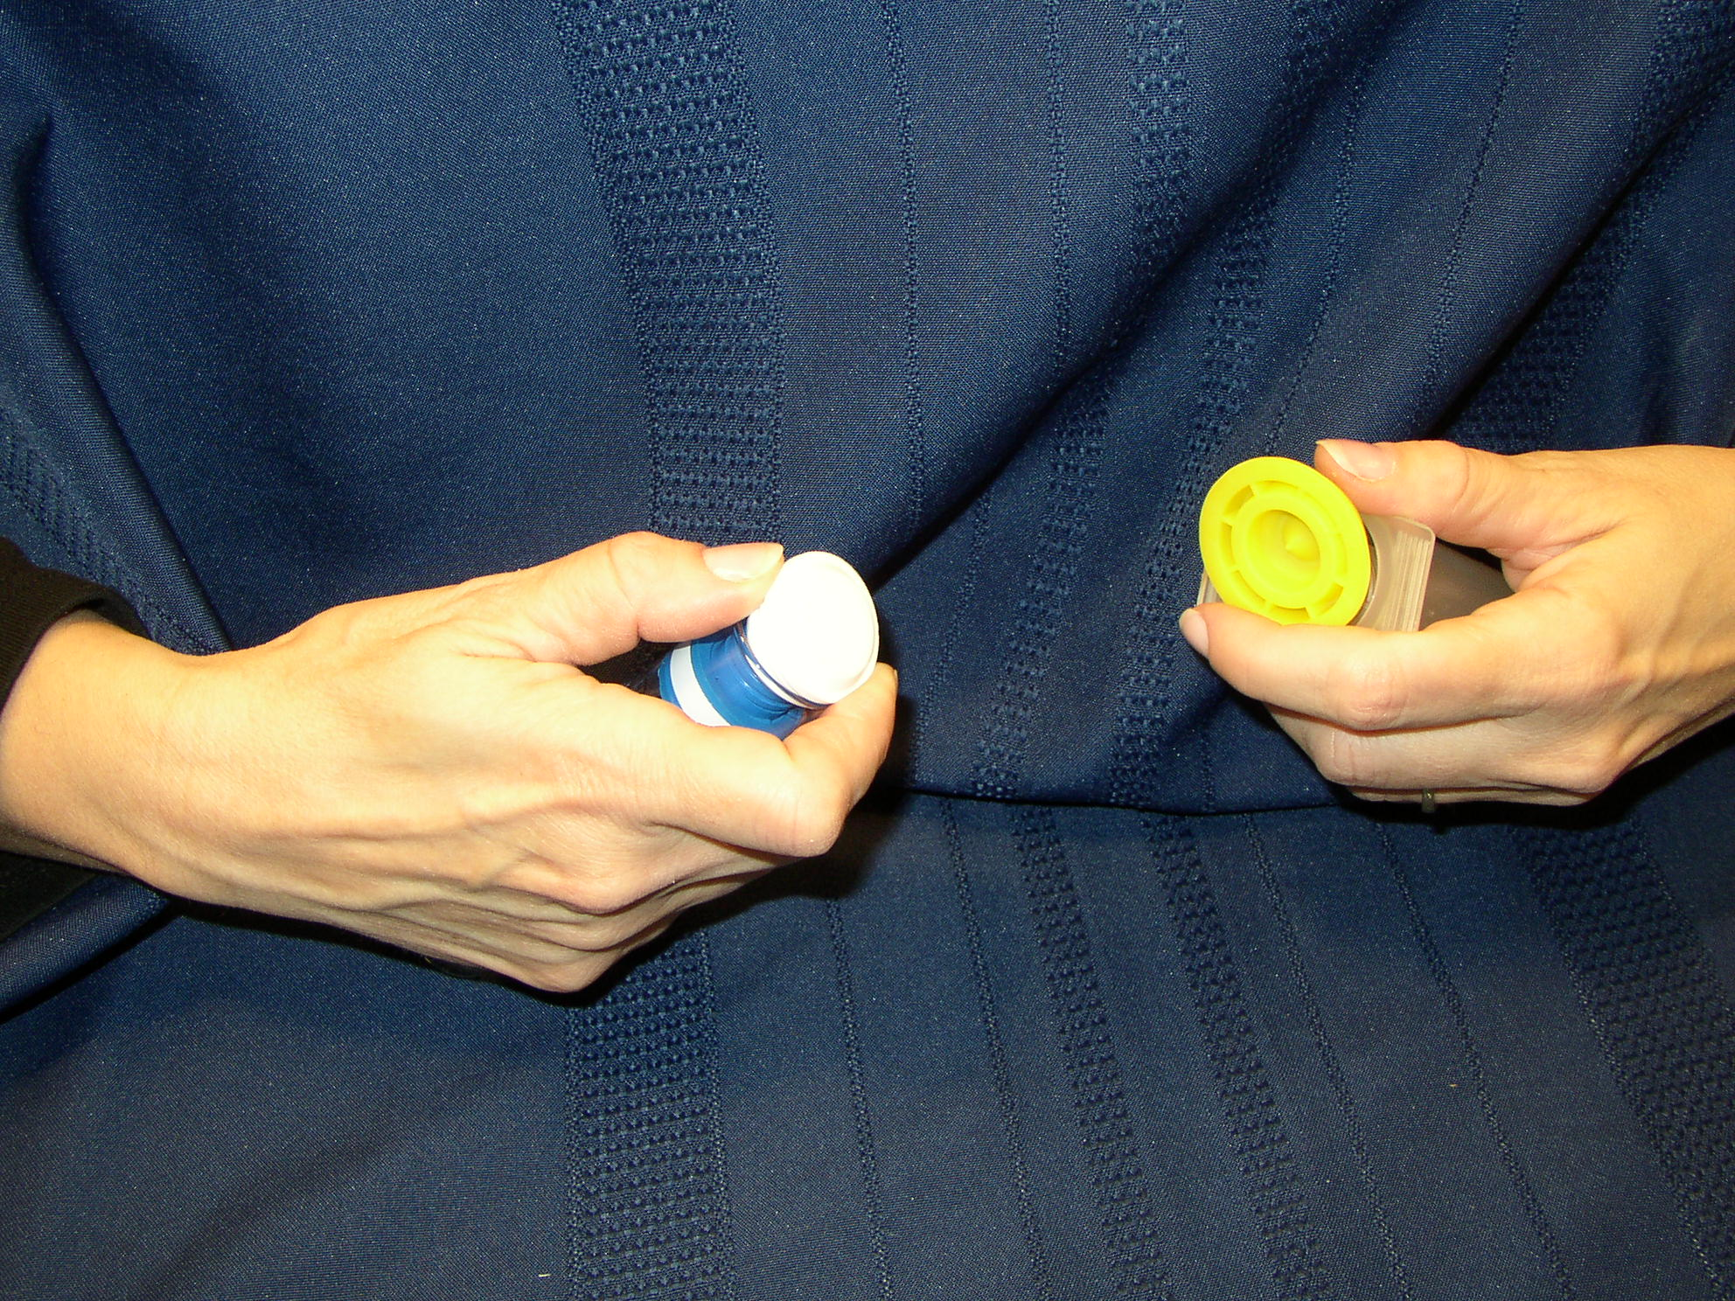
- Attach the medication half to the plunger half with a push | 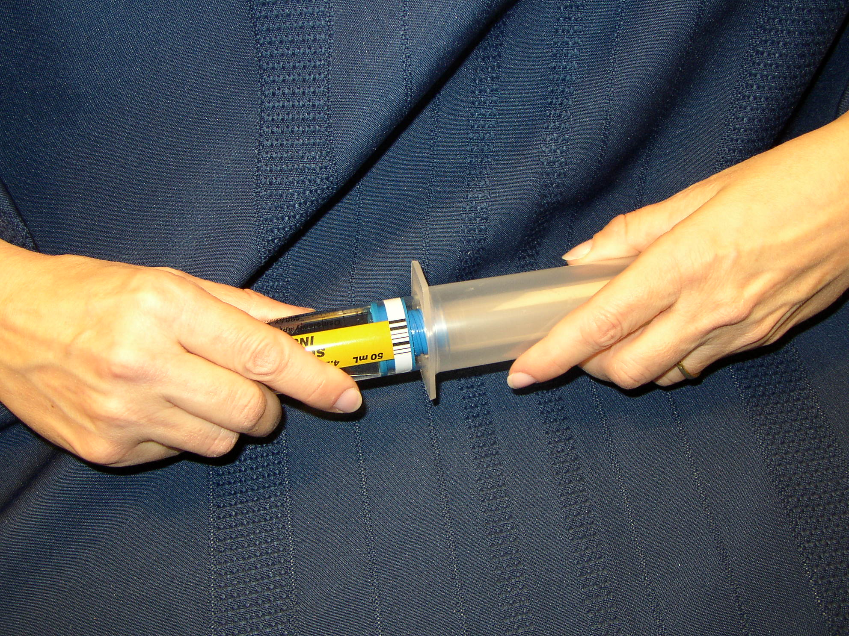
- And a twist until resistance is met. | 