Knowledge Management Glossary
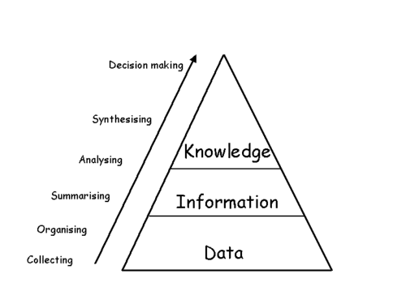

Attention
http://en.wikipedia.org/wiki/Attention_management

Knowledge
http://en.wikipedia.org/wiki/Knowledge

Knowledge/Information/Data
http://www.landcareresearch.co.nz/research/social/images/dataknowledgesmall.gif

Knowledge
Davenport distinguishes between different types of knowledge. Knowledge can exist as a stand alone primary asset, as a secondary asset that augments the value of another asset, or as knowledge that does not directly affect the bottom line.(Tom Davenport, 2003; T. H. Davenport, 2001)Knowledge can be simple and rule-based, or complex- requiring judgment and interpretation to give it value. Knowledge can be explicitly available in an external product; or tacit and invisible, residing in the 30 years of experience of senior management. (Thomas Davenport & Long, 2003) In all cases, Davenport stresses the importance of aligning knowledge management with the organization’s strategic goals.

