Add your thoughts
Either add a new concept off the main idea or add to another’s concept
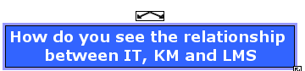

Click on the angled arrow above the box to create a new link

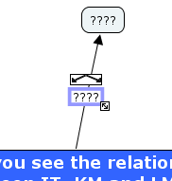

Drag out the arrow to create a new concept box.
Please make sure to fill out both the box and the connector so that there is a logical connection.

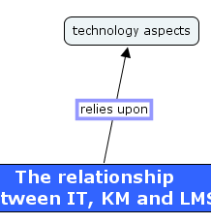
To add additional information you may right click on the box and “Add Info” to add text in a mouse over.
Or you can add information thru internet links, word documents, or other resources by first creating/finding the resource and just dragging and dropping it over the box. (including urls).
Just change the size of the windows so you can see both and drag and drop.

Remember don’t feel shy about contacting me – Stacey srhodes38750@yahoo.com

