Name_______________________________________________Date________________

- What are the 3 routes of medications used during a code blue emergency?
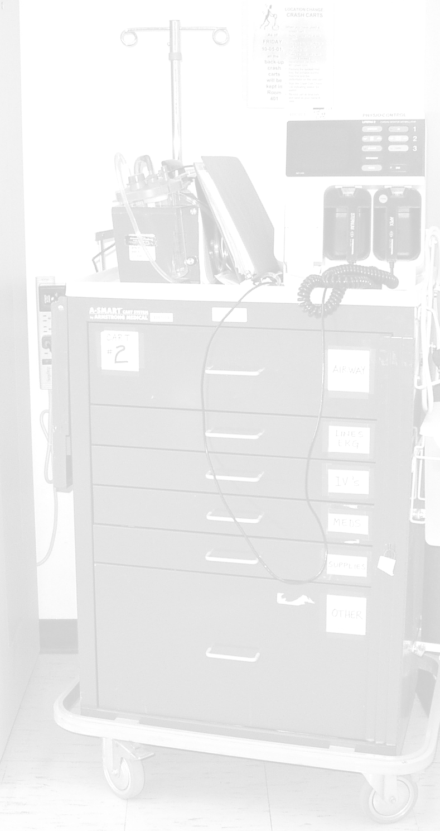

- What are 2 of the 4 medications that can be used endotracheally?

- What is the mnemonic used to remember the drugs given endotracheally?

- What 3 medications can be given either IVP or IVPB?

- Why are algorithms used to treat patients during code blue emergencies?

- For the mnemonic of TEA used during asystole, what do the letters stand for?

- What arrhythmia does the mnemonic “all trained dogs eat iams” treat?

- What medications does the partial mnemonic “And lets make patients better” stand for?

- What arrhythmia does following the mnemonic in question 8 treat?

- 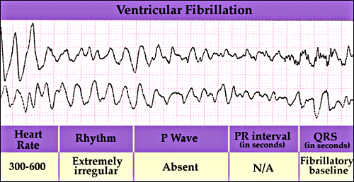What is this arrhythmia?

