Gary D Stroh
AE 790
5/23/06

Final Paper

I define an Intelligent Building as a building that is design to take into consideration all phases of a buildings life cycle.
Which are defined as the following:
- Have a need for a building
- Design
- Construction
- Operation/Maintenance
- Addition/Renovation
- Demolition
These are very general and each can be further divided into sub categories. The need for a building or structure is very general. It can be a place for my family to live or a place for my company to manufacture its product. Each building design team must take into account what is the intended use of the building. The design professional must meet the requirements of the owners/operators.
There are many challenges facing widespread use of intelligent buildings.
Below are some of the highlights of the challenges of implementing widespread intelligent building technologies. Taken from the paper “Technology Roadmap for Intelligent Buildings” by the Continental Automated Buildings Association (CABA) in Canada.

- The reluctance of developers/owners to implement intelligent building technologies due to the perception of increased initial cost and concern over
unproven technologies; • the unwillingness to change from the traditional construction process arrangement, where each of the specialized.
- The need to achieve co-operation and agreement among the stakeholders and
their interests.
- The development of the procedures needed to implement an integrated communications system, that The ability to fully realize the benefits of intelligent building technologies is hampered by a number of challenges: differ from those that have traditionally been used.
- The lifespan issues posed in making investment decisions for an intelligent
building technologies construction project.
- The ongoing service arrangements required by an integrated system.
- The need to achieve co-operation and agreement among the stakeholders and their interests.
The have been many advances in Intelligent Buildings. The one that I’m going to cover is during the construction/demolition phase. This area is the development of new methods and materials that use less material during the construction and the recycling of debris from demolition of buildings.
One material that has gained wide scale use is the use of engineered lumber such as: laminated wood beams and the wood I-beam. These beams use less material than regular beams so they are lighter than the typical full size beams.
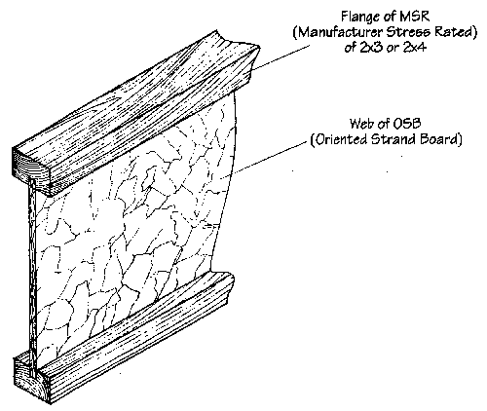

However they are much stronger than you typical full size beams and they can span greater distances. This saves on labor and installation costs. One new I-beam to be developed by Georgia Pacific is the “Wide Open Beams”. This beam is exactly like a wood I-Beam; however it has openings cut out in the web to allow for HVAC, Electrical, and Plumbing penetrations. This allows for faster and easier installation of the HVAC, Electrical and Plumbing. One other benefit that may occur is during the renovation/addition phase. As it would allow for faster installation of new equipment.
However there is one drop back that is of great concern to firefighters. Since these beams are made of less material. In a fire situation there is a great risk that the structure may collapse a lot sooner than that with a structure building using typical stick framing. There are currently several studies being conducted to determine the char rate and possible solutions to this problem. These beams are also designed for specific use, if the building use changes. Will these types of beams be able to handle any additional load?
Now once the building reaches its life expectancy and demolition needs to occur, what happens with all the debris from the demolition? Since landfill space keeps shrinking and construction waste keeps coming. We need to perform much research into how to recycle the different materials typically found in structures. In the article by Boston Business Journal “State works to reduce amount of construction debris in area landfills” It states that More than 130 million tons of debris from construction sites is dumped in U.S. landfills annually, according to the U.S. Environmental Protection Agency. And more than half of that comes from nonresidential renovation and demolition projects. The collapse of the World Trade Buildings on 9/11/01 created an estimated 1.2 million tons of building debris. Even though this was not your typical demolition project, it shows how much material can be created. So it is very important that we develop new technologies that recycle existing materials. The website http://www.cdrecycler.com/ is the best location for all your recycling questions and needs. Below is a chart showing the typical construction waste for a 2000 sq.ft. Home.

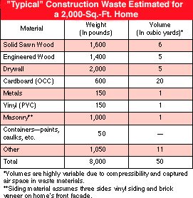

If we can significantly reduce the amount of waste that goes into our landfills than we can prolong the life of our landfills. This is because approximately 40% There are many materials can be recycled. However a lot of contractors lack the education to be aware of recycling resources or are reluctant because of concerns over initial costs for recycling equipment. The governmental agencies that are responsible for our environment and inspections not only during construction but also during the demolition of a structure. Must take part to insure that all materials that can be recycled are. Another way to reduce the amount of construction waste is to have a more accurate list of the required material. This is something that must be done during the design phase by the design professionals.
One company that is a pioneer and leader in developing Virtual Building™ solutions is Graphisoft. The company is widely acknowledged as the world's #1 supplier of model-based software and services for the building industry. Graphisoft's clients are at the forefront of the industry - delivering projects that are better designed, more predictable to construct and less expensive to operate. The company has software that accurately estimates directly from a building design model. Here is a quote from the Graghisoft website “Graphisoft's software and services offerings are revolutionizing the way we plan projects. The tools provide a quantum leap in our ability to collaborate with the architect and the sub-contractors, leading to huge reductions in the inefficiencies, waste, and rework that plague our industry. In essence, it allows us to build the building virtually, before ever putting a shovel in the ground," said Andy Ball, CEO, Webcor Builders”. We must can the unwillingness of owners, professionals & operators to implement the intelligent buildings technologies. I think this will be the greatest challenge that intelligent buildings will face.

