Timothy Moore
Life Science: U2, L2 Lab
19 September 2006
Score: 100%

Growing Bacteria from Clean and Dirty Hands

Purpose
The purpose of this activity is to see if hand-washing makes a difference. You will compare bacteria cultures grown from unwashed hands, from intentionally dirtied hands, and from washed hands.
Materials
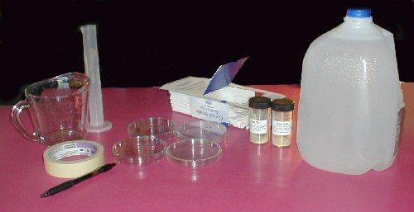 | 4 petri dishes  soap  distilled water  masking tape  nutrient agar vial  cotton swabs  tap water  pot for boiling water  potholder  Note: We had to add 1 pkg. unflavored gelatin to get our agar to get it to set up.

Procedure
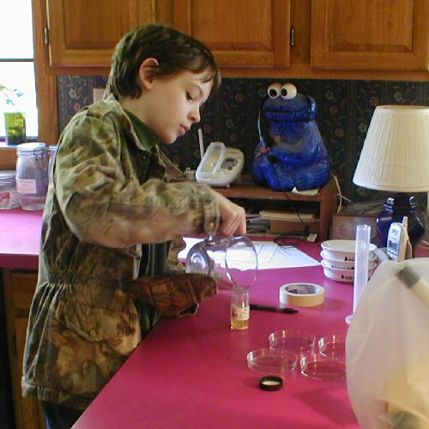 | 1. Boil 100mL of distilled water.  2. Carefully pour boiling water into the vial with agar. Cover with lid and shake. Note: The vial will become hot from the water. Use a potholder when touching the vial.

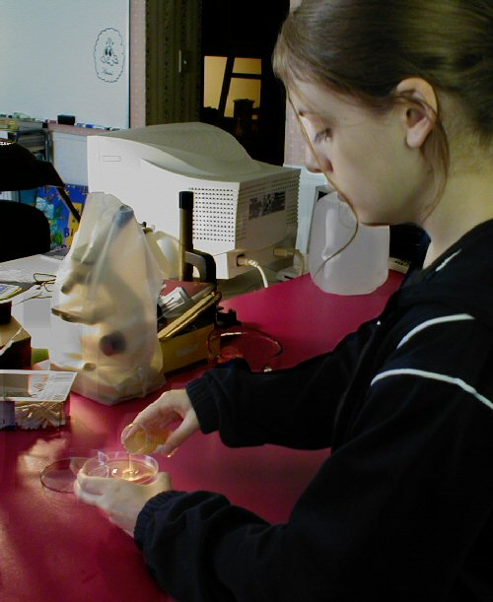 | 3. Fill the bottom of each of the petri dishes one-half full with the boiling agar solution.  4. Cover and let cool.  5. Once the agar has solidified (agar is “set” when it is solid, like gelatin), label the three petri dishes “standard,” “rubbed,” and “washed.”

6. Wet one end of a cotton swab and rub it on your fingers. Then, carefully rub the cotton swab on the surface of the agar in the dish labeled “standard,” being careful not to prick the agar.
7. Cover this dish with its top and tape it shut.
8. Go to a room in your home or school and rub a wet cotton swab on a surface such as a floor, counter, or walls
9. Touch the cotton swab to the agar in the petri dish labeled “rubbed” by pressing lightly with the swab on top of the agar as you did in step 6 of the procedure. Cover with the top and tape shut.
10. Wash your hands thoroughly with soap and water; rub your hands together vigorously while you’re washing them. Let your hands air dry for about 30 seconds.
11. Rub a wet cotton swab on your hands and then touch the agar petri dish labeled “washed” following step 6 in the procedure. Cover this dish with the top and tape shut.
12. Apply Cycle aquarium bacteria to the last petri dish.
- Place the petri dishes in a warm, dark place
13. After 24 hours, examine the petri dishes for the amount of growth of bacteria. Put the petri dishes in order, from least amount of growth to greatest. If no growth has occurred, let them sit for another 24 hours.
14. Observe the results, photograph each petri dish, and write a brief summary of what you see in each and explain the results, and write your explanation in the next section.

Data:
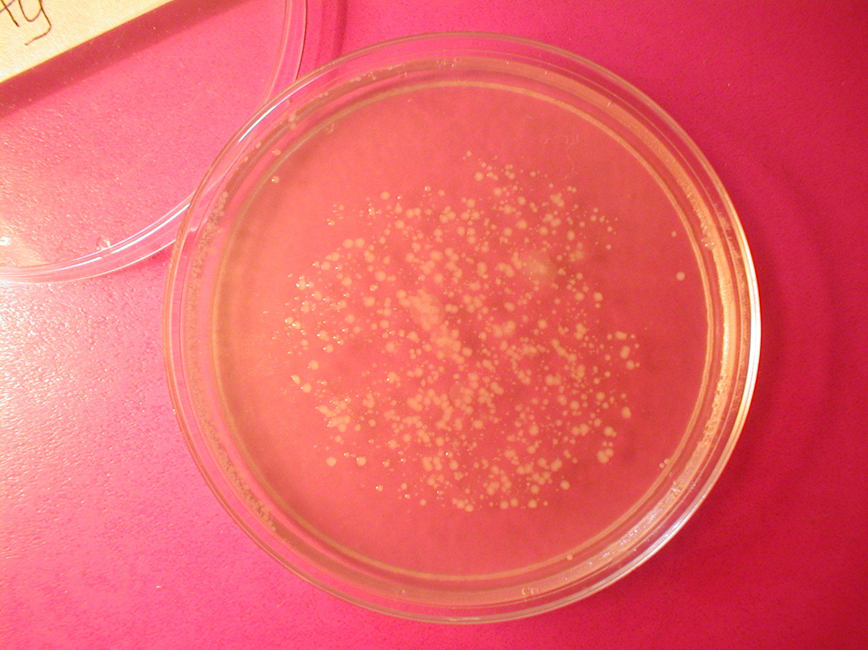  Unwashed Hands | 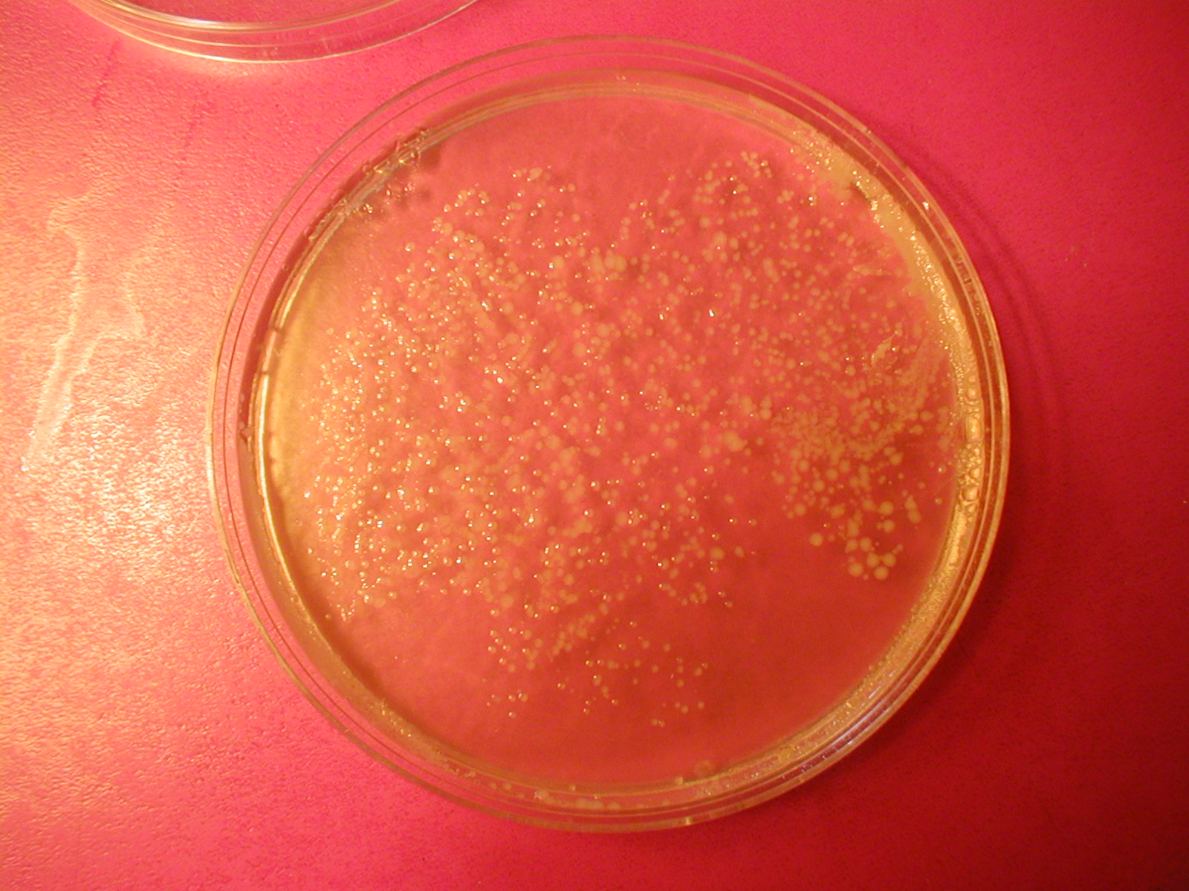  Washed Hands
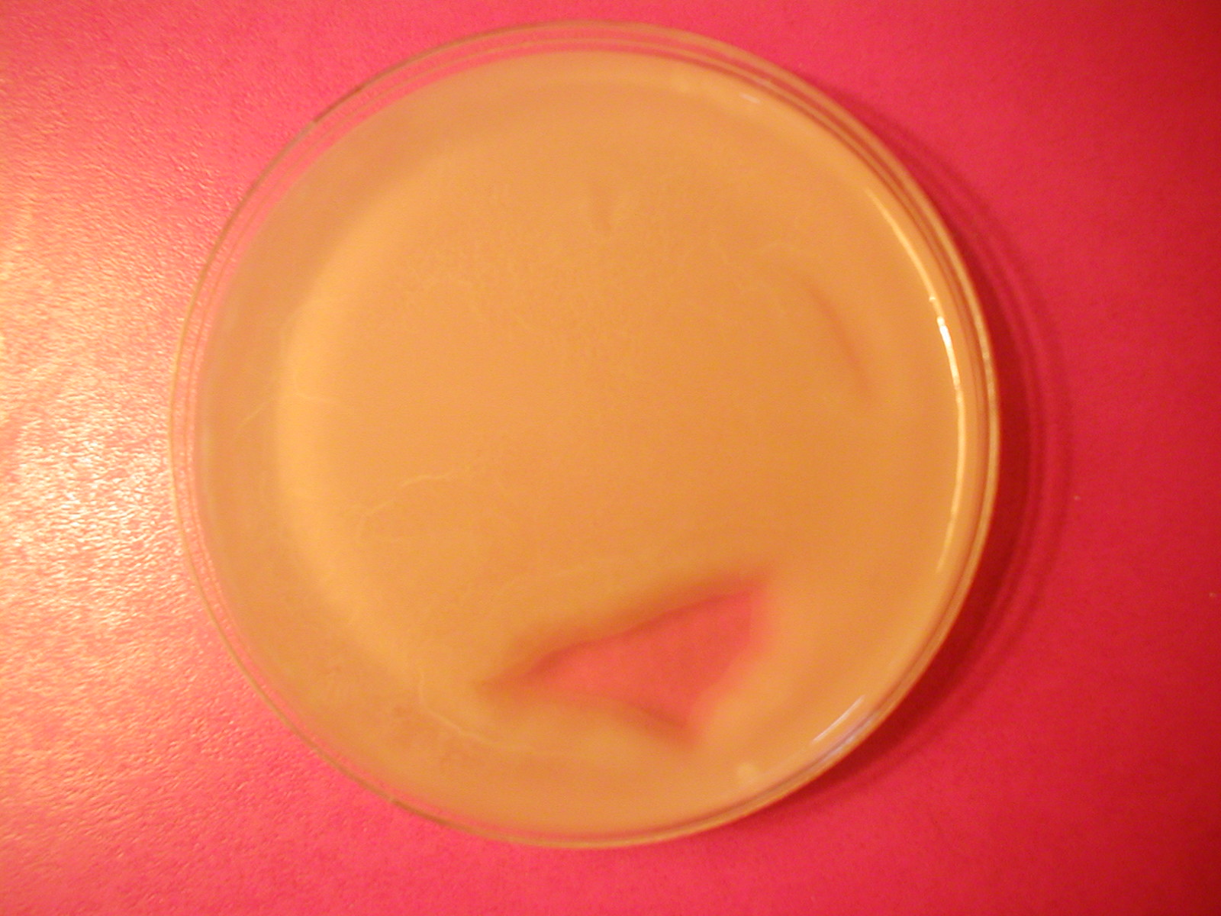  Cycle | 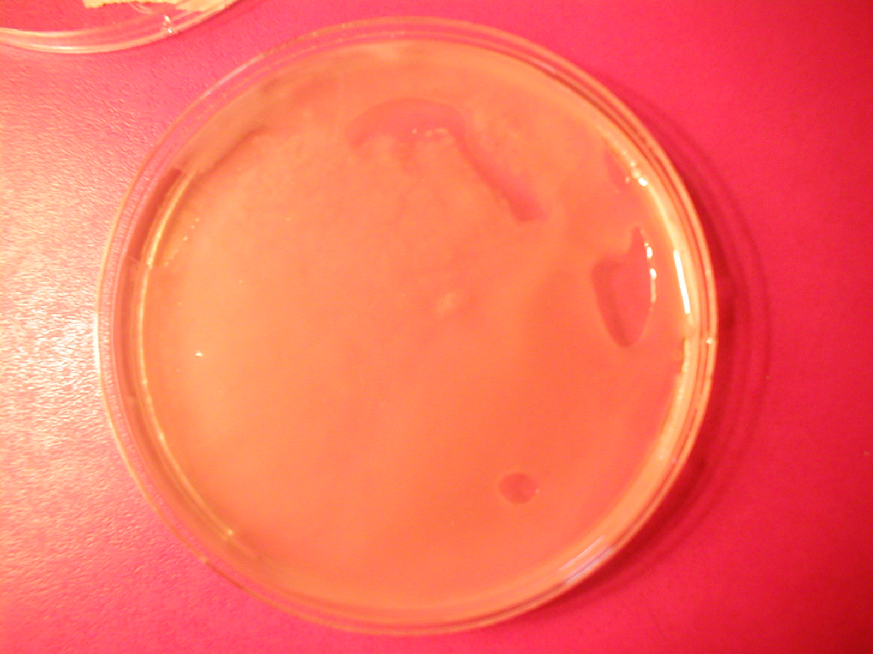  Under the Toilet Seat

Analysis:
Washed Versus Unwashed Hands Analysis:
Though we expected the washed hands to show less bacteria than the unwashed hands sample, it was clear that there was more bacterial growth in our washed hands one. This may be because of the soap that was used or the fact that we used two different people's hands instead of using the same person's before and after hand washing.
The soap may be the cause of the unexpected results. Though antibacterial soap is in common use these days, we had a family member that had fungal growth because of it. We discovered that bacteria is an antagonist to fungus. When overuse of antibacterial soap occurs in people whose skin provides the right moisture and pH conditions, the fungus will grow rampant. We have been using a soap called Milk and Honey because it has allowed this family members skin to return to normal. This ws the soap that was used in the lab.
I plan on returning to this lab when time allows and run a more controlled experiment to see if the same result occurs consistently with this soap and to see what results occur with antibacterial soap. I would also like to experiment with the balance and types of bacteria needed for healthy skin in regards to controlling fungal growth and to see if skin problems related to fungus increased once anti-bacterial soaps were in common use in households.

Cycle Analysis:
It wasn't really a surprise that the Cycle petri dish would have lots of bacterial growth. That is what this product is. It is almost pure bacteria – two strains. The purpose of cycle is to speed up the naturalization of new aquariums. It takes two tiers of bacteria in water for animal life to survive. One to turn ammonia into nitrates and one to turn the nitrates into harmless nitrites. The instructions said that the bacteria in the bottle were in a state of 'hibernation' waiting for conditions to be right to become active. We were not sure if our agar would be the 'right conditions'. It was.

Under the Toilet Seat Analysis:
Mom specifically didn't cleanse our spot for a week so we would get good growth. It worked. I almost expected it to grow ugly green and purple bacteria from that location, but it looked much like the Cycle sample only less concentrated growth.

Lab participants:
Timothy Moore, Melody Moore, and Zachary Moore

