Timothy Moore
Life Science: Unit 2; L4
7 September 2006 on OLS, 23 August 2006 (actual lab)
Score: 30/30, 100% (Scoring Guidelines included)
Looking At Cells Lab

Purpose

To observe cells and their structures.
Materials
microscope
slides
stain: Eyosin Y, iodine
onion
spoon
various pond water samples
Procedure
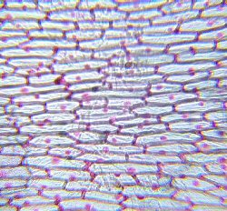Nucleus Cell Wall Cytoplasm | Onion Cells (Eukaryotic)  1. Take a small piece of the outermost skin of a raw onion.  2. Place the piece of onion onto a microscope slide. Add one small drop of Eyosin Y onto the piece of onion.  3. Place a cover slip on the sample.  4. Look at the cells using the lowest setting on the microscope. Line up the sample so that a single cell appears in the center of your view.  5. Look at the cell using the highest setting. Photograph what you see and add to the left.

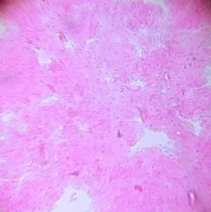 | Cheek Cells (Eukaryotic)  1. Use the edge of a spoon and gently scrape the inside of your cheek.  2. Transfer the cells onto a microscope slide. Add one small drop of Eyosin Y onto the cheek cells.  3. Place a cover slip on the sample.  4. Look at the cells using the lowest setting on the microscope. Line up the sample so that a single cell appears in the center of your view.  5. Look at the cell using the highest setting. Photograph what you see and add to the left.

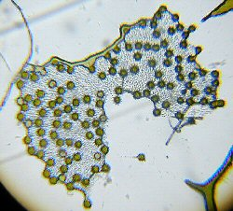 | Algae Cells (Eukaryotic)  1. Collect algae from our stream studies observation tank.  2. Transfer to a slide. Place a cover slip on the sample.  3. Look at the cells using the lowest setting on the microscope. Line up the sample so that a single cell appears in the center of your view.  4. Look at the cell using the highest setting. Photograph what you see and add to the left.

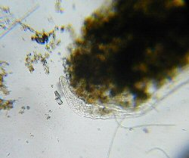 | Amoeba (Eukaryotic) and Bacteria (Prokaryotic)  1. Collect a sample from our English Ivy rooting water  2. Transfer to a slide. Place a cover slip on the sample.  3. Look at the cells using the lowest setting on the microscope. Line up the sample so that a single cell appears in the center of your view.  4. Look at the cell using the highest setting. Photograph what you see and add to the left.

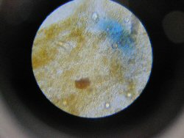 | Bacteria (Prokaryotic)

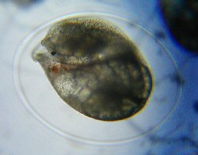 | Snails - developing in the jelly (Eukaryotic)  We were able to see the snail's heart beating.

Scoring Guidelines:
This one is correctly listed in this lesson's assessment
10/10 points earned | 1. Did your student complete the lab?Yes
These assessment questions are incorrectly listed on the bacteria lab in lesson 2.
10/10 points earned | 14. For the photos of the cells, did your student label which cell is prokaryotic and which is eukaryotic? Yes

10/10 points earned | 15. For the photos of the cells, did your student correctly label the parts of the cells? Yes

Just some fun pictures from the lab:

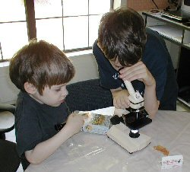 | 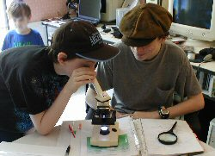
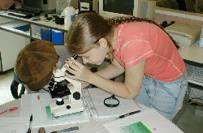 | 