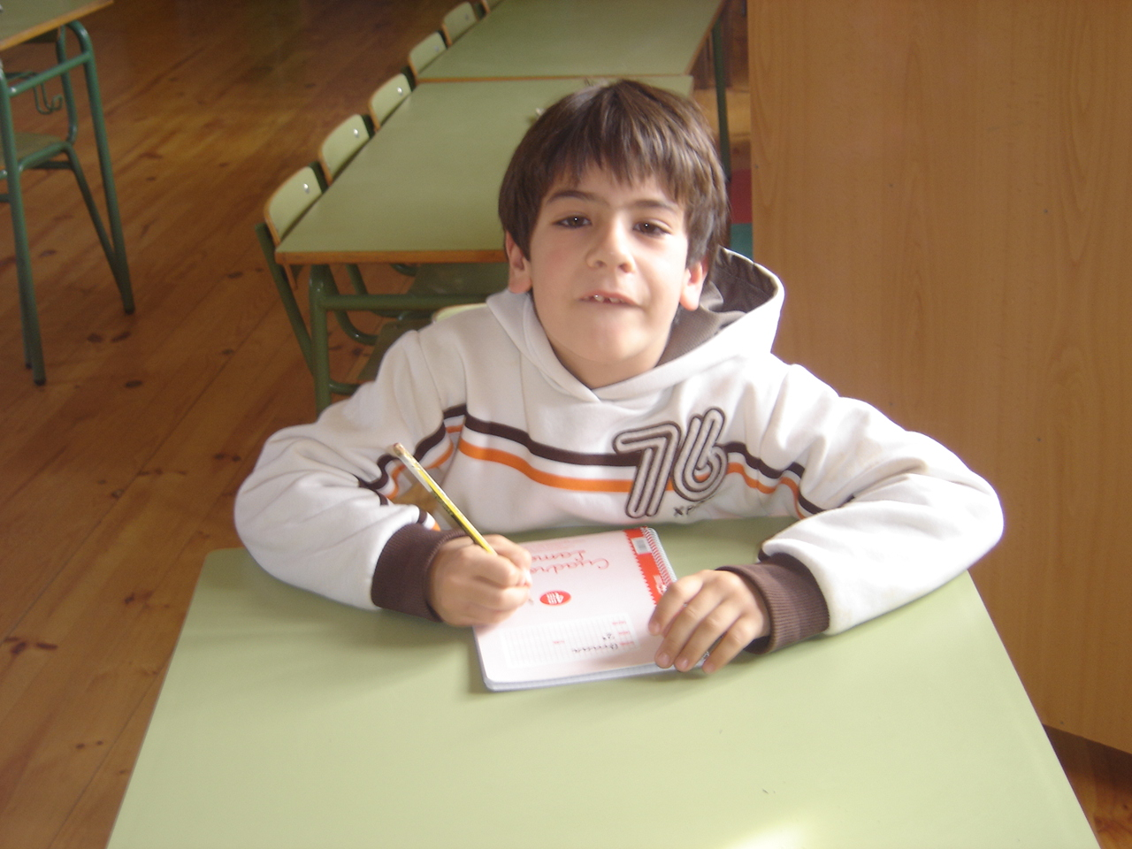

Hello.
My name is Omar.
My favourite colour is red.
I’m seven years old.
My favourite animal is elephant.
My favourite number is eleven.

