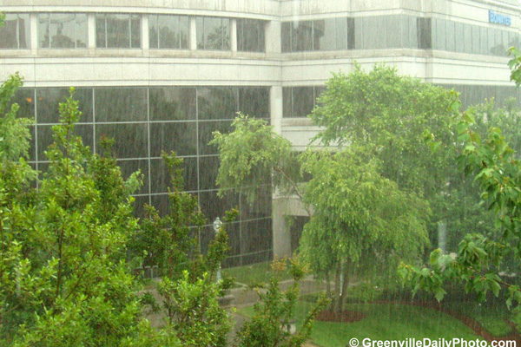

sources of water

Gebel Umm Hammad in the Red Sea Mountains east of Quseir, Egypt, today enjoys small but irregular amounts of winter rain, enabling the widening of joint controlled openings in the Thebes Limestone. Cavities are especially affected by flaking, while rock fragmentation is more active on the outside. The sedimentological and botanical study of fan deposits at the outlet of a karstic shaft in the Tree Shelter showed the local Holocene environmental evolution. Three periods of different degree of aridity can be considered: (i) Before 8120±45 BP (UtC-5389), bedload aggradation points to rare but occasionally heavy rains, lasting for several hours, attaining intensities of more than 76 mm/h and covering some 20 km². Wadi flash floods occasionally attained bankfull stage. (ii) Since 8120±45 BP (UtC-5389), such heavy rains have not occurred in the Egyptian Red Sea Mountains. Instead, a more moderate but maybe wetter precipitation regime was established. The karstic shafts were active, and there was water and life in the desert. Two humid pulses can be distinguished within this period. The first occurs at ±8000 BP, the second between 6630±45 (GrN-22560) and 6770±60 BP (GrN-22562). (iii) After the last wet culmination, there was a gradual shift to drier conditions. Shortly after ±5000 BP, modern climatic conditions are believed to have been attained. Today, the occasional rain storms are less heavy than before ±8000 BP. Bankfull stage river floods do not occur. Instead, secondary channels are eroded in the wadi beds. The general arid character during the whole period and the inherent local and temporal variations in precipitation patterns might explain apparent aberrations between the palaeoenvironmental evolution of the Tree Shelter site and remote study areas in Egypt and Suda…

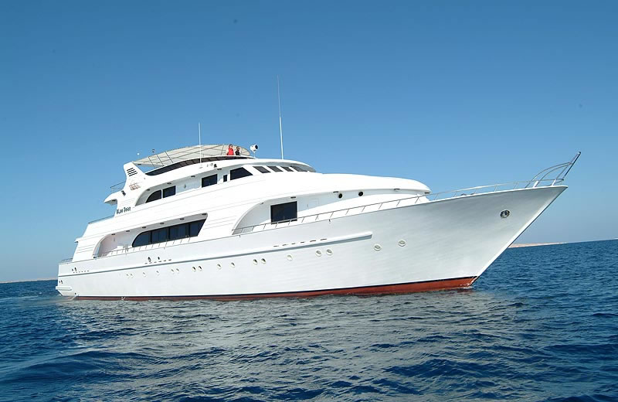


In 1995, in collaboration with local Bedouin fishermen, five no-take fisheries reserves were established within the Nabq Natural Resource Protected Area, South Sinai, Egyptian Red Sea. The abundance, size structure and catch of commercially targeted groupers (Serranidae), emperors (Lethrinidae) and snappers (Lutjanidae) were investigated before the establishment of these reserves, then in 1997 and again in 2000. By 1997, these fish had shown a significant increase in mean abundance within two of the no-take reserves. By 2000 each family and three individual species (Lethrinus obsoletus, Cephalopholis argus and Variola louti) had increased in abundance in the reserves. There were significant increases in mean individual length of the serranids Epinephelus fasciatus and C. argus and of the lethrinids L. nebulosus and Monotaxis grandoculis. Meanwhile, mean recorded catch per unit effort (CPUE) within the adjacent fished areas increased by about two-thirds (P <0.05) during the 5 years. The establishment of the no-take reserves appears to have played a key role in maintaining the sustainability of the fishery. The involvement of local Bedouin and fishermen in the co-management of fisheries resources was critical to the success of this initiative….

