BRAINSTORMING
Look at the famous people pictured below. What do they have in common?
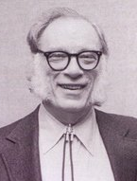
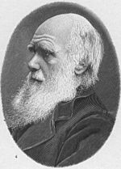
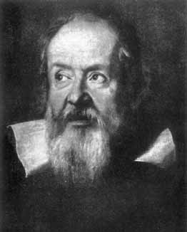

- Galileo Galilei -
- Charles Darwin -
- Isaac Asimov -
FOREWORD

The relationship between Humanities* and the Sciences has never been easy, and this is a very old issue. However, in ancient times it was quite different : all Greek philosophers had an advanced scientific knowledge; the Latin poet and philosopher Lucretius (1st century BC) in his long poem De Rerum Natura (“On the Nature of Things”) turned the scientific knowledge of his era (the physical theory of Epicurus; the main principles of atomism; atomic structure; sense perception, and the mechanics of certain bodily functions; the celestial bodies, etc.) into poetry; and later on learned people were somehow compelled to know about literature and astronomy as well.
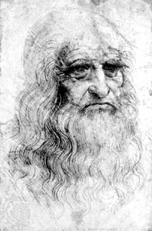
The conflict between humanistic and scientific cultures came out later: in the Middle Ages they did not like science very much but during the Renaissance there was a sort of symbiosis between the two fields again: the Italian, Leonardo da Vinci (1452- 1519) embodied the perfect prototype humanist in the Italian Renaissance, i.e. a man who was a great scientist (architect, engineer, physician) and artist (painter, sculptor, draftsman) at the same time.
Such a dialogue went on during the Enlightenment until, in the nineteenth century, there was the divorce between literature and exact sciences. Why? First of all because of the increasing development of science, that greatly specialized its language; secondly, the school systems from the nineteenth century on did not aim at letting people get learned but at training qualified work force for the society of the Industrial Revolution.
Leonardo da Vinci
Besides Leonardo da Vinci there have been some more scientists who were also great writers, e.g. Galileo Galilei who is also considered a model of literary style, or the naturalist Charles Darwin, whose scientific treatise On the origin of Species may be appreciated also as a classic of English literature for the clear and artistic descriptions of living beings. Some more examples can be listed: Isaac Asimov, Richard Dawkins, Bertrand Russell, John Barrow, the British-U.S. neurologist and writer Oliver Sacks - author of Awakenings (1973), which was filmed in 1990 starring Robert De Niro and Robin Williams, The Man Who Mistook His Wife for a Hat (1986), An Anthropologist on Mars (1995) -; the Russian-born American novelist and critic, Vladimir Nabokov (1899-1977) who – not many people know - was an accomplished lepidopterist and researcher on entomology, a recognized authority on butterflies; then there is the Italian chemist Primo Levi (1919-87), the survivor of the horrors of the Nazi concentration camps, who was also a novelist and poet. One of his greatest books, The Periodic Table is structured according to Mendeleyev’s table of the elements, with the subject of each chapter being linked in some way to chemical properties of a particular element.
Yet in current times it is hard to find such great minds working in both the field of humanities and the field of sciences.
Actually, in modern era the scientific and technological progress has undergone a dramatic acceleration, acquiring new dimensions and facing daily challenges: the energetic issue, the climate, the technology of information, etc. As a consequence of extreme modernity, everything has become so complex and overspecialized that the different disciplines are quite incomprehensible to one another.
According to the British novelist, scientist, and a scientific adviser to the British government, C. P. Snow (1905-80) [His novels include The Two Cultures and the Scientific Revolution (1959) and later non fiction works dealing with the cultural separation between practitioners of science and literature], there seems to be no dialogue between science and literature: for novelists and poets, science is just a cold set of formulas which can not be comprehended but by the specialists; for scientists, instead, those who write novels and poems have a too abstract and inadequate idea of nature. May literature be open to the world of science? In Hans Magnus Enzensberger’s opinion, literature is too full of subjectivism, and most novels speak of their authors only and very little of outer reality; moreover most artists - or humanists - keep having some disdainful and sceptical feelings towards scientists; on the other side, some scientists see literature a useless thing, although, the old stereotype of scientific researchers closed in their own discipline is disappearing. An encouraging example of a still possible osmosis between science and literature is provided by the term ‘Quark’ (= any of a group of subatomic particles thought to be among the fundamental constituents of matter, more specifically, of protons and neutrons), which etymologically was taken from James Joyce’s novel Finnegan’s' Wake and first proposed in 1964 by Murray Gell-Mann (1929 - ), the U.S. physicist (Nobel Prize in 1969) who had invented that physical concept.
However, apart from writers who are also scientists, and vice versa, it could be important to establish a communication between the two separate fields by translating the specialist denotative language into a universal connotative one which enables to popularise science also from an aesthetic point of view.
Nowadays science needs to be submitted from the outside to the criticisms of society on its dangerous developments (let us think of cloning, the invasive technologies, the science applied to the rearmament, transgenic food…). Even if an intrinsic conflict is inevitable, the two cultures could understand each other and find some shared values at last. The ultimate need is to learn better, to refuse the subculture of mass and filter learning.
Is school up to such a task? The aim of this anthology is approaching literature from a more pragmatic point of view, so as to help overcome the traditional chiasmus between the Humanities* and the Sciences.

