Timothy Moore
Mrs. Tammy Moore
VHSG Online Chemistry
3 March 2009

ELECTRICAL CONDUCTIVITY OF COMPOUNDS DISSOLVED IN WATER
Experiment 3.2 (Wile, 86,87)

Determining if a compound is ionic or covalent by whether it will conduct electricity once dissolved in water

ABSTRACT

In this lab, I determined that the baking soda was [ionic or covalent] because it [conducted or did not conduct] electricity. I determined that sugar was [ionic or covalent] because it [conducted or did not conduct].

INTRODUCTION
Compounds are substances made up of two or more different atoms. They can be classified as either ionic or covalent. Chemically, the difference is that covalent molecules will be made up of two or more non-metal atoms. Ionic compounds will be made up of at least one metal and one non-metal. Ionic and covalent compounds differ in some key characteristics including their electrical conductivity. Ionic compounds will conduct electricity when dissolved in water (we will be using distilled). You can tell if electricity is being conducted by the bubbles that will form around the wire.

MATERIALS AND METHODS

MATERIALS
- Distilled water  - Baking soda (1/2 tsp)  - Sugar (1/2 tsp)  - 2 pieces of water (preferably insulated)  - Wire strippers (scissors can work)  - Tape (preferably black electrical tape)  - 100 ml beaker or small glass  - 9 volt battery | 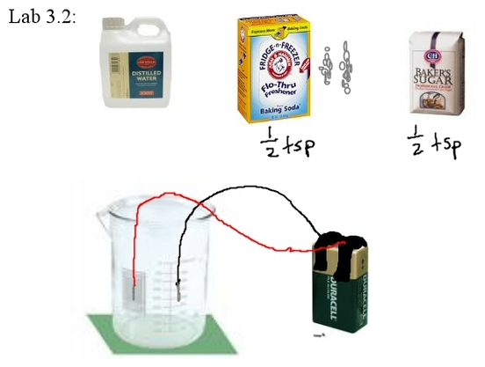

PROCEDURES:

Setting up the lab involved connecting each wire to one terminal of the 9 volt battery. In a beaker, I poured distilled water and dissolved first the baking soda in it. I then placed each end of the wires in the liquid and observed if there were any visible bubbles. Then, I washed everything up and ran the lab again, but this time I used sugar instead of baking soda.

RESULTS

[Indicate which one bubbled an what that means about whether it is ionic or covalent]
BIBLIOGRPAHY

Wile, Dr. Jay L. Exploring Creation With Chemistry. Vol. ed. 1. Chelsea: Sheridan Books, Inc, 2000.

