[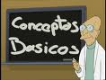](http://terceracultura.cl/wp-content/uploads/2010/07/conceptos-basicos1.jpg?w=300)