What is the basis of autoimmune diseases (think of four diseases)?
There are more than eighty illnesses caused by autoimmunity.Autoimmune diseases (AD) arise from an overactive immune response of the body against substances and tissues normally present in the body. In other words, the body attacks its own cells. It can be restricted to certain organs or involve a certain tissue in different places. 79% of autoimmune disease patients in the USA are women and it usually appears during or shortly after puberty. A healthy immune system recognizes, identifies, remembers, attacks, and destroys bacteria, viruses, fungi, parasites, and cancer cells or any health-damaging agents not normally present in the body. A defective immune system directs antibodies against its own tissues. Any disease in which cytotoxic cells are directed against self-antigens in the body's tissues is considered autoimmune in nature. The treatment of autoimmune diseases is typically with immunosuppression—medication which decreases the immune response.
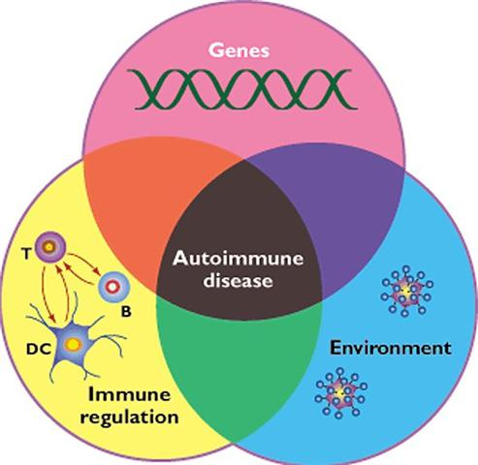 Figure 1.

Requirements for the development of an autoimmune disease. (figure 1)
The immune response of a genetically predisposed individual to an environmental pathogen, in association with defects in immunoregulatory mechanisms, can lead to the development of an autoimmune disease. The importance of the single components represented in this Venn diagram may vary between individuals and diseases. However, the appearance of an autoimmune disease requires the convergence of three components, the T, T cell; B, B cell; DC, dendritic cell.
Nature Immunology 2, 759 - 761 (2001)
doi: 10.1038/ni0901-759
We will take a closer look at four different AD’S:
1. Goodpasture’s syndrome (GS) is the co-existence of acute glomerulonephritis and pulmonary alveolar hemorrhage, Goodpasture's disease is one cause. Goodpasture's disease is a specific autoimmune disease caused by a type II antigen-antibody reaction leading to diffuse pulmonary hemorrhage and glomerulonephritis. There are circulating anti–glomerular basement membrane (anti-GBM) antibodies within the body. This syndrome is very uncommon. It represents 1 to 2% of all cases of rapidly progressive glomerulonephritis and the incidence is about 1 in 2 million it affects both sexes equally in children, and between 60 and 80% of patients have both renal and pulmonary disease. The kidneys alone are affected in 20 to 40% of cases and in about 10% of cases only the lungs are affected.
2. Guillain-Barré syndrome is an inflammatory disorder in which the body's immune system attacks part of the peripheral nervous system. The first symptoms of this disorder include varying degrees of weakness or tingling sensations in the extremities. These symptoms can increase in intensity until the muscles cannot be used at all and the patient is almost totally paralyzed. Many patients end up intubated and ventilated for a period of time. Most patients, however, recover from even the most severe cases of Guillain-Barré syndrome, although some continue to have some degree of weakness. Usually Guillain-Barré occurs a few days or weeks after the patient has had symptoms of a respiratory or gastrointestinal viral infection. Occasionally, surgery or vaccinations will trigger the syndrome. The disorder can develop over the course of hours or days, or it may take up to 3 to 4 weeks. If this diagnosis is suspected early treatment is important and hospitalization is crucial due to the rapid progression of the muscle weakness. Guillain-Barré is called a syndrome rather than a disease because it is not clear that a specific disease-causing agent is involved.

3. Grave’s disease is an organ specific autoimmune disease predominantly affecting the thyroid gland and causing clinical symptoms of hyperthyroidism (Janeway, Travers, Walport, and Shlomichik, 2005). It is the most common cause of hyperthyroidism and is more common in middle aged women. Symptoms include diffuse goiter, exophthalmos and non-pitting edema (Wikipedia, the free encyclopedia, 2009). It is characterized by antibodies being produced against the thyroid-stimulating hormone receptor in the thyroid gland (Janeway et al, 2005). These antibodies bind to the receptor causing its’ over stimulation which then leads to abnormally high amounts of thyroid hormone (T3 and T4) being produced. Three known autoantibodies are thyroid stimulating immunoglobulin’s which activate the thyroid longer than thyroid stimulating hormone (TSH), thyroid growth immunoglobulin’s which are involved with the growth of follicles in the thyroid and thyrotrophic binding-inhibiting immunoglobulin’s which affect TSH binding with its receptor (Wikipedia, 2009). Antithyroid drugs, radioiodine and surgery are treatment options.
4. Hashimoto’s Thyroiditis is the most frequent cause of hypothyroidism. Thyroiditis is an inflammation of the thyroid gland. Hypothyroidism is a decrease in thyroid hormone production. Hashimoto’s results from an autoimmune disorder where there is an attack on the thyroid gland by the patient’s own immune system. The thyroid gland, a butterfly-shaped organ that lies flat against the windpipe in the throat, becomes enlarged (called a goiter), firm, and rubbery but not usually tender. Thyroid gland tissue is slowly destroyed by lymphocytes that move into the thyroid gland and by thyroid antibodies.

References

Wikipedia. (2009). Graves’ disease. Retrieved January 12, 2009

from http://en.wikipedia.org/wiki/Graves%27_disease.

Janeway, C. A., Travers, P., Walport, M., and Shlomchik, M. J. (2005). Immunobiology:

The immune system in health and disease (6th ed.). New York: Garland Science

Publishing
Valentini, R. P. (2006). Paediatric
Guillain-Barré syndrome. Retrieved January 11, 2009
from http://www.mayoclinic.com/health/guillain-barre syndrome/DS00413
University of Western Ontario. (2004). Neurological medicine pocketbook. Retrieved January 11, 2009
from http://www.uwo.ca/cns/resident
Nature. (2001). Immunology. Retrieved January 13, 2009 from http://
www.nature.com/.../n9/fig_tab/ni0901-759_F1.html

