How long has this tumor been growing in him?
Colorectal cancer usually grows slowly, and in a predictable way (Canadian Cancer Society, 2008). In most people, colorectal cancers develop slowly over a period of several years (American Cancer Society, 2008). Nearly all colorectal cancers (99%) begin as polyps, benign tumors of the inner lining of the bowel (Colorectal Cancer Association of Canada, 2008). About one in twenty polyps become cancerous.
Over the years, a number of “genetic hits” or mutations occurred within the colon resulting in the development of Mr. C’s cancer. According to Safa (2007) many colon cancers begin with polyp formation. Further, he suggested that the average time between polyp formation and cancer is approximately 10 years. Clonal proliferation is characterized by mutations of progeny cells, which accumulate faster than the normal cells within the mucosal epithelium of the colon. The mutant cells may experience not only increased growth rates but also decreased apoptosis. Once Mr. C’s adenoma “traverses the muscularis mucosa, it becomes invasive and highly malignant (McCance & Huether, 2006, p. 1431). (see Figure 1)

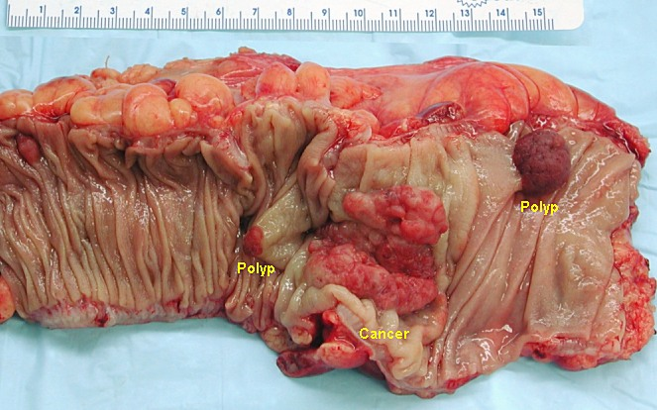
Figure 1. Gross appearance of a colectomy specimen containing two adenomatous polyps (the brownish oval tumors above the labels, attached to the normal beige lining by a stalk) and one invasive colorectal carcinoma (the crater-like, reddish, irregularly-shaped tumor located above the label). http://en.wikipedia.org/wiki/Image:Colon_cancer.jpg
For Mr. C., it is likely that his cancer has been slowly growing for some time, but could possibly have been diagnosed at the point three months earlier when he first noticed a change in his bowel habit. One of the cardinal signs or symptoms of colorectal cancer, cited by many of the references listed, is a noted change in bowel habit. We don’t have much information about what changes Mr. C. had experienced, but this change hopefully prompted further assessment and diagnosis.

References
American Cancer Society. (2008). Colorectal cancer: Early detection. Retrieved May 19, 2008 from http://www.cancer.org/docroot/CRI/content/CRI_2_6X_Colorectal_Cancer_Early_Detection_10.asp
Canadian Cancer Society. (2008). What is colorectal cancer? Retrieved May 19, 2008 from http://www.cancer.ca/ccs/internet/standard/0,3182,3172_10175_273118_langId-en,00.html
Colorectal Cancer Association of Canada. (2008). Just the facts. Retrieved May 19, 2008 from http://www.colorectal-cancer.ca/en/just-the-facts
Huether, S. E. (2006). Alterations of digestive function. In McCance, K. L., & Huether, S. E. Pathophysiology: The biologic basis for disease in adults and children (5th ed.). Philadelphia: Elsevier Mosby.
Safa, M. (2007). Colon cancer tumor growth time. Retrieved May 20, 2008 from http://www.netwellness.org/question.cfm/47949.htm
Virsup, D. M., & McCance, K. L. (2006). Biology of cancer. In McCance, K. L., & Huether, S. E. Pathophysiology: The biologic basis for disease in adults and children (5th ed.). Philadelphia: Elsevier Mosby.
Wikipedia. (2008). Image of colon cancer. Retrieved May 20, 2008 from http://en.wikipedia.org/wiki/Image:Colon_cancer.jpg

