What end organs can be affected by diabetes?
Long-term complications of diabetes develop gradually. The earlier that type 2 diabetes is developed and the longer that blood sugars are uncontrolled— the higher the risk of complications. Eventually, diabetes complications may be disabling or even life-threatening.
- Heart and blood vessel disease. Diabetes dramatically increases the risk of various cardiovascular problems, including coronary artery disease with chest pain (angina), heart attack, stroke, atherosclerosis and high blood pressure. Hyperglycemia can contribute to the endothelial cell dysfunction, which may play a role in development of atherosclerosis. This dysfunction inhibits vasodilation and increases vascular smooth muscle proliferation and thrombogenesis. In the microcirculation, it may contribute to ischemia. Hypertension and hyperlipidemia also cause dysfunction of endothelial cells that contributes to the process of atherosclerosis. About 80 percent of people who have diabetes die of some type of heart or blood vessel disease, according to the Canadian Diabetes Association. People with diabetes may also develop heart disease 10-12 years earlier than people without diabetes. Coronary heart disease is the most common form of heart disease in diabetes.
- Nerve damage (neuropathy). Excess sugar can injure the walls of the capillaries that nourish the body’s nerves, especially in the legs. This can cause tingling, numbness, burning or pain that usually begins at the tips of the toes or fingers and over a period of months or years gradually spreads upward. If left untreated, this could cause loss of sensation in the affected limbs. Damage to the nerves that control digestion can cause problems with nausea, vomiting, diarrhea or constipation.
- Kidney damage (nephropathy). The kidneys contain millions of tiny blood vessels that filter waste from your blood. Over the long term, hyperglycemia damages these vessels causing them to not function properly. Eventually proteinuria develops and the kidneys begin to fail. Severe damage leads to end-stage renal failure that is irreversible requiring dialysis or a kidney transplant. About one third of people with diabetes for 15 years or more will develop kidney disease.
- Eye damage. Diabetes can damage the blood vessels of the retina (diabetic retinopathy), potentially leading to blindness. Diabetic retinopathy is the most common cause of blindness in people under the age of 65. The arteries of the retina weaken and become leaky, eventually forming small hemorrhages. This often leads to edema in the retina which then causes decreased vision. Diabetes also increases the risk of other serious vision conditions, such as cataracts and glaucoma.
- Gastrointestinal problems. Many people with diabetes have issues with digestion, with constipation being most common. Diabetes is the most common cause of gastroparesis, which is the delayed emptying of the stomach. Nerve damage occurs from chronic hyperglycemia affecting the vagus nerve which controls the movement of food from the stomach to the intestines.
- Alzheimer's disease. Type 2 diabetes may increase the risk of Alzheimer's disease. The less control there is over blood sugars, the greater the risk. So what connects the two conditions? One theory is that cardiovascular problems caused by diabetes could contribute to dementia by blocking blood flow to the brain or causing strokes. Other possibilities are that too much insulin in the blood leads to brain-damaging inflammation, or lack of insulin in the brain deprives brain cells of glucose.

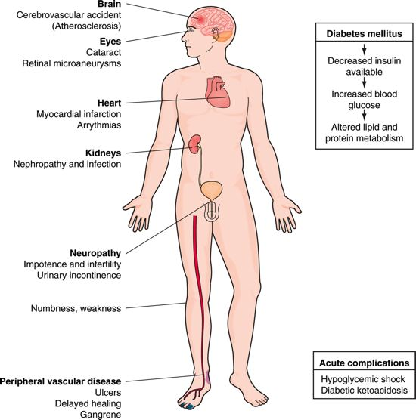

Potential complications of diabetes mellitus (Gould, 2006).

References
American Diabetes Association. (2009). Diabetes and cardiovascular disease
review. Retrieved February 1, 2009, from
http://www.diabetes.org/uedocuments/DCVDissue1.pdf
Canadian Diabetes Association. (2009). Living with diabetes. Retrieved
February 1, 2009, from http://www.diabetes.ca/
Gould, B. (2006). Pathophysiology for the Health Profession (3rd ed).
Philadelphia: Elsevier Inc.

