Unit 3

What did they mean by "staging" of his cancer?

Staging is a method for describing how much a cancer has grown, and spread to other local tissue, and if any, metastases. By staging a cancer appropriately physicians are able to recommend the best treatment options, and provide a prognosis. The best prognosis can be obtained with early detection and intervention. The potential for cure declines with increased tumor size, lymph node involvement, and metastases.

The most common staging system is TNM; T is for tumor spread, N is for lymph node involvement; M is the presence of distant metastasis. Once the tumor is staged then a biopsy can determine the tumor grade based on the appearance of the cancer cells, and how aggressive they are in comparison to normal cells.

T= Primary tumor; the number equals size of tumor and its local extent. The number can vary according to its site.
T0= Breast free of tumor
T1= Lesion<2 cm in size
T2= Lesion 2-5 cm
T3= Skin and/or chest wall involved by invasion

N= Lymph node involvement; a higher number means more nodes are involved.
N0= No axillary nodes involved
N1= Mobile nodes involved
N3= Fixed nodes involved

M= Extent of distant metastases.
M0= No metastases
M1= Demonstrable metastases
M2= Suspected metastases

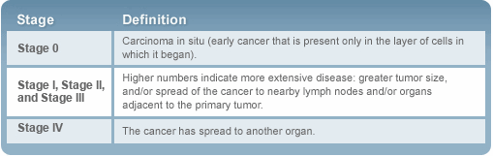

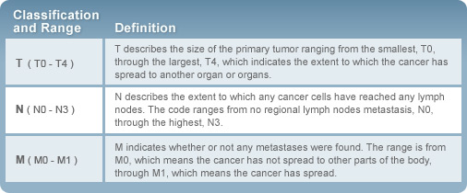
Images from Cancer. com, 2008.

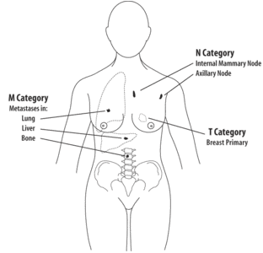

Image from International Union Against Cancer, 2009.

Staging Colon Cancer
Staging colon cancer is based on how many layers of the bowel wall are penetrated, the invasion of lymph nodes and the metastasis to distance sites (Mayo Clinic, 2008).
Staging tests may colon cancer may include imaging procedures such as abdominal CT scan or chest X-ray (Mayo Clinic, 2008). Yet staging is more often completed after surgical removal of the primary tumor, surrounding tissue and lymph nodes and possibly lesions found on other local organs, such as the liver (Colorectal Cancer Association of Canada, 2009). Surgical specimens are studied by a pathologist to determine the stage. Colon cancer types include (National Cancer Institute, 2008):
- Adenocarcinoma (most colon cancers including mucinous[colloid] adenocarcinoma and signet ring adenocarcinoma)
- Scirrhous tumors
- Neuroendocrine tumors (tumors with neuroendocrine differentiation have poor prognosis than pure adenocarcinomas)
The most widely used and precise staging system for colon cancer is the Tumor Nodes Metastases (TNM) system (Colorectal Cancer Association of Canada, 2009).

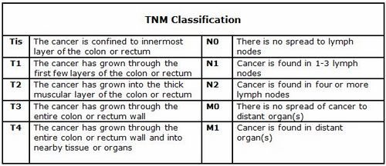

Table from Colorectal Cancer Association of Canada, 2009

After each element (tumor, nodes, metastases) has been determined, they are combing to form an over cancer stage. The stages of colon cancer are (Mayo Clinic, 2008 and Colorectal Cancer Association of Canada, 2009):

- Stage 0. Cancer is in the earliest stage. Has not extended beyond the inner layer (mucosa) of the colon or rectum. This stage of cancer may also be called carcinoma in situ.
- Stage I. Cancer has grown through the mucosa but has not penetrated beyond the colon wall.
- Stage II. Cancer has penetrated through the wall of the colon into the muscle wall but has not spread to nearby lymph nodes.
- Stage III. Cancer has invaded nearby lymph nodes.
- Stage IV. Cancer has metastasized to distant sites, such as liver, lung, peritoneum, ovaries.
- Recurrent. Cancer has come back after treatment. It may recur in the colon, rectum or other part of the body.

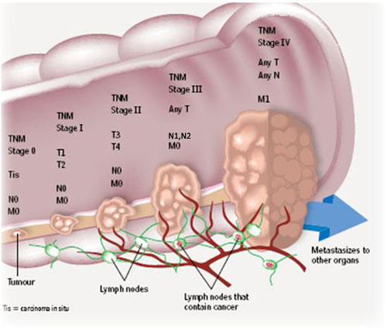

Image from Colorectal Cancer Association of Canada, 2009

Patterns of Spread: Metastasis

Metastasis – spread of cancer cells from primary site of origin to distant site; life threatening characteristic of malignancy.
Steps of metastasis:
1) Direct or continuous extension of local invasion of tumor cells into surrounding tissue
2) Penetration into lymphatic’s, blood vessels, or body cavities
3) Release into lymph or blood
4) Transport to secondary sites
5) Entry and growth in secondary sites

Distribution and Common Sites of Distant Metastases (p.385)

Primary Tumor Major Anatomic Pathway Frequent Site of Distant
Metastasis

Lung pulmonary vein, left ventricle multiple organs, brain

Colorectal mesenteric lymphatic’s, portal vein liver

Testicular lymphatic’s to perimetric area to lungs
Subcl. Vein to right ventricle

Prostate batsonplexus of paravertebral veins, bones, lung, liver, Ilium, lumbar spine endocrine, glands, CNS

Breast batson plexus of paravertebral bony skeleton, lungs
Veins, lymph nodes, sup vena cava

Head and neck direct extension, batson plexus lymphatics, liver, bone

Ovarian direct extension peritoneal surfaces, omentum and mesenteric veins diaphram omentum, liver

Sarcoma (extremity) inferior vena cava, rt ventricle, lungs
pulmonary artery

References

Cancer.com. (2008, May 19). Retrieved January 20, 2009 from: http://www.cancer.com/cancer/images/chart_TNM.jpg
Colorectal Cancer Association of Canada. (2009). Just the facts: What is colorectal cancer? Retrieved January 20th, 2009, from http://www.colorectal-cancer.ca/en/just-the-facts/what-cancer/
International Union Against Cancer. (2009). Retrieved January 20, 2009 from: http://docs.google.com/Doc?id=dgqm7knk_5d6c9hrhm&hl=en

Mayo Clinic. (2008, May 2). Retrieved January 20, 2009, from http://www.mayoclinic.com/health/coloncancer/DS00035/DSECTION=tests-and-diagnosis
McCance, K.L., & Huether, S.E. (2006). Pathophysiology: The biological basis for disease in adults and children (5th ed.). St.Louis, MI: Elsevir Mosby.

National Cancer Institute.(December 12, 2008). Colon cancer treatment: Health professional version: cellular classification. Retrieved January 20, 2009 from http://www.cancer.gov/cancertopics/pdq/treatment/colon/HealthProfessional/page3

