How long has this cancer been growing inside me?
The presenting signs and symptoms of colon cancer vary depending on the tumor location. Large bulky tumors in the ascending colon are typically associated with vague, dull pain and anemia. These symptoms are often mistaken for other disorders until the tumor is advanced. Cancer of the transverse colon is often associated with rectal bleeding, pain, blood in the stools and a change of bowel habits. Tumors invading the descending colon present with abdominal pain, alternating constipation and diarrhea, nausea, and vomiting. Advanced colon cancer is associated with severe pain, anorexia, and weight loss. Colon cancer can be present for several years before symptoms develop. Mr. C.’s symptoms started three months prior to his visit with the NP. With further history taking there may be other symptoms that Mr. C is experiencing that he has not realized could be related to his diagnosis. Mr. C has likely had this cancer for many months, possibly years before his symptoms started to develop.
Colorectal cancer is believed to develop through the process of adenoma-carcinoma sequence. Initially, cells in the luminal part of the colon begin to reproduce due to a mutation in the APC gene on chromosome 5. These rapidly growing cells create an adenoma. Certain oncogenes, such as the ras oncogene, are responsible for the malignant change of the adenoma to a carcinoma. Most malignant neoplasms develop from adenomatous polyps, of which there is a diversity of types. A polyp is a mass, often on a stem that protrudes into the lumen. Many polyps represent genetic abnormalities. As polyps increase in size; they carry an increased risk of dysplasia and malignant changes (Gould, 2006). The average length of time it takes for a polyp to form is five years. The change to malignancy can then take up to five more years to occur. These adenocarcinomas are distributed about equally in the right (or ascending) colon, the left (or descending) colon, and the distal sigmoid colon and rectum. In recent years, an increasing number of tumors have been found in the right colon using barium enema or CT scans. Lesions in this location are more difficult to diagnose at an early stage because routine rectal digital examination or proctosigmoidoscopy do not suffice. Tumors in the sigmoid colon and rectum are more easily accessible.
This information is important to remember as it is useful when explaining to patients why it is important they are screened with a colonoscopy regularly. In the United States, colorectal cancer ranks high as a lethal cancer in individuals older than age 50. The estimates for 2004 include 147,000 persons to be diagnosed and an anticipated 57,000 deaths (Thibodeau, 2007). The American Cancer Society recommends fecal tests for occult blood (FOBT), every year for those over 40 years and a sigmoidoscopy every 3 to 5 years for those over 50. It is also recommended that patients have a colonoscopy every 5 years starting at 50 unless there is a family history of colorectal cancer, then screening should start at 40 years. Following a survey, the CDC and American Cancer Society are promoting a routine screening for all persons over age 50, to include FOBT, sigmoidoscopy and colonoscopy, to ensure more early detection and treatment (Thibodeau, 2007).

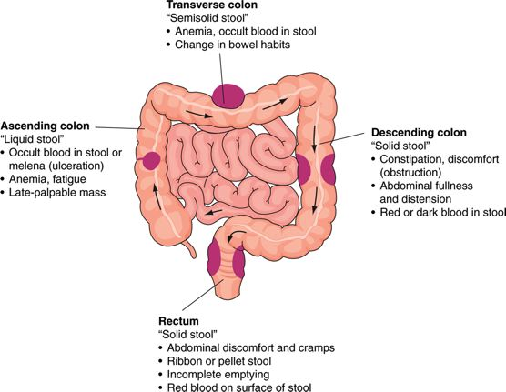

Gould, Barbara E. Pathophysiology for the Health Professions, 3rd Edition.

References
Gould, B. (2006). Pathophysiology for the Health Profession (3rd ed). Philadelphia: Elsevier Inc.

McCance, K. L., Huether, S.D. (2006). Pathophysiology: the biologic basis for disease in adults
and children (5th ed.) Mosby. St. Louis, MS.
de Snoo, L. (2003). Colorectal cancer. Primary Health Care, 13(3), 43-49.
Shelton, B.K. (2002). Introduction to colorectal cancer. Seminars in Oncology Nursing, 18(2), 2-12.
Thibodeau, G. A. (2007). Anatomy & Physiology (6th ed.) Mosby. St. Louis, Missouri

