Case 2 Group D
Finally, Mr. C. says that while in hospital he fell and hit his head on the floor. He was told he had a head injury. He doesn't remember any loss of consciousness but did have double/blurred vision for 1-2 hours after and a couple days of dizziness and nausea. What is the pathophysiology behind concussion/head injury?
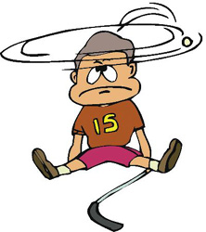

Concussion
Concussion is derived from the Latin word concutere, which means to shake violently (Wikipedia, 2009). Concussion, also known as mild traumatic brain injury (MTBI) and is the most common form, but least serious type of traumatic brain injury. Injuries, which result a diagnosis of concussion, typically arise from impact of mechanical searing forces of rapid acceleration, and deceleration on the brain. The injuries can by described coup, directly below the point of impact, and contercoup, on the pole opposite of the site of impact.
Brain trauma is categorized by the blunt (closed, nonmissile), the most common trauma. It is usually the result of a head strike to a hard surface, or a rapidly moving object, which strikes the head. The dura mater intact, brain tissue not exposed, with no focal and diffuse injury. Open (penetrating missile trauma), which results in the dura mater being broken, exposure of brain, and focal injury.

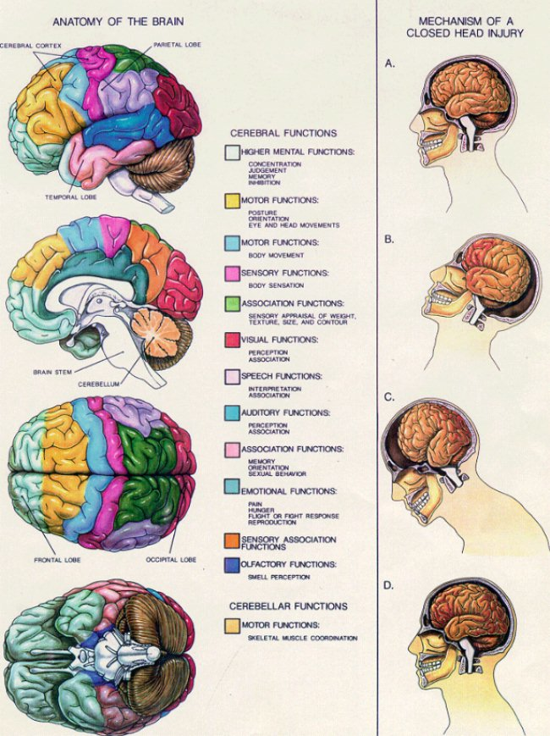
Merck Manual, 2007

The most common causes of include motor vehicle collisions (MVCs) 50%, falls 21%, sports related events 10%, and violence (12%) (McCance and Huether, 2006). The populations at highest risk for MTBI are 15-24 year olds, infants 6 months to 2 yrs, young school age children and elderly. The male/female ratio for traumatic brain injury is 2:1 (McCance, 2006, p.547).

Pathophysiology
Traumatic brain injury damage arises from three mechanisms: primary, secondary, and tertiary.
- Primary injury is caused by impact and involves neural injury, primary glial injury and vascular response.
- Secondary injury can result in cerebral edema, brain swelling, hemorrhage, infection, increased ICP; tissue hypoxia, ischemia
- Tertiary injury is caused by apnea, hypotension, change in pulmonary resistance, change in ECG (ST and T wave changes).

The impact of forces applied to the human brain during an accident can disrupt the cellular processes of brain function for days, weeks, or months. The injuries sustained with MTBI are more temporary microscopic axonal disturbances, or stretching in comparison with moderate to severe brain trauma. According to Merck Manual (2007) concussion is a transient, reversible posttraumatic alteration in mental status (loss of consciousness) lasting seconds, minutes, but less than 6 hours. There are no gross temporary structural brain lesions, or serious neurologic brain residue with MTBI.

MTBI can alter the brains physiologic functions by impairing neurotransmitter function, and reversing cellular metabolic processes can result in a minimal amount of cell death days after the event. The cascade of events, which follow concussion, also include loss of ion regulation, deregulation of energy use, and reduction in cerebral blood flow. The brain can be in state of hypermetabolism for weeks following MTBI; this leads to increased glucose demand, and adenosine triphosphate (ATP) production for cell energy. With decreased cerebral blood flow, and increased energy demand the brain function may experience cell “energy crisis”, thus explaining the diffuse symptoms experienced by patients who have sustained MTBI.

Physical Signs
- Headache
- Dizziness
- Nausea and vomiting.
- Visual symptoms (i.e. light sensitivity, blurred, or double vision).
- Lack of motor coordination, and difficulty balancing.
- Tinnitus

Cognitive and Emotional
- Confusion
- Disorientation
- Poor concentration
- Personality change
- Slow to answer questions, or repeatedly asking the same questions.
- Slurred speech

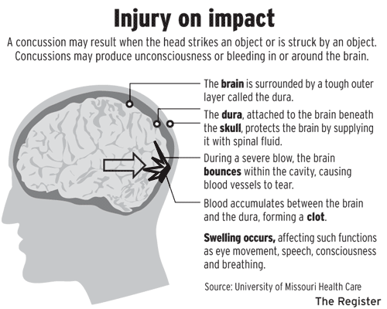

Orange County Register Communications, 2008
Concussion Grading
Mild concussion – involves temporary axonal disturbances:
Grade I – confusion and disorientation with amnesia (momentary)
Grade II – momentary confusion and retrograde amnesia that develops after 5-10 min (memory loss involves only events occurring several minutes before injury)
Grade III – confusion, retrograde amnesia present from impact, persists for several minutes
Grade IV – Classic cerebral concussion; diffuse cerebral disconnection from brainstem reticular activating system; physiologic, neurologic dysfunction without anatomic disruption; loss of consciousness (less than 6 hours), retrograde and anterograde amnesia.
The most common brain injuries are mild concussion, and classic cerebral concussion. Many patients who sustain MTBI experience postconcussive syndrome. The most common symptoms of include headache, cognitive impairment, psychologic and somatic complaints, cranial nerve signs and symptoms; treatment is reassurance and symptomatic relief, close observation
Other more severe brain injuries include:
Focal brain injury is more specific; they have grossly observable brain lesions, cortical contusions, epidural hemorrhage, subdural hematoma, and intracerebral hematoma. The smaller the area of impact, the greater the severity of injury as force is concentrated. Contusions are most commonly found in frontal lobes, in temporal lobes.
Subdural hematoma accounts for approximately 10-20% of TBI. It develops within 48 hrs, and is usually located usually at top of skull.
Intracerebral hematoma accounts for 2-3% of TBI. It commonly occurs in the frontal and temporal lobes, as a result of shearing forces. Delayed intracerebral hematomas may appear 3-10 days after injury.
Diffuse brain injury (Diffuse Axonal Injury, DAI) occurs from shaking effect, shearing of brain tissue; cognitive and affective impairment.
Mild diffuse axonal injury (DAI) is a posttraumatic coma, which lasts 6-24 hours. Death is uncommon but residual cognitive, psychologic and sensorimotor deficits may persist.
Moderate diffuse axonal injury – widespread physiologic impairment exists t/o cerebral cortex and diencephalons, tearing of some axons in both hemispheres, basal skull fracture, focal injury, prolonged coma for more than 24 hr; recover is often incomplete in survivors
Severe diffuse axonal injuries result in severe mechanical disruption of many axons in cerebral hemispheres, the diencephalons and brain stem. It has a survival rate of 64%. 30-40% stay at low level or reduced states of consciousness for prolonged period of time.
Diffuse brain injury results in disorientation, confusion, short attention span, memory deficits, dysphasia, poor judgment, perceptual deficits, and behavior disorders like agitation, impulsiveness, blunt affect, and depression.

The Glasgow Coma Scale (GCS) is the most common assessment tool used to determine MTBI severity.
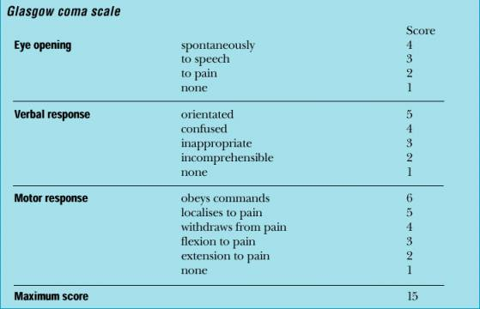
Student BMJ, 2000.

- GCS 13-15 – mild concussion
- GCS 9-12 – structural injury such as hemorrhage or contusion
- GCS 3-8 – cognitive and/or physical disability or death
Taking into consideration Mr.C’s reported case we can assign a concussion grading of MTBI to Grade 1. The recommended treatment management would be time, and rest with avoidance of strenuous activities, and symptom control.

Center for Brain Health, 2008.

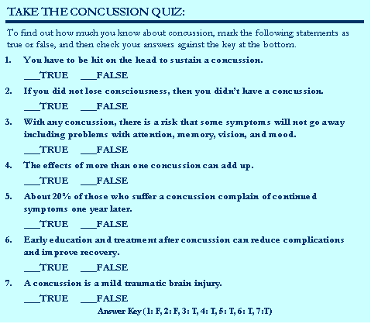

References

McCance, K.L., & Huether, S.E. (2006). Pathophysiology: The biological basis for disease in adults and children (5th ed.). St.Louis, MI: Elsevir Mosby.

Merck Manual Professional: Traumatic Brain Injury. Retrieved January 24, 2009 from: http://www.merck.com/mmpe/sec21/ch310/ch310a.html

Turner, K., Jones, A., & Handa, A. Emergency Management of Head Injuries. Student BMJ. 2000;08: 131-174.

Wikipedia: Concussion. Retrieved January 24, 2009 from: http://en.wikipedia.org/wiki/Concussion

