Understanding T_{3 and} T_{4,}

The thyroid gland secretes two thyroid hormones, thyroxin or T_{4,} and triiodothyronine or T_{3.} It also secretes the hormone calcitonin. It is important to know that T₄ is the more abundant; however, T₃ is the more potent and is considered by physiologists to be the principal thyroid hormone. In order for T₄ and T₃ to be produced in adequate amounts, a person’s diet must contain sufficient iodine. The two thyroid hormones, thyroxin and triiodothyronine, are secreted by the thyroid gland in response to hypothalamic-pituitary secretion of thyroid-stimulating hormone (Gould, 2006).
Most endocrine glands do not store their hormones but instead secrete them directly into the blood as they are produced. The thyroid gland is different in that it stores considerable amounts of the thyroid hormones in the form of a colloid compound. The colloid material is stored in the follicles of the gland, and when the thyroid hormones are needed, they are released from the colloid and secreted into the blood. (See below)

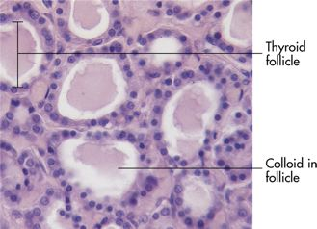

Thyroid and parathyroid glands. Note their relationship to each other and to the larynx
Thyroid and parathyroid glands. Note their relationship to each other and to the larynx

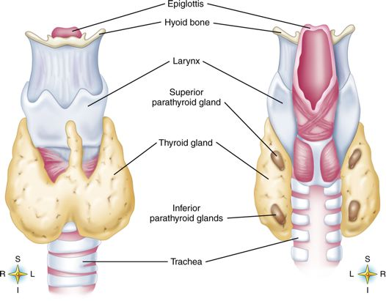

T₄ and T₃ influence every single cell in our bodies. They make them speed up their release of energy from foods. It is safe to say that these thyroid hormones stimulate cellular metabolism. All body functions depend on a normal supply of energy, they all depend on normal thyroid secretion. Even normal mental and physical growth and development depend on normal thyroid functioning.(Gould,2006)
Calcitonin decreases the concentration of calcium in the blood by first acting on bone to inhibit its breakdown. With less bone being reabsorbed, less calcium moves out of bone into blood, and, as a result, the concentration of calcium in blood decreases. An increase in calcitonin secretion quickly follows any increase in blood calcium concentration, even if it is a slight one. This causes blood calcium concentration to decrease to its normal level. Calcitonin thus helps maintain homeostasis of blood calcium. It prevents a harmful excess of calcium in the blood.

Hyperthyroidism

The terms thyrotoxicosis and hyperthyroidism are often used interchangeably. Hyperthyroidism is an over secretion of circulating thyroid hormones therefore dramatically increasing the metabolic rate. Food material is burned by the cells at an excessive rate, and individuals who suffer from this condition lose weight, have an increased appetite, and show signs of nervous irritability. They appear restless, jumpy, and excessively active. Many patients with hyperthyroidism also have very prominent, almost protruding eyes—a condition called exophthalmos. Hyperthyroidism with exophthalmos is characteristic of Graves’s disease, an inherited condition that occurs five times more frequently in women than in men.
Primary hyperthyroidism is a form of thyrotoxicosis in which excess thyroid hormones are secreted by the thyroid gland. Thyrotoxicosis has a variety of causes. Identifying the cause is important because the treatment and expected outcome vary accordingly. Specific diseases that can cause hyperthyroidism include Graves disease; toxic multinodular goiter; solitary hyperfunctioning nodules; and very rarely, follicular thyroid carcinoma. Secondary hyperthyroidism is very rare and is caused by TSH-secreting pituitary adenomas. Thyrotoxicosis not associated with hyperthyroidism includes Thyroiditis or ingestion of excess TH. (McCance & Huether, 2006)

References

Gould, B. (2006). Pathophysiology for the Health Profession (3rd ed). Philadelphia: Elsevier Inc.

McCance, K. L., & Huether, S.D. (2006). Pathophysiology: the biologic basis for disease in adults and children (5th ed.) Mosby. St. Louis, MS

