How is the pathology of Type 2 diabetes mellitus different than Type 1 diabetes mellitus?

|  |  |  |
| --- | --- | --- |
|  | **Type 1 Diabetes** | **Type 2 Diabetes** |
| **Also known as** | IDDM or juvenile onset** | NIDDM or adult onset |
| **The breakdown** | Accounts for 5-10 % of all cases of diabetes | Accounts for 90-95% of all cases of diabetes |
| **Ages affected** | Peak onset at age 11-13 | Affects people primarily after 40 yrs of age |
| **Types** | 1. Immune- cell mediated destruction of beta cells of pancreas 2. Nonimmune- idiopathic cases such as pancreatitis, tumors of the pancreas | 1. Maturity onset diabetes of youth** 2. Gestational diabetes 3. Regular type II diabetes |
| **Causes** | Mixed genetic and environmental   1. Genetic- between 10-13% have a first degree relative with type I | Mixed genetic and risk factors such as obesity, advanced age, physical inactivity, prior history of gestational diabetes mellitus (GDM), family history of diabetes, hypertension, dyslipidemia, polycystic ovary syndrome (PCOS) and race/ethnicity (African Americans, Latino, Hispanic, American Indians) |
| **Pathophysiology** | In immune type there is an autoimmune reaction to antigens of the islet cells of the pancreas, leading to destruction of the beta cells leading to a deficiency in insulin secretion. Macrophages, T and B lymphocytes, and natural killer cells are held responsible for destruction | 1. Insulin resistance: suboptimal response of insulin sensitive cells to insulin 2. Decreased insulin secretion by beta cells: amyloid infiltration of islets and islet cell destruction |
| **Insulin** | Not enough is produced | Cells become resistant to it and/or production is decreased |
| **Glucagon** | There is excessive secretion of glucagon in these patients relative to insulin secretion because the alpha cells are also functioning abnormally. | Not as big of a player |
| **Amylin**- a hormone co-secreted with insulin by the beta cells- usually suppresses glucagon secretion | Deficient | Deficient |
| **Consequences for metabolism** | Relative increase in glucagon stimulates overproduction of glucose and ketones; deficiency of insulin results in an increase in fat catabolism | Hyperglycemia d/t insulin resistance or underproduction of insulin leads to abnormal lipid synthesis, fatigue, and increased gluconeogenesis |

**This has been further confused by maturity type onset diabetes of the young (MODY)- a form of diabetes type II that affects people under the age of 25.

Here are a few more concept maps that we created to help us put it all together

TYPE I DIABETES

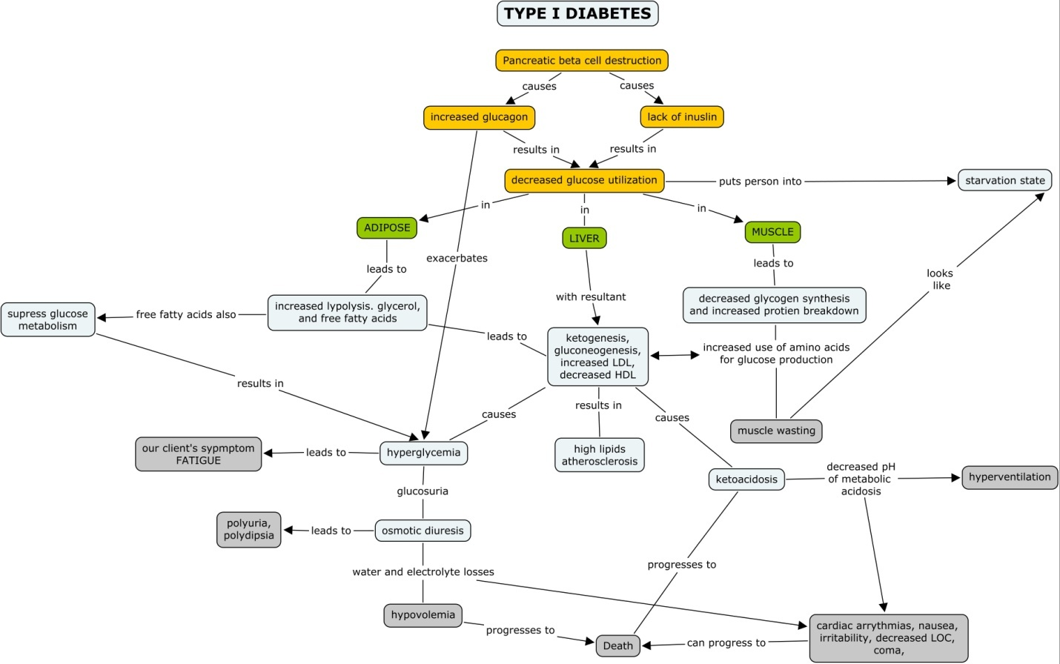

TYPE II DIABETES

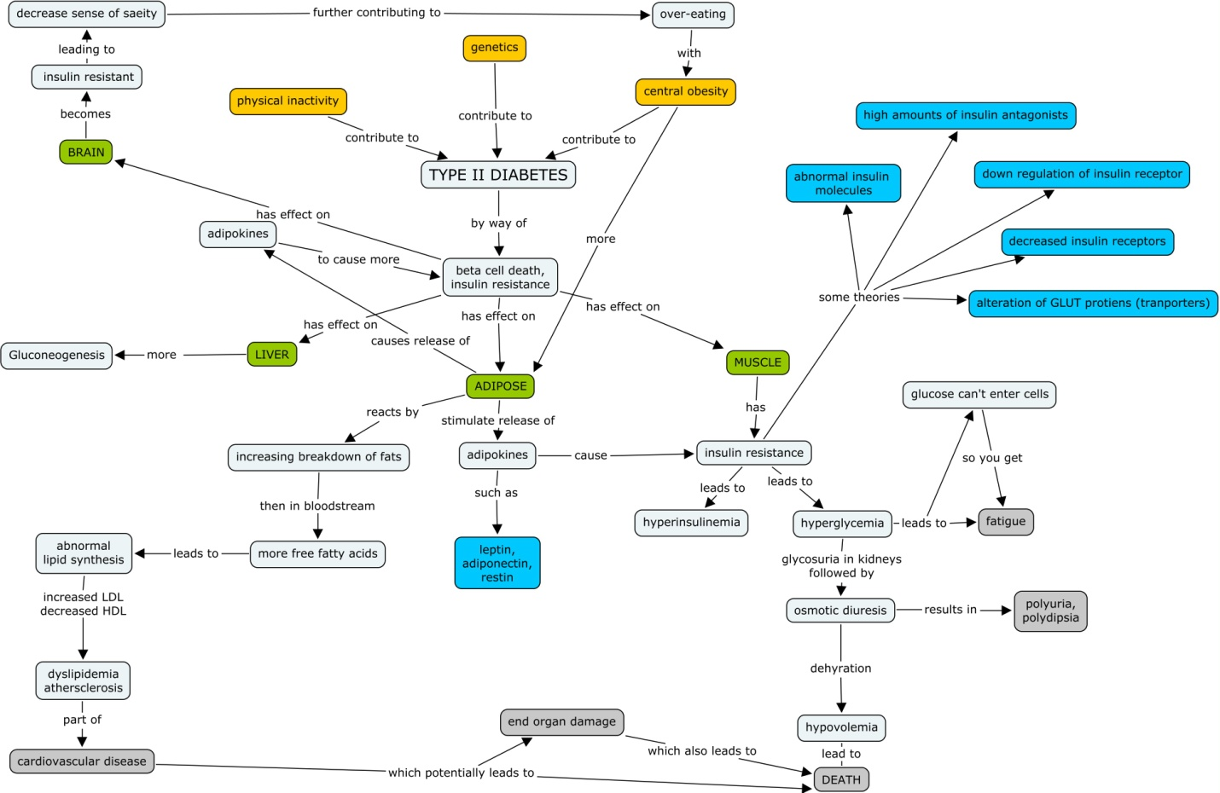

References

American Diabetes Association (2008). *DiabetesPro: Professional resources online*. Retrieved February 3,

2009 from http://professional.diabetes.org/Disease_Backgrounder.aspx?MID=230&RD=1.

King, M. (2008). *Definition of diabetes*. Retrieved February 2, 2009 from

<http://themedicalbiochemistrypage.org/diabetes.html>.

McCance, K.L., & Huether, S.E. (2006). *Pathophysiology: The biologic basis for disease in adults and*

*children* (5th ed.). St. Louis: Elsevier Mosby.