Case Study 1
Mr. H. has come to see you because his brother has just had a "heart attack" and he wants to know if this is going to happen to him.
Mr. H. says someone told him he could have atherosclerosis and could have a blood clot and die. He want to know, first, if this is true and second, if true, what is atherosclerosis and what happens to the heart to make a person have a "heart attack."
Atherosclerosis
- Commonly referred to as hardening of the artery walls due to plaque build up
- Plaque is made up of calcium, fats, cholesterol and other substances (National Heart and Lung Institute, 2007)
- Chronic inflammatory response of the artery wall due to accumulation of macrophage white blood cells without adequate removal of fats and cholesterol (Wikipeda, 2008)
- The arteries lose their elasticity and narrow which makes it more difficult for the blood to flow through (Heartandstroke.com, 2008)
- Overtime this build up decreases the blood flow (National Heart and Lung Institute, 2007;Wikipeda, 2008)
- If left untreated can lead to total blockage of blood flow resulting in a heart attack or stroke ((National Heart and Lung Institute, 2007
- 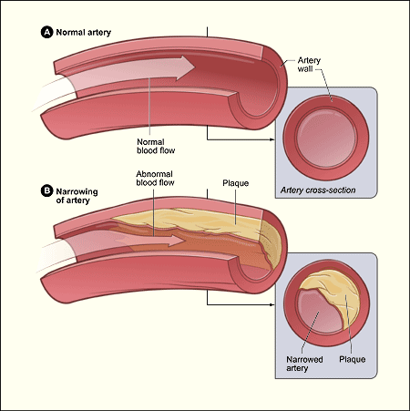
- Healthy artery (fig A) versus artery with Artherosclerosis (Fig B). Reproduced from National Heart and Lung Institute (2007). Retrieved June 22, 2008 from http://www.nhlbi.nih.gov/health/dci/Diseases/Atherosclerosis/Atherosclerosis_WhatIs.html
Heart Attack
- Heart attack occurs when blood flow to a section of the heart becomes blocked. Prolonged blockage results in muscle death due to hypoxia (National Heart and Lung Institute, 2007). The heart muscle is replaced with scar tissue. This may result in severe long standing cardiac issues such as arrhythmias (ventricular fibrillation) or heart failure (heart is unable to pump blood the way it should).

- 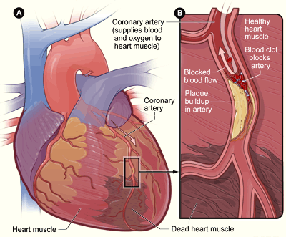
- Figure B -demonstrates blocked artery. Figure A, Shows Heart muscle death due to blocked artery. Reproduced from National Heart and Lung Institute (2007). Retrieved June 22, 2008 from http://www.nhlbi.nih.gov/health/dci/Diseases/HeartAttack/HeartAttack_WhatIs.html.
Could he have a blood clot and die?
The answer to this question depends on the progression of Mr H's atherosclerosis. Atherosclerosis causes a narrowing of the artery because of plaque build up along the walls and this affects blood flow. A ruptured plaque (complicated plaque) exposes underlying tissue, initiates the clotting cascade and a thrombus forms. The thrombus can occlude the artery causing ischemia and infarction. (McCance & Huether, 2006)
In answer to Mr H's question: Yes, he could die from a blood clot if his atherosclerosis is progressed enough.
Could he have Atherosclerosis?
The exact cause of atherosclerosis is unknown however there are certain risk factors that could increase your chances of developing it. Some risk factors that increase your chances of developing atherosclerosis are: (National Heart, Lung and Blood Institute, 2008)
- High LDL cholesterol and low HDL cholesterol
- Blood pressure above 140/90 over a long period of time
- Smoking
- Diabetes and insulin resistance
- Obesity
- Men over 45 years of age and women over 55 years of age
- If your father or a brother was diagnosed with heart disease before 55 years of age, or if your mother or a sister was diagnosed with heart disease before 65 years of age
- Lack of physical activity
- Sleep apnea
- Stress
- Alcohol
To answer Mr. H's question:
The National Heart, Lung and Blood Institute states that even if you have one or more risk factor, you can prevent atherosclerosis by making healthy lifestyle choices and taking medication, when necessary, to treat risk factors. We do not know how old Mr H's brother is, but if he is under 55 years of age then Mr H is at higher risk of developing atherosclerosis. We also need to know more information about his lifestyle choices such as his activity level and eating habits before we can determine if he is at risk of having atherosclerosis.
Mr. H. returns for a follow up visit after having the "tests" you advised. You review the results with him. The only abnormality to date is ECG evidence of left ventricular hypertrophy (LVH). You are not surprised, as last visit you checked Mr. H.'s blood pressure (BP) and it was 180/100. When you take his BP at this visit, it is the same. You tell him this and he shrugs and tells you it has been high for a while. About a year
What is Left Ventricular Hypertrophy (LVH)?
Left ventricular hypertrophy (valvular or hypertensive hypertrophic cardiomyopathy)is characterized by the enlargement of the left ventricle heart muscle, in response to increased resistance in the circulation (Medical University of South Carolina, 1999) the ventricular cavity may or may not be enlarged as well (Kaplan & Douglas 2007). Usual causes of increased resistance include hypertension, and valvular stenosis (McCance & Huether, 2006). Ideopathic hypertrophic cardiomyopathy is a genetic disease with an autosomal dominant inheritance, there is muscle thickening without any of the hypertrophy stimuli (Zevitz, 2006). The muscle fibres hypertrophy in response to increased workload, causing an enlarged left ventricle. With time the enlarged muscles become stiff and short, leaving the heart less able to relax and less able to meet output demands of the body (Medical University of South Carolina).
What are the Signs and Symptoms?
The symptoms of LVH are caused by ischemia of the heart muscle, and inadequate perfusion to the tissues. LVH is caused by the body’s attempts to compensate and symptoms therefore develop gradually. LVH symptoms may include shortness of breath, chest pain, palpitations, dizziness, fainting, and rapid exhaustion with activity (Mayo Clinic, 2008). The presence of LVH is associated with increased occurrence of heart failure, ventricular arrhythmias, death following myocardial infarction, decreased LV ejection fraction, sudden cardiac death, aortic root dilation, and a cerebrovascular event (Kaplan & Douglas, 2007). The extent of left ventricle wall thickness is positively related to risk of sudden death from hypertrophic cardiomyopathy (Spirito, Bellone, Harris, Bernabo, Bruzzi, & Maron, 2000).
Why is LVH a problem for Mr H? How does Mr. H High Blood pressure relate to this?
LVH is a problem for Mr.H due to his prolonged hypertension for an unknown length of time. Mr. H's heart has incurred a prolonged period of preload and afterload on his heart. Preload indicates
"High blood pressure is defined as a sustained elevation of systemic arterial blood pressure" (McCance & Huether, 2006 p. 1086). Some individuals may have systolic or diastolic or both hypertension (McCance and Huether, 2007). Mr. H may have a predisposition to hypertension as his brother had a heart attack. "The inherited defects are associated with renal sodium excretion, insulin and insulin sensitivity, activity of the renin and angiotensin - aldosterone system, cell membrane and calcium transport, and sympathetic response to neurogenic hormones" (McCance & Huether, 206 p. 1086). The genetic changes interact with the environment to increase peripheral resistance and blood volume, therefore causing a prolonged increase in BP (McCance & Huether, 2006).
Here is a pathway created by McCance & Huether 2006, Fig 30-6 p. 1087.
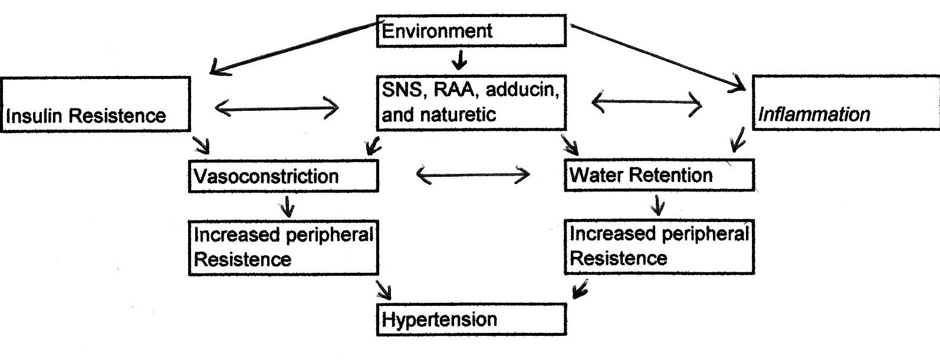
Individuals with a high blood pressure retain more salt in the vascular components than a person with normal blood pressure (McCance & Huether, 2006).
In Summary, the increased size of the heart muscle increases the demand for coronary perfusion along with increased workload and overtime the contractility of the heart is impaired and Mr. H is a risk for heart failure (McCance & Huether, 2006).
Signs and Symptoms
- Mr. H may not have any symptoms that require him to seek medical attention; this condition is also referred to as the "SILENT KILLER" (McCance & Huether, 2006).
- Developing high blood pressure can increase with age
- Most manifestations of hypertension are caused by complications that damage organs and tissues outside the vascular system (McCance & Huether, 2006).
- Heart disease, renal insufficiency, CNS dysfunction - headaches, impaired vision, impaired mobility, vascular occlusion, or edema may be seen in conjuction with hypertension (McCance & Huether, 2006).
- Edema and headaches may be the first signs an individual will find and seeking medical attention ASAP is advised to have further testing done.
- An ECG will also detect LVH.
Mr. H has hypertension because of the sustained high blood pressure and unfortunately we do not know how long his blood pressure was high prior to coming to see the practitioner.
Reference:
American Heart Association (2008). Congestive Heart Failure. Retrieved June 22, 2008 from http://www.americanheart.org/presenter.jhtml?identifier=4585
Heart and stroke foundation (2008). Atherosclerosis. Retrieved June 23, 2008 from http://www.heartandstroke.com/site/c.ikIQLcMWJtE/b.3484059/k.9F8E/Atherosclerosis.htm
Kaplan, N. M., & Douglas, P. S. (2007). Clinical implications and treatment of left ventricular hypertrophy in hypertension. Retrieved June 23, 2008, from http://www.uptodate.com/patients/content/topic.do?topicKey=hyperten/20309
Mayo Clinic, 2008. Left Ventricular hypertrophy. Retrieved June 22, 2008 from http://www.mayoclinic.com/health/left-ventricular-hypertrophy/DS00680/DSECTION=symptoms
McCance, K., L. and Huether, S. E. (2006) Pathophysiology: The biologic basis for disease in adults and children (5th Ed.). St. Louis: Missouri: Elsevier.
Medical Encyclopaedia (n.d.). Congestive Heart Failure. Retrieved June 22, 2008 from http://www.nlm.nih.gov/medlineplus/ency/article/000158.htm
Medical University of South Carolina, 1999. Left Ventricular Hypertrophy. Retrieved June 22, 2008 from http://www.musc.edu/bmt737/Spr_1999/russell/index.html
National Heart and Lung Institute. (2007). What is Atherosclerosis? Retrieved from http://www.nhlbi.nih.gov/health/dci/Diseases/Atherosclerosis/Atherosclerosis_WhatIs.html
Spirito, P., Bellone, P., Harris, K. M., Bernabo, P., Bruzzi, P., & Maron, B. J. (2000). Magnitude of left ventricular hypertrophy and risk of sudden death in hypertrophic cardiomyopathy [Electronic version]. The New England Journal of Medicine, 342 (24), 1778-1785.
Wikipedia. (2008). Atherosclerosis. Retrieved June 22, 2008 from http://en.wikipedia.org/wiki/Atherosclerosis
Zevitz, M., E. (2006). Cardiomyopathy, Hypertrophic. Retrieved June 22, 2008 from http://www.emedicine.com/med/topic290.htm

