Croup
Croup is the term that refers to several respiratory illnesses that are characterized by varying degrees of inspiratory stridor, barking cough, and hoarseness due to obstruction in the region of they larynx (Cherry, 2008). Froh (2006) termed croup ‘acute laryngotreacheobronchitis’, although there is some discrepancy in the literature whether this classification is precise. Cherry (2008) described the vast majority of cases of croup as being either laryngotracheitis or spasmodic croup, while laryngotracheobronchitis was reserved for illness caused by bacterial infection. (A table containing the classifications and clinical features detailed by Cherry, 2008, is included at the end of this document).
Croup is typically a pediatric ailment that occurs within the first five years of life (Froh, 2006; Worrall, 2008). It is more common in boys than girls; most cases occur in late autumn and winter; it occurs more in children who are prone to allergies (atopic); and is often a recurrent problem for affected children (Froh, 2006; Worrall, 2008).
Croup is usually caused by a viral infection, the most common being parainfluenza, but influenza A and B, adenovirus, and respiratory syncytial virus have occasionally been implicated as the causative viruses (Froh, 2006; Worrall, 2008). The infection is self-limiting and usually resolves spontaneously after a few days (Froh, 2006; Worrall, 2008).
The etiology of croup is associated with edema of the subglottic space (Froh, 2006). The edema may extend into the area of the cricoid cartilage, which is already the narrowest point in the airway, therefore prone to potential obstruction (Froh, 2006). There is increased airflow resistance, leading to increased work of breathing, more negative intrathoracic pressure, and the possibility of upper airway collapse (Froh, 2006).
The symptoms of croup are usually preceded by nonspecific cold symptoms such as cough, rhinorrhea, and fever (Froh, 2006; Worrall, 2008). The child then develops the characteristic seal-like barking cough, hoarseness, respiratory distress, and in some cases, may progress to inspiratory stridor (Bjornson & Johnson, 2008; Froh, 2006; Worrall, 2008). Part of the distress parents experience related to the symptoms of croup has been blamed on the nature of symptoms worsening in the middle of the night.
Cherry (2008) included the following outline of the different levels of severity of croup as defined by the Alberta Medical Association:
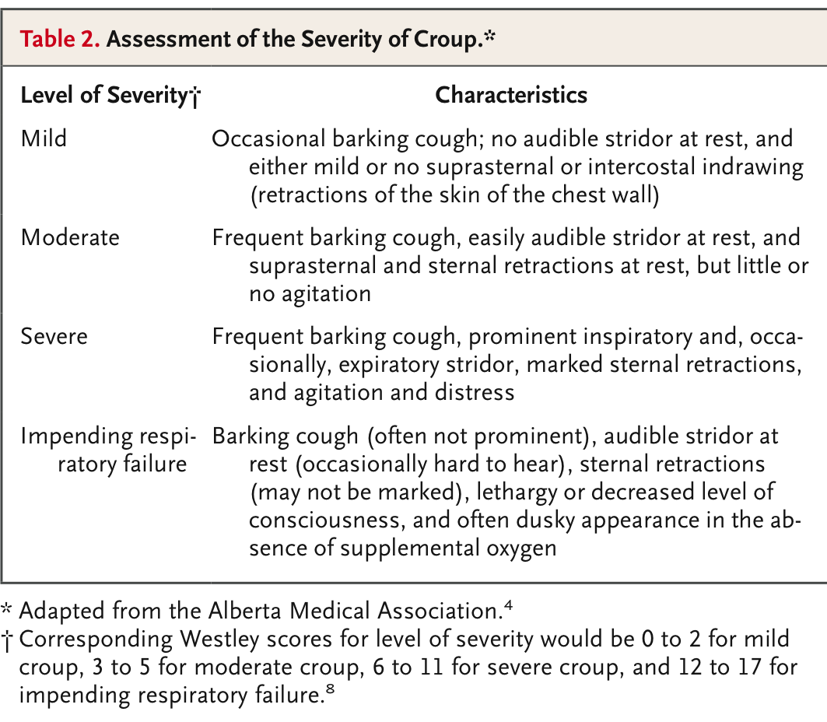
It is important that parents are aware of the self-limiting nature of croup, but also when to recognize that a child’s condition is worsening. Treatment of choice has evolved to administration of nebulized epinephrine, as a temporary measure to decrease airway secretions and edema, accompanied by a single dose of corticosteroid, often dexamethasone, which provides longer-term relief due to it’s long half-life (Froh, 2006; Worrall, 2008). The use of dexamethasone will hopefully carry the child through the acute phase of the illness.
Mrs. B. would probably know if Joey had croup based on the presence of the characteristic seal-like barking cough, which would likely develop after a few days of nonspecific viral illness. This is a good opportunity to explain the symptoms to her, as well as what to watch for in the event of worsening illness.
Cherry, 2008
Cheers!
Lisa and Nadine

References
Bjornson, C. L., & Johnson, D. W. (2008). Croup. Lancet, 371, 329-339.
Cherry, J. D. (2008). Croup. The New England Journal of Medicine, 358, 384-391.
Froh, D. K. (2006). Alterations of pulmonary function in children. In McCance, K. L., & Huether, S. E. (Eds.), Pathophysiology: The Biologic Basis for Disease in Adults and Children (5th ed., pp. 1249-1278). Elsevier Mosby: St Louis.
Worrall, G. (2008). Croup. Canadian Family Physician, 54, 573-574.

