Examination Strategies

For case study style questions, read the question stem and scan the options; then go back and read the case. You may get your answer without having to read through the whole case.

There is no penalty for guessing, so you should never leave a question blank.

Good pacing is key. You need to leave adequate time to get to all the questions. Even though you have one and a half to two minutes per question on average, you should aim for a pace of 90 to 100 seconds per question. If you do not know the answer within a short period, make an educated guess and move on.

It is okay to second guess yourself, if you know from past experience that this helps. Research shows that our “second hunches” tend to be better than our ﬁrst guesses for those where secnd guessing improves their score. If you know that second guessing decreases your score, then avoid it.

Do not panic with “impossible” questions. Make your best guess and move on.

Note the age and race of the patient in each clinical scenario. When ethnicity is given, it is often relevant. Know these well, especially for more common diagnoses.

All questions whose answers are known should be answered first. Spend adequate time on questions for which you are certain of the answers to ensure that they are answered correctly. It is easy to become overconfident with such questions and thus you may fail to read the questions or the answer options carefully. Make sure you never make mistakes on easy questions.

Read the final sentence (that appears just before the multiple answers) several times to understand how an answer should be selected. Recheck the question format before selecting the correct answer. Read each answer option completely. Occasionally a response may be only partially correct. At times, the traditionally correct answer is not listed. In these situations, select the best alternative listed. Watch for qualifiers such as next, immediately, or initially.

Avoid answers that contain absolute or very restrictive words such as always, never, or must. Answer options that contain absolutes are likely incorrect.

Try to think of the correct answer to the question before looking at the list of potential answers. Assume you have been given all the necessary information to answer the question. If the answer you had formulated is not among the list of answers provided, you may have interpreted the question incorrectly. When a patient’s case is presented, think of the diagnosis before looking at the list of answers. It will be reassuring to realize (particularly if your diagnosis is supported by the answers) that you are on the right track.

If you do not know the answer to a question, very often you are able to rule out 1 or several answer options and improve your odds at guessing.

Occasionally you can use information presented in one question to help you answer other difficult questions.

Review for Examination Strategies

As you study, concentrate on the nuances of management, especially for difﬁcult or complicated cases. For common diseases, learn both common and uncommon presentations; for uncommon diseases, focus on the classic presentations and manifestations. Draw on the experiences of your clinical practice, whenever possible, to anchor some of your learning.

Write your own notes for each topic, or generate diagrams or concept maps or tables or summaries. They key to understanding and applying content specific material is to own the material, and the key to owning the material is to create your own organizing strutures.

Create your own summaries of presentations for a given topic, for example:

History (Symptoms) | Physical Findings (Signs) | Likely Diagnosis
Gait impairment, falls, dysphagia, dysarthria | Inability to look up & side to side | Progressive supranuclear palsy
Muscle stiffness, clumsiness, occasional emotional lability | Brisk reflexes, spasticity (upper motor neuron signs), atrophy, fasciculation (lower motor neuron signs) | Amyotrophic lateral sclerosis
Paroxysmal pain affecting the side of the face | Usually normal | Trigeminal neuralgia affecting  1 of the branches of cranial  nerve V

or for a given disease, generate a summary of its hallmarks, for example:

Asthma

- Mucous gland hypertrophy
- Mucus hypersecretion
- Alteration of tinctorial & viscoelastic properties of mucus
- Widening of basement membrane zone of bronchial epithelial
- membrane
- Increased number of intraepithelial leukocytes & mast cells
- Round cell infiltration of bronchial submucosa
- Intense eosinophilic infiltration of submucosa
- Widespread damage to bronchial epithelium

and/or develop a concept map, for example:

You can use free concept mapping software called CmapTools to create such concept maps. Some people even build such diagrams to create their organizational structure of the content and its relationships, then add significant resource links to them to aid in quick review. These would be called concept-resource maps. If you take this one step further, you could add exam questions to your concept-resource map, giving a concept-resource-review map.
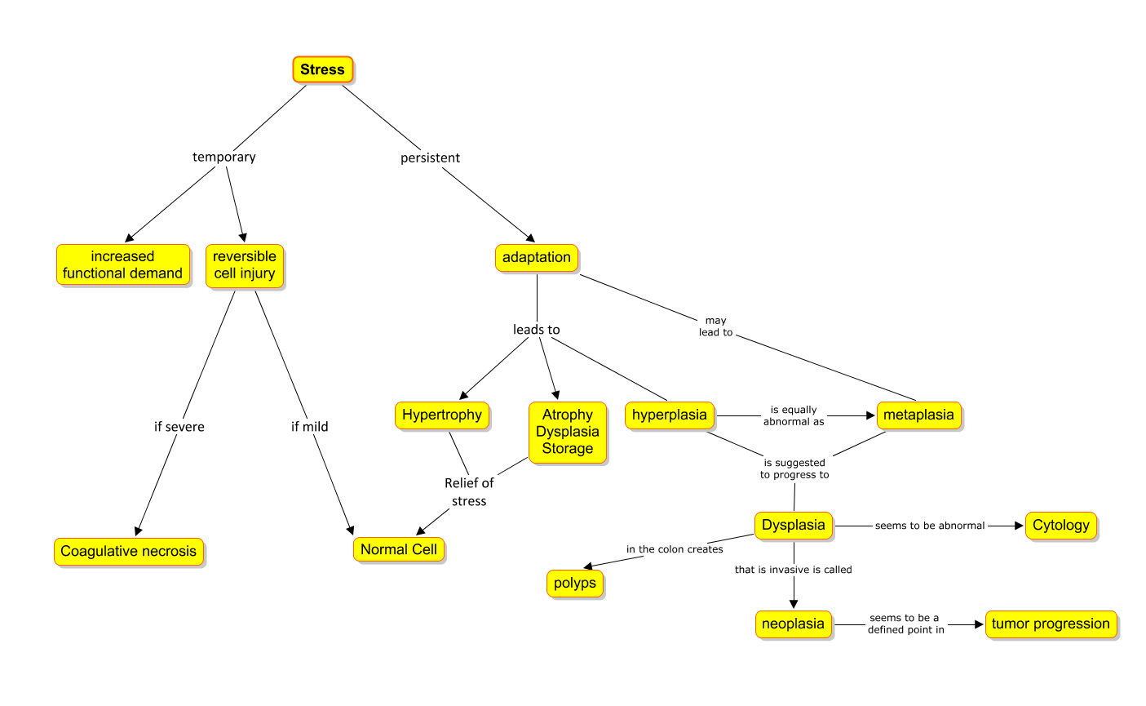
After reading or drawing diagrams, practice, practice, practice with exam questions.

Do such practice questions under exam conditions, i.e. allow 1-2 minutes per question.

