Intelligent Building
Definition: a building that uses the latest advances in information technology to enhance the way your campus buildings can work, it can deliver a new standard of performance and profitability.

Some applications of home automation systems include but are not limited to:
- Control of lighting
- Control of HVAC
- Control of doors, windows, curtains, gates, …
- Access to and control of security systems
- Access to and control of multimedia systems, home entertainment systems
Since this document discusses embedded control systems in building automation systems, it is not necessary to give an accurate view of the tasks than can be completed by such an automation system. More information can be found here: Home automation and building automation.

Component functions
Systems commonly exist of several components, which are all part of the complete system. Each of these components can perform a function, some components are multifunctional.
Most components functions can be categorized into 3 categories:
- Input
- Output
- Control
Some components can be used for input, output and control. A multimedia terminal for example can be used for:
- Input (using keyboard, switches, … )
- Output ( display, loudspeakersloudspeakers, … )
- Control (controlling other components like dimming the lights, closing the curtains, …).

Input Functions
Input functions are mostly performed by components called sensors. Sensors can be anything from a simple on/off switch to a capacitive proximity switch to a complex audio/video recognition system.
Some examples of sensors:
- Switch
- Motion sensor
- humidity / pressure sensor
- Light sensor ( photodiode, photoresistor )
- Temperature sensor ( thermistor, thermocouple, resistance thermometer, thermostat )
- Video/audio acquisition sensor ( video camera, microphone )
- Smoke detector
- Flow sensor
  - Fluids ( flowmeter, mass flow meter )
  - Electricity meter
A lot of the more complex sensors need some electronics to condition the sensor signal and transform it into a signal suitable for the home automation system.

Output functions
Output functions are mostly performed by components called actuators. Actuators use a signal from the automation system to change the state of an object in the controlled environment (e.g. switching AC power to the circuit feeding the light bulbs, moving an object).
Some examples of actuators:
- Electro-mechanical switches ( relays )
- Electronic controllers:
  - Dimmers
  - Power switches
  - Motor controllers
- Mechanical actuators:
  - Motor
  - Pneumatic actuator
  - Linear actuator
  - Solenoid valve
To get an actuator to do something useful in an automation system, most of the time it has to be equipped with extra mechanical/electric systems. A stepper motor e.g. won’t do much unless it’s attached to something, a fluid control valve for example. The output function is thus being performed by a combination of a basic actuator in conjunction with some additional systems.

Control functions
Control functions are somewhat different than input/output functions in that their functionality itself is not so easy to describe. Control functions can be a lot of things, including but not limited to:
- Setting an output after a timer has reached a certain state
- Setting an output after a logical combination of inputs has occurred
- Setting a diversity of outputs after an input occurs
- Contacting an external service when an input occurs ( smoke alarm/ security breach)
Control functions are performed by a control unit, but since there are so many different forms of systems and again due to the changing nature of home automation systems in time, it is difficult to describe the system that performs these control functions. Systems performing control functions can be as simple as a few logical gates or as complex as a full-blown mainframe.

Communication
Evidently, there is a need for a communication system between all these components. Since the birth of home and building automation systems, a multitude of standards has popped up.
In the early days of home automation systems, communication occurred over simple copper wiring. There was no need for high data speed or interference shielding. At the time of writing a lot more possibilities exist for communication in such systems.
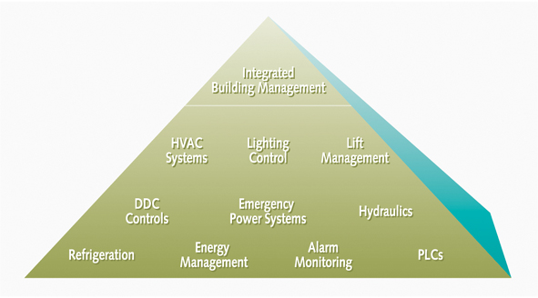
All these communication means have their own characteristics, discussing them falls out of the scope of this document. Which standard uses which communication method can be found on the general Wiki page about Home automation.

Design characteristics
First of all a short list of embedded control system design characteristics and their application to the current subject of home/building automation systems. These are the characteristics a design engineer has to keep in mind when designing such an automation system:
High importance characteristics:
- Focused functionality: a home/building automation system typically has one fixed set of functionalities, and its design is optimized for this specific set. An example set of functionalities consist of improving user comfort and security while saving energy
- Boot-up time: home automation systems are supposed to be in working state at all times. Timers keep ticking, lights need to be switched on/off immediately, …
- Safe failure modes: domotics can fail but there should be a provision for safe failure in emergency states such as power spikes, loss of power, break-down of components. When failing a home automation system should give back control to the users of the home without for example closing down the house and switching off all the lights.
- Communication: since most recent home/building automation systems consist of a large number of subsystems, there is an inherent need for communication between these subsystems.
- Energy consumption: low energy consumption is necessary since the newer energy-friendly home automation systems strive to lower the house’s energy usage (e.g. by planning energy-consuming tasks at night or closing the curtains on time to save on heating fuel)
- System adaptibility:
  - Most recent automation systems require custom installations and settings due to the uniqueness of the house / building. Therefore the installer should be able to choose the necessary components for the current configuration, combine them to a working system and set them up to his/her or the end-user's wishes.
  - Most recent automation systems are capable of working on a higher abstraction level (see further in this document). Therefore the user should be able to adjust such an automation system, setting up his/her own 'mood settings', room configurations, colour tastes, voice recognition, ... without the help of an installer / customer service.
Medium importance characteristics:
- Space constraints: the ideal home/building automation system takes up no space in the home/building it controls, it should be invisible except for the input/output.
- Long life time: home automation systems must be in working state as long as possible since costs to replace it are higher than replacement costs for simple appliances (e.g. breaking into wall to insert new cables vs. replacing a coffee machine).
- Cost: cost is getting more and more important with rising prices (including heating oil, building materials etc.). So a low-cost home automation system is more attractive. On the higher end of the scale cost is less important since the high-end domotics systems are semi-custom built for that customer and most of the time very expensive.
- Temperature and humidity: sensors and/or actuators for outdoor use can be succumbed to high temperature (sunlight) or high humidity (rain). Protection against temperature and humidity is necessary for components for outdoor use and components for use in bathrooms / swimming pools / sauna / …
- Shocks and vibrations: components of automation systems must be able to withstand small shocks and vibrations coming from users abuse etc. but most of them are not protected to prolonged exposure to shock / vibrations.
- EMC: embedded systems in home/building automation should not be disturbed by (nor disturb themselves) other devices in their environment.
- Remote servicing: since more and more of the components in home/building automation systems use a mixed software/hardware setup, there is a need to be able to monitor each component and upgrade the software part of it remotely.
- Superior quality: most users expect their home automation systems to work all the time, without bugs or errors. Since quite a large part of today’s home automation components consist of recent electronics in combination with software to control the electronics, the expectancy for perfect quality is not as high as it could be. However for the high-end automation systems there is a correlation between cost and quality expectancy, making build quality more important.
Low importance characteristics:
- Dependability by redundancy: some application domains request 100% robustness against failure of hardware or software components, which requires these components to be provided multiple times. This, however, is not the case for home/building automation systems. Doing so would eradicate the low cost characteristic.
- Space hardened: Not applicable to home/building automation systems (no home/building automation systems in space yet)

Advantages and Disadvantage Intelligent Building

Advantages:
- Reduced administration costs
- Smartcards - single card for security and cash transactions
- Reduced system costs by sharing infrastructure
- Easier integration into university systems (e.g. HR and scheduling databases)
- Information can be delivered to all interested parties in the manner they need.
- Increased mobility - not tied to a specialist workstation
- Training is minimised, use standard operating environments.

Disadvantages:
- Increased complexity of the system
- Initial cost + the cost of installing a cooling system for the computers
- Normal buildings last longer than intelligent buildings
The main advantage of automation are:
- Replacing human operators in tasks that involve hard physical or monotonous work.
- Replacing humans in tasks that should be done in dangerous environments (i.e. fire, space, volcanoes, nuclear facilities, underwater, etc)
- Making tasks that are beyond the human capabilities such as handling too heavy loads, too large objects, too hot or too cold substances or the requirement to make things too fast or too slow.
- Economy improvement. Sometimes and some kinds of automation implies improves in economy of enterprises, society or most of humankind. For example, when an enterprise that has invested in automation technology recovers its investment; when a state or country increases its income due to automation like Germany or Japan in the 20th Century or when the humankind can use the internet which in turn use satellites and other automated engines.

The main disadvantages of automation are:
- Technology limits. Current technology is unable to automate all the desired tasks.
- Unpredictable development costs. The research and development cost of automating a process is difficult to predict accurately beforehand. Since this cost can have a large impact on profitability, it's possible to finish automating a process only to discover that there's no economic advantage in doing so.
- Initial costs are relatively high. The automation of a new product required a huge initial investment in comparison with the unit cost of the product, although the cost of automation is spread in many product batches. The automation of a plant required a great initial investment too, although this cost is spread in the products to be produced.

Controversial factors suitable
- Unemployment. It is commonly thought that automation implies unemployment because the work of a human being is replaced in part or completely by a machine. Nevertheless, the unemployment is caused by the economical politics of the administration like dismissing the workers instead of changing their tasks. Since the general economical policies of most of the industrial plants are to dismiss people, nowadays automation implies unemployment. In different scenarios without workers, automation implies more free time instead of unemployment like the case with the automatic washing machine at home. Automation does not imply unemployment when it makes tasks unimaginable without automation such as exploring mars with the Sojourner or when the economy is fully adapted to an automated technology as with the Telephone switchboard.
- Environment. The costs of automation to the environment are different depending on the technology, product or engine automated. There are automated engines that consume more energy resources from the Earth in comparison with previous engines and those that do the opposite too.

Sample Comparison Calculation Installation Between Traditional and Intelligent Building
The cost comparison for this first scenario was carried out by Turner and Townsend Group (http://www.turnerandtownsend.com). T & T created a research and development project so as to guarantee their independence; the hypothesis was that an integrated building based on the benefit of the LonMark System and its certified interoperability would cost less in capital expenditure than the traditional conventional approach. The summary cost comparison table was published last month and is repeated here.
Virtual Building Head Quarters 118,402 sq ft² | Conventional Installation | Cost per foot² net |  | Open System Installation | Cost per foot² net
Shell & Core and Category A, Basic Works: | $ | $ |  | $ | $
The M&E works, Cat A | 7,198,400 | 60.80 |  | 6,668,800 | 56.32
Testing and Commissioning, Preliminaries, BWIC | 1,169,600 | 9.88 |  | 1,064,000 | 8.99
Lifts And Conveyors | 1,152,000 | 9.73 |  | 1,152,000 | 9.73
Shell & Core and CATEGORY A Works Total | 9,520,000 | 80.40 |  | 8,884,800 | 75.04
Capital Saving "CAT A", no LON integration works |  | 6.67% |  | 635,200 | 5.36
Category B, Fit Out Works
The M&E works, Cat B | 2,702,400 | 22.82 |  | 2,632,000 | 22.23
Testing and Commissioning, Preliminaries, BWIC | 440,000 | 3.72 |  | 428,800 | 3.62
CATEGORY B Works Total | 3,142,400 | 26.54 |  | 3,060,800 | 25.85
Network Integrator | 0 | 0 |  | 200,000 | 1.69
External Services | 180,800 | 1.53 |  | 180,800 | 1.53
CATEGORY A and B Works Grand Total | 12,843,200 | 108.47 |  | 12,326,400 | 104.11
Capital Saving "CAT A" and "CAT B" |  | 4.02% |  | 516,800 | 4.36
This cost comparison table is converted from standard prices in London, U.K. and converted to US dollars at the average exchange rate of 1.6 USD to 1.0 GBP. The rate for square feet is converted from meters net. As can be seen this analysis has produced a good half million dollars US of capital cost saving.
This cost comparison must be further understood, I will explain the key points to note next month, however for now I shall introduce you to the VBHQ. The comparison was deliberately managed in a very conservative manner to be fair to the conventional traditional method. The integration of the LonMark System products is taken for granted and is a real benefit. No integration was priced for the conventional traditional solution. The gateways and the integration BACnet infrastructure and the BACnet supervisors are all not included in the pricing comparison; for full apples versus apples one can see even further savings will be available. The following diagrams demonstrate the two schemes, the conventional installation 3-tier proprietary compares to 2-tier open as depicted by these pictures.
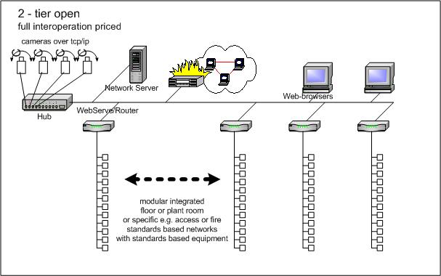
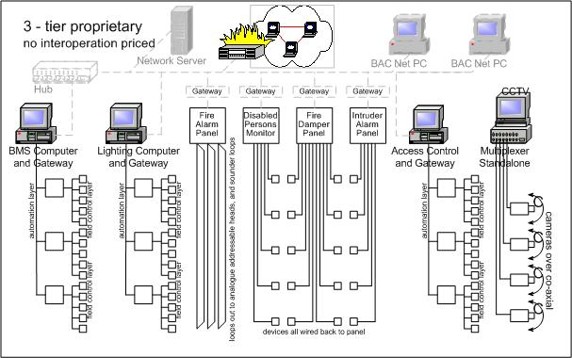
A couple of shots of the drawings of the building follow to give you an idea of the scheme.
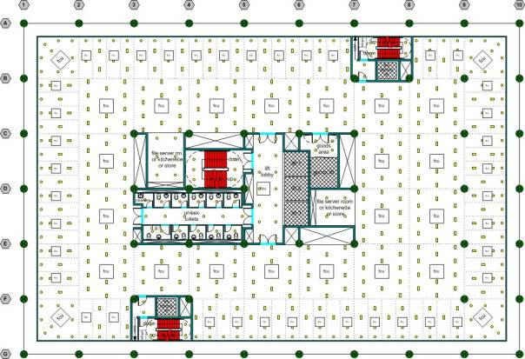
In order to price the building a sufficient series of drawings for each of the systems were produced. An example of the benefit of network cabling is the fire damper system, see the following drawing. This saves 0.75 miles of fire rated cable (or 1.2km) and the carcassing and installation of the cable.
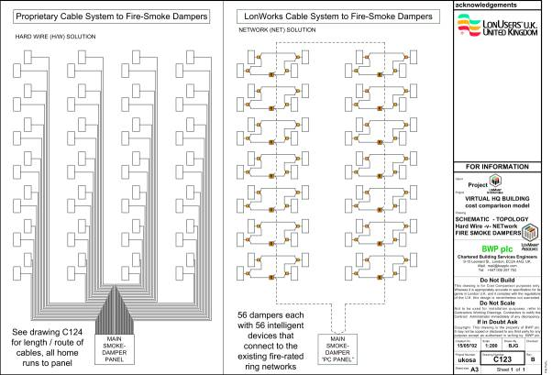
Intelligent building is reputedly more expensive. The proposal here is that by design and by an intelligent procurement technique the automation element of an intelligent integrated building has less capital cost than a similar disintegrated traditional conventional installation.
4% less on the whole building services "standard" budget is a serious number and worth achieving. This saving is achieved using standard "commodity" products that are all interoperable and thereby facilitate integration. Interoperability is the key issue, international standards, common agreement by the widest possible industry trade association and quality certification are completely necessary for good interoperability. The ability to choose different manufacturers products each with similar performance is part of the story. The interoperability is the essence of the cost saving.
The procurement technique needs some explaining as it is an important part of the savings. In order to understand the saving it is necessary to understand the procurement models of the 3-tier and the 2 tier-options.
"3-tier" The BACnet model and the traditional proprietary BMS models for procurement are the same. They each pander to the contract divisions in the U.S., the UK has imported this "vertical" market division and many people are comfortable with this traditional 20 year old method for system procurement. This method was born out of the need to buy everything from each of the vertical markets so that each would work. These "vertical" markets are depicted in the drawing "3-tier proprietary". Integration of these vertical markets is not priced in the cost comparison. This familiar "3-tier" solution is a well trodden path of understandable risk however the customer pays.
"2-tier" Interoperability at the device level using fast secure reliable networks provides the opportunity for a "horizontal" system. This "flat architecture" means that different products of all the contracting divisions can be bought and installed and wired together.
The second tier is the now famous TCP/IP over Ethernet, which is a fast reliable securable network. Interoperation doesn't stop because of this upper level; integration with the enterprise network has long been possible now. Through the CABA oBIX initiative we expect to have interoperability schema standardised with OASIS and these are fundamentally the LonMark profiles that have been agreed by the LonMark International Trade Association of 300 members.
So how does two-tier procurement save money? And at the same time keep everyone comfortable with their part of the market, bearing in mind that the contracting business has long been familiar with the three-tier model of procurement.
First to make happy in the change to two-tier are the M & E contractors. The horizontal market is daunting at first like any other "change" but actually it is hardly any different. The M & E contractors are given the specification to use the standard LonMark System components and cables and connections and install them. No software, no complication just buying and installing.
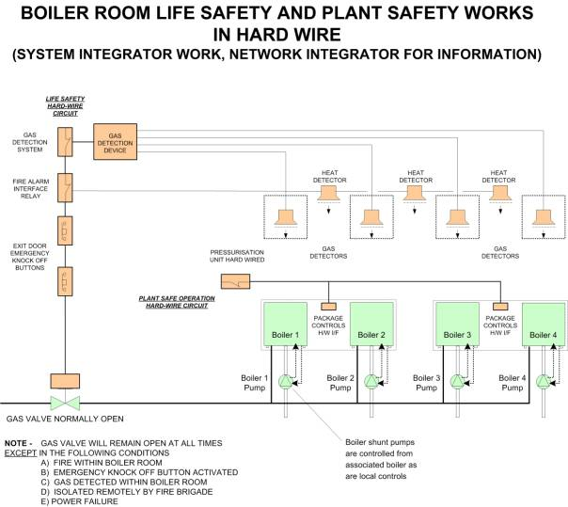

This two-tier methodology requires plant room design to be different but again easier. No motor control centres are used, local panels maybe used, everything is distributed and maximum utilisation of package plant devices, e.g. pumps with built in controls and variable speed drives is the normal way. These products are factory built with high volume and high quality but with the minimum site time. The cost profile changes with more spent at the factory but overall the cost is reduced, 4% saving on the whole M & E cost for a Category A fit-out. In legal terms this puts the suppliers of these products as a straightforward manufacturer product warranty as no design or reconfiguring is done - just supply and install.
The plant room is designed to work "standalone" i.e. the boilers work directly with their own pumps as do chillers etc and all with their local respective safety devices. It works on the package controls only and hardwire safety devices, not efficient but a simple hardwire maintenance mode - all networks disconnected and the plant working at a basic on 24/7/365. In this model the electrical does most of the cables but mechanical keeps the high terminal devices with controls on-board. More details on the procurement technique are given in the up-coming September edition. How everyone wins in this two-tier process is explained in the up-coming October edition.
The software application and the network products are bought from the system or "Network" Integrator. The Network Integrator only works direct to the Main Contractor, because they will be integrating across the division of supply and install. The design warranty for a working integrated interoperable system is achieved here with the Network Integrator.

Sources:
http://nreionline.com/technology/smart_buildings/
http://en.wikipedia.org/wiki/Intelligent_home#Natural_lighting
http://www.tefma.com/infoservices/papers/2001/Dearlove.ppt

