If all the Raindrops
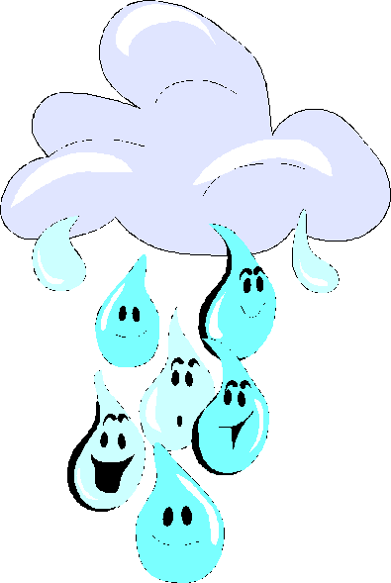

If all the raindrops were lemon drops and gum drops, oh what a rain that would be.
Standing outside with my mouth open wide, AH AH AH AH AH AH AH AH AH AH
If all the raindrops were lemon drops and gum drops, oh what a rain that would be.

If all the snowflakes were candy bars and milk shakes, oh what a snow that would be.
Standing outside with my mouth open wide, AH AH AH AH AH AH AH AH AH AH
If all the snowflakes were candy bars and milk shakes, oh what a snow that would be.

If all the sunbeams were jelly beans and ice cream, oh what a sun that would be.
Standing outside with my mouth open wide, AH AH AH AH AH AH AH AH AH AH
If all the sunbeams were jelly beans and icecream, oh what a sun that would be.

Weather Song
What's the Weather? What's the Weather?
What's the Weather Today?
Is it Windy is it Cloudy?
Is there sun or is there rain? (then sing the next part corresponding to the weather)
Sunny (fast clapping)
The weather's sunny, The weather's sunny
The weather's sunny today
It makes me happy, The weather's sunny
The weather's sunny today
Cloudy (slow, pretend to be falling asleep)
The Weather's cloudy, The Weather's cloudy
The Weather's cloudy today
It makes me sleepy The Weather's cloudy
The Weather's cloudy today
Rainy (sad tone pretending to cry)
The weather's rainy, The weather's rainy
The weather's rainy today
It makes me sad The weather's rainy
The weather's rainy today

