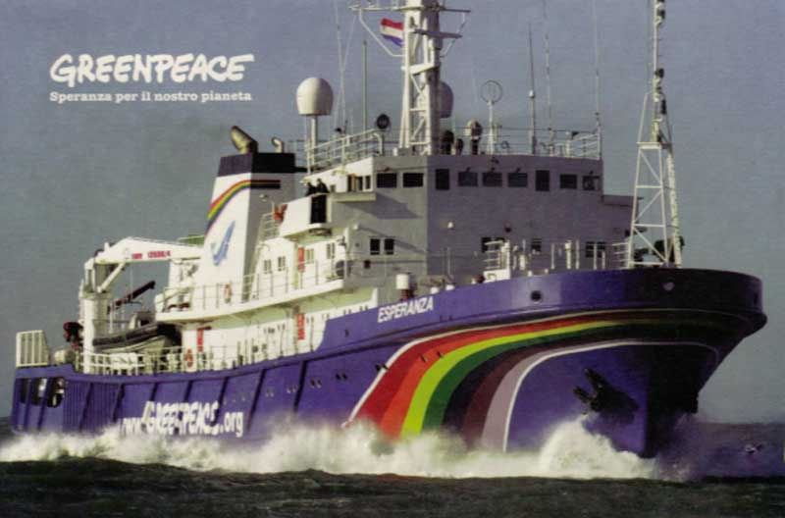
Greenpeace is a worldwide organisation that protects the environment. Greenpeace is a non-governmental environmental and peace activist based in Vancouver since 1971. Greenpeace has national and regional offices in 41 countries, all affiliated with Greenpeace International, based in Amsterdam. The executive director of Greenpeace is Kumi Naidoo. Greenpeace does not take money from governements and industry because it wants to be independent. People from all over the world donate money to Greenpeace. Greenpeace protests against governments and industries that pollute the environment. It wants to protect the forests, save the oceans and stop the use of toxic chemicals, but is also against nuclear testing. Ships play an important role in the organisation. Greenpeace’s most famous ship is called “The Rainbow Warrior”. This name comes from a north American indian legend. The legend tells about a time when the earth became ill. A tribe of people called the “Warriors of the Rainbow” went out to save the earth. The modern Greenpeace warriors are hoping that they, too, will be able to save the earth before it’s too late.

