Artifacts caused by careless handling of cassettes

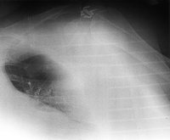
A wire mesh cart loaded with unexposed imaging plates (IPs) was placed too near a source of scatter radiation. Because of the high sensitivity of the phosphor to scatter, exposure that may have been minimally seen on a film/screen image was well demonstrated on this portable image. Artifact remedy: protect IPs from sources of scatter radiation. Erase IPs that have been unused for an unknown period of time. One vendor recommends that IPs be erased if left unused for more than 8 h [5]. We have had good results using 1 week as the time limit.
http://bjr.birjournals.org/cgi/content/full/74/878/195#top

