Google Product Search Results Poach Traditional Natural Search Traffic
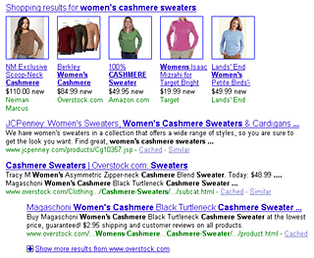In 2009, Google made a lot of changes to its page one search results, not the least of which was the placement testing of Google Product Search (formerly Google Base and/or Froogle) listings in the natural results. At times, if someone searched for a particular product or class of product, say "women's cashmere sweaters", Google would populate the body of the natural listings with a few entries from their Google Product Search datafeed.
The results were popping up at the top of the results, at the very bottom of the results and also right in the middle or a few positions down. It would seem Google has settled on returning their Google Base results towards the top if not before the "normal" natural listings entirely.
In addition, Google has (depending on the keyword search) decided to include photos of particular products, not just text listings pulled from the datafeeds.
Why does this matter?
For retailers who run datafeeds in Google and also rank well for generic product terms, tracking their non-brand natural search traffic/visits may have changed drastically towards the end of Q3 and during Q4. I've witnessed first hand retailer brands whose YoY non-brand natural traffic decreased but had their datafeed traffic shoot through the roof. Point being, now that the datafeed results are trumping top ranking natural results (and have pictures in the listings to boot), more people are noticing and clicking on datafeed results, thus "poaching" what would normally be considered natural search traffic.
The lesson learned here is that if you are a retailer and are not taking advantage of Google Base, you are definitely losing out on potential natural search traffic, as the combined total traffic of datafeed and natural search is your "real" natural search visitor count on a monthly basis.
The ever-changing world of page one results is making search marketers re-evaluate what value each channel represents in the mix of their online marketing efforts.

