Trent Forkert
CS 360
Dr. Tanik
Exam 2
Option 1

What I did
Having four people in a project that lasts multiple semesters may have caused our workload to end up thin from what it otherwise would have been. Nevertheless, I worked on (in no particular order):

SWEBOK
As with everyone in the class, one of my tasks this semester was to complete the SoftWare Engineering Body Of Knowledge KAs 1-11.

Research, prototypes
As I do not use Windows for my main system, I would usually head up things that did not depend on having access to a Windows-based environment. This included research into different technologies, and making some basic prototypes to investigate the utility of these technologies. This research included (list truncated to things that are still noteworthy within the context of our project): Spring, Google Web Toolkit, Sugar and Cream.

SRS
In the world of things that do not require Windows, one of the first we encountered was the SRS. Partially due to this fact, and partially due to my being the architect, I was assigned, and subsequently worked on, the SRS. This was a long and stressful part of my workload, but I got it done, even if it somewhat lacks in quality.

Architecture
As the architect, I had significant weight to pull in the various architecture diagrams. While I rarely did one of these myself, I feel I was instrumental in determining what the diagram should be during our meetings, before someone else on the team would actually assemble the diagram in the software as per the course requirements.

UML
Our primary focus for most of this semester has been our UML diagram. Our first UML diagram was mostly created by Marat based on documentation on the project we were provided by Prof. Wolfe. From there, the entire team would reevaluate and consider upgrades to the UML during our meetings, and we would update the diagram accordingly.

FMEA
While we used the Acclaro software for the final version of this, the initial version was just a table constructed in a document editor. FMEA, for the most part, was (perhaps regrettably) just mental notes, or things that were understood amongst the team. The actual document was fairly simple to make, considering these mental notes we had accumulated.

What I learned

UML
Over the duration of this course, I learned much more detail into UML than I had previously known. I learned things like UML notation, but also that there are extensions to UML for various purposes.

RUP
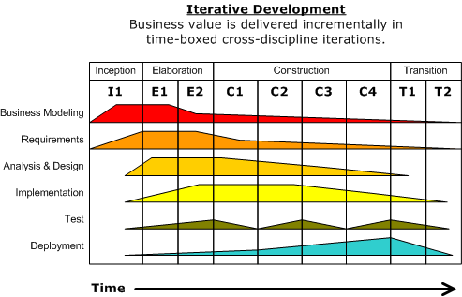
Most of the course consisted of learning the ropes of IBM’s rational unified process. As such, I learned about the stages of development as envisioned by RUP.

Scrum
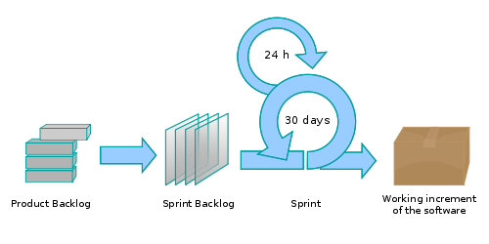
Tangentially to this class during independent research spurred by frustration with how we were going about project management and development, I learned of the Scrum methodology for software engineering. Scrum appeals to me quite a bit more than RUP, as Scrum enables the developers to efficiently turn around something that the client can grasp and make useful comments on. This allows a product that more closely meets the client’s demands in a shorter amount of time.

