Name _Trent Forkert___________Date _________
(Type answers and include question)
CS 360 Midterm I: Software Architecture and OO Detailed Design (Fall 2011)
- [10 pts] We have covered the architectural hierarchical decomposition process from your initial vision document. Describe:
  - Application architecture
Diagram showing the different layers of the system, for example: presentation, business, persistence layers.
  - Information architecture
Diagram showing functional requirements and which design parameters will fulfill them.
  - Systems architecture
Diagram showing the overlaps amongst the design parameters.
  - UML architecture
Diagram showing the relationships between different components labeled in the System Architecture.
- [10 pts] In RUP, we are leveraging the axiomatic design process in the inception and elaboration phase. Describe the requirements engineering and elicitation process in more detail from initial gathering of VOC to CN to FR in axiomatic design, including risk concepts.
  - Design matrix results in which UML diagram type?
Class diagram
  - DSM results in which UML diagram type?
Component diagram
  - What is the V-Model
A development model intended to simplify project engineering.
  - QFD
A method to break user demands into subsystems and components in the overall system.
  - FMEA
A method of analyzing and prioritizing the management of potential errors and failures.
- [5 pts] We have covered how to establish class architecture first as a foundation to detailed design with UML. When using Axiomatic Design process to develop classes, how do the following map to OO Design object elements [hint: see paper handout on “Object Oriented Design with Axiomatic Design” :
  - FR
Functional requirements map to objects
  - DP
Design Parameters map to data.
  - FR/DP design matrix intersection
FR/DP intersections map to methods
- [5 pts] Describe the purpose of these tools/software used in your project:
  - Acclaro DFSS
Enables teams to implement systems using the axiomatic design methodology
  - Visio
Used for creating diagrams, such as UML.
  - Basecamp
Used for collaborating with teammates and keeping track of what everyone should be doing.
  - MS Project
Used for Project Management, has overlap with basecamp
  - MS Powerpoint
Used for creating presentations
- [5 pts] Describe the standards applied in this project
  - IEEE-830 SRS
Software Requirements Specification describes the behavior and requirements of the system.
  - IEEE-1058 PMP
Project Management Plan is used for Project leaders to keep track of what everyone is assigned in the implementation of a system.
  - IEEE-1016 SDD
Software Design Description goes hand in hand with the 830, describing system architecture and application design.
- [5 pts] In OO design, describe the concept [with symbol]:
  - Aggregation
Objects contain references to other objects, which are not dependent on the parent object.
  - Composition
Objects contain other objects, which are dependent on the parent object.
  - Polymorphism
The ability of an object to act as any type in its inheritance chain
  - Inheritance
One object type is based on another type
  - Blackbox
An device with unknown internals
- [5 pts] In OO design, describe the concept [with symbol]:
  - Public operations
Operations anything with a reference to the object can do.
  - Private operations
Operations which only the object can do to itself
  - Inclusions
  - extensions
- [5 pts] You were given a handout on software project management by Fairley. Describe how the following concepts are used in your project.
  - Architecture Decomposition View (ADV)
ADV is used to examine the different parts of the overall system.
  - Work Breakdown Structure (WBS)
WBS is used in dividing up tasks and workflow.
- [5 pts] In Object oriented (OO) design, describe the concept [with symbol]:
  - Association
A relationship between classes of objects that allows one instance to cause another to act on its behalf.
  - Generalization
The reverse of inheritance.
  - Dependency
An object requires the presence of another.
  - Realization
Implementation of an interface
  - Annotation
Provide metainformation about the thing being annotated
  - Interface
Describes functionality without implementing it
- [5 pts] Define each performance attribute:
  - Efficiency
Do not waste system resources
  - Flexibility
Software can scale to differing amounts of system resources
  - Integrity
Software performs as expected.
  - Security
No damage in the event of a failure. Malicious users should not be able to damage the system.
  - Maintainability
Software is written so that it can evolve to suit the needs of the customer.
  - Portability
Software can run in different environments as much as possible
  - Reliability
Software is available when needed
  - Usability
Software is easy for users to grasp and use without (significant) training.
- [5 pts] Describe how you have used your concept map and basecamp tool to organize your work as a team using RUP as a guide.
We have used Cmaps only sparingly, using basecamp and in person meetings to coordinate our development
- [5 pts] You are working on SWEBOK reviews KA-1 through KA-11. Which three areas apply to your role in the project and why?
  - Area 1
Software design, as I am assisting in the design.
  - Area 2
Software construction, as I am a developer.
  - Area 3
Software requirements, as I am the architect.
- 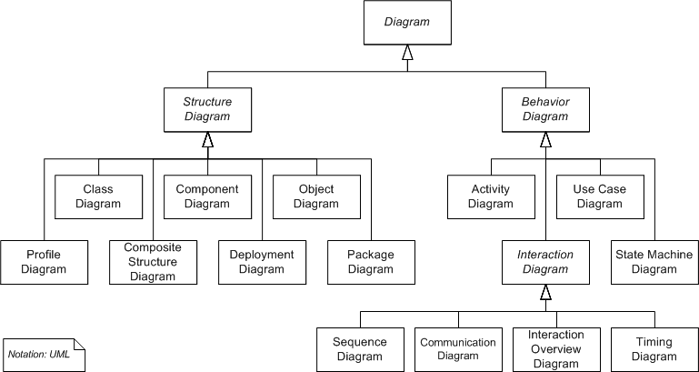[10 pts] Other than class and component diagrams that all teams are required to use, select 3 UML behavior diagram types that your project could use and why?
Use Case diagrams could be useful to help look at the project from the user perspective.
Communication diagrams could be useful to better show how the parts of our system interact with each other.
Deployment diagrams looks useful to show an overview of what happens in our system.
- [10 pts] We reviewed UML and related concepts for automation in software systems engineering.
  - What is the relationship between UML and SysML?
SysML is UML for systems engineering
  - What is executable UML?
UML that can be run as if it were code, without doing actual programming

- [10 pts] Describe how this course has helped you organize your team
  - Management
Defining and assigning tasks has kept everyone on the same page.
  - Architecture
Big picture design work made sure we knew what the overall system looked like.
  - Detail design
Detail design ensures the parts of the system interact correctly and efficiently.
  - Documentation
Documentation ensures that those not working directly with our system as we develop it can still understand it.

Bonus: [10 pts] List up to 10 aspects of this course you enjoyed/learned from the most?
It has challenged me in ways no other course I have taken did.
It has given experience in mock industry.
It is allowing me to participate in a larger project than I could do by myself.
I have met and interacted with peers I never knew before this class.
I have learned that Agile development is a few orders of magnitude better than axiomatic design for the majority of projects.
Through interaction with those professionally employed in software development/engineering, I have learned that, with the exception of large corporations with lots of legacy systems, most of industry has moved on to Agile development.
I have reconfirmed that working with other people can be very stressful at times.

