Does Fructose Sweetener Affects Teen Health?
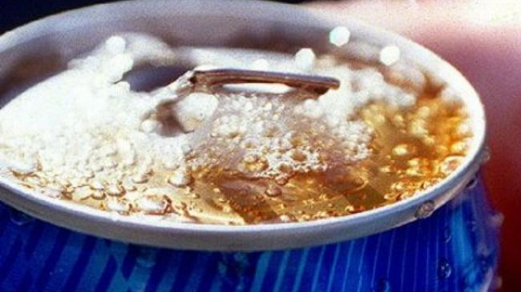
Adolescents who consume high amounts of fructose containing sweeteners may be at a greater risk of developing diabetes and cardiovascular disease, experts warn.
--------------------------------------------------------------------------------------------------
1 Fructose is a natural sugar found in fruits and vegetables. Many people especially teenagers usually receive much of it through processed foods and beverages sweetened by high-fructose corn syrup.
-------------------------------------------------------------------------
2 A study of 559 teens aged between 14 and 18 revealed that those who received high levels of fructose were at a greater risk of developing high insulin resistance, which leads to diabetes.
----------------------------------------------------------------------------
3 Findings also showed that kids who consumed a lot of fructose were more likely to develop high blood pressure and have lower levels of HDL or good cholesterol.
---------------------------------------------------------------------------------
4 Young fructose consumers including fizzy drinks lovers were also at a higher risk of visceral adiposity or deposition of excess fat around the belly which is a known risk factor for heart disease and diabetes, says the study published in the Journal of Nutrition.
-----------------------------------------------------------------------------------------
5 “The overall amount of fructose that is in high fructose corn syrup is not much different than the amount in table sugar but it's believed there's something in the syrup processing that plays a role in the bad byproducts of metabolism,” said co-author Dr. Vanessa Bundy of Georgia Health Sciences University.
----------------------------------------------------------------------------------------------
6 “Fructose itself is metabolized differently than other sugars and has some byproducts that are believed to be bad for us,” he added.
---------------------------------------------------------------------------------------------------
7 Researchers suggested parents to provide a healthy balance of high quality food to their children and pay close attention to the fructose and sucrose they are consuming at their home or anyone else's.
---------------------------------------------------------------------------------------------------------
8 “The nutrition that caregivers provide their children will either contribute to their overall health and development or potentially contribute to cardiovascular disease at an early age,” they added.

