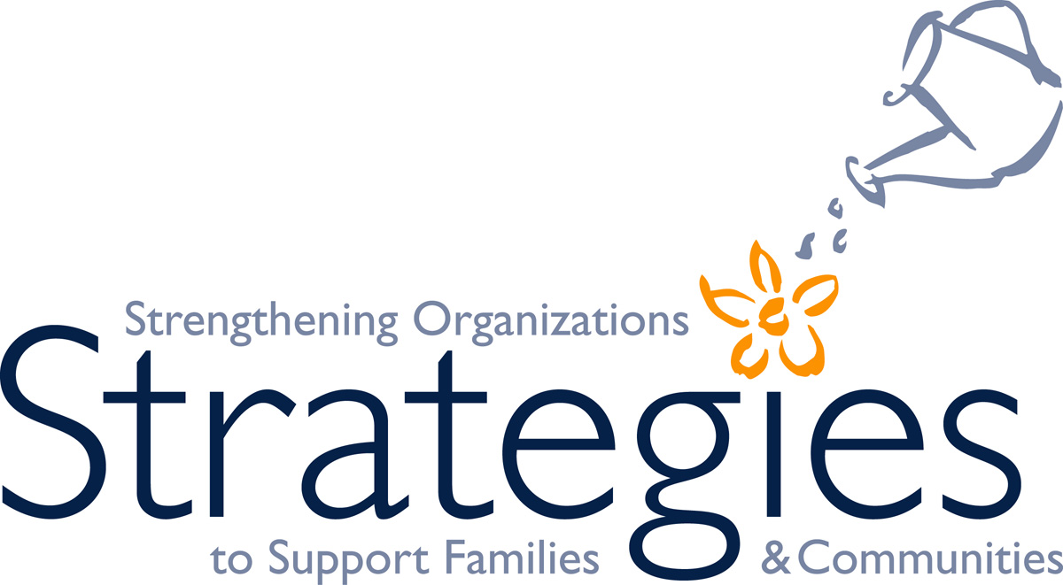


Capacity Building for Family Strengthening Networks

Application Instructions

Application Due Date: Friday, August 17, 2012, 5:00 p.m.

Strategies and the California Department of Social Services Office of Child Abuse Prevention (OCAP) recognize the role that family support networks play in strengthening the field and their member agencies. Therefore one of Strategies’ goals from its OCAP Scope of Work is to:

… improve family strengthening … networks’ abilities to provide quality child abuse prevention services, implement effective practices, and enhance child permanency, safety, and well-being.

From on or about October 1, 2012, through June 7, 2013, we will provide selected networks with up to $3,000 and up to 15 hours of direct technical assistance to support their capacity building efforts.

We invite family strengthening networks to apply for the Capacity Building for Family Strengthening Networks Project. To be considered, please complete all sections of the attached Application Form for 2012-13 and send it to the Strategies regional office served by your county by the August 17th due date.

Conference Call. Strategies will host a conference call for interested applicants on Wednesday, July 18, 2012, from 10 a.m. to 11:30 a.m. to answer questions regarding the project and/or application process. Please register to participate in this call at: https://www.familyresourcecenters.net/onevent/details.php?id=571.

Questions. If you have questions regarding the project or application process, please contact your Strategies regional representative (see list of counties and regions on page 2). Strategies will notify networks of acceptance to the project by Wednesday, September 5, 2012.

(Note: If you were one of the networks funded last year, you are eligible to apply for support again this year.)

Definition. Capacity building activities are those that help enhance the effectiveness of the network and/or offer opportunities for peer exchange, including but not limited to the following:

Vision/Mission Statement Development | Shared Purpose and Values | Building Allies and Champions
Telling Your Story | Marketing and Outreach | Advocacy
Fund Development | Defining and Measuring Outcomes | Evaluation
Strategic Planning | Action Planning | Peer Review
Shared Leadership | Decision-Making | Membership
Communication | Inspiration/Motivation/ Retention | Leadership Development

Submission of Your Application.

- Please email your completed application to the appropriate Strategies regional contact person listed below by 5:00 p.m., Friday, August 17, 2012.

- Also mail a hard copy of your completed application to the appropriate Strategies regional contact person listed below with a postmarked date of August 17, 2012, or sooner.

Counties by Strategies Region.

Strategies – Northern Region:

Alameda | Lake | Shasta
Alpine | Lassen | Sierra
Amador | Marin | Siskiyou
Butte | Mendocino | Solano
Calaveras | Modoc | Sonoma
Colusa | Napa | Sutter
Contra Costa | Nevada | Tehama
Del Norte | Placer | Trinity
El Dorado | Plumas | Tuolumne
Glenn | Sacramento | Yolo
Humboldt | San Joaquin | Yuba

- Strategies – Northern Region Contact: Candace J. Carroll, Project Specialist, Strategies – Northern Region, 6249 Skyway, Paradise, CA 95969, 888-505-0597, x127, ccarroll@youth4change.org

Strategies – Central Region:

Fresno | Merced | San Mateo
Inyo | Mono | Santa Barbara
Kern | Monterey | Santa Clara
Kings | San Benito | Santa Cruz
Madera | San Francisco | Stanislaus
Mariposa | San Luis Obispo | Tulare
 |  | Ventura

- Strategies – Central Region Contact: Judi Sherman, Projects Manager, Strategies – Central Region, 1305 Del Norte Road, Suite 130, Camarillo, CA 93010, 888-505-0597, x4, jsherman@icfs.org

Strategies – Southern Region:

Imperial | Orange | San Bernardino
Los Angeles | Riverside | San Diego

- Strategies – Southern Region Contact: Samantha Florey, Training Specialist,
Strategies – Southern Region, 50 South Anaheim Boulevard, Suite 241 Anaheim, CA 92805, 888-505-0597 x212, samanthaflorey@all4kids.org

In addition to this network development opportunity, Strategies offers training in a variety of topics, technical assistance tailored to the needs of your organization or collaborative, and peer review. For more information on training, technical assistance, and/or peer review, please visit our website at www.familyresourcecenters.net.

