Vangelo secondo Matteo, Cap. 11, 16

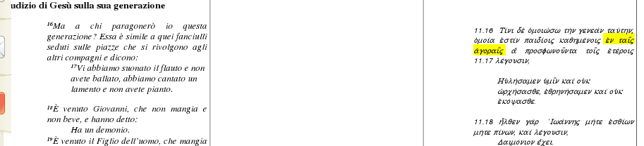

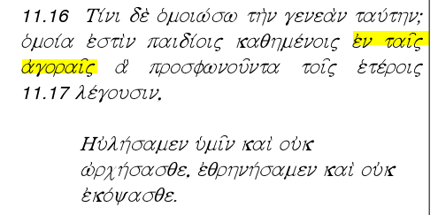

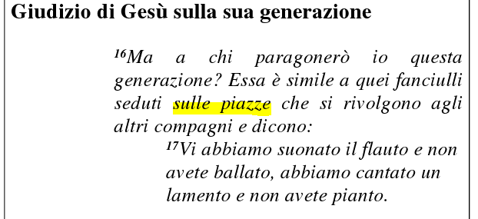

http://ebookbrowse.com/matteo-testo-greco-e-italiano-cei-1974-pdf-d75225963

