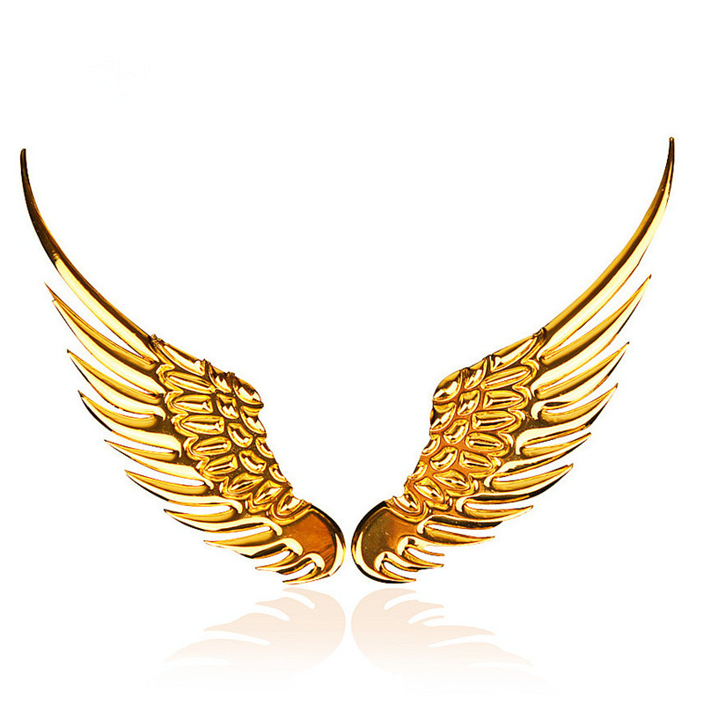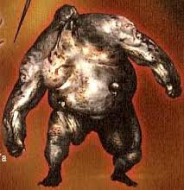

**Plan what materials you need to make your monster**:

1. …
2. …
3. …
4. …

HEAD

BODY

LEGS AND ARMS

#### POWER

#### PHYSICAL CHARACTERISTICS

## Write here the description of the siren you have found in <http://www.theoi.com/Encyc_M.html>

# Read the description of a siren and draw it:

### FACTS

2

2

4

3

Mythology is not a lie, Mythology is poetry. Joseph Campbell, The Power of Myth

siren