
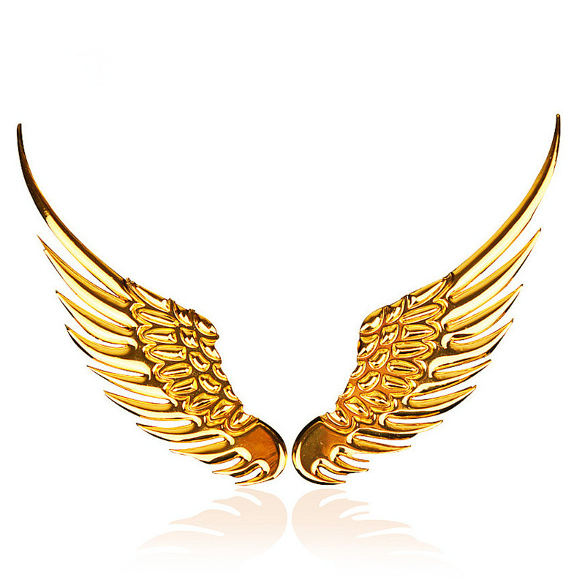
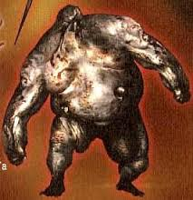
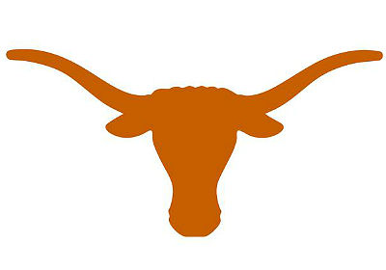

Plan what materials you need to make your monster:
- …
- …
- …
- …

HEAD
BODY
LEGS AND ARMS

POWER

PHYSICAL CHARACTERISTICS

Write here the description of the pegasus you have found in http://www.theoi.com/Encyc_M.html

Read the description of a pegasus and draw it:

FACTS
2
2
4
3

Mythology is not a lie, Mythology is poetry. Joseph Campbell, The Power of Myth

pegasus

