LAMPIRAN
FORMAT SOALAN
Bold

1 (b) FIGURE 2 shows structures of polysaccharides.
Tab
0.5
Tab
0.5

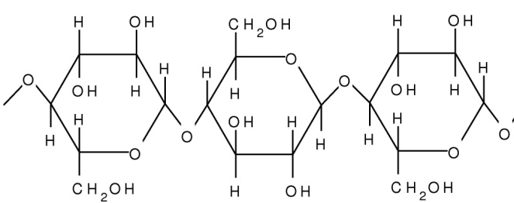
Centre
Tab
0.5
Huruf label Times New Roman: 12 dan Bold
A
Center

FIGURE 2
LEVEL 1
Italic
- Name the monomer and specific bond present in polysaccharide A
[2 marks]
________________________________________________________________________________________________________________________
LEVEL 2
Align text right
- State TWO structural differences between polysaccharide A and amylopectin.
[2 marks]
____________________________________________________________________________________________________________________________________________________________________________________
LEVEL 3
- Why human intestine unable to digest polysaccharide A?
[1 mark]
Line spacing 1.5
________________________________________________________________________________________________________________________

