Look at the pictures and write questions.
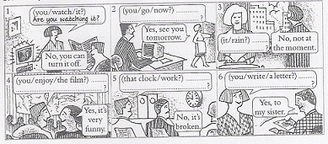

inserta tabla y ver como desea el diseño con recor o sin el

Look at the pictures and complete the questions. Use one of these:
Cry eat go laugh look at read
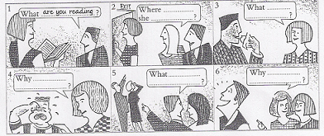
Write questions from these words. Use Is or are and put the wods in order.
1 (working / Paul / today?) Is Paul working today?
2 (what / doing / the children?) What are the children doing?
3 (you / listening / to me?) …………………………………………………………………………………………… .
4 (where / going / your Friends?) …………………………………………………………………………………. .
5 (your parents / television / watching?) ………………………………………………………………………. .
6 (what / cooking / Ann?) …………………………………………………………………………………………….. .
7 (why / you / looking / at me?) ……………………………………………………………………………………. .
8 (coming / the boss?) ………………………………………………………………………………………………….. .

Write short answers (Yes, I am. / No, he isn’t. etc.)
1 Are you watching TV? No, I’m not.
2 Are you wearing a watch? ………………………….. .
3 Are you eating something? ………………………….. .
4 Is it training? ………………………………………………. .
5 Are you sitting on the floor? ………………………… .
6 Are you feeling well? ……………………..……………. .

