

Scheme of Work
Cambridge Primary
Mathematics 0096
Stage 6

This Cambridge Scheme of Work is for use with the Cambridge Primary
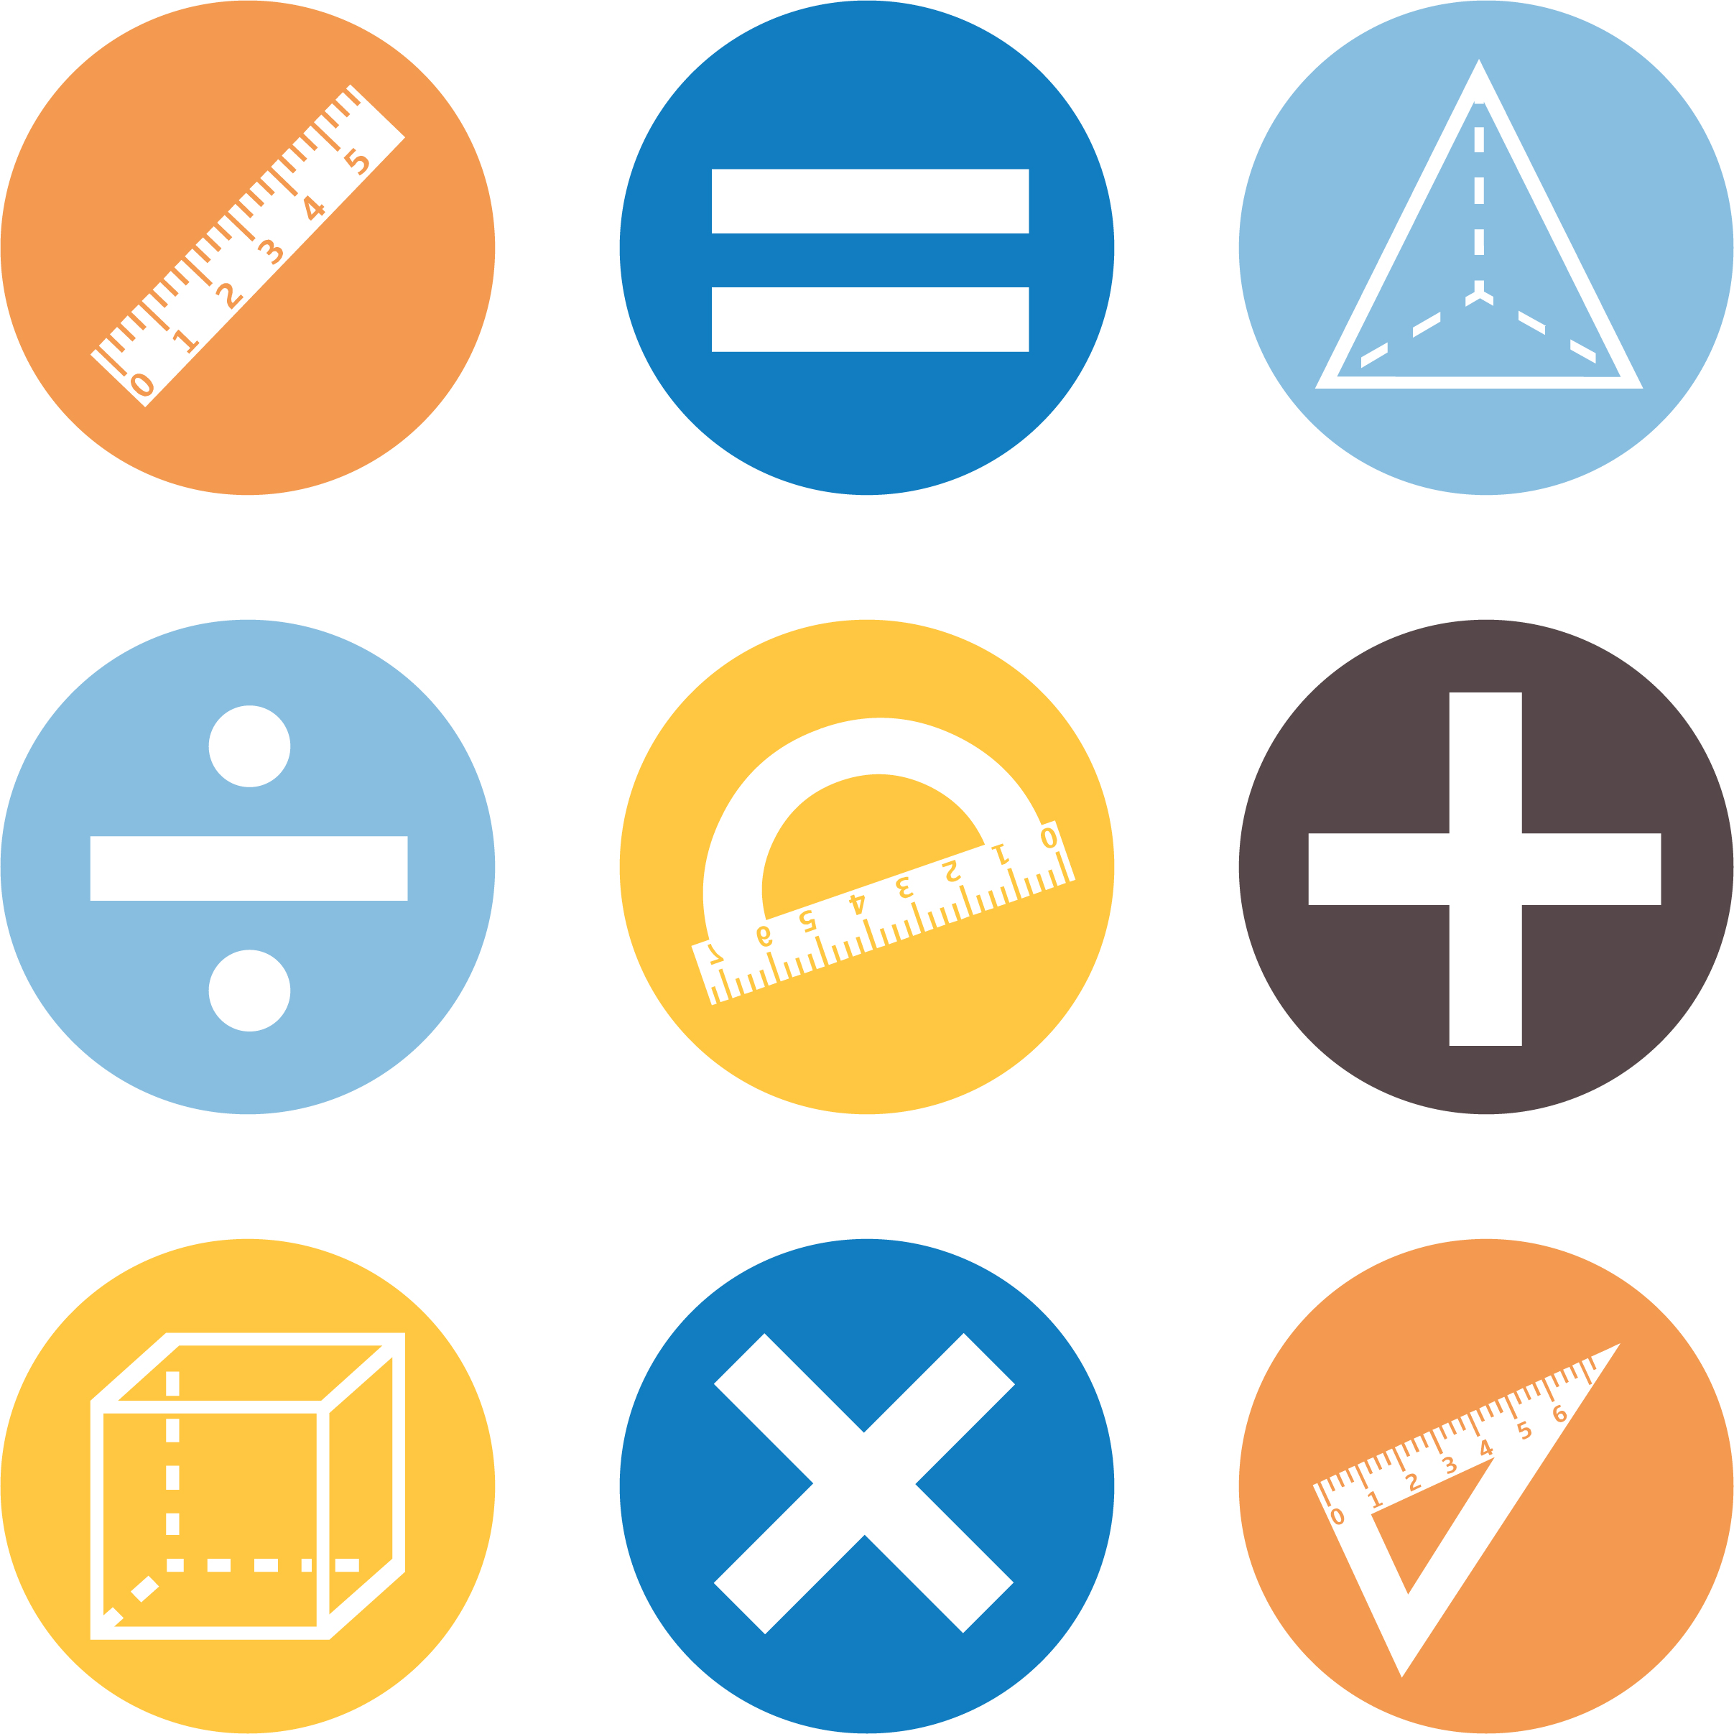
Mathematics Curriculum Framework published in September
2020 for first teaching in September 2021.

© UCLES 2020
Cambridge Assessment International Education is part of the Cambridge Assessment Group. Cambridge Assessment is the brand name of the University of Cambridge Local Examinations Syndicate (UCLES), which itself is a department of the University of Cambridge.

UCLES retains the copyright on all its publications. Registered Centres are permitted to copy material from this booklet for their own internal use. However, we cannot give permission to Centres to photocopy any material that is acknowledged to a third party, even for internal use within a Centre.

Contents

Contents 3
Introduction 5
Unit 6.1 Number 9
Unit 6.1 Topic 1 The number system 10
Unit 6.1 Topic 2 Number patterns 19
Unit 6.2 2D and 3D shape 22
Unit 6.2 Topic 1 Quadrilaterals, circles and area 23
Unit 6.2 Topic 2 Angles 28
Unit 6.2 Topic 3 3D shapes, volume and capacity 31
Unit 6.3 Calculation 35
Unit 6.3 Topic 1 Addition and subtraction 36
Unit 6.3 Topic 2 Multiplication and division 39
Unit 6.4 Statistical methods 45
Unit 6.4 Topic 1 Designing the enquiry 46
Unit 6.4 Topic 2 Presenting and explaining results 48
Unit 6.4 Topic 3 Using statistical measures 52
Unit 6.4 Topic 4 The statistical cycle 54
Unit 6.5 Fractions, percentages, decimals and proportion 58
Unit 6.5 Topic 1 Comparing fractions 59
Unit 6.5 Topic 2 Calculating with fractions 62
Unit 6.5 Topic 3 Understanding percentage and equivalence 66
Unit 6.5 Topic 4 Ratio and proportion 68
Unit 6.6 The coordinate grid 71
Unit 6.6 Topic 1 Using coordinates 72
Unit 6.6 Topic 2 Reflection and rotation 75
Unit 6.7 Probability 78
Unit 6.7 Topic 1 Describing possibilities 79
Unit 6.7 Topic 2 Conducting tests 82
Sample lesson 1 84
Sample lesson 2 87
Changes to this Scheme of Work 89

Changes to this Scheme of Work
For information about changes to this Scheme of Work, go to page 89.
The latest Scheme of Work is version 2.0, published January 2021.

Introduction
This document is a scheme of work created by Cambridge Assessment International Education for Cambridge Primary Mathematics Stage 6.

It contains:
- suggested units showing how the learning objectives in the curriculum framework can be grouped and ordered
- at least one suggested teaching activity for each learning objective
- a list of subject-specific language that will be useful for your learners
- common misconceptions
- sample lesson plans
- links to relevant NRICH activities to enrich learners’ mathematical experiences, https://nrich.maths.org/

You do not need to use the ideas in this scheme of work to teach Cambridge Primary Mathematics Stage 6. Instead use them as a starting point for your planning and adapt them to suit the requirements of your school and the needs of your learners. The schemes of work are designed to indicate the types of activities you might use, and the intended depth and breadth of each learning objective. These activities are not designed to fill all the teaching time for this stage. You should use other activities with a similar level of difficulty, for example, those from endorsed resources.

The accompanying teacher guide for Cambridge Primary Mathematics suggests effective teaching and learning approaches. You can use this scheme of work as a starting point for your planning, adapting it to suit the requirements of your school and needs of your learners.

Long-term plan
This long-term plan shows the units in this scheme of work and a suggestion of how long to spend teaching each one. The suggested teaching time is based on learners having about 4 to 5 hours of Mathematics per week (about 120 to 150 hours per stage). The actual number of teaching hours may vary according to your context.
Unit and suggested order | Suggested teaching time
Unit 6.1 Number | 13% (20 hours)
Unit 6.2 2D and 3D shape | 20% (30 hours)
Unit 6.3 Calculation | 17% (25 hours)
Unit 6.4 Statistical methods | 13% (20 hours)
Unit 6.5 Fractions, percentages, decimals and proportion | 20% (30 hours)
Unit 6.6 The coordinate grid | 10% (15 hours)
Unit 6.7 Probability | 7% (10 hours)
Total | 150 hours

Sample lesson plans
You will find two sample lesson plans at the end of this scheme of work. They are designed to illustrate how the suggested activities in this document can be turned into lessons. They are written in more detail than you would use for your own lesson plans. The Cambridge Primary Mathematics Teacher Guide has information on creating lesson plans.

Other support for teaching Cambridge Primary Mathematics Stage 6
Cambridge Primary centres receive access to a range of resources when they register. The Cambridge Primary support site at https://primary.cambridgeinternational.org is a password-protected website that is the source of the majority of Cambridge-produced resources for the programme. Ask the Cambridge Coordinator or Exams Officer in your school if you do not already have a log-in for this support site.

Included on this support site are:
- the Cambridge Primary Mathematics Curriculum Framework, which contains the learning objectives that provide a structure for your teaching and learning
- grids showing the progression of learning objectives across stages
- the Cambridge Primary Mathematics Teacher Guide, which will help you to implement Cambridge Primary Mathematics in your school
- templates for planning
- worksheets for short teacher training activities that link to the teacher guide
- assessments provided by Cambridge
- a list of endorsed resources, which have been through a detailed quality assurance process to make sure they are suitable for schools teaching Cambridge Primary Mathematics worldwide
- links to online communities of Cambridge Primary teachers.

Resources for the activities in this scheme of work
We have assumed that you will have access to these resources:
- paper, pens and pencils for learners to use
- rulers, set squares, protractors and calculators.

Other suggested resources for individual units and/or activities are described in the rest of this document. You can swap these for other resources that are available in your school.

Websites
We recommend NRICH to support Cambridge Primary Mathematics at https://nrich.maths.org/

NRICH publishes free and challenging mathematics activities for learners of all ages. The resources assist teachers to embed thinking and working mathematically with mathematics content. NRICH is based in both the University of Cambridge's Faculty of Education and the Centre for Mathematical Sciences.

There are many excellent online resources suitable for teaching Cambridge Primary Mathematics. Since these are updated frequently, and many are only available in some countries, we recommend that you and your colleagues identify and share resources that you have found to be effective for your learners.

Approaches to teaching Cambridge Primary Mathematics Stage 6

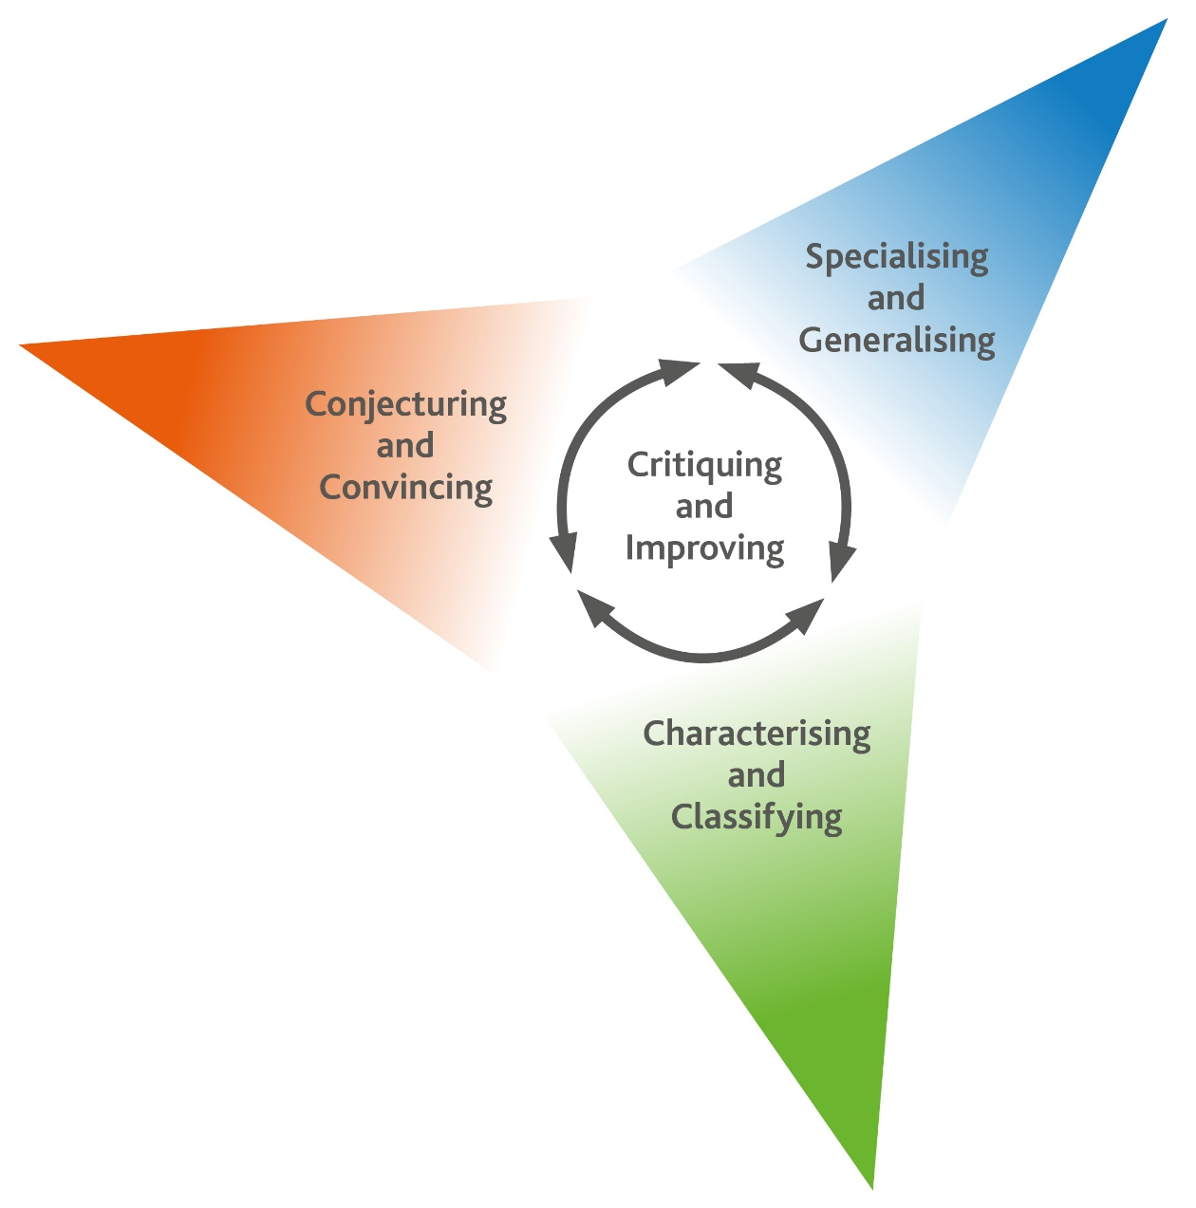
Thinking and Working Mathematically
Thinking and Working Mathematically supports the mathematical concepts and skills in all strands of the Cambridge Primary Mathematics curriculum. When learners think and work mathematically, they actively engage with their learning of mathematics. They try to make sense of ideas and build connections between different facts, procedures and concepts. Learners who do not think and work mathematically can carry out processes that their teacher has shown them, but they may not understand why the processes work or what the results mean. Noticing inconsistencies, patterns and particular representations encourages learners to think and work mathematically. Practice, reflection and questioning will help them to improve.

Thinking and Working Mathematically has eight characteristics that are presented in four pairs:

- Specialising and Generalising
- Conjecturing and Convincing
- Characterising and Classifying
- Critiquing and Improving.

The eight Thinking and Working Mathematically characteristics are all closely connected and interdependent. A high-quality mathematics task may include one or more of them. The characteristics provide learners with the language they need to think and work mathematically. Learners can then decide what mathematical knowledge, procedures and strategies to use in order to gain a deeper understanding of mathematical questions.

Throughout this scheme of work, there are examples of classroom activities that link the Thinking and Working Mathematically characteristics with content learning objectives. We recommend you use the ideas in these examples to create further classroom activities.

Thinking and Working Mathematically characteristics: |  | Unit 6.1 | Unit 6.2 | Unit 6.3 | Unit 6.4 | Unit 6.5 | Unit 6.6 | Unit 6.7
TWM.01 | Specialising – Choosing an example and checking to see if it satisfies or does not satisfy specific mathematical criteria
TWM.02 | Generalising – Recognising an underlying pattern by identifying many examples that satisfy the same mathematical criteria
TWM.03 | Conjecturing – Forming mathematical questions or ideas
TWM.04 | Convincing – Presenting evidence to justify or challenge a mathematical idea or solution
TWM.05 | Characterising – Identifying and describing the mathematical properties of an object
TWM.06 | Classifying – Organising objects into groups according to their mathematical properties
TWM.07 | Critiquing – Comparing and evaluating mathematical ideas, representations or solutions to identify advantages and disadvantages
TWM.08 | Improving – Refining mathematical ideas or representations to develop a more effective approach or solution

Misconceptions
Mathematical misconceptions are usually incorrect generalisations made by learners. Misconceptions should not be avoided, but instead used for teaching purposes to reveal learners’ thinking. Research suggests that asking learners open-ended questions about mathematical concepts is the most appropriate way to uncover misconceptions. Once a learner’s misconceptions have been identified, the next step is to know how to correct them. One approach is to give learners a variety of mathematical strategies to draw upon when finding solutions so that they can gain a deeper understanding of each mathematical concept.

Mental strategies and calculators
Mental calculation is a skill needed for everyday life, especially when paper or calculators are not available. Mental calculation relies on working memory, the organisation of thoughts and the use of efficient mathematical strategies when solving mathematical computations. It is important for learners to practise mental calculations and have a range of strategies as this improves understanding and recall as well as increasing confidence and proficiency.

Calculators are useful teaching aides. Although learners need to practise doing mental and written calculations, calculators can help them to notice patterns. They are also useful when learners are solving problems where non-calculator calculations would take the focus away from strategies. When well used, calculators can help learners to learn about numbers and the number system. Use calculators as a teaching aid to promote mental calculation and mental strategies and to explore mathematical patterns. Learners should understand when it is best to use calculators to help them calculate, and when to calculate mentally or using written methods.

As Cambridge International includes calculator-based assessments at Stages 5, 6, 7, 8, and 9, we recommend that learners begin to use calculators for performing and checking calculations from Stage 4. At Stages 5 and 6, learners should be developing effective use of calculators so that they are familiar with the buttons and functions of a basic calculator.

Unit 6.1 Number

Learning objectives covered in Unit 6.1 and topic summary: |  | 6.1 Topic 1  The number system | 6.1 Topic 2  Number patterns | Thinking and Working Mathematically
6Nc.01 | Count on and count back in steps of constant size, including fractions and decimals, and extend beyond zero to include negative numbers. |  |  | TWM.02 Generalising
6Nc.03 | Use the relationship between repeated addition of a constant and multiplication to find and use a position-to-term rule. |  |  | TWM.01 Specialising  TWM.02 Generalising
6Nc.04 | Use knowledge of square numbers to generate terms in a sequence, given its position. |  |  | TWM.05 Characterising
6Ni.02 | Use knowledge of laws of arithmetic and order of operations to simplify calculations. |  |  | TWM.04 Convincing  TWM.08 Improving
6Ni.03 | Understand that brackets can be used to alter the order of operations. |  |  | TWM.01 Specialising
6Np.01 | Understand and explain the value of each digit in decimals (tenths, hundredths and thousandths).
6Np.02 | Use knowledge of place value to multiply and divide whole numbers and decimals by 10, 100 and 1000.
6Np.03 | Compose, decompose and regroup numbers, including decimals (tenths, hundredths and thousandths).
6Np.04 | Round numbers with 2 decimal places to the nearest tenth or whole number. |  |  | TWM.04 Convincing
6Gt.01 | Convert between time intervals expressed as a decimal and in mixed units. |  |  | TWM.07 Critiquing  TWM.08 Improving

Unit 6.1 Topic 1 The number system

Outline of topic:
Learners will explore counting on and counting back with integers and decimals and develop their understanding of the laws of arithmetic and use of brackets. They will use the order of operations to find the answer to calculations that include one pair of brackets, one multiplication/division and one addition/subtraction.

Learners will understand the value of each digit in numbers with up to three decimal places. They will be able to use this knowledge of place value to compose, decompose and regroup integers and decimals and to multiply and divide integers and decimals by 10, 100 and 1000.

Learners will round numbers with two decimal places and develop confidence in converting between time expressed as a decimal and in mixed units.

Language:
Key vocabulary:
place value, digit, position
decimals, tenths, hundredths, thousandths
commutative, associative, distributive, inverse
negative, positive, zero
operation, round, estimate

Key phrases:
Round … to the nearest …
Write … to the nearest …
Estimate the value of …
An example of the commutative law is …

Recommended prior knowledge:
- 1-10 times tables
- Place value (integers and decimals)
- Counting forwards and backwards in steps of constant size for integers
- Recognise that time can be expressed as a decimal or in mixed units
- Understand that operations follow a particular order
- Round integers and numbers with one decimal place

Learning objectives | Suggested teaching activities and resources | Mental strategies, possible misconceptions and comments
6Nc.01 Count on and count back in steps of constant size, including fractions and decimals, and extend beyond zero to include negative numbers. | Use a counting stick, divided by lines into 10 sections, as a model for counting on and back. Decide what the start and end numbers will be, and ask learners to work out what each line in-between represents. Point to each line and ask learners to say the number out loud in unison. Repeat this several times, sometimes counting on and sometimes counting back. Use this to count in fractions, decimals and negative numbers. Include some examples where zero is in the middle of the counting stick.  Individually ask learners to draw an empty number line. Give them a starting number and a constant size to count in, then ask them to annotate each step on the number line. In further similar examples, vary the placement of the number you give them, sometimes at the beginning of the number line (so they will count on), at the end (so they will count back) or in the middle (so they have to count on and count back). Use a variety of integers, fractions, decimals and negative numbers.  Resources:  Counting stick, empty number line | Purposeful counting is an essential skill in mathematics as it provides key building blocks to support calculation and other mathematical content.  Possible misconceptions:  Listen out for learners using integers when counting in decimals, e.g. 1.8, 1.9, 1.10.
6Nc.01 Count on and count back in steps of constant size, including fractions and decimals, and extend beyond zero to include negative numbers.  TWM.02 Generalising  Recognising an underlying pattern by identifying many examples that satisfy the same mathematical criteria | Ask learners to start at 7.5 and count back in 0.4s:  7.5, 7.1, 6.7, …  Ask learners questions about the sequence such as:  - Will one of the numbers in this sequence be 1? How do you know?  - Will one of the numbers in this sequence be 0? How do you know?  - Will one of the numbers this sequence be -1.8? How do you know?    Learners will show they are generalising (TWM.02) when they notice certain properties of the sequence and use these to answer the questions above.  For example:  - All of the numbers in this sequence are decimals (with one decimal place), so neither 1 nor 0 can be in the sequence.  - The digit in the tenths column are all odd numbers so -1.8 cannot be in the sequence.  Ask learners to make their own sequences by starting with other numbers and counting up or down in a step size of their choice.  Ask learners, Can you find any generalisations about your sequence? | Possible misconceptions:  Learners may think that the sequence cannot continue below zero. For example: 1.1, 0.7, 0.3, 0.
6Ni.02 Use knowledge of laws of arithmetic and order of operations to simplify calculations.  TWM.04 Convincing  Presenting evidence to justify or challenge a mathematical idea or solution | Ask learners, How many possible answers can you find by combining 3, 4 and 5 with + and × ?  3 4 5 with + ×  Learners should use each number exactly once for each calculation but can use + or x as many or as few times as they wish. (Concatenation, i.e. putting 3 and 4 together to make 34, is not allowed.)  How can you be certain that you have found all the possible solutions?  Learners need to be systematic in varying the order of the three numbers, as well as varying the operations used. They need to apply the operations in the conventional order to obtain the correct answers.  Learners will show they are convincing (TWM.04) when they can justify why they think they have found all the possible solutions.  This activity can be extended by asking learners:  Can any other solutions be found if you also use one pair of brackets? | Learners could use a table to systematically list all possible solutions:  The only possible solutions are 12, 17, 19, 23 and 60.  With brackets three more solutions are possible:  $$(3 + 4) × 5=35$$  $$(3 + 5) × 4=32$$  $$(4 + 5) × 3=27$$  Possible misconception:  Learners may apply the order of operations incorrectly. For example, learners may think that $3 + 4 × 5 =35$.
  $$3 + 4 + 5 =12$$ | $$3 + 4 × 5 =23$$
  $3 + 5 + 4 =12$ | $$3 + 5 × 4 =23$$
  $$4 + 3 + 5 =12$$ | $$4 + 3 × 5 =19$$
  $4 + 5 + 3 =12$ | $$4 + 5 × 3 =19$$
  $$5 + 3 + 4 =12$$ | $$5 + 3 × 4 =17$$
  $5 + 4 + 3 =12$ | $$5 + 4 × 3 =17$$
  $$3 × 4 + 5 =17$$ | $$3 × 4 × 5 =60$$
  $$3 × 5 + 4 =19$$ | $$3 × 5 × 4 =60$$
  $$4 × 3 + 5 =17$$ | $$4 × 3 × 5 =60$$
  $4 × 5 + 3 =23$ | $$4 × 5 × 3 =60$$
  $$5 × 3 + 4 =19$$ | $$5 × 3 × 4=60$$
  $$5 × 4+ 3 =23$$ | $$5 × 4 × 3 =60$$
6Ni.02 Use knowledge of laws of arithmetic and order of operations to simplify calculations.  TWM.08 Improving  Refining mathematical ideas or representations to develop a more effective approach or solution | Ask learners:  How might the commutative law, the associative law and the distributive law help simplify calculations?  For example, it may be simpler to conceptualise 26 x 4 as 4 groups of 26, (i.e. 4 x 26) rather than 26 groups of 4.  Show learners the following calculations and ask them to find answers using the laws of arithmetic to simplify:  - 7 x 301 Answer: distributive law, 7 x 300 + 7 x 1 = 2100 + 7  - 19 x 7 + 19 x 3 Answer: distributive law, 19 x 10  - 5 x 39 x 2 Answer: commutative law, 5 x 2 x 39 = 10 x 39  - 21 x 13 – 20 x 13 Answer: distributive law, 1 x 13  - 17 + 46 + 4 Answer: associative law 17 + (46 + 4) = 17 + 50  Learners will show they are improving (TWM.08) when they consider how they can perform the calculations differently to refine and simplify the method. | Commutative:  67 x 72 = 72 x 67  Associative:  34 x 60 = 34 x (6 x 10)  or  34 x 60 = (34 x 10) x 6  Distributive:  23 x 38 = 23 x (40 – 2) = (23 x 40) – (23 x 2)  Possible misconceptions:  Learners may apply the laws incorrectly and think they apply to all operations,  e.g. 56 – 5 – 4 = 56 – 1.  Addition and multiplication follow the commutative and associative laws but subtraction and division do not (except in a few special cases).
6Ni.03 Understand that brackets can be used to alter the order of operations. | Write the same sequence of numbers but with brackets in different places and ask learners to calculate the solutions.  Use examples with one multiplication/division and one addition/subtraction.  - 20 – 5 ÷ 5 Answer: 19  - (20 – 5) ÷ 5 Answer: 3  Repeat this, except this time include the answer but do not include the brackets and ask learners if the calculation needs brackets, and if so, to place the brackets in the correct place.  - 1 + 9 x 5 = 50 Answer: (1 + 9) x 5 = 50  - 9 – 6 ÷ 3 = 7 Answer: this calculation does not need brackets  Use the NRICH task: Become Maths Detectives (https://nrich.maths.org/6928) to explore the use of mixed operations further.  Resources:  NRICH task | Learners need to understand that calculations with mixed operations follow mathematical rules, which can be referred to as BIDMAS (Brackets, Indices, Division, Multiplication, Addition and Subtraction).  Only include examples with one pair of brackets, one multiplication/division and one addition/subtraction. For example, avoid questions such as 9 – 3 + 4.  Possible misconceptions:  Learners may calculate from left to right ignoring the significance of the brackets.
6Ni.03 Understand that brackets can be used to alter the order of operations.  TWM.01 Specialising  Choosing an example and checking to see if it satisfies or does not satisfy specific mathematical criteria | Write this calculation on the board:  3 + 1 + 2 × 6 + 4 × 2 = 44  Ask learners to copy the calculation into their books and discuss with other learners whether they think it is correct or incorrect. Make sure all learners understand why the calculation is incorrect. Multiplication is performed before addition when following the correct order of operations, unless there are brackets, in which case these need to be calculated first.  Ask learners to make the calculation they have written in their book correct, by placing one pair of brackets in various positions until the answer is 44. Learners will show they are specialising (TWM.01) by choosing where to place the brackets and testing their examples, using the order of operations, to see whether each calculation they try gives the correct solution.  This activity can be extended by asking learners to devise similar problems for other learners to solve. | When following the correct order of operations, the answer to the original question should be 24.  3 + 1 + 2 × 6 + 4 × 2 = 24  By placing a pair of brackets as shown below, the answer is 44.  3 + 1 + 2 × (6 + 4) × 2 = 44  Possible misconceptions:  Some learners may think that the answer should be 80 as they have calculated from left to right rather than follow the correct order of operations.
6Np.01 Understand and explain the value of each digit in decimals (tenths, hundredths and thousandths). | Learners work in pairs for this activity. Give each learner a set of 0–9 digit cards. Each pair of learners take turns to make a 4-, 5- or 6-digit number that has 3 decimal places, for example 27.819. Ask learners to tell their partner the value of each digit to see if they agree.  Ask learners questions such as:  - In 226.831 which digit is in the tenths place?  - In 19.053 the digit in the hundredths place is …?  - In 1.943 what does the digit 3 represent?  Then ask learners to use their cards to try and make a number based on information about each place value. For example:  My number has 4 tens, 5 tenths, 6 thousandths, 2 ones and 1 hundredth. What is my number?  Learners continue to take turns and make numbers using the digit cards, but this time they hide the number from their partner and give clues about each place value, similarly to the example given above.  Resources:  Set of 0–9 digit cards per learner | Possible misconceptions:  Learners may confuse the language associated with integers and decimals.  For example, for 0.99 saying zero point ninety-nine rather than zero point nine nine.  Learners may not realise that 4.1 is the same as 4.10. Both numbers have 4 units, 1 tenth and 0 hundredths.
6Np.02 Use knowledge of place value to multiply and divide whole numbers and decimals by 10, 100 and 1000. | Write a number on the board, e.g. 541, and ask one third of the class to multiply it by 10, another third to multiply it by 100 and the remaining third to multiply it by 1000. Record the answers and ask learners:  What is the same and what is different about these answers?  Repeat this activity but this time use division of 10,100 and 1000.  Repeat this activity again but start with a decimal instead of an integer.  Ask learners to choose their own 3-digit number with 2 decimal places, for example 3.45, and to record what it would be after it is multiplied by 10, 100 and 1000 and divided by 10, 100 and 1000. | Multiplying and dividing by 10, 100 and 1000 are important skills. They enable learners to convert between standard units of measurement and are also key skills in many calculation questions.  Possible misconceptions  Learners may be adding zeros when multiplying by 10,100 or 1000. This is a misconception that will lead to difficulties when the question or answer involves decimals,  e.g. 4.5 x 10 = 4.50.  Learners sometimes try to remember how to multiply and divide numbers by trying to remember if they move to the left or the right. Try to encourage learners to think if the numbers are getting ten times larger (if multiplying by 10) or ten times smaller (if dividing by 10) to emphasise the conceptual understanding involved.
6Np.03 Compose, decompose and regroup numbers, including decimals (tenths, hundredths and thousandths). | Learners work in pairs, each pair has three different place value dice (0–9, 0.1–0.9 and 0.01–0.09) and a set of decimal place value cards (tenths, hundredths and thousandths). Roll each dice once and then find the corresponding place value card. Encourage learners to read the number that has been generated and to describe the separate parts that make up the number. Also ask learners to record the number additively, e.g. 3.61 = 3 + 0.6 + 0.01.  Reverse this activity so that learners now choose a decimal and then find the place value cards to match it.  How could you decompose this number?  Resources:  0-9 dice  0.1-0.9 dice  0.01-0.09 dice  Decimal place value cards (sometimes called arrow cards) | Understanding how to compose, decompose and regroup numbers in many different ways is essential for learners to become effective at calculating.  Possible misconceptions:  Learners may think numbers can only be regrouped by splitting them into tenths, hundredths and thousandths rather than 0.56 could be regrouped into 0.55 and 0.01.
6Np.04 Round numbers with 2 decimal places to the nearest tenth or whole number.  TWM.04 Convincing  Presenting evidence to justify or challenge a mathematical idea or solution | Learners work in pairs and each pair has a 0-9 dice. Taking turns, one learner rolls the dice 3 times to generate 3 digits. Ask learners to use the digits to make a number with 2 decimal places, e.g. 5, 2, 8 could become 5.28 or 8.25. Learners then round their number to the nearest tenth (5.28 to 5.3) and the nearest whole number (5.28 to 5).  Ask learners:  - How do you know whether to round up or down?  - How can you be sure that you have rounded the numbers correctly?  - Convince your partner that you are right.  Learners will show they are convincing (TWM.04) when they can justify why their rounding is correct. Using a number line is helpful to show spatially how near numbers are to each other. For example, 23.61 is nearer to 24 than to 23, and nearer to 23.6 than to 23.7.  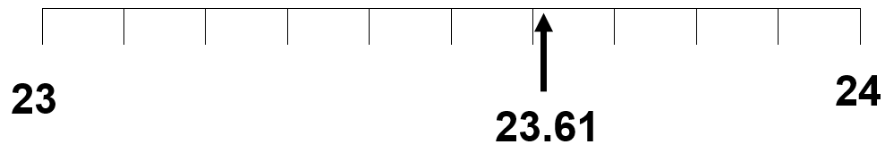  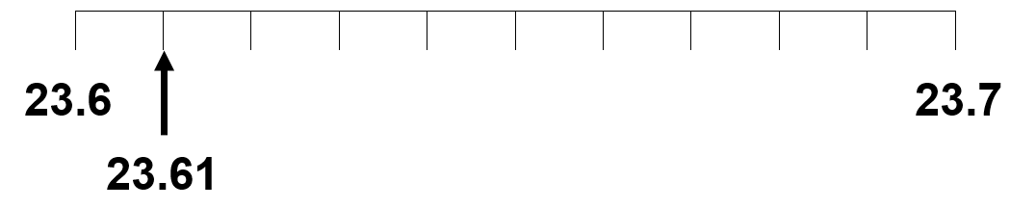  This activity can be extended by asking learners:  When might I need to round numbers?  Ask learners to write division questions which result in a decimal answer. Then practise rounding the number to the nearest tenth or whole number or rounding down as appropriate.  For example:  - I share 150 pencils equally between 16 people. How many pencils do they each get? Answer: 9 (as 9.375 rounds to 9 to the nearest whole number)  - I share 150 pencils equally between 17 people. How many pencils do they each get? Answer: 8 (even though 8.82 rounds to 9 to the nearest whole number, there would not be enough pencils to give everyone 9 each)  Resources:  0-9 dice  Number line | Rounding helps learners to make useful estimates.  Possible misconceptions:  Rounding 3.57 to 3 because it starts with a 3.  Giving an answer of 9.375 pencils rather than rounding to 9 as it is impractical to break a pencil into parts.
6Gt.01 Convert between time intervals expressed as a decimal and in mixed units. | Ask learners how they would write one and a half hours. Compare and discuss the different responses. Explain that we can write time as a decimal and in mixed units. One and a half hours could be written as 1 hour and 30 minutes, as 90 minutes, as 1.5 hours etc.  Use a pie chart with a total value of 60 (to represent minutes in an hour) to show how 0.5 of the pie is equivalent to 30 minutes.  Ensure that learners understand that it is the tenths and hundredths that represent the minutes, while the ones and tens represent the hours.  Set the following examples for learners to practice. Ask them to draw a pie chart for each decimal to show the fraction of minutes.  - 0.75 (45 minutes)  - 0.25 (15 minutes)  - 0.1 (6 minutes)  - 1.25 (1 hour and 15 minutes)  - 1.75 (1 hour and 45 minutes)  - 2.5 (2 hours and 30 minutes)  - 5.5 (5 hours and 30 minutes)  Then challenge learners to set questions for each other to solve. | Possible misconceptions:  Learners forget that time recorded as a decimal is base 60, so they read 1.5 as 1 hour and 5 minutes or 1 hour and 50 minutes.
6Gt.01 Convert between time intervals expressed as a decimal and in mixed units.  TWM.07 Critiquing  Comparing and evaluating mathematical ideas, representations or solutions to identify advantages and disadvantages  TWM.08 Improving  Refining mathematical ideas or representations to develop a more effective approach or solution | Give learners the following problem:  Chris was asked to convert a time expressed as a decimal, 1.25 hours to hours and minutes:$1.25 × 60 = 75$ minutes. He then subtracts 60 minutes (1 hour) from 75 minutes which equals 15 minutes. So his answer is 1 hour 15 minutes.  Ask learners what they think of this method:  - Does Chris’ method give the correct answer?  - How easy is it to understand Chris’ method?  - What are the advantages and disadvantages of this method?  - Would Chris be able to use this method to convert 29.25 hours into hours and minutes?  - Would you recommend a different method to Chris? Why / why not?  Learners will show they are critiquing (TWM.07) when they can identify possible advantages and disadvantages of Chris’ method and are improving (TWM.08) when they are able to refine the method to calculate the answer more efficiently. | Mental strategies:  Chris’ method used is accurate and could be easily performed on a calculator. However, this method would not be as easy to perform mentally. A more efficient mental strategy could be to recall that 0.25 hours is 15 minutes, so 1.25 hours is 1 hour and 15 minutes. This method can be more easily applied when the time expressed as a decimal is larger, such as 29.25 hours.

Unit 6.1 Topic 2 Number patterns

Outline of topic:
Learners will explore the relationship between repeated addition and multiplication to understand how to help predict numbers in a sequence. They will understand how to find and use a position-to-term rule.

Learners will use knowledge of square numbers to be able to identify and continue the sequence of square numbers. They will further develop their knowledge of square numbers to begin generating terms in number sequences when given its position.

Language:
Key vocabulary:
predict, term, position, rule, sequence
addition, repeated addition, multiplication, square numbers

Key phrases:
The pattern of this sequence is …
The next number in the sequence will be …
The rule for this sequence is …
… will / will not be in this sequence because …

Recommended prior knowledge:
- Make and describe number sequences
- Identify the term-to-term rule for a sequence
- Extend sequences
- Find a missing term of a linear sequence
- Knowledge of square numbers

Learning objectives | Suggested teaching activities and resources | Mental strategies, possible misconceptions and comments
6Nc.03 Use the relationship between repeated addition of a constant and multiplication to find and use a position-to-term rule.  TWM.01 Specialising  Choosing an example and checking to see if it satisfies or does not satisfy specific mathematical criteria  TWM.02 Generalising  Recognising an underlying pattern by identifying many examples that satisfy the same mathematical criteria | Write the equation 3 + 3 + 3 + 3 on the board and ask learners what the total is. Ask learners how else we could solve this equation using multiplication (4 x 3). Establish that the first method uses repeated addition of the constant 3, while the second method is using multiplicative reasoning and that 3 is being multiplied four times. Both generate the same answer of 12.  Ask learners:  - If this equation (4 x 3) is the 4th term, what would be the 1st, 2nd and 3rd terms? (1 x 3), (2 x 3), (3 x 3). Do you notice a pattern?  - Can you predict what the 10th, 20th, 100th term would be? (10 x 3), (20 x 3), (100 x 3).  - What about the nth term? (n x 3 or 3n)  Ask learners questions about the sequence such as:  - Will one of the numbers in this sequence be 21? How do you know?  - Will one of the numbers in this sequence be 0? How do you know?  In pairs, ask learners to generate other number sequences, beginning with repeated addition and then linking it to multiplication. With another pair, give them your list of numbers and ask them to find the term rule.  Learners will show they are specialising (TWM.01) when they create their own number sequences from specific numbers.  Learners will show they are generalising (TWM.02) when they notice certain properties of the sequence. | Possible misconceptions:  Learners think that the constant can change value.  e.g. for the sequence 1, 3, 6, 10, 15, …  the differences are +2, +3, +4, +5, …
6Nc.04 Use knowledge of square numbers to generate terms in a sequence, given its position.  TWM.05 Characterising  Identifying and describing the mathematical properties of an object | Ask learners to make the first 4 square numbers using cubes so they can refresh knowledge of the spatial pattern of square numbers. Record as a class using mathematical language.  For example:  First term is 1 (1 squared)  Second term is 4 (2 squared)  Third term is 9 (3 squared)  Fourth term is 16 (4 squared)  What is the fifth term?  Can you suggest what the nth term would be? (n x n)  Then look at the differences between the terms:  First term to second term +3  Second term to third term +5  Third term to fourth term +7  What is the difference between the fourth term to the fifth term? (+9)  Ask learners what they notice about the pattern. Observe how the difference between each term increases (or decreases) at a constant rate.  Ask learners questions such as:  - Will one of the numbers in this sequence be 30? How do you know?  - Will one of the numbers in this sequence be 101? How do you know?  Learners will show they are characterising (TWM.05) when they identify the features of square numbers.  For another challenge involving square numbers try the NRICH task: Filling the Gaps (https://nrich.maths.org/7547).  Resources:  Cubes  NRICH task | Possible misconceptions:  Not understanding the mathematical relationship between the visual appearance of the sequence and the rule.

Unit 6.2 2D and 3D shape

Learning objectives covered in Unit 6.2 and topic summary: |  |  | 6.2 Topic 1  Quadrilaterals, circles and area |  | 6.2 Topic 2 Angles |  | 6.2 Topic 3  3D shapes, volume and capacity |  | Thinking and Working Mathematically
6Gg.01 | Identify, describe, classify and sketch quadrilaterals, including reference to angles, symmetrical properties, parallel sides and diagonals. |  |  |  |  |  |  | TWM.01 Specialising  TWM.02 Generalising  TWM.05 Characterising
6Gg.02 | Know the parts of a circle:  - centre  - radius  - diameter  - circumference. |  |  |  |  |  |  | TWM.03 Conjecturing  TWM.04 Convincing
6Gg.03 | Use knowledge of area of rectangles to estimate and calculate the area of right-angled triangles. |  |  |  |  |  |  | TWM.02 Generalising  TWM.03 Conjecturing
6Gg.04 | Identify, describe and sketch compound 3D shapes. |  |  |  |  |  |  | TWM.05 Characterising
6Gg.05 | Understand the difference between capacity and volume. |  |  |  |  |  |  | TWM.03 Conjecturing  TWM.08 Improving
6Gg.06 | Identify and sketch different nets for cubes, cuboids, prisms and pyramids.
6Gg.07 | Understand the relationship between area of 2D shapes and surface area of 3D shapes.
6Gg.08 | Identify rotational symmetry in familiar shapes, patterns or images with maximum order 4. Describe rotational symmetry as ‘order $x$’.
6Gg.09 | Classify, estimate, measure and draw angles. |  |  |  |  |  |  | TWM.04 Convincing
6Gg.10 | Know that the sum of the angles in a triangle is 180º, and use this to calculate missing angles in a triangle. |  |  |  |  |  |  | TWM.04 Convincing
6Gg.11 | Construct circles of a specified radius or diameter.

Unit 6.2 Topic 1 Quadrilaterals, circles and area

Outline of topic:
Learners will develop their understanding of 2D shapes, specifically quadrilaterals and circles. They will construct circles using given properties and be able to describe the different parts of a circle. They will also extend their knowledge of symmetry by exploring rotational symmetry.
Learners will use and apply knowledge of area of rectangles to understand how to work out the area of right-angled triangles.

Language:
Key vocabulary:
quadrilaterals, parallelogram, rhombus, rectangle, square, trapezium, kite
properties, symmetry, angles, sides, edges, vertex, vertices, adjacent
centre, radius, diameter, circumference
formula, equation
perimeter, area, rectangles, right-angled triangles
centimetres, metres, square centimetres, square metres

Key phrases:
A …. has … sides/vertices
Properties of a shape
The area of the rectangle is …
The area of the triangle is …

Recommended prior knowledge:
- Draw 2-D shapes using given dimensions and angles
- Compare and classify 2-D shapes based on their properties and sizes
- Distinguish between regular and irregular polygons
- Find the area of rectangles

Learning objectives | Suggested teaching activities and resources | Mental strategies, possible misconceptions and comments
6Gg.01 Identify, describe, classify and sketch quadrilaterals, including reference to angles, symmetrical properties, parallel sides and diagonals.  TWM.02 Generalising  Recognising an underlying pattern by identifying many examples that satisfy the same mathematical criteria  TWM.01 Specialising  Choosing an example and checking to see if it satisfies or does not satisfy specific mathematical criteria | Ask learners to sketch the following quadrilaterals:  Parallelogram, rhombus, rectangle, square, trapezium, kite. Ask them to label each sketch with information about angles, symmetrical properties, parallel sides and diagonals.  Next, ask them to complete the following statements:  A square is a … (rectangle) with …. (four) equal sides.  A ….. (rectangle) has four right angles and its opposite sides are equal.  A parallelogram has opposite …… (sides) equal and …. (parallel)  A kite has … (two) pairs of equal-length adjacent sides.  A …. (rhombus) is a parallelogram with four equal sides.  A trapezium has … (one) pair of opposite parallel sides.  The diagonals of any square, rhombus or kite intersect at …(right) angles.  In pairs, ask learners to devise more statements using properties including angles, symmetrical properties, parallel sides and diagonals. Swap with another pair and solve.  Ask learners:  What is the same and what is different between a square and a rectangle?  What is the same and different between a square and a kite?  Ask learners to choose other shapes to compare.  Learners will show they are generalising (TWM.02) when they recognise the common features that belong to all quadrilaterals. Learners will show they are specialising (TWM.01) when they are able to use specific features to describe a specific quadrilateral.  This activity can be extended by asking learners to draw examples of “less obvious” and “obvious” shapes. For example, less obvious and obvious examples of a rectangle.  ’Less obvious’ rectangle: ’Obvious’ rectangle:  Ask learners to explain their reasoning and challenge conceptions of orientation. | Possible misconceptions:  Learners forget that some shapes are a special type of others. For example, squares are a special type of parallelograms, which are a special type of quadrilaterals, which are a special type of polygons.  Some learners only see the prototypical images of shapes so do not necessarily remember that a shape can be in any orientation. For example, a square is still a square even if it is resting on a corner.
6Gg.08 Identify rotational symmetry in familiar shapes, patterns or images with maximum order 4. Describe rotational symmetry as ‘order $x$’. | Find a square and draw around it on the whiteboard. Count how many times the square can be turned to fit on to itself until it comes back to its original position (4). This demonstrates that a square has a rotational symmetry with order of 4. Show learners that the centre of symmetry (the point about which a shape is turned) is in the middle of the square.  Remind learners that all shapes have an order of rotational symmetry of at least 1.  Ask learners to investigate other shapes, patterns or images and explore their order of rotational symmetry. Ask learners to predict a shape’s order of rotational symmetry before they test it.  Resources:  2D shapes, patterns and images (with maximum order 4) | A rotation is specified by a centre of rotation and an angle of rotation.  A shape has rotational symmetry if it can be rotated to give an identical shape.  Possible misconceptions:  Learners may think that all triangles have an order of rotation of 3 (not just equilateral triangles).
6Gg.03 Use knowledge of area of rectangles to estimate and calculate the area of right-angled triangles.  TWM.02 Generalising  Recognising an underlying pattern by identifying many examples that satisfy the same mathematical criteria  TWM.03 Conjecturing  Forming mathematical questions or ideas | Check that learners understand what area means and that it is a measure of the space inside a 2D shape.  Ask learners to draw any rectangle on a sheet of squared paper and to calculate and write the area of their rectangle. Then ask learners to pick any three corners of their rectangle, draw lines between them and colour in the triangle formed. Ask learners to estimate the area of their triangle by counting the squares inside and to write this down.  Ask learners to compare and discuss their answers with a group of other learners.  What do you notice about the rectangles and triangles you have drawn and the areas you have written down?  Learners will show they are generalising (TWM.02) when they recognise similarities and differences between each other’s examples. For example:  - all the triangles are right-angled triangles  - the triangles cut the rectangles in half  - some areas are whole numbers, but some are not  - the area of the triangle is always smaller than the area of the rectangle  - the area of the triangle is (approximately) half of the area of the rectangle.  Show learners a picture of a right-angled triangle drawn on plain paper. Ask learners: How could you find the area of this triangle?  Learners will show they are conjecturing (TWM.03) when they offer ideas of how they might find the area of the triangle.  For example:  - draw a square grid onto the picture and count the squares inside the triangle  - draw a rectangle around the triangle and halve the area of the rectangle  - multiply the length and width of the rectangle and halve the answer.  Resources:  Squared paper | Possible misconceptions:  Learners may attempt to find the area of the rectangles or triangles by measuring the side lengths and adding them up. This would calculate perimeter rather than area.
6Gg.02 Know the parts of a circle:  - centre  - radius  - diameter  - circumference.  TWM.03 Conjecturing  Forming mathematical questions or ideas  TWM.04 Convincing  Presenting evidence to justify or challenge a mathematical idea or solution | Ask learners to draw a circle using a compass and identify and label all the different parts of a circle: centre, radius, diameter, and circumference. As an alternative, you can provide circles drawn on A4 paper.  Ask learners to draw different sizes of circles. Ask them to investigate the relationship between the radius and the diameter.  Ask learners to suggest some conjectures. For example, the diameter is always twice the radius. Then ask learners to explain how they came to their conjecture and how they are convinced it is true.  Learners will show they are conjecturing (TWM.03) when they offer ideas towards the mathematical relationship between the radius and diameter of a circle.  Learners will show they are convincing (TWM.04) when they offer reasoning to convince why their conjecture is true.  Confirm that d = 2r.  Resources:  Compasses  Circles (drawn on A4 paper) | Remember a circle is not a polygon because it does not have straight edges. As the number of sides on a polygon increases towards infinity the polygon becomes closer and closer to the shape of a circle.  Possible misconceptions:  Learners may not correctly draw their diameter and radius lines through the centre of the circle.
6Gg.11 Construct circles of a specified radius or diameter. | Ask learners to use a compass to draw a circle using given information.  Remind them that d = 2r.  Ask them to fill in the missing information in the table.  Check understanding:  If d = 4cm what is the radius?  If r = 12cm what is the diameter?  If d = 9cm what is the radius?  Resources:  Compasses
  Radius | Diameter
  9cm | ?
  ? | 24cm
  4cm | ?
  ? | 0.1m

Unit 6.2 Topic 2 Angles

Outline of topic:
Learners will be able to recognise, classify and draw angles in 2D shapes and they will be able to find unknown angles in triangles.

Language:
Key vocabulary:
acute, obtuse, reflex
opposite angles, perpendicular
protractor, intersect, intersection

Key phrases:
Intersecting lines
Point of intersection

Recommended prior knowledge:
- Estimate, compare and classify angles
- Understand that the sum of angles on a straight line is 180°
- Know that an angle is a description of a turn
- Find unknown angles in any triangles, quadrilaterals and regular polygons

Learning objectives | Suggested teaching activities and resources | Mental strategies, possible misconceptions and comments
6Gg.01 Identify, describe, classify and sketch quadrilaterals, including reference to angles, symmetrical properties, parallel sides and diagonals.  TWM.05 Characterising  Identifying and describing the mathematical properties of an object | For this activity, learners work in pairs. Give each learner one piece of paper and ask them to fold it in half. On one side ask them to draw any quadrilateral using a ruler and pencil and on the other half they should write as many properties as they can to describe their quadrilateral.  Ask learners to tear their pieces of paper in half. Learners should keep the half with their drawing on hidden and give the half with the list of properties on to their partner. Learners then attempt to draw their partner’s quadrilateral, by using only the list of properties they have been given.  When they have finished, ask each pair of learners to work together to compare the new drawings with the original drawings. Ask them to discuss the accuracy of the list of properties and why the drawings are or are not the same.  Learners will show they are characterising (TWM.05) when they identify several properties such as parallel sides, symmetry, diagonal and angle properties to describe various quadrilaterals. | Possible misconceptions:  Learners forget that some shapes are a special type of others. For example, squares are a special type of parallelograms, which are a special type of quadrilaterals, which are a special type of polygons.
6Gg.09 Classify, estimate, measure and draw angles.  TWM.04 Convincing  Presenting evidence to justify or challenge a mathematical idea or solution | Using paper or mini whiteboards ask learners to draw an example of an acute, an obtuse and a reflex angle. Ask for explanations for each one.  Using drinking straws, ask learners to estimate different angle sizes (e.g. 67°, 150°). Ask learners to provide reasons to a partner of how close their estimate is, without measuring.  Learners will show they are convincing (TWM.04) when they explain to their partners that their angles are a good estimation. For example, learners might compare the angles to right angles, or use the fact that half a right angle is 45°.  Give learners two thin strips of card, fastened in the centre with a paper fastener. Ask them to notice what happens to the opposite angles as they move the strips to increase and decrease the angle size. Ask learners to use their protractors to measure these angles to confirm that the opposite angles change size but are still equal. Ask learners to draw their own two intersecting lines on paper and then use a protractor to find the missing angles.  Ask learners to use a protractor draw angles such as 67°, 150°, 312° etc. This activity can be extended by challenging learners to draw an angle bigger than 360°. Ask learners what happens when we try to draw this angle and how we could represent something that is bigger than a whole turn.  Resources:  Drinking straws  Strips of card and paper fasteners  Protractors  Mini whiteboards | Remind learners that an angle is a measurement of the space between two intersecting lines and is useful for describing geometric shapes. Angles are also used to describe rotations as they are a measure of the amount of turn.  Possible misconceptions:  Learners may think that it is not possible to have an angle greater than 360°
6Gg.10 Know that the sum of the angles in a triangle is 180ºand use this to calculate missing angles in a triangle.  TWM.04 Convincing  Presenting evidence to justify or challenge a mathematical idea or solution | Ask learners to draw any triangle, then tear off the corners and put the angles together.  What do you notice?  The angles will always make 180° and learners can prove this by placing the angles on a straight line.  Learners will show they are convincing (TWM.04) when they can justify why angles in a triangle always add up to 180°  Ask learners:  What else do we know about angles in triangles?  For example:  - a right-angled triangle will have one angle of 90°  - equilateral triangles have three angles of 60°  Give learners different triangles with one or two angles given and ask them to calculate the missing angles, using the above information. | Possible misconceptions:  Learners sometimes apply the rule of angles without understanding it.

Unit 6.2 Topic 3 3D shapes, volume and capacity

Outline of topic:
Learners will develop their knowledge of 3D shapes by using their properties to identify, describe and sketch shapes, including their nets. They will explore the relationship between the area of 2D shapes and the surface area of 3D shapes.

Learners will revisit their knowledge for converting between different metrics units for length, mass and capacity. They will explore the difference between capacity and volume.

Language:
Key vocabulary:
net, cube, cuboid, prism, pyramid
face, vertex, vertices, edge
kilometres, metres and centimetres, kilograms and grams, litres and millilitres, cubic centimetres and cubic metres
capacity, volume, measure,

Key phrases:
Properties of a shape
Net of a 3D shape
A … has … faces, ... edges and ….vertices
The capacity of the container is …
The volume of the liquid is …

Recommended prior knowledge:
- Recognise, describe and build simple 3D shapes, including making simple nets
- Identify 2D faces on 3D objects
- Match nets to their corresponding 3D shapes
- Understand that capacity is the measure of an object’s ability to hold a substance
- To be able to use capacity in context

Learning objectives | Suggested teaching activities and resources | Mental strategies, possible misconceptions and comments
6Gg.04 Identify, describe and sketch compound 3D shapes.  TWM.05 Characterising  Identifying and describing the mathematical properties of an object | Ask learners to work in pairs. Each learner should think of a 3D shape (e.g. cube, square based pyramid, etc.) and draw a sketch of their shape.  Learners show their partner their sketch and see if their partner can name the shape they have drawn.  Then ask each pair to combine their two 3D shapes to create a compound 3D shape and to draw a sketch of the shape.  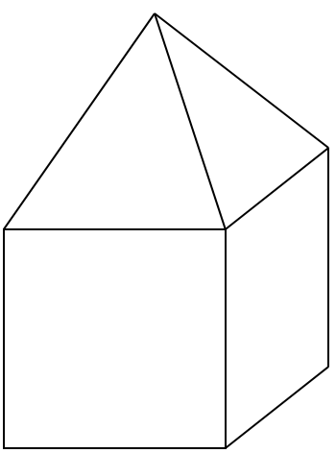  For example, a cube and a square based pyramid could create the compound 3D shape below.  If available, learners could combine plastic or wooden 3D shapes to create compound 3D shapes.  Ask learners to describe the compound 3D shape, using its properties. Encourage the correct use of vocabulary (e.g. face, vertex, vertices, edge, pyramid, prism, etc.).  Learners will show they are characterising (TWM.05) when they identify several properties such as faces, vertices, edges to describe various 3D shapes and compound 3D shapes.  Resources:  3D shapes | Possible misconceptions:  Learners may refer to faces of a shape as sides.
6Gg.06 Identify and sketch different nets for cubes, cuboids, prisms and pyramids. | Remind learners that a net is an outline made when a 3D shape is opened out flat.  Show learners pictures of a variety of nets and ask them what 3D shapes they will make. Make sure to include nets for cubes, cuboids, prisms and pyramids. Include some pictures that cannot be made into a 3D shape (e.g. a net with 6 squares that cannot be folded into a cube).  Collect a range of boxes which are in the shape of cubes, cuboids, prisms and pyramids. Ask learners to take them apart and sketch their nets.  As a revision exercise, ask learners to sketch different types of nets for a cube (there are 35 different combinations of 6 squares but only 11 of them create unique nets for a cube).  Resources:  Pictures of a variety of nets of cubes, cuboids, prisms and pyramids  A range of different shaped boxes | Possible misconceptions:  Learners may think that all nets make 3D shapes.
6Gg.07 Understand the relationship between area of 2D shapes and surface area of 3D shapes. | Hold up a cube and ask learners what the relationship is between a square and a cube. Check learners know that area is the amount of space in a 2D shape and that they know how to calculate the area of a square.  Challenge learners to use this information to work out the surface area of a cube (provide dimensions for one side of the square on the cube, e.g. 4cm).  Check that if the area of a square is 16cm squared, then a cube which uses these squares would have a surface area of 16 x 6 = 96cm².  Ask learners to choose other 3D shapes and calculate the surface area using their knowledge of 2D shapes and area.  Resources:  3D shapes | Possible misconceptions:  Learners may refer to curved surfaces as faces when describing 3D objects. Faces of objects are always flat. Cylinders have curved surfaces and cubes have faces.
6Gg.05 Understand the difference between capacity and volume.  TWM.03 Conjecturing  Forming mathematical questions or ideas  TWM.08 Improving  Refining mathematical ideas or representations to develop a more effective approach or solution | Ask learners to explain the difference between capacity and volume (capacity is a property of a container and is the amount the container can hold, volume is the measure of the space an object occupies).  Give learners a statement that exemplifies the difference between capacity and volume and then ask them to write other examples.  For example:  I have a 1 litre bottle of water that is half full. The capacity of the bottle is 1 litre and the volume of water in the bottle is 0.5 litre or 500 cm³.  Now ask learners to work in groups of four. Give each group a different container and some plastic glasses or cups. Ask them to estimate how many glasses or cups of water the container could hold (capacity).  Ask the groups to swap their containers and repeat the activity.  Learners will show they are conjecturing (TWM.03) when they suggest the possible capacity of a container and then demonstrate they are improving (TWM.08) when they test this out and offer a more accurate conjecture for a different container.  Then give each group a container partly filled with water. Ask them to estimate how many glasses or cups of water (volume of the water) they need to fill the container (capacity).  Ask the groups to swap their containers and repeat the activity.  Resources:  Containers such as jugs or buckets  Glasses  Water | Possible misconceptions:  Learners mistakenly refer to capacity instead of volume and refer to volume when they mean capacity.

Unit 6.3 Calculation

Learning objectives covered in Unit 6.3 and topic summary: |  | 6.3 Topic 1 Addition and subtraction | 6.3 Topic 2 Multiplication and division | Thinking and Working Mathematically
6Nc.02 | Recognise the use of letters to represent quantities that vary in addition and subtraction calculations. |  |  | TWM.01 Specialising
6Ni.01 | Estimate, add and subtract integers.
6Ni.02 | Use knowledge of laws of arithmetic and order of operations to simplify calculations. |  |  | TWM.07 Critiquing
6Ni.04 | Estimate and multiply whole numbers up to 10 000 by 1-digit or 2-digit whole numbers. |  |  | TWM.07 Critiquing
6Ni.05 | Estimate and divide whole numbers up to 1000 by 1-digit or 2-digit whole numbers.
6Ni.06 | Understand common multiples and common factors.
6Ni.07 | Use knowledge of factors and multiples to understand tests of divisibility by 3, 6 and 9. |  |  | TWM.04 Convincing
6Ni.08 | Use knowledge of multiplication and square numbers to recognise cube numbers (from 1 to 125). |  |  | TWM.02 Generalising
6Nf.09 | Estimate, add and subtract numbers with the same or different number of decimal places.
6Nf.10 | Estimate and multiply numbers with one or two decimal places by 1-digit and 2-digit whole numbers.
6Nf.11 | Estimate and divide numbers with one or two decimal places by whole numbers.

Unit 6.3 Topic 1 Addition and subtraction

Outline of topic:
Learners will continue to practice counting on and counting back with integers and decimals. They will further develop their understanding of the laws of arithmetic and use of brackets, and become confident in using letters to represent quantities in addition and subtraction calculations.

Learners will practice adding and subtracting integers and numbers with the same or different number of decimal places. They should be able to find the difference between positive and negative integers, and between two negative integers.

In this topic learners should be given sufficient time to complete practice questions, in order to secure their written methods and mental strategies for addition and subtraction.

Language:
Key vocabulary:
addition, total, sum
subtraction, difference
estimate
negative, positive, zero
algebra, equation, formula, formulae, variables

Key phrases:
An estimate for the answer is …
The sum of the numbers … and … is …
The difference between the numbers … and … is …

Recommended prior knowledge:
- Counting forwards and backwards in steps of constant size for integers
- Add and subtract whole numbers mentally and using a written method
- Add and subtract decimals with the same number of decimal places
- Solve missing number problems
- Recognise that letters represent an unknown

Learning objectives | Suggested teaching activities and resources | Mental strategies, possible misconceptions and comments
6Nc.02 Recognise the use of letters to represent quantities that vary in addition and subtraction calculations.  TWM.01 Specialising  Choosing an example and checking to see if it satisfies or does not satisfy specific mathematical criteria | Write a + b = c on the board. Ask learners:  If a is equal to 5 and b is equal to 7, then what is the value of c?  Then tell learners that c now stands for 100. Draw a bar model to reinforce that a + b is equivalent to c.  Record the different calculations possible using letter notation,  e.g. b + a = c, c – a = b etc.  Ask learners:  What are the possible values of a and b if c is equivalent to 100?  Learners will show they are specialising (TWM.01) by testing examples for a and b to see if they satisfy the mathematical equation with a total of 100.  Repeat this task with other formulae e.g. a = c + d + d + d.  Vary which letter you reveal the value of and ask learners to find as many examples as they can for the other letters. | A variable is a quantity that can vary in value.  Possible misconceptions:  Learners can sometimes think that if ‘a’ represents 5 in one calculation, it will always represent 5 in any calculation.
  a | b
  c
6Ni.01 Estimate, add and subtract integers.  6Ni.02 Use knowledge of laws of arithmetic and order of operations to simplify calculations.  TWM.07 Critiquing  Comparing and evaluating mathematical ideas, representations or solutions to identify advantages and disadvantages | Write an addition or subtraction calculation on the board, for example 122 – 92, and ask learners to estimate rather than calculate the answer.  Ask learners:  What is your estimate?  Why would certain answers not be appropriate?  Then ask learners to solve the calculation in as many different ways as they can. Compare learners’ solutions.  For example:  122 – 92 = ? (using a written method of subtraction or number line)  92 + ? = 122 (finding the difference or counting on)  120 – 90 = ? (constant difference)  Ask learners:  What are the advantages and disadvantages of each strategy?  Learners will show they are critiquing (TWM.07) by comparing and evaluating different approaches to calculations, based on their arithmetic knowledge.  Repeat this activity but with calculations using negative numbers or resulting in a negative number, for example: 12 – 15, -4 + 10, -9 – 2.  Then write a 3-, 4- or 5-digit number, for example 8723, on the board or piece of paper. Ask learners to create as many different addition and subtraction calculations as they can that result in this number. Remind learners they could use their knowledge of the laws of arithmetic to help.  For example:  8723 = 8701 + 19 + 3  8723 = 8701 + 3 + 19  Repeat this activity with negative numbers, for example -18. | Using the language of augend + addend = total and minuend – subtrahend = difference will enable learners to explain their thinking because they can name the different parts of the calculation.  Possible misconceptions:  Learners often try to work out the answer immediately rather than offer an estimate first.
6Nf.09 Estimate, add and subtract numbers with the same or different number of decimal places. | Learners choose two decimals (using decimal dice or decimal digit cards) and use them to write both an addition and a subtraction calculation question.  Then in pairs, give learners a specific number. Ask them to write an addition calculation and a subtraction calculation that would result in this number.  For example, if the specific number is 17.11, an addition calculation might be 17.11 = 16.03 + 1.08.  Encourage learners to generate some calculations where the numbers have different numbers of decimal places.  For example, a subtraction calculation could be 17.11 = 20.51 – 3.4.  Resources:  Decimal dice or decimal digit cards | Encourage learners to use mental calculation strategies to add and subtract decimals where possible. Remind them to regroup numbers to help with adding or subtracting different parts of the number.  Possible misconceptions:  Learners may line up their numbers in columns, but they may not pay attention to the lining up of the same type of digit they so may include both decimal points in the answer, e.g. 1.23 + 4.5 = 1.6.8.

Unit 6.3 Topic 2 Multiplication and division

Outline of topic:
Learners will develop their understanding of the laws of arithmetic and use of brackets within a multiplication and division context.

Learners will practice solving multiplication and division calculations involving large numbers and decimals as well as exploring common multiples, common factors, square and cube numbers. Learners will also connect their knowledge of tests of divisibility to solve factor questions.

In this topic, learners should be given sufficient time to complete practice questions, in order to secure their written methods and mental strategies for multiplication and division.

Language:
Key vocabulary:
multiplication, product
multiples, common multiples, factors, common factors, square numbers, cube numbers
decimals, tenths, hundredths, thousandths

Key phrases:
The product of the numbers … and … is …
The common multiples of the numbers … and … are …

Recommended prior knowledge:
- 1-10 times tables
- Multiply and divide by 10, 100, 1000
- Multiply and divide whole numbers and using a written method
- Multiply decimals with the same number of decimal places
- Knowledge of multiples and factors
- Know the square numbers between 0-100
- Knowledge of the tests of divisibility for 2, 4, 5, 8, 10, 25, 50 and 100

Learning objectives | Suggested teaching activities and resources | Mental strategies, possible misconceptions and comments
6Ni.05 Estimate and divide whole numbers up to 1000 by 1-digit or 2-digit whole numbers.  6Ni.02 Use knowledge of laws of arithmetic and order of operations to simplify calculations.  TWM.07 Critiquing  Comparing and evaluating mathematical ideas, representations or solutions to identify advantages and disadvantages | Give learners some division questions to complete, but challenge them to use at least two different ways to solve each calculation.  For example, to solve 925 ÷ 25 learners could:  - decompose 925 into 900 + 25 and divide each part by 25, or  - calculate how many 25’s are in 100, 900 and 25, or  - divide by 5 and divide by 5 again.  Then ask learners to explain their different strategies to the class and ask questions such as:  What are the advantages or disadvantages of this strategy?  Which strategy was the most effective way for you to solve this question?  Learners will show they are critiquing (TWM.07) when they compare and evaluate different approaches to solving division calculations. | Encourage learners to use mental strategies where possible, including knowledge of multiplication facts.  Using the language of dividend ÷ divisor = quotient will enable learners to explain their thinking because they can name the different parts of the calculation.
6Ni.04 Estimate and multiply whole numbers up to 10 000 by 1-digit or 2-digit whole numbers.  TWM.07 Critiquing  Comparing and evaluating mathematical ideas, representations or solutions to identify advantages and disadvantages | Ask learners:  Eva calculated 426 x 24 and got the answer 2337. Without calculating the exact answer, how do you know whether the answer is correct or incorrect? Answer: using estimation we know 400 x 20 = 8000 so the answer is too small. Or 6 x 4 = 24 so we know it should end in a 4.  Ask learners to complete some multiplication questions, but challenge them to estimate the answer first and then use at least two different ways to solve each calculation.  For example, to solve 245 x 5, learners could:  - decompose 245 into 200 + 40 + 5 and multiply each part by 5, or  - first calculate 245 x 10, then divide by 2, or  - round 245 to 250, multiply by 5, then adjust (subtract 5 x 5), or  - use a grid or array method, or  - use a column method.  Then ask learners to explain their different strategies to the class and ask questions such as:  What are the advantages or disadvantages of this strategy?  Which strategy was the most effective way for you to solve this question?  Learners will show they are critiquing (TWM.07) when they compare and evaluate different approaches to solving multiplication calculations. | Encourage learners to use mental strategies where possible, including knowledge of multiplication facts.  Using the language of multiplicand x multiplier = product will enable learners to explain their thinking because they can name the different parts of the calculation.  Possible misconceptions:  Learners decompose numbers but forget to multiply all the partial products.
6Ni.06 Understand common multiples and common factors. | Choose two numbers (e.g. 40 and 64) and ask learners to write all the factors of these individual numbers. Then ask learners to find the common factors of these two numbers.  Now choose two more numbers (e.g. 4 and 6) and ask learners to write as many multiples of these individual numbers as they can in 30 seconds. Then ask learners to find the common multiples of these two numbers.  Repeat this activity so that learners practice finding common factors and multiples of numbers.  This activity can be extended by playing ‘I am thinking of a number’.  I am thinking of 2 different numbers. They have 6 as a common factor and 180 as a common multiple. What are the numbers? (One answer could be 6 and 30).  Ask learners to think of 3 more problems like this and then challenge the rest of the class to find their numbers. | When recording factors of numbers, it is useful to record in factor pairs to ensure learners have found them all. For example, factor pairs of 40 are 1 and 40, 2 and 20, 4 and 10 and, 5 and 8. Factor pairs of 64 are 1 and 64, 2 and 32, 4 and 16, 8 and 8. So the common factors of 40 and 64 are 1, 2, 4 and 8.  In mathematics common means ‘belonging to each one’ so 4 is a common factor of 8 and 12, which means 4 is a factor of both 8 and 12.  Multiples of 4 are 4, 8, 12, 16, 20, 24, …  Multiples of 6 are 6, 12, 18, 24, …  So, 12 and 24 are common multiples of 4 and 6.  Possible misconceptions:  Learners confuse definitions for multiples and factors so be clear about the difference.
6Ni.07 Use knowledge of factors and multiples to understand tests of divisibility by 3, 6 and 9.  TWM.04 Convincing  Presenting evidence to justify or challenge a mathematical idea or solution | Write these numbers on the board and ask learners:  What do you notice about the numbers 36, 72, 90, 144?  (Some possible answers could be that the numbers are all even and they are also all divisible by 3, 6 and 9).  Then ask learners to find more examples of 3-digit numbers that are divisible by 3, 6 and 9.  Introduce learners to the tests of divisibility for 3, 6 and 9 and ask them to use these to check their answers.  This NRICH article may help: Divisibility Tests (https://nrich.maths.org/1308).  Then give learners the following statements and ask them to explain whether they are true or false:  - All numbers that are divisible by 3 are also divisible by 9  - All numbers that are divisible by 9 are also divisible by 3  - All numbers that are divisible by 3 are also divisible by 6  - All numbers that are divisible by 6 are also divisible by 3  Learners will show they are convincing (TWM.04) when they can give reasons or examples (using multiples and factors) as evidence for why they think the statements about tests of divisibility are true or false.  This activity can be extended by using the NRICH task: Dozens (https://nrich.maths.org/559).  Resources:  NRICH tasks | Numbers are divisible by 3 if the sum of the digits add up to 3, 6 or 9. For example, 723 is divisible by 3 because 7+2+3=12 and 1+2=3.  If a number is divisible by 2 and 3, then it is divisible by 6, e.g. 1332 is even and 1 + 3 + 3 + 2 = 9 which is divisible by 3. So, 1332 is divisible by 6.  Possible misconceptions:  Learners apply tests of divisibility to different groups of numbers. For example, they apply the test of divisibility for 10 (numbers end in a 0) and use this as a test of divisibility for 3, incorrectly thinking that numbers which end in a 3 must be divisible by 3.
6Ni.08 Use knowledge of multiplication and square numbers to recognise cube numbers (from 1 to 125).  TWM.02 Generalising  Recognising an underlying pattern by identifying many examples that satisfy the same mathematical criteria | Review square numbers. Ask learners to draw at least one square number.  Ask learners:  If a square number is a number multiplied by itself (e.g. to square 6 work out  6 x 6 = 36) what do you think a cube number could be?  Then ask learners to try to build a cube number from cubes.  How could you calculate cube numbers if do not have enough cubes?  Ask learners to systematically record the first 3 square numbers and the first 3 cube numbers.  For example:  1 squared = 1 and 1 cubed = 1  2 squared = 4 and 2 cubed = 8  3 squared = 9 and 3 cubed = 27  Ask learners:  What do you notice?  Can you see a pattern or connection between the square and cube numbers?  Learners will show they are generalising (TWM.02) when they recognise the wider pattern of how to calculate cube numbers and how they are related to square numbers.  Resources:  Cubes | Learners might draw a square that has 4 equal sized squares within it (2 x 2 = 2² = 4) or 9 equal sized squares (3 x 3 = 3² = 9)  Possible misconceptions:  Learners often confuse square numbers and cube numbers. This is because they do not have a conceptual understanding of what these numbers look like. If this happens, encourage them to build or draw square and cube numbers so they can see the similarities and differences.
6Nf.10 Estimate and multiply numbers with one or two decimal places by 1-digit and 2-digit whole numbers. | Start with the calculation 6 x 0.3. Give learners counters and tell them each counter represents 0.1. Ask them to show an array for this calculation. In total there are 18 tenths in the array which totals 1.8.  What do you notice about the answers to 6 x 0.3 and 6 x 3? What explanations can you give?  Then, in pairs ask learners to roll a dice 3 times to generate 3 digits. Use them to make a 3-digit number (with either 1 or 2 decimal places) e.g. 2.45 or 24.5 or 0.45. Ask learners to roll the dice once or twice more. Multiply this number by the first number, e.g. 2.45 x 8 or 24.5 x 8 or 0.45 x 58. The aim is to make the largest possible answer (product). Repeat several times.  Look at patterns of numbers and calculations that use the same digits but in different place value positions.  For example: 24 x 5 = 120, 2.4 x 5 = 12, 0.24 x 5 = 1.2. Ask learners to generate similar patterns.  Resources:  Counters  0-9 dice | Encourage learners to use reasoning about known facts when multiplying with decimals. For example, 6 x 3 = 18 so 6 x 0.3 = 1.8.  This highlights the idea that many areas of mathematics are connected.  Ensure that learners are reading and saying decimals correctly, e.g. 3.45 is three point four five, not three point forty-five.  Possible misconceptions:  Ignoring the decimal point and treating decimals as integers.  Incorrectly thinking that 3.4 x 10 = 3.40.
  0.1 | 0.1 | 0.1 | 0.1 | 0.1 | 0.1
  0.1 | 0.1 | 0.1 | 0.1 | 0.1 | 0.1
  0.1 | 0.1 | 0.1 | 0.1 | 0.1 | 0.1
6Nf.11 Estimate and divide numbers with one or two decimal places by whole numbers. | Write a few decimal division calculations on the board. For example:  45.5 ÷ 5 = 9.1, 3.69 ÷ 3 = 1.23, 0.84 ÷ 4 = 0.21.  Ask learners:  What do you notice about the answers to 45.5 ÷ 5 and 455 ÷ 5? What explanations can you give?  In pairs, ask learners to roll a dice 3 times to generate 3 digits. Use them to make a 3-digit number (with either 1 or 2 decimal places) e.g. 78.4 or 7.84. Ask learners to roll the dice once more. Divide the first number by this number, e.g. 78.4 ÷ 2 or 7.84 ÷ 2. The aim is to make the largest possible answer (quotient). Repeat several times.  Look at patterns of numbers and calculations that use the same digits but in different place value positions.  For example, 56 ÷ 8 = 7, 5.6 ÷ 8 = 0.7, 0.56 ÷ 8 = 0.07. Ask learners to generate similar patterns.  Resources:  0-9 dice | Encourage learners to use reasoning about known facts when dividing with decimals. This highlights the idea that many areas of mathematics are connected.  Make sure that learners are reading and saying decimals correctly, e.g. 3.45 is three point four five, not three point forty-five.  The quotient of a number is the result of dividing one number by another. Dividend ÷ divisor = quotient, e.g. 12 ÷ 3 = 4, so 4 is the quotient.  Possible misconceptions:  Incorrectly thinking that you move the decimal point, and not the digits.  Writing that 6 ÷ 0.3 = 2 because the decimal point has been ignored.

Unit 6.4 Statistical methods

Learning objectives covered in Unit 6.4 and topic summary: |  | 6.4 Topic 1  Designing the enquiry | 6.4 Topic 2 Presenting and explaining results | 6.4 Topic 3 Using statistical measures | 6.4 Topic 4 The statistical cycle | Thinking and Working Mathematically
6Ss.01 | Plan and conduct an investigation and make predictions for a set of related statistical questions, considering what data to collect (categorical, discrete and continuous data). |  |  |  |  | TWM.07 Critiquing
6Ss.02 | Record, organise and represent categorical, discrete and continuous data. Choose and explain which representation to use in a given situation:  - Venn and Carroll diagrams  - tally charts and frequency tables  - bar charts  - waffle diagrams and pie charts  - frequency diagrams for continuous data  - line graphs  - scatter graphs  - dot plots. |  |  |  |  | TWM.07 Critiquing
6Ss.03 | Understand that the mode, median, mean and range are ways to describe and summarise data sets. Find and interpret the mode (including bimodal data), median, mean and range, and consider their appropriateness for the context.
6Ss.04 | Interpret data, identifying patterns within and between data sets, to answer statistical questions. Discuss conclusions, considering the sources of variation, and check predictions. |  |  |  |  | TWM.03 Conjecturing  TWM.04 Convincing

Unit 6.4 Topic 1 Designing the enquiry

Outline of topic:
Learners will decide on a problem or question that can be addressed using statistical methods and identify related questions to explore.

Language:
Key vocabulary:
interpret, calculate, construct
survey, questionnaire, experiment
data, statistics
tally, table, frequency, data collection, database

Key phrases:
Data collection method

Recommended prior knowledge:
- Knowledge of different data collection methods
- Categorical and discrete data
- Specifying a problem, planning and collecting data

Learning objectives | Suggested teaching activities and resources | Mental strategies, possible misconceptions and comments
6Ss.01 Plan and conduct an investigation and make predictions for a set of related statistical questions, considering what data to collect (categorical, discrete and continuous data).  TWM.07 Critiquing  Comparing and evaluating mathematical ideas, representations or solutions to identify advantages and disadvantages | Ask learners to work in pairs and choose a question to pursue. Examples could include:  - What is the height of your peers?  - What method of transport do learners use to travel to school?  - Do different types of newspapers use words (or sentences) of different lengths?  Learners must first agree the data they need to collect and an appropriate format to collect and record the results, so they are able to answer the question they chose. Before they begin, ask learners to think of three questions they want to find out from the data (e.g. What is the mean height of my peers? Do learners who walk to school have less distance to travel? Do certain newspapers use words that appeal to a wider audience?). Also, ask them to make predictions for each question.  Collection methods could include a questionnaire, an interview or an experiment, for example. Ask learners to collect, interpret and present their findings to the class.  Learners will show they are critiquing (TWM.07) when they can identify possible advantages and disadvantages for using one data collection method over another.  Resources:  Resources will depend on the questions learners choose to pursue, but may include tape measures, newspapers etc. | Categorical data refers to characteristics such as colour, names, personal preferences, etc.  Discrete data refers to data that can be counted and has a finite number of possible values in a given range, such as number of siblings, how many books they have read this month etc.  Continuous data refers to data that can be measured and has an infinite number of possible values within a selected range, e.g. weight, height, temperature.  Learners conduct simple statistics investigations as part of a four-part statistical enquiry cycle:  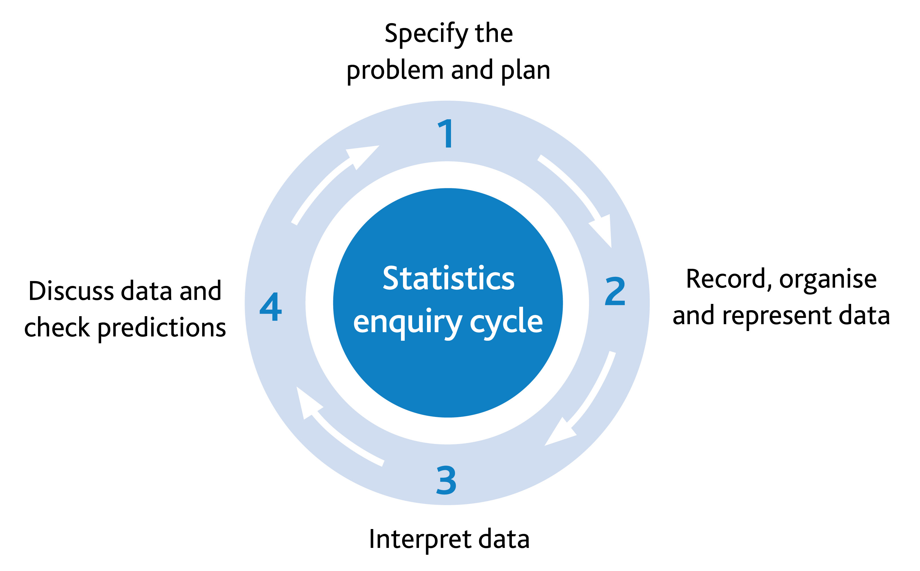  Possible misconceptions:  Learners may not gather sufficient data.

Unit 6.4 Topic 2 Presenting and explaining results

Outline of topic:
Learners will explore different methods of data collection and justify the choice of statistical representation. They will critique the advantages and disadvantages of different ways to present data and explain their results.

Language:
Key vocabulary:
Venn and Carroll diagrams, tally charts, frequency tables, bar charts, waffle diagrams, pie charts, frequency diagrams, line graphs, scatter graphs, dot plots
continuous data, discrete data

Key phrases:
Appropriate presentation of data

Recommended prior knowledge:
- Present conclusions made by self and others
- Consideration of the validity of different sources

Learning objectives | Suggested teaching activities and resources | Mental strategies, possible misconceptions and comments
6Ss.02 Record, organise and represent categorical, discrete and continuous data. Choose and explain which representation to use in a given situation:  - Venn and Carroll diagrams  - tally charts and frequency tables  - bar charts  - waffle diagrams and pie charts  - frequency diagrams for continuous data  - line graphs  - scatter graphs  - dot plots.  TWM.07 Critiquing  Comparing and evaluating mathematical ideas, representations or solutions to identify advantages and disadvantages | Divide the class into 8 groups and allocate them a different graph or chart. Ask them to research their graph or chart and prepare a poster to present back to the class. The poster should explain which will explain the advantages and disadvantages of their graph or chart, e.g. a pie chart is a useful way of showing proportion, but it is difficult to read exact values from a pie chart.  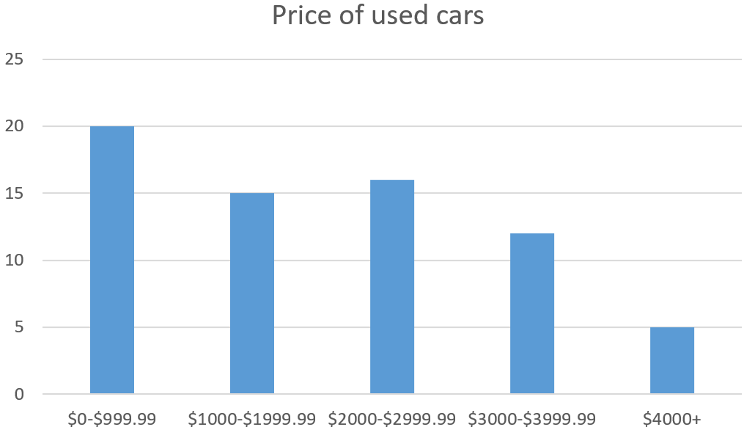  Now choose a piece of data (categorical, discrete or continuous) to represent in three different ways. For example, used car prices represented as a bar chart, a pie chart and a line graph.  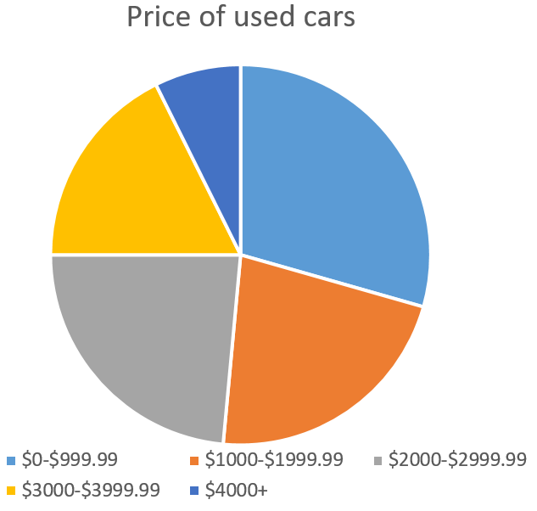  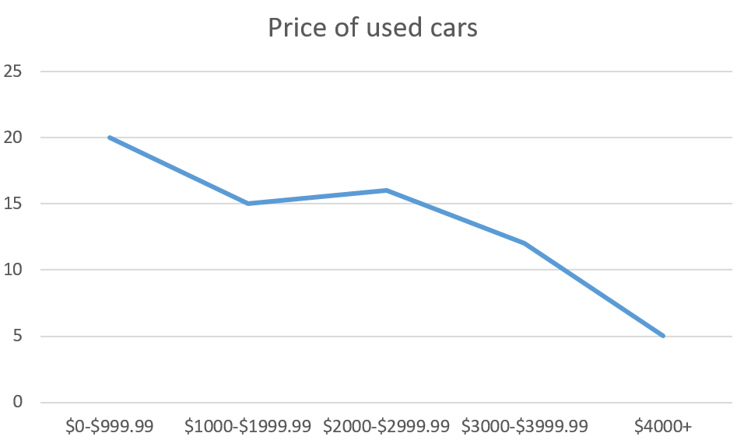  Discuss how different representations may be more or less useful depending on the question asked about the data.  For example:  What is the % of used cars costing between $1000 and $1999? (Pie charts are best for comparing proportions.)  How many more used cars cost between $1000 -$1999 than cost $4000+? (It is easy to read values from a bar chart to answer this question.)  The line graph is not an appropriate representation as joining the dots does not accurately describe grouped data. The line graph would better represent continuous data.  Learners will show they are critiquing (TWM.07) when they can identify possible advantages and disadvantages for using one data presentation method over another.  Resources:  Examples of graphs, diagrams and charts of different types. | Possible misconceptions:  Sometimes graphs or charts have incomplete information, or the scales used are inappropriate.  Learners conduct simple statistics investigations as part of a four-part statistical enquiry cycle. The second part of the cycle is recording, organising and representing data.
6Ss.04 Interpret data, identifying patterns within and between data sets, to answer statistical questions. Discuss conclusions, considering the sources of variation, and check predictions.  TWM.03 Conjecturing  Forming mathematical questions or ideas  TWM.04 Convincing  Presenting evidence to justify or challenge a mathematical idea or solution | Give learners a line graph but with no title or explanation about the graph. Here is an example:  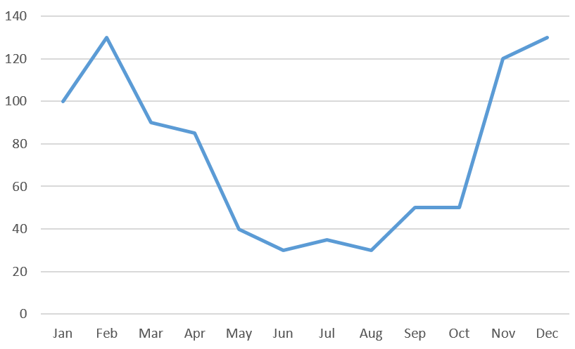  In pairs ask them to write the story of the graph.  What patterns in the data can you see?  What do you think the numbers represent?  Find another pair and compare your stories. Whose story is more plausible?  Learners will show they are conjecturing (TWM.03) when they suggest ideas of what data is being represented by the line graph. They will show they are convincing (TWM.04) when they explain the patterns they have noticed and how these support their stories for the graph.  Now give learners a line graph for another set of data, for example: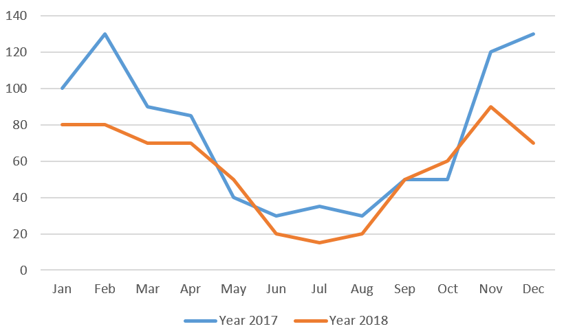  Ask learners:  What are the similarities and differences between these two sets of data? (In general the blue line is above the orange line so the data for Year 2017 is higher than the data for Year 2018.)  Do you notice any patterns? (Both lines follow a similar pattern, higher in January-February and November-December, lowest during May-August.)  What might be the reason for the difference between the data for year 2017 and year 2018?  Resources:  Example line graphs | Learners conduct simple statistics investigations as part of a four-part statistical enquiry cycle:  This activity focuses on interpreting secondary data (data collected by others). Learners should be given opportunities to interpret and identify patterns in primary data (data collected by them). As a class discuss why using secondary data can be more economical and less time consuming but is also more open to different interpretations.  Possible misconceptions:  Learners think that all data is valid and accurate.

Unit 6.4 Topic 3 Using statistical measures

Outline of topic:
Learners will use the mode, median, mean and range to communicate methods and results. They will consider when each are appropriate to use for real life contexts.

Language:
Key vocabulary:
mode, median, mean, range

Key phrases:
The mean. mode, median or range of the data is …

Recommended prior knowledge:
- Knowledge of the mode, median and range

Learning objectives | Suggested teaching activities and resources | Mental strategies, possible misconceptions and comments
6Ss.03 Understand that the mode, median, mean and range are ways to describe and summarise data sets. Find and interpret the mode (including bimodal data), median, mean and range, and consider their appropriateness for the context.  6Ss.01 Plan and conduct an investigation and make predictions for a set of related statistical questions, considering what data to collect (categorical, discrete and continuous data). | Give learners a set of related statistical questions about the class, for which the learners could collect data. For example:  How far do learners in this class travel to school?  How long does it take them?  What is their method of transport? (categorical)  Ask learners to work in small groups to consider what data to collect and how they plan to do this.  Once they have collected the data, elicit from the learners how they could analyse the data. Recap on the definitions of ‘median’ and ‘mode’. Explain the definitions of ‘mean’ and ‘range’ and how to calculate them. Ask learners to find the mode, median, mean and range for their sets of data, where possible.  Ask learners to discuss which of mode, median, mean and range is most appropriate for each set of data. For example, learners may notice it is not possible to find the mean, median or range of categorical data, so the mode is most appropriate. However, it might not be appropriate to find the mode journey distance if a few learners catch the same bus but the rest walk.  For example,  0.3km, 0.4km, 0.6km, 0.6km, 0.8km, 0.9km, 1km, 8.2km, 8.2km, 8.2km, 8.2km  Four learners have the same journey distance of 8.2km, but the majority of the class travel less than 1km. In this case the mode would not be representative of the whole class. | Categorical data refers to characteristics such as colour, names, personal preferences, etc  Learners conduct simple statistics investigations as part of a four-part statistical enquiry cycle:  Possible misconceptions:  Learners confuse the meanings of mode, median, mean and range.
6Ss.03 Understand that the mode, median, mean and range are ways to describe and summarise data sets. Find and interpret the mode (including bimodal data), median, mean and range, and consider their appropriateness for the context. | Give learners the following set of data:  Shoe sizes of a group of maths teachers in Europe:  35, 37, 37, 37, 38, 38, 38, 38, 39, 39, 40, 41, 41, 43, 43, 44, 44, 44, 44, 46  Ask learners to find the mode for this data. Learners should notice that sizes 38 and 44 both occur the most (four times each).  Explain to learners that this is an example of bimodal data (there are two modes).  This activity can be extended by asking learners to interpret the mode:  Why might there be two modes for this data? A possible answer: 38 is the mode female shoe size and 44 is the mode male shoe size.

Unit 6.4 Topic 4 The statistical cycle

Outline of topic:
In order for learners to understand the statistical cycle, they will apply all elements of the cycle to conduct a statistical investigation by:
- specifying the problem, planning the investigation and making predictions
- collecting, recording and organising the data
- considering how to appropriately represent the data
- interpreting the data and discussing conclusions.

Language:
Key vocabulary:
interpret, calculate, construct
survey, questionnaire, experiment
data, statistics
tally, table, frequency, data collection, database
Venn and Carroll diagrams, tally charts, frequency tables, bar charts, waffle diagrams, pie charts, frequency diagrams, line graphs, scatter graphs, dot plots
continuous data, discrete data
mode, median, mean, range

Key phrases:
Data collection method
Appropriate presentation of data
The mean, mode, median or range of the data is …

Recommended prior knowledge:
- Knowledge of different data collection methods
- Categorical and discrete data
- Specifying a problem, planning and collecting data
- Present conclusions made by self and others
- Consideration of the validity of different sources
- Knowledge of the mode, median and range

Learning objectives | Suggested teaching activities and resources | Mental strategies, possible misconceptions and comments
6Ss.01 Plan and conduct an investigation and make predictions for a set of related statistical questions, considering what data to collect (categorical, discrete and continuous data).  6Ss.02 Record, organise and represent categorical, discrete and continuous data. Choose and explain which representation to use in a given situation:  - Venn and Carroll diagrams  - tally charts and frequency tables  - bar charts  - waffle diagrams and pie charts  - frequency diagrams for continuous data  - line graphs  - scatter graphs  - dot plots.  6Ss.03 Understand that the mode, median, mean and range are ways to describe and summarise data sets. Find and interpret the mode (including bimodal data), median, mean and range, and consider their appropriateness for the context.  6Ss.04 Interpret data, identifying patterns within and between data sets, to answer statistical questions. Discuss conclusions, considering the sources of variation, and check predictions. | This activity is based on the NRICH task: Estimating Time (https://nrich.maths.org/10629).  Pose the questions:  How well can you estimate time?  How could you measure how well someone can estimate time?  What might make someone better at estimating time?  Learners should discuss their ideas and consider which data they might collect and how they should collect it. They should think about who they are going to ask, how they will record their data and how they will make their investigation fair.  Learners should also suggest some predictions, for example:  - people are better at estimating time if they have their eyes shut  - females are better than males at estimating time  - people are better at estimating time if they count aloud.  Learners should create a data collection sheet or tally table to record their data. Based on their predictions, learners may choose to collect more than two variables. For example:  Learners should then organise and create representations of the data e.g. frequency tables, frequency diagrams for continuous data, pie charts etc.  For grouped data, learners should consider where values that fall exactly on the boundary are recorded e.g. exactly 5 seconds.  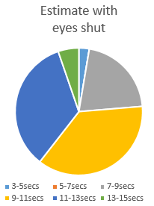  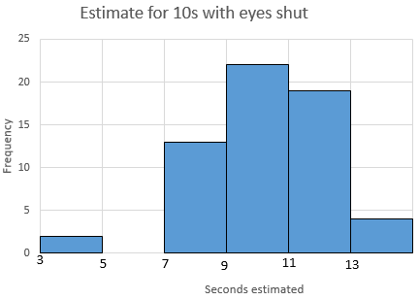  The frequency table is a good way of organising the data instead of a list, but does not give a very good visual picture of the data. The bar chart shows the pattern clearly (goes up, peaks in the middle and then goes down) and it is easy to read exact frequencies. The pie chart shows proportions of the data clearly (you can see 9-11 seconds is approximately $\frac{1}{3}$ of the data), but there is not enough information to read exact frequencies from the pie chart.  Learners should calculate the mean, median and mode for their data and consider which of these three averages are the most appropriate for the data.  For example, data collected on a person’s estimate for 10 seconds with their eyes open:  3.5, 9.3, 9.3, 9.6, 9.7, 9.9, 10.0, 10.1, 10.3, 10.5, 10.5  Mode: 9.3 and 10.5  Median: 9.9  Mean: 9.3  In this case the median represents the data well as the majority of the estimates were very close to the median (most were between 9.3 seconds and 10.5 seconds). The data is bimodal data (there are two modes). These modes do not represent the data as well as the median, because the modes are the highest estimates (10.5 seconds) and almost the lowest estimates (9.3 seconds). The mean is also at the lower end of the estimates (9.3 seconds). The mean has been affected by one estimate of 3.5 seconds, which is much lower than all the other estimates.  Learners should also calculate and interpret the range. In the example above, the range is 10.5-3.5 = 7. The range is large as there is a big difference between the highest estimate and the lowest estimate.  Learners should then interpret their data and identify patterns within. They might also decide to explore patterns further and compare sub-groups, identifying patterns between the graphs.  For example, for the graphs below learners may identify that the graph for females has a bump in the middle and is symmetric, whereas the male data is uneven towards the higher estimates. They may notice more females guessed between 9 and 11 seconds than males, and the male data is less spread out as no males guessed below 7 seconds or above 13 seconds.  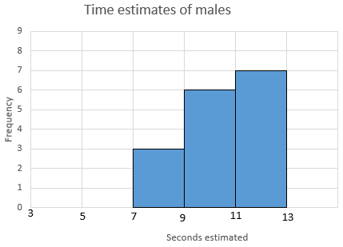  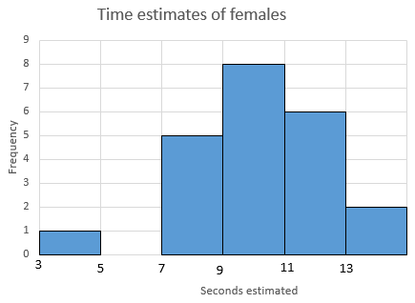  Learners should discuss conclusions and consider whether their predictions were correct. They should also consider reasons for these and possible sources of variation (addressing why the data shows variations and giving reasons for the differences in the data they collected). For example, learners might have found that people were better at estimating 10 seconds with their eyes shut and propose that this was because they could concentrate more, but this also could have been because it was a person’s second attempt, as they had practiced it once already with their eyes open.  Resources:  NRICH task  Stopwatches | Continuous data refers to data that can be measured and has an infinite number of possible values within a selected range, e.g. weight, height, temperature.  Grouped data is data represented by a range of numbers e.g. 3-5 seconds rather than by one number e.g. 3 seconds.  Learners conduct simple statistics investigations as part of a four-part statistical enquiry cycle:
  Gender | Estimate for 10 seconds (eyes open) | Estimate for 10 seconds (eyes shut)
  Estimate with eyes shut | Frequency
  3–5secs | 2
  5–7secs | 0
  7–9secs | 13
  9–11secs | 22
  11–13secs | 19
  13–15secs | 4

Unit 6.5 Fractions, percentages, decimals and proportion

Learning objectives covered in Unit 6.5 and topic summary: |  | 6.5 Topic 1  Comparing fractions | 6.5 Topic 2 Calculating with fractions | 6.5 Topic 3 Understanding percentage and equivalence | 6.5 Topic 4 Ratio and proportion | Thinking and Working Mathematically
6Nf.01 | Understand that a fraction can be represented as a division of the numerator by the denominator (proper and improper fractions).
6Nf.02 | Understand that proper and improper fractions can act as operators. |  |  |  |  | TWM.04 Convincing
6Nf.03 | Use knowledge of equivalence to write fractions in their simplest form. |  |  |  |  | TWM.04 Convincing  TWM.05 Characterising
6Nf.04 | Recognise that fractions, decimals (one or two decimal places) and percentages can have equivalent values. |  |  |  |  | TWM.06 Classifying
6Nf.05 | Estimate, add and subtract fractions with different denominators. |  |  |  |  | TWM.04 Convincing  TWM.05 Characterising
6Nf.06 | Estimate, multiply and divide proper fractions by whole numbers.
6Nf.07 | Recognise percentages (1%, and multiples of 5% up to 100%) of shapes and whole numbers.
6Nf.08 | Understand the relative size of quantities to compare and order numbers with one or two decimal places, proper fractions with different denominators and percentages, using the symbols =, > and <. |  |  |  |  | TWM.04 Convincing
6Nf.12 | Understand the relationship between two quantities when they are in direct proportion.
6Nf.13 | Use knowledge of equivalence to understand and use equivalent ratios.

Unit 6.5 Topic 1 Comparing fractions

Outline of topic:
Learners will develop their understanding of the relationship between fractions and division and consider how fractions can be written in their simplest form. They will explore equivalent values between fractions, decimals and percentages and use mathematical symbols to order and compare fractions, decimals and percentages.

Language:
Key vocabulary:
order, compare
numerator, denominator, unit fraction, non-unit fraction
decimal, percentage
simplify, simplest form, equivalent

Key phrases:
Fraction in its simplest form
The fraction/decimal/percentage … and … are equivalent

Recommended prior knowledge:
- Recall and use equivalence between simple fractions, decimals and percentages
- Recognise the link between fractions and division
- Understand that a fraction can be represented as a division of the numerator by the denominator
- Compare and order fractions
- Understand that for something to be equivalent it does not have to look the same

Learning objectives | Suggested teaching activities and resources | Mental strategies, possible misconceptions and comments
6Nf.01 Understand that a fraction can be represented as a division of the numerator by the denominator (proper and improper fractions). | Write the fraction $\frac{1}{2}$ on the board. Ask learners to discuss what this means.  Ask learners to read the fraction as one divided by two. Ask learners to draw a picture to show what this looks like (e.g. one circle divided equally into two parts).  Ask learners:  How much is one divided by two? (half)  Now ask learners to type into their calculator 1 ÷ 2.  What do you notice?  Learners may notice that $\frac{1}{2}$ is equivalent to the decimal 0.5.  Ask learners to draw a number line, then choose fractions (proper and improper) and divide the numerator by the denominator using their calculator and place the answers on their number line.  Resources:  Calculators | It is important when working with fractions to remind learners about the whole-part relationships. You may like to introduce the term ‘vinculum’ to describe the line between the numerator and denominator.  Possible misconceptions:  Learners may not realise that the numerator can be larger than the denominator (e.g. $\frac{3}{2}$).
6Nf.03 Use knowledge of equivalence to write fractions in their simplest form. | Remind learners that equivalent fractions do not need to look the same to be equivalent. Give learners fractions and ask them to write three equivalent fractions for each : $\frac{1}{4}$, $\frac{3}{8}$, $\frac{5}{10}$, $\frac{3}{6}$  For each fraction, ask learners:  Which fraction is in its simplest form?  Then ask learners:  What do you notice about the denominators when fractions are equivalent? What about the numerators?  In pairs, learners use digit cards 0-9. They turn over two cards and make a fraction with them. Ask learners whether they can simplify the fraction or whether it is already in its simplest form. Learners continue to turn two cards until they are confident in writing the simplest form.  Now challenge learners to choose a fraction and write 10 equivalent fractions. Once complete, circle the fraction in its simplest form. If the simplest form is not among the 10 fractions, ask learners to find it.  Give learners this problem:  $\frac{2}{5}$ of 40 and $\frac{8}{10}$ of 20 are both 16 so $\frac{2}{5}$ and $\frac{8}{10}$ are equivalent fractions. Do you agree? (No) Explain why. ($\frac{2}{ 5}$of 40 is 16 but $\frac{8}{10}$ of 40 is 32 so they are not equivalent)  Resources:  0-9 digit cards | A fraction is in simplest form when the denominator and numerator cannot be any smaller, while still being whole numbers.  An understanding of equivalent fractions is important, for example, in the context of statistics.  Possible misconceptions:  Learners can overlook some common factors and not simplify to the simplest form  e.g. They might say $\frac{18}{36}$ simplifies to $\frac{9 }{18}$rather than $\frac{1}{2}$
6Nf.04 Recognise that fractions, decimals (one or two decimal places) and percentages can have equivalent values.  TWM.06 Classifying  Organising objects into groups according to their mathematical properties | Give learners a blank 1-100 square. Tell learners that we can express each individual square either as a fraction ($\frac{1}{100}$) a decimal (0.01) or as a percentage (1%). Ask learners:  If 25 of the squares were shaded what is the fraction? ($\frac{25}{100})$  How would we express this as a decimal and as a percentage?  In pairs, ask learners to cover (with small cubes) different sections of the hundred square and then decide what the equivalent fraction, decimal and percentage would be.  Learners will show they are classifying (TWM.06) when they group together fractions, decimals and percentages that are equivalent.  Resources:  blank 1-100 squares  small cubes | It is important that learners can think flexibly and convert easily between fractions, decimals and percentages.  Possible misconceptions:  Learners can confuse digit notation, so they think that $\frac{1}{2}$ is equivalent to 1.2.
6Nf.08 Understand the relative size of quantities to compare and order numbers with one or two decimal places, proper fractions with different denominators and percentages, using the symbols =, > and <. | Write three sets of numbers on the board:  Set 1: $\frac{3}{5}$, $\frac{2}{5}$, $\frac{7}{10}$, $\frac{1}{4}$  Set 2: 0.04, 0.6, 0.5, 0.75  Set 3: 35%, 8%, 60%, 12%  Ask learners to choose a number from each set, and then relate all three numbers using the symbols =, > and <. For example, 8% < $\frac{2}{5}$ < 0.6.  Then ask learners to repeat this several times to compare three other numbers from the sets above. | Possible misconceptions:  Learners may ignore the place value of the digits and just read the quantities as whole numbers e.g. 0.75 < 15%.

Unit 6.5 Topic 2 Calculating with fractions

Outline of topic:
Learners will solve problems which require adding and subtracting fractions with different denominators. They will explore how fractions can act as operators and solve problems involving simple multiplication and division of proper fractions by whole numbers.

Language:
Key vocabulary:
order, compare
fractions, numerator, denominator, common denominator, vinculum
add, subtract, multiply, divide
equivalent, simplify, simplest form
order, compare

Key phrases:
The fractions … and … are equivalent
The fractions … and … have a common denominator
multiplicand x multiplier = product
dividend ÷ divisor = quotient

Recommended prior knowledge:
- Recall and use equivalence of fractions
- Adding and subtracting fractions with the same denominators
- Understand that for something to be equivalent it does not have to look the same
- Recognise the link between fractions and division
- Understand the part-whole relationship of fractions
- Multiply and divide unit fractions by whole numbers

Learning objectives | Suggested teaching activities and resources | Mental strategies, possible misconceptions and comments
6Nf.05 Estimate, add and subtract fractions with different denominators.  6Nf.03 Use knowledge of equivalence to write fractions in their simplest form.  TWM.05 Characterising  Identifying and describing the mathematical properties of an object  TWM.04 Convincing  Presenting evidence to justify or challenge a mathematical idea or solution | Write $\frac{1}{2}$ + $\frac{1}{3}$ = ?  Ask learners to draw a rectangle and divide it horizontally into 2 equal parts to show $\frac{1}{2}$ (shade).  Now ask learners to draw another identical rectangle, but this time to divide it vertically into 3 equal parts to show $\frac{1}{3}$ (shade).  Finally ask learners to draw another identical rectangle and this time divide it both horizontally (2 parts) and vertically (3 parts) to show how both fractions relate to the whole.  How many sections is the original rectangle now divided into? (6)  Shade $\frac{1}{2}$ and shade $\frac{1}{3}$.  How many parts out of the 6 represent $\frac{1}{2}$ and $\frac{1}{3}$? ( $\frac{3}{6}$ and$\frac{2}{6}$)  So, $\frac{3}{6}$ + $\frac{2}{6}$ = $\frac{5}{6}$ or $\frac{1}{2}$ + $\frac{1}{3}$ = $\frac{5}{6}$.  Ask learners to do more examples with different fractions, which include both subtraction and addition.  Explain that to add and subtract fractions with different denominators, we have to change the denominators to a common denominator.  Ask learners to try to find a method to do this without drawing rectangles.  Learners will show they are characterising (TWM.05) when they identify that to add or subtract fractions that have different denominators, the fractions need to be changed so that the denominators are the same.  This activity can be extended by asking learners to prove that $\frac{1}{2}$ = $\frac{1}{3}$ + $\frac{1}{6}$.  Learners will show they are convincing (TWM.04) when they can justify why they think this equation is correct. | Learners should be given sufficient time to complete practice examples, in order to secure their understanding.  When denominators are different learners can sometimes multiply the denominator to find a common one, without checking whether they are both already multiples of the same number.  Knowing about equivalent fractions is important when adding or subtracting fractions with different denominators. In the extended activity learners will also need to be able to write their answer in its simplest form.  Possible misconceptions:  Sometimes learners add the numerators and the denominators together:  e.g. $\frac{1}{2}$ + $\frac{1}{3}$ = $\frac{2}{5}$.
6Nf.02 Understand that proper and improper fractions can act as operators.  TWM.04 Convincing  Presenting evidence to justify or challenge a mathematical idea or solution | Remind learners that fractions relate to division. For example, finding one third is equivalent to dividing by 3, so $\frac{1}{3}$ of 15 is equivalent to 15 ÷ 3.  Ask learners to write the following fractions in a different way (e.g. 3 ÷ 4 = $\frac{3}{4}$ or $\frac{2}{5}$= 2 ÷ 5):  $\frac{12}{3}$, 4 ÷ 14, $\frac{6}{3}$, 5 ÷ 2.  Give learners the following questions to solve:  What is three tenths of 80, 10, 100?  What is nine hundredths of 100, 400, 1000?  What is $\frac{4}{5}$ of 50, 35, 100, 2 litres, 5 km?  What fraction of one year is one week or one day? ($\frac{1}{365}$ or $\frac{1}{52}$)  To understand the multiplicative nature of fractions as operators ask questions such as:  Which is greater: $\frac{3}{4}$ of 24 or $\frac{2}{3}$of 21?  Learners will show you they are convincing (TWM.04) when they can prove how different size fractions act as operators. | Possible misconceptions:  Learners only see fractions as numbers and not operators, e.g. $\frac{3}{4}$ is only seen as $\frac{3}{4}$ of a whole (3 parts out of four), but not $\frac{3}{4}$ operating on a number ($\frac{3}{4}$ of 20 = 15).
6Nf.06 Estimate, multiply and divide proper fractions by whole numbers. | There are two different components to this objective.  Dividing proper fractions by whole numbers  Set the question $\frac{1}{2}$ ÷ 2.  Ask learners to draw a rectangle and divide horizontally into 2 equal parts to show $\frac{1}{2}$. Shade one part.  Remind learners that $\frac{1}{2}$ is the dividend and the divisor is 2.  Now divide the rectangle vertically into 2 equal parts.  How many parts in total is the rectangle split into? (4)  So, $\frac{1}{2}$ ÷ 2 = $\frac{1}{4}$.  Repeat with several different questions.  For example: $\frac{1}{3}$ ÷ 4, $\frac{1}{5}$ ÷ 2, $\frac{2}{3}$ ÷ 3, $\frac{1}{2}$ ÷ 4.  Multiplying proper fractions by whole numbers  Give learners the following example: Farmer Ali has one bale of hay for his cows and he has three hungry cows. Each cow eats a fifth of a bale a day. So farmer Ali cuts his bale of hay into five pieces. He gives one fifth to each of his three cows.  Ask learners:  How much hay has farmer Ali used and how much does he have left?  Show learners that this is like a bar divided into five parts.  He gives one part out of five to each cow, so three lots of one fifth is 3 x $\frac{1}{5}$ = $\frac{3}{5}$. Show learners that this is the same as $\frac{1}{5}$ + $\frac{1}{5}$ + $\frac{1}{5}$.  Repeat with several different examples and ask the learners to also think of a contextual story to go with each one. | Using the language of dividend ÷ divisor = quotient or multiplicand x multiplier = product will enable learners to explain their thinking because they can name the different parts of the calculation.  Possible misconceptions:  Learners sometimes incorrectly think that the denominator does not change when two fractions with the same denominator are multiplied together.  e.g. $\frac{1}{3}$ x $\frac{1}{3}$ = $\frac{2}{3}$ instead of $\frac{1}{3}$ x $\frac{1}{3}=\frac{1}{9}$ whereas $\frac{1}{3}+\frac{1}{3}= \frac{2}{3}$  Rather than giving learners rote methods (e.g. 4 = $\frac{4}{1}$ then invert) to calculate $\frac{1}{3}$ ÷ 4 = $\frac{1}{12}$, instead use diagrams to assist understanding.

Unit 6.5 Topic 3 Understanding percentage and equivalence

Outline of topic:
Learners will deepen their understanding of percentage by recognising percentages of shapes and numbers. They will further develop their ability to compare fractions, decimals and percentages.

Language:
Key vocabulary:
percentage
parts, whole
compare

Key phrases:
The percentage of … is …

Recommended prior knowledge:
- Find and use simple fraction, decimal and percentage equivalents
- Compare and order fractions
- Recall and use equivalence between fractions, decimals and percentages
- Understand that fractions and decimals are not different concepts
- Understand percentage as the number of parts in each hundred

Learning objectives | Suggested teaching activities and resources | Mental strategies, possible misconceptions and comments
6Nf.07 Recognise percentages (1%, and multiples of 5% up to 100%) of shapes and whole numbers. | In pairs, give learners 100 cubes or counters of different colours.  Ask them to work out what fraction and what percentage of the cubes are red, yellow, blue and so on.  Set questions such as:  What is 30% of 5km?  What is 70% of 300cm?  What is 40% of 3m?  What is 1% of 50?  Chen got 40 marks out of 80 in his maths test. Rajiv got 45%. Who did better?  What percentage of each shape is shaded?  Resources:  Coloured cubes or counters
6Nf.08 Understand the relative size of quantities to compare and order numbers with one or two decimal places, proper fractions with different denominators and percentages, using the symbols =, > and <.  TWM.04 Convincing  Presenting evidence to justify or challenge a mathematical idea or solution | Give learners the following statement:  Naomi thinks that $\frac{1}{4}$ is the same as 0.4 which is the same as 4%.  Who agrees with Naomi? Who does not? Why?  You can then ask learners to convince each other of the correct answer.  Learners will show they are convincing (TWM.04) when they give reasons why the statement is incorrect (or correct). They may use knowledge of equivalence or they may use diagrams to show 4% of a shape is not equal to $\frac{1}{4}$ of a shape.

Unit 6.5 Topic 4 Ratio and proportion

Outline of topic:
Learners will understand how to find missing values in the context of problems involving direct proportion. They will explore the concept of equivalence in the context of equivalent ratios.

Language:
Key vocabulary:
ratio, proportion, direct proportion, parts, whole
equivalent, simplify

Key phrases:
The ratios … and … are equivalent

Recommended prior knowledge:
- Understand that for something to be equivalent it does not have to look the same
- Understand the part-whole relationship of fractions
- Understand the difference between ratio and proportion

Learning objectives | Suggested teaching activities and resources | Mental strategies, possible misconceptions and comments
6Nf.12 Understand the relationship between two quantities when they are in direct proportion. | Remind learners that proportion is used to show how quantities and amounts are related to each other. Ratio and proportion are also connected to the part-part and part-whole concepts. Remind learners that ratio is a part-part relationship with the whole. Proportion is a part-whole relationship and is therefore also connected to the fraction of a whole.  Two quantities are in direct proportion when they increase or decrease in the same ratio. For example, 1cm = 10mm. To convert cm to mm the multiplier is always 10.  Provide a context to exemplify this. For example, when making a drink you mix one part orange with four parts water. The ratio of orange to water is 1:4.  For every 1 litre of orange, use 4 litres of water (1:4).  For every 2 litres of orange, use 8 litres of water (2:8).  For every 10 litres of orange, use 40 litres of water (10:40).  These ratios are all equivalent and in direct proportion to each other. Tell learners that the parts in each ratio are still connected to the whole. The mixed drink in the example has a whole of 5 which is scaled up in direct proportion. In the first example above, you have a total of 5 litres of which 1 is orange and 4 are water. In the second you have a total of 10 litres and so on.  Can learners work out the following missing values:  How many litres of water would I need for 5 litres of orange? 50 litres of orange? 30 litres of orange?  How many litres of orange would I need if I used 100 litres of water?  Set a different context for learners to find missing values and explore the relationship between quantities. | Possible misconceptions:  Learners use additive rather than multiplicative reasoning.
6Nf.13 Use knowledge of equivalence to understand and use equivalent ratios. | Give learners the following problem to solve:  I have two fish. One fish is 4 times as long as the other. If the small fish is 3cm long, how long is the other fish?  Encourage learners to represent the problem using manipulatives such as cubes or coloured rods. Record answers on the board. Establish that the other fish is 12cm as it is 4 times longer than the small fish. Establish the ratio is 1:4  Ask learners to create more problems involving equivalent ratios, swap with a partner and solve.  Ask learners to simplify ratios such as 2:10 and 4:40  This activity can be extended by using the NRICH task: Little Man (https://nrich.maths.org/4789).  Resources:  Cubes or coloured rods (optional)  NRICH task | Recipes are a useful context for understanding equivalent ratios.  Possible misconceptions:  Learners add or subtract rather than multiply or divide to find equivalent ratios.
  3cm

Unit 6.6 The coordinate grid

Learning objectives covered in Unit 6.6 and topic summary: |  | 6.6 Topic 1  Using coordinates | 6.6 Topic 2 Reflection and rotation | Thinking and Working Mathematically
6Gp.01 | Read and plot coordinates including integers, fractions and decimals, in all four quadrants (with the aid of a grid).
6Gp.02 | Use knowledge of 2D shapes and coordinates to plot points to form lines and shapes in all four quadrants. |  |  | TWM.07 Critiquing
6Gp.03 | Translate 2D shapes, identifying the corresponding points between the original and the translated image, on coordinate grids.
6Gp.04 | Reflect 2D shapes in a given mirror line (vertical, horizontal and diagonal), on square grids. |  |  | TWM.02 Generalising
6Gp.05 | Rotate shapes 90º around a vertex (clockwise or anticlockwise).

Unit 6.6 Topic 1 Using coordinates

Outline of topic:
Learners will use coordinates to describe and plot positions accurately in all four quadrants and draw and translate simple shapes on the coordinate plane.

Language:
Key vocabulary:
origin, x-coordinate, y-coordinate, x-axis, y-axis, coordinate pairs, plot, intersection, quadrant

Key phrases:
Plot the coordinate …
Point of intersection

Recommended prior knowledge:
- Understand that position can be described using coordinates
- Read and plot coordinates in the first quadrant

Learning objectives | Suggested teaching activities and resources | Mental strategies, possible misconceptions and comments
6Gp.01 Read and plot coordinates including integers, fractions and decimals, in all four quadrants (with the aid of a grid). | Using squared paper, ask learners to draw a horizontal line from -5 to +5. Ask learners:  How can we show the line continues in both directions? (By including arrows at each end).  Agree this is the x-axis and add in the y-axis, again from +5 to -5, crossing at 0. Check learners have scaled and marked the line equally.  Now ask learners to practise plotting the position of coordinate pairs in all four quadrants. Tell learners it is good practice to plot points using a small cross at the intersection.  Then ask learners to think of a coordinate and plot it on a set of axes. Ask learners to swap their plotted coordinate with another learner. Learners should write the coordinates of the point plotted by their partner and then check they agree.  Resources:  Squared paper | Practice addition and subtraction of numbers beyond zero to revisit negative numbers.  Include coordinates that are decimals and fractions to prevent learners developing the misconception that coordinates are integers only.  Possible misconceptions:  Learners may not realise the order of the coordinates is significant or may confuse the x-coordinate and y-coordinate.
6Gp.02 Use knowledge of 2D shapes and coordinates to plot points to form lines and shapes in all four quadrants.  TWM.07 Critiquing  Comparing and evaluating mathematical ideas, representations or solutions to identify advantages and disadvantages | Ask learners to draw a four-quadrant grid with an x-axis from -8 to +8 and a y-axis from -8 to +8, crossing at 0. Ask learners to draw a triangle, star, rectangle and hexagon each in a different quadrant. Record the coordinates of each 2D shape on a different piece of paper.  Learners give the coordinates to a partner and ask them to plot the shapes. Compare grids and check they have identical shapes drawn in the same place. If they do not, discuss what might have gone wrong.  Learners will show they are critiquing (TWM.07) when they comment on the accuracy of each other’s work as well as their own.  Resources:  Squared paper | Remind learners that -3 is called negative three not minus three.  Possible misconceptions:  Learners may think that a coordinate is a number and not a location in two dimensions.

Learning objectives | Suggested teaching activities and resources | Mental strategies, possible misconceptions and comments
6Gp.03 Translate 2D shapes, identifying the corresponding points between the original and the translated image, on coordinate grids. | Ask learners to draw a four-quadrant grid with an x-axis from -10 to +10 and a y-axis, crossing at 0. Ask them to draw a square in the third quadrant and write the coordinates. Make an identical paper square and place the paper square in a new position in a different quadrant.  What are the new coordinates?  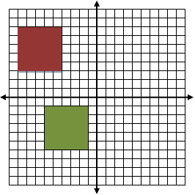  Ask learners to repeat individually with different shapes.  Now ask learners to work in pairs. They should each draw a 2D shape and translate it somewhere on their grid. They can now challenge their partner to describe how the shape has been translated, e.g. it has moved left 3 and up 9.  This activity can be extended asking the partner to specify the coordinates which the 2D shape should be translated to.  Resources:  Squared paper  Plain paper

Unit 6.6 Topic 2 Reflection and rotation

Outline of topic:
Learners will understand and be able to reflect 2D shapes in vertical, horizontal or diagonal lines. They will investigate rotating objects around a vertex by 90°.

Language:
Key vocabulary:
reflection, mirror line, line of symmetry, line symmetry
rotate, rotation, rotational symmetry

Key phrases:
Reflect a shape in a mirror line
Rotate a shape around a vertex

Recommended prior knowledge:
- Knowledge of 2D shapes
- Knowledge of reflecting 2D shapes in a given mirror line

Learning objectives | Suggested teaching activities and resources | Mental strategies, possible misconceptions and comments
6Gp.04 Reflect 2D shapes in a given mirror line (vertical, horizontal and diagonal), on square grids.  TWM.02 Generalising  Recognising an underlying pattern by identifying many examples that satisfy the same mathematical criteria | Ask learners to draw a mirror line on a piece of paper. Mark point P on one side of the line. Fold the paper along the line and pierce the paper at point P. Label the new point P’. Open out the paper and join P to P’ by a straight line. Check that PP’ is at right angles to the mirror line and that P and P’ are the same distance from it. Repeat for other points. Experiment with different lines (e.g. vertical, horizontal, diagonal).  Now ask learners to sketch a 2D shape on a square grid where only one vertex of the shape is touching the mirror line and where the edges of the shape are not necessarily parallel or perpendicular to the mirror line. Swap with a partner and ask them to sketch the reflection.  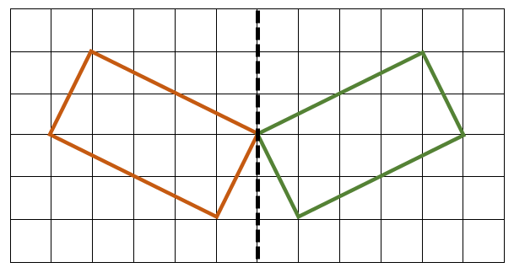  In pairs ask learners to list the properties for reflecting 2D shapes in a given mirror line.  Look for properties such as:  - Points on the mirror line do not change their position after the reflection;  - A reflection which maps A to A’ also maps A’ to A  Learners will show they are generalising (TWM.02) when they notice certain properties for line symmetry.  Resources:  Paper  Square grids | Possible misconceptions:  Learners may only recognise horizontal and vertical mirror lines.
  P | P’
6Gp.05 Rotate shapes 90º around a vertex (clockwise or anticlockwise). | Provide learners with pictures of 2D shapes or ask them to cut out a 2D shape of their choice. Ask learners to draw around the shape on a piece of paper, then rotate the shape 90° anticlockwise and then clockwise around a vertex. Practise with different shapes.  Resources:  Pictures of 2D shapes  Paper  Scissors | Possible misconceptions:  Learners do not fix one vertex when rotating the shape.

Unit 6.7 Probability

Learning objectives covered in Unit 6.7 and topic summary: |  | 6.7 Topic 1  Describing possibilities | 6.7 Topic 2  Conducting tests | Thinking and Working Mathematically
6Sp.01 | Use the language associated with probability and proportion to describe and compare possible outcomes. |  |  | TWM.06 Classifying
6Sp.02 | Identify when two events can happen at the same time and when they cannot, and know that the latter are called 'mutually exclusive'. |  |  | TWM.04 Convincing
6Sp.03 | Recognise that some probabilities can only be modelled through experiments using a large number of trials.
6Sp.04 | Conduct chance experiments or simulations, using small and large numbers of trials. Predict, analyse and describe the frequency of outcomes using the language of probability.

Unit 6.7 Topic 1 Describing possibilities

Outline of topic:
Learners will understand and use the probability scale.

Language:
Key vocabulary:
fair, unfair, likely, unlikely, equally likely, certain, uncertain, probable, possible, impossible
chance, good chance, poor chance, no chance, fifty-fifty chance, even chance
likelihood, probability, risk, doubt, random

Key phrases:
The probability of … is …
The events … and … are mutually exclusive

Recommended prior knowledge:
- Knowledge of language of probability
- Recognise that some outcomes are equally likely to happen and some are more likely to happen

Learning objectives | Suggested teaching activities and resources | Mental strategies, possible misconceptions and comments
6Sp.01 Use the language associated with probability and proportion to describe and compare possible outcomes.  TWM.06 Classifying  Organising objects into groups according to their mathematical properties | Give each pair of learners a set of cards describing events and possible outcomes. For example:  - I roll a 1-6 dice and get a ’3’  - I flip a standard coin and it shows ’tails’  - I throw a ball in the air and it comes back down  - It will be Saturday tomorrow  - I roll a 1-6 dice and it shows an even number  - I drop a glass and it breaks  - I roll a 1-6 dice and it shows ’7’  - It will rain tomorrow  Ask learners to discuss these events in their pairs and to sort or group them. Each pair should decide how they do this.  Learners will show they are classifying (TWM.06) by deciding which events and outcomes are similar in some way. For example, learners could group the events by:  - ’certain’, ‘likely’, ‘unlikely’, and ‘impossible’, or they may order them from least to most likely  - probabilities that are ‘exactly 50%’, ‘less than 50%’ and ‘more than 50%’  - probabilities that can be tested by an experiment and those that cannot  Now give learners events with two or more equally likely outcomes and ask them to discuss each one using the language associated with probability.  For example:  Consider a 1-6 dice. What is the probability of:  - rolling a 4?  - rolling an even number?  - rolling a number greater than 2?  - rolling zero?  Resources:  Sets of cards, each with an outcome of an event (one set per pair). | Possible misconceptions:  Learners may incorrectly think each outcome of every event is equally likely, e.g. if I drop a glass on a hard surface it either breaks or does not break. Learners may incorrectly think that the chance the glass breaks is exactly 50%, whereas, in reality, the chance of it breaking would be much higher.
6Sp.02 Identify when two events can happen at the same time and when they cannot, and know that the latter are called 'mutually exclusive'.  TWM.04 Convincing  Presenting evidence to justify or challenge a mathematical idea or solution | Give learners a 1-6 dice and ask them to test the probability of rolling an even and odd number at the same time. Establish that this is impossible and discuss that these are an example of mutually exclusive events.  Can you think of any more mutually exclusive events?  In pairs, give learners a set of 1-30 number cards. Ask learners to take turns to turn over one card at random, then notice and record if their number is:  - even  - prime  - a number between 1 and 10  - a number between 24 and 28  Which events are not mutually exclusive? Explain why.  (For example, ‘a number between 1 and 10’ and ‘even’ are not mutually exclusive, because we recorded that card 4 was both of these.)  Which events are mutually exclusive? Explain why.  (‘Prime’ and ‘a number between 24 and 28’ are mutually exclusive because there are no prime numbers between 24 and 28.)  Learners will show they are convincing (TWM.04) when they can explain why a pair of events is or is not mutually exclusive.  Resources:  1-6 dice  1-30 number cards | Possible misconceptions:  Incorrectly predicting the outcome of the next trial in an experiment based on a previous pattern rather than what is likely to occur based on probability.

Unit 6.7 Topic 2 Conducting tests

Outline of topic:
Learners will collect and record experimental data and estimate probabilities based on the data.

Language:
Key vocabulary:
frequency table, probability, experiment, estimate

Key phrases:
Frequency of outcomes

Recommended prior knowledge:
- Knowledge of language of probability
- Plan and conduct experiments using small and large numbers of trials to explain results

Learning objectives | Suggested teaching activities and resources | Mental strategies, possible misconceptions and comments
6Sp.03 Recognise that some probabilities can only be modelled through experiments using a large number of trials. | Ask learners to roll two 1-6 dice and record the total score. Represent the different outcomes in a frequency table. Ask learners to observe:  - the pattern of results  - that increasing the number of trials generates better estimates of probability  Resources:  1-6 dice | Possible misconceptions:  Learners may think that any amount of data is sufficient to answer a question (i.e. insufficient data).
6Sp.04 Conduct chance experiments or simulations, using small and large numbers of trials. Predict, analyse and describe the frequency of outcomes using the language of probability. | In groups of four, give learners four different coloured cubes in a bag. Without looking, ask learners to take a cube from the bag, but before they do, they must guess the colour. If they are right they put a tick in the first column, if they are wrong they put a cross. Put the cube on the table. Carry on until you have taken out all four cubes.  Repeat this experiment 10 times and record the results in a table, similar to the one below:  Ask learners questions such as:  - What is the chance of being right on the first guess?  - What is the chance of being right on the 4th guess?  - Why do you think this?  Resources:  Bags with four different coloured cubes | Possible misconceptions:  Learners do not always understand the difference between theoretical and practical experiments.
  Experiment number | Guesses
  Experiment number | 1st | 2nd | 3rd | 4th
  1
  2
  3
  4
  5
  6
  7
  8
  9
  10

Sample lesson 1

CLASS:
DATE:
Learning objectives | 6Np.01 Understand and explain the value of each digit in decimals (tenths, hundredths and thousandths).  6Nf.08 Understand the relative size of quantities to compare and order numbers with one or two decimal places, proper fractions with different denominators and percentages, using the symbols =, > and <.
Lesson focus /  success criteria | Learners can explain and demonstrate place value for decimal numbers.  - I can read and write numbers up to 1000 and explain the value of each digit.  - I can read and write numbers with three decimal places and explain the value of each digit.  - I can explain why one decimal number is larger than another.
Prior knowledge / previous learning | Knowledge of place value for integers.  Learners covered the concept of tenths and hundredths in Stage 5.
Plan
Lesson | Planned activities | Notes
Introduction | Show learners the learning objectives and lesson focus and agree the success criteria:  - I can read and write numbers up to 1000 and explain the value of each digit.  - I can read and write numbers with three decimal places and explain the value of each digit.  - I can explain why one decimal number is larger than another.  Revisit the concept of tenths and hundredths first to ensure learners remember the relative size of these values. Show them 3.33 using a diagrammatic representation and explain what each digit represents (whole number, tenths and hundredths).  ones tenths hundredths  3 3 3  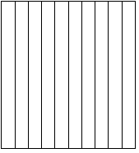  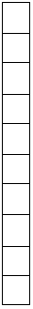  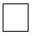  Then ask learners how they could add to the diagrammatic representation to make the number 3.333. They would need to split each square representing one hundreth into ten again. Explain that the place value after hundredths is called thousandths.
Main activities | Ask learners:  What is wrong with reading this number (23.45) as twenty three point forty five?  How would you read the number 3.418?  How would you read the number 203.203?  Learners work in pairs for this activity. Give each learner a set of 0–9 digit cards. Each pair of learners take turns to make a 4-, 5- or 6-digit number that has 3 decimal places, for example 27.819. Ask learners to tell their partner the value of each digit to see if they agree.  Ask learners questions such as:  - In 226.831 which digit is in the tenths place?  - What value does the 8 represent (8 tenths or 80 hundredths or 800 thousandths)  - In 19.053 the digit in the hundredths place is …?  - In 1.943 what does the digit 3 represent?  Then ask learners to use their cards to try to make a number based on information about each place value. For example:  My number has 4 tens, 5 tenths, 6 thousandths, 2 ones and 1 hundredth. What is my number?  Learners continue to take turns and make numbers using the digit cards, but this time they hide the number from their partner and give clues about each place value, similar to the example given above.  Check learners’ understanding by asking learners which is the larger number 0.12, 0.2 or 0.02? Then show them a representation of these values on a 100 grid.  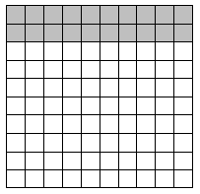  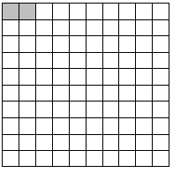  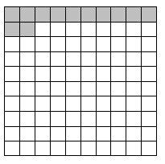  This activity can be extended by giving learners different numbers and asking them to compare and sort numbers from the smallest to largest e.g. 0.35, 0.125, 0.3 or 23.123, 23.5, 23.012. | Possible misconceptions:  Learners sometimes think that 0.12 is larger than 0.2 because they read these numbers as “zero point twelve” and “zero point two”.  Resources:  0–9 digit cards  Mini whiteboards
End/Close/  Reflection/  Summary | Show learners some numbers and ask them to write the place and the value of the digit that is underlined.  e.g. 5012.622  What place is the underlined digit? (tenths)  What is the value of the underlined digit? (6 tenths, or 60 hundredths or 600 thousandths)  Revisit the learning objectives and success criteria. Ask learners to explain whether they have met the success criteria and if they have any questions or comments.

Reflection
Use the space below to reflect on your lesson. Answer the most relevant questions for your lesson.
Were the learning objectives and lesson focus realistic? What did the learners learn today?
What was the learning atmosphere like?
What changes did I make from my plan and why?
If I taught this lesson again, what would I change?
What two things really went well (consider both teaching and learning)?
What two things would have improved the lesson (consider both teaching and learning)?
What have I learned from this lesson about the class or individuals that will inform my next lesson?

Next steps
What will I teach next, based on learners’ understanding of this lesson?

Sample lesson 2

CLASS:
DATE:
Learning objectives | 6Gp.02 Use knowledge of 2D shapes and coordinates to plot points to form lines and shapes in all four quadrants.  TWM.07 Critiquing
Lesson focus /  success criteria | Learners can draw, generate and plot coordinates on the full coordinate grid.  - I can draw an x and y axis that shows the four quadrants  - I can read and plot coordinates in all four quadrants  - I can plot points to form lines and 2D shapes
Prior knowledge / previous learning | Knowledge of plotting coordinates in the first quadrant.  In Stage 5, learners covered the concept of coordinates in the first quadrant where positive numbers only were used.
Plan
Lesson | Planned activities | Notes
Introduction | Show learners the learning objectives and lesson focus and agree the success criteria:  - I can draw an x and y axis that shows the four quadrants  - I can read and plot coordinates in all four quadrants  - I can plot points to form lines and 2D shapes  Revisit plotting and reading coordinates in the first quadrant and drawing a set of axes. Remind learners that coordinates are read in a specific order, x then y. Show them an example e.g. where (4, 8) is located.  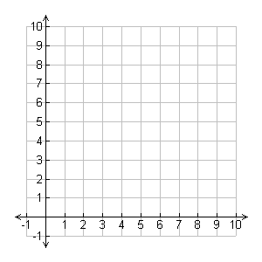  Then, show learners all four quadrants and how to add negative values to the x and y axis.  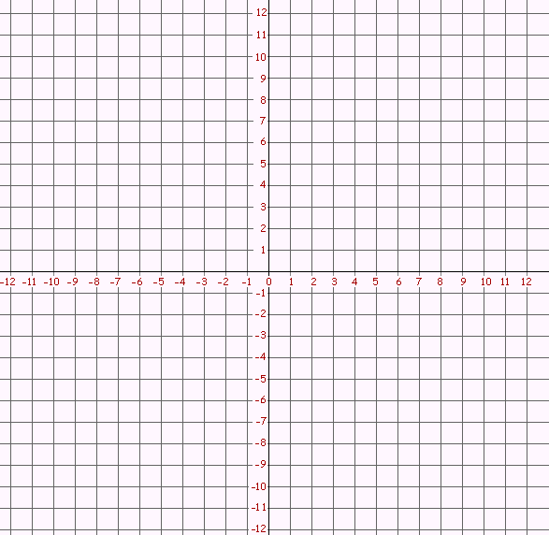  Read out some coordinates and ask for a volunteer to show you where that point is located e.g. (3, 4). Repeat this ensuring that you give coordinates for all four quadrants.
Main activities | Ask learners to draw a four-quadrant grid with an x-axis from -8 to +8 and a y-axis from -8 to +8, crossing at 0. Ask learners to draw a triangle, star, rectangle and hexagon each in a different quadrant, making sure the vertices of the shapes lie on points where the grid lines cross. Ask them to record the coordinates of each 2D shape on a different piece of paper.  Give the coordinates to a partner and ask them to plot the shapes. Compare grids. Do they have identical shapes drawn in the same place? If not, discuss what might have gone wrong.  This activity can be extended by asking learners to plot these points: (1,3),  (-2, 2), (-1, 4) and show where they would need to add a fourth point to make:  a) a kite b) a parallelogram c) an arrowhead  Is it possible to make a rectangle? Explain why or why not.  Learners will show they are critiquing (TWM.07) when they can comment on the accuracy of each other’s work as well as their own. | Resources:  Squared paper  Possible misconceptions:  Learners may think that a coordinate is a number and not a location in two dimensions.
End/Close/  Reflection/  Summary | To formatively assess if learners have understood how to plot coordinates in the four quadrants, ask learners to plot these points: (5,3), (-7, 7), (4, -6), then ask them to plot a point in the quadrant that does not have a point and to write the coordinate next to the point.  Revisit the learning objectives and success criteria. Ask learners to explain whether they have met the success criteria and if they have any questions or comments.

Reflection
Use the space below to reflect on your lesson. Answer the most relevant questions for your lesson.
Were the learning objectives and lesson focus realistic? What did the learners learn today?
What was the learning atmosphere like?
What changes did I make from my plan and why?
If I taught this lesson again, what would I change?
What two things really went well (consider both teaching and learning)?
What two things would have improved the lesson (consider both teaching and learning)?
What have I learned from this lesson about the class or individuals that will inform my next lesson?

Next steps
What will I teach next, based on learners’ understanding of this lesson?

Changes to this Scheme of Work

This Scheme of Work has been amended. The latest Scheme of Work is version 2.0, published January 2021.

- The definition of the Thinking and Working Mathematically characteristic TWM.03 Conjecturing has been changed to: Forming mathematical questions or ideas.
- The definition of the Thinking and Working Mathematically characteristic TWM 04 Convincing has been changed to: Presenting evidence to justify or challenge a mathematical idea or solution.

There may be other minor changes that do not affect teaching and learning.

Cambridge Assessment is committed to making our documents accessible in accordance with the WCAG 2.1 Standard. We are always looking to improve the accessibility of our documents. If you find any problems or you think we are not meeting accessibility requirements, contact us at info@cambridgeinternational.org with the subject heading: Digital accessibility. If you need this document in a different format, contact us and supply your name, email address and requirements and we will respond within 15 working days.

Cambridge Assessment International Education
The Triangle Building, Shaftesbury Road, Cambridge, CB2 8EA, United Kingdom
t: +44 1223 553554 f: +44 1223 553558
e: info@cambridgeinternational.org www.cambridgeinternational.org

© UCLES September 2020

