

Scheme of Work
Cambridge Primary
Mathematics 0096
Stage 4

This Cambridge Scheme of Work is for use with the Cambridge Primary
Mathematics Curriculum Framework published in September
2020 for first teaching in September 2021.

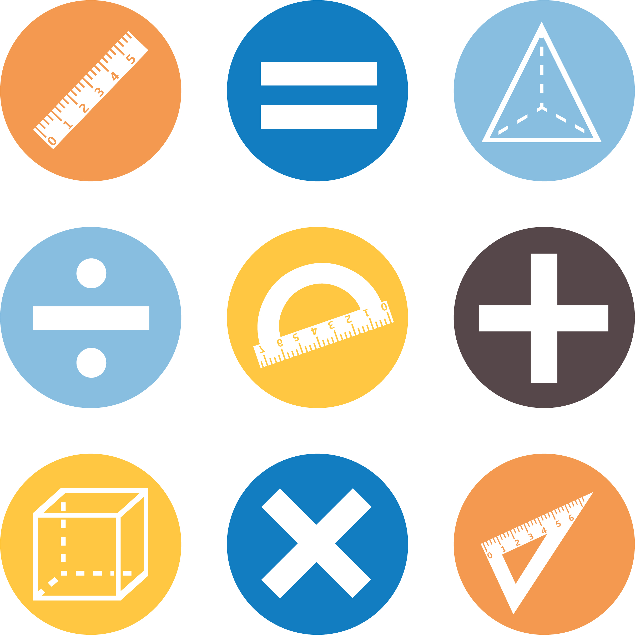

© UCLES 2020
Cambridge Assessment International Education is part of the Cambridge Assessment Group. Cambridge Assessment is the brand name of the University of Cambridge Local Examinations Syndicate (UCLES), which itself is a department of the University of Cambridge.

UCLES retains the copyright on all its publications. Registered Centres are permitted to copy material from this booklet for their own internal use. However, we cannot give permission to Centres to photocopy any material that is acknowledged to a third party, even for internal use within a Centre.

Contents

Contents 3
Introduction 5
Unit 4.1 Number 9
Unit 4.1 Topic 1 Introducing negative numbers 10
Unit 4.1 Topic 2 Patterns and sequences 14
Unit 4.1 Topic 3 Place value and rounding 17
Unit 4.1 Topic 4 Factors and multiples 21
Unit 4.2 Time 24
Unit 4.2 Topic 1 Reading and recording time 25
Unit 4.2 Topic 2 Time problems 28
Unit 4.3 2D and 3D shape 30
Unit 4.3 Topic 1 Tessellation, symmetry and reflection 31
Unit 4.3 Topic 2 Area and perimeter 35
Unit 4.3 Topic 3 Recognising and building 3D shapes 39
Unit 4.4 Calculation 41
Unit 4.4 Topic 1 Addition and subtraction 42
Unit 4.4 Topic 2 Multiplication and division 45
Unit 4.5 Statistical methods 50
Unit 4.5 Topic 1 Collecting data 51
Unit 4.5 Topic 2 Presenting and interpreting data 53
Unit 4.5 Topic 3 The statistical cycle 55
Unit 4.6 Fractions and percentages 58
Unit 4.6 Topic 1 Understanding fractions 59
Unit 4.6 Topic 2 Calculating with fractions 64
Unit 4.6 Topic 3 Percentages and equivalence 66
Unit 4.7 Angles, position and direction 69
Unit 4.7 Topic 1 Angles 70
Unit 4.7 Topic 2 Position and direction 72
Unit 4.8 Probability 75
Unit 4.8 Topic 1 Describing chance 76
Unit 4.8 Topic 2 Conducting experiments 78
Sample lesson 1 80
Sample lesson 2 83
Changes to this Scheme of Work 85

Changes to this Scheme of Work
For information about changes to this Scheme of Work, go to page 85.
The latest Scheme of Work is version 2.0, published January 2021.

Introduction
This document is a scheme of work created by Cambridge Assessment International Education for Cambridge Primary Mathematics Stage 4.

It contains:
- suggested units showing how the learning objectives in the curriculum framework can be grouped and ordered
- at least one suggested teaching activity for each learning objective
- a list of subject-specific language that will be useful for your learners
- common misconceptions
- sample lesson plans
- links to relevant NRICH activities to enrich learners’ mathematical experiences, https://nrich.maths.org/

You do not need to use the ideas in this scheme of work to teach Cambridge Primary Mathematics Stage 4. Instead use them as a starting point for your planning and adapt them to suit the requirements of your school and the needs of your learners. The schemes of work are designed to indicate the types of activities you might use, and the intended depth and breadth of each learning objective. These activities are not designed to fill all the teaching time for this stage. You should use other activities with a similar level of difficulty, for example, those from endorsed resources.

The accompanying teacher guide for Cambridge Primary Mathematics suggests effective teaching and learning approaches. You can use this scheme of work as a starting point for your planning, adapting it to suit the requirements of your school and needs of your learners.

Long-term plan
This long-term plan shows the units in this scheme of work and a suggestion of how long to spend teaching each one. The suggested teaching time is based on learners having about 4 to 5 hours of Mathematics per week (about 120 to 150 hours per stage). The actual number of teaching hours may vary according to your context.
Unit and suggested order | Suggested teaching time
Unit 4.1 Number | 17% (25 hours)
Unit 4.2 Time | 10% (15 hours)
Unit 4.3 2D and 3D shape | 17% (25 hours)
Unit 4.4 Calculation | 13% (20 hours)
Unit 4.5 Statistical methods | 10% (15 hours)
Unit 4.6 Fractions and percentages | 17% (25 hours)
Unit 4.7 Angles, position and direction | 10% (15 hours)
Unit 4.8 Probability | 7% (10 hours)
Total | 150 hours

Sample lesson plans
You will find two sample lesson plans at the end of this scheme of work. They are designed to illustrate how the suggested activities in this document can be turned into lessons. They are written in more detail than you would use for your own lesson plans. The Cambridge Primary Mathematics Teacher Guide has information on creating lesson plans.

Other support for teaching Cambridge Primary Mathematics Stage 4
Cambridge Primary centres receive access to a range of resources when they register. The Cambridge Primary support site at https://primary.cambridgeinternational.org is a password-protected website that is the source of the majority of Cambridge-produced resources for the programme. Ask the Cambridge Coordinator or Exams Officer in your school if you do not already have a log-in for this support site.

Included on this support site are:
- the Cambridge Primary Mathematics Curriculum Framework, which contains the learning objectives that provide a structure for your teaching and learning
- grids showing the progression of learning objectives across stages
- the Cambridge Primary Mathematics Teacher Guide, which will help you to implement Cambridge Primary Mathematics in your school
- templates for planning
- worksheets for short teacher training activities that link to the teacher guide
- assessments provided by Cambridge
- a list of endorsed resources, which have been through a detailed quality assurance process to make sure they are suitable for schools teaching Cambridge Primary Mathematics worldwide
- links to online communities of Cambridge Primary teachers.

Resources for the activities in this scheme of work
We have assumed that you will have access to these resources:
- paper, pens and pencils for learners to use
- rulers, set squares, protractors and calculators.

Other suggested resources for individual units and/or activities are described in the rest of this document. You can swap these for other resources that are available in your school.

Websites
We recommend NRICH to support Cambridge Primary Mathematics at https://nrich.maths.org/

NRICH publishes free and challenging mathematics activities for learners of all ages. The resources assist teachers to embed thinking and working mathematically with mathematics content. NRICH is based in both the University of Cambridge's Faculty of Education and the Centre for Mathematical Sciences.

There are many excellent online resources suitable for teaching Cambridge Primary Mathematics. Since these are updated frequently, and many are only available in some countries, we recommend that you and your colleagues identify and share resources that you have found to be effective for your learners.

Approaches to teaching Cambridge Primary Mathematics Stage 4
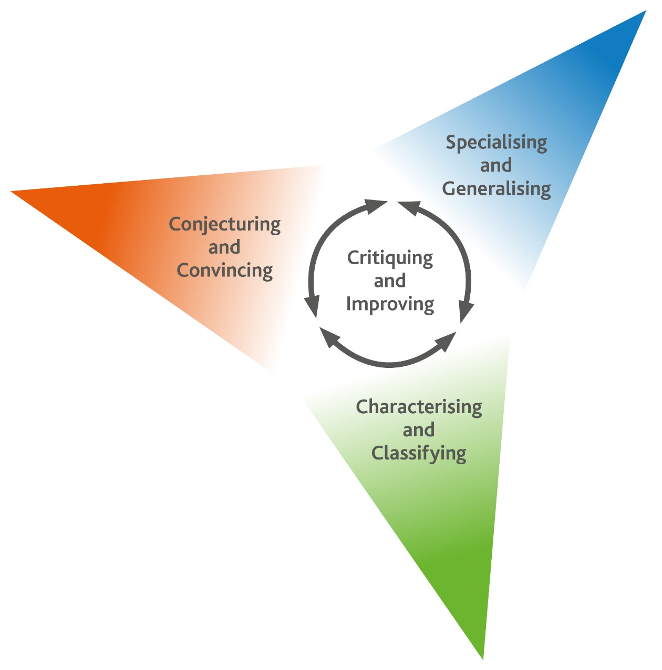
Thinking and Working Mathematically
Thinking and Working Mathematically supports the mathematical concepts and skills in all strands of the Cambridge Primary Mathematics curriculum. When learners think and work mathematically, they actively engage with their learning of mathematics. They try to make sense of ideas and build connections between different facts, procedures and concepts. Learners who do not think and work mathematically can carry out processes that their teacher has shown them, but they may not understand why the processes work or what the results mean. Noticing inconsistencies, patterns and particular representations encourages learners to think and work mathematically. Practice, reflection and questioning will help them to improve.

Thinking and Working Mathematically has eight characteristics that are presented in four pairs:

- Specialising and Generalising
- Conjecturing and Convincing
- Characterising and Classifying
- Critiquing and Improving.
The eight Thinking and Working Mathematically characteristics are all closely connected and interdependent. A high-quality mathematics task may include one or more of them. The characteristics provide learners with the language they need to think and work mathematically. Learners can then decide what mathematical knowledge, procedures and strategies to use in order to gain a deeper understanding of mathematical questions.

Throughout this scheme of work, there are examples of classroom activities that link the Thinking and Working Mathematically characteristics with content learning objectives. We recommend you use the ideas in these examples to create further classroom activities.

Thinking and Working Mathematically characteristics: |  | Unit 4.1 | Unit 4.2 | Unit 4.3 | Unit 4.4 | Unit 4.5 | Unit 4.6 | Unit 4.7 | Unit 4.8
TWM.01 | Specialising – Choosing an example and checking to see if it satisfies or does not satisfy specific mathematical criteria
TWM.02 | Generalising – Recognising an underlying pattern by identifying many examples that satisfy the same mathematical criteria
TWM.03 | Conjecturing – Forming mathematical questions or ideas
TWM.04 | Convincing – Presenting evidence to justify or challenge a mathematical idea or solution
TWM.05 | Characterising – Identifying and describing the mathematical properties of an object
TWM.06 | Classifying – Organising objects into groups according to their mathematical properties
TWM.07 | Critiquing – Comparing and evaluating mathematical ideas, representations or solutions to identify advantages and disadvantages
TWM.08 | Improving – Refining mathematical ideas or representations to develop a more effective approach or solution

Misconceptions
Mathematical misconceptions are usually incorrect generalisations made by learners. Misconceptions should not be avoided, but instead used for teaching purposes to reveal learners’ thinking. Research suggests that asking learners open-ended questions about mathematical concepts is the most appropriate way to uncover misconceptions. Once a learner’s misconceptions have been identified, the next step is to know how to correct them. One approach is to give learners a variety of mathematical strategies to draw upon when finding solutions so that they can gain a deeper understanding of each mathematical concept.

Mental strategies and calculators
Mental calculation is a skill needed for everyday life, especially when paper or calculators are not available. Mental calculation relies on working memory, the organisation of thoughts and the use of efficient mathematical strategies when solving mathematical computations. It is important for learners to practise mental calculations and have a range of strategies as this improves understanding and recall as well as increasing confidence and proficiency.

Calculators are useful teaching aides. Although learners need to practise doing mental and written calculations, calculators can help them to notice patterns. They are also useful when learners are solving problems where non-calculator calculations would take the focus away from strategies. When well used, calculators can help learners to learn about numbers and the number system. Use calculators as a teaching aid to promote mental calculation and mental strategies and to explore mathematical patterns. Learners should understand when it is best to use calculators to help them calculate, and when to calculate mentally or using written methods.

As Cambridge International includes calculator-based assessments at Stages 5, 6, 7, 8 and 9, we recommend that learners begin to use calculators for performing and checking calculations from Stage 4. At Stages 5 and 6, learners should be developing effective use of calculators so that they are familiar with the buttons and functions of a basic calculator.

Unit 4.1 Number

Learning objectives covered in Unit 4.1 and topic summary: |  | 4.1 Topic 1  Introducing negative numbers | 4.1 Topic 2  Patterns and sequences | 4.1 Topic 3  Place value and rounding | 4.1 Topic 4  Factors and multiples | Thinking and Working Mathematically
4Nc.01 | Count on and count back in steps of constant size: 1-digit numbers, tens, hundreds or thousands, starting from any number, and extending beyond zero to include negative numbers.
4Nc.04 | Recognise and extend linear and non-linear sequences, and describe the term-to-term rule.
4Nc.05 | Recognise and extend the spatial pattern of square numbers.
4Ni.01 | Read and write number names and whole numbers greater than 1000 and less than 0.
4Ni.07 | Understand the relationship between multiples and factors.
4Ni.08 | Use knowledge of factors and multiples to understand tests of divisibility by 2, 5, 10, 25, 50 and 100. |  |  |  |  | TWM.05 Characterising
4Np.01 | Understand and explain that the value of each digit in numbers is determined by its position in that number. |  |  |  |  | TWM.08 Improving
4Np.02 | Use knowledge of place value to multiply and divide whole numbers by 10 and 100.
4Np.03 | Compose, decompose and regroup whole numbers.
4Np.04 | Understand the relative size of quantities to compare and order positive and negative numbers, using the symbols =, > and <.
4Np.05 | Round numbers to the nearest 10, 100, 1000, 10 000 or 100 000.

Unit 4.1 Topic 1 Introducing negative numbers

Outline of topic:
Learners will explore very large numbers and how they are written. They will also look at negative numbers and consider their size and placement on a number line.

Language:
Key vocabulary:
zero
positive, negative
constant steps / jumps
die, dice
place value
range
maximum, minimum

Recommended prior knowledge:
- Recite, read and write number names and whole numbers from 0 to 1000
- Understand zero as a countable value on a number line (e.g. -1 + 2 = 1)
- Understand and use symbols =, < and >

Learning objectives | Suggested teaching activities and resources | Mental strategies, possible misconceptions and comments
4Nc.01 Count on and count back in steps of constant size: 1-digit numbers, tens, hundreds or thousands, starting from any number, and extending beyond zero to include negative numbers. | Give learners a number line from -20 to 20, marked off in ones.  Roll a die, inform learners that this is the starting number and ask learners to place a counter at that value. Roll the die a second time and inform learners that this is the size of the constant steps (jumps). For example, the starting number is 3 and the size of the constant step (jump) is 5.  Learners need to show two jumps forward and two jumps back (according to the size indicated by the second throw of the die) from the starting value. Ask learners to record their results. Ask them if they can extend this by a further two jumps (the values might go beyond the number line -20 to 20).  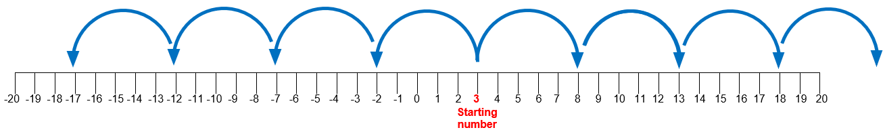  In pairs, ask learners to roll the dice to create their own starting numbers and constant size steps (jumps), recording their results each time. Ask some pairs to share their results with the class.  Encourage learners to look for patterns when adding and subtracting, particularly noticing patterns that bridge through zero.  This activity can be extended by rolling the die to get the starting number and then asking the class to count in tens from that number. This can be repeated for counting in hundreds and thousands.  Resources:  Number lines  Dice  100 squares (optional) | A 100 square can support this activity, especially when looking at jumps of 10. So, 10 more than 3 is 13. Learners should notice that the pattern is the increase in the tens part of the number.  Possible misconceptions:  Some learners may incorrectly assume that adding and subtracting across zero will produce the same pattern. For example, learners might incorrectly assume that -3 + 10 = 3 or that 3 - 10 = -3. To counteract this misconception, encourage moves across zero using bridging techniques such as the number to zero and then the rest beyond zero. For example, -3 + 10 = -3 + 3 + 7  -3 + 3 = 0 then 0 + 7 = 7
4Ni.01 Read and write number names and whole numbers greater than 1000 and less than 0. | Ask learners to choose a number between 10 and 20 (e.g. a learner chooses 17) and then ask them to count on from that number in hundreds. Stop them before they reach 1000 and write down the number they have reached. Write the number in figures and words.  Ask learners:  - If we continue this sequence, what will be the first number past 1000?  - How would we write this number? (show on mini whiteboards or paper)  - What number comes before this?  - What number comes after this?  Repeat this activity using a starting number between 100 and 200, counting in thousands. Stop before reaching 10 000 and ask learners to write the number reached on their mini whiteboards or paper. Ask learners to write the number in figures and words.  This activity can be extended by showing learners the number 6125 and asking them to sketch a number line to show what the 3-digit starting number was.  The world’s greatest temperature range at a single location is 105°C,  from -68°C to 37°C recorded at Verkhoyansk, Siberia.  Show this range on a vertical number line, marked off in tens.  Ask learners:  - What do you think ‘range’ means?  - How can we show the range is 105°C?  - What is the temperature at this point? (point to a value such as 27°C)  - What is the temperature at this point? (point to a value such as -15°C)  - What do you notice about the numbers above and below zero? (Answer: the values appear to increase either side of zero and the numbers appear symmetrical apart from the sign)  - Which number is larger, -15°C or -5°C?  Repeat this last question for several numbers.  Give the maximum and minimum temperature for your locality or another country that includes negative numbers. Ask learners to show this on a vertical number line and work out the range.  Resources:  Vertical number lines  Mini whiteboards (optional) | Possible misconceptions:  Some learners may incorrectly think that the value of numbers increases as you move away from zero. They need to see that numbers can become negative, but this does not mean that the numbers are actually larger. So, -2 is greater than -9.  Learners should practice writing larger numbers in words as well as in figures, taking care to hyphenate where needed and making use of the ‘and’ for the last part of the number (e.g. 2 054 999 would be written as two million, fifty-four thousand, nine hundred and ninety-nine). Learners should listen to how the number sounds when spoken.  Range is the difference between the highest and lowest number.
4Np.04 Understand the relative size of quantities to compare and order positive and negative numbers, using the symbols =, > and <. | From the previous activity, ask learners to choose a temperature from Siberia and one from their chosen locality and compare (e.g. -5°C in Siberia < -3°C in another location). Give learners examples that require them to use all three symbols =, > and <. | Learners sometimes misunderstand the symbols < and > especially when they also misunderstand the relative size of negative numbers.  For example, 5 > 3 but -5 < -3. Encourage learners to compare numbers using a number line. Ensure that they know that when reading numbers from left to right on the number line, they increase in size, but numbers read from right to left decrease in size.

Unit 4.1 Topic 2 Patterns and sequences

Outline of topic:
Learners will recognise linear and non-linear sequences and identify inter-relationships making use of term-to-term rules.

Learners will also understand the spatial aspect of numbers as they investigate different square numbers.

Language:
Key vocabulary:
sequence, list
linear, non-linear
term-to-term rule
square numbers

Recommended prior knowledge:
- Know how to extend sequences by counting on or counting back
- Draw squares accurately to given dimensions

Learning objectives | Suggested teaching activities and resources | Mental strategies, possible misconceptions and comments
4Nc.04 Recognise and extend linear and non-linear sequences, and describe the term-to-term rule. | Using small cubes, ask learners, in pairs, to show a linear sequence (e.g. 2, 4, 6 …). Discuss what makes it linear (it increases or decreases by the same amount each time). If you draw a graph of the numbers and join them together, they make a straight line.  Ask learners:  How much is being added on or subtracted each time?  Explain that this is the term-to-term rule.  Ask learners:  Can you show a sequence that is not linear?  (For example, 2, 3, 5, 6, 8 … goes up by 1 then 2 then 1, etc.)  Learners should explain their pattern each time. They can record their results, drawing pictures, diagrams or spatial patterns in their books.  Explore other types of non-linear sequences by giving the rule and starting number and asking the learners to write down the first five terms (e.g. starting at 3, double the previous term and subtract 1).  Ask learners to come up with their own rules, which they can give to the class for them to calculate the first five terms.  Resources:  Small cubes (inter-linking if possible) | Possible misconceptions:  Learners should understand the difference between a list of numbers (e.g. the ages of ten people in a survey) and a sequence where the numbers are governed by a rule.  Learners should be careful to see that not all rules written with 2 steps are non-linear (e.g. add 3 then subtract 1 each time is linear and equivalent to add 2).
4Nc.05 Recognise and extend the spatial pattern of square numbers. | Learners should draw the first 5 square numbers, using centimetre-squared paper and record how each is made (e.g. 4 × 4 = 16).  Ask learners to draw them as squares inside each other with one corner that is common to each, so the learners can see the pattern as increasing but not by the same amount each time. Relate this activity to the previous activity.  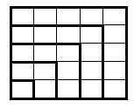  Ask learners:  What do you notice about how the pattern increases?  Can you see any patterns?  Learners should then draw a square measuring 12 x 12.  Ask learners:  What square number does this represent? (Answer: 144)  Explain that their challenge is to draw as many different sized squares in this 12 x 12 square as possible. Squares are not allowed to be inside each other or overlap. Every gap should be filled. This will result in more smaller squares (e.g. 2 x 2). For example:  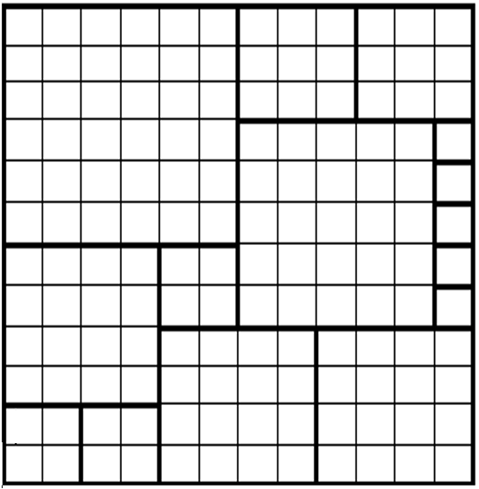  Which learner can use the least number of squares to fill the larger square? They can have several attempts at this. Encourage learners to talk about their squares using dimensions and their square value (e.g. ‘I used a 7 by 7 square, which is 49 and a …’)  Resources:  Centimetre-squared paper

Unit 4.1 Topic 3 Place value and rounding

Outline of topic:
Learners will work with numbers in the thousands, using place value and looking at what happens when they are multiplied and divided by 10 and 100. They will also learn how to round numbers.

Language:
Key vocabulary:
place value
digit, thousands, hundreds, tens, ones, position
die, dice
consecutive numbers
compose, decompose

Key phrases:
Round … to the nearest …

Recommended prior knowledge:
- Multiply numbers by 10 using knowledge of place value
- Understand zero as a place holder
- Understand and explain that the value of each digit is determined by its position in that number (up to 3-digit numbers)

Learning objectives | Suggested teaching activities and resources | Mental strategies, possible misconceptions and comments
4Np.01 Understand and explain that the value of each digit in numbers is determined by its position in that number.  TWM.08 Improving  Refining mathematical ideas or representations to develop a more effective approach or solution | Learners should draw a place value table showing thousands, hundreds, tens and ones. By rolling a die they should select the value of each place value and record them in the table. The teacher should ask some learners to share what numbers they have made (they need to say the place values as well as say the whole number itself).  Ask learners:  - What is the largest number you can get using the dice? (Answer: 6666)  - What is the smallest number you can get using the dice? (Answer: 1111)  - What numbers can you make with consecutive digits? (Answer: 1234, 2345, 3456, 4321, 5432, and 6543)  Ask learners to work in pairs and take turns to roll a die. For each roll, the learner will place their number in the position that they think will give them the highest total in the end. After four rolls each, the learner with the highest value number wins.  This activity can be extended by asking learners how many four-digit numbers that are multiples of 25 they can make by rolling a die and completing the place values. This will require a methodical approach, possibly starting with the lowest possible number and building up, remembering 0, 7, 8 and 9 cannot be used as they are not on a die. (Answer: 36 numbers 1125, 1225, 1325, 1425, 1525, 1625, 2125 etc ....)    Learners will show they are improving (TWM.08) when they establish a methodical approach to the task (e.g. seeing there is one possible multiple between 1100 and 1200 (1125) and then seeing a repeated pattern for between 1200 and 1300 and continuing to two thousand, etc.).  Resources:  Dice
4Np.02 Use knowledge of place value to multiply and divide whole numbers by 10 and 100. | Ask learners to look at the numbers they generated in the previous activity. How big are the numbers? (All the numbers are in the thousands)  Ask learners:  - What happens to your numbers if you multiply them by 10?  - What happens to your numbers if you multiply them by 100?  Show learners the number 65 000 and ask them to represent it on a place value grid.  Then ask them to divide it by 10. They should notice that the number is now 10 times smaller. This is the inverse of multiplying 6500 by 10. Explore the effect of multiplying and dividing different numbers by 10 and 100, avoiding answers with decimal numbers. | Possible misconceptions:  Learners often incorrectly place a zero at the end of a number to show it has been multiplied by 10. Ensure that learners understand that multiplying a number by 10 means that the place value of every digit in the number increases by one place.
  10000s | 1000s | 100s | 10s | 1s
  6 | 5 | 0 | 0 | 0
   | 6 | 5 | 0 | 0
4Np.03 Compose, decompose and regroup whole numbers. | Give learners a decomposed or regrouped number and ask them to compose it as a number. For example:  5 thousands, 9 hundreds, 4 tens and 7 ones = 5947 or  5000 + 900 + 45 + 2 = 5947  Give learners the following three numbers: 15, 18 and 27. Ask learners for examples of how each can be decomposed (e.g. 15 = 10 + 5 or 15 = 5 + 10) and regrouped (e.g. 15 = 9 + 6 or 15 = 7 + 8).  Learners should regroup each of the three numbers, side by side, and then put squares around any number that combine to total ten. Learners should repeat this several times. Finally, ask learners if they can find an effective way of adding 15 + 18 + 27 using regrouping.  For example:  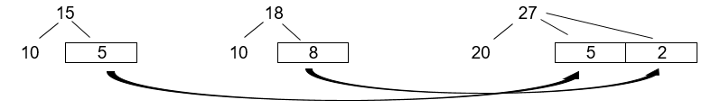  Using this strategy of finding tens will lead to the calculation 10 + 10 + 20 and 5 + 5 and 8 + 2, giving a total of 60.  Give learners a selection of numbers and ask them to compose, decompose or regroup the numbers, explaining their strategy. Share strategies with the whole class and discuss the most efficient strategies for each number. | Composing and decomposing should focus on every individual place value position of numbers: 1000s (thousands), 100s (hundreds), 10s (tens) and 1s (ones). For example:  = 1000s + 100s + 10s + 1s  4687 = 4000 + 600 + 80 + 7  Regrouping should focus on expressing a number in different ways to assist with calculations. For example:  4687 can be expressed as:  4000 + 687  4650 + 37  Possible misconceptions:  Learners sometimes incorrectly believe that numbers can only be regrouped into tens and units. Draw on examples where numbers are decomposed differently, such as 15 = 9 + 6
4Np.05 Round numbers to the nearest 10, 100, 1000, 10 000 or 100 000. | Using a vertical number line showing temperature marked off in tens from 0°C to 50°C, point to any temperature (e.g. 27°C) and ask what this would be if it was rounded to the nearest ten (30°C).  What other temperatures would equal 30°C when rounded to the nearest ten?  How would you round to the nearest ten if the temperature was 25°C or 35°C?  Explain that it is exactly half way between 20 and 30 or between 30 and 40, so it could round either way, but mathematicians agree that these numbers should always be rounded up.  Mercury is the closest planet to the sun and can reach temperatures of 427°C.  What would this temperature be if it was rounded to the nearest ten and nearest hundred?  Demonstrate how to find the answer using a number line. Ask learners to show other possible temperatures on Mercury and how they are rounded to the nearest 10 or 100. Find out what the temperatures would be on other planets and put those on a number line rounded to the nearest 10 and nearest 100.  The temperature on the surface of the sun is about 5600°C.  What would this number be if it was rounded to the nearest thousand?  The temperature increases as you go towards the centre of the sun (up to  15 000 000°C). Ask learners to write possible temperatures within the sun and show how they can be rounded in different ways. They should use rounding to the nearest 10, 100, 1000 and 10 000.  Resources:  Vertical number lines

Unit 4.1 Topic 4 Factors and multiples

Outline of topic:
Learners will become familiar with multiples and factors and recognise the difference between them. They will also use their knowledge of multiples and factors to check for divisibility.

Language:
Key vocabulary:
multiple
factor
divisible, divisibility

Recommended prior knowledge:
- Recognise multiples of 2, 5 and 10 (up to 1000)
- Have a good understanding of the times tables (up to 10 x 10)

Learning objectives | Suggested teaching activities and resources | Mental strategies, possible misconceptions and comments
4Ni.07 Understand the relationship between multiples and factors. | Ask learners:  Which times tables is the number 6 part of? (Answer: 1,2,3 and 6)  Demonstrate this by writing out the first 10 multiples, circling the number 6 in each sequence e.g.  1 → 1, 2, 3, 4, 5, 6, 7, 8, 9, 10  2 → 2, 4, 6, 8, 10, 12, 14, 16, 18, 20  3 → 3, 6, 9, 12, 15, 18, 21, 24, 27, 30  6 → 6, 12, 18, 24, 30, 36, 42, 48, 54, 60  Explain that 1, 2, 3, and 6 are factors of 6.  What numbers can 6 be a factor of? (Answer: 6, 12, 18, etc)  Demonstrate each by writing out the factors of each number, circling the number 6 in each list (e.g. 18 → 1, 2, 3, 6, 9, 18). | Possible misconceptions:  Learners sometimes confuse the meaning of multiple and factor.  Ensure learners understand the difference between a factor and a multiple.  e.g. 3 and 4 are factors of 12 because 3 x 4 = 12.  12 is a multiple of 3 and 4 because 12 ÷ 3 = 4 and 12 ÷ 4 = 3
4Ni.08 Use knowledge of factors and multiples to understand tests of divisibility by 2, 5, 10, 25, 50 and 100.  TWM.05 Characterising  Identifying and describing the mathematical properties of an object | Write the number 50 on the board. Ask learners what information they know about this number. (For example, it is a multiple of 2 because it is even, it is a multiple of 5 because it ends in a zero, etc.)  Divide the class into 3 groups and give each group a set of cards (e.g. green cards with ÷3 written on them, yellow with ÷5 and blue with ÷10).  On the board, write a number between 1 and 99. Learners should hold up one of their coloured cards if they notice that the number written on the board can be divided by the number on their card. Ask the learners to explain their choice of card and whether they used any tests of divisibility to calculate the answer.  Continue this activity by writing other numbers between 1 and 99 on the board.  Learners will show they are characterising (TWM.05) when explain why a number is a divisible by another number (e.g. 95 is divisible by 5 because it ends in 5 and multiples of 5 follow a pattern of 0 and 5 in the ones place).  Write the number 100 on the board and ask learners to hold up the correct cards.  Ask learners if they notice any other numbers that divide equally into 100. Ask how they know. (Answers: 1, 2, 4 ,5 ,10 ,20, 25, 50, 100)  Resources:  Green cards with ÷3  Yellow cards with ÷5  Blue cards with ÷10

Unit 4.2 Time

Learning objectives covered in Unit 4.2 and topic summary: |  | 4.2 Topic 1  Reading and recording time | 4.2 Topic 2  Time problems | Thinking and Working Mathematically
4Gt.01 | Understand the direct relationship between units of time, and convert between them.
4Gt.02 | Read and record time accurately in digital notation (12- and 24-hour) and on analogue clocks.
4Gt.03 | Interpret and use the information in timetables (12- and 24-hour clock).
4Gt.04 | Find time intervals between different units:  - days, weeks, months and years  - seconds, minutes and hours that do not bridge through 60.

Unit 4.2 Topic 1 Reading and recording time

Outline of topic:
Learners will be able to use digital notation for time (12-hour and 24-hour) and read time on analogue clocks. Using this knowledge, learners will be able to plan and create timetables.

Language:
Key vocabulary:
digital clock, analogue clocks
12-hour time
24-hour time
a.m., p.m.
midday, noon, midnight
timetable

Recommended prior knowledge:
- Read and record time accurately in digital notation (12-hour clock) and on analogue clocks
- Interpret and use the information in timetables (12-hour clock)

Learning objectives | Suggested teaching activities and resources | Mental strategies, possible misconceptions and comments
4Gt.02 Read and record time accurately in digital notation (12- and 24-hour) and on analogue clocks. | Explain that some countries write the time using 12-hour digital notation, other countries only use 24-hour notation and some countries use a combination of both. It is important for learners to understand both the 12-hour and 24-hour notation in case they use digital devices that use both.  Ask learners to complete the first activity using 12-hour time in the NRICH task: The Time Is… (https://nrich.maths.org/7384).  Ask learners:  How many times does the hour hand go round a clock in one day?  (Two, often shown as a.m. and p.m. when using 12-hour time)  For the NRICH task, ask learners to record an activity for each time that is typical for that time of day, showing if the time is a.m. or p.m. (e.g. at 12:17p.m. I will be eating my lunch).  The same task can be completed for the 24-hour NRICH time sheet. Ensure learners understand why a.m. and p.m. are not required when using 24-hour time.  Resources:  NRICH task | Possible misconceptions:  Learners often get confused when recording midday and midnight. Explain that the beginning of a day is 00:00 (no time has passed yet) and therefore midnight can be recorded as 24:00. Digital clocks do not display 24:00 instead they display 00:00 as the start of the next day.  In some countries they use the abbreviation a.m. to represent morning (times between 00:00 and 11:59) and p.m. to represent afternoon or evening (time between 12:00 and 23:59). Explain that the abbreviations: a.m. stands for ante meridiem, which is Latin for ‘before midday’ and p.m. stands for post meridiem, which is Latin for ‘after midday’.  Midday is represented by 12p.m. and midnight is represented by 12a.m. when using 12-hour time because it is the start of the next morning.  Ensure learners write 4 digits when recording 24-hour time.
4Gt.03 Interpret and use the information in timetables (12- and 24-hour clock). | Explain that learners will create an imaginary large school that has a range of facilities (e.g. a library, a swimming pool, a racing track, etc.). Ask them to draw a map to show the layout of the school. The school is so large they will need to design a railway line on a loop to transport learners around the facilities.  In pairs, learners decide when and where the first train departs (e.g. the school entrance) and where it will stop. They will need to think about time intervals between stops and create a timetable so that trains run throughout the school day (suggest 6 times of day that the train stops at each location).  Ask learners a range of questions that allow them to interpret the information in their timetables:  If you arrive at the school entrance at 09:00 what time will the next train arrive?  How long will it take to get from the school’s entrance to the swimming pool?  If you get on the train at the swimming pool, how long will it take to travel 2 stops?  If you are at the library and want to get the first train available after midday, what time will the train arrive?  Ask learners to write their answers in 12-hour and 24-hour notation.  Learners should share their answers with another pair and explain their thinking.

Unit 4.2 Topic 2 Time problems

Outline of topic:
Learners will become familiar with different units of time and how they relate. They will solve problems involving differences in time.

Language:
Key vocabulary:
millennium, century
decade, year, month
fortnight, week, day
hour, minute, second

Recommended prior knowledge:
- Find intervals between the same units of time in days, weeks, months and years
- Know basic time facts (e.g. 24 hours in one day and 60 minutes in an hour)

Learning objectives | Suggested teaching activities and resources | Mental strategies, possible misconceptions and comments
4Gt.01 Understand the direct relationship between units of time, and convert between them. | Show learners the following measures of time and discuss what each represents:  Ask learners:  If there are 60 seconds in a minute, how many seconds are there in an hour?  How many seconds are there in a day? etc.  Explore as many relationships as possible, using a calculator if needed (e.g. how many seconds in a year). Learners should share their answers with the class, explaining how they calculated each relationship. | Possible misconceptions:  Learners need to be aware that a week is 7 days, but that sometimes people refer to a week colloquially, such as a working week which is 5 days.  Similarly, a year is not always 365 days (a leap year has 366 days, with 29 days instead of 28 days in February). Leap years occur every 4 years. Leap years are divisible by 4 (e.g. 2016, 2020, 2024).
  Millennium | Month | Hour
  Century | Fortnight (2 weeks) | Minute
  Decade | Week | Second
  Year | Day | …
4Gt.04 Find time intervals between different units:  - days, weeks, months and years  - seconds, minutes and hours that do not bridge through 60. | Review the number of days in each month (perhaps using a poem). Ask learners to write each month and the number of days. Remind learners about leap years.  Choose two learners and ask them to share their birthdays. For example, 21 March and 5 July.  Discuss with the class how far apart their birthdays are in days, weeks and months. In pairs, ask learners to calculate the difference between these birthdays. Ask learners if they think these birthdays are close or far apart.  Give learners this problem to solve:  Two brothers are 1 year, 2 months and 3 days apart in age. If the older brother was born on the 1 January 2010, when was the younger brother born? (Answer: 4 March 2011)  Ask learners to write their own date problems and ask a partner to solve their problems.  Resources:  Calendars (for support) | Learners should start with earliest date and count up to second date.  Some learners may need calendars to assist them in calculating their answers.

Unit 4.3 2D and 3D shape

Learning objectives covered in Unit 4.3 and topic summary: |  | 4.3 Topic 1  Tessellation, symmetry and reflection |  | 4.3 Topic 2  Area and perimeter |  | 4.3 Topic 3  Recognising and building 3D shapes |  | Thinking and Working Mathematically
4Gg.01 | Investigate what shapes can be made if two or more shapes are combined, and analyse their properties, including reference to tessellation. |  |  |  |  |  |  |  | TWM.03 Conjecturing  TWM.04 Convincing  TWM.05 Characterising
4Gg.02 | Estimate and measure perimeter and area of 2D shapes, understanding that two areas can be added together to calculate the area of a compound shape.
4Gg.03 | Draw rectangles and squares on square grids, and measure their perimeter and area. Derive and use formulae to calculate areas and perimeters of rectangles and squares.
4Gg.04 | Estimate the area of irregular shapes on a square grid (whole and part squares).
4Gg.05 | Identify 2D faces of 3D shapes, and describe their properties.
4Gg.06 | Match nets to their corresponding 3D shapes.
4Gg.07 | Identify all horizontal, vertical and diagonal lines of symmetry on 2D shapes and patterns.
4Gp.03 | Reflect 2D shapes in a horizontal or vertical mirror line, including where the mirror line is the edge of the shape, on square grids.

Unit 4.3 Topic 1 Tessellation, symmetry and reflection

Outline of topic:
Learners will explore different 2D shapes and use tessellations and reflections to understand their properties.

Language:
Key vocabulary:
tessellation
right angles
parallel sides
symmetry, line of symmetry
reflection, mirror line

Recommended prior knowledge:
- Identify both horizontal and vertical lines of symmetry on 2D shapes and patterns
- Identify, describe, classify and name 2D shapes by their properties

Learning objectives | Suggested teaching activities and resources | Mental strategies, possible misconceptions and comments
4Gg.01 Investigate what shapes can be made if two or more shapes are combined, and analyse their properties, including reference to tessellation.  TWM.05 Characterising  Identifying and describing the mathematical properties of an object  TWM.03 Conjecturing  Forming mathematical questions or ideas  TWM.04 Convincing  Presenting evidence to justify or challenge a mathematical idea or solution | Give each learner an equilateral triangle, an isosceles triangle and a square drawn or printed on a piece of paper.  Explain that for this activity learners can only use these three shapes. They may use the same shape twice and they may change the size of the shapes to make them bigger or smaller if they want to.  Ask learners to visualise placing any two of these shapes together, touching or overlapping, and to draw the new shape. Learners may decide to cut out the three shapes so they can move them and try different combinations.  Ask learners:  - Do you know the mathematical name for your new shape?  - How many edges does your new shape have?  - How many right angles does your new shape have?  - How many pairs of parallel sides does your new shape have?  - Does your shape have any lines of symmetry?  - Can you list any other properties of your new shape?  Learners will show they are characterising (TWM.05) when they identify and describe the mathematical properties of their new shape.  This activity can be extended by asking learners:  - What is the largest possible number of sides of a new shape?  - What is the largest possible number of right angles of a new shape?  - What is the largest possible number of pairs of parallel sides of a new shape?  Learners will show they are conjecturing (TWM.03) when they suggest ideas about the answers to these questions and think about how to create the shape with these properties. They will show they are convincing (TWM.04) when they justify or challenge their initial ideas about the questions.  Resources:  Sets of three shapes  Scissors
4Gg.07 Identify all horizontal, vertical and diagonal lines of symmetry on 2D shapes and patterns. | Ask learners to draw 4 symmetrical shapes on a sheet of centimetre-squared paper. They must include vertical and diagonal lines of symmetry.  When you say ‘pass’, each learner passes their sheet of paper to the next learner, who will draw one line of symmetry on one of the shapes. When you say ‘pass’ again, they will pass the sheet to a new learner.  After the first ‘pass’, ask learners:  Is it likely that any of the shapes have more than one line of symmetry? (Answer: yes, as shapes often have 2 or more, for example a square)  Continue asking learners to pass the sheets around until all the lines of symmetry are drawn on all the shapes. This is a useful activity as learners will need to check that all the lines of symmetry for all the shapes are correctly shown.  Resources:  Centimetre-squared paper | Encourage learners to draw lines of symmetry as dashed lines.
4Gp.03 Reflect 2D shapes in a horizontal or vertical mirror line, including where the mirror line is the edge of the shape, on square grids. | Using centimetre-squared paper, ask learners to draw a vertical mirror line, in the middle and on a grid line. Ask them to draw a design that is just touching the mirror line. They should swap papers with their partner and complete the reflections. Do they agree on their reflections?  Encourage learners to check the distances of each object and its corresponding image point from the mirror line. They can use mirrors to check for the accuracy of the symmetry created by the reflection.  On another piece of centimetre-squared paper they should now draw a horizontal mirror line (this does not need to be in the middle of the paper, as several mirror lines will be drawn). Ask them to copy the shape below:  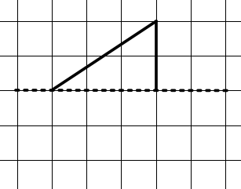  Ask learners:  When you complete the reflection, what shape will it be? (Answer: an isosceles triangle)  Ask learners to explain how they know that is an isosceles triangle.  Using more horizontal mirror lines, ask them to draw the following shapes:  - A rectangle  - A square  - A right-angled triangle (clue: the right angle will be made when a 45° angle is reflected)  - Other quadrilaterals (e.g. arrowhead and kite)  - A hexagon  - A pentagon (clue: one side will need to be 90° to the mirror line)  - A pentagon with 3 right-angles  Resources:  Centimetre-squared paper  Mirrors

Unit 4.3 Topic 2 Area and perimeter

Outline of topic:
Learners will estimate and measure areas and perimeters. They will also derive formulas for calculating areas and perimeters of squares and rectangles. For irregular shapes, rounding will be used to help estimate areas of shapes.

Language:
Key vocabulary:
2D shapes
compound shapes
perimeter, area
metre, centimetre
formula
irregular shapes
estimate, round

Recommended prior knowledge:
- Identify, describe, classify and name 2D shapes by their properties
- Understand the difference between perimeter and area and find these for simple standard shapes

Learning objectives | Suggested teaching activities and resources | Mental strategies, possible misconceptions and comments
4Gg.02 Estimate and measure perimeter and area of 2D shapes, understanding that two areas can be added together to calculate the area of a compound shape.  4Gg.03 Draw rectangles and squares on square grids, and measure their perimeter and area. Derive and use formulae to calculate areas and perimeters of rectangles and squares. | Show learners a square and a rectangle drawn on centimetre-squared paper.  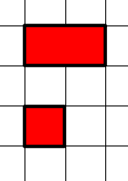  Ask learners:  - What is the area of the square and rectangle?  - What is the perimeter of the square? (Answer: 4cm)  - What is the perimeter of the rectangle? (Answer: 6cm)  Give learners centimetre-squared paper and ask them to design as many capital letters as they can, using rectangles and squares. For example, the letter E:  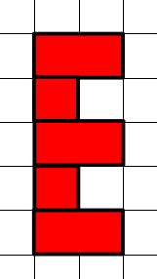  Ask learners:  - What is the area of the E shape? How do you know?  - If the E shape is made of 2 squares and 3 rectangles its perimeter must be 2 × 4cm plus 3 × 6cm = 26cm. Is this correct? Why not? What is its perimeter? (Answer: 18cm)  Once the learners have drawn at least 4 letters (e.g. F, T, H, etc.) they should estimate the areas of each letter. Ask them to cut out each letter and arrange them in order, from largest to smallest area. Ask them to calculate the area of each shape and write it inside the shape (e.g. A = 8cm²). Did they place the shapes in the correct order? Now repeat the activity by arranging them by the size of their perimeters.  Draw the following shapes on the board and ask learners how they could write area and perimeter, making reference to the letters given:  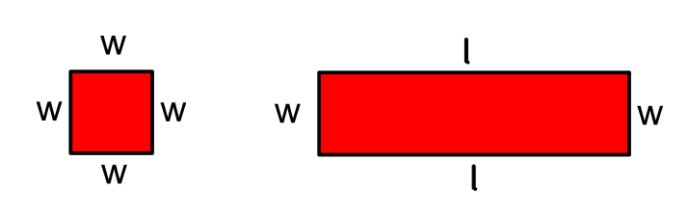  Suggestions may be:  P = w + w + w + w  P = 4 × w  etc.  Explain to learners that they are deriving formulas for the areas and perimeters of squares and rectangles, which can then be used to calculate areas and perimeters of any sized square or rectangle.  Resources:  Centimetre-squared paper | Possible misconceptions:  Learners should take care with the spelling of centimetre and perimeter (different endings despite sounding similar). It may be worth explaining ‘metre’, the metric measure, has its origins in France and is a French word. Whereas, meter is an English word relating to the actual measuring: so perimeter means to ‘measure around’.  Learners often confuse area and perimeter. It is important for them to remember the definition that perimeter is a measure of the boundary of the shape while area is the amount of space within a shape.
4Gg.04 Estimate the area of irregular shapes on a square grid (whole and part squares). | Ask learners to draw a 10cm by 10cm square. Ask learners:  What is the area of the square?  Do you think your hand has a larger or smaller area than this?  Ask learners to estimate the area of their hand. Then ask learners to draw their handprint on centimetre-squared paper:  All the whole squares should be counted, and the remaining squares marked with > or < signs, depending on whether they are more or less than half a square in size.  Ask learners to calculate the area of their handprint. Squares less than half can be rounded down to ‘no’ squares (zero), whilst those more than half can be rounded up to whole squares (1cm²). Or each square less than half is matched with a square more than half so overall, they approximate to a whole square.  Resources:  Centimetre-squared paper | Possible misconceptions:  Learners need to be aware that regular polygons have equal side lengths and equal angles and irregular polygons do not. These are not to be confused when referring to irregular shapes, that tend to imply that the shape is not a standard recognised shape (e.g. not a rectangle or kite, etc.).

Unit 4.3 Topic 3 Recognising and building 3D shapes

Outline of topic:
Learners will explore various 3D shapes by looking at their properties and considering what the nets of these shapes might look like.

Language:
Key vocabulary:
3D shapes, solids
faces, flat faces, curved faces
cylinder, cylindrical
net

Recommended prior knowledge:
- Identify, describe, sort and name 3D shapes by their properties

Learning objectives | Suggested teaching activities and resources | Mental strategies, possible misconceptions and comments
4Gg.05 Identify 2D faces of 3D shapes, and describe their properties. | Ask learners to bring in empty containers from home. In groups of four, they can discuss their objects in terms of the types of 3D shapes that they can see and what types of faces they can recognise.  Ask learners:  - Are there any shapes with circular faces?  - Are there any shapes with curved faces?  Show learners cylindrical shapes, explaining how the curved face can be flattened into a rectangle.  To support the next task on nets, ask learners to pull apart their shapes (particularly ones made of card) to see how they are formed. Ask them if they can they identify which parts are the faces of the 3D shapes and which are the tabs (used for holding the containers together).  Resources:  Selection of everyday containers or 3D shapes (e.g. empty food boxes) | Possible misconceptions:  Learners sometimes incorrectly think that the curved face of a cylinder is flat when it is represented as a rectangle in the net of the shape.
4Gg.06 Match nets to their corresponding 3D shapes. | Give learners four 3D shapes (these can be pictures or the actual solid shapes). Then give them eight nets (four of which are incorrect).  Working in pairs or small groups ask learners to organise their shapes so that each 3D shape is next to its net. Learners should also mark an “X” on any nets that do not match the 3D shapes, placing them next to the shape which they might look similar to even though they are incorrect. They should be able to explain why the net does not represent a 3D shape (e.g. two faces overlap or there is a face missing, etc.).  This activity can be extended by asking learners to take one of their shapes and draw an alternative net on squared paper. Ask them to cut it out and fold it to show that it actually forms the correct shape.  Resources:  Selection of 3D shapes  Eight nets (four correct and four incorrect)

Unit 4.4 Calculation

Learning objectives covered in Unit 4.4 and topic summary: |  | 4.4 Topic 1  Addition and subtraction | 4.4 Topic 2  Multiplication and division | Thinking and Working Mathematically
4Nc.02 | Recognise and explain generalisations when adding and subtracting combinations of even and odd numbers. |  |  | TWM.02 Generalising
4Nc.03 | Recognise the use of objects, shapes or symbols to represent unknown quantities in addition and subtraction calculations.
4Ni.02 | Estimate, add and subtract whole numbers with up to three digits.
4Ni.03 | Understand the associative property of multiplication, and use this to simplify calculations.
4Ni.04 | Know all times tables from 1 to 10.
4Ni.05 | Estimate and multiply whole numbers up to 1000 by 1-digit whole numbers.
4Ni.06 | Estimate and divide whole numbers up to 100 by 1-digit whole numbers. |  |  | TWM.07 Critiquing  TWM.08 Improving

Unit 4.4 Topic 1 Addition and subtraction

Outline of topic:
Learners will find generalisations when adding and subtracting numbers, use symbols to represent numbers and investigate possible solutions.

Language:
Key vocabulary:
odd, even
symbol, unknown
addition, subtraction
column method

Recommended prior knowledge:
- Estimate, add and subtract whole numbers with up to 3 digits

Learning objectives | Suggested teaching activities and resources | Mental strategies, possible misconceptions and comments
4Nc.02 Recognise and explain generalisations when adding and subtracting combinations of even and odd numbers.  TWM.02 Generalising  Recognising an underlying pattern by identifying many examples that satisfy the same mathematical criteria | Ask learners to choose any five odd numbers and add them together.  When they have done this, tell them that all of their answers will be odd.  Let learners confirm this. Then ask them:  How did I know?  Learners should realise why the answer will always be odd when they add any five odd numbers. Can they explain or show why?  Learners can then explore what happens when they add or subtract odd or even numbers to create their own generalisations.  Learners will show they are generalising (TWM.02) when they notice other similar underlying patterns, for example:  - Subtract an even number from an even number. Your answer will be always be even.  - Add any four odd numbers and subtract one even number. Your answer will always be even.  Ask some learners to share their generalisations with the class.  This activity can be extended by using the NRICH task: Always, Sometimes or Never? (https://nrich.maths.org/12670)  Resources:  NRICH task
4Nc.03 Recognise the use of objects, shapes or symbols to represent unknown quantities in addition and subtraction calculations. | Show learners the following three symbol sentences and explain that each shape represents a single different digit number. Also, each symbol sentence has a value of 8.  Can you find the value of each shape?  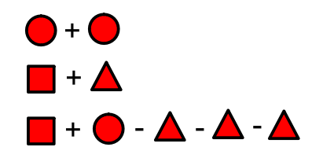  (Answers: circle = 4, square = 7 and triangle = 1)  Now ask learners to see how many symbol sentences they can create that have a value of 10.  Here are some possible solutions:  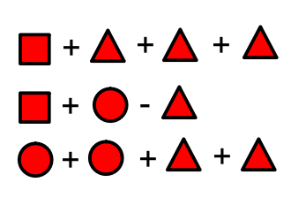
4Ni.02 Estimate, add and subtract whole numbers with up to three digits. | Ask learners to create pairs of 3-digit numbers using dice.  For example, they may generate the numbers 265 and 426. Ask them to find the sum and the difference of these numbers. They can check their answers using calculators.  Ask learners to investigate the types of numbers that can be created using the dice (pair of 3-digit numbers) using these questions:  Ask learners:  - What is the smallest sum that can be made? (Answer: 222)  - What is the largest sum that can be made? (Answer: 1332)  - What is the smallest difference that can be made? (Answer: 0).  - How many ways can this be made? (Answer: 666 - 111 + 1 = 556 ways. Any number taken from itself will give zero and there are 556 numbers that can do this, between 111 and 666.)  - What is the largest difference that can be made? (Answer: 555)  - What sum and difference will be made if numbers are odd/even? Can you give examples?  Resources:  Dice | When finding differences, explain to learners that the larger number needs to be placed on top when using column subtraction.  This last question can be used to review the work done earlier in the unit.

Unit 4.4 Topic 2 Multiplication and division

Outline of topic:
Learners will develop a deeper understanding of multiplying and dividing numbers by considering the associative law and other ways to simplify calculations.

Language:
Key vocabulary:
multiplication, division
associative law
times tables
multiple, factor
square number
halving

Recommended prior knowledge:
- Understand and explain the commutative and distributive properties of multiplication
- Have a good understanding of the times tables (up to 10 x 10)

Learning objectives | Suggested teaching activities and resources | Mental strategies, possible misconceptions and comments
4Ni.03 Understand the associative property of multiplication, and use this to simplify calculations. | Show learners the question 7 × 5 × 6 and ask how they could work this out.  Most learners will calculate 7 × 5 = 35 and then 35 × 6 = 210.  Introduce learners to the associative property of multiplication. Explain that this calculation could also be calculated as 5 × 6 = 30 and then 7 × 30 = 210.  Ask learners:  Which method of calculating 7 × 5 × 6 did you find easier? Why?  Give learners further similar questions and ask learners to consider whether the associative property might help simplify the calculation.  For example:  - 8 × 2 × 4  - 12 × 5 × 2  - 6 × 4 × 3  Learners could also create their own similar questions where the associate law can be applied to find the answer. Select learners to come up to the board and demonstrate how they worked out their answers.  Learners may also draw on their prior knowledge of the commutative law for multiplication from Stage 3 and realise calculations such as 4 x 9 x 5 could be calculated more simply as 4 × 5 × 9 = 20 x 9 = 180. | Learners often confuse this rule with commutativity because it appears as if numbers can be calculated in any order. The important aspect to remember with associativity is that the order remains the same, but the numbers which are calculated first might change.
4Ni.04 Know all times tables from 1 to 10. | In pairs, give learners a 10 by 10 blank grid. Explain this is a times table grid, the first row and column representing the one times table, etc.  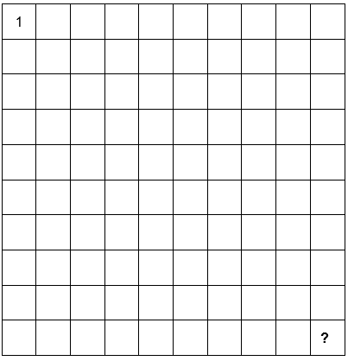  Ask learners:  What value will go into the last square (i.e. the bottom right-hand corner)?  (Answer: 10 × 10 so they should write 100 in this square)  Tell them to enter 1 in the top left-hand corner.  Explain that they are going to play a game where you ask different mathematical questions. Learners need to find and place the answers in the correct squares. Each answer will require them to know their times tables. The winner is the first learner to complete a row or column or one of the diagonals.  Here are some example questions:  - 4 × 3  - A multiple of 5 (you can ask a specific multiple of 5 or ask them to write in any number which is a multiple of 5)  - 7 × 7  - A two-digit even number  - A factor of 20  - A square number  - 6 × 9  The game can be played several times. Ask learners to generate some questions (with answers) that you can randomly select from a box to ask the whole class.  Resources:  Blank 10 by 10 grids | To support learners who may struggle with this, give grids that have the column and row numbers marked out (i.e. 1 to 10). The strength of this activity is, however, in having it completely blank to start with, encouraging learners to look for relationships between numbers.  Give learners sufficient time to think about their answers and work out where to place them.
4Ni.05 Estimate and multiply whole numbers up to 1000 by 1-digit whole numbers. | Give learners a set of cards with the numbers 1, 2, 3, 4, and 5 written on them. Ask learners to arrange the digits 1 to 5 in the order shown:  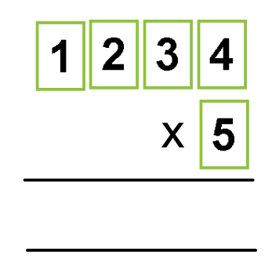  Ask learners:  Will the answer be greater than 5000?  How do you know?  Ask learners if they can estimate more accurately what the answer will be. (Their estimates should be close to 6000, since there are 5 lots of 200 and 5 lots of 1000). Now ask the learners to calculate the actual answer. (Answer: 6170)  Using the 1-5 cards, ask learners if it is possible to get an answer greater than 6170 if they use 4 as the multiplier (yes, for example 5231 × 4 = 20 924).  What is the largest possible answer you can make using the cards?  (4321 × 5 = 21 605)  Ask learners to explain, making reference to place value, why 4321 × 5 is bigger than 5321 × 4. Explain to learners that 4000 × 5 is the same as 5000 × 4, reinforcing the associative law.  Resources:  1-5 digit cards | This activity reinforces understanding of place value.  For all attempts, they can only multiply by a one-digit number.
4Ni.06 Estimate and divide whole numbers up to 100 by 1-digit whole numbers.  TWM.07 Critiquing  Comparing and evaluating mathematical ideas, representations or solutions to identify advantages and disadvantages  TWM.08 Improving  Refining mathematical ideas or representations to develop a more effective approach or solution | Ask learners to find three different ways to calculate 864 ÷ 8  For example, learners might use short division, or they might divide by 4 and then divide by 2, or they might halve the number three times. They might also immediately see that 800 ÷ 8 = 100 and 64 ÷ 8 = 8 so 864 ÷ 8 = 108.  Ask learners:  What are the advantages and disadvantages of the different strategies for this calculation?  Using a written strategy, such as short division, may be easiest for some learners, but may require paper. Other learners may find halving three times is possible for them to do mentally. Other strategies may be more prone to error. One strategy might be better for some numbers and not for others.  Give learners other questions to calculate so that they can try different strategies for calculating the answers.  Learners will show they are critiquing (TWM.07) when they compare the different strategies to identify advantages and disadvantages of each. They will show they are improving (TWM.08) when the select a more effective strategy and can explain why it is more effective. | Possible misconceptions:  Some learners may incorrectly think that dividing by 2 four times is equivalent to dividing by 8, because 2 + 2 + 2 + 2 = 8.

Unit 4.5 Statistical methods

Learning objectives covered in Unit 4.5 and topic summary: |  | 4.5 Topic 1  Collecting data | 4.5 Topic 2  Presenting and interpreting data | 4.5 Topic 3  The statistical cycle | Thinking and Working Mathematically
4Ss.01 | Plan and conduct an investigation to answer statistical questions, considering what data to collect (categorical and discrete data). |  |  |  | TWM.07 Critiquing  TWM.08 Improving
4Ss.02 | Record, organise and represent categorical and discrete data. Choose and explain which representation to use in a given situation:  - Venn and Carroll diagrams  - tally charts and frequency tables  - pictograms and bar charts  - dot plots (one dot per count).
4Ss.03 | Interpret data, identifying similarities and variations, within and between data sets, to answer statistical questions. Discuss conclusions, considering the sources of variation.

Unit 4.5 Topic 1 Collecting data

Outline of topic:
Learners will plan and design a questionnaire and then, by trialling it, look for ways to improve the questions asked in order to gain better responses to statistical questions.

Language:
Key vocabulary:
investigation
questionnaire
information
categorical and discrete data

Recommended prior knowledge:
- Recognise different types of data (formal definitions such as categorical and discrete data are not required)
- Familiar with the layout of a questionnaire

Learning objectives | Suggested teaching activities and resources | Mental strategies, possible misconceptions and comments
4Ss.01 Plan and conduct an investigation to answer statistical questions, considering what data to collect (categorical and discrete data).  TWM.07 Critiquing  Comparing and evaluating mathematical ideas, representations or solutions to identify advantages and disadvantages  TWM.08 Improving  Refining mathematical ideas or representations to develop a more effective approach or solution | Ask learners to work in pairs to design a questionnaire to find out information for a new café opening near their school.  Learners should think about what questions would provide helpful information for the café owner such as:  - What food and drink people would like to buy  - How much people would pay for their food and drink  - What time the café should open and close.  Now ask learners to swap their questionnaires with another pair and try to answer each other’s questions. As they are doing this, they should also annotate the questionnaire with any problems they find.  Learners will show they are critiquing (TWM.07) when they evaluate the questionnaire and explain any possible problems with the design.  Ask learners to return the questionnaires, read the comments the other pair has written and then try to improve their original design. Learners will show they are improving (TWM.08) when they act on the advice of the other learners to refine their questions and develop a more effective questionnaire.

Unit 4.5 Topic 2 Presenting and interpreting data

Outline of topic:
Learners will consider ways of recording and representing data. In analysing the data, learners will be able to draw conclusions in response to statistical questions, thinking about similarities and differences and sources of variation.

Language:
Key vocabulary:
record, organise, represent
tally, chart, block graph, bar chart
interpret
source of variation

Recommended prior knowledge:
- Record, organise and represent categorical and discrete data (formal definitions such as categorical and discrete data are not required)
- Interpret data, identifying similarities and variations

Learning objectives | Suggested teaching activities and resources | Mental strategies, possible misconceptions and comments
4Ss.02 Record, organise and represent categorical and discrete data. Choose and explain which representation to use in a given situation:  - Venn and Carroll diagrams  - tally charts and frequency tables  - pictograms and bar charts  - dot plots (one dot per count). | Give learners the NRICH task: Class 5’s Names (https://nrich.maths.org/7522).  Ask learners to consider the effectiveness and usefulness of the different representations of the data that the activity asks them to create.  Ask learners to add axes to the block graph so that it becomes a bar chart.  The same activity can be completed with the names of your learners.  A similar activity could be completed for discrete data, such as recording, organising and representing the number of siblings of each learner in the class.  Resources:  NRICH task | The last part of the NRICH task shows part of a block graph. The activity is good for looking at patterns, but the quantities are not obvious.
4Ss.03 Interpret data, identifying similarities and variations, within and between data sets, to answer statistical questions. Discuss conclusions, considering the sources of variation. | A plant grower wants to find the best conditions for her seeds to grow. She plants 20 seeds in a tray of ordinary soil and then 20 seeds in a tray of fertilised soil. After two months of growth, she measures their heights in centimetres:  Tray A (no fertiliser):  5, 6, 8, 7, 6, 8, 5, 4, 6, 7, 6, 7, 5, 6, 5, 6, 7, 6, 8, 4  Tray B (with fertiliser):  7, 6, 9, 7, 7, 10, 6, 7, 6, 7, 8, 8, 7, 6, 8, 6, 7, 7, 8, 6  Ask learners:  - In which tray did the seeds grow more?  - How can we best represent these results?  (Learners could organise the data and draw some suitable graphs.)  - Are there any similarities or differences in the results?  - Which heights occurred the most for each tray? (6cm in tray A and 7cm in tray B)  - How much more did the seeds grow in tray B? (comparing 6cm and 7cm learners may suggest 1cm, but they should compare all the heights)  Ask learners to consider the differences between the shortest and tallest plants (both have 2cm differences).  - What is the difference in the total of heights of both trays of plants? (122cm in tray A and 143cm in tray B so 21cm difference) | Explain to learners that measurements of plants are unlikely to be accurate. So, the heights are recorded to the nearest cm. Learners should appreciate that they could also be measured to the nearest mm or even nearest tenth of a mm, etc.  Help learners to see that 21cm difference in total tray height for 10 plants represents 2.1cm difference per plant.

Unit 4.5 Topic 3 The statistical cycle

Outline of topic:
Learners will conduct an experiment so that they can respond to a statistical question. They will consider how they can record the data and organise it in a way that best responds to the statistical question. By drawing relevant graphs and analysing the data, they will be able to make conclusions and also consider other sources of variation, which they can investigate further.

Language:
Key vocabulary:
statistical question
data, record, organise, represent
table, tally, chart, block graph, bar chart, pictogram
interpret
source of variation

Recommended prior knowledge:
- Record, organise and represent categorical and discrete data
- Interpret data, identifying similarities and variations

Learning objectives | Suggested teaching activities and resources | Mental strategies, possible misconceptions and comments
4Ss.01 Plan and conduct an investigation to answer statistical questions, considering what data to collect (categorical and discrete data).  4Ss.02 Record, organise and represent categorical and discrete data. Choose and explain which representation to use in a given situation:  - Venn and Carroll diagrams  - tally charts and frequency tables  - pictograms and bar charts  - dot plots (one dot per count).  4Ss.03 Interpret data, identifying similarities and variations, within and between data sets, to answer statistical questions. Discuss conclusions, considering the sources of variation. | Research suggests that we can work twice as fast with our dominant hand compared with our non-dominant hand. To test this suggestion, ask learners to conduct this simple experiment:  Ask learners to draw a 10cm x 10cm grid on two pieces of centimetre-squared paper (creating 100 squares on each). Set a time of 30 seconds and ask learners to put as many crosses (X or +) in the boxes as possible, using their dominant hand (right hand for most learners). Any crosses not complete (i.e. the 2 lines do not cross) or any crosses that do not fit fully inside the boxes, should not be counted.  Ask learners to repeat the activity in the second grid, this time using their non-dominant hand (left hand for most learners).  To analyse this data, learners will consider the research that suggests that they will draw twice as many (double) crosses with their dominant hand. For example, Tom scored 24 with his non-dominant hand and 46 with his dominant hand. Doubling 24 he gets 48, but 46 is less than 48 by 2, so the difference from the double is -2.  Learners can produce a tally table to record this data (e.g. with headings of -8 or less, -7 to -3, -2 to 2, 3 to 7 and 8 or more).  Once the results are recorded for the whole class, ask if these groupings can be improved.  Ask learners:  - Would it be fair to say the group -2 to 2 would show the dominant hand is twice as fast?  - What if we chose 0 to represent this? (too precise, groups not equal in size and not enough data)  - How could the other groups be renamed? (e.g. far more than double, etc.)  Learners should work in pairs or small groups to discuss how to organise and represent the data. They should then create the different representations.  Ask learners:  What conclusions can you draw from the tables and graphs?  If the experiment was repeated several times, would the results be any different? (yes, more crosses filled in, having practised the skill, particularly for the non-dominant hand which will have been completely unfamiliar with the activity the first time)  If time is available, repeat the experiment to see if this is true. Explain to learners that in doing this they are also answering a statistical question.  Resources:  Centimetre-squared paper | Learners conduct simple statistics investigations as part of a four-part statistical enquiry cycle:  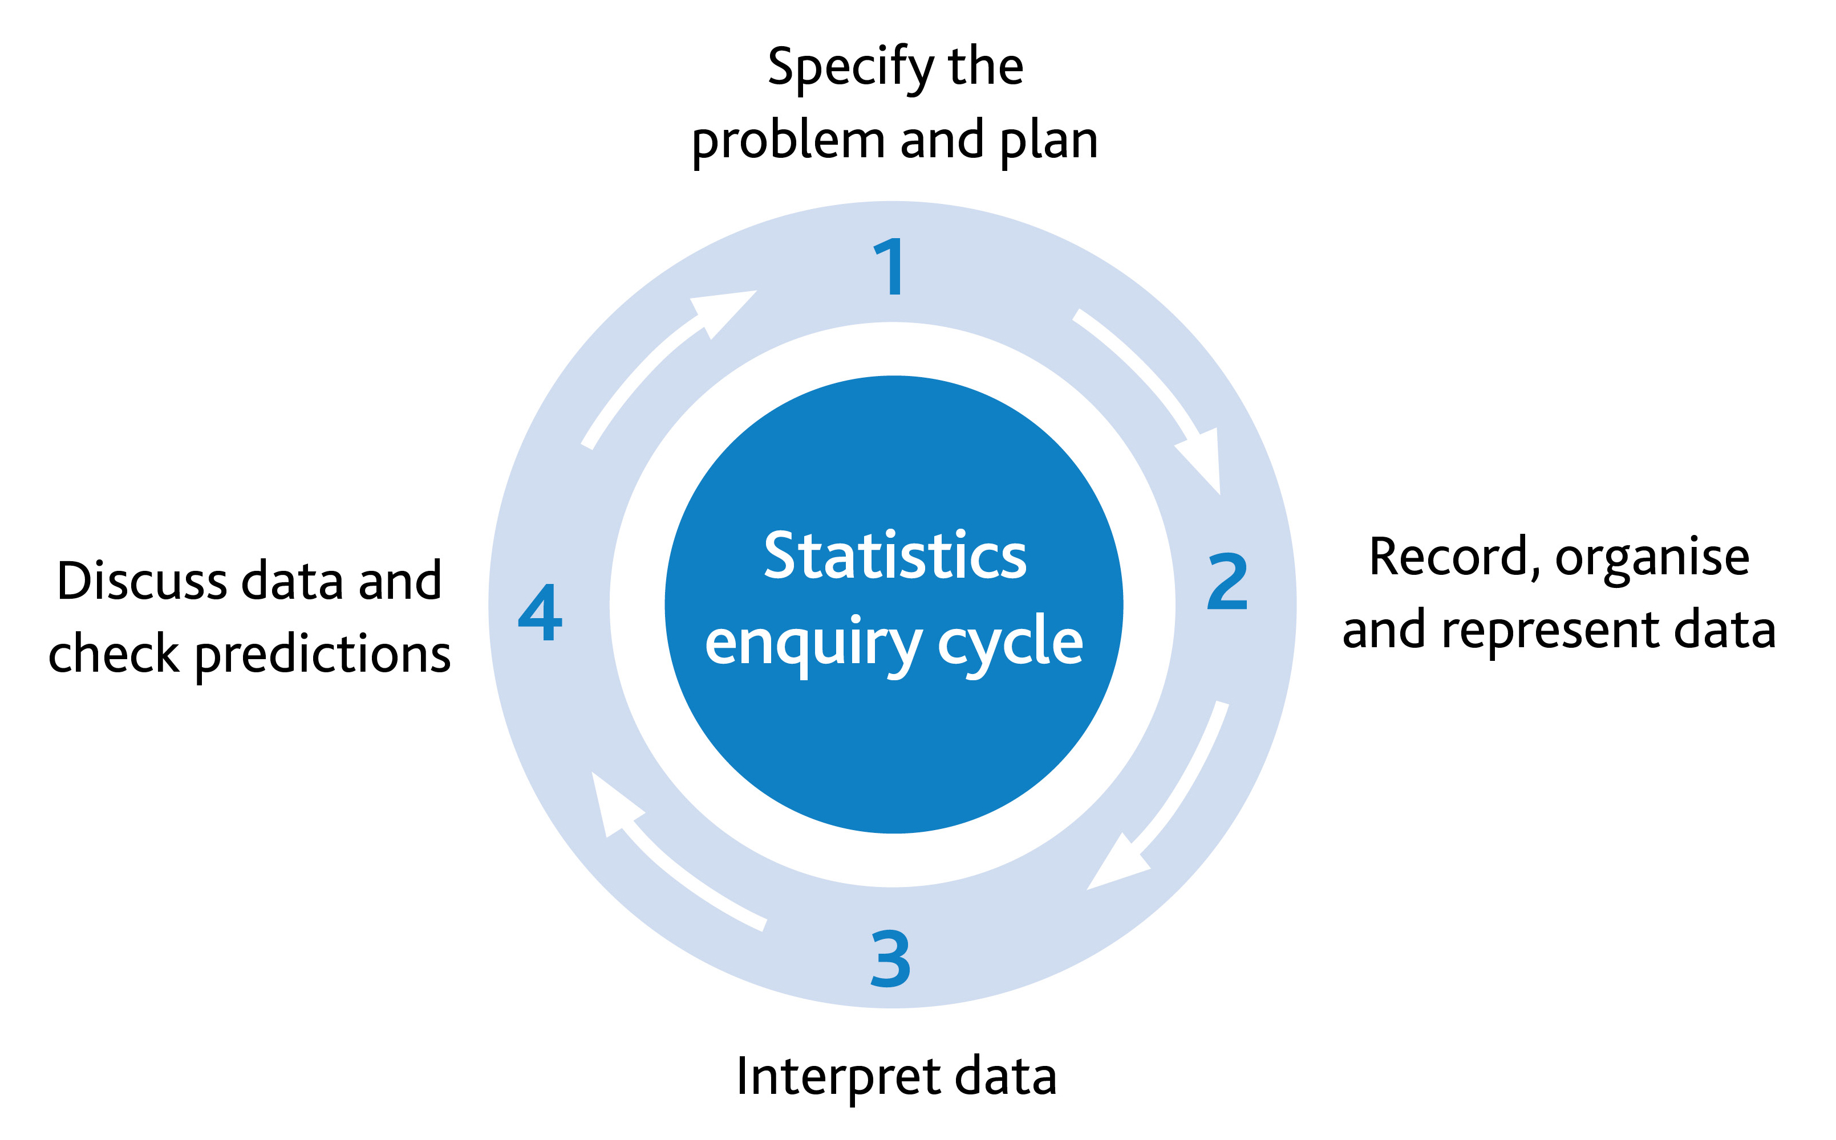

Unit 4.6 Fractions and percentages

Learning objectives covered in Unit 4.6 and topic summary: |  | 4.6 Topic 1  Understanding fractions | 4.6 Topic 2  Calculating with fractions | 4.6 Topic 3  Percentages and equivalence | Thinking and Working Mathematically
4Nf.01 | Understand that the more parts a whole is divided into, the smaller the parts become.
4Nf.02 | Understand that a fraction can be represented as a division of the numerator by the denominator (unit fractions and three-quarters).
4Nf.03 | Understand that unit fractions can act as operators.
4Nf.04 | Recognise that two proper fractions can have an equivalent value.
4Nf.05 | Estimate, add and subtract fractions with the same denominator.
4Nf.06 | Understand percentage as the number of parts in each hundred, and use the percentage symbol (%).
4Nf.07 | Use knowledge of equivalence to compare and order proper fractions, using the symbols =, > and <. |  |  |  | TWM.01 Specialising  TWM.04 Convincing
4Gg.09 | Use knowledge of fractions to read and interpret a measuring scale.

Unit 4.6 Topic 1 Understanding fractions

Outline of topic:
Learners will consider how fractions can be read and shown in different contexts, using circles, rectangles and measuring jugs. They will also be able to recognise equivalent fractions and appreciate the connection between fractions and division.

Language:
Key vocabulary:
fraction, numerator, denominator
equal parts, whole
half, halves, halve
quarter, three-quarters
divide, division, share
equivalent
scale

Key phrases:
Divide into …
Divided by …
Is equivalent to …

Recommended prior knowledge:
- Understand that an object or shape can be split into equal parts
- Understand that a half and a quarter can describe two or four equal parts respectively
- Understand that a fraction can be represented as a division of the numerator by the denominator

Learning objectives | Suggested teaching activities and resources | Mental strategies, possible misconceptions and comments
4Nf.01 Understand that the more parts a whole is divided into, the smaller the parts become.  4Nf.02 Understand that a fraction can be represented as a division of the numerator by the denominator (unit fractions and three-quarters). | Show learners these diagrams:  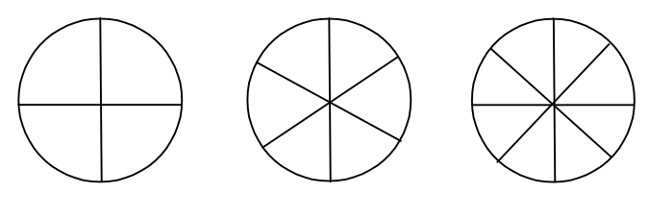  Each circle represents a cake and how it can be cut into equal parts. Ask the learners to describe each cake in different ways (e.g. 4 equal slices … each slice is a quarter, etc.).  Give learners two blank circles and ask them:  - If you divide my cake into 16 pieces would there be more cake? (No, it is still the same size cake, but each piece is smaller). Ask learners to do this by sub-dividing one of the circles: halves to quarters to eighths to sixteenths.  - If my cake was divided into just two pieces, I have less cake than the one with 16 pieces. Put your hands up if you agree. Why is this not true?  - If I divide my cake into 100 slices, how big would the slices be?  - As the size of the slices get smaller will there be more or less slices?  - What’s the largest slice we can divide the cake into? Learners may say 1 or 2 slices. Whilst you could argue that 1 cannot be an answer as the cake has not been divided, with fractions 1 is theoretically acceptable. (The cake is divided into 1 equal part and 1 part is taken – all of it! This person does like sharing with others.)  Ask learners to divide the second blank circle into equal pieces in a way that has not yet been shown and not into halves. Ask learners to explain how they have divided it. Show learners how sixths can be adapted (rub out every other line to make thirds or subdivided to make twelfths).  This activity can be repeated using a ‘chocolate bar’ that is drawn on a grid of 12 squares (allowing it to be divided easily into thirds and quarters, etc.).  Resources:  Blank circles  Returning to the cake examples above, remind learners what the word ‘divided’ means. Explain that we can use division when calculating fractions. When one whole cake is divided into 4 pieces it can be written as 1 ÷ 4.  Ask learners:  How can you express 1 ÷ 4 as a fraction?  (Answer = $\frac{1}{4}$. 1 whole cake divided by 4 will give $\frac{1}{4}$ cake, a slice that is $\frac{1}{4}$ of the size of the whole cake.)  Ask learners to make up other divisions where 1 whole (using other items) is divided. They should describe the fraction they have made each time.  Show the learners the fraction $\frac{3}{4}$ and ask what division this would represent. Use 3 whole cakes to demonstrate how $\frac{3}{4}$ is made:  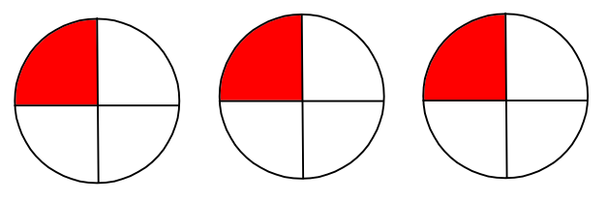  Ask learners:  - Do you agree that the 3 whole cakes have each been divided by 4?  - How many quarters are there all together? (Three, in other words $\frac{3}{4}$)  Learners may see this more clearly if they cut out a quarter of each cake and place the 3 pieces together to make $\frac{3}{4}$ as in the diagram below:    This activity can be extended by asking learners to give an example to show that 2 ÷ 3 = $\frac{2}{3}$ | During this activity it is important to refer to the idea of a ‘whole’ (e.g. a ‘whole’ cake, rather than saying a ‘cake’) as this will reinforce the idea of parts of a whole.  Possible misconceptions:  Learners will not be used to seeing division where the first number is smaller than the divisor. They may be tempted to see 1 ÷ 4 as 4. Use the cake example to challenge this. If I have 1 cake and divide it by 4 will I get 4 cakes?
4Nf.04 Recognise that two proper fractions can have an equivalent value. | Give learners a worksheet with 12 circles on as shown below. Ask learners to use the top row of circles to show how the other two circles can show equivalents.  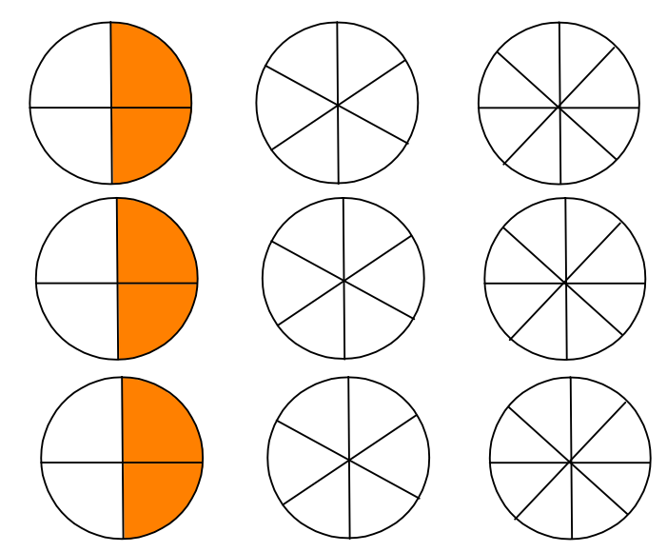  Can the learners find other ways of showing equivalents of one half using the remaining circles? It is important for learners to understand that the coloured parts do not have to be on the same side and next to each other as shown:  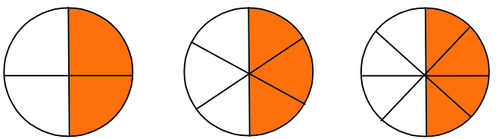  Learners should label their circles with the fractions that are coloured: $\frac{2}{4}$, $\frac{3}{6}$, $\frac{4}{8}$ etc.  This activity can be extended by asking learners to demonstrate equivalents for a half using diagrams of 3 × 4 rectangles. Also use other representations such as bunches of flowers.  Resources:  Worksheets with 12 circles on as shown in the diagram above | Learners often become confused by unusual representations of fractions because they are used to the pie, pizza, cake or chocolate bar models. Show fractions in different ways that demonstrate fractions of quantities as well as fractions of shapes, e.g. fractions of bunches of flowers, fractions of quantities of money in a wallet.
4Gg.09 Use knowledge of fractions to read and interpret a measuring scale. | Give learners a large image of a large measuring jug that can hold 4 litres of water:  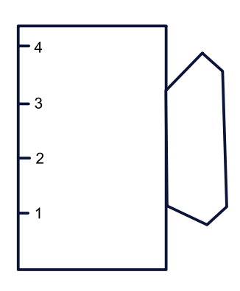  Ask learners where they might see fractions being used on the measuring scale on the side of the jug. Discuss what half a litre might look like, etc.  Ask learners to draw on their diagrams any quantity of water involving halves or quarters. They should colour in the quantity and mark clearly what amount is shown. Ask each learner to show the class their jug, explaining how much water is in it.  On a new jug, ask learners if they can show 2$\frac{3}{4}$ litres.  Can learners describe how much water is in the jug when it is filled to the very top? (Best estimate: 4$\frac{1}{3}$ litres. They need to visualise the whole between 4 and 5, which is only partly visible.)  Resources:  Diagrams of large measuring jugs | Whilst the fractions here are part way along a number line, reinforce the concept of being part of a whole. For example, from 1 to 2 is a whole unit, so to show 1$\frac{1}{2}$ we must fill to 1 then halfway to 2. The difference here compared with normal fraction shading is that the amounts must be shown in a particular order. You can’t shade between 0 and 1 and then between 2 and 2$\frac{1}{2}$ to show 1 $\frac{1}{2}$.

Unit 4.6 Topic 2 Calculating with fractions

Outline of topic:
Learners will find fractions of amounts and see how fractions can be added and subtracted.

Language:
Key vocabulary:
unit fraction
numerator, denominator

Key phrases:
Divide by …
Fraction of …

Recommended prior knowledge:
- To find one half and one quarter of an amount
- Add simple fractions within one whole using the same denominator (e.g. $\frac{1}{4}$ + $\frac{3}{4}$ = 1)

Learning objectives | Suggested teaching activities and resources | Mental strategies, possible misconceptions and comments
4Nf.03 Understand that unit fractions can act as operators. | In the Roman era, Emperor Augustus wanted to tax goods that were sold at auction and decided that $\frac{1}{100}$ of the value of each item should be given to the emperor.  If a chariot was sold for 500 denarii (the Roman currency), how many denarii would the Emperor be given? (500 ÷ 100 = 5 denarii)  Learners should understand that the answer will be less than 500 because $\frac{1}{100}$ of something is the same as dividing the value by 100.  Ask learners what $\frac{1}{2}$ is the same as (dividing by 2). Ask similar questions for other unit fractions.  In pairs, ask learners to create a new tax rule tax rule for another aspect of Roman life and then give examples. This does not have to be monetary. (For example, a farmer must give $\frac{1}{5}$ of all his sheep to the Emperor. He has 100 sheep.) | Denarii is plural of denarius.
4Nf.05 Estimate, add and subtract fractions with the same denominator. | Write a list of fraction questions with on the board e.g. $\frac{1}{5}$ + $\frac{2}{5}$ = ?  Randomly distribute cards with fractions written on them to learners (e.g. one learner has $\frac{1}{5}$, another has $\frac{2}{5}$ and another has $\frac{3}{5}$). On the command ‘GO’ learners need to find their trio partners in order to make a correct number sentence. Once they have joined, they record the answer to the questions in their books. They can also think of how the cards can be re-arranged to make subtractions (e.g. $\frac{3}{5}$ - $\frac{2}{5}$ = $\frac{1}{5}$). Collect all the cards, shuffle them and then repeat the activity. This can be done several times, so that learners record several number sentences involving fractions.  Resources:  Cards with fractions written on them

Unit 4.6 Topic 3 Percentages and equivalence

Outline of topic:
Learners will be introduced to percentages, recognising that they are a special type of fractions, where the denominator is 100. Learners will also recognise the size of fractions and compare fractions of the same amount.

Language:
Key vocabulary:
percent (%), percentage
fraction
quantity, part, whole
order, compare, greater than, less than

Key phrases:
Out of a hundred
Percentage of …

Recommended prior knowledge:
- Use knowledge of equivalence to order and compare unit fractions, and fractions with the same denominator using the symbols > and <
- Understand the relevance of the terms denominator and numerator

Learning objectives | Suggested teaching activities and resources | Mental strategies, possible misconceptions and comments
4Nf.06 Understand percentage as the number of parts in each hundred, and use the percentage symbol (%). | Remind learners of the activity where the Emperor’s tax on goods sold at auction was $\frac{1}{100}$ . Inform them that this was the first time ever that percentages were used and that our word percentage comes from the Latin per centum which means ‘by the hundred’.  Ask learners to draw a 10cm x 10cm grid on centimetre-squared paper, so there are 100 small squares.  Ask learners to colour in any number of squares and express the amount shown as:  - a quantity (e.g. 23 blue squares)  - a fraction (e.g. $\frac{23}{100}$)  - a percentage (e.g. 23%)  They can then colour in the remaining squares a different colour.  What do you notice about the totals? (The total is 100 squares; $\frac{100}{100}$ or 1 whole; 100%)  Ask learners to draw more 100 square grids and on each one show different ways of showing 25%.  Ask learners to draw one of their grids so that it is not 25%, but close to 25%. Learners can swap their diagrams and then see if they can notice which ones are not 25%.  Resources:  Centimetre-squared paper | Learners often only consider one visual representation of $\frac{1}{4}$. This activity helps to reinforce different ways 25% can be shown.
4Nf.07 Use knowledge of equivalence to compare and order proper fractions, using the symbols =, > and <.  TWM.01 Specialising  Choosing an example and checking to see if it satisfies or does not satisfy specific mathematical criteria  TWM.04 Convincing  Presenting evidence to justify or challenge a mathematical idea or solution | Ask learners to find 4 possible fractions that could go in the box:  $$\frac{1}{4} < < \frac{11}{12}$$  Learners will show they are specialising (TWM.01) when they choose examples of fractions and check to see whether their answer is correct.  Ask learners:  How do you know that the fractions you have found are between$\frac{1}{4}$ and $\frac{11}{12}$ ?  Now ask learners to order their four fractions to fit in the boxes below:  < < <  Ask learners:  How do you know that the order is correct?  Learners will show they are convincing (TWM.04) when they use knowledge of equivalence of fractions to justify why the ordering is correct. | Encourage learners to use physical resources or diagrams to find and check their answers.  $$\frac{1}{4}$$  $$\frac{11}{12}$$

Unit 4.7 Angles, position and direction

Learning objectives covered in Unit 4.7 and topic summary: |  | 4.7 Topic 1  Angles | 4.7 Topic 2  Position and direction | Thinking and Working Mathematically
4Gg.08 | Estimate, compare and classify angles, using geometric vocabulary including acute, right and obtuse. |  |  | TWM.05 Characterising  TWM.06 Classifying
4Gp.01 | Interpret and create descriptions of position, direction and movement, including reference to cardinal and ordinal points, and their notations.
4Gp.02 | Understand that position can be described using coordinate notation. Read and plot coordinates in the first quadrant (with the aid of a grid). |  |  | TWM.05 Characterising  TWM.06 Classifying

Unit 4.7 Topic 1 Angles

Outline of topic:
Learners will be introduced to a range of angles and find ways of comparing sizes and categorising them.

Language:
Key vocabulary:
angle, acute, right angle, obtuse

Recommended prior knowledge:
- Understand that an angle is a description of a turn
- Know what a right angle is and what it looks like

Learning objectives | Suggested teaching activities and resources | Mental strategies, possible misconceptions and comments
4Gg.08 Estimate, compare and classify angles, using geometric vocabulary including acute, right and obtuse.  TWM.05 Characterising  Identifying and describing the mathematical properties of an object  TWM.06 Classifying  Organising objects into groups according to their mathematical properties | 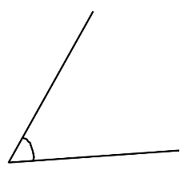  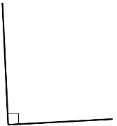  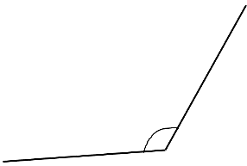    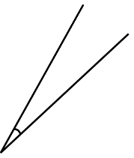    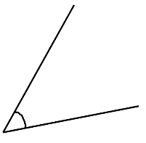  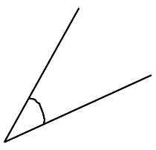  Give learners a selection of drawn angles and ask them to sort them into different categories. Learners should be able to explain how they have sorted the angles and the properties of the angles in each group.  Learners will show they are characterising (TWM.05) when they identify a property of the angles which they could use to sort them. They will show they are classifying (TWM.06) when they organise the angles according to the properties they have identified.  Ask some learners to share their ideas with the rest of the class.  Then introduce learners to the definitions of acute, right and obtuse angles and ask them to classify the angles again, but this time into the three groups: acute angles, right angles and obtuse angles.  Once learners have sorted the angles into acute, right and obtuse angles, ask them to estimate the size of each angle.  Resources:  Selection of angles | At first, learners may decide to classify the angles based on size, but might not know the traditional categories of acute, right and obtuse. For example, they might at first use less well-defined categories of ‘small’, ‘medium’ and ‘large’. They might also focus on other properties of the angles, such as noticing the 90-degree angle is presented with a square symbol, whereas the other angles use the conventional arc.

Unit 4.7 Topic 2 Position and direction

Outline of topic:
Learners will describe movement giving compass directions (cardinal and ordinal points) and will also consider how coordinates are used to mark locations.

Language:
Key vocabulary:
direction, movement
compass directions
north, north-east, east, south-east, south, south-west, west, north-west
coordinates
grid
x-axis, y-axis, axes
quadrant

Key phrases:
Plot the point (… , …)

Recommended prior knowledge:
- Understand that cardinal points (north, east, south and west) are at 90º on a compass
- Understand that position can be described using coordinates
- Read and plot points in the first quadrant

Learning objectives | Suggested teaching activities and resources | Mental strategies, possible misconceptions and comments
4Gp.01 Interpret and create descriptions of position, direction and movement, including reference to cardinal and ordinal points, and their notations. | Explain that cardinal points and ordinal points are shown on compasses. Cardinal points are north (N), east (E), south (S) and west (W) and ordinal points are north-east (NE), south-east (SE), south-west (SW) and north-west (NW).  Give learners the diagram below:  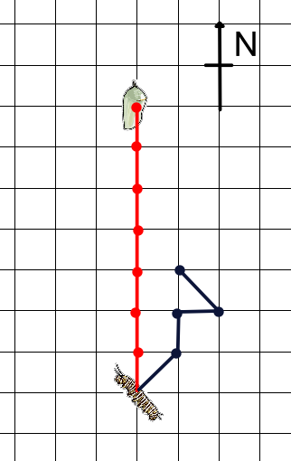  The caterpillar at the bottom of the grid needs to reach the location shown at the top of the grid to build its cocoon. The most direct route is N (North), N, N, N, N, N and N (as show by the red lines). The caterpillar may decide to travel in a different route as shown by the black lines: NE (north-east), N, E, NW …. Ask learners to complete this route then describe the route to a partner using cardinal and ordinal descriptions. The partner should draw the route described.  Ask learners what the effect is of moving one square NE and then immediately one square SW? (They cancel each other, so you return to the previous point)  Ask learners to create another route in a different colour. As a challenge, suggest they use all 8 compass directions. Ask a learner to share their journey and write the directions on the board.  Ask learners:  Are there any directions that can cancel each other out?  What do you notice about most of the directions? (Most involve the north direction)  Resources:  Copies of the diagram
4Gp.02 Understand that position can be described using coordinate notation. Read and plot coordinates in the first quadrant (with the aid of a grid).  TWM.05 Characterising  Identifying and describing the mathematical properties of an object  TWM.06 Classifying  Organising objects into groups according to their mathematical properties | Introduce the concept of co-ordinates using the NRICH task: Two Number Lines (https://nrich.maths.org/5653), which helps learners to explore the relationship between number lines and coordinates.  Ask learners to write three pairs of coordinates in the first quadrant, for example (2, 3), (4, 5) and (1, 7) and ask them to plot them on a grid. Then ask learners to join their three coordinates with straight lines.  Ask learners:  - What shape have the coordinates made?  - Compare your answer with another learner. What is the same and what is different about your shapes?  Learners will show they are characterising (TWM.05) when they identify and describe the mathematical properties of the shape they have created. Most learners will have drawn a triangle, but some may have plotted all three coordinates on a straight line, for example (1, 3), (1, 5), (1, 6).  Give learners several more sets of three coordinates, for example:  - (4, 3), (2, 5), (9, 6)  - (8, 3), (5, 3), (9, 3)  - (5, 2), (9, 1), (3, 6)  - (2, 2), (2, 5), (2, 3)  - (1, 3), (2, 5), (3, 7)  - (9, 3), (7, 5), (5, 7)  - (4, 3), (6, 5), (1, 0)  Ask learners to classify the sets of coordinates into those that create a triangle and those that create a straight line. Learners will show they are classifying (TWM.06) when they organise the sets of coordinates into two groups according to the shape they make when plotted.  Resources:  NRICH task | Explain to learners that when reading coordinate pairs, the x coordinate is read first and the y coordinate second. Use strategies for remembering x first y second, such as x comes before y in the alphabet.

Unit 4.8 Probability

Learning objectives covered in Unit 4.8 and topic summary: |  | 4.8 Topic 1  Describing chance | 4.8 Topic 2  Conducting experiments | Thinking and Working Mathematically
4Sp.01 | Use language associated with chance to describe familiar events, including reference to maybe, likely, certain, impossible.
4Sp.02 | Conduct chance experiments, using small and large numbers of trials, and present and describe the results using the language of probability.

Unit 4.8 Topic 1 Describing chance

Outline of topic:
Learners will become more familiar with the language of probability and see how it is used in everyday contexts.

Language:
Key vocabulary:
probability
impossible, certain
likely, unlikely
even chance

Key phrases:
What is the chance of …
What is the probability of …

Recommended prior knowledge:
- Use familiar language associated with chance to describe events, including reference to ‘it will happen’, ‘it will not happen’, ‘it might happen’

Learning objectives | Suggested teaching activities and resources | Mental strategies, possible misconceptions and comments
4Sp.01 Use language associated with chance to describe familiar events, including reference to maybe, likely, certain, impossible. | Show learners a selection of familiar events and ask them to discuss in pairs. For example:  - Tomorrow it will rain  - I will come to school on Saturday  - I will play football at lunchtime today  - When I flip a coin it will show tails  Select pairs of learners to share their discussion with the class. Encourage learners to use the language of chance, including maybe, likely, certain and impossible.  Give learners the NRICH task: Probable Words (https://nrich.maths.org/7247).  This NRICH task can be used to encourage learners to use the language of probability, and to consider the relative likelihood or ‘risk’ of events described.  Resources:  NRICH task

Unit 4.8 Topic 2 Conducting experiments

Outline of topic:
Learners will investigate a dice game and think about the likelihood of getting certain outcomes.

Language:
Key vocabulary:
probability
outcome
impossible, certain
likely, unlikely
even chance
trials

Key phrases:
What is the chance of …
What is the probability of …

Recommended prior knowledge:
- Use familiar language associated with chance to describe events, including likely, certain, impossible
- Conduct chance experiments, and present and describe the results

Learning objectives | Suggested teaching activities and resources | Mental strategies, possible misconceptions and comments
4Sp.02 Conduct chance experiments, using small and large numbers of trials, and present and describe the results using the language of probability. | Explain to learners how a game of Ludo works and that you need to roll a 6 on a die in order to begin playing.  Ask learners:  - How many turns will a player have to wait before they can move? (Answer: 1 or more)  - Is it possible that someone may never get a 6?  - How many rolls do you think most people would have to wait before being able to begin? (Learners should estimate this before they try this for themselves later in this activity.)  - How could you change the rules to make it more likely to start the game quicker? (For example, roll a number less than 3, or an even number, or any number less than 6) Discuss the chances of starting for each of these scenarios (e.g. ‘almost certain to start’ for ‘any number less than 6’).  Ask learners to roll a die and record how many times they have to roll it before they get a 6. Collate three learners’ results to see which result was recorded the most. (It is likely that all three will be different.)  Then collate the whole class’ results. See if learners can identify any patterns (e.g. 3 and 4 turns seem most common). Ask learners if they think collecting more results will help determine better probabilities of events happening.  Ask learners to write statements from this data. (For example, the chance of scoring a 6 after 3 turns is likely or the chance of scoring a 6 after 10 turns is almost certain, etc.)  Ask learners, working in small groups, to choose a starting rule (e.g. throw an even number) and then see how the results differ (e.g. there is a greater chance of starting when rolling an even number and you are very likely to get an even number after three throws). | The game of Ludo is a game played by moving counters on a board where players must roll 6 on a die to start the game.  Possible misconceptions:  Learners may assume that since there are 6 numbers on the die, a 6 is certain to show after 6 throws. However, they will learn from this activity that probability is always an estimate and will rarely yield exact results.

Sample lesson 1

CLASS:

DATE:
Learning objectives | 4Gg.02 Estimate and measure perimeter and area of 2D shapes, understanding that two areas can be added together to calculate the area of a compound shape.  4Gg.03 Draw rectangles and squares on square grids, and measure their perimeter and area. Derive and use formulae to calculate areas and perimeters of rectangles and squares.
Lesson focus /  success criteria | Learners will be able to distinguish between area and perimeter and learn how these can be calculated with compound shapes.  - I can find the perimeters of squares, rectangles and compound shapes (formed of squares and rectangles)  - I can find the areas of squares, rectangles and compound shapes (formed of squares and rectangles)  - I can derive formulae that allow me to calculate areas and perimeters of any square or rectangle
Prior knowledge /  previous learning | Learners will be familiar with different 2D shapes and have a basic knowledge of how to find their perimeters and areas.
Plan
Lesson | Planned activities | Notes
Introduction | Show learners the learning objectives and lesson focus and agree the success criteria:  - I can find the perimeters of squares, rectangles and compound shapes (formed of squares and rectangles)  - I can find the areas of squares, rectangles and compound shapes (formed of squares and rectangles)  - I can derive formulae that allow me to calculate areas and perimeters of any square or rectangle  Ask learners which upper case letters can be made with just straight lines (e.g. E) and which are made with curved lines (e.g. C) and which have both (e.g. B). Ask learners to present the upper-case letters in a Venn diagram. Is it possible to show the letter S using straight lines? (Yes: )  What other letters can be shown this way? | This will be useful for the main activity.
Main activities | Give learners centimetre-squared paper and ask them to design as many capital letters as possible, using the rectangles and squares shown:  Ask learners:  - What is the area of the square and rectangle?  - What is the perimeter of the square? (Answer: 4cm)  - What is the perimeter of the rectangle? (Answer: 6cm)  One example is the letter E:  Ask learners:  - What is the area of the E shape? How do you know?  - If the E shapes is made of 2 squares and 3 rectangles its perimeter must be 2 × 4cm plus 3 × 6cm = 26cm. Is this correct? Why not? What is its perimeter? (Answer: 18cm)  Once learners have drawn at least 4 letters (e.g. F, T, H, etc.) they should cut them out and arrange them in order of the size of their area, by estimating the areas. Then they should calculate the area of each shape and write it inside the shape (e.g. A = 8cm²). Did they get the shapes in the correct order? Now repeat the activity by arranging them in order of the size of their perimeters.  This activity can be extended by considering general cases where there are no specific dimensions given to the squares or rectangles.  Draw the following shapes on the board and ask learners how they could show the area and perimeter, making reference to the letters given:  Suggestions may be:  P = w + w + w + w  P = 4 × w  Can learners now write formulae for the perimeter and area of any of their chosen letter designs? Some learners may see opportunities to simplify their solutions (e.g. w + w becomes 2w).  To make the work more accessible, learners can take the length, l, to be equal to 2w when looking at their compound shapes. | Resources:  Centimetre-squared paper  Learners should take care when spelling centimetre and perimeter (different endings despite sounding similar). Explain that ‘metre’, the metric measure, has its origins in France and is a French word. Whereas, meter is an English word relating to the actual measuring: so perimeter means to ‘measure around’.
Summary | Explain to learners that a new letter ‘Jig’ has been invented and added to our alphabet and this is what it looks like:  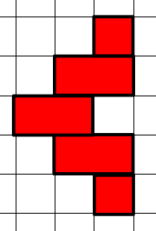  Ask learners to find its perimeter and area and also express them algebraically (as a formula). The width of each square is w.  Answers: Perimeter = 18cm (P = 18w), Area = 8cm² (A = 8w²)  Revisit the learning objectives and success criteria. Ask learners to explain whether they have met the success criteria and if they have any questions or comments.

Reflection
Use the space below to reflect on your lesson. Answer the most relevant questions for your lesson.
Were the learning objectives and lesson focus realistic? What did the learners learn today?
What was the learning atmosphere like?
What changes did I make from my plan and why?
If I taught this lesson again, what would I change?
What two things really went well (consider both teaching and learning)?
What two things would have improved the lesson (consider both teaching and learning)?
What have I learned from this lesson about the class or individuals that will inform my next lesson?
Next steps
What will I teach next based on learners’ understanding of this lesson?

Sample lesson 2

CLASS:

DATE:
Learning objectives | 4Nf.06 Understand percentage as the number of parts in each hundred, and use the percentage symbol (%).
Lesson focus /  success criteria | Learners will see that using percentage is another way of expressing proportion, using 100 equal parts.  - I know that percent means out of a hundred  - I can show different percentage amounts  - I can calculate what percentage remains when a certain percentage is taken
Prior knowledge /  previous learning | Learners will be familiar with what fractions look like (e.g. they can draw a picture to show $\frac{2}{10}$) and will be familiar with what the numerator and denominator represent.
Plan
Lesson | Planned activities | Notes
Introduction | Show learners the learning objectives and lesson focus and agree the success criteria:  - I know that percent means out of a hundred  - I can show different percentage amounts  - I can calculate what percentage remains when a certain percentage is taken  Ask learners where they have heard percentages used in everyday life. This activity can be supported by showing them newspapers or informative websites that have percentages quoted. Discuss what each percentage means or shows. | Resources:  Newspapers, magazines, sales brochures or informative websites.
Main activities | In Roman times, Emperor Augustus wanted to tax goods that were sold at auction and decided that $\frac{1}{100}$ of the value of the goods would be given to him.  If a chariot was sold for 500 denarii (the Roman currency), how many denarri would the Emperor be given?  Explain that $\frac{1}{100}$ of something is the same as dividing it by 100.  Inform learners that this was the first time ever that percentages were used and that the word percentage comes from the Latin per centum which means ‘by the hundred’.  Ask learners to draw a 10cm x 10cm grid on centimetre-squared paper, so there are 100 small squares.  Ask learners to colour in any number of squares and express the amount shown as:  - a quantity (e.g. 23 blue squares)  - a fraction (e.g. $\frac{23}{100}$)  - a percentage (e.g. 23%)  Ask them to colour the remaining squares a different colour.  What do you notice about the totals? (Answers: they make 100 squares; $\frac{100}{100}$ or 1 whole; 100%)  Ask the learners to draw more 100 square grids and on each one show different ways of representing 25%.  Ask learners to draw one of their grids so that it is not 25%, but close to 25%. Learners can swap their diagrams and then see if they can spot which ones are not 25%.  This activity can be extended by asking learners to shade their 100 grids using more than 2 colours. They can then ask their partners to estimate what percentage of each colour is shown.  Do all the percentages total 100%?  If not, which ones do you want to adjust to make the total is 100%?  Now ask learners to count the squares to see how accurate their estimate was. | Resources:  Centimetre-squared paper  Learners often only consider one visual representation of $\frac{1}{4}$. This activity helps to reinforce different ways 25% can be shown.
Summary | Explain that they will have to show the square numbers 1, 4, 9 and 16 within a 100 grid, shading them in.  What % of the grid will be left unshaded? (70%)  Revisit the learning objectives and success criteria. Ask learners to explain whether they have met the success criteria and if they have any questions or comments. | It would be good to get learners to shade in the four square numbers so they can see what 70% looks like (the unshaded parts).

Reflection
Use the space below to reflect on your lesson. Answer the most relevant questions for your lesson.
Were the learning objectives and lesson focus realistic? What did the learners learn today?
What was the learning atmosphere like?
What changes did I make from my plan and why?
If I taught this lesson again, what would I change?
What two things really went well (consider both teaching and learning)?
What two things would have improved the lesson (consider both teaching and learning)?
What have I learned from this lesson about the class or individuals that will inform my next lesson?
Next steps
What will I teach next based on learners’ understanding of this lesson?

Changes to this Scheme of Work

This Scheme of Work has been amended. The latest Scheme of Work is version 2.0, published January 2021.

- The definition of the Thinking and Working Mathematically characteristic TWM.03 Conjecturing has been changed to: Forming mathematical questions or ideas.
- The definition of the Thinking and Working Mathematically characteristic TWM 04 Convincing has been changed to: Presenting evidence to justify or challenge a mathematical idea or solution.

There may be other minor changes that do not affect teaching and learning.

Cambridge Assessment is committed to making our documents accessible in accordance with the WCAG 2.1 Standard. We are always looking to improve the accessibility of our documents. If you find any problems or you think we are not meeting accessibility requirements, contact us at info@cambridgeinternational.org with the subject heading: Digital accessibility. If you need this document in a different format, contact us and supply your name, email address and requirements and we will respond within 15 working days.

Cambridge Assessment International Education
The Triangle Building, Shaftesbury Road, Cambridge, CB2 8EA, United Kingdom
t: +44 1223 553554 f: +44 1223 553558
e: info@cambridgeinternational.org www.cambridgeinternational.org

© UCLES September 2020

