

Scheme of Work
Cambridge Primary
Mathematics 0096
Stage 1

This Cambridge Scheme of Work is for use with the Cambridge Primary
Mathematics Curriculum Framework published in September
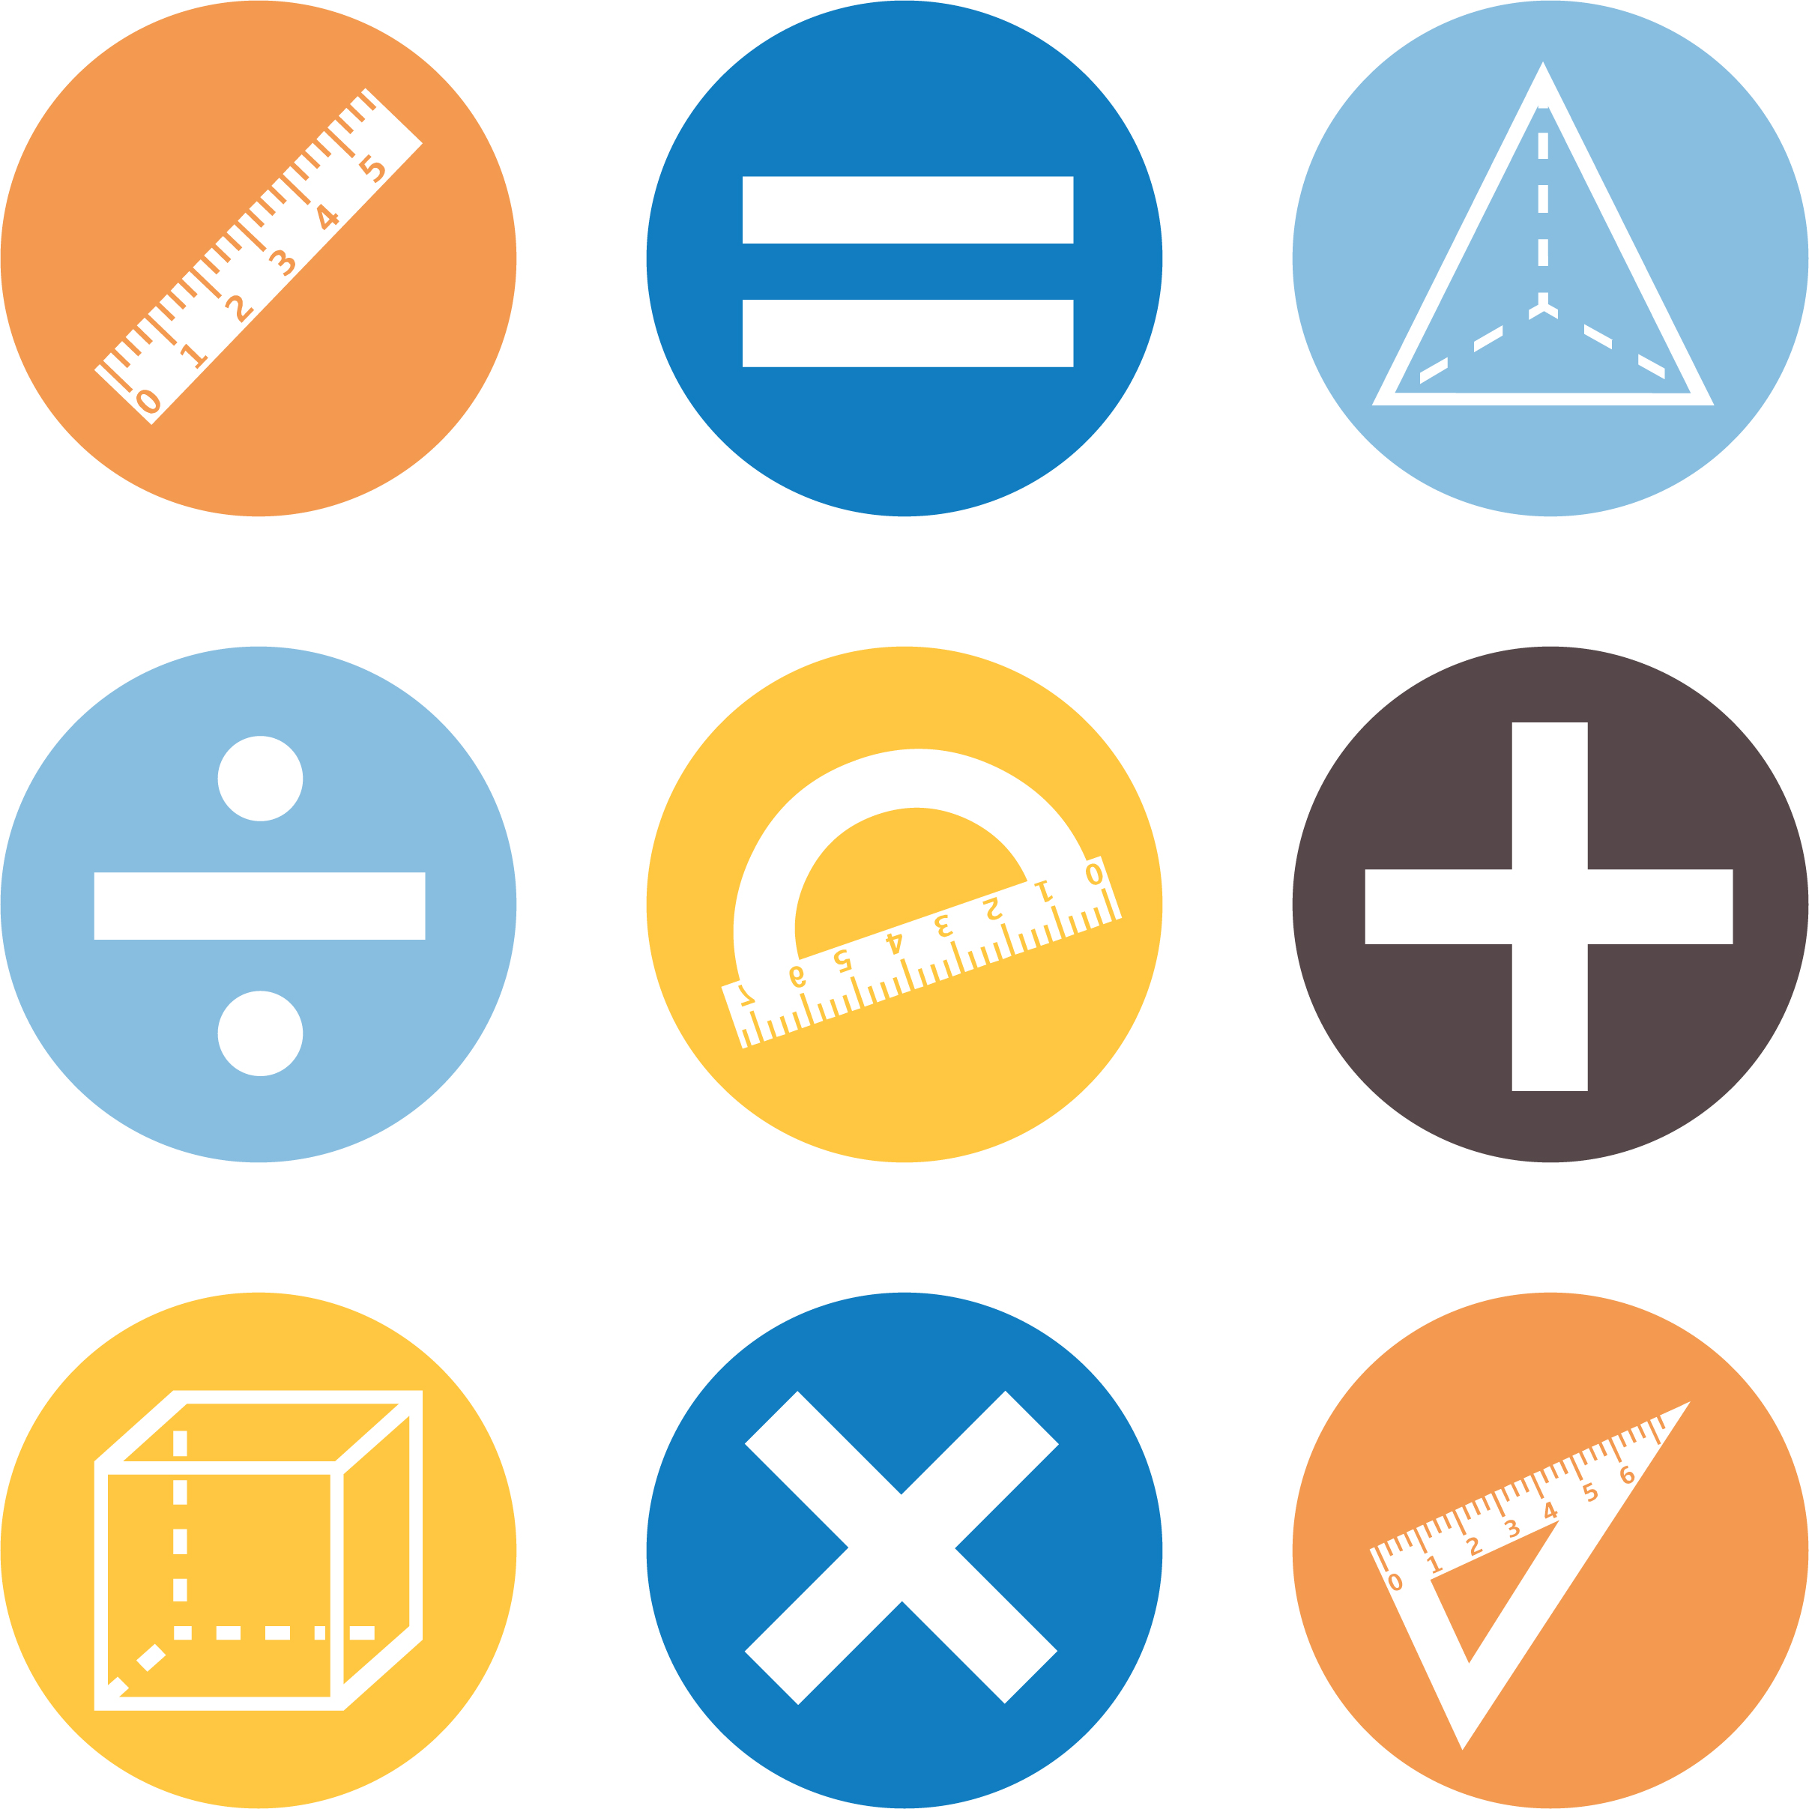
2020 for first teaching in September 2021.

© UCLES 2020
Cambridge Assessment International Education is part of the Cambridge Assessment Group. Cambridge Assessment is the brand name of the University of Cambridge Local Examinations Syndicate (UCLES), which itself is a department of the University of Cambridge.

UCLES retains the copyright on all its publications. Registered Centres are permitted to copy material from this booklet for their own internal use. However, we cannot give permission to Centres to photocopy any material that is acknowledged to a third party, even for internal use within a Centre.

Contents

Contents 3
Introduction 5
Unit 1.1 Numbers to 20 9
Unit 1.1 Topic 1 Counting, estimating and recognising numbers 10
Unit 1.1 Topic 2 Number patterns 16
Unit 1.1 Topic 3 Comparing numbers 23
Unit 1.2 Time 26
Unit 1.2 Topic 1 Time 27
Unit 1.3 Shapes, direction and movement 31
Unit 1.3 Topic 1 Describing 2D and 3D shapes 32
Unit 1.3 Topic 2 Position, direction and movement 36
Unit 1.4 Addition, subtraction and doubles 39
Unit 1.4 Topic 1 Understanding addition 40
Unit 1.4 Topic 2 Understanding subtraction 43
Unit 1.4 Topic 3 Complements and doubles 46
Unit 1.5 Money 50
Unit 1.5 Topic 1 Recognising money 51
Unit 1.6 Measurement 53
Unit 1.6 Topic 1 Describing length, mass and capacity 54
Unit 1.6 Topic 2 Measuring instruments 58
Unit 1.7 Fractions 60
Unit 1.7 Topic 1 Splitting shapes 61
Unit 1.7 Topic 2 Finding halves 64
Unit 1.8 Statistical methods 67
Unit 1.8 Topic 1 The statistical cycle 68
Sample lesson 1 72
Sample lesson 2 74
Changes to this Scheme of Work 76

Changes to this Scheme of Work
For information about changes to this Scheme of Work, go to page 76.
The latest Scheme of Work is version 2.0, published January 2021.

Introduction
This document is a scheme of work created by Cambridge Assessment International Education for Cambridge Primary Mathematics Stage 1.

It contains:
- suggested units showing how the learning objectives in the curriculum framework can be grouped and ordered
- at least one suggested teaching activity for each learning objective
- a list of subject-specific language that will be useful for your learners
- common misconceptions
- sample lesson plans
- links to relevant NRICH activities to enrich learners’ mathematical experiences, https://nrich.maths.org/

You do not need to use the ideas in this scheme of work to teach Cambridge Primary Mathematics Stage 1. Instead use them as a starting point for your planning and adapt them to suit the requirements of your school and the needs of your learners. The schemes of work are designed to indicate the types of activities you might use, and the intended depth and breadth of each learning objective. These activities are not designed to fill all the teaching time for this stage. You should use other activities with a similar level of difficulty, for example, those from endorsed resources.

The accompanying teacher guide for Cambridge Primary Mathematics suggests effective teaching and learning approaches. You can use this scheme of work as a starting point for your planning, adapting it to suit the requirements of your school and needs of your learners.

Long-term plan
This long-term plan shows the units in this scheme of work and a suggestion of how long to spend teaching each one. The suggested teaching time is based on learners having about 4 to 5 hours of Mathematics per week (about 120 to 150 hours per stage). The actual number of teaching hours may vary according to your context.
Unit | Suggested teaching time
Unit 1.1 Numbers to 20 | 17% (25 hours)
Unit 1.2 Time | 10% (15 hours)
Unit 1.3 Shapes, direction and movement | 13% (20 hours)
Unit 1.4 Addition, subtraction and doubles | 17% (25 hours)
Unit 1.5 Money | 3% (5 hours)
Unit 1.6 Measurement | 10% (15 hours)
Unit 1.7 Fractions | 17% (25 hours)
Unit 1.8 Statistical methods | 13% (20 hours)
Total | 150 hours

Sample lesson plans
You will find two sample lesson plans at the end of this scheme of work. They are designed to illustrate how the suggested activities in this document can be turned into lessons. They are written in more detail than you would use for your own lesson plans. The Cambridge Primary Mathematics Teacher Guide has information on creating lesson plans.

Other support for teaching Cambridge Primary Mathematics Stage 1
Cambridge Primary centres receive access to a range of resources when they register. The Cambridge Primary support site at https://primary.cambridgeinternational.org is a password-protected website that is the source of the majority of Cambridge-produced resources for the programme. Ask the Cambridge Coordinator or Exams Officer in your school if you do not already have a log-in for this support site.

Included on this support site are:
- the Cambridge Primary Mathematics Curriculum Framework, which contains the learning objectives that provide a structure for your teaching and learning
- grids showing the progression of learning objectives across stages
- the Cambridge Primary Mathematics Teacher Guide, which will help you to implement Cambridge Primary Mathematics in your school
- templates for planning
- worksheets for short teacher training activities that link to the teacher guide
- assessments provided by Cambridge
- a list of endorsed resources, which have been through a detailed quality assurance process to make sure they are suitable for schools teaching Cambridge Primary Mathematics worldwide
- links to online communities of Cambridge Primary teachers.

Resources for the activities in this scheme of work
We have assumed that you will have access to these resources:
- paper, pens and pencils for learners to use
- rulers, set squares, protractors and calculators.

Other suggested resources for individual units and/or activities are described in the rest of this document. You can swap these for other resources that are available in your school.

Websites
We recommend NRICH to support Cambridge Primary Mathematics at https://nrich.maths.org/

NRICH publishes free and challenging mathematics activities for learners of all ages. The resources assist teachers to embed thinking and working mathematically with mathematics content. NRICH is based in both the University of Cambridge's Faculty of Education and the Centre for Mathematical Sciences.

There are many excellent online resources suitable for teaching Cambridge Primary Mathematics. Since these are updated frequently, and many are only available in some countries, we recommend that you and your colleagues identify and share resources that you have found to be effective for your learners.

Approaches to teaching Cambridge Primary Mathematics Stage 1
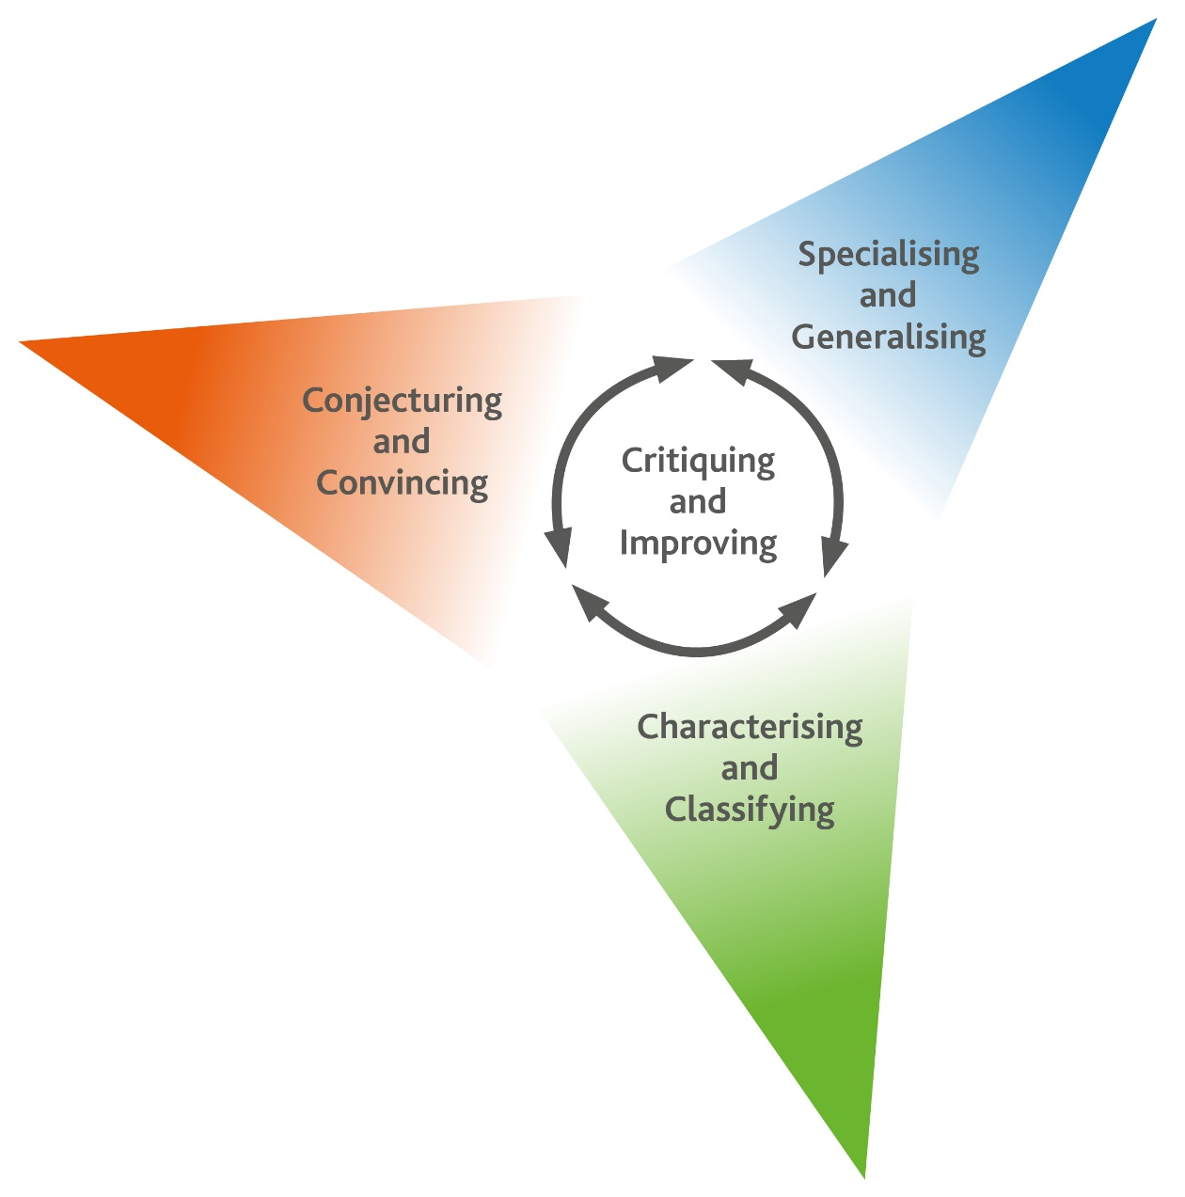
Thinking and Working Mathematically
Thinking and Working Mathematically supports the mathematical concepts and skills in all strands of the Cambridge Primary Mathematics curriculum. When learners think and work mathematically, they actively engage with their learning of mathematics. They try to make sense of ideas and build connections between different facts, procedures and concepts. Learners who do not think and work mathematically can carry out processes that their teacher has shown them, but they may not understand why the processes work or what the results mean. Noticing inconsistencies, patterns and particular representations encourages learners to think and work mathematically. Practice, reflection and questioning will help them to improve.

Thinking and Working Mathematically has eight characteristics that are presented in four pairs:

- Specialising and Generalising
- Conjecturing and Convincing
- Characterising and Classifying
- Critiquing and Improving.
The eight Thinking and Working Mathematically characteristics are all closely connected and interdependent. A high-quality mathematics task may include one or more of them. The characteristics provide learners with the language they need to think and work mathematically. Learners can then decide what mathematical knowledge, procedures and strategies to use in order to gain a deeper understanding of mathematical questions.

Throughout this scheme of work, there are examples of classroom activities that link the Thinking and Working Mathematically characteristics with content learning objectives. We recommend you use the ideas in these examples to create further classroom activities.

Thinking and Working Mathematically characteristics: |  |  | Unit 1.1 |  | Unit 1.2 |  | Unit 1.3 |  | Unit 1.4 |  | Unit 1.5 |  | Unit 1.6 |  | Unit 1.7 |  | Unit 1.8
TWM.01 | Specialising – Choosing an example and checking to see if it satisfies or does not satisfy specific mathematical criteria
TWM.02 | Generalising – Recognising an underlying pattern by identifying many examples that satisfy the same mathematical criteria
TWM.03 | Conjecturing – Forming mathematical questions or ideas
TWM.04 | Convincing – Presenting evidence to justify or challenge a mathematical idea or solution
TWM.05 | Characterising – Identifying and describing the mathematical properties of an object
TWM.06 | Classifying – Organising objects into groups according to their mathematical properties
TWM.07 | Critiquing – Comparing and evaluating mathematical ideas, representations or solutions to identify advantages and disadvantages
TWM.08 | Improving – Refining mathematical ideas or representations to develop a more effective approach or solution

Misconceptions
Mathematical misconceptions are usually incorrect generalisations made by learners. Misconceptions should not be avoided, but instead used for teaching purposes to reveal learners’ thinking. Research suggests that asking learners open-ended questions about mathematical concepts is the most appropriate way to uncover misconceptions. Once a learner’s misconceptions have been identified, the next step is to know how to correct them. One approach is to give learners a variety of mathematical strategies to draw upon when finding solutions so that they can gain a deeper understanding of each mathematical concept.

Mental strategies and calculators
Mental calculation is a skill needed for everyday life, especially when paper or calculators are not available. Mental calculation relies on working memory, the organisation of thoughts and the use of efficient mathematical strategies when solving mathematical computations. It is important for learners to practise mental calculations and have a range of strategies as this improves understanding and recall as well as increasing confidence and proficiency.

Calculators are useful teaching aides. Although learners need to practise doing mental and written calculations, calculators can help them to notice patterns. They are also useful when learners are solving problems where non-calculator calculations would take the focus away from strategies. When well used, calculators can help learners to learn about numbers and the number system. Use calculators as a teaching aid to promote mental calculation and mental strategies and to explore mathematical patterns. Learners should understand when it is best to use calculators to help them calculate, and when to calculate mentally or using written methods.

As Cambridge International includes calculator-based assessments at Stages 5, 6, 7, 8 and 9, we recommend that learners begin to use calculators for performing and checking calculations from Stage 4. At Stages 5 and 6, learners should be developing effective use of calculators so that they are familiar with the buttons and functions of a basic calculator.

Unit 1.1 Numbers to 20

Learning objectives covered in Unit 1.1 and topic summary: |  | 1.1 Topic 1  Counting, estimating and recognising numbers | 1.1 Topic 2  Number patterns | 1.1 Topic 3  Comparing numbers | Thinking and Working Mathematically
1Nc.01 | Count objects from 0 to 20, recognising conservation of number and one-to-one correspondence.
1Nc.02 | Recognise the number of objects presented in familiar patterns up to 10, without counting.
1Nc.03 | Estimate the number of objects or people (up to 20), and check by counting.
1Nc.04 | Count on in ones, twos or tens, and count back in ones and tens, starting from any number (from 0 to 20). |  |  |  | TWM.04 Convincing
1Nc.05 | Understand even and odd numbers as ‘every other number’ when counting (from 0 to 20). |  |  |  | TWM.02 Generalising
1Nc.06 | Use familiar language to describe sequences of objects.
1Ni.01 | Recite, read and write number names and whole numbers (from 0 to 20).
1Np.01 | Understand that zero represents none of something.
1Np.02 | Compose, decompose and regroup numbers from 10 to 20. |  |  |  | TWM.01 Specialising  TWM.02 Generalising
1Np.03 | Understand the relative size of quantities to compare and order numbers from 0 to 20.
1Np.04 | Recognise and use the ordinal numbers from 1st to 10th. |  |  |  | TWM.05 Characterising

Unit 1.1 Topic 1 Counting, estimating and recognising numbers

Outline of topic:
Learners will practise their counting skills using the correct number names, one number for each object. They will also explore conservation of number. They will understand that they can sometimes recognise a number of objects without having to count them, and that zero is an important number. Learners will develop understanding of the ordinal numbers and also practise their estimation skills.

Language:
Key vocabulary:
count, counting
one, two, three, four, five, six, seven, eight, nine, ten, eleven, twelve, thirteen, fourteen, fifteen, sixteen, seventeen, eighteen, nineteen, twenty
one-to-one
estimate, estimation
first, second, third, fourth, fifth, sixth, seventh, eighth, ninth, tenth

Key phrases:
How many … are there?
There are … counters.
The first cube is purple.

Recommended prior knowledge:
- Recognise, read and write numbers from 1 to 10
- Count from 1 to 10

Learning objectives | Suggested teaching activities and resources | Mental strategies, possible misconceptions and comments
1Nc.01 Count objects from 0 to 20, recognising conservation of number and one-to-one correspondence. | Place between 0 and 20 objects into several different bowls or containers. Use small objects such as paperclips, counters, cubes, buttons, toy animals etc.  Choose a bowl and count the number of objects in the bowl as a class. Remove the objects one at a time and count each as it is removed. Then place the objects back in the bowl, counting each object as it is returned.  Repeat this several times with other bowls of objects.  Give each small group of learners one of the bowls of objects. Ask learners:  How many objects are in your bowl?  How can you check your answer?  Ask each group to place three objects in their bowl. Ask learners to check each other’s counting.  Then, show them the three counters on the class board in two rows with different spacing between the counters. Ask which row has the most counters?  Learners should know that both rows have the same number of counters. Count each row to show that them both have 3 counters.  Resources:  Bowls or containers  Small objects such as paperclips, counters, cubes, buttons, toy animals etc. | Possible misconceptions:  Learners need to match one number name to each object in turn, making sure that they do not count any twice or omit any.  Learners need to know that the number of items in a group remains the same even if we rearrange them or count them in a different order (conservation of number). Learners need to know that if the same number of objects are spaced differently that the total remains the same (conservation of number).  This learning objective can also be consolidated through general classroom activities such as asking learners to tell each other five different foods they like to eat, or, when it is time for learners to tidy the classroom, ask learners to each pick up 10 pieces of litter to throw away.
1Nc.02 Recognise the number of objects presented in familiar patterns up to 10, without counting. | Give each learner a “Hungarian number frame” and ten counters.  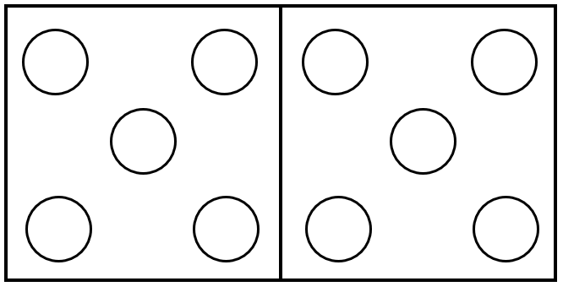  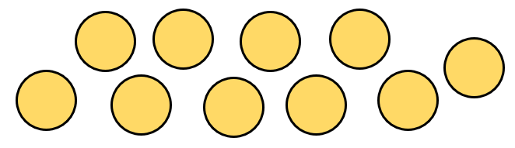  Ask learners to choose any number of the 10 counters and place them on their frame. Encourage them to always use the first five dots before putting counters onto the next five dots. This helps learners to become familiar with the dice pattern of five.  Ask learners to say what they see. For example, if they arranged six counters on the Hungarian number frame, learners may be able to explain they see a five and a one:  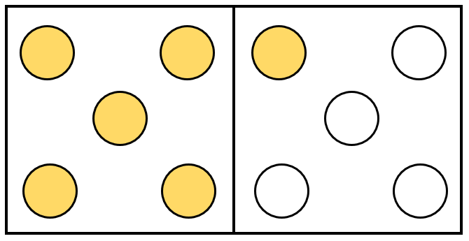  The NRICH task: Eightness of Eight (https://nrich.maths.org/13704) can be used for further practice of recognising a number of objects presented in familiar patterns.  Resources:  Hungarian number frames  Counters  NRICH task | Some arrangements of numbers are very familiar, and learners can see how many counters, dots or objects there are without having to count. This is called subitising.  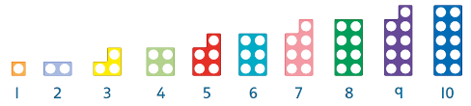  The Hungarian number frame pattern of two fives enables learners to see numbers such as 7 as ‘5 and 2’, while also showing 7 as 3 less than 10.  Possible misconceptions:  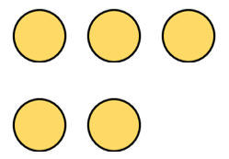  Learners may not recognise five in a pattern. They may not realise that it can be a numeral, or presented in a different way. They may also not recognise five in other familiar representations, patterns or orientations such as:
1Nc.03 Estimate the number of objects or people (up to 20), and check by counting.  1Nc.01 Count objects from 0 to 20, recognising conservation of number and one-to-one correspondence. | Give each pair of learners a container and 20 small objects such as paperclips, counters, cubes, buttons, toy animals etc. In pairs, learners take turns to take a handful of the objects from the container and place them on the table. Ask learners to estimate the number of objects on the table.  Do you agree with your partner’s estimate?  Then ask learners to count the objects on the table and circle the number on a hundred square.  Ask learners to compare this with their estimate:  Was your estimate close to the number you counted?  This activity can be extended by using the NRICH task: Count the Crayons (https://nrich.maths.org/10653)  Resources:  Bowls or containers  Small objects such as paperclips, counters, cubes, buttons, toy animals etc.  Hundred squares  NRICH task | Estimation is an important skill in mathematics but one that many learners of all ages find difficult.  Hundred square:  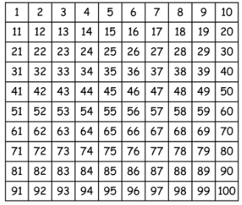  Possible misconceptions:  Learners may find it hard to understand that an estimate is not exact.
1Ni.01 Recite, read and write number names and whole numbers (from 0 to 20).  1Nc.01 Count objects from 0 to 20, recognising conservation of number and one-to-one correspondence. | Write the numbers from 0 to 20 in order on the class board:  0, 1, 2, 3, 4, 5, 6, 7, 8, 9, 10, 11, 12, 13, 14, 15, 16, 17, 18, 19, 20  Ask learners to recite the numbers from 0 to 20 as a class and point to each number as learners say it. Then point to one of the numbers written on the board and ask learners to say the name of the number. Repeat this several times.  Place several small objects (between 0 and 20) in a bowl. Remove the objects one at a time and ask learners to count the objects as a class. When all objects have been counted agree the total number of objects. Ask learners to record the number of objects on a mini whiteboard as a numeral and hold up their answer. You may ask learners to also record their answer by circling the number on a number line or shading the number on a hundred square.  Give each pair of learners a set of cards with the numbers 0 to 20, and another set of cards showing a group of objects totalling between 0 and 20. Ask learners to count the number of objects and match it to the number card, for example:  Encourage learners to practise counting the objects and reading the numbers aloud.  This activity can be extended by using the NRICH task: Writing Digits (https://nrich.maths.org/161).  Resources:  Several small objects in a bowl  Mini whiteboards  Number lines or hundred squares  Sets of cards showing the numbers 0 to 20  Sets of matching cards showing a group of objects  NRICH task | Ensure learners are using one-to-one correspondence, conservation of number and the correct number names. Ensure learners recite the numbers in a consistently correct order.  Possible misconceptions:  Learners often omit 13 and 15 when learning to count.  Learners often have difficulties with 11 and 12 because they do not follow the pattern with 13 onwards.  Some learners believe that objects can only be counted in lines or rows. Demonstrate that objects can be counted from a pile in any order, but the number names remain consistent as they denote the total.
   | 3
   | 7
   | 2
  □□□□□□□□□□□ | 11
1Np.01 Understand that zero represents none of something. | Show learners an empty container.  How many counters are in the container? (none or zero)  Place five objects in the container one at a time, and count them as they are placed:  zero (none), one, two, three, four, five.  Then remove the objects from the container one by one:  five, four, three, two, one, zero (none)  Give each small group of learners an empty container and a selection of objects and repeat the counting activity.  Resources:  Bowls or containers  Small objects such as paperclips, counters, cubes, buttons, toy animals etc. | Zero is an important number and it is important that we have several words for it, which we choose depending on the context. For example, we might use nought or none.  Possible misconceptions:  Learners may not recognise that zero is a number. Some learners also confuse the number zero with the letter ‘o’. Be certain to use the word zero and not the letter ‘o’ (oh).
1Np.04 Recognise and use the ordinal numbers from 1st to 10th.  TWM.05 Characterising  Identifying and describing the mathematical properties of an object | Explain that 10 people are in a race and as each one crosses the finishing line, they are 1st, 2nd, 3rd….10th.  Write the ordinal numbers from 1st to 10th on the class board and ask learners to recite these in order:  1st, 2nd, 3rd, 4th, 5th, 6th, 7th, 8th, 9th, 10th  Point at one of the ordinal numbers and ask learners to say it aloud. Repeat this several times. Then, give learners a set of cards labelled from 1st to 10th and ask them to place them in order.    Learners will show they are characterising (TWM.05) when they begin to identify familiar and unfamiliar properties of ordinal numbers.  Ask learners to create a row of cubes or counters using different colours, for example:  Learners should keep their pattern hidden from their partner and describe the order of the colours using first, second, third etc so that their partner can create the same pattern.  Take opportunities to reinforce the ordinal numbers by asking learners to stand in lines when entering and leaving the classroom. Ask the learners to say who is first, second, third in the line etc.  Resources:  Sets of cards labelled from 1st to 10th  Coloured cubes or counters | Numbers can be used as labels to put things in order.  Possible misconceptions:  Learners do not always connect ordinal and cardinal numbers, so the last number is also the cardinal number of the set.

Unit 1.1 Topic 2 Number patterns

Outline of topic:
Learners will explore counting in ones, twos and tens and also consider how every other number is either odd or even when counting in ones. Learners will begin to describe sequences of objects.

Language:
Key vocabulary:
counting, count on, count back
odd, even
pattern, sequence
most, least, greatest

Key phrases:
The next number is …
What do you notice?
What is the same or different?

Recommended prior knowledge:
- Count to 10 and beyond
- Read and write numbers to 10 and beyond

Learning objectives | Suggested teaching activities and resources | Mental strategies, possible misconceptions and comments
1Nc.04 Count on in ones, twos or tens, and count back in ones and tens, starting from any number (from 0 to 20).  TWM.04 Convincing  Presenting evidence to justify or challenge a mathematical idea or solution | Using a large number line marked from 0 to 20 ask learners to count in ones.  Start at 0 and count on (forwards) to 20. When learners are counting, point to the corresponding number on the number line. When you reach 20 count back to 0.  Vary the number you start at. For example, you can start at 3 or 8 or 14. Decide if you are going to count on or count back first.  Repeat this, but this time count on in twos or count back in tens. Continue pointing to the corresponding number on the number line as learners say the numbers aloud.  Give learners their own individual number line and ask them to count on in ones, twos or tens, and count back in ones and tens. Ask learners to start from different numbers when counting.  Then use an empty counting stick, divided into 10 sections, as a model for counting on and back:  Count on in either ones, twos or tens. Point to each line and ask learners to say the number out loud in unison. Repeat this several times.  Count on and count back in ones  0 1 2 3 4 5 6 7 8 9 10  5 6 7 8 9 10 11 12 13 14 15  Count on or count back in twos  0 2 4 6 8 10 12 14 16 18 20  Count on count back in tens  0 10 20 30 40 50 60 70 80 80 100  Ask learners what they notice about the first and last number on the counting stick when they are counting in different numbers. Ask learners to suggest any patterns that they notice.    Learners will show they are convincing (TWM.04) when they can offer suggestions as to why the last number is different.  Resources:  Large number line 0 to 20  Individual number lines 0 to 20  Counting stick | When learners are leaning to count, It is important to use concrete objects initially before using pictorial representations. You should only use abstract concepts such as numerals 0 to 20 once learners have mastered both concrete and pictorial representations of numbers.  Learners sometimes find it difficult to start from any number other than zero and will go back to the beginning. It is important to practise counting on, starting from numbers other than zero.
1Nc.05 Understand even and odd numbers as ‘every other number’ when counting (from 0 to 20). | Give each learner 11 ten-frames.  Ask them to shade the numbers 0 to 10 on each of the ten-frames, ensuring they start colouring from the top row for each:  Ask learners:  What do you notice about the shapes made on the ten-frames for each number?  Learners should notice that every other number has rows where all squares are shaded and every other number has rows where only one square is shaded.  Explain to learners that even numbers can be organised in pairs or equal groups (0, 2, 4, 6, 8, 10) and odd numbers cannot (1, 3, 5, 7, 9). Draw two circles on the class board. Choose a number between 0 and 10.  The number four can be shared equally into the two circles. There are the same number of squares (two squares) in both circles so four is an even number.  The number five cannot be shared equally into two circles. There are two squares in each circle and one square that cannot be put anywhere.  Repeat this with all numbers from 0 to 10, ask learners which numbers are even and odd numbers and record this on the class board. | Make sure that the ten-frames are vertical so that pairs of ten-frame can be seen easily.
1Nc.05 Understand even and odd numbers as ‘every other number’ when counting (from 0 to 20).  TWM.02 Generalising  Recognising an underlying pattern by identifying many examples that satisfy the same mathematical criteria | Give learners cubes and ask them to build a staircase from 0 to 20.  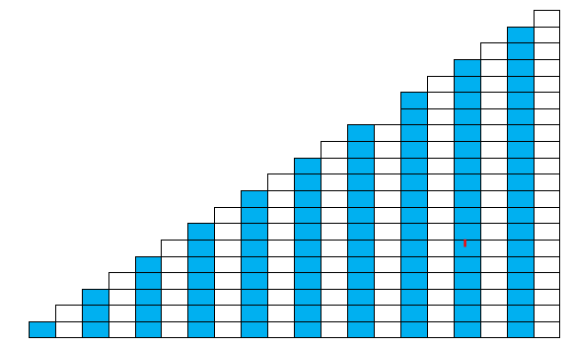  Ask learners:  What do you notice about the next number? (The next number is one more than the previous number.)  Then ask learners:  Which of the numbers from 0 to 20 can be made from pairs of the same number?  Give learners time to investigate this and suggest numbers. Take suggestions from the learners and write these numbers on the board in order.  Ask learners:  What do you notice about these numbers?  Learners should notice that only some numbers can be made from pairs of the cubes and there is a pattern of every other number.  Explain that numbers which can be made from pairs of cubes are called even numbers and those that cannot are called odd numbers.  Now count the numbers, using the staircase: zero, one, two, three, four, five, six…  Now count but use the words even and odd: even (zero), odd (one), even, odd, even, odd, even…  Ask learners:  - What do you think the next number will be? Odd or even?  - How do you know?  Learners will show they are generalising (TWM.02) when they notice that every other number is either odd or even.  Resources:  Cubes | One way of helping learners to understand odd and even numbers is to ask them to investigate making pairs.  Possible misconceptions:  Learners may not realise that zero is an even number.
1Nc.06 Use familiar language to describe sequences of objects. | Take 12 objects and arrange them in three rows of four.  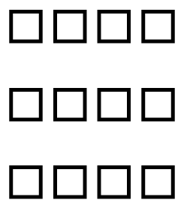  Ask learners to say what they see. For example:  - I see 1, 2, 3, 4 ...  - I see 3 and another 3 and another 3 and another 3.  - I see 4 and another 4 and another 4.  - This group (column) is odd and this group (row) is even.  Ask learners to make up their own groups of objects using 12 objects and say what they see. Ask learners how many ways they can arrange the 12 objects into groups.  Show learners four ladybirds with different numbers of spots. Ask learners to order the ladybirds from the least number of spots to the greatest number of spots.  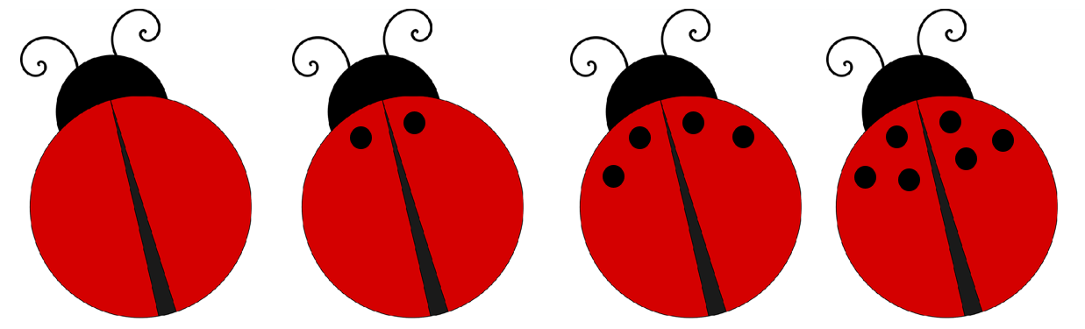  Ask learners to describe the pattern the they see (0, 2, 4, 6). Ask learners to suggest how many spots the next two ladybirds will have and how they know.  Resources:  Small objects such as counters or cubes to arrange in groups  Pictures of ladybirds

Unit 1.1 Topic 3 Comparing numbers

Outline of topic:
Learners will explore how to compose, decompose and regroup numbers from 10 to 20. They will also explore the relative size of numbers by putting numbers in order and comparing them.

Language:
Key vocabulary:
smaller, smallest, larger, largest
part, whole

Key phrases:
How can you decompose this number?
How can you regroup this number?
How many parts?
What is the whole?

Recommended prior knowledge:
- Count to 10 and beyond
- Read and write numbers to 10 and beyond

Learning objectives | Suggested teaching activities and resources | Mental strategies, possible misconceptions and comments
1Np.02 Compose, decompose and regroup numbers from 10 to 20.  TWM.01 Specialising  Choosing an example and checking to see if it satisfies or does not satisfy specific mathematical criteria  TWM.02 Generalising  Recognising an underlying pattern by identifying many examples that satisfy the same mathematical criteria | Choose one card from a set of cards with the numbers from 10 to 20 written on them. As a class, count out the number using objects. For example, if you choose the number 13, count out 13 paper clips or counters etc. with learners.  Demonstrate how you can separate the objects in many ways.  For example, 13 can be separated into 10 and 3, or 8 and 5, or 5, 5 and 3 and so on.  Introduce the part-whole model. Demonstrate 13 is the whole and it can be separated into two parts (or three parts or more). For example, 10 and 3, 8 and 5:  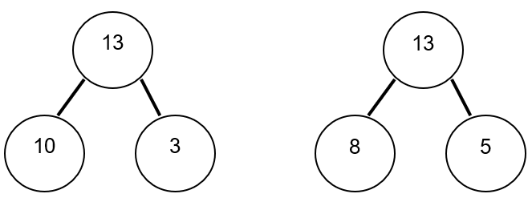  Ask learners to find more examples of how to regroup the chosen number and to record these in part-whole models.  Ask learners to choose a number card between 10 and 20 and count the same number of objects as the number on the card. Then ask learners to see how many ways they can separate that number into at least two other numbers by separating the group of objects into two groups or more.  Learners will show they are specialising (TWM.01) when they find further examples of regrouping the number. Learners will show they are generalising (TWM.02) when they notice and can explain that however they separate the whole, it can still be combined to return to the whole.  Repeat the activity by choosing another card with a number from 10 to 20.  Resources:  Number cards with numbers from 10 to 20  Objects to count | Composing and decomposing numbers: If you combine 10 and 4 you will compose the number 14. If you decompose 14 you will get 10 + 4 (1 ten and 4 ones).  Regrouping numbers should focus on expressing a number in different ways to assist with calculations.  e.g. 14 can be expressed as:  14 = 10 + 4  14 = 8 + 6  14 = 8 + 4 + 2  14 = 8 + 2 + 4 and in many other ways  Ensure learners understand teen numbers as tens and ones (with understanding of place value) and not just as number pairs.
1Np.03 Understand the relative size of quantities to compare and order numbers from 0 to 20. | Give each pair of learners a selection of counters, cubes etc. Ask each learner to take a handful of the objects without looking. Ask learners:  - How many objects do you think you have in your hand?  - Count your objects. Do you think you have more or less than your partner?  Ask learners to compare their number of objects with their partner. Encourage learners to use familiar language, such as same, more, or less, to compare and order their numbers. For example:  - Safia has more objects than me.  - Rajiv has less objects than me.  Once learners have decided on the order, ask them to mark each of their number of objects on a number line, for example:  Rajiv’s objects  Safia’s objects  Ask learners to repeat the task.  Challenge learners to try and take a handful of about 20 objects, 5 objects and so on.  Resources:  Small objects  Number lines | It is important that learners understand the relative size of numbers, for example, 6 is smaller than 8 but larger than 4.  Possible misconceptions:  Sometimes larger objects can appear to have a larger value than smaller objects.  Sometimes learners put objects out in a line to count. If their line of objects is longer than their partner’s, they may incorrectly assume they have a larger number of objects. Remind learners that they must count to be sure.

Unit 1.2 Time

Learning objectives covered in Unit 1.2 and topic summary: |  | 1.2 Topic 1  Time | Thinking and Working Mathematically
1Gt.01 | Use familiar language to describe units of time.
1Gt.02 | Know the days of the week and the months of the year. |  | TWM.04 Convincing
1Gt.03 | Recognise time to the hour and half hour.

Unit 1.2 Topic 1 Time

Outline of topic:
Learners will recognise and use language relating to the days of the week and the months of the year. They will also begin to use language to describe familiar units of time, including hour and half hour.

Language:
Key vocabulary:
clock
hour, half hour
Monday, Tuesday, Wednesday, Thursday, Friday, Saturday, Sunday
yesterday, today, tomorrow
January, February, March, April, May, June, July, August, September, October, November, December

Key phrases:
Today it is …
The time is ...
How long will … take?
Where will the hour hand be at …?

Recommended prior knowledge:
- Recognise some of the names of the days of the week
- Recognise some of the months of the year
- Basic understanding about clocks and time

Learning objectives | Suggested teaching activities and resources | Mental strategies, possible misconceptions and comments
1Gt.01 Use familiar language to describe units of time. | Ask learners to watch the sand running through a one-minute timer to get an idea of how long a minute is. Now ask learners to estimate how many hops, claps or jumps they might be able to do in one minute. Then ask learners to hop, clap or jump for one minute.  Give learners lots of opportunities to time themselves for one minute doing various activities.  Give learners some activities and ask them to describe these using familiar language, such as yesterday, today and tomorrow; morning, afternoon and evening; minute, day, week and year.  For example, a learner may say:  - I brush my teeth every day.  - My dad reads his book in the evening.  - It is my birthday once a year.  - We can play outside for one hour.  Ask learners to recall something they did yesterday. Then ask:  What might you do tomorrow?  Resources:  One-minute sand timer | It is useful to introduce different units over a series of lessons so that learners do not confuse units of time.  Possible misconceptions:  Learners may incorrectly think that different units of time are equal. For example, they may think one day is equal to one month because they both use the unit of one. This may be particularly problematic when comparing 1 minute with 1 hour.
1Gt.02 Know the days of the week and the months of the year.  TWM.04 Convincing  Presenting evidence to justify or challenge a mathematical idea or solution | Ask learners to offer ideas about what they do on different days of the week. Record this as a class display. Come back to this each day for at least a week.  As a class, practise reciting the days of the week in order.  Give learners strips of paper with each day of the week on them. Ask them to order them. Once they have ordered them join the ends together so they can understand the cyclical nature of each week.  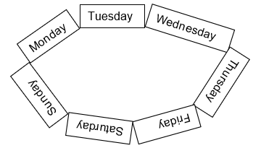  Repeat the above for the months of the year.  Give learners true or false statements such as:  - Today is Wednesday so yesterday was Thursday.  - Today it is March so next month will be May.  - Tomorrow it is Monday, so today it is Sunday.  Ask learners to make up their own statements to go with something that they did or will do for each day of that week. For example:  On Tuesday I went to play with my friend.  Learners will show they are convincing (TWM.04) when they can justify why each statement is true or false.  Resources:  Strips of paper with the days of the week on  Strips of paper with the months of the year on | Rhymes and songs are also a good way to help learners memorise the days of the week and the months of the year.  Possible misconceptions:  Learners may not understand that the days of the week or the months of the year have a set order.
1Gt.03 Recognise time to the hour and half hour. | Show learners an analogue clock and ask them to tell you what they see.  Once they are familiar with the clock show them 3 o’clock and tell them the time. Discuss how we know it is 3 o’clock. Repeat for different hours.  Now give learners clocks (these can made from paper plates, with two pointers attached with a split pin) and ask them to show you different hours. For example, 1 o’clock, 6 o’clock, 10 o’clock.  Once learners are confident in recognising the time to the hour, introduce half hours. Ask learners:  - Which is the hour hand?  - Which is the minute hand?  - How do you know?  - Where does the minute hand point to at half past?  - Where does the hour hand point to at half past?  Give learners pictures of clocks and times and ask them to match the correct time to the clock. For example:  This activity can be extended by giving learners challenges such as:  The minute hand is pointing at the six. The hour hand is halfway between 10 and 11. What time is it?  Resources:  Analogue clocks made from paper plates, with two pointers attached with a split pin  Matching activity with pictures of clocks and corresponding times | Possible misconceptions:  Learners sometimes do not understand that the hour hand moves progressively over the hour between two numbers so at half past, the hour hand will be halfway between two numbers.
  Half past 2 | 3 o’clock | Half past 9
  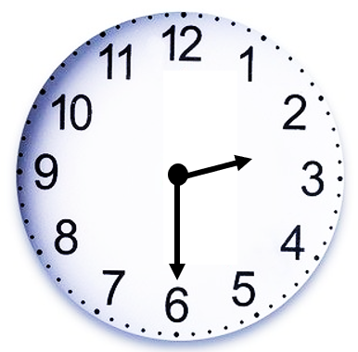 | 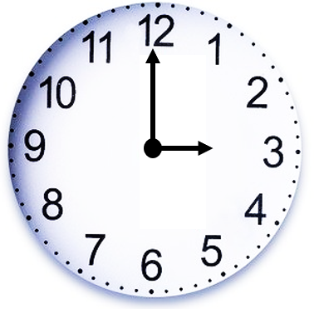 | 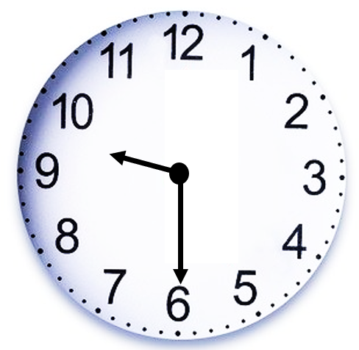

Unit 1.3 Shapes, direction and movement

Learning objectives covered in Unit 1.3 and topic summary: |  | 1.3 Topic 1  Describing 2D and 3D shapes | 1.3 Topic 2  Position, direction and movement | Thinking and Working Mathematically
1Gg.01 | Identify, describe and sort 2D shapes by their characteristics or properties, including reference to number of sides and whether the sides are curved or straight.
1Gg.03 | Identify, describe and sort 3D shapes by their properties, including reference to the number of faces, edges and whether faces are flat or curved. |  |  | TWM.06 Classifying  TWM.05 Characterising
1Gg.06 | Differentiate between 2D and 3D shapes.
1Gg.07 | Identify when a shape looks identical as it rotates.
1Gp.01 | Use familiar language to describe position and direction.

Unit 1.3 Topic 1 Describing 2D and 3D shapes

Outline of topic:
Learners will explore 2D and 3D shapes and begin to use correct mathematical vocabulary to describe their properties.

Language:
Key vocabulary:
2D, 3D
rectangle, square, circle, triangle
curved, flat, straight
cube, cuboid
edge, face

Key phrases:
A … has … sides.
A … has … faces.

Recommended prior knowledge:
- Knowledge of everyday language to describe shapes
- Recognise simple properties and patterns of 2D and 3D shapes inside and outside the classroom

Learning objectives | Suggested teaching activities and resources | Mental strategies, possible misconceptions and comments
1Gg.01 Identify, describe and sort 2D shapes by their characteristics or properties, including reference to number of sides and whether the sides are curved or straight. | Show learners a variety of different 2D shapes:  Ask them to describe the shapes in their own words. Learners may focus on the number of sides, the colours, whether the sides are curved or straight, the size of the shapes etc.  Ask learners if they know the name of the shapes. Support learners to identify the two squares, two circles, two rectangles and two triangles.  In small groups, give each group a bag (or envelope) with one of each shape inside. Give the bag to a learner and ask them to find the square. Repeat with different shapes until all learners have had a go.  Ask learners to draw a shape person using 2D shapes.  - How many different 2D shapes can you use?  - Can you explain how your shape person is made up?  Encourage learners to describe their shape person using the names of the shapes and their properties. For example:  My shape person is made from one circle, one triangle and four rectangles. The person’s head is a circle and it has one curved side.  Put learners into groups of four and ask them to make 2D shapes with their bodies. Everyone in the group must be part of the shape.  Resources:  Bags (or envelopes) with 2D shapes inside | 2D shapes can be described as flat shapes. They have no thickness and are the faces of 3D shapes.  Possible misconceptions:  Learners sometimes do not recognise shapes unless they are in their usual orientation, so it is important to show them shapes in all positions.  Some misconceptions come from having shapes that are described as 2D and used for 2D activities but have some thickness. It is not possible to obtain a true 2D shape without some thickness, but it is important to use shapes which are as thin as possible. It is also important to refer to the plane surface as the 2D shape, rather than the shapes themselves when they have some thickness.
1Gg.03 Identify, describe and sort 3D shapes by their properties, including reference to the number of faces, edges and whether faces are flat or curved.  TWM.06 Classifying  Organising objects into groups according to their mathematical properties  TWM.05 Characterising  Identifying and describing the mathematical properties of an object | Show learners an example of a cube and a cuboid and ask:  What is the same and what is different?  Establish that both a cube and cuboid have six flat faces and that the faces of a cube are square, whereas some or all of the faces of a cuboid are rectangular.  Give each small group of learners a collection of cubes and cuboids. Where possible use real life examples such as packaging, cereal boxes, etc. Ask learners to sort the 3D shapes into cubes and cuboids.  Now give learners further different 3D shapes, such as pyramids, spheres and cylinders. Ask learners to sort the 3D shapes using whatever properties they like.  Learners will show they are classifying (TWM.06) when they sort the 3D shapes into groups with common properties. For example, 3D shapes with curved surfaces, and 3D shapes with only flat faces.  Learners will show they are characterising (TWM.05) when they notice properties of the shapes by which they can sort by and when they explain how they have sorted the shapes.  Ask learners to describe the 3D shapes using their 2D vocabulary. For example, a cylinder has two flat faces that are circles and one curved face. Ask them to explain how they have sorted their shapes and explain their decisions using the vocabulary.  The NRICH resource: Making Footprints (https://nrich.maths.org/8860) provides a practical activity to support learners to identify the shapes of faces of 3D shapes.  Resources:  3D shapes  NRICH task | 3D shapes take up space. 3D shapes have 2D faces. Two faces meet at an edge. Each corner of a 3D shape is called a vertex.  Possible misconceptions:  Learners sometimes do not recognise shapes unless they are in their usual orientation, so it is important to show them shapes in all positions.
1Gg.06 Differentiate between 2D and 3D shapes. | Establish the difference between 2D and 3D shapes with learners. 2D shapes can be described as flat shapes. They have no thickness and are the faces of 3D shapes. 3D shapes take up space. 3D shapes have 2D faces.  Give learners opportunities to explore and identify 2D and 3D shapes in the environment.  Ask learners to find examples of 2D and 3D shapes in their classroom.  - How many 2D shapes can you find?  - How do you know they are 2D shapes?  - How many 3D shapes can you find?  - How do you know they are 3D shapes?  Show learners a picture, photograph or piece of art, such as a piece by Wassily Kandinsky. Ask them to identify and annotate the 2D and 3D shapes they can see.  Ask learners to share and compare the 2D and 3D shapes they found with a partner.  Resources:  Picture, photograph, or piece of art containing 2D or 3D shapes for learners to identify | Possible misconceptions:  Some misconceptions come from having shapes that are described as 2D and used for 2D activities but have some thickness. It is not possible to obtain a true 2D shape without some thickness, but it is important to use shapes which are as thin as possible. It is also important to refer to the plane surface as the 2D shape, rather than the shapes themselves when they have some thickness.

Unit 1.3 Topic 2 Position, direction and movement

Outline of topic:
Learners will begin to explore rotational symmetry by identifying when shapes look identical as they rotate. Learners will use simple language to describe position and direction.

Language:
Key vocabulary:
rotate
similar, identical, different
left, right, forwards, backwards, up, down
top, middle, bottom
behind, in front of, between
under, above, below
inside, outside

Key phrases:
The … is behind the …
The … is left of the …
The … is in the middle

Recommended prior knowledge:
- Everyday words to describe position and direction (e.g. top, middle, bottom, forwards, backwards, inside, outside, in front, behind)

Learning objectives | Suggested teaching activities and resources | Mental strategies, possible misconceptions and comments
1Gg.07 Identify when a shape looks identical as it rotates. | Use the NRICH task: Posting Triangles (https://nrich.maths.org/2642) to allow learners to investigate when a triangle looks identical as it rotates.  Ask learners:  - What do you notice about the triangles?  - Do they all fit through the black hole?  - Is this the same for all shapes?  Ask learners to create their own version of the game for different shapes. Learners should draw and cut out a shape, then trace around it on paper to make the black hole.  Resources:  NRICH task  Scissors
1Gp.01 Use familiar language to describe position and direction. | Show learners a table of 2D and 3D shapes in different cells, for example:  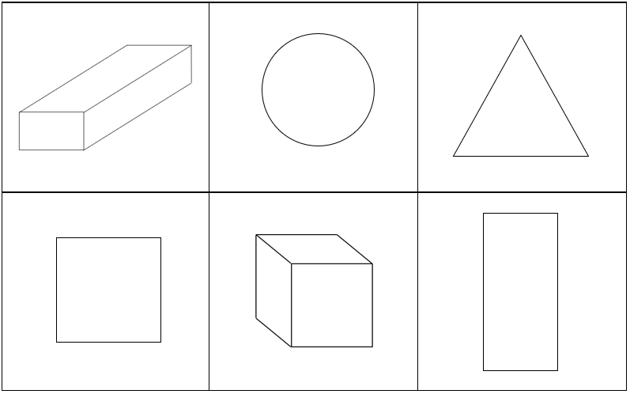  Ask learners:  - Which shape is in the top row on the left?  - Which shape is in the bottom row on the right?  - Which shape is in the middle of the top row?  - Which shape is in the middle of the bottom row?  - Can you describe where the triangle is?  - Can you describe where the square is?  Now ask learners to draw a picture following your instructions:  - Draw a person in the middle of your paper.  - Add a tree to the left of your person.  - Draw the sun in the top right-hand corner of your paper.  - Draw a cat below the tree.  - Draw a bird behind the tree.  - Draw grass under the person.  In pairs, ask one of the learners to pretend to be a robot while the other learner gives their partner instructions on how to move from one position to the next.  Resources:  Table with 3D shapes in it | Many position and direction words come in pairs, so it is useful to play games where you say one of the words (e.g. left) and learners tell you the opposite.  Ensure learners use the most appropriate word (e.g. ‘above’ rather than ‘on top of’). Reinforce prepositional words such as behind, underneath, below etc.

Unit 1.4 Addition, subtraction and doubles

Learning objectives covered in Unit 1.4 and topic summary: |  | 1.4 Topic 1  Understanding addition | 1.4 Topic 2  Understanding subtraction | 1.4 Topic 3  Complements and doubles | Thinking and Working Mathematically
1Ni.02 | Understand addition as:  - counting on  - combining two sets. |  |  |  | TWM.07 Critiquing
1Ni.03 | Understand subtraction as:  - counting back  - take away  - difference. |  |  |  | TWM.07 Critiquing
1Ni.04 | Recognise complements of 10. |  |  |  | TWM.04 Convincing
1Ni.05 | Estimate, add and subtract whole numbers (where the answer is from 0 to 20). |  |  |  | TWM.08 Improving
1Ni.06 | Know doubles up to double 10. |  |  |  | TWM.01 Specialising  TWM.02 Generalising

Unit 1.4 Topic 1 Understanding addition

Outline of topic:
Learners will explore two models for adding numbers together, through counting on and combining sets of numbers. They will estimate the answers before performing the calculations.

Language:
Key vocabulary:
count on
combining
adding, addition
total, sum

Key phrases:
There are … altogether.
The total of … and … is …
… add … is …

Recommended prior knowledge:
- Count reliably to 10 and beyond
- Read and write numbers to 10 and beyond
- Have some practical experience of adding numbers together

Learning objectives | Suggested teaching activities and resources | Mental strategies, possible misconceptions and comments
1Ni.02 Understand addition as:  - counting on  - combining two sets.  TWM.07 Critiquing  Comparing and evaluating mathematical ideas, representations or solutions to identify advantages and disadvantages | Counting on:  Remind learners of the lesson where they previously counted on and counted back. Practice with a few examples first, counting on from numbers between 0 and 10. For example:  Start on 2 and count on in ones from 2.  Give learners a number line from 0 to 20. Ask them to find and mark the number 7. Write the calculation 7 + 5 on the board. Instruct learners to start at 7 and count on 5. Emphasise and count the jumps using vocabulary of more. For example, say:  Seven and one more (making the jump along the line), two more (making the jump) three more, four more, five more.  Ask learners:  What number do we reach? (Answer: 12)  Establish that we can write 7 + 5 = 12.  Try another example using a concrete image of jumping like frogs or children. For example, ask:  A frog is sitting on the second lily pad and makes five jumps, which lily pad will he land on?  Use the number line as before to emphasise the five jumps from 2 to 7.  Give learners a 1-6 dice and ask them to roll the dice once to find their starting point on the number line. Then roll again to find out how many to count on along the number line. For example, if they rolled a 5 then a 6:  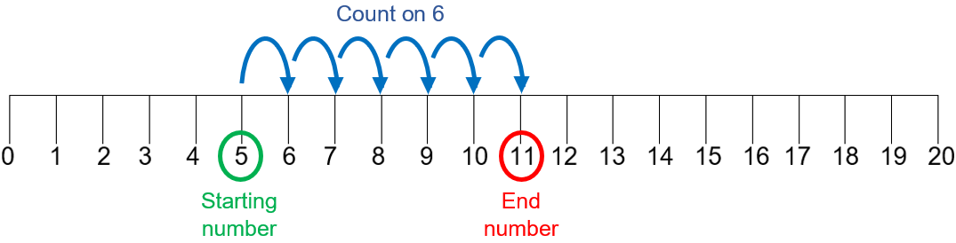  Combining two sets:  Give each pair of learners a selection of small objects, such as paperclips, counters or cubes. Ask each learner to take a small handful of objects.  Ask learners:  How many objects do you have? Count them.  How many objects do you and your partner have altogether?  Ask learners to repeat combining two sets of objects several times.  Once confident with both addition structures give learners some simple calculations (e.g. 4 + 5) and ask them to use both strategies to solve the same question. Ask learners:  What do you notice when you do the questions both ways?  Establish that each way gives the same answer. Ask:  If your answers are not the same, can you see why and what happened?  Learners will show they are critiquing (TWM.07) when they can explain which strategy they prefer to use for each calculation. They may also be able to explain where they might have made mistakes that led to an incorrect answer.  Resources:  Objects to count  0-20 number lines  1-6 dice | Addition can be explored in two different ways:  - Combining two sets is where two quantities are combined into a single quantity.  - Counting on is where a quantity is increased by an amount. It is the addition structure which lies behind the idea of counting on along a number line.  Learners need to experience both structures of addition, even if they prefer one over another.  Possible misconceptions:  Learners sometimes count on by counting the first number rather than counting the jumps between numbers. It is important to count the jumps from the starting number. It is important to use concrete resources and pictorial images to emphasise the jumps between numbers when counting on and back.  Learners may not realise that both strategies lead to the same answer, as they may see adding on as different from combining two sets. This may particularly be the case because learners may not see the initial number in counting on as a quantity, but as a number. It is important to relate to objects and images. Establish that the answers are the same.
1Ni.05 Estimate, add and subtract whole numbers (where the answer is from 0 to 20).  TWM.08 Improving  Refining mathematical ideas or representations to develop a more effective approach or solution | Ask learners to make up addition stories using a variety of contexts and equipment. Give some examples:  - There are 7 red aliens. Then 4 blue aliens appeared. How many aliens are there altogether?  - Jamila has 3 sweets and Yuri has 15 sweets. How many do they have altogether?  Encourage learners to estimate the answer before calculating.  Notice which addition strategy learners choose to solve the questions.  Ask learners:  How did you solve the problems?  Why did you choose that way?  Learners will show they are improving (TWM.08) when they are able to say why they are choosing one strategy over another.

Unit 1.4 Topic 2 Understanding subtraction

Outline of topic:
Learners will explore three models for subtraction through counting back, finding the difference and taking away. They will estimate the answers before performing the calculations.

Language:
Key vocabulary:
take away
count back
difference
subtracting, subtraction

Key phrases:
The difference between … and … is …
… take away … is …
… subtract … is …
There are … left over.

Recommended prior knowledge:
- Count reliably forwards and backwards to 10 and beyond
- Read and write numbers to 10 and beyond
- Have some practical experience of subtracting numbers

Learning objectives | Suggested teaching activities and resources | Mental strategies, possible misconceptions and comments
1Ni.03 Understand subtraction as:  - counting back  - take away  - difference.  TWM.07 Critiquing  Comparing and evaluating mathematical ideas, representations or solutions to identify advantages and disadvantages | Counting back:  Give learners a number line from 0 to 20. Ask them to find and mark the number 12. Write the calculation 12 - 4 on the board. Instruct learners to start at 12 and count back 4. Ask learners:  What number do we land on? (Answer: 8)  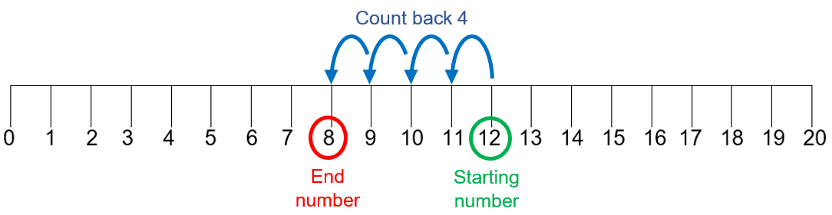  Repeat this several times with different starting numbers and counting back different amounts.  Taking away:  Ask learners to take one handful of objects and count them. Roll a dice to find out how many to take away. Ask learners to remove this amount from their pile of objects.  Ask learners:  How many objects are left?  Ask learners to repeat this several times.  Difference:  Show learners a tower of 10 red cubes and another tower of 7 blue cubes. Ask learners:  What is the difference between the number of red cubes and the number of blue cubes?  Ask learners to make their own towers of different colours and to find the difference in the number of cubes in each. Ask them to repeat this several times.  Once confident with all subtraction structures, give learners some simple calculations (e.g. 9 - 4) and ask them to use all three strategies to solve the same question.  Ask learners:  How did you solve the problems?  Why did you choose that way?  Learners will show they are critiquing (TWM.07) when they can talk about which strategy they prefer for each calculation.  Resources:  0-20 number lines  1-6 dice  Objects to count  Two different colours of cubes | Subtraction can be explored in three different ways:  - Counting back is the subtraction structure which lies behind the idea of counting back along a number line.  - Taking away is where a quantity is partitioned off in some way and subtraction is required to find how many or how much remains.  - Finding the difference is where subtraction is required to make a comparison between two quantities.  Learners need to experience all structures of subtraction, even if they prefer one over another.  Possible misconceptions:  Learners sometimes confuse difference with everyday use of the word and so find it hard to relate to difference between two sets of objects or numbers.  For example, they may see the difference between the 8 and 12 as one is red and the other is green. It is important to relate to the difference in number.  Learners sometimes count back by counting the first number rather than counting the jumps between numbers. It is important to count the jumps from the starting number. It is important to use concrete resources and pictorial images to emphasise the jumps between numbers when counting on and back.  Learners may not realise that the strategies lead to the same answer as they may see taking away as different to counting back and difference. It is important to relate to objects and images. Establish that the answers are the same.
1Ni.05 Estimate, add and subtract whole numbers (where the answer is from 0 to 20).  TWM.08 Improving  Refining mathematical ideas or representations to develop a more effective approach or solution | Ask learners to make up subtraction stories using a variety of contexts and equipment. Give some examples:  - Mike has 5 coins but loses one of them. How many coins does he have now?  - There are 11 cakes, but now 9 of them are eaten. How many cakes are left?  Encourage learners to estimate the answer before calculating.  Notice which subtraction strategy learners choose to solve the questions.  Ask learners:  How did you solve the problems?  What is the same and what is different between your way and a friend’s way?  Why did you choose that way?  Learners will show they are improving (TWM.08) when they are able to say why they are choosing one strategy over another.

Unit 1.4 Topic 3 Complements and doubles

Outline of topic:
Learners will explore complements to 10 and will also begin to know their doubles to 10.

Language:
Key vocabulary:
complement, number bond
addition, subtraction
combinations, possibilities
doubles, double

Key phrases:
Double … is …

Recommended prior knowledge:
- Reading, writing and ordering numbers to 10
- Counting skills
- Simple addition and subtraction calculations

Learning objectives | Suggested teaching activities and resources | Mental strategies, possible misconceptions and comments
1Ni.04 Recognise complements of 10.  TWM.04 Convincing  Presenting evidence to justify or challenge a mathematical idea or solution | Give each pair of learners a ten-frame and 10 counters or small objects of one colour and 10 counters or small objects of a different colour.  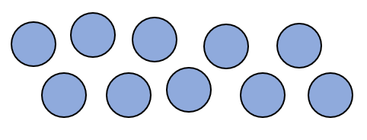  Ask learners to fill their ten-frame with counters of the two different colours in as many ways as possible. For example, they may have 5 yellow and 5 blue counters, or 8 yellow and 2 blue counters:  Ask learners to record the different combinations using number sentences. For example:  10 + 0 = 10 or 10 = 10 + 0  9 + 1 = 10 or 10 = 9 + 1  8 + 2 = 10 or 10 = 8 + 2  etc.  Ask learners:  How many different ways can you fill the ten-frame?  How do you know you have found all the ways?  Learners will show they are convincing (TWM.04) when they can justify why they think they have found all the different solutions.  Take some of their answers and write these on the board. Establish an order to write the answers in.  Ask learners:  What do you notice about the calculations?  Can you see any patterns?  When learners have discovered all the addition number sentences encourage them to find the subtraction number sentences. For example:  10 – 0 = 10  10 – 9 = 1  10 – 8 = 2  etc.  Ask learners:  What do you notice about 9 + 1 = 10 and 10 – 1 = 9?  How are they linked?  In pairs, learners play a guessing game with 10 counters. Player 1 picks up some of the counters while player 2 has their eyes closed. Player 2 works out how many counters player 1 has in their hand by checking what is left on the table.  Encourage learners to check to see if player 2 is correct, then swap and play again.  Resources:  Ten-frames  Counters or objects | When recording calculations remember to use the equals sign in different places within the calculation; e.g. 10 = 3 + 7 and 3 + 7 = 10  Working systematically helps learners to be certain they have found all the possible combinations. However, learners find being systematic difficult and will often choose random numbers to start with. It is important to help them to write their answers in an order so they are systematic.  Possible misconceptions:  Learners sometimes only remember the addition complements and forget about the subtraction complements.
1Ni.06 Know doubles up to double 10.  TWM.01 Specialising  Choosing an example and checking to see if it satisfies or does not satisfy specific mathematical criteria  TWM.02 Generalising  Recognising an underlying pattern by identifying many examples that satisfy the same mathematical criteria | Ask learners to put up one finger on one hand and another finger on their other hand. Using the same number of fingers on each hand, learners can quickly establish that 1 add 1 equals 2, or double 1 is 2.  Ask learners:  Can you use your fingers to show double 3?  What about double 5?  How can you double 6?  Ask learners if they can see any patterns.  Learners will show they are specialising (TWM.01) when they can give you an example of a double. They will show they are generalising (TWM.02) when they notice that raising the same number of fingers on each hand will find a double and apply this understanding of doubles to double 6.  Roll a dice and ask learners to double the number shown.  Give learners dice and ask them to roll the dice and calculate the double. Ask them to check with a partner.  Give each learner 2 ten-frames and ask them to explore doubles up to double 10.  Ask learners to write their answers as number sentences such as  7 + 7 = 14 or 14 = 7 + 7  Resources:  Ten-frames  Counters or objects  1-6 dice | Remember to include double 0 when learning about doubles.  Learners may have heard the term double but may not be clear what it actually means. It is important to remind them of previous experiences such as counting pairs of numbers and relate this to the new vocabulary of doubling.

Unit 1.5 Money

Learning objectives covered in Unit 1.5 and topic summary: |  | 1.5 Topic 1  Recognising money | Thinking and Working Mathematically
1Nm.01 | Recognise money used in local currency. |  | TWM.04 Convincing

Unit 1.5 Topic 1 Recognising money

Outline of topic:
Learners will explore using money in their own local currency.

Language:
Key vocabulary:
money
coins, notes
value

Key phrases:
What is this coin or note worth?

Recommended prior knowledge:
- Read and write numbers to at least 20
- Recognise 0 as none of something

Learning objectives | Suggested teaching activities and resources | Mental strategies, possible misconceptions and comments
1Nm.01 Recognise money used in local currency. | Ask learners to discuss with their partner what they know about money and their local currency.  Ask questions such as:  How many coins and notes are there?  What shape are the coins and notes?  What colour are the coins and notes?  Provide learners with coins in your local currency. Ask learners:  Which coin is the greatest in value? Least in value?  Can you order them from smallest to largest in value?  Show learners pictures or photographs of items for sale with prices attached, for example, a fruit stall. Ask learners to read the amounts that each piece of fruit costs. In a small group, ask learners to match the coins to the corresponding number and word.  Set up a shop in the classroom and invite learners to buy items in exchange for money.  Resources:  Coins and notes in your local currency  Pictures or photographs of items for sale  Labels with the number and word on  Classroom shop role play area | Money is quite an abstract concept for many learners so, if possible, use either real or plastic money.  Possible misconceptions:  Learners often forget that not all numbers are represented by a coin or note and so will often try to use a coin or note which does not exist, such as a $3 note in US Dollar (USD).  Learners also find the one-to-many concept difficult so will take time to understand that one coin can represent more than one in value.
1Nm.01 Recognise money used in local currency.  TWM.04 Convincing  Presenting evidence to justify or challenge a mathematical idea or solution | Give learners word problems about money in your local currency such as:  Anastasia says she has more money than Chen because her coin is larger than Chen’s. Is Anastasia correct? Why or why not?  Hassan has 2 silver coins. Lily has 5 bronze coins. Oliver has 1 gold coin. They all have the same amount of money. Which coins might they each have?  Learners will show they are convincing (TWM.04) when they can justify and offer explanations for how they solved the problems. | Possible misconceptions:  Learners may incorrectly think that a larger coin or note always represents a larger value. For certain local currencies this is not always the case, for example a 2 pence coin is larger than a 5 pence coin in Pound Sterling (GBP).

Unit 1.6 Measurement

Learning objectives covered in Unit 1.6 and topic summary: |  | 1.6 Topic 1  Describing length, mass and capacity | 1.6 Topic 2  Measuring instruments | Thinking and Working Mathematically
1Gg.02 | Use familiar language to describe length, including long, longer, longest, thin, thinner, thinnest, short, shorter, shortest, tall, taller and tallest. |  |  | TWM.02 Generalising
1Gg.04 | Use familiar language to describe mass, including heavy, light, less and more. |  |  | TWM.03 Conjecturing
1Gg.05 | Use familiar language to describe capacity, including full, empty, less and more.
1Gg.08 | Explore instruments that have numbered scales, and select the most appropriate instrument to measure length, mass, capacity and temperature. |  |  | TWM.04 Convincing

Unit 1.6 Topic 1 Describing length, mass and capacity

Outline of topic:
Learners will explore length, mass and capacity in practical situations. They will begin to develop the language for each and will begin to solve practical problems for each measurement.

Language:
Key vocabulary:
long, longer, longest
thin, thinner, thinnest
short, shorter, shortest
tall, taller, tallest
heavy, heavier, heaviest
light, lighter, lightest
less, more
full, empty

Key phrases:
… is longer than …
… is the tallest.
… is heavy.

Recommended prior knowledge:
- Count to 10 and beyond
- Read and write numbers to 10 and beyond

Learning objectives | Suggested teaching activities and resources | Mental strategies, possible misconceptions and comments
1Gg.02 Use familiar language to describe length, including long, longer, longest, thin, thinner, thinnest, short, shorter, shortest, tall, taller and tallest.  TWM0.2 Generalising  Recognising an underlying pattern by identifying many examples that satisfy the same mathematical criteria | Prepare some towers made from cubes (alternating colours will make the cubes easier for learners to count). Choose two towers and place them side-by-side.  Ask learners:  Which tower is taller? How do you know?  How much taller is one tower than the other?  Relate to previous lesson on difference by considering how much one is taller than the other.  Ask learners to make a tower that is taller (or shorter) than the tallest tower.  Check by direct comparison and seeing how much taller one is than the other. Also check by counting the cubes in each tower and then repeat.  Pass around some different coloured ribbons of assorted lengths. Ask learners to compare their lengths. Check they are matching up one end of the ribbons, so they are accurately comparing length. Ask learners to describe what they have noticed using the words: long, longer, longest, short, shorter, shortest.  For example:  - The blue ribbon is longer than the red ribbon.  - The yellow ribbon is the shortest.  Ask learners to choose one ribbon and using cubes, measure the length of it. Can they now find a ribbon that is longer and shorter than their ribbon? Check by measuring with cubes.  In groups of three ask learners to order themselves into height order. Who is tall, taller, tallest or short, shorter, shortest? Ask learners:  Is it true that the oldest person is always the tallest?  Learners will show they are generalising (TWM.02) when they realise that age and height do not always correlate.  Ask learners to draw around their own footprint. Ask them to find three things that are longer, three things that are shorter and three things that are about the same length.  Using playdough, ask learners to make three snakes of different widths. Ask learners:  Which snake is the thinnest?  Can you sort your snakes into thin, thinner, thinnest?  Resources:  Cubes of different colours  Ribbons of assorted lengths and colours  Playdough | Learners begin to measure by making direct comparisons, one object against another. Initially they are not measuring against any absolute standard, so the language is not yet accurate. It is important to use the correct language so that learners begin to hear it and use it. It is also important to connect to comparatives and superlatives for example:  - tall, taller, tallest  - short, shorter, shortest.  Possible misconceptions:  Learners do not always measure accurately so ensure they always match ends to ends.
1Gg.04 Use familiar language to describe mass, including heavy, light, less and more.  TWM.03 Conjecturing  Forming mathematical questions or ideas | Give learners a range of five objects from everyday life, such as packets of rice, tins of food, pencils, school bags etc.  Ask learners to estimate which one is lightest and which is heaviest without feeling them. This is to challenge the misconception that size relates to mass. Ask learners to think about how it feels carrying the objects and whether they think they are heavy or light. Then ask learners to feel the objects and see how heavy each is, then rank them from lightest to heaviest.  Give small groups of learners one of the items to place onto some balance scales. Ask learners to find objects which are heavier or lighter than their item. Ask learners for their conjectures:  - How many objects do you think you will find that weigh less than your item?  - How many objects do you think you will find that weigh more than your item?  - Do you think … will be heavier or lighter than your item?  Learners will show they are conjecturing (TWM.03) when they offer ideas as to how many objects they might find, or whether certain objects will weigh more or less than the item.  Repeat this balance scale activity but this time use a different item.  Resources:  Five every-day objects that can be weighed using balance scales  Balance scales | Learners need lots of experience of weighing using balance scales. This gives them the opportunity to see the scales balance and hold weights in one hand and the object in their other hand. Learners also need experience with relating weight and mass to everyday objects and their experiences of them because this is important for developing their estimation skills.  Possible misconceptions:  Learners need to be reminded that the balance scale pointer needs to be on 0 before they start to weigh any objects.  Learners confuse weight and mass so when weighing objects try to refer to the mass of the object and not its weight.  Learners sometimes think that the size of objects is related to their mass, so small objects are lighter than bigger objects. It is important to give them some examples of objects to weigh to show that this is not necessarily the case.
1Gg.05 Use familiar language to describe capacity, including full, empty, less and more. | Show learners a variety of jugs and bottles. Ask learners:  - Which jug or bottle has the most space to hold something?  - Which jug or bottle has the least?  Tell learners that the container does not have to be full. The capacity is the total space available inside it.  Ask learners to check their ideas by filling the jugs and bottles with water. Encourage learners to use the vocabulary full, empty, less, more.  Now show learners some empty boxes. Ask them to order the boxes according to which box has the most space and which box has the least space. Using the same objects (e.g. cubes, balls) ask learners to test out their ideas. It does not matter if the largest box cannot be filled completely. Even if there is space left, this will show it has the largest capacity.  Now show learners different containers that all hold 1 litre. Ask them which container has the most and which has the least space inside it. Once learners have discussed, explained and ordered the containers, show them that each container has the same amount of space inside it.  Resources:  Jugs and bottles  Boxes, cubes or balls  Several different 1-litre containers | Capacity is the amount a container can hold.  Possible misconceptions:  Learners confuse capacity and volume and although this objective does not cover volume it is important to ensure learners have a good grasp of capacity so that future confusion can be limited.  Learners may enjoy listening to the story My Cat Likes to Hide in Boxes by Eve Sutton, before introducing them to the empty boxes.

Unit 1.6 Topic 2 Measuring instruments

Outline of topic:
Learners will explore the different measuring equipment used to measure length, mass, capacity and temperature.

Language:
Key vocabulary:
length, mass, capacity, temperature
long, longer, longest
thin, thinner, thinnest
short, shorter, shortest
tall, taller and tallest
heavy, heavier, heaviest
light, lighter, lightest
less, more
full, empty

Recommended prior knowledge:
- Count to 10 and beyond
- Read and write numbers to 10 and beyond
- Understanding of length, mass and capacity

Learning objectives | Suggested teaching activities and resources | Mental strategies, possible misconceptions and comments
1Gg.08 Explore instruments that have numbered scales, and select the most appropriate instrument to measure length, mass, capacity and temperature.  TWM.04 Convincing  Presenting evidence to justify or challenge a mathematical idea or solution | Give all learners a marked 0-20 number line. Ask them to find and circle numbers that you choose.  Now give learners a number line that is presented in a semi-circle. Ask them to find and circle numbers that you choose.  In small groups place a variety of measuring equipment on the table.  For example: balance scales with 1-gram and 1-kilogram masses, thermometer, ruler, containers and jugs with marked scales on.  Ask learners to look at each piece of measuring equipment and notice how the scale on each one is like the number lines they were just using (although the numbers might be slightly different).  Now ask learners to draw some things that can be measured by each of the measuring equipment.  Finally ask each learner to choose a piece of measuring equipment and measure something with it. Ask them to come back to the group once they have had a go and share their findings.  Learners will show they are convincing (TWM.04) when they can explain why the piece of measuring equipment was suitable for the object they measured.  Resources:  0-20 number lines  Semi-circle number lines  Balance scales with 1-gram and 1-kilogram masses  Thermometers  Rulers  Containers and jugs with marked scales on | Possible misconceptions:  Learners sometimes think that all measuring equipment works in the same way, so it is useful to give them exposure to several different types, so they get used to using each one.  Learners find the one-to-many concept difficult here, where one scale might represent more than one measure. Choose simple instruments with simple, single scales such as rulers, and balance scales rather measuring scales.

Unit 1.7 Fractions

Learning objectives covered in Unit 1.7 and topic summary: |  | 1.7 Topic 1  Splitting shapes | 1.7 Topic 2  Finding halves | Thinking and Working Mathematically
1Nf.01 | Understand that an object or shape can be split into two equal parts or two unequal parts. |  |  | TWM.06 Classifying
1Nf.02 | Understand that a half can describe one of two equal parts of a quantity or set of objects.
1Nf.03 | Understand that a half can act as an operator (whole number answers). |  |  | TWM.04 Convincing
1Nf.04 | Understand and visualise that halves can be combined to make wholes.

Unit 1.7 Topic 1 Splitting shapes

Outline of topic:
Learners will understand that an object or shape can be split into two equal parts or two unequal parts. Learners will explore that halves can be combined to make wholes.

Language:
Key vocabulary:
equal, unequal, not equal
split, splitting
half, halves
less, more

Key phrases:
Are these two parts equal or unequal?

Recommended prior knowledge:
- Count, read and write numbers to at least 20
- Simple understanding of 2D shapes

Learning objectives | Suggested teaching activities and resources | Mental strategies, possible misconceptions and comments
1Nf.01 Understand that an object or shape can be split into two equal parts or two unequal parts.  TWM.06 Classifying  Organising objects into groups according to their mathematical properties | Tell learners that Naomi has been splitting shapes into two parts. Show learners some pictures where some of the shapes have been split equally and others have not. Begin by showing the same shape split in different ways:  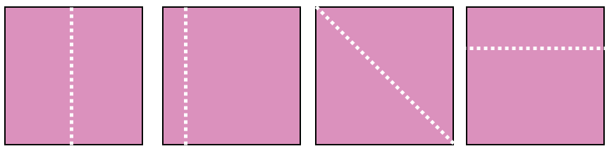  Ask learners:  - What do you notice?  - Which shapes do you think have been split equally?  Then show learners other shapes, some split in two equal parts and some in two unequal parts:  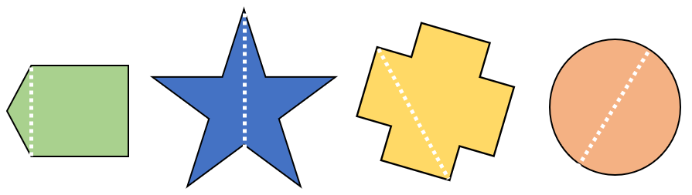  Ask learners:  - What do you notice?  - Which shapes do you think have been split equally?  Show learners two or three items of food you might share on a picnic (e.g. an apple, a piece of cheese, a small cake, or alternatively use playdough). Choose one item and cut it into two unequal pieces. Ask learners:  - Which part would you choose?  - Is it fair?  Repeat this for the other items of food.  Ask learners to create their own picnic food out of playdough. Ask them cut all of the pieces into two, and to group those that are split into equal parts and those that are split into unequal parts.  Learners will show they are classifying (TWM.06) by deciding which items go into each pile.  Resources:  Pictures of shapes cut into equal and unequal parts  Items of real (or playdough) food  Playdough | Possible misconceptions:  Learners may see an object split into two unequal parts and consider them to be halves. Ensure learners understand that shapes that are cut into two unequal parts are not halves.
1Nf.04 Understand and visualise that halves can be combined to make wholes. | Show learners a picture of a sandwich that has been cut into half. Then show three other pictures and ask:  Which one of the three is the other half of the sandwich?  For example:  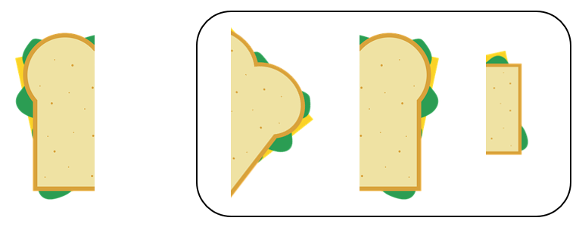  Ask learners why the other two pictures are not halves of this sandwich.  Give learners some different lengths of the same ribbon. Ask them to fold their ribbon in half and cut it. Mix up the ribbons and challenge learners to find the two pieces that originally went together by comparing lengths.  For another challenge involving halves, use the NRICH task: Halving (https://nrich.maths.org/1788)  Resources:  Ribbon  NRICH task

Unit 1.7 Topic 2 Finding halves

Outline of topic:
Learners will explore halves as both two equal parts of a quantity or a set of objects, and half as an operator.

Language:
Key vocabulary:
half, halving
double, doubling
equal, twice

Key phrases:
Half of … is …

Recommended prior knowledge:
- Count, read and write numbers to at least 20

Learning objectives | Suggested teaching activities and resources | Mental strategies, possible misconceptions and comments
1Nf.02 Understand that a half can describe one of two equal parts of a quantity or set of objects. | Give learners 10 counters or other small objects. Ask them to share the objects into two equal groups. Change the number of objects each learner has and repeat several times.  Demonstrate that objects can be taken two at a time (or any other unit) as long as each group has the same number of objects in it at the end.  Ask learners:  What happens when you have an odd number of counters?  Explain that you can half any number but sometimes it is not physically possible to cut objects in half.  Challenge learners to halve numbers without the use of counters. Ask learners:  What is half of 4?  What is half of 10?  Resources:  Counters or other small objects | Ensure learners understand that half is the inverse of double.  Possible misconceptions:  Learners may see an object or set of counters split into two unequal parts and consider them to be halves.
1Nf.03 Understand that a half can act as an operator (whole number answers).  TWM 0.4 Convincing  Presenting evidence to justify or challenge a mathematical idea or solution | Show learners two bags of sweets:  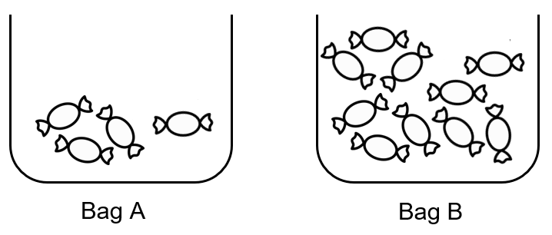  Ask learners:  - Would you rather have all of the sweets in Bag A or half of the sweets in Bag B?  - How can you make it equal, so that Bag A has the same number of sweets as Bag B?  Ask learners for their strategies for altering them into equal amounts.  Some learners will take the total number of sweets and share them out again into two equal groups. Others will focus on adjustment strategies, taking some from one group and giving them to the other group, so they become equal.  Repeat this with other pictures, for example:  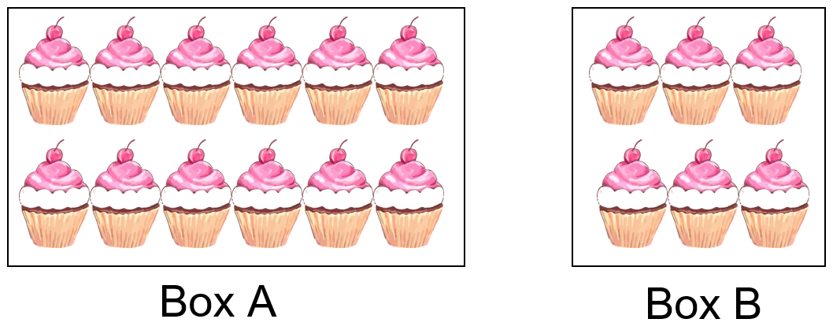  Ask learners:  Would you rather have all the cakes in Box B or half of the cakes in Box A?  Learners will show they are convincing (TWM.04) when they reason which choice they would rather have.  Play halves bingo. Give each learner a 3 x 3 grid and ask them to write these numbers anywhere on their grid: 2, 3, 4, 5, 6, 7, 8, 9, 10.  You need the cards: 4, 6, 8, 10, 12, 14, 16, 18, 20.  Shuffle the cards and then choose one to read out (e.g. 4). Learners have to halve the number to find the answer in their grid. The player with two lines (rows or columns) completed wins.  Resources:  3 x 3 grids  One pack of even cards 4-20 | Different representations of fractions will help learners develop their concept of fractions, which will support future learning.  Possible misconceptions:  Learners often only see fractions as numbers and not as operators so introducing this concept very early on is crucial.  Learners sometimes confuse sharing with social stories. For example, they might say they prefer bag A, but this is because they do not like whatever is in the bags (such as sweets) so choose the lesser amount rather than because they are confused about the concept of equal shares.  It is important for the learners to relate to the whole. In the cases here, the whole is the total number of sweets or cakes. It is also important for them to develop strategies for making adjustments between the two bags or two boxes to ensure they are equal.

Unit 1.8 Statistical methods

Learning objectives covered in Unit 1.8 and topic summary: |  | 1.8 Topic 1  The statistical cycle |  | Thinking and Working Mathematically
1Ss.01 | Answer non-statistical questions (categorical data).
1Ss.02 | Record, organise and represent categorical data using:  - practical resources and drawings  - lists and tables  - Venn and Carroll diagrams  - block graphs and pictograms. |  |  |  | TWM.06 Classifying
1Ss.03 | Describe data, using familiar language including reference to more, less, most or least to answer non-statistical questions and discuss conclusions.

Unit 1.8 Topic 1 The statistical cycle

Outline of topic:
Learners will explore asking and answering simple questions for which they can collect and interpret data.

Language:
Key vocabulary:
sort, classify
count, set, represent, label
list, graph, table, Venn diagram, Carroll diagram
most, least, more, less
data collection

Recommended prior knowledge:
- Count, read and write numbers to 20
- Simple addition and subtraction
- Understanding of 2D shapes

Learning objectives | Suggested teaching activities and resources | Mental strategies, possible misconceptions and comments
1Ss.01 Answer non-statistical questions (categorical data). | Ask learners questions on topics that are familiar and of interest to them. For example:  - What is your favourite game?  - What colour is your school bag?  - What is the name of the road you live on?  Ask learners to share their answers and discuss with a partner. Ask learners:  - Did you and your partner give the same answer?  - Do you think anyone else in the class gave the same answer as you? Why or why not?  - How can you find out if your answer is correct? | Categorical data refers to characteristics such as colour, names, personal preferences, etc. where there is only one answer.
1Ss.02 Record, organise and represent categorical data using:  - practical resources and drawings  - lists and tables  - Venn and Carroll diagrams  - block graphs and pictograms. | This activity is based on the NRICH task: The Voting Station (https://nrich.maths.org/13894)  Give each learner a cube. Ask them to vote on which book should be chosen for the next class reading book. Give four options.  Ask learners to vote by placing their cube next to their preferred book.  Build a physical block graph with the cubes.  Ask questions such as:  - Which book is the most popular?  - Why do you think this is?  - How many learners did we ask?  - Will the information be different if we ask more or less learners?  This activity can be repeated using other situations that learners must vote on, such as which song to play at the end of the day or which fruit is their favourite.  Resources:  Cubes  NRICH task | Collecting data can often take too much time, so try to collect information quickly so that learners can focus on interpreting it.
1Ss.02 Record, organise and represent categorical data using:  - practical resources and drawings  - lists and tables  - Venn and Carroll diagrams  - block graphs and pictograms.  TWM.06 Classifying  Organising objects into groups according to their mathematical properties | Give learners a range of 2D objects and ask them to classify them according to one criterion. For example, shapes that are squares and shapes that are not squares or shapes with only straight lines and shapes with curved lines.  Display the data in either a Carroll diagram or a Venn diagram.  For example:  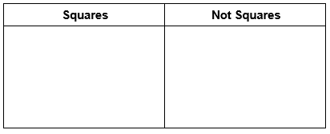  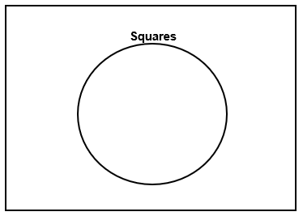  Learners will show they are classifying (TWM.06) by deciding which 2D shapes fit the given criteria.  Resources:  A range of 2D objects  Hoops | Possible misconceptions:  With diagrams like the Venn diagram that uses a 2D shape to represent a set of objects, learners can have difficulty seeing that it is a circle that can hold a set of objects. The rectangle around the outside then is to hold the set of objects that do not meet the criteria of the set in the circle. It is important to use different categories and criteria for these, so they are seen as shapes, but also as holders of sets. Start by using hoops and putting objects into the hoops, before moving to pictorial representations of circles.
1Ss.03 Describe data, using familiar language including reference to more, less, most or least to answer non-statistical questions and discuss conclusions.  1Ss.02 Record, organise and represent categorical data using:  - practical resources and drawings  - lists and tables  - Venn and Carroll diagrams  - block graphs and pictograms. | Ask learners:  - How many cubes do you think you can you hold in your hand?  - How can you find out?  Ask all learners to take a handful of cubes to test the maximum number they can hold. Select learners to share how many cubes they can hold with the rest of the class and record it on the board.  For example:  - Eva can hold 7 cubes.  - Gabriella can hold 8 cubes.  - Pierre can hold 5 cubes.  - Youssef can hold 6 cubes.  Ask learners:  How shall we organise the information?  Show learners how to make and organise a table. For example:  Ask learners:  - Who can hold the most cubes?  - Who can hold one more cube than Pierre?  - How many more cubes can Gabriella hold than Youssef?  Ask learners, in groups of four or five, to create their own table to organise the information. Then they should challenge each other to answer questions about the data using the language more, less, most or least.  Resources:  Cubes | Possible misconceptions:  Learners can struggle to interpret tables when the numbers are not in ascending or descending order. In some cases, they ignore the value of the numbers and read the data as though it is in order, even when it is not.
  Name | Number of cubes
  Eva | 7
  Gabriella | 8
  Pierre | 5
  Youssef | 6

Sample lesson 1

CLASS:

DATE:
Learning objectives | 1Nc.01 Count objects from 0 to 20, recognising conservation of number and one-to-one correspondence.
Lesson focus /  success criteria | Learners can count objects reliably.  - I can count objects correctly  - I can count from zero to twenty.
Prior knowledge /  previous learning | Count to 10 and beyond  Read and write numbers to 10 and beyond
Plan
Lesson | Planned activities | Notes
Introduction | Show learners the learning objectives and lesson focus and agree the success criteria:  - I can count objects correctly.  Ask learners to close their eyes. Slowly drop three objects individually into a tin or container. Ask learners to open their eyes and show you on their fingers how many objects they think are in the tin. Agree the correct amount.  Ask learners to find the correct number on a number line.  Repeat this several times. | Resources:  Tin or container  A handful of small objects such as cubes or counters  Large number line
Main activities | Place between 0 and 20 objects into a number of different bowls or containers. Use small objects such as paperclips, counters, cubes, buttons, toy animals etc.  Choose a bowl and count the number of objects in the bowl as a class. Remove the objects one at a time and count each as it is removed.  Let’s check our counting.  One, two, three, four … so how many altogether?  Then place the objects back in the bowl, counting each object as it is returned.  Repeat this several times with other bowls of objects.  Give each small group of learners one of the bowls of objects. Ask learners:  - How many objects are in your bowl?  - How can you check your answer?  Ask learners to swap containers with each other so they now have different objects to count.  Ask each group to place three objects in their bowl. Ask learners to check each other’s counting.  - Can you count three objects?  - Can you count seventeen objects?  - Can you count the total number of objects from two bowls altogether?  In pairs, learners roll a 1-6 dice and count out the number shown on the dice. They continue to roll the dice and count on the new number shown. The winner is the learner who reaches 20 first. | Resources:  Bowls or containers  Small objects such as paperclips, counters, cubes, buttons, toy animals etc.  1-6 dice
End | Repeat the activity from the introduction but this time ask learners to keep their eyes open and count aloud as you drop the objects into the tin or container. Explain that you may try to mislead them by dropping a number of objects into the container different from the number you are saying, for example, you might drop two objects in while only saying one number. They must listen and decide whether or not you have dropped the number you indicated.  Ask learners:  - Did I drop in more or less objects than I counted?  - How can I check?  Revisit the learning objectives and success criteria. Ask learners to explain whether they have met the success criteria and if they have any questions or comments.  Tidy the classroom, ask learners to count and put away 5 items each. | Resources:  Tin or container  A handful of small objects such as cubes or counters

Reflection
Use the space below to reflect on your lesson. Answer the most relevant questions for your lesson.
Were the learning objectives and lesson focus realistic? What did the learners learn today?
What was the learning atmosphere like?
What changes did I make from my plan and why?
If I taught this lesson again, what would I change?
What two things really went well (consider both teaching and learning)?
What two things would have improved the lesson (consider both teaching and learning)?
What have I learned from this lesson about the class or individuals that will inform my next lesson?
Next steps
What will I teach next based on learners’ understanding of this lesson?

Sample lesson 2

CLASS:

DATE:
Learning objectives | 1Np.02 Compose, decompose and regroup numbers from 10 to 20.  TWM.01 Specialising  TWM.02 Generalising  TWM.04 Convincing
Lesson focus /  success criteria | Learners can use the part-whole method to compose, decompose and regroup numbers.  - I can separate numbers and put them back together.
Prior knowledge /  previous learning | Count, read and write numbers from 0-20
Plan
Lesson | Planned activities | Notes
Introduction | Show learners the learning objectives and lesson focus and agree the success criteria:  - I can separate numbers and put them back together.  Ask eight learners to stand at the front of the class. Ask them to think of a way to group themselves. They may group themselves according to eye or hair colour, gender, who is wearing a jumper etc.  Draw how they have represented themselves on the board. For example, they started with 8 and then separated the 8 into a 3 and 5.  Ask them to go back into their original group of eight. Ask them to think of another way to separate themselves. Again, draw a representation of this on the board.
Main activities | Choose one card from a set of cards with the numbers from 10 to 20 written on them. As a class, count out the number using objects. For example, if you choose the number 13, count out 13 paper clips or counters etc with learners.  Demonstrate how you can separate the objects in lots of different ways.  For example, 13 can be separated into 10 and 3, or 8 and 5, or 5, 5 and 3 and so on.  Introduce the part-whole model. Demonstrate 13 is the whole and it can be split into two parts (or more). For example, 10 and 3, 8 and 5.  Ask learners to find more examples of how to regroup the chosen number and to record these in part-whole models.  Ask learners to choose a number card between 10 and 20 and count out a number of objects to go with the card. Then ask learners to see how many ways they can separate that number into at least two other numbers by separating the group of objects into two groups, three groups or more.  Learners will show they are specialising (TWM.01) when they find further examples of regrouping the number. Learners will show they are generalising (TWM.02) when they notice and can explain that however they split up the whole, it can still be combined to return to the whole.  Repeat the activity by choosing another card with a number from 10 to 20, asking learners to complete part-whole diagrams for this number.  Ask learners:  - What does the whole mean?  - What does part mean?  - Can zero be a part?  - Can the parts be swapped around?  - Can the whole be swapped with a part? | Resources:  Number cards with numbers from 10 to 20  Objects to count
End | Ask learners whether the following statement is true or false:  14 can be separated into 10 and 5  Ask learners to discuss with a partner:  Can you convince me?  Can you prove it?  Learners will show they are convincing (TWM.04) when they explain their reasoning.  Ask learners:  If 4 is the whole how many different part-whole models can you draw to show this? Use different numbers for the parts every time.  Are any the same? Why?  Revisit the learning objectives and success criteria. Ask learners to explain whether they have met the success criteria and if they have any questions or comments.

Reflection
Use the space below to reflect on your lesson. Answer the most relevant questions for your lesson.
Were the learning objectives and lesson focus realistic? What did the learners learn today?
What was the learning atmosphere like?
What changes did I make from my plan and why?
If I taught this lesson again, what would I change?
What two things really went well (consider both teaching and learning)?
What two things would have improved the lesson (consider both teaching and learning)?
What have I learned from this lesson about the class or individuals that will inform my next lesson?
Next steps
What will I teach next based on learners’ understanding of this lesson?

Changes to this Scheme of Work

This Scheme of Work has been amended. The latest Scheme of Work is version 2.0, published January 2021.

- The definition of the Thinking and Working Mathematically characteristic TWM.03 Conjecturing has been changed to: Forming mathematical questions or ideas.
- The definition of the Thinking and Working Mathematically characteristic TWM 04 Convincing has been changed to: Presenting evidence to justify or challenge a mathematical idea or solution.

There may be other minor changes that do not affect teaching and learning.

Cambridge Assessment is committed to making our documents accessible in accordance with the WCAG 2.1 Standard. We are always looking to improve the accessibility of our documents. If you find any problems or you think we are not meeting accessibility requirements, contact us at info@cambridgeinternational.org with the subject heading: Digital accessibility. If you need this document in a different format, contact us and supply your name, email address and requirements and we will respond within 15 working days.

Cambridge Assessment International Education
The Triangle Building, Shaftesbury Road, Cambridge, CB2 8EA, United Kingdom
t: +44 1223 553554 f: +44 1223 553558
e: info@cambridgeinternational.org www.cambridgeinternational.org

© UCLES September 2020

