

Scheme of Work
Cambridge Primary
Mathematics 0096
Stage 2

This Cambridge Scheme of Work is for use with the Cambridge Primary
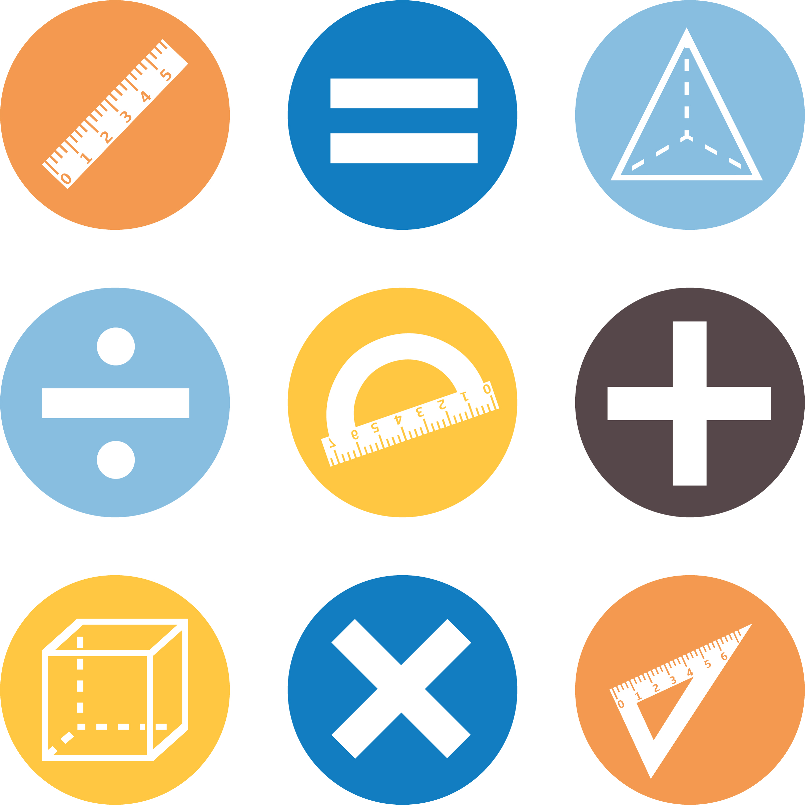
Mathematics Curriculum Framework published in September
2020 for first teaching in September 2021.

© UCLES 2020
Cambridge Assessment International Education is part of the Cambridge Assessment Group. Cambridge Assessment is the brand name of the University of Cambridge Local Examinations Syndicate (UCLES), which itself is a department of the University of Cambridge.

UCLES retains the copyright on all its publications. Registered Centres are permitted to copy material from this booklet for their own internal use. However, we cannot give permission to Centres to photocopy any material that is acknowledged to a third party, even for internal use within a Centre.

Contents

Contents 3
Introduction 5
Unit 2.1 Numbers to 100, addition and subtraction 9
Unit 2.1 Topic 1 Counting and estimating 10
Unit 2.1 Topic 2 Using and comparing numbers 16
Unit 2.1 Topic 3 Addition and subtraction 21
Unit 2.2 Time 27
Unit 2.2 Topic 1 Units of time 28
Unit 2.2 Topic 2 Knowing the time 30
Unit 2.3 Exploring shapes and movement 33
Unit 2.3 Topic 1 Describing shapes 34
Unit 2.3 Topic 2 Symmetry and reflecting shapes 38
Unit 2.3 Topic 3 Angles, turning and moving shapes 41
Unit 2.3 Topic 4 3D shapes 44
Unit 2.4 Number patterns and place value 46
Unit 2.4 Topic 1 Understanding place value 47
Unit 2.4 Topic 2 Finding patterns 51
Unit 2.5 Multiplication and division 55
Unit 2.5 Topic 1 Understanding multiplication 56
Unit 2.5 Topic 2 Understanding division 60
Unit 2.6 Measurement 62
Unit 2.6 Topic 1 Measuring length 63
Unit 2.6 Topic 2 Mass and capacity 67
Unit 2.7 Fractions 70
Unit 2.7 Topic 1 Finding quarters 71
Unit 2.7 Topic 2 Building with fractions 77
Unit 2.8 Statistical methods and chance 80
Unit 2.8 Topic 1 The statistical cycle 81
Unit 2.8 Topic 2 Chance 85
Sample lesson 1 88
Sample lesson 2 91
Changes to this Scheme of Work 93

Changes to this Scheme of Work
For information about changes to this Scheme of Work, go to page 93.
The latest Scheme of Work is version 2.0, published January 2021.

Introduction
This document is a scheme of work created by Cambridge Assessment International Education for Cambridge Primary Mathematics Stage 2.

It contains:
- suggested units showing how the learning objectives in the curriculum framework can be grouped and ordered
- at least one suggested teaching activity for each learning objective
- a list of subject-specific language that will be useful for your learners
- common misconceptions
- sample lesson plans
- links to relevant NRICH activities to enrich learners’ mathematical experiences, https://nrich.maths.org/

You do not need to use the ideas in this scheme of work to teach Cambridge Primary Mathematics Stage 2. Instead use them as a starting point for your planning and adapt them to suit the requirements of your school and the needs of your learners. The schemes of work are designed to indicate the types of activities you might use, and the intended depth and breadth of each learning objective. These activities are not designed to fill all the teaching time for this stage. You should use other activities with a similar level of difficulty, for example, those from endorsed resources.

The accompanying teacher guide for Cambridge Primary Mathematics suggests effective teaching and learning approaches. You can use this scheme of work as a starting point for your planning, adapting it to suit the requirements of your school and needs of your learners.

Long-term plan
This long-term plan shows the units in this scheme of work and a suggestion of how long to spend teaching each one. The suggested teaching time is based on learners having about 4 to 5 hours of Mathematics per week (about 120 to 150 hours per stage). The actual number of teaching hours may vary according to your context.
Unit | Suggested teaching time
Unit 2.1 Numbers to 100, addition and subtraction | 17% (25 hours)
Unit 2.2 Time | 10% (15 hours)
Unit 2.3 Exploring shapes and movement | 13% (20 hours)
Unit 2.4 Number patterns and place value | 10% (15 hours)
Unit 2.5 Multiplication and division | 10% (15 hours)
Unit 2.6 Measurement | 10% (15 hours)
Unit 2.7 Fractions | 17% (25 hours)
Unit 2.8 Statistical methods and chance | 13% (20 hours)
Total | 150 hours

Sample lesson plans
You will find two sample lesson plans at the end of this scheme of work. They are designed to illustrate how the suggested activities in this document can be turned into lessons. They are written in more detail than you would use for your own lesson plans. The Cambridge Primary Mathematics Teacher Guide has information on creating lesson plans.

Other support for teaching Cambridge Primary Mathematics Stage 2
Cambridge Primary centres receive access to a range of resources when they register. The Cambridge Primary support site at https://primary.cambridgeinternational.org is a password-protected website that is the source of the majority of Cambridge-produced resources for the programme. Ask the Cambridge Coordinator or Exams Officer in your school if you do not already have a log-in for this support site.

Included on this support site are:
- the Cambridge Primary Mathematics Curriculum Framework, which contains the learning objectives that provide a structure for your teaching and learning
- grids showing the progression of learning objectives across stages
- the Cambridge Primary Mathematics Teacher Guide, which will help you to implement Cambridge Primary Mathematics in your school
- templates for planning
- worksheets for short teacher training activities that link to the teacher guide
- assessments provided by Cambridge
- a list of endorsed resources, which have been through a detailed quality assurance process to make sure they are suitable for schools teaching Cambridge Primary Mathematics worldwide
- links to online communities of Cambridge Primary teachers.

Resources for the activities in this scheme of work
We have assumed that you will have access to these resources:
- paper, pens and pencils for learners to use
- rulers, set squares, protractors and calculators.

Other suggested resources for individual units and/or activities are described in the rest of this document. You can swap these for other resources that are available in your school.

Websites
We recommend NRICH to support Cambridge Primary Mathematics at https://nrich.maths.org/

NRICH publishes free and challenging mathematics activities for learners of all ages. The resources assist teachers to embed thinking and working mathematically with mathematics content. NRICH is based in both the University of Cambridge's Faculty of Education and the Centre for Mathematical Sciences.

There are many excellent online resources suitable for teaching Cambridge Primary Mathematics. Since these are updated frequently, and many are only available in some countries, we recommend that you and your colleagues identify and share resources that you have found to be effective for your learners.

Approaches to teaching Cambridge Primary Mathematics Stage 2
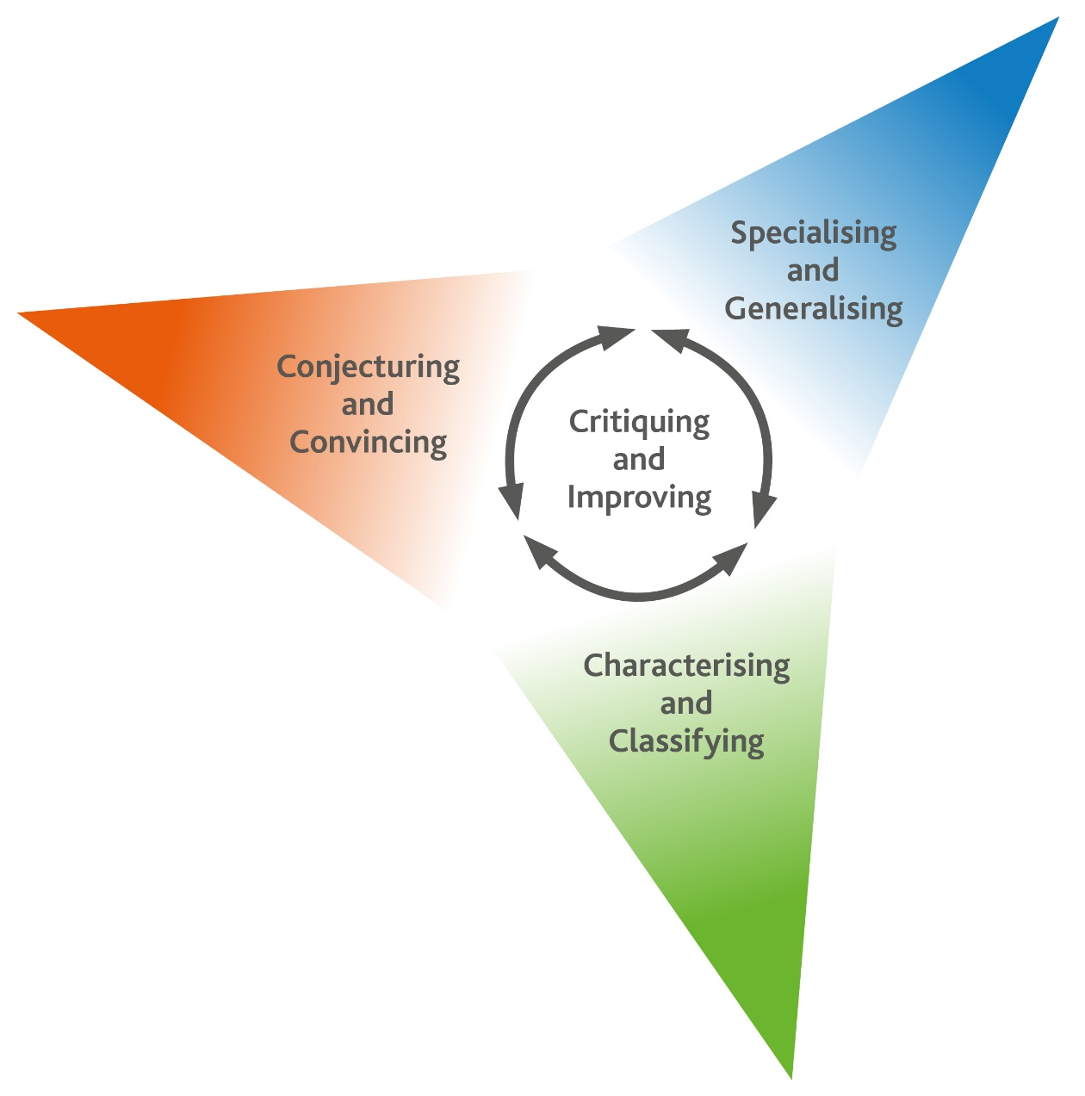
Thinking and Working Mathematically
Thinking and Working Mathematically supports the mathematical concepts and skills in all strands of the Cambridge Primary Mathematics curriculum. When learners think and work mathematically, they actively engage with their learning of mathematics. They try to make sense of ideas and build connections between different facts, procedures and concepts. Learners who do not think and work mathematically can carry out processes that their teacher has shown them, but them may not understand why the processes work or what the results mean. Noticing inconsistencies, patterns and particular representations encourages learners to think and work mathematically. Practice, reflection and questioning will help them to improve.

Thinking and Working Mathematically has eight characteristics that are presented in four pairs:

- Specialising and Generalising
- Conjecturing and Convincing
- Characterising and Classifying
- Critiquing and Improving.
The eight Thinking and Working Mathematically characteristics are all closely connected and interdependent. A high-quality mathematics task may include one or more of them. The characteristics provide learners with the language they need to think and work mathematically. Learners can then decide what mathematical knowledge, procedures and strategies to use in order to gain a deeper understanding of mathematical questions.

Throughout this scheme of work, there are examples of classroom activities that link the Thinking and Working Mathematically characteristics with content learning objectives. We recommend you use the ideas in these examples to create further classroom activities.

Thinking and Working Mathematically characteristics: |  | Unit 2.1 | Unit 2.2 | Unit 2.3 | Unit 2.4 | Unit 2.5 | Unit 2.6 | Unit 2.7 | Unit 2.8
TWM.01 | Specialising – Choosing an example and checking to see if it satisfies or does not satisfy specific mathematical criteria
TWM.02 | Generalising – Recognising an underlying pattern by identifying many examples that satisfy the same mathematical criteria
TWM.03 | Conjecturing – Forming mathematical questions or ideas
TWM.04 | Convincing – Presenting evidence to justify or challenge a mathematical idea or solution
TWM.05 | Characterising – Identifying and describing the mathematical properties of an object
TWM.06 | Classifying – Organising objects into groups according to their mathematical properties
TWM.07 | Critiquing – Comparing and evaluating mathematical ideas, representations or solutions to identify advantages and disadvantages
TWM.08 | Improving – Refining mathematical ideas or representations to develop a more effective approach or solution

Misconceptions
Mathematical misconceptions are usually incorrect generalisations made by learners. Misconceptions should not be avoided, but instead used for teaching purposes to reveal learners’ thinking. Research suggests that asking learners open-ended questions about mathematical concepts is the most appropriate way to uncover misconceptions. Once a learner’s misconceptions have been identified, the next step is to know how to correct them. One approach is to give learners a variety of mathematical strategies to draw upon when finding solutions so that they can gain a deeper understanding of each mathematical concept.

Mental strategies and calculators
Mental calculation is a skill needed for everyday life, especially when paper or calculators are not available. Mental calculation relies on working memory, the organisation of thoughts and the use of efficient mathematical strategies when solving mathematical computations. It is important for learners to practise mental calculations and have a range of strategies as this improves understanding and recall as well as increasing confidence and proficiency.

Calculators are useful teaching aides. Although learners need to practise doing mental and written calculations, calculators can help them to notice patterns. They are also useful when learners are solving problems where non-calculator calculations would take the focus away from strategies. When well used, calculators can help learners to learn about numbers and the number system. Use calculators as a teaching aid to promote mental calculation and mental strategies and to explore mathematical patterns. Learners should understand when it is best to use calculators to help them calculate, and when to calculate mentally or using written methods.

As Cambridge International includes calculator-based assessments at Stages 5, 6, 7, 8 and 9, we recommend that learners begin to use calculators for performing and checking calculations from Stage 4. At Stages 5 and 6, learners should be developing effective use of calculators so that they are familiar with the buttons and functions of a basic calculator.

Unit 2.1 Numbers to 100, addition and subtraction

Learning objectives covered in Unit 2.1 and topic summary: |  | 2.1 Topic 1  Counting and estimating | 2.1 Topic 2  Using and comparing numbers | 2.1 Topic 3  Addition and subtraction | Thinking and Working Mathematically
2Nc.01 | Count objects from 0 to 100.
2Nc.02 | Recognise the number of objects presented in unfamiliar patterns up to 10, without counting. |  |  |  | TWM.04 Convincing
2Nc.03 | Estimate the number of objects or people (up to 100). |  |  |  | TWM.03 Conjecturing  TWM.04 Convincing  TWM.07 Critiquing  TWM.08 Improving
2Nm.01 | Recognise value and money notation used in local currency.
2Nm.02 | Compare values of different combinations of coins or notes. |  |  |  | TWM.03 Conjecturing  TWM.04 Convincing
2Ni.01 | Recite, read and write number names and whole numbers (from 0 to 100).
2Ni.02 | Understand and explain the relationship between addition and subtraction. |  |  |  | TWM.03 Conjecturing  TWM.04 Convincing
2Ni.03 | Recognise complements of 20 and complements of multiples of 10 (up to 100).
2Ni.04 | Estimate, add and subtract whole numbers with up to two digits (no regrouping of ones or tens). |  |  |  | TWM.07 Critiquing  TWM.08 Improving
2Np.03 | Understand the relative size of quantities to compare and order 2-digit numbers.
2Np.04 | Recognise and use ordinal numbers.

Unit 2.1 Topic 1 Counting and estimating

Outline of topic:
In this topic, learners develop their understanding of counting and estimating objects to 100. They will explore the number of objects represented in unfamiliar ways for up to 10 objects without counting. Learners will read and write numbers as words and whole numbers from 0 to 100.

Language:
Key vocabulary:
estimate
tens, fives, twos, ones, units
one, two, three, four, five, six, seven, eight, nine
ten, twenty, thirty, forty, fifty, sixty, seventy, eighty, ninety, hundred
numerals, figures, digits

Key phrases:
Make an estimate of …
Estimate how many …
What is the difference between …?

Recommended prior knowledge:
- Count objects from 0 to 20 using one-to-one correspondence
- Recognise conservation of number
- Estimating quantities of objects up to 20
- Recognise, read and recite number names and symbols from 0 to 20
- Know numbers have a fixed stable order

Learning objectives | Suggested teaching activities and resources | Mental strategies, possible misconceptions and comments
2Nc.01 Count objects from 0 to 100. | Show learners a container filled with 20 to 100 objects e.g. marbles. Ask learners to discuss in pairs before sharing answers with the class:  How many objects do you think are in this container and what is the easiest way to count them?  Discuss strategies for counting in groups of twos, fives or tens and then ones. Ask learners:  Which way is the best? Counting in twos, fives or tens?  Count the objects, saying the numbers out loud, in groups of tens and then the remaining objects either as fives, twos or ones to find the total. Ask learners to stand in a line, count the objects together giving each learner in the line a group of ten objects, then the ones remaining. Check this with learners by counting the number of tens in a different order. Explain that the total is the same even when you count in a different order (conversation of number).  Give each pair of learners two dice (1-6 or 1-9) and a set of objects such as multi-link cubes or counters. Learners throw the two dice to create a two-digit number (e.g. 23). Then they make the corresponding number of objects by counting out the groups of tens and the units. Learners then change the dice order round to make the other possible number. (e.g. 32)  Resources  Container of objects such as marbles.  Sets of two dice.  Sets of objects such as multi-link cubes, counters or pebbles. | Possible misconceptions:  Learners may not be counting each object reliably. Reinforce the one-to-one correspondence when counting.  Learners may not understand conservation of numbers. Reinforce this principle by asking them to count and check the total in a different order.
2Nc.02 Recognise the number of objects presented in unfamiliar patterns up to 10, without counting.  TWM.04 Convincing  Presenting evidence to justify or challenge a mathematical idea or solution | Show a set of objects that are arranged in a familiar pattern. For example  Show the objects for approximately 5 to 10 seconds.  Then ask learners:  - How many are there all together?  - How do you know?  - Did you count them individually?  Discuss strategies such as recognising groups of two, or three, or that there is a group of four and a group of two.  Now, show a set of objects that are arranged in an unfamiliar pattern. For example:  Show the objects for approximately 5 to 10 seconds.  Then ask learners:  - How many were there?  - How did you know?  - Did you count them individually?  - What other strategies can you use to recognise the number of objects?  Discuss strategies such as recognising groups of two, or that there is a group of four and a group of two (similar to what they might do with a familiar pattern)  Do this with more shapes or objects in different arrangements of up to 10 objects each time. Ask learners to try to say how many there are all together without counting them individually.  Give pairs of learners ten-frames and counters.  Ask learners:  How many different ways can you arrange four, five, six, seven or eight counters on a ten-frame?  Tell each group of learners to focus on one of the numbers of counters to arrange. Ask learners:  How do you know you have all the possible ways?    Learners will show they are convincing (TWM.04) when they justify why they know all the ways of representing their number on the ten-frame.  Resources:  Sets of up to 10 objects arranged in different ways on large cards  Sets of objects such as multi-link cubes, counters or uni-fix cubes  Ten-frames  Counters | Possible misconceptions:  Learners focus on counting one-to-one but might forget to look for patterns in the overall group. Subitizing is important for developing a concept of the whole as a sum of its parts. Encourage learners to look for groups of two, three or four within the overall group.
2Nc.03 Estimate the number of objects or people (up to 100).  TWM.07 Critiquing  Comparing and evaluating mathematical ideas, representations or solutions to identify advantages and disadvantages  TWM.08 Improving  Refining mathematical ideas or representations to develop a more effective approach or solution  TWM.03 Conjecturing  Forming mathematical questions or ideas  TWM.04 Convincing  Presenting evidence to justify or challenge a mathematical idea or solution | Discuss with learners what estimating means and remind them of work they did in Stage 1. Show a handful of objects (up to 20) on a plate. Ask learners:  - Without counting the objects, how many objects do you think are on the plate?  - How did you estimate?  Next, show a container with more than 20 objects but less than 100 objects (e.g. marbles). Ask learners to discuss in pairs first:  How many objects do you think are in this container and how did you estimate?  Ask learners to tell you their estimate and how they decided. Discuss individual strategies and ask:  - Which total can it definitely not be? (e.g. 5)  - What total is too few or too many?  - Whose strategies do you think you can use so that your estimate is nearest to the correct total?  Learners will show they are critiquing (TWM.07) when they can evaluate the strategies for making estimates.  Count the objects in the container. Discuss again how they estimated and their strategies. Ask learners:  How can you improve your strategies for estimating?  Learners will show they are improving (TWM.08) when they can improve their strategies for making estimates.  Repeat this with another container of objects.  Ask learners:  How many children do you think we can fit into this classroom?  How can you be convinced your estimate is close to the actual total?  Learners will show they are conjecturing (TWM.03) when they make estimates for the number of children that will fit in the classroom. They will show they are convincing (TWM.04) when they suggest ways that they can check their estimates.  Resources:  Containers with different quantities of objects (20 to 99) | Learners sometimes find it difficult to make estimates because of the fear of being incorrect. Encourage making estimates without focusing on the actual total as a right or wrong answer. Encourage approaches to making estimates that are based on strategies such as scaling up or relating to a smaller known amount.
2Ni.01 Recite, read and write number names and whole numbers (from 0 to 100). | As a class, ask learners to start at a number and count together in ones. For example, starting at 71, learners would recite together 71, 72, 73, 74, 75…  Repeat this several times starting at different numbers. For support, ensure learners are counting slowly and join in with the counting. For additional challenge, speed up the pace of the counting.  Prepare a set of cards which are labelled with numbers from 20 to 99 and a corresponding set which are labelled with the number words from twenty to ninety-nine.  Ensure sure each learner has at least one card. Choose one learner to read their card out loud. Ask the other learners:  Who has the matching card?  Give pairs of learners a set of digit cards from 0 to 9. In pairs, leaners choose two digit cards to form a two-digit number (e.g. 72). Learners then read the number out loud and write the number in words (e.g. seventy-two). They also write the next number that follows it (e.g. 73, seventy-three) and the number that is before it (e.g. 71, seventy-one).  Resources:  Sets of cards with a number from 20 to 99 written in numerals on each  A corresponding set of cards with a number from 20 to 99 written in words  0-9 digit cards | Possible misconceptions:  Children misread the teen numbers (11 to 19) because the way they are verbalised does not follow the same convention as numbers from 20. For example, learners may confuse 14 with 41 because 14 is said with the 4 first.  Focus on numbers from 20 to 99 in order to develop an understanding of place value with the pattern before then going back to reinforce numbers from 11 to 19.

Unit 2.1 Topic 2 Using and comparing numbers

Outline of topic:
In this topic, learners will recognise money values and notation and explore different combinations of coins or notes. Learners will compare the relative sizes between different quantities to order two-digit numbers. This topic will also develop understanding of ordinal numbers.

Language:
Key vocabulary:
value, size
greater, bigger, more
smaller, less
1st or first, 2nd or second … to 12th or twelfth
ordinal numbers

Vocabulary of local currency including coins and notes
Currency colours such as bronze, copper, silver, gold, green, blue, brown

Key phrases:
… is greater than …
… is less than …

Recommended prior knowledge:
- Knowing the size and colour of notes and coins in the local currency
- Comparing the relative size of quantities up to 20
- Comparing and ordering numbers to 20
- Recognise ordinal numbers to 10

Learning objectives | Suggested teaching activities and resources | Mental strategies, possible misconceptions and comments
2Nm.01 Recognise value and money notation used in local currency. | Give learners pictures of local currency. Using play money, take a coin or note and ask learners to point to the currency that corresponds to the coin being shown.  Ask learners:  - What colour and shape is this coin?  - What is the same and what is different from other coins?  Encourage answers that refer to the characteristics including colour, size and relative value.  In all examples below, replace the currency of dollars and cents with your own currency within the questions and explanations.  Show a range of pictures of objects with price labels. For example: a sweet for 1 cent and a pencil for 5 cents. Show one item for each value of coin or note available.  For each coin or note for your local currency, ask learners:  What is the value of this coin?  What item can I buy with this coin?  Start with low value coins and then show the larger value coins or notes in the local currency. Encourage learners to focus on the value of a coin such as, with 5 cents I can buy five sweets that are 1 cent each or I can buy one pencil for 5 cents.  This activity can be extended by setting up a pretend shop with items for sale. Give small groups of learners sets of different coins or notes in your local currency and sets of objects with price labels.  Ask learners questions about how they can pay for the items, for example:  How many ways can I pay for the ball costing 50 cents from these coins?  If you have 1 dollar (or local currency), what can you buy at the shop?  Resources:  Sets of play money in the local currency  Sets of cards with a picture of a different coin on each one  Sets of cards with the value and currency symbol for each coin  Pictures of objects or real objects with price labels (or a classroom shop) | Possible misconceptions:  Learners do not always understand that a picture of the corresponding concrete object is essentially a representation of the same thing. For example, a coin showing $1 has the same value as a pictorial representation of it, although only the real concrete object of $1 can be taken and spent. Encourage learners to see concrete examples of money (from the plastic toy money) alongside pictorial representations and the corresponding symbols together. It is also important for learners to see and experience real money as well as plastic toy versions.  Learners sometimes find it difficult to know the difference between the value of a coin and a number of coins. This is because one thing represents two concepts (a quantity and a value).  Learners sometimes also confuse value with size. In some countries a higher value coin is smaller in size than a lower value coin. For example in England the 5 pence coin is higher in value but smaller in size than the 2 pence coin. Ensure learner focus on the value rather than the relative size of coins.
2Nm.02 Compare values of different combinations of coins or notes.  TWM.03 Conjecturing  Forming mathematical questions or ideas  TWM.04 Convincing  Presenting evidence to justify or challenge a mathematical idea or solution | Ask learners to describe coins or notes that are different in colour and shape. Ask learners to compare different coins by shape, colour and relative sizes. Ask learners to compare the relative values for lower value coins or notes.  In all examples below, replace the currency of dollars and cents with your own currency within the questions and explanations.  Give small groups of learners sets of different coins or notes in your local currency. Ask learners:  - How many ways can you make 50 cents from the coins?  - How can you check that you have made 50 cents?  - How do you know you have found all the ways of making 50 cents?  Now show coins and notes of larger value such as $1 and $5 and ask learners:  - What is this coin or note and what is it value?  - What is the difference between $1 and 1 cent?  - How many cents are equal to $1?  Repeat this for several coins up to $1 in local currency.  Ask learners:  How many ways can I make $3 by only using coins?  Ask learners to conjecture about the number of ways. Learners will be conjecturing (TWM.03) when they can suggest how many ways they think there will be to make $3.  Ask learners:  How can convince me that you have found all the different ways?  Learners will show they are convincing (TWM.04) when they justify why they think they have found all the ways of making a particular amount.  Resources.  Sets of play money in the local currency  Sets of cards with a picture of a different coin on each one  Sets of cards with the value and currency symbol for each coin. | Possible misconceptions:  Learners do not always understand that a picture of the corresponding concrete object is essentially a representation of the same thing. For example, a coin showing $2 is the same value as a pictorial representation of it, although only the real concrete object of $2 can be taken and spent. Encourage learners to see concrete examples of money (from the plastic toy money) alongside pictorial representations and the corresponding symbols together. It is also important for learners to see and experience real money as well as plastic toy versions.  Learners sometimes find it difficult to tell the difference between the value of a coin and a number of coins. This is because one thing represents two concepts (a quantity and a value).  Learners sometimes also confuse value with size. In some countries a higher value coin is smaller in size than a lower value coin. For example in England the 5 pence coin is higher in value but smaller in size than the 2 pence coin. Ensure learner focus on the value rather than the relative size of coins.
2Np.03 Understand the relative size of quantities to compare and order 2-digit numbers.  2Nm.02 Compare values of different combinations of coins or notes. | Show a large number line or washing line in the classroom which is marked in 10s between 0 and 100. Prepare a set of cards with different 2-digit numbers on each. Show the 2-digit number cards two at a time and ask learners:  - Which is the bigger number and which is the smaller one? How do you know?  - Which is greater than the other?  - Which is smaller than the other?  Ensure learners use familiar vocabulary as well as introducing more formal use of greater than and less than.  Select learners to place each of the pairs of cards on the number line.  Ask the other learners:  - Do you agree?  - How do you know it goes there?  Ensure learners’ explanations involve the place value of the tens digit to position between the groups of 10, and the place value of the ones digit in order to position the number nearer to the closest group of 10. For example, 43 will be placed nearer to 40 than to 50.  With each new pair of cards ask learners:  - Where will this number go on the line now?  - Which numbers is it greater than?  - Which numbers is it less than?  Give small groups of learners a smaller number line marked from 0 to 100 and a set of 0-9 digit cards. Ask learners to choose two of the digit cards and make them into two different numbers and write them on their number line.  Ask learners to discuss with their group which number is the smallest, which is the biggest and how they know.  As a whole class, ask learners questions such as:  - Which is bigger: 20 or 30?  - How do you know?  - Where will this number be on the number line?  - Which is taller: 35cm or 39cm?  - How do you know?  - Which is more money: 55 cents or $55? How do you know?  - Which is more money: three 5 cents coins or two 10 cents coins? How do you know?  Resources.  Sets of cards with different values marked from 10 to 99  Large number line from 0 to 100 marked in 10s  Smaller number lines marked from 0 to 100  Sets of 0-9 digit cards | Use a range of units to compare numbers in different contexts.
2Np.04 Recognise and use ordinal numbers. | Read a story about a running race, a queue or a line of characters which could involve learners using ordinal numbers to describe the plot. For example, you may wish to tell the story or show a short video of the Russian folktale ‘The Enormous Turnip’.  At each point in the story use the language of ordinals to consolidate those already known from 1st to 10th. Use language alongside both representations as numbers and words. Encourage learners to say who is 1st, 2nd etc. in the line of characters pulling the turnip from the ground. Have character cards for each character and place on the number line (0-20) along with the related cards with ordinal number and words.  Extend the story to include more characters to include up to 12. Use number cards and ask learners to put these on the number line each time.  Ask learners to work in pairs to make up a story using their own characters for a race or a similar story plot for up to 12 characters. Tell learners to explain their story to another pair of learners.  Select one pair of learners to retell their story to the rest of the class. Encourage other learners to then ask questions such as:  Who is first? Who came last? Who was 6th?  These questions are then answered by another learner.  Resources.  Story such as ‘The Enormous Turnip’ with focus on lines, queues or races  Character cards for each character in the chosen story  Ordinal cards up to 12 with both number and word form on each  Large number line marked from 0 to 20

Unit 2.1 Topic 3 Addition and subtraction

Outline of topic:
In this topic, learners will understand and explain the relationship between addition and subtraction. They will recognise the complements of 20 and the complements of multiples of 10 up to 100. Learners will add and subtract whole two-digit numbers without regrouping.

Language:
Key vocabulary:
add, altogether, extra, total
difference, subtract, take away, less than
estimate
tens, units, ones, digits
number bonds, complements
multiples of ten

Key phrases:
The total of … and … is …
The difference between … and … is …

Recommended prior knowledge:
- Experience of addition and subtraction using concrete apparatus and pictorial representations with numbers up to 10
- Use vocabulary of ‘difference’ in the form of ‘how many more…’ or ‘how many less….’
- Use the complements to 10 as number bonds to a total of 10, including zero
- Estimate simple calculations to reason why some answers to calculations cannot be correct
- Experience using the +, - and = sign
- Know that = means that both sides of the sign have the same value. For example, 3 + 4 = 2 + 5

Learning objectives | Suggested teaching activities and resources | Mental strategies, possible misconceptions and comments
2Ni.02 Understand and explain the relationship between addition and subtraction.  TWM.03 Conjecturing  Forming mathematical questions or ideas  TWM.04 Convincing  Presenting evidence to justify or challenge a mathematical idea or solution | Give between one and five counters to one learner. Then give between one and five counters to another learner and ask them to stand next to the first learner. Ask learners:  - If I add these two groups of counters together what will be the total altogether?  - How many different ways can I add these two numbers?  - What will your answer be?  - What do you notice?  Use digit cards to show the number of counters and pin the digit cards to a board as a number sentence such as:  2 + 5 = 7  5 + 2 = 7  Draw attention to the fact that the total is the same each time. Ask learners:  - Does this always happen?  - How do you know and how can you be convinced?  Look for responses that show understanding that the learners holding counters can swap places, but the total remains the same. Check understanding of conservation of number.  Learners will show they are conjecturing (TWM.03) when they suggest that the answers will be the same both ways round for addition. They will show they are convincing (TWM.04) when they justify why they think this will always be true.  Choose two more learners and repeat this using a different number of counters and different digit cards. For example, give the first learner four counters and the second learner five counters, and show this can be written using the number sentences:  4 + 5 = 9  5 + 4 = 9  Then ask the two learners to give their counters to a third learner.  Ask learners:  All the counters are with learner 3 (name). If learner 2 (name) takes back his counters, how many will learner 3 have?  Model the answers with the digit cards as number sentences that relate to subtraction. For example:  9 – 5 = 4  9 – 4 = 5  Repeat this with more examples using different numbers of counters and digit cards.  Give each pair of learners two dice and ask them to work together to produce their own number sentences. For example, if they roll a 6 and a 1, their number sentences will be:  1 + 6 = 7  6 + 1 = 7  7 – 6 = 1  7 – 1 = 6  Bring the class together and ask:  What do you notice about your number sentences?  Draw attention to the link between the three numbers in each set of number sentences. Read them forwards and backwards so that learners understand the relationship between addition and subtraction.  Resources:  Digit cards from 0 to 9  Counters  Dice | Possible misconceptions:  Learners sometimes do not understand addition and subtraction as the inverse but see them as separate operations.
2Ni.03 Recognise complements of 20 and complements of multiples of 10 (up to 100).  2Ni.02 Understand and explain the relationship between addition and subtraction. | Using digit cards from 0–9, turn one over and ask learners:  How many more do I need to make 10 altogether?  Repeat this several times, and then ask learners:  How many different ways can you make 10 by adding two numbers?  In pairs, ask learners to discuss and record as many complements of 10 as they can. Then ask learners to suggest ways to make 10 and collate the answers from the whole class on the board.  Using the 0–9 digit cards again, turn one over and ask learners:  How many more will I need to make 20?  Write the numbers on a board as a number sentence, for example:  8 + 12 = 20  Remind learners of their previous learning and ask:  How else can you write this? What else do you know?  Draw attention to the different ways the number sentence can be written. For example, 12 + 8 = 20 but also 20 – 12 = 8 and 20 – 8 = 12  Give each pair of learners a set of 0–9 digit cards and ask them to reveal a card and each find the complement to 20. They should also write the four different number sentences that connect the number complements to 20 and then compare these with their partner.  Then as a whole class, using a set of cards with 10, 20, 30, …, 90 written on each, turn one over and ask learners:  How many more will I need to make 100?  Write the number sentences on the board, for example:  10 + 90 = 100  90 + 10 = 100  100 – 90 = 10  100 – 10 = 90  Repeat this several times, and then ask learners:  How many different ways can you make 100 using only these cards?  Give learners a set of cards with 10, 20, 30, …, 90 written on each and in pairs, ask learners to discuss and record as many examples as they can. Then ask learners to suggest ways to make 100 from the multiples of 10 and collate the answers from the whole class on the board.  Draw learners’ attention to patterns that link the complements to 10 and complements to 100, for example 1 + 9 = 10 and 10 + 90 = 100  Resources:  Digit cards from 0 to 9  Tens cards 10, 20, 30 etc. up to 90 | Possible misconceptions:  Learners might believe that addition means starting with the first number and adding the second number.  Learners might not remember to count on by ‘holding’ one number they are starting with and then counting on from that number. For example they might count 1, 2, 3 and then 4, 5 rather than starting from 3 and then counting 4, 5.  With subtraction, learners similarly sometimes include the number when counting back. For example, for 8 – 3 they count 8, 7, 6 and say  8 – 3 = 6.
2Ni.04 Estimate, add and subtract whole numbers with up to two digits (no regrouping of ones or tens).  TWM.07 Critiquing  Comparing and evaluating mathematical ideas, representations or solutions to identify advantages and disadvantages  TWM.08 Improving  Refining mathematical ideas or representations to develop a more effective approach or solution | Begin by asking learners questions within a total of 10 such as:  - If Mia has 3 counters and Rajiv has 5 counters, how many counters are there altogether?  - If Mia has 9 counters and Rajiv takes away 5 counters, how many will Mia have left?  - If Mia has 9 counters and Rajiv has 4 counters, what is the difference between them? How many more counters does Mia have?  - How do you know?  - How did you work it out?  - What is a good way to add 5 more?  - What is a good way to take away 5?  - How can you check your answer?  Discuss strategies for adding and subtracting units by partitioning the units. For example, adding or subtracting 5 can be done by adding or subtracting 2 first and then 3 next so the total change is 5. Discuss which strategies are easiest and most effective and whether they will change their method next time. Discuss how they could check their answer and how they know an answer cannot be correct.  Now give learners similar questions which have tens and units between 20 and 99 but adding or subtracting only within the group of 10 (no regrouping). Only move to numbers in the teens when learners are confident within 20 to 99.  - If Carlos has 23 counters and Naomi has 7 counters, how many counters are there altogether?  - If Carlos has 59 counters and Naomi takes away 18 counters, how many will Carlos have left?  - If Carlos has 39 counters and Naomi has 34 counters, what is the difference between them? How many more counters does Carlos have?  - How do you know?  - How did you work it out?  - What is a good way to add 7 more?  - What is a good way to take away 18?  - How can you check your answer?  Learners will show they are critiquing (TWM.07) when they can suggest effective ways of adding and subtracting tens and units from tens and units. They will also be critiquing when they evaluate their answers by estimation. Learners will show they are improving (TWM.08) when they modify their strategies and check their answers are approximately correct. | Possible misconceptions:  Learners are sometimes confused by number sentences, instead expecting to find the answer to a calculation with all the numbers given before the = sign. For example, for  ? + 3 = 10 they might add 3 and 10 to make 13 rather than read it as a number sentence.  Sometimes learners add or subtract by including counting the starting number. For example, 4 + 5 = 8 by counting the first number as 4 then counting on 4, 5, 6, 7, 8.  Learners sometimes do not remember that subtraction is not commutative in the way that addition is.

Unit 2.2 Time

Learning objectives covered in Unit 2.2 and topic summary: |  | 2.2 Topic 1  Units of time | 2.2 Topic 2  Knowing the time | Thinking and Working Mathematically
2Gt.01 | Order and compare units of time (seconds, minutes, hours, days, weeks, months and years).
2Gt.02 | Read and record time to five minutes in digital notation (12-hour) and on analogue clocks. |  |  | TWM.02 Generalising
2Gt.03 | Interpret and use the information in calendars.

Unit 2.2 Topic 1 Units of time

Outline of topic:
In this topic, learners develop their knowledge of different units of time, and the relationship between them.

Language:
Key vocabulary:
second, minute, hour
day, week, month, year
Monday, Tuesday, Wednesday, Thursday, Friday, Saturday, Sunday
January, February, March, April, May, June, July, August, September, October, November, December

Key phrases:
… is longer than …
… is shorter than …
… is the same as …

Recommended prior knowledge:
- Counting to 60

Learning objectives | Suggested teaching activities and resources | Mental strategies, possible misconceptions and comments
2Gt.01 Order and compare units of time (seconds, minutes, hours, days, weeks, months and years). | Provide learners with cards with the following written on them. ‘1 second’, ‘1 minute’, ‘1 hour’, ‘1 day’, ‘1 week’, ‘1 month’ and ‘1 year’. Ask them to work in pairs to order them, starting with the shortest duration. Then ask learners to discuss together the relationship between the different units of time that they have been given. For example, a year is longer than a month. They should know there are 60 minutes in 1 hour, but do not need to know any other equivalences at this stage.  Learners play a game of ‘more or less’ with the cards in pairs. Ask learners to shuffle the cards and lay them in a row face down. Learners take it in turns to turn the first card and then guess whether the next card will be more time or less time than this. If they guess correctly, they continue along the row to see how far they can get. If they guess incorrectly, they shuffle the cards and start again.  Tell learners which month you were born in. Select learners to share which month of the year they were born in too. As learners share their birth months, write them on the board.  Ask learners:  - Which months haven’t I written up yet?  - How many months are there altogether?  Once all the months are written on the board, challenge learners to write these in order.  Give learners mini whiteboards to write and hold up their answers, and ask them quick questions about the months of the year such as:  - Which month comes after April?  - Which month comes before November?  Repeat this activity for days of the week and ask questions such as:  - Which day comes after Tuesday?  - Which day comes before Saturday?  Resources:  Cards with units of time written on them | Possible misconceptions:  Due to their familiarity with the base 10 system of number, learners may incorrectly think that there are 100 minutes in an hour. Ensure learners know there are 60 minutes in an hour as they will need this information to be able to accurately read and record the time.

Unit 2.2 Topic 2 Knowing the time

Outline of topic:
In this topic, learners develop their knowledge of reading the time using both analogue and 12-hour digital clocks to the nearest 5 minutes. Learners also begin to explore and solve problems with calendars.

Language:
Key vocabulary:
to, past
12-hour clock
analogue clock
hour hand
minute hand

Key phrases:
The time is …
… on an analogue clock is the same as … on a digital clock.

Recommended prior knowledge:
- Reading time to the nearest hour and half hour
- Order of the days of the week
- Counting in 5’s from 0

Learning objectives | Suggested teaching activities and resources | Mental strategies, possible misconceptions and comments
2Gt.02 Read and record time to five minutes in digital notation (12-hour) and on analogue clocks.  TWM.02 Generalising  Recognising an underlying pattern by identifying many examples that satisfy the same mathematical criteria | Ask learners to create their own clock face. Provide learners with a pre-printed circle with 12 equal divisions marked around the edge. Learners can then write the numbers on the clock face and cut out and label the hour hand and minute hand, drawing their attention to the relative size of each hand. These can then be attached to the clock face using split pins or sticky tack.  Then, support learners in recording the minute element of the time in words (in one colour) and digits (in another) around the side of the clock face. For example, next to the number 1, they can record ‘five past’ and ‘5’ and next to the number 8 ‘twenty to’ and ‘40’.  Once learners have created their own clocks, challenge learners to create times on their clocks that you give them, or which are displayed on the classroom board as the time in digital notation.  The NRICH task: What Is the Time? (https://nrich.maths.org/7377) can also be used to help learners practise reading the time on an analogue clock. Learners can then be challenged to write the time that would be shown on a digital clock (12-hour) for each analogue clock face from the activity.  The NRICH task: Stop the Clock (https://nrich.maths.org/6071) can be used to develop learners understanding of both units of time and reading and recording time on an analogue clock. In this activity learners advance the time, as shown on an analogue clock, by set intervals, aiming to be the player who makes the time read 12:00. Learners will show they are generalising (TWM.02) as they begin to consider, apply and refine strategies for success in this game.  Reading and recording the time on analogue and digital clocks is an ideal area of maths to practise and use as part of your day to day classroom activities and teaching. At various times during the day, invite learners to read the time on an analogue clock that is clearly displayed in your classroom, ensuring that any digital clocks, for example, on your classroom interactive display, are hidden. Another learner can then be challenged to write this time as it would be shown on a digital clock. With regular practice and exposure to the language of time, learners will develop their proficiency in reading the time to the nearest five minutes.  Resources:  NRICH tasks  Printed clock faces and hands, scissors, split pins etc. to make paper clocks | Possible misconceptions:  Learners may confuse the hour and minute hand on an analogue clock.  Learners may incorrectly record the analogue time on a digital clock for times that are after half past the hour. For example, they may record ‘twenty to 5’ as either 20:5 or 5:20.
2Gt.03 Interpret and use the information in calendars. | Recap the order of the days of the week and months of the year. Present learners with a calendar which shows all months of the current year. Ask them to discuss in small groups what they notice about the calendars. Share ideas together and draw out key features and structures from the calendars, linking this to their knowledge of the number of days in a week, month and year.  Learners can reason and problem solve using their knowledge of the structure of calendars and units of time, in the NRICH task: Calendar Sorting (https://nrich.maths.org/10322). Ask learners to solve the problem presented in the activity using the colour coded cards which are available in the ‘possible support’ section of the teachers’ resources. Once learners have solved this version of the problem, they can then progress to solving the problem as presented in the main section of the task, which uses a different set of calendars from the additional support task.  Resources:  NRICH task | It is important that learners have a secure knowledge of the order of the days of the week before beginning work on using and interpreting calendars. Learners’ knowledge of the order of days of the week can be practised and reinforced using the NRICH task: Snap (https://nrich.maths.org/6082).  You can amend the NRICH task and create a calendar that includes key local or national events.

Unit 2.3 Exploring shapes and movement

Learning objectives covered in Unit 2.3 and topic summary: |  | 2.3 Topic 1  Describing shapes | 2.3 Topic 2  Symmetry and reflecting shapes | 2.3 Topic 3  Angles, turning and moving shapes | 2.3 Topic 4  3D shapes | Thinking and Working Mathematically
2Gg.01 | Identify, describe, sort, name and sketch 2D shapes by their properties, including reference to regular polygons, number of sides and vertices. Recognise these shapes in different positions and orientations. |  |  |  |  | TWM.05 Characterising  TWM.06 Classifying
2Gg.02 | Understand that a circle has a centre and any point on the boundary is at the same distance from the centre. |  |  |  |  | TWM.02 Generalising
2Gg.05 | Identify, describe, sort and name 3D shapes by their properties, including reference to number and shapes of faces, edges and vertices. |  |  |  |  | TWM.05 Characterising  TWM.06 Classifying
2Gg.08 | Identify 2D and 3D shapes in familiar objects. |  |  |  |  | TWM.05 Characterising  TWM.06 Classifying
2Gg.09 | Identify a horizontal or vertical line of symmetry on 2D shapes and patterns.
2Gg.10 | Predict and check how many times a shape looks identical as it completes a full turn.
2Gg.11 | Understand that an angle is a description of a turn, including reference to the terms whole, half and quarter turns, both clockwise and anticlockwise.
2Gp.01 | Use knowledge of position and direction to describe movement. |  |  |  |  | TWM.07 Critiquing  TWM.08 Improving
2Gp.02 | Sketch the reflection of a 2D shape in a vertical mirror line, including where the mirror line is the edge of the shape.

Unit 2.3 Topic 1 Describing shapes

Outline of topic:
In this topic, learners will explore the properties of 2D shapes and begin to sort, classify and describe them using an increasing range of mathematical vocabulary. Learners will also begin to explore circles and the relationship between the centre of the circle and any point on its boundary.

Language:
Key vocabulary:
2D shape
side, vertex, vertices
polygon, pentagon, hexagon, octagon
regular
orientation, position

Key phrases:
This shape has … sides and … vertices.
This shape is regular because….
This shape is irregular because….

Recommended prior knowledge:
- Learners should have some familiarity with basic 2D shapes and should be able to identify them by name (for example, square, rectangle, circle and triangle)

Learning objectives | Suggested teaching activities and resources | Mental strategies, possible misconceptions and comments
2Gg.01 Identify, describe, sort, name and sketch 2D shapes by their properties, including reference to regular polygons, number of sides and vertices. Recognise these shapes in different positions and orientations.  TWM.05 Characterising  Identifying and describing the mathematical properties of an object  TWM.06 Classifying  Organising objects into groups according to their mathematical properties | Show learners two regular hexagons on the class board, for example:  Ask learners to discuss in pairs:  What is the same and what is different between the two shapes?  Select pairs of learners to share their ideas with the class. Begin to model, explain and encourage mathematical language such as:  - Both shapes are polygons (a 2D shape formed with straight lines).  - Both shapes have 6 sides and 6 vertices (where two lines meet, corners).  - Both shapes are hexagons.  - One hexagon is in a different orientation to the other.  Next, show a 2D shape, for example a rectangle on the class board. Ask learners to discuss in pairs:  How can you describe this shape?  Select pairs of learners to share their descriptions with the class. Encourage learners to use mathematical language, including sides, vertices, polygon and regular.  Repeat with a range of 2D shapes, including pentagons and octagons, ensuring you provide each shape in different positions and orientations.  Learners will show they are characterising (TWM.05) when they describe shapes by their specific properties using mathematical vocabulary. Learners will show they are classifying (TWM.06) when they are able to specify which shapes are pentagons, octagons, etc. even when they are oriented differently.  The NRICH task: Shapely Lines (https://nrich.maths.org/7009) provides an interesting way for learners to gain more practice at recognising and classifying shapes.  Resources:  NRICH task | Possible misconceptions:  Learners often have misconceptions related to a shape’s prototypical image and orientations. Many learners believe that a square for example is different if it is presented resting on a corner. Some learners call this a diamond and believe it is different to a square. It is important to characterise and classify shapes using specific properties.  The following NRICH resources provide useful activities and questions to help learners develop confidence in their ability to recognise and describe shapes:  Exploring 2D Shapes: (https://nrich.maths.org/8852)  Shapes in the Bag:  (https://nrich.maths.org/10387)  A polygon is regular when all angles are equal and all sides are equal.
2Gg.02 Understand that a circle has a centre and any point on the boundary is at the same distance from the centre.  TWM.02 Generalising  Recognising an underlying pattern by identifying many examples that satisfy the same mathematical criteria | Provide each learner with a printed copy of a circle. Ensure each circle is identical, has the centre marked and the radius is a whole number. For example 3cm..  Ask learners to choose any point on the circle boundary and to cut a piece of string so that it measures the same as the distance between this point and the centre of the circle.  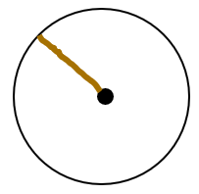  String  Then invite learners to compare their length of string with several other learners. Ask learners:  What do you notice?  You may choose to repeat this for another different sized printed circle. Ask learners to reflect on their experiences in groups to see if they can begin to form a generalised statement about the relationship between any point on a circle and the centre of the circle.  Learners will show they are generalising (TWM.02) when they notice for each example that their lengths of string are the same and that the distance from the centre to any point on the boundary of a circle is the same.  This activity can be extended by asking learners to repeat this for shapes other than circles, for example, a square. Learners should notice that their lengths of string measuring the distance from the centre of the square to different points on the edge are not the same. This will emphasise that a circle is the only shape with this property.  Resources:  Printed circles  String  Scissors | Possible misconceptions:  Some learners may not understand conservation of length and believe that something is a different length when it is moved, especially if it changes shape from being straight. Draw attention to the fact that the string being moved away is still the same length even though it was not necessarily straight when it was moved away.
2Gg.08 Identify 2D and 3D shapes in familiar objects.  TWM.05 Characterising  Identifying and describing the mathematical properties of an object  TWM.06 Classifying  Organising objects into groups according to their mathematical properties | Challenge learners to go on a shape hunt around the school in small groups, ensuring each group is accompanied by an adult. Ask learners to spot as many 2D shapes as they can on their shape hunt. If available, provide learners with digital cameras (or equivalent photograph-taking devices) to record the shapes they have seen. If cameras are unavailable, encourage learners to draw pictures or make notes to describe the shapes they have seen.  You may wish to provide learners with a tick list of the shapes they should try to find, such as:  Once all learners have returned from the shape hunt, invite learners to share some of the shapes they have found with the class, encouraging the use of mathematical language.  Learners will show they are characterising (TWM.05) when they describe shapes by their specific properties using mathematical vocabulary. They will show they are classifying (TWM.06) when they are able to specify which shapes are rectangles, squares, etc. even when they are oriented differently.  Resources:  Equipment to take photographs if available | Whilst learners are participating in the shape hunt, the accompanying adult should continue to model and encourage mathematical language to describe the shapes that learners have found.  This activity can easily be adapted into an interesting home-learning activity, with learners challenged to identify as many 2D shapes in their house as possible.
  Shape | Tick when found
  Circle
  Square
  Rectangle
  …

Unit 2.3 Topic 2 Symmetry and reflecting shapes

Outline of topic:
In this topic, learners explore symmetry in both patterns and 2D shapes.

Language:
Key vocabulary:
symmetry
line of symmetry
horizontal, vertical

Key phrases:
This shape has a line of symmetry.
This shape does not have a line of symmetry.

Recommended prior knowledge:
- Learners should be confident with the basic concept of symmetry before commencing work on this topic

Learning objectives | Suggested teaching activities and resources | Mental strategies, possible misconceptions and comments
2Gg.09 Identify a horizontal or vertical line of symmetry on 2D shapes and patterns. | Show learners the patterns below:  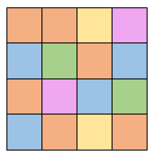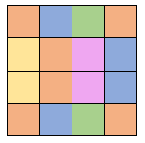  Ask learners:  What is the same and what is different about the two patterns?  Learners may notice they both are made from 16 squares (4x4 grid) and that they both use the same number of blue, yellow, orange, green and pink squares. However, learners may notice the second pattern has a horizontal line of symmetry, whereas the first does not.  Ask learners:  How can you check whether a pattern has a line of symmetry?  Use the NRICH task: Colouring Triangles (https://nrich.maths.org/171) to provide further opportunities for learners to explore and investigate symmetrical patterns.  Once learners have a secure understanding of symmetry, provide them with a range of 2D shapes (some with a horizontal line of symmetry, some with a vertical line of symmetry, and some with no lines of symmetry). Ask learners to work together using a mirror and a ruler to discover any lines of symmetry within the shapes.  Resources:  NRICH task  Mirrors
2Gp.02 Sketch the reflection of a 2D shape in a vertical mirror line, including where the mirror line is the edge of the shape. | Give learners a selection of shapes drawn on plain paper for them to reflect over a given vertical mirror line. For example:  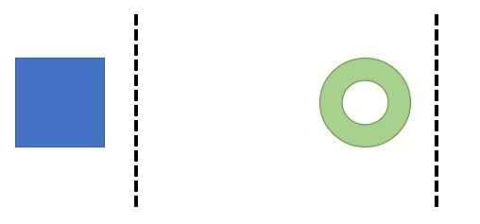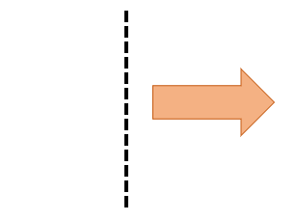  Include examples where the mirror line is the edge of the shape, for example:  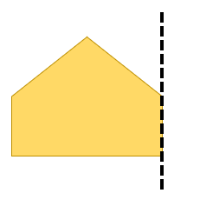  You may wish to include examples of reflection from the environment, for example a butterfly or a leaf:  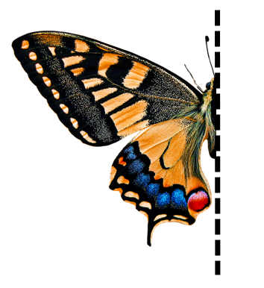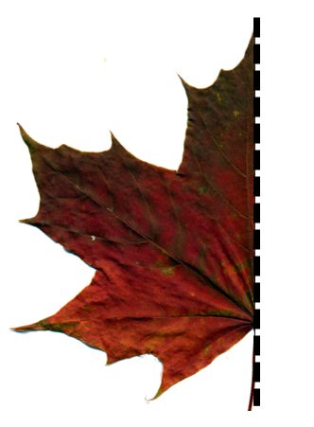  Ask learners:  How can you check your reflections are correct?  Resources:  Selection of shapes or pictures for learners to sketch the reflection  Mirrors to check reflections | Learners should sketch the shapes on plain paper rather than on grids because it is the concept of reflection that is important rather than accuracy of the shape at this stage of learning.

Unit 2.3 Topic 3 Angles, turning and moving shapes

Outline of topic:
In this topic, learners will investigate turns and begin to make the connection between turns and angles. Learners will also begin to investigate the rotational symmetry of 2D shapes. Learners will then use their knowledge of position and direction to describe movement.

Language:
Key vocabulary:
turn
rotate
quarter turn, half turn
clockwise, anticlockwise
left, right, forward, back

Recommended prior knowledge:
- Learners should have a basic understanding of turns and position/direction, including clockwise and anticlockwise and left and right.

Learning objectives | Suggested teaching activities and resources | Mental strategies, possible misconceptions and comments
2Gg.11 Understand that an angle is a description of a turn, including reference to the terms whole, half and quarter turns, both clockwise and anticlockwise. | The NRICH task: Turning Man (https://nrich.maths.org/5560) provides an interesting way to introduce learners to turning.  Ask learners to use the interactivity (or print off and cut out a man) to explore the relationship between quarter, half and whole turns. During the activity, encourage learners to begin to use the terminology ‘quarter turn’, ‘half turn’, ‘full turn’ and ‘clockwise’ and ‘anticlockwise’, and begin to explain to learners that these terms describe the turn, or the angle of the turn.  Relate the turns to clocks and time from Unit 2.2. Ask learners:  - Where have you seen these turns before?  - What will a quarter turn look like on a clock?  - Is there more than one way of getting a quarter turn? (clockwise and anticlockwise)  - What will half a turn and three quarter turns look like on a clock?  Resources:  NRICH task | It is important for learners to see turns in different ways and contexts, such as a car or bicycle making a turn to face a different direction, and clock hands making a turn round the circle.  For learners who are not confident with the concept of turning, ensure that you provide plenty of practical opportunities for learners to explore turning themselves. For example, ask learners to stand and turn themselves a half turn, or a full turn.
2Gg.10 Predict and check how many times a shape looks identical as it completes a full turn. | Provide learners with a range of tactile resources representing 2D shapes. Ask learners to choose a 2D shape and to rotate it through a full turn. Challenge learners to count how many times the shape looks identical during the turn.  Invite learners to share their findings with a partner, before discussing them as a class, drawing attention to the differences in the number of times a shape looks identical as it is completing a full turn. For example, learners should notice that a square looks identical after each quarter turn, whereas the shape below only looks identical after a full turn.  Finally, provide learners with a range of 2D shapes printed on paper and ask them to predict how many times the shape will look identical during a full turn, before inviting learners to cut out the shapes and to check their predictions.  Resources:  2D shapes  2D shapes printed on paper, and scissors | For learners who are not confident with the concept of turning, ensure that you provide plenty of practical opportunities for learners to explore turning themselves. For example, ask learners to stand and turn themselves a half turn, or a full turn.
2Gp.01 Use knowledge of position and direction to describe movement.  TWM.07 Critiquing  Comparing and evaluating mathematical ideas, representations or solutions to identify advantages and disadvantages  TWM.08 Improving  Refining mathematical ideas or representations to develop a more effective approach or solution | Set up a simple obstacle course using cones or other objects, which involves several turns. Show learners the course (or a photograph of the course) and explain that they will be challenged to provide instructions to their partner explaining how to navigate the course without touching any of the obstacles.  Ask learners to discuss in pairs the key language and phrases that they may need to use to help their partner navigate the course. Share ideas as a class.  Explore equivalent movements, for example, two quarter turns clockwise is equivalent to a half turn clockwise, and reverse descriptions, such as two steps forwards is the reverse of two steps backwards.  Challenge learners to work in pairs to navigate their partner around the course. The partner who is on the course should only move as instructed by the partner giving directions. You may choose to ask the learner who is completing the course to close their eyes, to ensure that they rely solely on their partner’s instructions.  Set pairs of learners off on the course one at a time, ensuring there is a gap between each pair. Whilst learners are waiting to start, encourage them to listen to the directions being given by learners who are completing the course.  Learners will show they are critiquing (TWM.07) when they consider what is and is not effective about the other groups’ directions and how they can use similar language when they are navigating the course. Learners will show they are improving (TWM.08) when they consider how their directions can be improved.  Once all learners have navigated the course, invite them to switch roles, so that the learner who was providing instructions is now navigating the course, based on the instructions of the other learner.  This activity can be extended by asking learners to use their experiences to write a set of instructions for how to navigate the course. Once the instructions have been written, encourage learners to test out their instructions to ensure that they work and that they describe the position and direction of movement needed, and to make refinements to them as necessary.  Resources:  Cones or obstacles | Show turns in different contexts so that they see turns as also involving facing a different direction or a different orientation.  If learners struggle to transfer their verbal instructions to a written description of the movement, it may be helpful to record them giving the verbal instructions, so that they can replay this to help them create written instructions.

Unit 2.3 Topic 4 3D shapes

Outline of topic:
In this topic, learners will explore a range of 3D shapes and begin to describe them according to their properties and names. They will also investigate the presence of 2D and 3D shapes in their physical environment.

Language:
Key vocabulary:
2D, 2-dimensional, 3D, 3-dimensional
vertex, vertices
edge
face

Key phrases:
This shape has … edges, … faces and … vertices.

Recommended prior knowledge:
- Learners should have had some experience with 3D shapes from their Stage 1 learning and be able to understand the difference between a 2D and 3D shape

Learning objectives | Suggested teaching activities and resources | Mental strategies, possible misconceptions and comments
2Gg.05 Identify, describe, sort and name 3D shapes by their properties, including reference to number and shapes of faces, edges and vertices.  TWM.05 Characterising  Identifying and describing the mathematical properties of an object  TWM.06 Classifying  Organising objects into groups according to their mathematical properties | Provide learners with a range of 3D shapes and ask them to work in groups to sort the shapes. Learners will show they are characterising (TWM.05) when they identify properties of shapes and classifying (TWM.06) when they sort the shapes by these properties.  Explore the different ways that learners have sorted the shapes, whilst modelling the use of and encouraging learners to begin to use mathematical language such as faces, edges and vertices.  Then challenge learners to sort their shapes in a different way and to describe the way they have sorted their shapes using mathematical language. Repeat this process, asking learners to sort their shapes in a different way again.  This activity can be extended by using the NRICH task: Shadow Play (https://nrich.maths.org/2350). This investigation challenges learners to identify 3D shapes based on the shapes of their faces.  Show learners a shadow of a square and ask:  - Which 3D shapes could make this shadow?  - Which 3D shapes could not?  Resources:  3D shapes or objects (or pictures of these)  NRICH task | Possible misconceptions:  When looking at a picture of a 3D shape, learners may not count or identify the faces and vertices which they cannot see. To help address this, encourage learners to physically handle representations of the 3D shapes that are shown in the picture.
2Gg.08 Identify 2D and 3D shapes in familiar objects. | Challenge learners to go on a shape hunt around the school in small groups, ensuring each group is accompanied by an adult. Ask learners to notice as many 3D shapes as they can on their shape hunt. If available, provide learners with digital cameras (or equivalent photograph-taking devices) in order to record the shapes they have seen. If cameras are unavailable, encourage learners to draw pictures or make notes to describe the shapes they have seen.  Once all learners have returned from the shape hunt, invite learners to share some of the shapes the have found with the class, encouraging the use of mathematical language.  Resources:  Equipment to take photographs (if available) | Whilst learners are participating in the shape hunt, the accompanying adult should continue to model and encourage mathematical language to describe the shapes that learners have found.  This activity can easily be adapted into an interesting home-learning activity, with learners challenged to identify as many 3D shapes in their house as possible.

Unit 2.4 Number patterns and place value

Learning objectives covered in Unit 2.4 and topic summary: |  | 2.4 Topic 1  Understanding place value | 2.4 Topic 2  Finding patterns | Thinking and Working Mathematically
2Nc.04 | Count on and count back in ones, twos, fives or tens, starting from any number (from 0 to 100). |  |  | TWM.05 Characterising
2Nc.05 | Recognise the characteristics of even and odd numbers (from 0 to 100). |  |  | TWM.05 Characterising  TWM.06 Classifying
2Nc.06 | Recognise, describe and extend numerical sequences (from 0 to 100).
2Np.01 | Understand and explain that the value of each digit in a 2-digit number is determined by its position in that number, recognising zero as a place holder. |  |  | TWM.01 Specialising  TWM.02 Generalising
2Np.02 | Compose, decompose and regroup 2-digit numbers, using tens and ones.
2Np.05 | Round 2-digit numbers to the nearest 10. |  |  | TWM.02 Generalising

Unit 2.4 Topic 1 Understanding place value

Outline of topic:
In this topic, learners explore the impact the position of a digit in a number has on its value. They begin to compose, decompose and regroup two-digit numbers into tens and ones. Learners are then introduced to rounding numbers and explore rounding two-digit numbers to the nearest 10.

Language:
Key vocabulary:
tens, ones
tens place, ones place
place value, position, digit
decompose, compose, regroup
round, rounded, rounding

Key phrases:
… has … tens and … ones
Round … to the nearest 10
… rounded to the nearest 10 is …

Recommended prior knowledge:
- Learners should be confident in recognizing and reading numbers up to 100

Learning objectives | Suggested teaching activities and resources | Mental strategies, possible misconceptions and comments
2Np.01 Understand and explain that the value of each digit in a 2-digit number is determined by its position in that number, recognising zero as a place holder.  TWM.01 Specialising  Choosing an example and checking to see if it satisfies or does not satisfy specific mathematical criteria  TWM.02 Generalising  Recognising an underlying pattern by identifying many examples that satisfy the same mathematical criteria | Write the following numbers on the board:  23 32  Ask learners:  What is the same and what is different about these numbers?  Encourage learners to discuss in small groups, before discussing as a class. Establish that both numbers have the same digits, but the value of the digits are different. Discuss how the value of the digit is given by its position in a number. Invite learners to discuss what each digit represents in the two numbers written on the board and establish their values.  Then write the following digits on the board:  7, 6, 3, 2  Ask learners to create the biggest and smallest two-digit numbers possible using these digits, inviting them to share their thinking with their partner before discussing as a class.  During this activity, learners will be specialising (TWM.01) when trying and testing the specific examples presented. They will show they are generalising (TWM.02) when they notice a strategy for making the biggest or smallest number from any sets of digits.  The NRICH task: 6 Beads (https://nrich.maths.org/152) can be used to encourage learners to further investigate place value, including the use of zero as a place holder.  Resources:  NRICH task | Possible misconceptions:  Learners may be unsure of the concept of exchange and that each place within a number can only hold a digit between 0 and 9. The NRICH task: Snail One Hundred (https://nrich.maths.org/8303) provides a useful way to begin to address this misconception.
2Np.02 Compose, decompose and regroup 2-digit numbers, using tens and ones. | Write the number 63 on the board and ask learners to write 63 as the sum of other numbers in as many ways as possible. You may choose to give learners a couple of examples, such as 63 = 50 + 13 and 63 = 30 + 30 + 3. Repeat this several times with different 2-digit numbers, asking learners to regroup these in as many ways as possible.  Ask learners to tell you the value of each digit in 63 i.e. the 6 represents 60 and the 3 represents 3. Record this on the board, by writing the number sentence 63 = 60 + 3.  Repeat this with a range of different numbers, until learners show confidence in decomposing two-digit numbers into tens and ones.  Then support learners to compose and decompose numbers by asking questions such as:  If I’ve got 6 ones and 7 tens, what two-digit number do I have?  Encourage discussion and establish that this number is 76.  This can be developed into a ‘guess my number’ style game. Tell learners you are thinking of a two-digit number, and ask them to ask questions about the number, encouraging them to ask questions relating to its size and the composite parts of the number (for example ‘Is the number larger than 40?’ or ‘If you decomposed the number, will one part be 50?’) until they have guessed your number.  This activity can be extended by using the NRICH task: What Number? (https://nrich.maths.org/984). Learners can then be supported to create their own ‘mystery number’ questions, in the same style as presented in the NRICH task, for their partner.  Resources:  NRICH task | Possible misconceptions:  Learners may incorrectly think that they can only regroup a number into tens and ones. It is important they understand that there are many different ways a 2-digit number can be regrouped, as well as focussing on composing and decomposing numbers into tens and ones.  Regrouping should focus on expressing a number in different ways to assist with calculations.  e.g. 35 can be expressed as:  35 = 32 + 3  35 = 10 + 10 + 10 + 5 and in many other ways  Compose and decompose should focus on every individual place value position of numbers: 10s (tens) and 1s (ones).  10s1s = 10s + 1s  e.g. 45 = 40 + 5  10s + 1s = 10s1s  40 + 5 = 45
2Np.05 Round 2-digit numbers to the nearest 10.  TWM.02 Generalising  Recognising an underlying pattern by identifying many examples that satisfy the same mathematical criteria | Introduce learners to the concept of rounding to the nearest 10 by using printed number lines which go from 0-100 in ones.  Ask learners to identify where 54 is on their number line and to circle it. Ask learners to discuss together which tens number is closest to 54.  To support learners, you could ask:  Is 54 closer to 50 or 60?  Discuss together, establishing that 54 is 4 away from 50 and 6 away from 60, and therefore that 50 is the nearest 10 to 54.  Introduce the terms ‘rounding’, ‘round’ and ‘rounded’ and explain that when numbers are rounded to the nearest 10, we identify which 10 is nearest to that number.  Explain that ‘54 rounded to the nearest 10 is 50.’  Encourage learners to repeat this back to you so that they become familiar with using the phrase.  Repeat this with a range of different numbers, initially avoiding numbers with a 5 in the ones column, inviting learners to identify the nearest 10 and to verbalise this in the same structure.  Then ask learners to round 45 to the nearest 10. Encourage them to discuss this with their partners, and then discuss this as a class. Identify that 45 is 5 steps away from both 40 and 50 and ask learners for suggestions as to what we should do in this situation. After some discussion explain that the rule in maths when rounding is that when a number is an equal number of steps away from two numbers we always round up.  Continue to ask learners to round a range of numbers using their number lines, and then ask learners:  What do you notice about the ones digit in all the numbers we round down or up?  Learners will show they are generalising (TWM.02) when they notice rules about rounding 2-digit numbers. For example, they may be able to explain that when the ones digit is 4, 3, 2, or 1 we round to the ten below and when the ones digit is 5, 6, 7, 8, or 9 we round to the ten above.  Resources:  Number lines from 0-100 | Ensure learners have a secure understanding of place value and composing and decomposing numbers before covering this learning objective.  It may be helpful to learners if the physical number lines have each ‘ten’ written in a different colour or size.

Unit 2.4 Topic 2 Finding patterns

Outline of topic:
In this topic, learners explore a range of patterns involving numbers. Learners first explore counting in steps of one, two, five and ten and the patterns that are formed. Learners then explore odd and even numbers, exploring various characteristics of odd and even numbers and begin to make generalisations about them. Learners then begin to explore a wider range of number sequences.

Language:
Key vocabulary:
count
odd, even
pattern
sequence

Key phrases:
The next number in the sequence is …

Recommended prior knowledge:
- Learners should be confident in recognising and reading numbers up to 100

Learning objectives | Suggested teaching activities and resources | Mental strategies, possible misconceptions and comments
2Nc.04 Count on and count back in ones, twos, fives or tens, starting from any number (from 0 to 100).  TWM.05 Characterising  Identifying and describing the mathematical properties of an object | This objective is best achieved through frequent practice and activities. Aim to include counting in steps of ones, twos, fives or tens as a regular part of your maths lessons, using a range of different activities.  Assign a value of one, two, five or ten to a marble or small stone. Ask learners to close their eyes so they can focus on the sound, and slowly drop a number of the marbles one at a time into a metal container. For example, you could drop 9 marbles into the container, with a value of 10 each. Then ask learners to tell their partner what the total value of the marbles is in the container (90 in the previous example). Discuss strategies with learners.  As learners become more confident in counting in steps of one, two, five or ten, increase the pace at which the marbles are dropped to challenge learners.  Repeat the activity but with the count from a non-zero starting point. Rather than starting with the container being empty, fill it with a number of marbles and tell learners how many marbles you have added and their collective value. For example, if the marbles have a value of 2, you could fill it with 9 marbles so that the container has a starting value of 18. Then add further marbles to the container one at a time and ask learners to tell you the new value in the container.  You could also assign the container a value of 100 to begin with, and ask learners to count back in ones, twos, fives or tens from 100 each time they hear a marble enter the tin.  Learners can be encouraged to compare counting in ones, twos, fives and tens. The NRICH tasks: Constant Counting (https://nrich.maths.org/184) and Clapping Times (https://nrich.maths.org/5482) encourage learners to explore patterns and relationships within different counts. Learners will begin characterising (TWM.05) different counts by making connections between them and exploring which numbers appear in different counts.  Resources:  Marbles, small stones or counters which make a noise when dropped  Metal container which makes a noise when marbles are dropped into it  NRICH tasks | Possible misconceptions:  Learners may believe that a count must always start at 0. To help address this, ensure learners are exposed to a range of different starting points when counting.
2Nc.05 Recognise the characteristics of even and odd numbers (from 0 to 100).  TWM.05 Characterising  Identifying and describing the mathematical properties of an object  TWM.06 Classifying  Organising objects into groups according to their mathematical properties | Learners can be supported to explore the characteristics of even and odd numbers through the NRICH task: Even and Odd (https://nrich.maths.org/6895).  Learners explore the structure of even and odd numbers through a range of representations. If available, encourage learners to use multilink cubes to build a visual representation of some small even and odd numbers. Particularly build the visual representation as pairs of cubes so it appears as arrays of multiples of 2. Build up from small numbers first. For example:  2 is even 3 is odd 4 is even …  Ask learners:  - What is the same and what is different between each representation?  - Do you see a pattern?  - Can you explain the pattern?  Then build up to larger numbers over 20.  Ask learners:  - Is 23 even or odd? How do you know?  - Is 38 even or odd? How do you know?  Learners will show they are characterising (TWM.05) when they identify properties of even and odd numbers and their representations. They will show they are classifying (TWM.06) when they apply this to determine whether a number from 0 to 100 is even or odd.  Once learners are confidently able to identify even and odd numbers, they should begin to reason about these numbers. Give each pair of learners a selection of digit cards such as 0, 4, 5, 7 and 9. Ask learners to use two of the digit cards to create:  - the largest even number possible  - the smallest even number possible  - the largest odd number possible  - the smallest odd number possible.  This activity can be extended by using the NRICH task: Largest Even (https://nrich.maths.org/7431). The teachers’ resources provide some interesting ways in which this idea can be further developed.  Resources:  NRICH tasks  Sets of 0-9 digit cards  Multilink cubes or other cubes | Possible misconceptions:  Learners may incorrectly think that numbers ending in 0 are not even. To help address this, encourage learners to represent a two digit number that ends in 0 (for example 10 or 20) using a range of representations and compare this representation to a known even number (for example 8) and a known odd number (for example 9). Ask learners to consider what representation the two-digit number which ends in ‘0’ is most similar to. Ten frames or number shapes can be particularly effective for this.  Also, arrays based on multiples of two (such as Numicon) show the structure of odd and even numbers. It is important to relate to the visual representation of an even number being an array of multiples of 2, whereas an odd number has one less or one more than an even number.
2Nc.06 Recognise, describe and extend numerical sequences (from 0 to 100). | Play a game of ‘Guess the number sequence’ to help learners to recognise and describe numerical sequences. Before starting this activity, write a sequence on paper, out of sight of the learners, for example: 8, 10, 12, 14, 16, 18, 20.  On the class board, record blank places that represent the secret sequence, for example:  ___ ____ ____ ___ ___ ___ ___  Ask learners to guess which numbers appear in the sequence, with any numbers that are in the sequence being recorded in their place in the sequence, and any numbers which do not appear being recorded on a separate part of the board. Give the class ten opportunities to guess the numbers and each time learners incorrectly guess a number, record this on the board too. Learners win if they manage to complete the whole sequence in 10 guesses or less, and you win if they do not.  Once learners are confident they can identify the sequence, they can then attempt to describe the sequence. For this example, they may notice it is the sequence of even numbers from 8 to 20. If they are correct, they should be invited to fill in the remaining places in the sequence on the board. Learners can then be invited to continue the sequence for a further 5 steps.  Once learners have experienced this game as a group, they can then be supported to play it in pairs or small groups, with each learner taking it in turns to set the sequence and to guess the numbers in the sequence. | You may choose to provide either the first or last number in the sequence at the start of this activity, to support learners in their understanding. When they develop in confidence you can remove this additional support.

Unit 2.5 Multiplication and division

Learning objectives covered in Unit 2.5 and topic summary: |  | 2.5 Topic 1  Understanding multiplication | 2.5 Topic 2  Understanding division | Thinking and Working Mathematically
2Ni.05 | Understand multiplication as:  - repeated addition  - an array. |  |  | TWM.04 Convincing
2Ni.06 | Understand division as:  - sharing (number of items per group)  - grouping (number of groups)  - repeated subtraction.
2Ni.07 | Know 1, 2, 5 and 10 times tables.

Unit 2.5 Topic 1 Understanding multiplication

Outline of topic:
In this topic, learners explore the concept of multiplication. They are first supported to explore the different ways in which multiplication be represented, including looking at multiplication as repeated addition and as an array. Learners are also encouraged to make connections between different multiplication representations and structures and to represent multiplication in different ways. Learners are then supported to develop a secure knowledge, and rapid recall of the 1, 2, 5 and 10 times tables.

Language:
Key vocabulary:
multiplication
(equal) groups
array

Key phrases:
… multiplied by … is …
… groups of … is …

Recommended prior knowledge:
- Counting in steps of 1, 2, 5 and 10
- Adding single digit numbers

Learning objectives | Suggested teaching activities and resources | Mental strategies, possible misconceptions and comments
2Ni.05 Understand multiplication as:  - repeated addition  - an array.  TWM.04 Convincing  Presenting evidence to justify or challenge a mathematical idea or solution | Introduce learners to the symbol for multiplication (×) and multiplication as repeated addition, for example:  5 added together 3 times is 5 + 5 + 5 or 3 lots of 5 or 5 × 3  Introduce learners to multiplication as an array, for example:  2 × 3 = 6  3 × 2 = 6  Draw attention to the structure and that the total is 6 both ways (commutativity) by drawing rings around to highlight two groups of 3 and three groups of 2.  Write the statement 5 × 4 = ? on the class board.  Provide learners with a range of practical resources and ask learners to work in pairs to represent this multiplication in as many different ways as they can, encouraging learners to continue to record and create representations so that the statement is represented in at least four different ways.  For example, learners may represent the statement in some of the following ways:  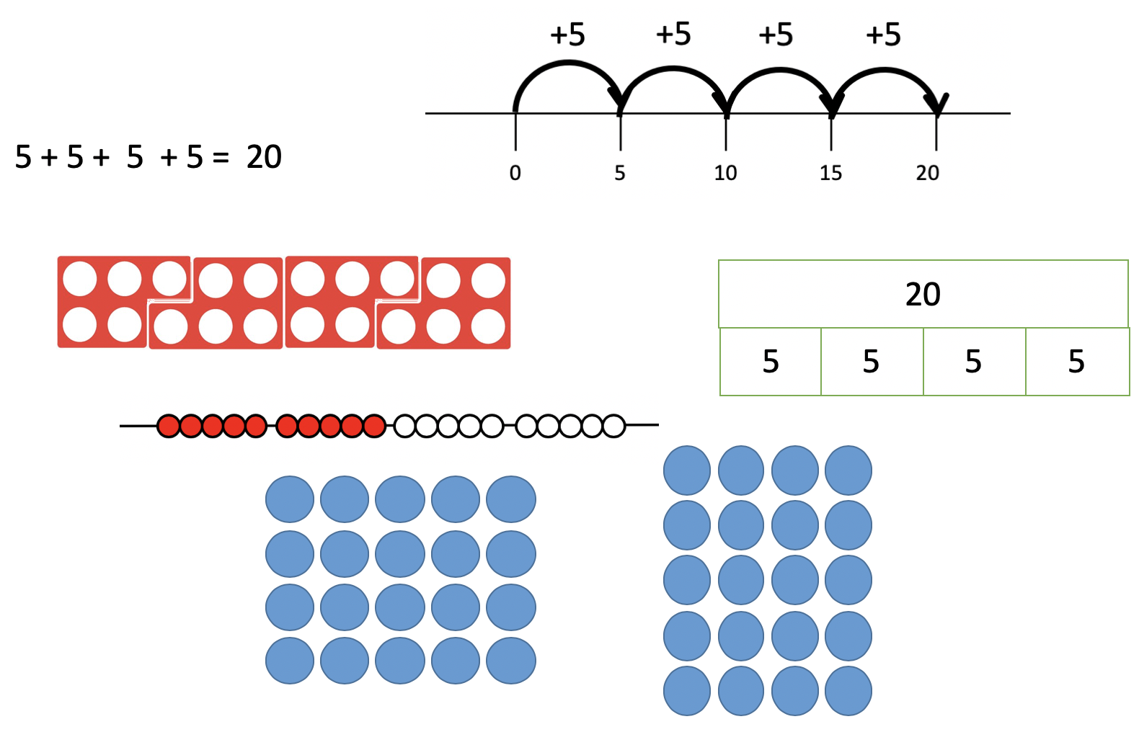  Once a range of representations have been created, ask learners to compare their representations with another pair. Learners will show they are convincing (TWM.04) when they explain how their representation shows 5 × 4.  Ask learners:  What is the same and what is different about these representations?  Through these discussions check learners’ understanding that multiplication is linked to repeated addition, and that this can be represented in many different ways, including through arrays. Explore with learners the link between the array and repeated addition, which can be shown by recording the repeated addition alongside the array, as shown below.  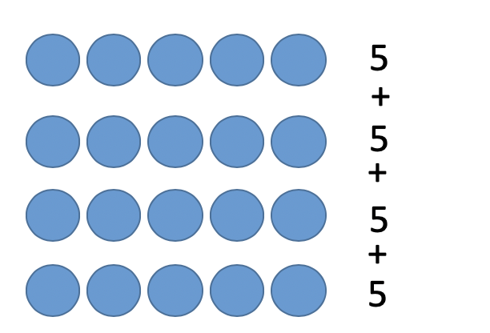  Resources:  A range of practical resources, such as counters and cubes | Continue to explore different representations of multiplication throughout learners’ multiplication learning journey.  Possible misconceptions:  Learners may believe that multiplication can only be represented in one way. The NRICH task: Catrina’s Cards (https://nrich.maths.org/203) can be used to help overcome this misconception, as this activity exposes learners to different ways of representing multiplication.
2Ni.07 Know 1, 2, 5 and 10 times tables. | Learners practise recall of the 1, 2, 5 and 10 times table through a range of games. To play, first decide on a focus times table, for example the 2 times table. Learners should play in pairs, and after chanting “one, two, three” they should each show between 1 and 5 fingers. Learners should then total the number of fingers that they show between them, and multiply this total by the chosen times table, calling out the answer.  For example, if learner A shows 4 fingers and learner B shows 3 fingers, they would each try to multiply 7 by 2 and call out the correct answer of 14. The first learner to call out the correct answer wins a point, and learners should play either until a defined number of points or for a set amount of time.  This activity can be extended by using the NRICH task: Tables Teaser (https://nrich.maths.org/14242). This task contains an interactivity which encourages learners to apply their knowledge of the 2, 5 and 10 times tables to identify the missing numbers based on numbers that have been revealed.  Resources:  NRICH task | Learners should be encouraged to regularly practise 1, 2, 5 and 10 times tables through a range of activities. Learners should also be encouraged to make links between the 1, 2, 5 and 10 times tables and counting. The activities suggested for learning objective 2Nc.04 can also be used to develop confidence and familiarity with the 1, 2, 5 and 10 times tables.

Unit 2.5 Topic 2 Understanding division

Outline of topic:
In this topic, learners develop their understanding of division and how division can be seen as repeated subtraction, grouping and sharing. Learners are encouraged to make connections between the different representations and structures of division.

Language:
Key vocabulary:
sharing, shared
group, grouping
equal groups
repeated subtraction
remainders

Key phrases:
… divided by … is …
… shared between … is …
… in groups of … is …

Recommended prior knowledge:
- Subtracting single digit numbers
- Multiplication and different representations for multiplication

Learning objectives | Suggested teaching activities and resources | Mental strategies, possible misconceptions and comments
2Ni.06 Understand division as:  - sharing (number of items per group)  - grouping (number of groups)  - repeated subtraction. | The NRICH task: Let Us Divide! (https://nrich.maths.org/8308) provides a useful introduction to the concept of division and encourages learners to explore different ways in which division can be represented. Each successive problem in this activity draws learners’ attention to division as sharing, grouping and repeated subtraction. The activity also encourages learners to make connections between multiplication and division.  Learners should explore the activity in small groups and be encouraged to focus on one problem from the activity at a time. When learners do this activity, ensure that they have a range of representations available as they may wish to use practical resources, such as counters or cubes to represent the situation. Initially observe the different approaches learners take to solving the different problems which are contained within the activity.  Invite learners to compare and contrast the different approaches taken by different groups, and to make connections between them. Draw learners’ attention to the different structures within each problem, exploring how division can be represented as sharing, grouping and repeated subtraction. Introduce learners to the symbol for division (÷).  This activity can be extended by asking learners to create their own set of division stories, focusing on division as sharing, grouping and repeated subtraction.  Once learners have a secure understanding of division, the concept of remainders can be introduced using the NRICH task: Grouping Goodies (https://nrich.maths.org/232).  Resources:  NRICH tasks  A range of practical resources, such as counters and cubes | The NRICH article: Difficulties with Division (https://nrich.maths.org/5450) provides a useful review of different approaches to both thinking about and teaching division and will make good background reading prior to teaching this objective.  Possible misconceptions:  Learners may believe that division can only be represented in one way. To help address this, draw learners’ attention to different ways in which other learners have represented division and ask them:  What is the same and what is different about these representations?

Unit 2.6 Measurement

Learning objectives covered in Unit 2.6 and topic summary: |  | 2.6 Topic 1  Measuring length | 2.6 Topic 2  Mass and capacity | Thinking and Working Mathematically
2Gg.03 | Understand that length is a fixed distance between two points. Estimate and measure lengths using non-standard or standard units. |  |  | TWM.07 Critiquing  TWM.08 Improving
2Gg.04 | Draw and measure lines, using standard units.
2Gg.06 | Understand that mass is the quantity of matter in an object. Estimate and measure familiar objects using non-standard or standard units. |  |  | TWM.07 Critiquing  TWM.08 Improving
2Gg.07 | Understand that capacity is the maximum amount that an object can contain. Estimate and measure the capacity of familiar objects using non-standard or standard units.
2Gg.12 | Understand a measuring scale as a continuous number line where intermediate points have value.

Unit 2.6 Topic 1 Measuring length

Outline of topic:
In this topic, learners are invited to explore the concepts of distance and length, initially by creating, comparing and using non-standard units, before being supported to explore centimetres and metres as standard units for length. Learners are then supported to use a ruler to accurately measure and draw lines.

Language:
Key vocabulary:
length
distance, furthest
longest, shortest
longer, shorter
centimetre, metre

Key phrases:
The length of … is … (units)
The … is shorter than …
The … is longer than …

Recommended prior knowledge:
- Use familiar language to describe length, including long, longer, longest, thin, thinner, thinnest, short, shorter, shortest, tall, taller and tallest

Learning objectives | Suggested teaching activities and resources | Mental strategies, possible misconceptions and comments
2Gg.03 Understand that length is a fixed distance between two points. Estimate and measure lengths using non-standard or standard units.  TWM.07 Critiquing  Comparing and evaluating mathematical ideas, representations or solutions to identify advantages and disadvantages  TWM.08 Improving  Refining mathematical ideas or representations to develop a more effective approach or solution | Introduce learners to the NRICH task: Car Journey (https://nrich.maths.org/10350). This task provides an interesting practical context for learners to explore the concept of length, and involves learners experimenting to see the difference distances toy cars travel when dropped down a slope.  Encourage learners to develop their own ways of measuring and recording the lengths that the different cars have travelled. Invite learners to develop other ways of measuring and recording by asking:  - Is there another way you can measure the lengths the cars have travelled?  - What equipment can you use to help you?  After learners have explored a range of different methods of measuring and recording length, as a class discuss and explore the different ways of measuring that they have used.  Learners will show they are critiquing (TWM.07) when they evaluate the approaches and ideas to consider which way(s) of measuring may be the most helpful and why. They will show they are improving (TWM.08) when they are able to explain the need for more accurate ways to measure length.  Once learners have explored a range of self-created non-standard measurement units, introduce the concept of a standard unit for measure. Explain that standard units are used to help people to compare measurements, giving the example that if we use a person’s hand or foot that each person’s hands or feet are different sizes so we will get different answers for the same distance. Introduce two standard units for measuring length: the centimetre (cm) and metre (m). Then show learners a range of rulers and measuring tapes.  Model to learners how to use an appropriate standard measurement tool, such as a tape measure or ruler to measure the distance travelled by the cars and explore with learners how these distances can be recorded.  Resources:  NRICH task  Toy cars or other vehicles on wheels  A ramp or slope  Rulers or measuring tapes | This activity provides a good opportunity for learners to practise and rehearse a wide range of vocabulary related to distance. To help develop this, ask questions such as:  - Which car travelled the furthest distance?  - Which car travelled the shortest distance?  - How far did that car go? How do you know?  - How much further did that car travel than the next car?

Learning objectives | Suggested teaching activities and resources | Mental strategies, possible misconceptions and comments
2Gg.04 Draw and measure lines, using standard units.  2Gg.12 Understand a measuring scale as a continuous number line where intermediate points have value. | Provide learners with a range of different lines drawn on paper, initially ensuring that each line is an exact whole number of centimetres.  Ask learners:  - Which line is the shortest?  - Which is the longest?  - How do you know?  Discuss learners’ responses together. Then ask learners:  How much longer is the longest line than the shortest line?  Explore learners’ initial responses and discuss together how we could answer this question. Establish that we will need to know the length of the different lines, using a standard unit, and remind learners that a standard unit of length is centimetres.  Provide learners with a ruler that is clearly marked in centimetres. Ask learners to work in pairs to measure the length of the lines, initially without any modelling. Observe the approaches learners take to measuring with the ruler, and discuss the different approaches together, drawing out any common errors or misconceptions. Through this discussion establish that the ‘0’ mark on the ruler must line up with the start of the line.  Once learners have measured the length of the shortest and longest line, ask learners to find the difference in length between them. Then ask learners to measure the length of the remaining lines.  Then, ask learners to draw their own straight lines of set lengths. They can be encouraged to create their own geometric artwork by changing the angle and orientation of the different length lines, creating a design similar to the image below:  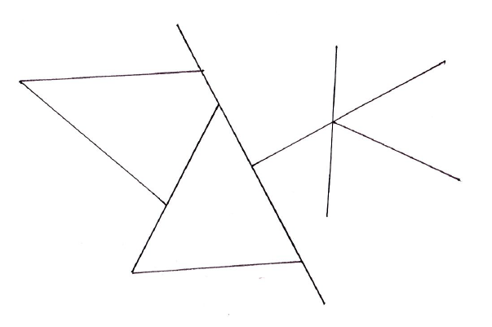  Once learners are confident with reading and measuring lines which are an exact whole number of centimetres, ensure learners are able to interpret the values that lie between whole number divisions on the ruler by using language of approximation. For example, learners may read a value as ‘more than 3 centimetres but less than 4 centimetres’ or ‘slightly more than 1 centimetre’.  Resources:  Worksheets with different length lines drawn on | Possible misconceptions:  When using a ruler, learners may not always line up the start point of the scale (0) with the line being measured or drawn. Some learners might incorrectly line up with the end of the ruler and others might line up with the 1.  To help address this, show two different measurements of items side by side, with one not starting at 0, such as the image below, and ask them to discuss which item will be measured accurately and why.  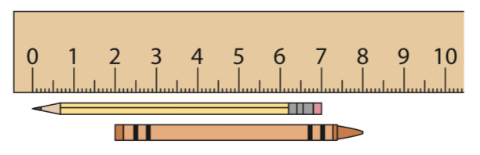  Learners are not introduced to decimals numbers until Stage 5. So at this stage, learners should just know that the line is slightly longer or shorter than a whole number.

Unit 2.6 Topic 2 Mass and capacity

Outline of topic:
In this unit, learners explore the concepts of mass and capacity, initially by creating and using non-standard units, before being supported to explore standard units and the benefits that these bring.

Language:
Key vocabulary:
mass
heavy, light, heaviest, lightest, heavier, lighter
capacity
full, empty
grams, kilograms
millilitres, litres

Key phrases:
The mass of … is … (units)
The capacity of … is … (units)

Recommended prior knowledge:
- Use familiar language to describe mass, including heavy, light, less and more

Learning objectives | Suggested teaching activities and resources | Mental strategies, possible misconceptions and comments
2Gg.06 Understand that mass is the quantity of matter in an object. Estimate and measure familiar objects using non-standard or standard units.  TWM.07 Critiquing  Comparing and evaluating mathematical ideas, representations or solutions to identify advantages and disadvantages  TWM.08 Improving  Refining mathematical ideas or representations to develop a more effective approach or solution | Provide each small group of learners with a balance scale along with items which can be used as non-standard units, such as beads or cubes. Ask learners to measure and compare the mass of objects they can find around the classroom such as an exercise book, a pencil case and a story book. Invite suggestions from learners as to how they can measure and compare the mass and encourage learners to use a range of non-standard units to record the mass. For example, they may find the mass of the exercise book is the same as 19 cubes and the mass of the pencil case is 35 cubes.  Ask learners:  Is there another way you can measure the mass?  What else can you use to compare the mass of the items?  Learners may also begin to use direct comparisons (i.e. placing one item on one side of the balance and another on the other side). After learners have had plenty of opportunity to investigate, ask them to share the different ways in which they recorded and compared the mass of the items.  Discuss the benefits and drawbacks of the different ways learners have recorded and compared the mass. Learners will show they are critiquing (TWM.07) when they evaluate the approaches and ideas to consider which way(s) of measuring may be the most helpful and why. They will show they are improving (TWM.08) when they are able to explain the need for more accurate ways to measure mass.  Establish with learners that, just like length and distance, there are standard units for mass which enable us to easily measure and compare the mass of different items. Introduce that two of these units are grams and kilograms. Provide learners with some small value masses (e.g. 5g, 10g) to hold so they can begin to appreciate the feel of different masses. Ask learners to try ordering the different objects by estimating the mass first by feel and say which is heaviest, lightest and in the middle. Then ask learners to measure and record the mass of the classroom items from earlier in standard units and check whether they were correct in placing heaviest and lightest.  Learners should also be exposed to opportunities to estimate the mass of objects. For example, you could provide a range of different objects, including objects which are physically large but low in mass. Ask learners to record their idea of the order of the mass of the items, initially without touching them. Then ask learners to hold the items and to adjust the order if they wish. Finally, work together to measure the mass of the items using standard units and to order them. Ask learners to reflect on the difference(s) between their estimated order and the actual order.  Resources:  Balance scales  Items which can be used as non-standard units, such as beads or cubes  Items with small masses such as 5g and 10g  Selection of objects of different masses  Measuring weights for use with balance scales | Through discussions, establish with learners that mass is the measure of the quantity of matter in an object. Building on learning from Stage 1, they should be able to use language such as heavy, light, heavier, lighter, heaviest and lightest to describe and compare the mass of objects.  Possible misconceptions:  Learners may believe that physically large items always have a higher mass than physically small items. To help address this provide learners with a range of different items to estimate and measure the mass of, including physically small but heavy items, such as a paperweight, and physically large but light items, such as an empty box.
2Gg.07 Understand that capacity is the maximum amount that an object can contain. Estimate and measure the capacity of familiar objects using non-standard or standard units.  2Gg.12 Understand a measuring scale as a continuous number line where intermediate points have value. | The NRICH task: Bottles (1) (https://nrich.maths.org/10337) provides a good introduction to the notion of capacity. Ideally, provide learners with a range of containers such as those pictured in the problem, and encourage them to practically explore the capacities of the different items, using the prompts in the teacher guidance to support learners.  The follow up NRICH task: Bottles (2) (https://nrich.maths.org/10382) can then be introduced, which encourages learners to create their own non-standard units and compare the capacity of different containers.  After learners have explored both of these activities, discuss with learners the benefits of a standard unit to measure capacity. Explain that a standard unit for capacity is millilitres and litres and provide a range of different measuring cylinders and jugs which have scales marked in millilitres up to 100 millilitres. Ask learners to explore the containers provided during the earlier activities alongside the measuring cylinder and jugs. Support learners to use the measuring cylinders and jugs to calculate the capacity of the different bottles and containers presented.  Ensure learners are able to interpret the values that lie between whole number divisions on the measuring cylinders by using language of approximation. For example, learners may read a value as ‘more than 3 but less than 4’ or ‘slightly more than 1’.  Resources:  NRICH tasks  Selection of containers of different capacities  Measuring cylinders or jugs marked with millilitres | Possible misconceptions:  Learners may believe that the taller the container, the larger its capacity. The NRICH task: Compare the Cups (https://nrich.maths.org/10656) can be used to help address this, as well as providing further opportunities for learners to practise and develop their language relating to capacity.  Ask learners to measure capacities between 1 and 100 millilitres. Learners are not introduced to numbers greater than 100 until Stage 3.  Learners are not introduced to decimals numbers until Stage 5. So at this stage, learners should just know that the values are larger or smaller than a whole number.

Unit 2.7 Fractions

Learning objectives covered in Unit 2.7 and topic summary: |  | 2.7 Topic 1  Finding quarters | 2.7 Topic 2  Building with fractions | Thinking and Working Mathematically
2Nf.01 | Understand that an object or shape can be split into four equal parts or four unequal parts. |  |  | TWM.05 Characterising  TWM.06 Classifying
2Nf.02 | Understand that a quarter can describe one of four equal parts of a quantity or set of objects. |  |  | TWM.04 Convincing
2Nf.03 | Understand that one half and one quarter can be interpreted as division.
2Nf.04 | Understand that fractions (half, quarter and three-quarters) can act as operators.
2Nf.05 | Recognise the relative size of $\frac{1}{4}$ , $\frac{1}{2}$ , $\frac{3}{4}$ and 1, and the equivalence of $\frac{1}{2}$ and $\frac{2}{4}$ , and $\frac{2}{2}$ , $\frac{4}{4}$ and 1.
2Nf.06 | Understand and visualise that wholes, halves and quarters can be combined to create new fractions.

Unit 2.7 Topic 1 Finding quarters

Outline of topic:
Learners begin this topic by exploring quarters and how shapes can be split into four in a way that creates equal and unequal groups. Learners are supported to establish that quarters are formed when objects are split into four equal parts and then to transfer this learning into finding quarters of objects and quantities. Learners are then asked to consider the link between fractions and division, and how fractions can act as operators.

Language:
Key vocabulary:
equal, unequal
fraction
quarter, three-quarters, half

Key phrases:
$\frac{1}{4}$ of … is …
$\frac{3}{4}$ of … is …
The shape is split into four equal/unequal parts.

Recommended prior knowledge:
- Learners should be confident at finding a half of a shape, object or quantity before commencing work on this topic

Learning objectives | Suggested teaching activities and resources | Mental strategies, possible misconceptions and comments
2Nf.01 Understand that an object or shape can be split into four equal parts or four unequal parts.  TWM.05 Characterising  Identifying and describing the mathematical properties of an object  TWM.06 Classifying  Organising objects into groups according to their mathematical properties | Give each learner a sheet of paper and a pair of scissors and ask them to cut the sheet of paper into four parts. Ask learners to compare the ways that they have split their paper into four parts in a small group.  Ask learners:  What is the same and what is different about the ways you cut the paper?  Discuss the different ways that learners cut their paper together as a class. Show learners a piece of paper that has been cut into four equal parts. Ask learners to consider:  What is the same and what is different about this way of cutting the paper and other ways learners cut their paper?  Draw learners’ attention to the fact that the parts are the same size and that all four pieces are equal.  Ask learners:  - Is there more than one way to cut the paper into four equal pieces?  - How many different ways can you think of?  Give each small group of learners some more pieces of paper and ask them to cut each into four equal pieces in different ways. Ask learners how they can check that the pieces are the same size and discuss this as a class.  In groups, ask learners to sort how they cut the paper into ways that result in four equal parts, or four parts that are not equal. Establish that we call things that are not equal, unequal.  Next, provide learners with a range of different shapes drawn on paper, ensuring that learners have two copies of each shape. Ask learners to cut each shape into four parts, asking them to cut one copy of the shape into four equal parts and the other into four unequal parts.  Finally, on the class board, show learners a range of different shapes, some cut into four equal parts and some cut into four unequal parts. Ask learners to discuss together and to classify these shapes into those that are have equal parts and those that have unequal parts.  Learners will show they are characterising (TWM.05) when they identify and describe the properties of the pieces of paper which have four equal or unequal parts. They will show they are classifying (TWM.06) when they organise their pieces of paper and shapes into those that have four equal parts and those that have four unequal parts.  Resources:  Scissors  Shapes drawn on paper | Possible misconceptions:  Learners may believe that shapes that are split unequally may be split equally. To help address this, encourage learners to physically compare the sizes of each piece of the shape by placing them on top of each other.
2Nf.02 Understand that a quarter can describe one of four equal parts of a quantity or set of objects.  TWM.04 Convincing  Presenting evidence to justify or challenge a mathematical idea or solution | Show learners a shape that has been cut into four equal parts and explain to learners that when things are cut into four equal parts, we can say they are quarters of the shape.  Provide learners with the shapes below and ask them to work in pairs to cut the shapes into quarters, reminding learners that this means four equal parts.  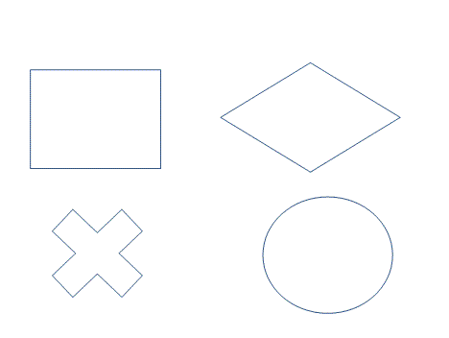  Once learners have cut each shape into quarters, ask each pair to explain to another pair how they know that their shapes have been cut into quarters. Learners will show they are convincing (TWM.04) when they show how they know each of the four pieces are equal and justify why their pieces are quarters.  Next, gather a group of eight learners at the front of the class. Ask learners how they can split this group of eight into quarters. Establish this means they need to be split into four equal groups. Share ideas together, and then model splitting the eight learners into four equal groups of two.  Then, show learners a group of 12 counters on the board. Ask them to discuss together how these counters can be split into four equal parts.  Model this by showing the four counters split into four equal parts of a square, to help learners make the connection between quartering shapes and objects.  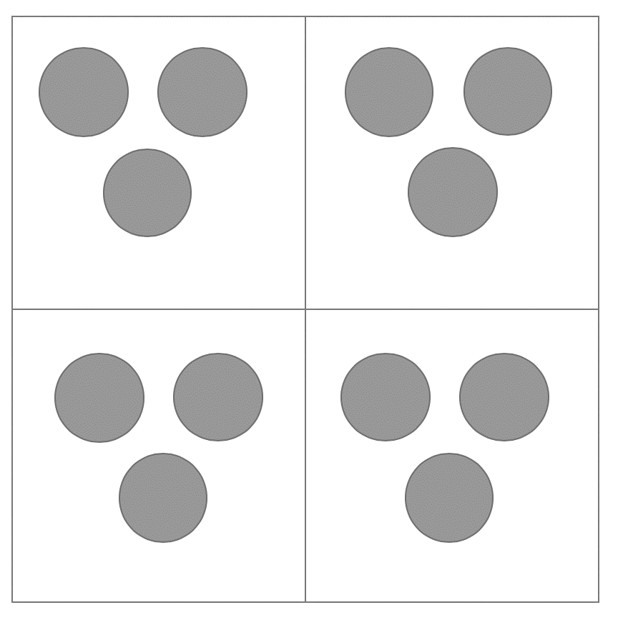  Provide learners with a range of different quantities (e.g. 4, 16, 20) to split into quarters, encouraging learners to use a range of representations, for example counters, cubes or bead strings to help them.  Ensure learners understand that parts of a set can also be put back together to make a whole set. Give learners questions such as:  This is one-quarter of a set of counters. How many counters are in the set?  Resources:  Printed shapes to be split into quarters  Counters, cubes or bead strings | You can help learners make the connection between finding quarters of a shape and a quantity by providing learners with a square cut into quarters. They can then share physical representations of a quantity or set of objects between the four quarters of the shape in order to find a quarter.  You may choose to relate this learning back to time, showing learners a clock and asking learners:  How can you cut the clock into quarters?
2Nf.03 Understand that one half and one quarter can be interpreted as division. | Provide learners with eight counters each and ask them to work with a partner for this activity. Ask one learner from each pair to split the eight counters into quarters. Ask the other learner to divide the eight counters by four.  Ask learners to compare their answers with their partner.  What do you notice?  Discuss as a class what learners notice about dividing by four and splitting a quantity into quarters and the ways that learners have both split the eight counters into quarters and divided them by four. Establish that finding a quarter of a quantity is the same as dividing the quantity by four.  Next, ask learners to find half of the eight counters. Ask learners to discuss together what number they are dividing the eight counters by when they are finding half of the counters, establishing that they are dividing the quantity by two, and that finding a half of a quantity is the same as dividing the quantity by two.  Use word problems to give a context for finding half and quarters, for example:  Chen has 12 biscuits. Then his friend Eva knocks on the door, so he decides to share them equally with Eva.  How many biscuits do Chen and Eva have each?  Then Chen’s sisters, Samira and Jamila arrive and also want to share the biscuits equally with Chen and Eva.  How many biscuits do they have each now?  How many different ways can they share them equally?  How can you check your answer?  Ask learners to create their own story for sharing 8 or 16 biscuits or toys etc. Learners can work in small groups of two or three and then retell or show their stories to the whole class.  Resources:  Counters | Possible misconceptions:  Some learners do not understand the link between fractions and division. It is important to contextualise the fractions and division with stories, especially social stories of sharing into equal parts. Books such as The Doorbell Rang by Pat Hutchins can help make these links.
2Nf.04 Understand that fractions (half, quarter and three-quarters) can act as operators. | Provide each pair of learners with 12 cubes. Ask learners to split the 12 cubes into two halves and discuss the answer. Write on the class board:  $\frac{1}{2}$ of 12 = 6  Then ask learners to split the 12 cubes into four quarters and ask learns if they can write the fraction number sentence that represents this. Share learners’ ideas and discuss them, establishing that the fraction number sentence will be:  $\frac{1}{4}$ of 12 = 3  Write the fractions $\frac{1}{4}$ and $\frac{3}{4}$ on the class board. Ask learners:  What do you notice about the two fractions?  What is the same and what is different?  Establish that $\frac{1}{4}$ is referred to as ‘one-quarter’ and $\frac{3}{4}$ is referred to as ‘three-quarters’ as the top number on $\frac{1}{4}$ is 1 and the top number on $\frac{3}{4}$ is 3.  Ask learners what they think the relationship is between $\frac{1}{4}$ and $\frac{3}{4}$ and establish that $\frac{3}{4}$ is 3 lots of $\frac{1}{4}$. Then ask learners to find $\frac{3}{4}$ of 12, discuss their ideas with a partner, before discussing answers and approaches with the class. Establish that $\frac{1}{4}$ of 12 is 3 and that $\frac{3}{4}$ is 3 lots of one-quarter, and therefore $\frac{3}{4}$ of 12 is 3 + 3 + 3 = 9.  Repeat this with two more numbers, finding $\frac{1}{4}$ and then $\frac{3}{4}$ of 8 and 16. Ask learners to draw a picture to show these so that they relate them to a visual representations.  Then provide learners with a range of fraction number sentences to solve, which use fractions as an operator, encouraging them to use physical representations to help them. Encourage learners to draw their solutions with the representations to convince others that their solutions are correct.  Resources:  Cubes, counters or objects | Possible misconceptions:  When asked to find $\frac{3}{4}$ of a quantity, learners may give the answer as the value of $\frac{1}{4}$ of the quantity. To help address this, provide learners with a square split into quarters. They can then share physical representations between the four quarters of the shape, and then see that $\frac{3}{4}$ is 3 of these quarters of the shape, and therefore 3 lots of $\frac{1}{4}$.  Learners are not expected to use the terms numerator and denominator at this stage.

Unit 2.7 Topic 2 Building with fractions

Outline of topic:
In this topic, learners explore the relationships between different fractions and how fractions can be combined to make new fractions.

Language:
Key vocabulary:
fraction
one-quarter, two-quarters, three-quarters, four-quarters
half, two-halves
whole

Key phrases:
… is the same as …

Recommended prior knowledge:
- Learners should be confident in finding $\frac{1}{2}$, $\frac{1}{4}$ and $\frac{3}{4}$ of a shape, object or quantity before commencing work on this topic

Learning objectives | Suggested teaching activities and resources | Mental strategies, possible misconceptions and comments
2Nf.05 Recognise the relative size of $\frac{1}{4}$ , $\frac{1}{2}$ , $\frac{3}{4}$ and 1, and the equivalence of $\frac{1}{2}$ and $\frac{2}{4}$ , and $\frac{2}{2}$ , $\frac{4}{4}$ and 1. | Provide learners with 5 strips of paper which are all the same size.  Ask learners to cut three strips of paper into quarters (writing $\frac{1}{4}$ on each quarter), cut one strip in half (writing $\frac{1}{2}$ on each half) and leave one whole.  Then, using their strips of paper, ask learners to show you $\frac{1}{4}$ and then ask them to represent 1, $\frac{1}{2}$, and $\frac{3}{4}$ in different ways.  Ask learners:  Which of the fractions is largest?  Which is smallest?  Ask learners to share their thinking and reasoning with their partner, before discussing as a class. Establish that the fractions, in order of size from smallest to largest are $\frac{1}{4}$, $\frac{1}{2}$, $\frac{3}{4}$ and 1.  Next, ask learners to use their strips of paper to investigate how many halves are equal in size to 1, and how many quarters are equal in size to 1. Establish through discussion that $\frac{4}{4}$ is the same as 1, as is $\frac{2}{2}$.  Next, ask learners to show you $\frac{2}{4}$using their strips of paper and ask:  Can you find any other fraction that is the same size as two-quarters?  Provide time for learners to explore this, before discussing together and establishing that $\frac{2}{4}$and $\frac{1}{2}$ are the same size.  Resources:  Strips of paper which are all the same size  Scissors | Possible misconceptions:  Learners may think that the larger the denominator of a fraction, the larger the fraction is. Help to address this by using physical representations of fractions, for example using strips of paper.
2Nf.06 Understand and visualise that wholes, halves and quarters can be combined to create new fractions. | Provide learners with some strips of paper that are the same size.  Ask learners to cut a few strips of paper into quarters (writing $\frac{1}{4}$ on each quarter), cut a few strips of paper into halves (writing $\frac{1}{2}$ on each half) and leave some strips whole.  Ask learners to put three halves together. Ask learners to discuss what fraction they created.  Then ask learners to use these strips to create a range of other fractions and then discuss what fraction they created. Challenge learners to see how many different fractions they can create using their strips.  If learners have not combined their strip(s) that represent 1 with other fractions, challenge learners to do so..  Resources:  Strips of paper which are all the same size  Scissors | If learners still have the strips of paper they created during the activity suggestion for 2Nf.05, these can be re-used for this activity.

Unit 2.8 Statistical methods and chance

Learning objectives covered in Unit 2.8 and topic summary: |  | 2.8 Topic 1  The statistical cycle | 2.8 Topic 2  Chance | Thinking and Working Mathematically
2Ss.01 | Conduct an investigation to answer non-statistical and statistical questions (categorical data).
2Ss.02 | Record, organise and represent categorical data. Choose and explain which representation to use in a given situation:  - lists and tables  - Venn and Carroll diagrams  - tally charts  - block graphs and pictograms. |  |  | TWM.07 Critiquing  TWM.08 Improving
2Ss.03 | Describe data, identifying similarities and variations to answer non-statistical and statistical questions and discuss conclusions.
2Sp.01 | Use familiar language associated with patterns and randomness, including regular pattern and random pattern.
2Sp.02 | Conduct chance experiments with two outcomes, and present and describe the results.

Unit 2.8 Topic 1 The statistical cycle

Outline of topic:
In this topic, learners explore how they can conduct investigation to answer statistical questions, and then explore a range of ways in which data can be presented. They interpret the results of their investigation, identifying similarities and differences in the data, and discuss conclusions.

Language:
Key vocabulary:
investigation
Venn diagram, Carroll diagram
block chart
pictogram
tally chart

Key phrases:
I am going to investigate …
I am going to present my results using …
Based on my investigation, I know that …

Recommended prior knowledge:
- Describe data, using familiar language including reference to more, less, most or least to answer non-statistical questions and discuss conclusions
- Answer non-statistical questions (categorical data)
- Draw and interpret Venn and Carroll diagrams with one criterion
- Draw and interpret pictograms and block graphs where one object or drawing represents one data value

Learning objectives | Suggested teaching activities and resources | Mental strategies, possible misconceptions and comments
2Ss.01 Conduct an investigation to answer non-statistical and statistical questions (categorical data). | Pose a statistical question for learners to investigate, such as:  What colour is the most popular favourite colour in our class?  Ask learners to work in pairs to discuss how they can answer this question. Then select pairs of learners to share their ideas with the class, drawing out the various different stages needed for the investigation, and how their results can be recorded.  Then ask learners to carry out the investigation. Depending on the type of question asked, it may be more efficient if you collect the data needed in order to answer the statistical question as a whole class.  Once the investigation is complete and the question answered, ask learners to discuss in small groups what other (statistical) questions they could investigate and answer. Discuss with learners what makes an effective question. Then ask groups of learners to choose a question and to plan how they will answer the question before carrying out the investigation. | This learning objective can be effectively explored through cross-curricular work, for example, when answering statistical questions in a science lesson.  Learners should conduct simple statistics investigations as part of a four-part statistical enquiry cycle:  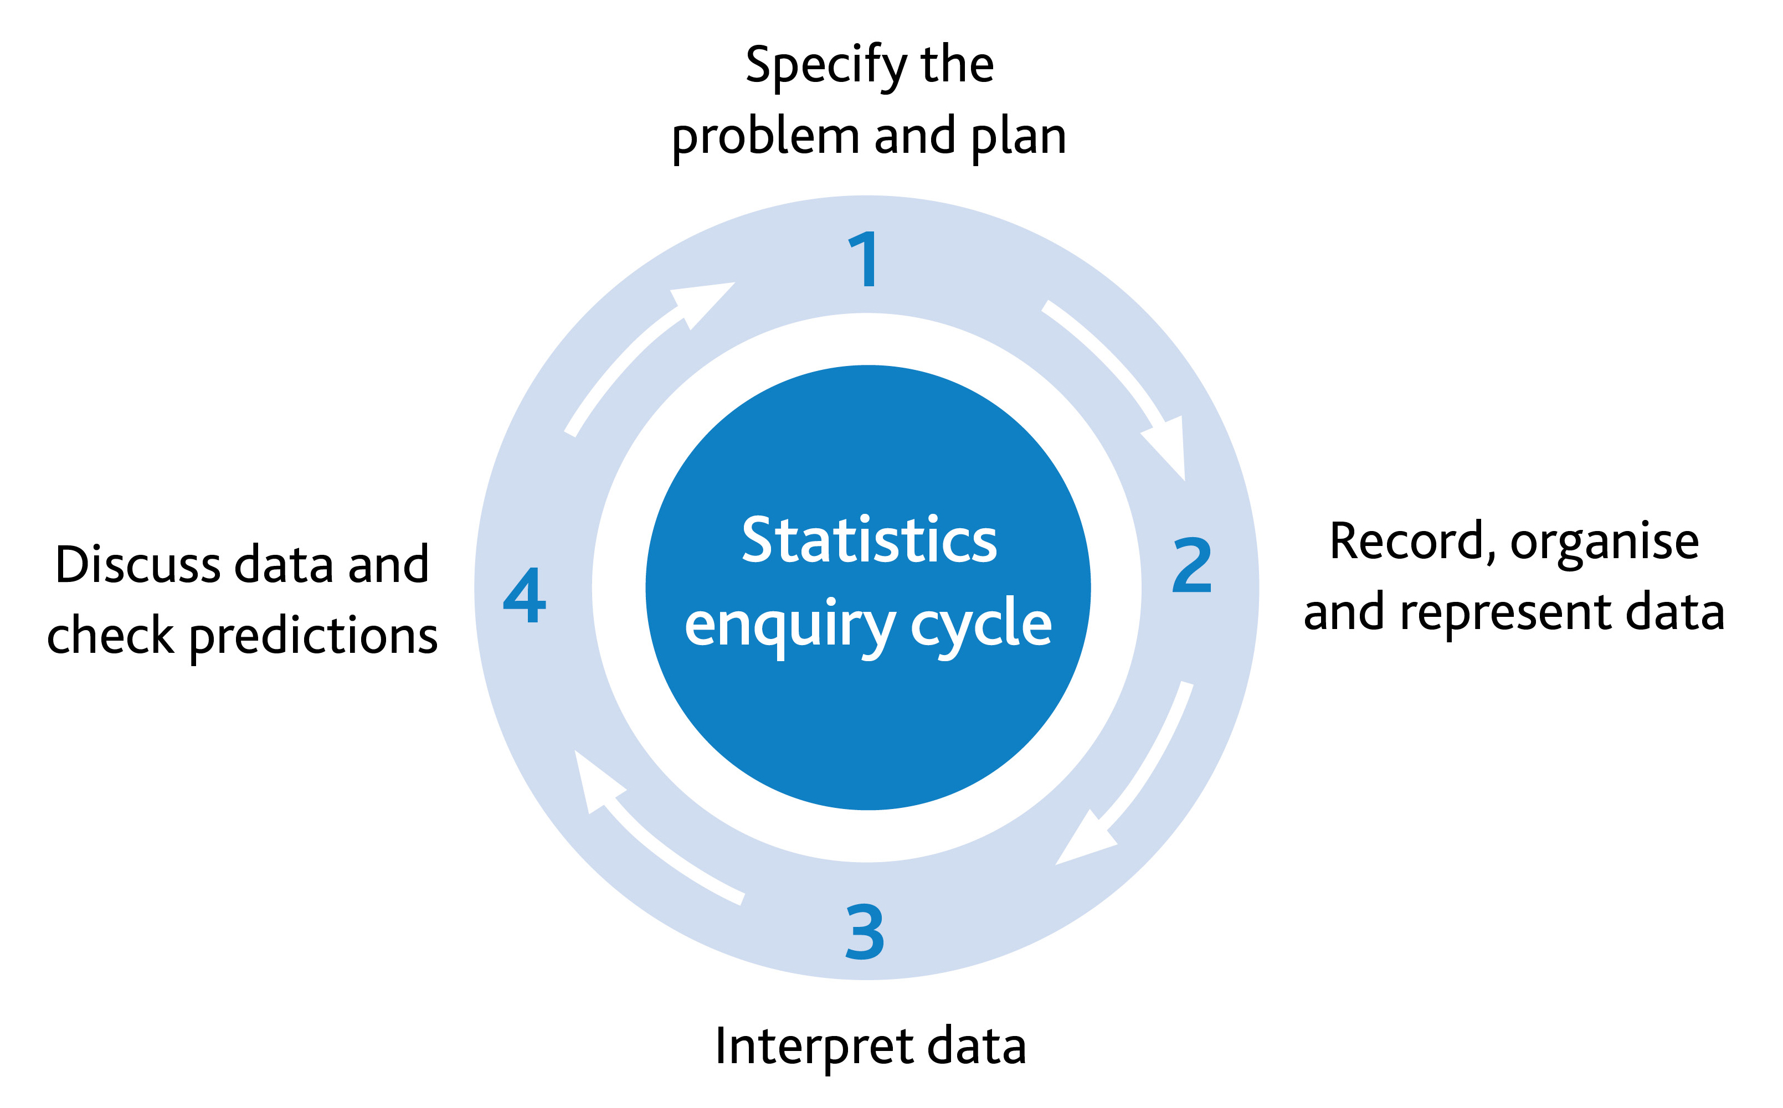
2Ss.02 Record, organise and represent categorical data. Choose and explain which representation to use in a given situation:  - lists and tables  - Venn and Carroll diagrams  - tally charts  - block graphs and pictograms. | Give learners a list of data such as:  Ask learners:  What do you think this list of data refers to?  How can we present it more clearly?  Learners may suggest reorganising the data or grouping the same colours together. Explore different ways of representing the data, including tally charts.  The NRICH task: Sticky Data (https://nrich.maths.org/7687) may be used to introduce learners to block graphs.  During this activity learners work as a class to create a block graph out of sticky notes, and then explore the types of questions that block graphs can help you to answer.  Resources:  NRICH task  Sticky notes | Learners should conduct simple statistics investigations as part of a four-part statistical enquiry cycle. Recoding data is the second step in the statistical enquiry cycle:
  Blue
  Green
  Blue
  Blue
  Brown
  Brown
  Brown
  Blue
2Ss.02 Record, organise and represent categorical data. Choose and explain which representation to use in a given situation:  - lists and tables  - Venn and Carroll diagrams  - tally charts  - block graphs and pictograms.  TWM.07 Critiquing  Comparing and evaluating mathematical ideas, representations or solutions to identify advantages and disadvantages  TWM.08 Improving  Refining mathematical ideas or representations to develop a more effective approach or solution | Provide learners with two categories which have an overlap, for example, ‘he is a boy’ and ‘he is 6 years old’. Assign each category to a hoop or circle drawn on the floor, initially presenting the circles as separate circles. Give each learner a piece of paper and ask them to write their name on it. Then ask learners, one at a time, to place their piece of paper in the hoop that describes them.  When a learner who meets both categories, for example a boy who is 6, is chosen to place their piece of paper, use this as an opportunity to discuss where this learner can place their paper.  Ask learners:  Where is the best place for this learner to place their piece of paper?  Can we change our diagram to enable this learner to show us that they are a boy and six years old?  Learners will show they are critiquing (TWM.07) when they evaluate the appropriateness of the original Venn diagram, noticing that there is no place for the learner to place their piece of paper which captures both pieces of information. They will show they are improving (TWM.08) when they understand and suggest how to adapt the Venn diagram to more effectively display the data.  Through discussion, establish that you can move the hoops or circles so that they overlap, and then the learner could place their sticky note in the space where the two circles overlap.  Repeat a similar discussion with a learner who does not fit into either category, for example a 7-year-old girl, establishing that this learner can place their piece of paper note outside all of the circles.  This activity can be extended by using the NRICH task: Data Shapes (https://nrich.maths.org/7523)  Resources:  Large hoops or circles  NRICH task | Learners should conduct simple statistics investigations as part of a four-part statistical enquiry cycle. Recoding data is the second step in the statistical enquiry cycle:
2Ss.01 Conduct an investigation to answer non-statistical and statistical questions (categorical data).  2Ss.02 Record, organise and represent categorical data. Choose and explain which representation to use in a given situation:  - lists and tables  - Venn and Carroll diagrams  - tally charts  - block graphs and pictograms.  2Ss.03 Describe data, identifying similarities and variations to answer non-statistical and statistical questions and discuss conclusions. | Pose a statistical question for learners to investigate, such as:  What book genre is the most popular of learners in our class?  Ask learners:  How can we find out the answer to this question?  What question can we ask? What sort of answers might be given?  Who do we need to ask?  Then ask learners to carry out the investigation. Depending on the type of question asked, it may be more efficient if you collect the data needed in order to answer the statistical question as a whole class.  Once learners have collected this data, they should record, organise and represent the data in an appropriate way. Ask learners to share and compare their ideas of how they will present the data with a partner. Encourage learners to pose questions about each other’s data. For example:  What is the least popular…?  Learners should then interpret their data. Encourage learners to answer the original question and to also identify similarities and variations within their data. For example, learners might say:  The most popular genre of book was adventure.  More learners liked mystery books than fantasy books.  The same number of learners liked mystery and science fiction books.  Only one learner liked fantasy books. This was the least popular genre. | Learners should conduct simple statistics investigations as part of a four-part statistical enquiry cycle:

Unit 2.8 Topic 2 Chance

Outline of topic:
In this topic, learners explore the concept of regular patterns and randomness, before beginning to explore the notion and language of chance.

Language:
Key vocabulary:
regular pattern
random
repeating pattern
most likely, least likely
chance

Key phrases:
I know these objects are arranged into a pattern because …
I know these objects are arranged randomly because …
… is the most likely because …
… is the least likely because …

Recommended prior knowledge:
- Understand how to record information in lists, tables and tally charts

Learning objectives | Suggested teaching activities and resources | Mental strategies, possible misconceptions and comments
2Sp.01 Use familiar language associated with patterns and randomness, including regular pattern and random pattern. | Provide learners with a selection of different objects with which they can create a pattern, for example coloured cubes, counters or shapes.  Ask learners to arrange their objects in a line, in any way they like. Then ask learners to look at the ways that other learners on their table or in their group arranged their objects.  Ask learners:  What is the same and what is different about the ways you arranged your objects?  Draw learners’ attention to the arrangement of one learner who has arranged their objects into a regular pattern, and to one who has arranged their objects randomly.  Ask learners:  What do you notice about the way that these objects have been arranged?  Through discussion establish that one learner has arranged their objects into a regular pattern, so that the same colours or objects repeat in the same order. Ensure learners understand that in regular patterns it is possible to predict what will be the next object in the pattern. Establish that the other learner has arranged their objects in a way that does not follow a regular pattern, and therefore we can say that they have arranged their objects randomly.  Then, invite learners to rearrange their objects so that they form a regular pattern, or, if learners’ objects already formed a regular pattern, to arrange them in a way that forms a different regular pattern.  Resources:  Objects such as counters, cubes or shapes | The NRICH resource: Pattern Making (https://nrich.maths.org/13250) provides some useful ideas of how to support children to develop their awareness of and ability to create patterns.  The NRICH article: Pattern Power (https://nrich.maths.org/2148) provides some further information on teaching patterns and additional teaching suggestions, which can be adapted to this stage of learning.
2Sp.02 Conduct chance experiments with two outcomes, and present and describe the results. | Ask learners to roll a six-sided die, and to record the result of their roll in two categories: ‘1-3’ and ‘4-6’. Ask learners to say if their number fitted into the ‘1-3’ category and then if their number fitted into the ’4-6’ category. Record the number of learners in each category:  Ask learners:  What do you notice about the number recorded in each category?  Can you describe the results?  Then invite learners to draw their own table with the same categories and to roll their dice 30 times recording the results of each roll. Learners may wish to use a tally chart to record their data.  Ask learners to describe their results to a partner.  Encourage learners to create another table with categories of their choice. For example, learners may choose to use the categories ‘6’ and ‘not a 6’. Learners repeat the chance experiment, recording, presenting and describing the results of another 30 rolls of the die.  Resources:  Six-sided dice
  Dice roll | Number of learners
  1-3
  4-6

Sample lesson 1

CLASS:

DATE:
Learning objectives | 2Nf.02 Understand that a quarter can describe one of four equal parts of a quantity or set of objects.  TWM.04 Convincing
Lesson focus /  success criteria | Learners will understand and interpret quarters.  - I can explain that when shapes or objects are split into four equal parts, we can say they are split into quarters.  - I can interpret quarters as comparing a part of a set of objects.  - I can show how parts of a set can be put back together to make a whole set.
Prior knowledge /  previous learning | Learners should understand that an object or shape can be split into four equal parts or four unequal parts. They should also understand that a half can describe one of two equal parts of a quantity or set of objects.
Plan
Lesson | Planned activities | Notes
Introduction | Show learners the learning objectives and lesson focus and agree the success criteria:  - know that when shapes or objects are split into four equal parts, we can say they are split into quarters  - interpret quarters as comparing a part of a set of objects.  - show that parts of a set can be put back together to make a whole set.  Review prior learning about splitting shapes or objects into four equal or four unequal parts.  Show learners a shape cut into four equal parts and the same shape cut into four unequal parts, for example:  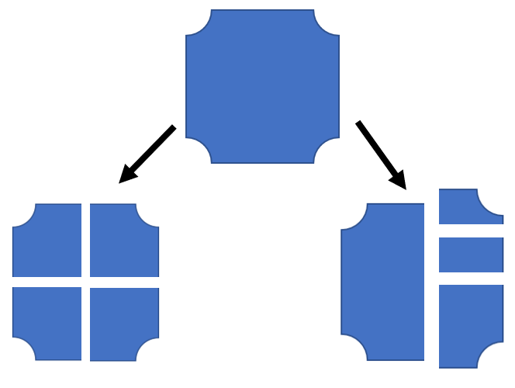  Ask learners:  What is the same and what is different about the ways this shape has been cut?  Explain to learners that when things are split into four equal parts, we can say they are split into quarters. In the example above, the shape on the left is split into quarters, but the shape on the right is not. | Resources:  Example of a shape split into four equal parts and the same shape split into four unequal parts
Main activities | Provide learners with the shapes below and ask them to work in pairs to split the shapes into quarters, reminding learners that this means four equal parts.  Once learners have split each shape into quarters, ask each pair to explain to another pair how they know that their shapes have been split into quarters. Learners will show they are convincing (TWM.04) when they show how they know each of the four pieces are equal and justify why their pieces are quarters.  Next, gather a group of eight learners at the front of the class. Ask learners how they can split this group of eight into quarters. Establish this means they need to be split into four equal groups. Share ideas together, and then model splitting the eight learners into four equal groups of two.  Next, show learners a group of 12 counters on the board. Ask them to discuss together how these counters can be split into four equal parts. Model this by showing the four counters split into four equal parts of a square, to help learners make the connection between quartering shapes and objects.  Provide learners with a range of different quantities (e.g. 4, 16, 20) to split into quarters, encouraging learners to use a range of representations, for example counters, cubes or bead strings to help them.  Ensure learners understand that parts of a set can also be put back together to make a whole set. Give learners questions such as:  This is one-quarter of a set of counters. How many counters are in the set? | You can help learners make the connection between finding quarters of a shape and a quantity by providing learners with a square split into quarters. They can then share physical representations of a quantity or set of objects between the four quarters of the shape in order to find a quarter.  Resources:  Shapes to be split into quarters  Counters, cubes or bead strings
End | Ask learners some true or false quick questions about different representations of quarters. For example:  1. This circle is split into quarters:  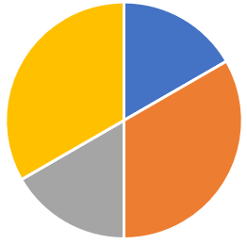  2. These counters are split into quarters:  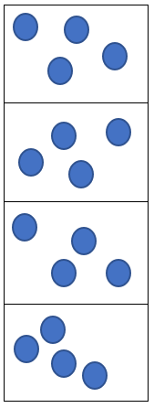  Revisit the learning objective and success criteria. Ask learners to explain whether they have met the success criteria and if they have any questions or comments. | Resources:  A selection of true or false quick questions about different representations of quarters

Reflection
Use the space below to reflect on your lesson. Answer the most relevant questions for your lesson.
Were the learning objectives and lesson focus realistic? What did the learners learn today?
What was the learning atmosphere like?
What changes did I make from my plan and why?
If I taught this lesson again, what would I change?
What two things really went well (consider both teaching and learning)?
What two things would have improved the lesson (consider both teaching and learning)?
What have I learned from this lesson about the class or individuals that will inform my next lesson?
Next steps
What will I teach next based on learners’ understanding of this lesson?

Sample lesson 2

CLASS:

DATE:
Learning objectives | 2Gp.01 Use knowledge of position and direction to describe movement.  TWM.07 Critiquing  TWM.08 Improving
Lesson focus /  success criteria | Learners will understand position and direction to give and follow movement instructions.  - I can describe movement using clockwise and anti-clockwise, left, right, forwards, backwards etc.  - I can interpret movement instructions to follow directions.
Prior knowledge /  previous learning | Learners should be able to use familiar language to describe position and direction such as left, right, up, down, under, above, below, in front of, behind.
Plan
Lesson | Planned activities | Notes
Introduction | Show learners the learning objectives and lesson focus and agree the success criteria:  - I can describe movement using clockwise and anti-clockwise, left, right, forwards, backwards etc.  - I can interpret movement instructions to follow directions.  Set up a simple obstacle course using cones or other objects, which involves several turns. Show learners the course (or a photograph of the course) and explain that they will be challenged to provide instructions to their partner explaining how to navigate the course without touching any of the obstacles.  Ask learners to discuss in pairs the key language and phrases that they may need to use to help their partner navigate the course. Share ideas as a class.  Explore equivalent movements, for example, two quarter turns clockwise is equivalent to a half turn clockwise, and reverse descriptions, such as two steps forwards is the reverse of two steps backwards. | Resources:  Cones or obstacles
Main activities | Challenge learners to work in pairs to navigate their partner around the course. The partner who is on the course should only move as instructed by the partner giving directions. You may choose to ask the learner who is completing the course to close their eyes to ensure that they rely solely on their partner’s instructions.  Set pairs of learners off on the course one at a time, ensuring there is a gap between each pair. Whilst learners are waiting to start, encourage them to listen to the directions being given by learners who are completing the course.  Learners will show they are critiquing (TWM.07) when they consider what is and is not effective about the other groups’ directions and how they can use similar language when they are navigating the course. Learners will show they are improving (TWM.08) when they consider how their directions can be improved.  Once all learners have navigated the course, invite them to switch roles, so that the learner who was providing instructions is now navigating the course based on the instructions of the other learner.  This activity can be extended by asking learners to use their experiences to write a set of instructions for how to navigate the course. Once the instructions have been written, encourage learners to test out their instructions to ensure that they work and that they describe the position and direction of movement needed, and to make refinements to them as necessary. | Resources:  If learners struggle to transfer their verbal instructions to a written description of the movement, it may be helpful to record them giving the verbal instructions, so that they can replay this to help them create written instructions.
End | Ask learners:  Can you think of any real-life situations where giving accurate descriptions of direction and position is important?  Discuss as a class a real-life situation where they may need to describe or follow a movement, such as navigation.  Revisit the learning objectives and success criteria. Ask learners to explain whether they have met the success criteria and if they have any questions or comments.

Reflection
Use the space below to reflect on your lesson. Answer the most relevant questions for your lesson.
Were the learning objectives and lesson focus realistic? What did the learners learn today?
What was the learning atmosphere like?
What changes did I make from my plan and why?
If I taught this lesson again, what would I change?
What two things really went well (consider both teaching and learning)?
What two things would have improved the lesson (consider both teaching and learning)?
What have I learned from this lesson about the class or individuals that will inform my next lesson?
Next steps
What will I teach next based on learners’ understanding of this lesson?

Changes to this Scheme of Work

This Scheme of Work has been amended. The latest Scheme of Work is version 2.0, published January 2021.

- The definition of the Thinking and Working Mathematically characteristic TWM.03 Conjecturing has been changed to: Forming mathematical questions or ideas.
- The definition of the Thinking and Working Mathematically characteristic TWM 04 Convincing has been changed to: Presenting evidence to justify or challenge a mathematical idea or solution.

There may be other minor changes that do not affect teaching and learning.

Cambridge Assessment is committed to making our documents accessible in accordance with the WCAG 2.1 Standard. We are always looking to improve the accessibility of our documents. If you find any problems or you think we are not meeting accessibility requirements, contact us at info@cambridgeinternational.org with the subject heading: Digital accessibility. If you need this document in a different format, contact us and supply your name, email address and requirements and we will respond within 15 working days.

Cambridge Assessment International Education
The Triangle Building, Shaftesbury Road, Cambridge, CB2 8EA, United Kingdom
t: +44 1223 553554 f: +44 1223 553558
e: info@cambridgeinternational.org www.cambridgeinternational.org

© UCLES September 2020

