

Scheme of Work
Cambridge Lower Secondary
Mathematics 0862
Stage 9

This Cambridge Scheme of Work is for use with the Cambridge Lower
Secondary Mathematics Curriculum Framework published in September
2020 for first teaching in September 2021.

© UCLES 2020
Cambridge Assessment International Education is part of the Cambridge Assessment Group. Cambridge Assessment is the brand name of the University of Cambridge Local Examinations Syndicate (UCLES), which itself is a department of the University of Cambridge.

UCLES retains the copyright on all its publications. Registered Centres are permitted to copy material from this booklet for their own internal use. However, we cannot give permission to Centres to photocopy any material that is acknowledged to a third party, even for internal use within a Centre.

Contents

Contents 3
Introduction 5
Unit 9.1 Number and calculation 9
Unit 9.1 Topic 1 Indices and standard form 10
Unit 9.1 Topic 2 The number system 15
Unit 9.2 Algebraic representation and manipulation 19
Unit 9.2 Topic 1 Manipulating algebra, expressions and formulae 20
Unit 9.2 Topic 2 Linear and simultaneous equations 25
Unit 9.2 Topic 3 Inequalities and upper and lower limits 28
Unit 9.3 Shape and measure 31
Unit 9.3 Topic 1 2D shapes and measure 32
Unit 9.3 Topic 2 3D shapes 38
Unit 9.3 Topic 3 Pythagoras’ theorem 43
Unit 9.4 Fractions, decimals, percentages, ratio and proportion 47
Unit 9.4 Topic 1 Calculating with fractions and decimals 48
Unit 9.4 Topic 2 Percentages 53
Unit 9.4 Topic 3 Ratio and proportion 55
Unit 9.5 Probability 58
Unit 9.5 Topic 1 Mutually exclusive and combined events 59
Unit 9.5 Topic 2 Expected frequency 64
Unit 9.6 Angles and constructions 66
Unit 9.6 Topic 1 Angles 67
Unit 9.6 Topic 2 Bearings and constructions 73
Unit 9.7 Sequences, functions and graphs 77
Unit 9.7 Topic 1 Generating terms and finding rules of sequences 78
Unit 9.7 Topic 2 Functions 82
Unit 9.7 Topic 3 Graphs and coordinates 84
Unit 9.8 Transformations 91
Unit 9.8 Topic 1 Reflections, rotations and translations 92
Unit 9.8 Topic 2 Enlargements 95
Unit 9.9 Statistics 99
Unit 9.9 Topic 1 Collecting, presenting and interpreting data 100
Unit 9.9 Topic 2 Descriptive statistics 106
Unit 9.9 Topic 3 The statistical cycle 109
Sample lesson 1 112
Sample lesson 2 115
Changes to this Scheme of Work 117

Changes to this Scheme of Work
For information about changes to this Scheme of Work, go to page 117.
The latest Scheme of Work is version 2.0, published January 2021.

Introduction
This document is a scheme of work created by Cambridge Assessment International Education for Cambridge Lower Secondary Mathematics Stage 9.

It contains:
- suggested units showing how the learning objectives in the curriculum framework can be grouped and ordered
- at least one suggested teaching activity for each learning objective
- a list of subject-specific language that will be useful for your learners
- common misconceptions
- sample lesson plans
- links to relevant NRICH activities to enrich learners’ mathematical experiences, https://nrich.maths.org/

You do not need to use the ideas in this scheme of work to teach Cambridge Lower Secondary Mathematics Stage 9. Instead use them as a starting point for your planning and adapt them to suit the requirements of your school and the needs of your learners. The schemes of work are designed to indicate the types of activities you might use, and the intended depth and breadth of each learning objective. These activities are not designed to fill all the teaching time for this stage. You should use other activities with a similar level of difficulty, for example, those from endorsed resources.

The accompanying teacher guide for Cambridge Lower Secondary Mathematics suggests effective teaching and learning approaches. You can use this scheme of work as a starting point for your planning, adapting it to suit the requirements of your school and needs of your learners.

Long-term plan
This long-term plan shows the units in this scheme of work and a suggestion of how long to spend teaching each one. The suggested teaching time is based on learners having about 4 to 5 hours of Mathematics per week (about 120 to 150 hours per stage). The actual number of teaching hours may vary according to your context.
Unit and suggested order | Suggested teaching time
Unit 9.1 Number and calculation | 10% (15 hours)
Unit 9.2 Algebraic representation and manipulation | 13% (20 hours)
Unit 9.3 Shape and measure | 17% (25 hours)
Unit 9.4 Fractions, decimals, percentages, ratio and proportion | 13% (20 hours)
Unit 9.5 Probability | 7% (10 hours)
Unit 9.6 Angles and constructions | 10% (15 hours)
Unit 9.7 Sequences, functions and graphs | 13% (20 hours)
Unit 9.8 Transformations | 7% (10 hours)
Unit 9.9 Statistics | 10% (15 hours)
Total | 150 hours

Sample lesson plans
You will find two sample lesson plans at the end of this scheme of work. They are designed to illustrate how the suggested activities in this document can be turned into lessons. They are written in more detail than you would use for your own lesson plans. The Cambridge Lower Secondary Mathematics Teacher Guide has information on creating lesson plans.

Other support for teaching Cambridge Lower Secondary Mathematics Stage 9
Cambridge Lower Secondary centres receive access to a range of resources when they register. The Cambridge Lower Secondary support site at https://lowersecondary.cambridgeinternational.org is a password-protected website that is the source of the majority of Cambridge-produced resources for the programme. Ask the Cambridge Coordinator or Exams Officer in your school if you do not already have a log-in for this support site.

Included on this support site are:
- the Cambridge Lower Secondary Mathematics Curriculum Framework, which contains the learning objectives that provide a structure for your teaching and learning
- grids showing the progression of learning objectives across stages
- the Cambridge Lower Secondary Mathematics Teacher Guide, which will help you to implement Cambridge Lower Secondary Mathematics in your school
- templates for planning
- worksheets for short teacher training activities that link to the teacher guide
- assessments provided by Cambridge
- a list of endorsed resources, which have been through a detailed quality assurance process to make sure they are suitable for schools teaching Cambridge Lower Secondary Mathematics worldwide
- links to online communities of Cambridge Lower Secondary teachers.

Resources for the activities in this scheme of work
We have assumed that you will have access to these resources:
- squared paper, pens and pencils for learners to use
- rulers, set squares, protractors, compasses and calculators.

Other suggested resources for individual units and/or activities are described in the rest of this document. You can swap these for other resources that are available in your school.

Websites
We recommend NRICH to support Cambridge Lower Secondary Mathematics at https://nrich.maths.org/

NRICH publishes free and challenging mathematics activities for learners of all ages. The resources assist teachers to embed thinking and working mathematically with mathematics content. NRICH is based in both the University of Cambridge's Faculty of Education and the Centre for Mathematical Sciences.

There are many excellent online resources suitable for teaching Cambridge Lower Secondary Mathematics. Since these are updated frequently, and many are only available in some countries, we recommend that you and your colleagues identify and share resources that you have found to be effective for your learners

Approaches to teaching Cambridge Lower Secondary Mathematics Stage 9
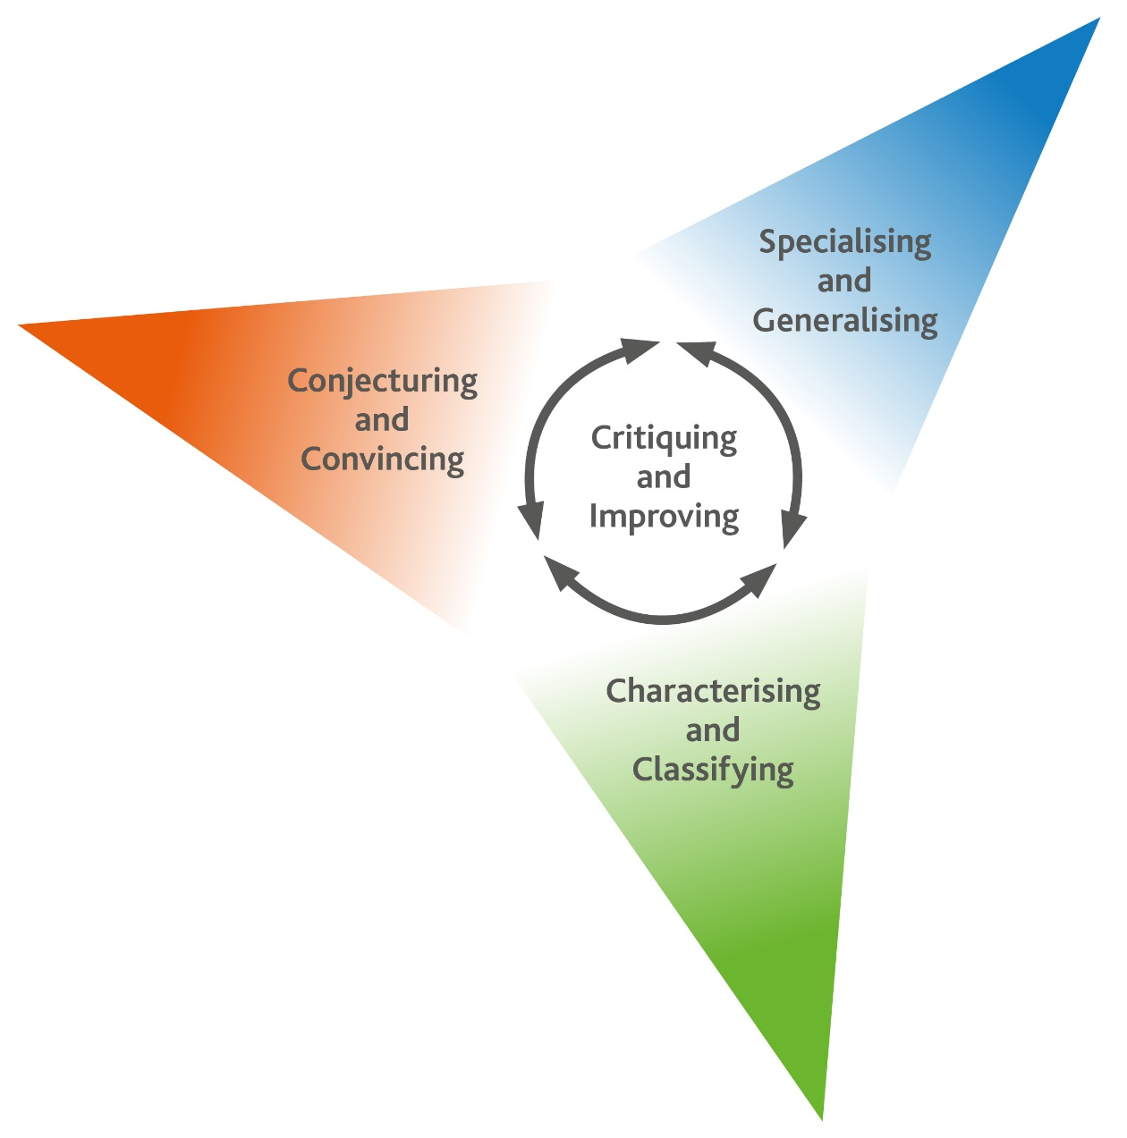
Thinking and Working Mathematically
Thinking and Working Mathematically supports the mathematical concepts and skills in all strands of the Cambridge Lower Secondary Mathematics curriculum. When learners think and work mathematically, they actively engage with their learning of mathematics. They try to make sense of ideas and build connections between different facts, procedures and concepts. Learners who do not think and work mathematically can carry out processes that their teacher has shown them, but they may not understand why the processes work or what the results mean. Noticing inconsistencies, patterns and particular representations encourages learners to think and work mathematically. Practice, reflection and questioning will help them to improve.

Thinking and Working Mathematically has eight characteristics that are presented in four pairs:

- Specialising and Generalising
- Conjecturing and Convincing
- Characterising and Classifying
- Critiquing and Improving.

The eight Thinking and Working Mathematically characteristics are all closely connected and interdependent. A high-quality mathematics task may include one or more of them. The characteristics provide learners with the language they need to think and work mathematically. Learners can then decide what mathematical knowledge, procedures and strategies to use in order to gain a deeper understanding of mathematical questions.

Throughout this scheme of work, there are examples of classroom activities that link the Thinking and Working Mathematically characteristics with content learning objectives. We recommend you use the ideas in these examples to create further classroom activities.

Thinking and Working Mathematically characteristics: |  | Unit 9.1 | Unit 9.2 | Unit 9.3 | Unit 9.4 | Unit 9.5 | Unit 9.6 | Unit 9.7 | Unit 9.8 | Unit 9.9
TWM.01 | Specialising – Choosing an example and checking to see if it satisfies or does not satisfy specific mathematical criteria
TWM.02 | Generalising – Recognising an underlying pattern by identifying many examples that satisfy the same mathematical criteria
TWM.03 | Conjecturing – Forming mathematical questions or ideas
TWM.04 | Convincing – Presenting evidence to justify or challenge a mathematical idea or solution
TWM.05 | Characterising – Identifying and describing the mathematical properties of an object
TWM.06 | Classifying – Organising objects into groups according to their mathematical properties
TWM.07 | Critiquing – Comparing and evaluating mathematical ideas, representations or solutions to identify advantages and disadvantages
TWM.08 | Improving – Refining mathematical ideas or representations to develop a more effective approach or solution

Misconceptions
Mathematical misconceptions are usually incorrect generalisations made by learners. Misconceptions should not be avoided, but instead used for teaching purposes to reveal learners’ thinking. Research suggests that asking learners open-ended questions about mathematical concepts is the most appropriate way to uncover misconceptions. Once a learner’s misconceptions have been identified, the next step is to know how to correct them. One approach is to give learners a variety of mathematical strategies to draw upon when finding solutions so that they can gain a deeper understanding of each mathematical concept.

Mental strategies and calculators
Mental calculation is a skill needed for everyday life, especially when paper or calculators are not available. Mental calculation relies on working memory, the organisation of thoughts and the use of efficient mathematical strategies when solving mathematical computations. It is important for learners to practise mental calculations and have a range of strategies as this improves understanding and recall as well as increasing confidence and proficiency.

Calculators are useful teaching aides. Although learners need to practise doing mental and written calculations, calculators can help them to notice patterns. They are also useful when learners are solving problems where non-calculator calculations would take the focus away from strategies. When well used, calculators can help learners to learn about numbers and the number system. Use calculators as a teaching aid to promote mental calculation and mental strategies and to explore mathematical patterns. Learners should understand when it is best to use calculators to help them calculate, and when to calculate mentally or using written methods.

As Cambridge International includes calculator-based assessments at Stages 7, 8 and 9, we recommend that learners develop effective use of calculators so that they are familiar with the buttons and functions of a basic calculator.

Unit 9.1 Number and calculation

Learning objectives covered in Unit 9.1 and topic summary: |  | 9.1 Topic 1  Indices and standard form | 9.1 Topic 2  The number system | Thinking and Working Mathematically
9Ni.01 | Understand the difference between rational and irrational numbers. |  |  | TWM.01 Specialising  TWM.04 Convincing
9Ni.02 | Use positive, negative and zero indices, and the index laws for multiplication and division. |  |  | TWM.01 Specialising  TWM.02 Generalising
9Ni.03 | Understand the standard form for representing large and small numbers.
9Ni.04 | Use knowledge of square and cube roots to estimate surds.
9Np.01 | Multiply and divide integers and decimals by 10 to the power of any positive or negative number.
9Nf.01 | Deduce whether fractions will have recurring or terminating decimal equivalents. |  |  | TWM.03 Conjecturing
9Ae.02 | Understand how to manipulate algebraic expressions including:  - expanding the product of two algebraic expressions  - applying the laws of indices  - simplifying algebraic fractions.

Unit 9.1 Topic 1 Indices and standard form

Outline of topic:
Learners will apply the index laws of multiplication and division to algebraic expressions as well as numerical examples. They will apply understanding of positive and zero powers to investigate negative powers.

Learners will be introduced to standard form and see how it is applied in real life contexts. They will convert numbers in normal form to standard form and vice versa.

Language:
Key vocabulary:
index, indices, power
index laws, laws of indices
standard form, normal form
base number

Key phrases:
Write … in standard form
Write … in normal form

Recommended prior knowledge:
- Use positive and zero indices, and the index laws for multiplication and division
- Multiply and divide whole numbers and decimals by any positive power of 10

Learning objectives | Suggested teaching activities and resources | Mental strategies, possible misconceptions and comments
9Ni.02 Use positive, negative and zero indices, and the index laws for multiplication and division.  9Ae.02 Understand how to manipulate algebraic expressions including:  - expanding the product of two algebraic expressions  - applying the laws of indices  simplifying algebraic fractions. | Recap the rules for simplifying 3⁷ × 3² and 4⁸ ÷ 4². Remind learners that expressions need to have the same base. Discuss how expressions such as$x^{4}×x^{2}$ and $y^{12}÷y^{4}$ can be simplified using the same index laws as for numbers. Remind learners that any number to the power of 1 equals itself and any number to the power of 0 is 1.  Ask learners:  How many different expressions can you make by completing the boxes in the expression a☐ × a☐ with the numbers -2, -1, 0, 1, 2?  Establish that some expressions are equivalent, even though different indices have been used. For example:  a⁻² × a² = a⁰ and a⁻¹ × a¹ = a⁰  Encourage learners to check their answers with a calculator, by choosing an appropriate value of a. For example, learners could check a⁻² × a² = a⁰ by substituting 2 for a, and noticing both sides are equal as 2⁻² × 2² = 1 and 2⁰ = 1.  This activity can be repeated for division a☐ ÷ a☐ and brackets (a☐)☐. Boxes representing the coefficients of ‘a’ could also be introduced, e.g. ☐a☐ × ☐a☐.
9Ni.02 Use positive, negative and zero indices, and the index laws for multiplication and division.  TWM 01 Specialising  Choosing an example and checking to see if it satisfies or does not satisfy specific mathematical criteria  TWM 02 Generalising  Recognising an underlying pattern by identifying many examples that satisfy the same mathematical criteria | Ask learners to discuss the following calculations in pairs:  2² = 4  2³ = 8  2⁴ = 16  Ask learners:  - Can you see a pattern? What comes next? (Answer: Learners should recognise that as they increase the index by one, the answer doubles, so the next calculation is 2⁵ = 32)  - What comes before 2² = 4? (Answer: Learners should recognise that as they decrease the index by one, the answer halves, so the previous calculation is 2¹ = 2)  - Can you continue to extend the pattern in this direction? (Answer: 2⁰ = 1,  2⁻¹ = ½, 2⁻² = ¼ …)  Ask learners to create and discuss the pattern with 3 as the base instead of 2 (e.g. 3² = 9, 3³ = 27 etc.).  Ask learners:  - What do you notice about 2⁰ and 3⁰? (Answer: they both equal 1)  - What do you notice about numbers with negative indices?  - Is there a simpler way to calculate these?    Learners will show they are specialising (TWM.01) and generalising (TWM.02) when they use examples to establish that a negative power equates to ‘one over the positive power’. For example:  2⁻¹ = $\frac{1}{2^{1}}$= $\frac{1}{2}$  2⁻² = $\frac{1}{2^{2}}$= $\frac{1}{4}$ | This activity can be used to introduce negative powers. Learners can also be shown a more formal approach such as:  $$a^{4}÷a^{7}=\frac{a×a×a×a}{a×a×a×a×a×a×a}$$  $$=\frac{1}{a×a×a}$$  $$=\frac{1}{a^{3}}$$  Possible misconceptions:  Learners may incorrectly think that any number to the power of zero is 0 (instead of 1). This task will challenge this misconception, as learners will follow the pattern to notice 2⁰ = 1 and 3⁰ = 1.
9Ni.02 Use positive, negative and zero indices, and the index laws for multiplication and division.  9Ae.02 Understand how to manipulate algebraic expressions including:  - expanding the product of two algebraic expressions  - applying the laws of indices  - simplifying algebraic fractions. | Give each small group of learners a set of cards with expressions or calculations that can be simplified or calculated by applying the index laws. Provide the corresponding answers or an equivalent expression.  For example:  Ask learners to work in small groups to match the cards into pairs.  This activity can be extended by including some cards, that have more than one equivalent match. For example, learners should recognise that the four cards below are all equivalent:  Resources:  Sets of cards
  7² × 7³ |  | 7⁵
  6⁰ |  | 1
  k²¹ ÷ k³ |  | k¹⁸
  9⁻² |  | $$\frac{1}{81}$$
  7¹ |  | 7
  k⁶ × k³ |  | k⁹
  18z⁷ ÷ 6z |  | 3z⁶
  (3z³)² |  | 9z⁶
  2² × 2 |  | 2³ |  | 8 |  | 2¹⁵ ÷ 2¹²
9Np.01 Multiply and divide integers and decimals by 10 to the power of any positive or negative number. | Ask learners to work in pairs to calculate 1384 × 10⁵ without using a calculator. They should discuss their approach in pairs, write their answer on a mini whiteboard or plain paper and hold up their answer.  Select one pair of learners to share their method with the class. Establish that by using knowledge of indices the calculation could be written as 1384 × 100 000, and by applying understanding of place value they can calculate the answer 138 400 000.  Repeat this activity with other multiplication and division questions, including those with decimals and negative powers. For example:  - 4.53 × 10⁴  - 4671 × 10⁻²  - 2.9 × 10⁻⁵  - 3398.3 × 10⁰  - 15 ÷ 10³  - 319.89 ÷ 10²  - 4671 ÷ 10⁻²  - 2.9 ÷ 10⁻⁵  Resources:  Mini whiteboards | Possible misconceptions:  Learners may use the strategy of writing zeros on the end of a number when multiplying by a power of 10. For example, they may incorrectly write 4.53 × 10⁴ = 4.530000.
9Ni.03 Understand the standard form for representing large and small numbers.  9Np.01 Multiply and divide integers and decimals by 10 to the power of any positive or negative number. | Show learners the following statement:  The Earth is approximately 150 million kilometres from the sun.  Ask learners:  Can you write 150 million kilometres as a number? (Answer: 150,000,000 km)  Are there any other ways to write this number?  Introduce learners to this number written in standard form:  1.5 x 10⁸  Explain that the first part of the number is a value between 1 and 10, and this is multiplied by a power of ten. Demonstrate to learners how to write a number written in normal form in standard form and vice versa.  Give learners other real-life examples of large numbers written in standard form or normal form, and ask them to convert between the representations. For example:  Then repeat this activity for small numbers using examples such as those in the table below:  This activity could be extended by using the NRICH task: A Question of Scale (https://nrich.maths.org/6349).  Resources:  NRICH task | Possible misconceptions:  Learners may incorrectly think that 10 × 10² is correctly written in standard form. Learners should understand standard form is a x 10^{n} where 1 ≤ a < 10, so the number should be written as 1 x 10³.  Learners should understand why standard form is important and be able to explain how it might be used in real life contexts.
   | Normal form | Standard form
  The approximate number of bricks used to build the Great Wall of China |  | 3.873 × 10⁹
  The length of the Nile river in miles | 4130
  The cost of building the London Eye in dollars | 88 546 000
  …
   | Normal form | Standard form
  The diameter of a virus in millimetres |  | 2 × 10⁻⁵
  The amount of blood a flea drinks in one day in millilitres | 0.00697
  The mass of a dust particle in kilograms |  | 7.53 × 10⁻¹⁰
  …

Unit 9.1 Topic 2 The number system

Outline of topic:
Learners will explore the differences between rational and irrational numbers. They will understand how to estimate the value of surds and establish which fractions are equivalent to terminating or recurring decimals.

Language:
Key vocabulary:
rational, irrational
square root, cube root
surd
approximate

Recommended prior knowledge:
- Know square numbers to 144 (12 × 12) and cube numbers to 125 (5 × 5 × 5)
- Understand the relationship between squares and corresponding square roots, and cubes and corresponding cube roots
- Knowledge of rational numbers (can be expressed as ª/_{b} where a and b are integers)

Learning objectives | Suggested teaching activities and resources | Mental strategies, possible misconceptions and comments
9Ni.04 Use knowledge of square and cube roots to estimate surds.  9Ni.01 Understand the difference between rational and irrational numbers. | Ask learners to work in pairs. They should give each other some quick questions to test each other on square numbers (up to 144), cube numbers (up to 125) and their corresponding roots. For example, they might ask questions such as:  - What is three squared?  - What is the cube root of 64?  Ask learners:  What is the square root of 19?  How could you estimate the answer?  Learners should realise that the answer will not be a whole number, since 19 is not a square number. Establish that $\sqrt{19}$ is irrational. They should recognise that $\sqrt{19}$ lies between 4 and 5, since 19 lies between 4² and 5². Introduce the term surd, explaining that when we cannot simplify a number to remove a square or cube (or other) root, then it is called a surd.  Ask learners to continue to work in pairs to play a game. They should take it in turns to ask each other to estimate a surd to the nearest whole number. They should check the answers using a calculator and score a point for each correct answer. Whoever has the most points at the end of the time limit is the winner.  This activity can be extended by giving learners the following problem to solve in pairs, without the use of a calculator:  Three sugar cubes have a total volume of 87cm³. Without crushing them, can they fit into a box that is 9cm by 4cm by 4cm? (Answer: no, each cube will have a volume of 29cm³ and the cube root of 29 is over 3. For the cubes to fit, they would each need to be 3cm wide or less.)  For more questions involving powers, roots and surds, use the NRICH short problems: Powers and Roots (https://nrich.maths.org/9324).  Resources:  NRICH task | Possible misconceptions:  Learners sometimes assume that all decimal numbers are surds and therefore are irrational. This is not true. For example, ³$\sqrt{0.125}$ = 0.5.

Learning objectives | Suggested teaching activities and resources | Mental strategies, possible misconceptions and comments
9Ni.01 Understand the difference between rational and irrational numbers.  TWM.01 Specialising  Choosing an example and checking to see if it satisfies or does not satisfy specific mathematical criteria  TWM.04 Convincing  Presenting evidence to justify or challenge a mathematical idea or solution | Remind learners that a rational number is a number that can be made by dividing an integer by an integer. They should understand that if a number is not rational then it is irrational. Ensure learners understand that some roots (e.g. $\sqrt{2}, \sqrt{3}, \sqrt{5})$are irrational but some roots are rational (e.g. $\sqrt{4 }$ is rational as it is equal to 2). Ensure learners understand that π is an example of an irrational number.  Ask learners to consider the expressions below:  - rational ÷ rational  - irrational + rational  - irrational + irrational  - irrational ÷ rational  - irrational ÷ irrational  - irrational × irrational  Ask learners to decide whether the answer to each statement is:  - always rational  - always irrational  - or could be either.  Learners will show they are specialising (TWM.01) when they try to find an example where the answer to each statement is rational and an example where it is irrational. If they cannot find an example of both, they will show they are convincing (TWM.04) when they explain why they think the answer to a statement will always be irrational or always rational. | Possible solutions:  - rational ÷ rational  always rational  - irrational + rational  always irrational  - irrational + irrational  always irrational  - irrational ÷ rational  always irrational  - irrational ÷ irrational  π ÷ π is rational  π ÷ $\sqrt{2}$ is irrational  - irrational × irrational  $\sqrt{2}$ × $\sqrt{2}$ is rational  π × π is irrational
9Nf.01 Deduce whether fractions will have recurring or terminating decimal equivalents.  TWM.03 Conjecturing  Forming mathematical questions or ideas | Ask learners to use a written division method to convert these fractions into equivalent decimals.  $\frac{1}{9}$ $\frac{3}{4}$ $\frac{7}{8}$ $\frac{2}{3}$ $\frac{1}{5}$ $\frac{5}{6}$  Ask learners:  - Which of these decimals terminate and which recur?  - How do you know that one of your recurring decimals will not eventually terminate?  - Do you notice anything about the properties of the fractions that have a recurring decimal equivalent?  Then ask learners to make conjectures about when a fraction will have a recurring decimal equivalent. Learners will show they are conjecturing (TWM.03) when they form ideas which may or may not be correct such as:  - Fractions with an odd denominator will always have a recurring decimal equivalent.  - Fractions with a denominator which is a multiple of 3 will always have a recurring decimal equivalent.  - Fractions where the numerator and denominator are prime numbers will always have a recurring decimal equivalent.  This activity can be extended by asking learners to investigate and explain whether their conjectures were correct or incorrect. Learners should give evidence by using examples of other fractions or explaining their reasoning. | Ensure learners understand how to use notation for recurring decimals. For example,  $$\frac{2}{3}=0.\dot{6}$$  Learners may notice that when the denominator of a fraction has a prime factor other than 2 or 5 the equivalent decimal is recurring.

Unit 9.2 Algebraic representation and manipulation

Learning objectives covered in Unit 9.2 and topic summary: |  | 9.2 Topic 1  Manipulating algebra, expressions and formulae | 9.2 Topic 2  Linear and simultaneous equations | 9.2 Topic 3  Inequalities and upper and lower limits | Thinking and Working Mathematically
9Np.02 | Understand that when a number is rounded there are upper and lower limits for the original number.
9Ae.01 | Understand that the laws of arithmetic and order of operations apply to algebraic terms and expressions (four operations and integer powers).
9Ae.02 | Understand how to manipulate algebraic expressions including:  - expanding the product of two algebraic expressions  - applying the laws of indices  - simplifying algebraic fractions. |  |  |  | TWM.02 Generalising
9Ae.03 | Understand that a situation can be represented either in words or as an algebraic expression, and move between the two representations (including squares, cubes and roots).
9Ae.04 | Understand that a situation can be represented either in words or as a formula (including squares and cubes), and manipulate using knowledge of inverse operations to change the subject of a formula.
9Ae.05 | Understand that a situation can be represented either in words or as an equation. Move between the two representations and solve the equation (including those with an unknown in the denominator).
9Ae.06 | Understand that the solution of simultaneous linear equations:  - is the pair of values that satisfy both equations  - can be found algebraically (eliminating one variable)  - can be found graphically (point of intersection). |  |  |  | TWM.07 Critiquing
9Ae.07 | Understand that a situation can be represented either in words or as an inequality. Move between the two representations and solve linear inequalities.

Unit 9.2 Topic 1 Manipulating algebra, expressions and formulae

Outline of topic:
Learners will manipulate expressions involving squares, cubes and roots, applying the order of operations and laws of arithmetic. They will understand that formulae and expressions can be used to represent situations and will be able to apply knowledge of inverse operations to change the subject of a formula.

Language:
Key vocabulary:
expression, formula
notation
manipulate
rearrange

Key phrases:
Make … the subject of the formula

Recommended prior knowledge:
- Understand the distributive law and order of operations
- Collect like terms and simplify expressions
- Substitute into expressions and formulae and rearrange formulae

Learning objectives | Suggested teaching activities and resources | Mental strategies, possible misconceptions and comments
9Ae.01 Understand that the laws of arithmetic and order of operations apply to algebraic terms and expressions (four operations and integer powers). | Show learners the three expressions below:  $$x + 4$$  $$2x + 4$$  $$2x^{2}+ 4$$  Ask learners:  If$x=5$, what is the value of each expression? (Answers: 9, 14, 54)  Ask learners to compare their answers with a partner. If they have different answers, they should explain their method to each other and agree on the correct solution.  Discuss the answers as a class and ask learners:  - If a learner thought the value of the last expression was 104, which part of their calculation was incorrect? (Answer: they multiplied by 2 before squaring the number, so they did not use the correct order of operations)  - What advice would you give this learner?  Challenge learners to write their own expressions using the variable$x$, and find the value of each when $x=5.$ Encourage learners to write more complicated expressions and use brackets, the four operations, powers and roots so that they must use the correct order of operations. | Possible misconceptions:  Learners may forget to use the correct order of operations when evaluating these expressions.  Learners may inadvertently use × and ÷ signs when writing the expressions. This is a good opportunity to reinforce correct notation with algebraic calculations (e.g. division shown in fractional form $\frac{1}{2}$rather than using ÷).
9Ae.02 Understand how to manipulate algebraic expressions including:  - expanding the product of two algebraic expressions  - applying the laws of indices  - simplifying algebraic fractions. | Display a rectangle with dimensions ($x +5$) cm by ($x +3$) cm. Ask learners to discuss in pairs how to find an expression for the area of the rectangle.  Establish that the rectangle can be divided into a square and 3 rectangles:  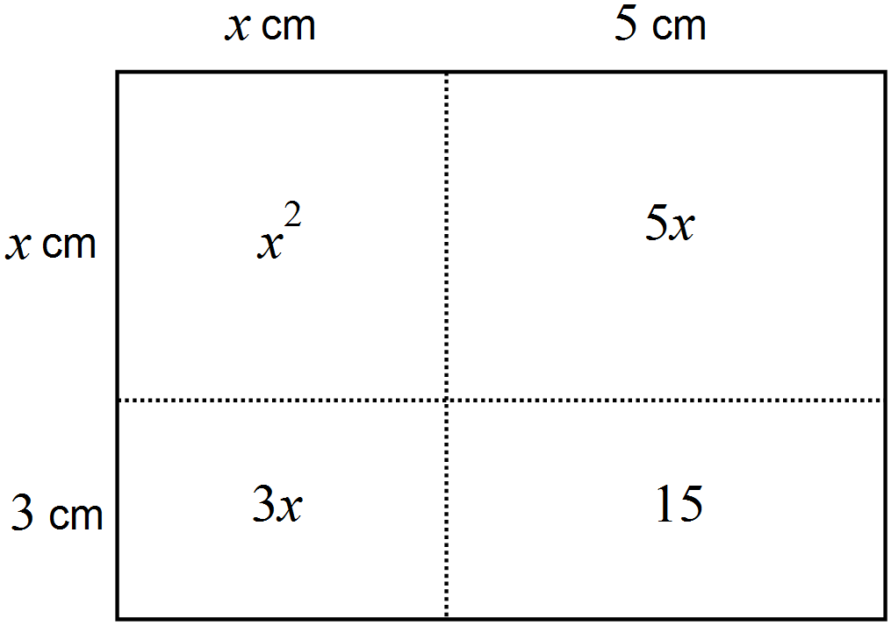  This means that the expression for the area (in cm²) would be $x^{2}+5x+3x+15$, which simplifies to $x^{2}+8x+15$.  Model a number of different methods for expanding the brackets of the expression $\left(x+4\right)\left(x+2\right)$.  For example:  - a grid approach, similar to the area model above:  - multiplying each term in the first bracket by each term in the second bracket:  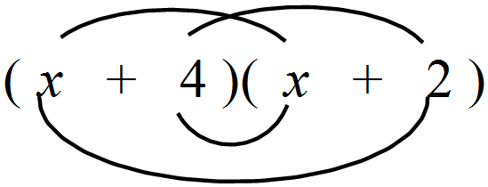  - splitting the bracket and applying the distributive law:  $\left(x+4\right)\left(x+2\right)$= $x\left(x+2\right)+4(x+2)$  Give learners some double brackets to expand. These should cover a range of situations, for example:  - $\left(x+3\right)\left(x+7\right)$  - $\left(x+9\right)\left(x-3\right)$  - $\left(x-6\right)\left(x-2\right)$  - ${\left(x+5\right)}^{2}$
   | $$x$$ | $$+4$$
  $$x$$ | $$x^{2}$$ | $$4x$$
  $$+$$  $$2$$ | $$2x$$ | $$8$$
9Ae.02 Understand how to manipulate algebraic expressions including:  - expanding the product of two algebraic expressions  - applying the laws of indices  - simplifying algebraic fractions.  TWM.02 Generalising  Recognising an underlying pattern by identifying many examples that satisfy the same mathematical criteria | Show learners the expression and its expansion below:  $$\left(x+1\right)\left(x-2\right)=x^{2}-x-2$$  Ask learners:  - Would the expansion of$\left(x-2\right)\left(x+1\right)$be the same or different? Explain your answer. (Answer: the same, the commutative law applies)  - Would the expansion of$\left(x-1\right)\left(x+2\right)$be the same or different? Explain your answer. (Answer: different, the middle term changes to be positive $x$)  - How does changing the signs to both be positive $\left(x+1\right)\left(x+2\right)$or both be negative $\left(x-1\right)\left(x-2\right)$affect the expansion?  - Does what you have noticed apply to other expansions?  Learners will show they are generalising (TWM.02) when they demonstrate what they have noticed, for example:  - The commutative law applies when the brackets are written in the opposite order, so the answer remains the same  - When both brackets are $x+$ a number, all terms in the expansion are positive  - When both brackets are $x-$ a number, the final term is positive but the coefficient of $x$ is negative
9Ae.03 Understand that a situation can be represented either in words or as an algebraic expression, and move between the two representations (including squares, cubes and roots). | Show learners the following information:  Photographs on display in an exhibition must be placed centrally on black backing card, so that there is a 5cm border around each photograph. One photograph is square, but the dimensions of the photograph are not known. If $x$ represents the length of each side of the photograph, write an expression for the area of the backing card in terms of$x$.  This activity can be extended by giving learners information about other photographs of different shapes, for example:  Another photograph is rectangular. Its width is double its length. If p represents the width of the photograph write an expression for the area of the backing card in terms of p. | Encourage learners to draw a diagram of the photograph with its backing card, showing the sides in terms of x.  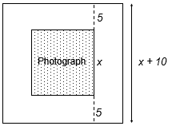  Their expression for the area of the card could be$\left(x+10\right)\left(x+10\right)$, ${\left(x+10\right)}^{2}$or if expanded$x^{2}+20x+100$.
9Ae.04 Understand that a situation can be represented either in words or as a formula (including squares and cubes), and manipulate using knowledge of inverse operations to change the subject of a formula. | Show learners the following information:  A paper manufacturer uses a formula to determine the quality of the different paper it sells. The Quality Index (Q) of paper is dependent on its weight (w in grams) and thickness (t in mm) and is found using the formula below:  Q = $\frac{w}{t^{2}}$  Ask learners:  What is the Quality Index of a piece of paper with weight 10 grams and thickness 0.2mm? (Answer: Q = 250)  What is the weight of a piece of paper with thickness 0.1mm and Quality Index 500? Rearrange the formula to make w the subject. (Answer: w = 5, w = Qt²)  What is the thickness of a piece of paper with weight 5 grams and Quality Index 125? Rearrange the formula to make t the subject. (Answer: t = 0.2, $t=\sqrt{\frac{w}{Q}}$)

Unit 9.2 Topic 2 Linear and simultaneous equations

Outline of topic:
Learners will be able to solve problems making use of their knowledge of linear and simultaneous equations. Learners will explore the different approaches to solving simultaneous equations and identify advantages and disadvantages of each method.

Language:
Key vocabulary:
equation, simultaneous equation
formula
eliminate
variable
substitute

Key phrases:
Solve simultaneously by eliminating the variable …

Recommended prior knowledge:
- Solve simple equations with integer coefficients
- Substitute into expressions and formulae
- Recognise that equations of the form y = mx + c correspond to straight-line graphs, where m is the gradient and c is the y-intercept (integer values of m)

Learning objectives | Suggested teaching activities and resources | Mental strategies, possible misconceptions and comments
9Ae.05 Understand that a situation can be represented either in words or as an equation. Move between the two representations and solve the equation (including those with an unknown in the denominator). | Show learners the following information:    The wheel from a child’s bicycle has n spokes. The total length of wire used to make the spokes is 1000cm. The equation used to determine the number of spokes is below:  $$\frac{1000}{n}=25$$  Ask learners:  What does the number 25 represent in this equation? (Answer: the length of each spoke, or approximate radius of the wheel in centimetres)  How many spokes are there? (Answer: $n$ = 40)  Ask learners if they can create an equation to find the angles between each spoke if there are 32 spokes on the wheel and they are equally spaced. (Answer:$\frac{360}{a}= 32$ or $\frac{360}{32}= a$, so the angle is 11.25°)  For similar questions, use the NRICH short problems: Equations and Formulae (https://nrich.maths.org/9331).  Resources:  NRICH task
9Ae.06 Understand that the solution of simultaneous linear equations:  - is the pair of values that satisfy both equations  - can be found algebraically (eliminating one variable)  - can be found graphically (point of intersection).  TWM.07 Critiquing  Comparing and evaluating mathematical ideas, representations or solutions to identify advantages and disadvantages | Show learners the following information:  Anastasia is $x$ years old and her younger brother Mike is $y$ years old. Anastasia and Mike have a combined total age of 15 years.  Ask learners:  Write an equation to represent the situation. (Answer:$x+y=15$)  Can you solve this equation?  Learners should notice there is more than one possible solution to this equation, for example $x=14$ and$y=1$, or $x=9$ and$y=6$, etc. Ask learners to write all possible integer solutions.  Then inform learners that the difference in the children’s ages is 7 years, and that this can be shown by the equation$x-y=7$. Learners should list some possible ages for the children based on this information, e.g. $x=8$ and$y=1$, or $x=9$ and$y=2$, etc.  Ask learners:  Is it possible to find the ages of Anastasia and Mike now?  Learners should notice that there is now only one pair of solutions for $x$ and $y$ that satisfy both equations, $x=11$ and $y=4$, so Anastasia is 11 years old and Mike is 4 years old.  Explain to learners that$x+y=15$ and $x-y=7$are simultaneous equations and the solution is the pair of values that satisfy both equations.  Demonstrate to learners how to solve the simultaneous equations algebraically and how to solve the simultaneous equations graphically.  Ask learners:  How could you check your solution?  Encourage learners to discuss the different methods and when they might be useful. Learners will show they are critiquing (TWM.07) when they can identify advantages and disadvantages of each method, for example, noticing the graphical solution gives a visual representation of the problem, but may only give approximate solutions if the point of intersection is not on an integer coordinate.  Give learners several more pairs of simultaneous equations to solve. Encourage learners to solve the simultaneous equations both algebraically and graphically and to check their solutions using substitution. | Solving algebraically example:  $x+y=15$  $$x-y=7$$  Subtracting to eliminate $x$gives:  $$2y=8$$  $$y=4$$  Substituting the value $y=4$ gives:  $x+y=15$  $x+4=15$  $x=11$  Solving graphically example:  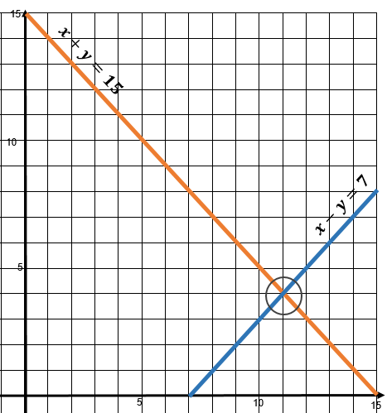  The point of intersection (11, 4) shows the solution is$x=11$,$y=4$.

Unit 9.2 Topic 3 Inequalities and upper and lower limits

Outline of topic:
Learners will appreciate that for any measure, there is a level of accuracy, defined by its upper and lower limits. Learners will also develop a greater understanding of inequalities and how they can be correctly applied to different contexts.

Language:
Key vocabulary:
upper and lower limits
rounding
greater than, less than
inequality

Recommended prior knowledge:
- Round numbers to different degrees of accuracy (e.g. to 2 decimal places)
- Use and interpret the symbols <, ≤, > and ≥

Learning objectives | Suggested teaching activities and resources | Mental strategies, possible misconceptions and comments
9Np.02 Understand that when a number is rounded there are upper and lower limits for the original number. | Show learners the following information:  A machine cuts pieces of wood, which are used to make furniture. To make sure the pieces fit together, each piece of wood must have length 160cm, when rounded to the nearest centimetre.  Ask learners:  What is the shortest and longest acceptable length of a piece of wood? (Answer: the length of wood must be between 159.5cm (including) and 160.5cm (excluding))  Explain to learners that these are the upper and lower limits for the length of each piece of wood and can be written using inequality notation:  159.5cm ≤ $l$ < 160.5cm  Ask learners:  Why is the symbol ≤ used for the lower limit and < used for the upper limit?  Ask learners, in pairs, to think of other areas of manufacture where there might be upper and lower limits for quality assurance. They should create their own situations and then swap with a partner to find the upper and lower limits.
9Ae.07 Understand that a situation can be represented either in words or as an inequality. Move between the two representations and solve linear inequalities. | Ask learners to discuss in pairs solving inequalities, with the unknown on one side and no multiplying or dividing by negative numbers required, such as:  $$3x>6$$  $$x-5≥2$$  $$2x+3<11$$  Learners should then draw their solutions on number lines.  Ask learners:  How can you check your values for $x$?  How was solving these inequalities similar to solving equations?  Then introduce learners to solving more difficult inequalities where the unknown appears on both sides. Also use examples with negative coefficients, such as:  $$3x+1 > 4x – 2$$  $$3x – 4x > -2 -1$$  $$-x > -3$$  $$x < 3$$  Encourage learners to consider why the final step of the calculation is correct and why the inequality sign appears to flip. Use diagrams to show this is a consequence of the symmetry of the number line. For example:  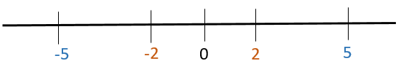  $$-5<-2$$  $$5>2$$  Provide learners with further examples of inequalities where the unknown appears on both sides and examples with negative coefficients. In pairs, learners should discuss and solve the questions. | Encourage learners to use substitution to check their solutions. For example:  if $x = 2 (<3)$  $$3×2+1>4×2-2$$  $$6 + 1 > 8 – 2$$  $7 > 6$ (true)  if $x = 3$  $$3×3+1>4×3-2$$  $$9 + 1 > 12 – 2$$  $10 > 10$ (false)
9Ae.07 Understand that a situation can be represented either in words or as an inequality. Move between the two representations and solve linear inequalities. | Show learners the following information:  Lily wants to give her two children some money. She wants to give her son, Youssef, $3 more than his younger sister, Eva. Lily wants to spend at most $20 a week on her children’s money altogether.  Ask learners to write an inequality to represent the problem. If learners need support, tell them that $x$ represents how many dollars pocket money Eva receives. Learners should then form an expression for Youssef’s pocket money, $x+3$, and form an inequality using the sum of both expressions:  $$x+x+3≤20$$  $$2x+3≤20$$  Then ask learners:  What is the maximum amount of pocket money Lily could give Youssef and Eva?  Learners should solve the inequality to find$x≤\$8.50$, so Eva could receive up to $8.50 and Youssef up to $11.50. | Encourage learners to use the correct language to describe the inequalities. For example, ‘more than’ means that the amount itself is not included, etc.

Unit 9.3 Shape and measure

Learning objectives covered in Unit 9.3 and topic summary: |  | 9.3 Topic 1  2D shapes and measure | 9.3 Topic 2  3D shapes | 9.3 Topic 3  Pythagoras’ theorem | Thinking and Working Mathematically
9Gg.01 | Know and use the formulae for the area and circumference of a circle. |  |  |  | TWM.07 Critiquing  TWM.08 Improving
9Gg.02 | Know and recognise very small or very large units of length, capacity and mass.
9Gg.03 | Estimate and calculate areas of compound 2D shapes made from rectangles, triangles and circles.
9Gg.04 | Use knowledge of area and volume to derive the formula for the volume of prisms and cylinders. Use the formula to calculate the volume of prisms and cylinders.
9Gg.05 | Use knowledge of area, and properties of cubes, cuboids, triangular prisms, pyramids and cylinders to calculate their surface area.
9Gg.06 | Identify reflective symmetry in 3D shapes.
9Gg.10 | Know and use Pythagoras’ theorem. |  |  |  | TWM.01 Specialising  TWM.02 Generalising

Unit 9.3 Topic 1 2D shapes and measure

Outline of topic:
Learners will be introduced to very small and very large units of length, capacity and mass. They will understand and apply the formula for the area of a circle and solve problems involving the areas of partial and compound shapes.

Language:
Key vocabulary:
circumference, radius, diameter
semi-circle
compound shapes
formula
measure, prefixes
capacity, volume
estimate

Recommended prior knowledge:
- Know and use the formula for the circumference of a circle and understand π as the ratio between a circumference and a diameter
- Use formulae to calculate the area of triangles and compound shapes made from rectangles and triangles
- Use a formula for the volume of a cube or cuboid

Learning objectives | Suggested teaching activities and resources | Mental strategies, possible misconceptions and comments
9Gg.02 Know and recognise very small or very large units of length, capacity and mass. | Explain that since gold is incredibly malleable, it can be beaten into very thin sheets. A typical sheet of gold leaf has a thickness of 0.1 micrometres.  Ask learners:  Can you estimate how many sheets of gold leaf would give the same thickness as a piece of 1mm thick writing paper?  Then tell learners that 1 metre is equivalent to 1 000 000 micrometres.  Ask learners:  Can you calculate how many sheets of gold leaf would give the same thickness as a piece of 1mm thick writing paper? (Answer: 10 000)  Introduce learners to different prefixes for very small measures and their equivalents, for example:  Inform learners that the Kariba Dam, between Zambia and Zimbabwe, forms Lake Kariba and holds 185 teralitres of water.  Then give learners the dimensions of a local swimming pool (e.g. 25m x 10m with an average depth of 1.5m) and ask them to find its capacity. Ask learners to calculate how many litres of water are required to fill the swimming pool (375 000 litres will be required; there are 1000 litres in 1m³).  Ask learners:  Can you estimate how many swimming pools of water would be required to fill Lake Kariba?  Then tell learners that 1 teralitre is equivalent to 1 000 000 000 000 litres.  Ask learners:  Can you calculate how many swimming pools of water would be required to fill Lake Kariba? (Answer: 185 000 000 000 000 ÷ 375 000 = 493 333 333; approximately 490 million)  Introduce learners to different prefixes for very large measures and their equivalents, e.g.  This task can be extended by asking learners to choose other known very small or very large objects (e.g. the height of a skyscraper, the mass of a grain of sand) and use prefixes from the tables above to write the measurements. | Care should be taken when converting cubic measures: e.g. 1km = 1000m,  yet 1km³ = 1 000 000 000m³.  You could demonstrate this using a simpler case, e.g. 1cm³ = 1000mm³.  Possible misconceptions:  Learners often confuse capacity and volume (capacity – the amount a container can hold usually measured in litres or millilitres; volume -the measure of space taken up by something usually measure in cm³ or m³).
  Prefix | Symbol | Factor | Example:
  milli | m | One thousandth | 1000ml = 1l  One thousand millilitres is equivalent to one litre
  micro | μ | One millionth | 1 000 000μg = 1g  One million micrograms is equivalent to 1 gram
  nano | n | One billionth | 1 000 000 000nm = 1m  One billion nanometres is equivalent to 1 metre
  …
  Prefix | Symbol | Factor | Example:
  Mega | M | One million | 1 000 000m = 1Mm  One million metres is equivalent to one megametre
  Giga | G | One billion | 1 000 000 000g = 1Gg  One billion grams is equivalent to one gigagram
  Tera | T | One trillion | 1 000 000 000 000$l$ = 1T$l$  One trillion litres is equivalent to one teralitre
  …
9Gg.01 Know and use the formulae for the area and circumference of a circle. | Ask learners to discuss in pairs:  What is the circumference of a circle?  How can you find the circumference of a circle?  Select learners to share their ideas with the class. Learners should recall that the circumference can be found by measuring the diameter of the circle and using the formula C = πd.  Ask learners to work in pairs to discuss questions that involve manipulating the formula for the circumference of a circle, or finding the perimeter of shapes created by combining circles or part circles. For example:  A circle has circumference 46 cm. What is the diameter of the circle? What is its radius?  What is the perimeter of the shape below?  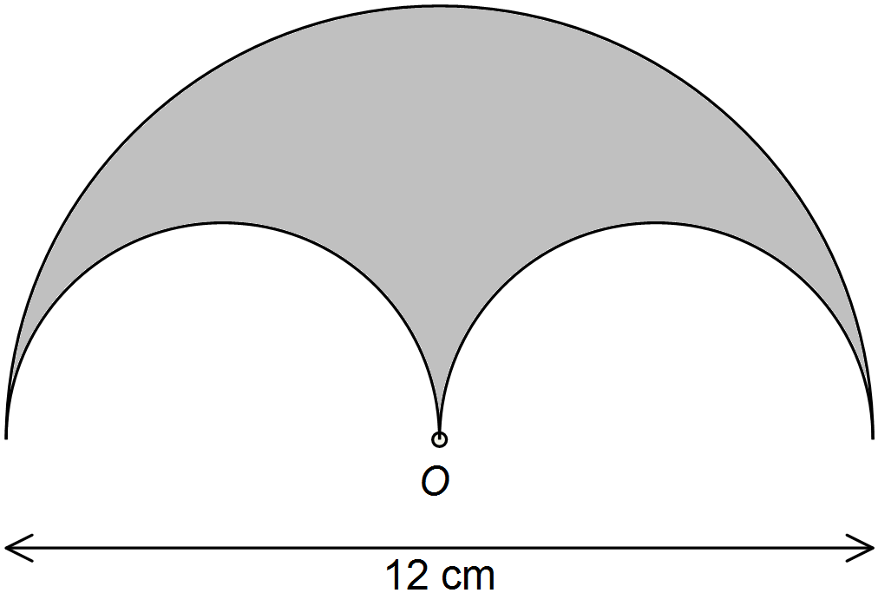  Then ask learners to draw a circle on centimetre squared paper. They should count the squares and partial squares to estimate the area of the circle.  Introduce the formula for the area of a circle: A = πr². Show learners the diagram below and explain that the area of the circle is π times larger than the square with side length of the radius.  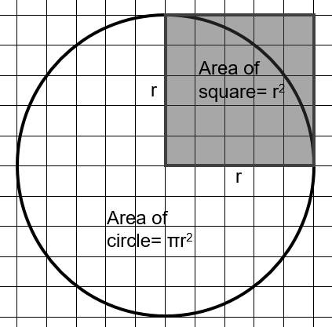  Learners should verify that their estimate for the area of their circle is approximately three times the square of the radius of their circle. Then ask learners to use the formula A = πr² to find the area of their circle.  Ask learners:  How does the calculated area compare to the counted one?  Give learners further problems involving finding the areas of circles and shapes created by combining circles.  Resources:  Centimetre squared paper | Remind learners that pi taken as 3.14 is an approximation. As far as possible, the use of π (its exact value) in calculations should be maintained, with rounding only taking place at the very end of a calculation or problem.
9Gg.01 Know and use the formulae for the area and circumference of a circle.  TWM.07 Critiquing  Comparing and evaluating mathematical ideas, representations or solutions to identify advantages and disadvantages  TWM.08 Improving  Refining mathematical ideas or representations to develop a more effective approach or solution | Show learners the following information:  Naomi wants to find the area of the pattern below. The pattern is made from four identical semi-circles.  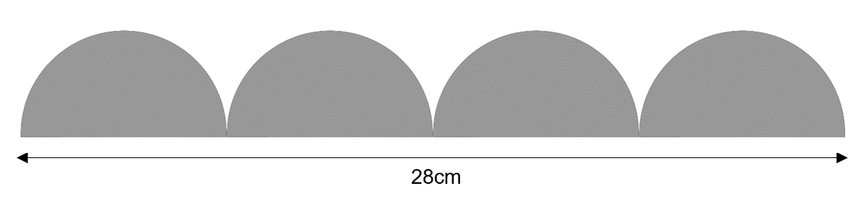  Here is Naomi’s solution:  28 ÷ 4 = 7cm  7 ÷ 2 = 3.5cm  π × 3.5² = 38cm²  38 ÷ 2 = 19cm²  19 × 4 = 76cm²  Ask learners:  - Is Naomi’s solution correct? Explain each step in Naomi’s method.  - Could Naomi have found the solution using a different method? Try to improve Naomi’s solution.  Learners will show they are critiquing (TWM.07) when they evaluate Naomi’s method and understand her reasoning at each step. They will show they are improving (TWM.08) when they can identify disadvantages to Naomi’s approach and refine her method. For example, they may notice that Naomi’s answer is not accurate, as she has rounded her answer too soon. Or they may notice that her calculations can be made more efficient, such as dividing by 8 in the first step, rather than dividing by 4 and then dividing by 2. | Remind learners that pi taken as 3.14 is an approximation. As far as possible, the use of π (its exact value) in calculations should be maintained, with rounding only taking place at the very end of a calculation or problem.

Learning objectives | Suggested teaching activities and resources | Mental strategies, possible misconceptions and comments
9Gg.03 Estimate and calculate areas of compound 2D shapes made from rectangles, triangles and circles. | Tell learners that they are going to investigate designs for a logo that are made using geometric shapes. Each logo design has to fit inside a 12cm sided square frame and have a central square measuring 6cm by 6cm, as shown below:  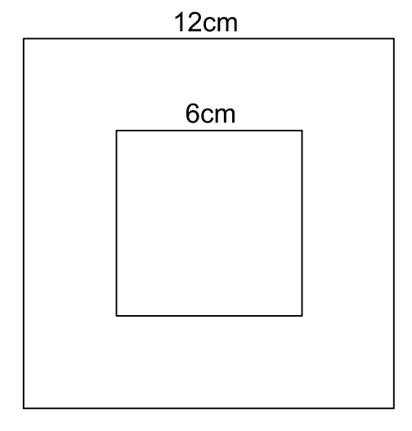  Show learners the following designs and ask them to estimate and calculate the area of each one:  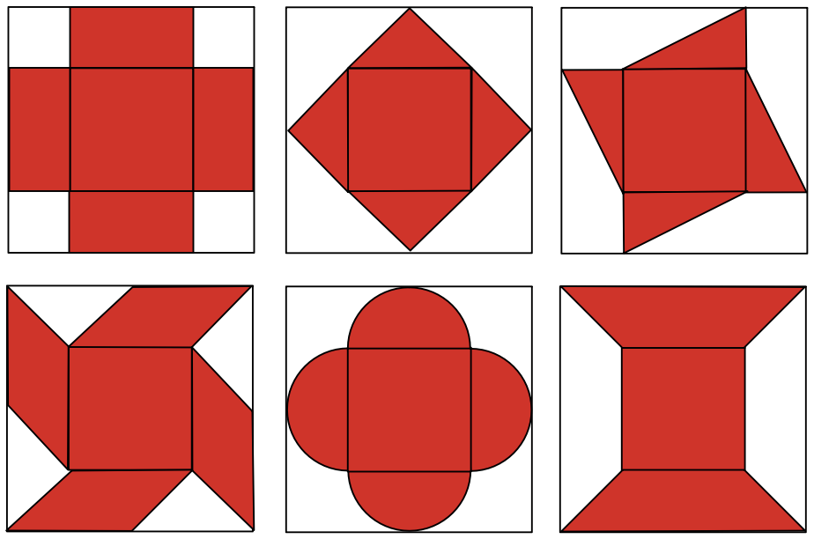  Then ask learners to design their own logos. Learners should record the dimensions and estimate and calculate the area of each design.  Resources:  Centimetre squared paper | Whilst there are additional shapes (e.g. parallelogram and trapezium) in this activity, learners should be able to recognise that they are formed of triangles. For support, encourage learners to copy the designs onto centimetre squared paper, as learners will find it easier to identify triangles and calculate these areas by counting squares and half squares. The formulas for areas of a parallelogram and trapezium, however, can be introduced.

Unit 9.3 Topic 2 3D shapes

Outline of topic:
Learners will develop their understanding of calculating the volume and surface area of 3D shapes and will identify plane symmetry of 3D shapes. They will apply their knowledge of volume and surface area to design and production situations.

Language:
Key vocabulary:
dimensions
cross-section, prism
volume, surface area
net
plane of symmetry

Recommended prior knowledge:
- Use knowledge of area, and properties of cubes and cuboids to calculate their surface area
- Use a formula for the volume of a cube or cuboid

Learning objectives | Suggested teaching activities and resources | Mental strategies, possible misconceptions and comments
9Gg.04 Use knowledge of area and volume to derive the formula for the volume of prisms and cylinders. Use the formula to calculate the volume of prisms and cylinders. | In pairs, learners discuss how to find the volume of prisms, such as:  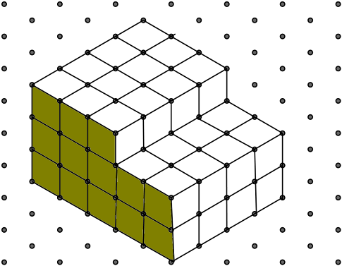  Discuss strategies which may include dividing the compound shapes into cuboids. Show that the volumes can be found by finding the area of the cross-section and then multiplying by the length of the prism:  volume of prism = area of cross section × length  In pairs, learners discuss applying the formula for the volume of a prism to find the volumes or missing side lengths of a range of prisms, for example:  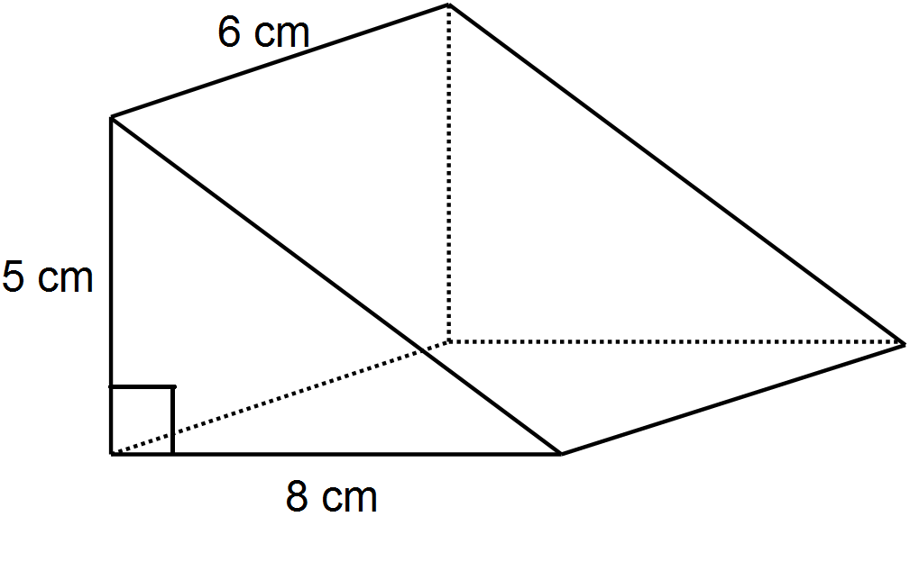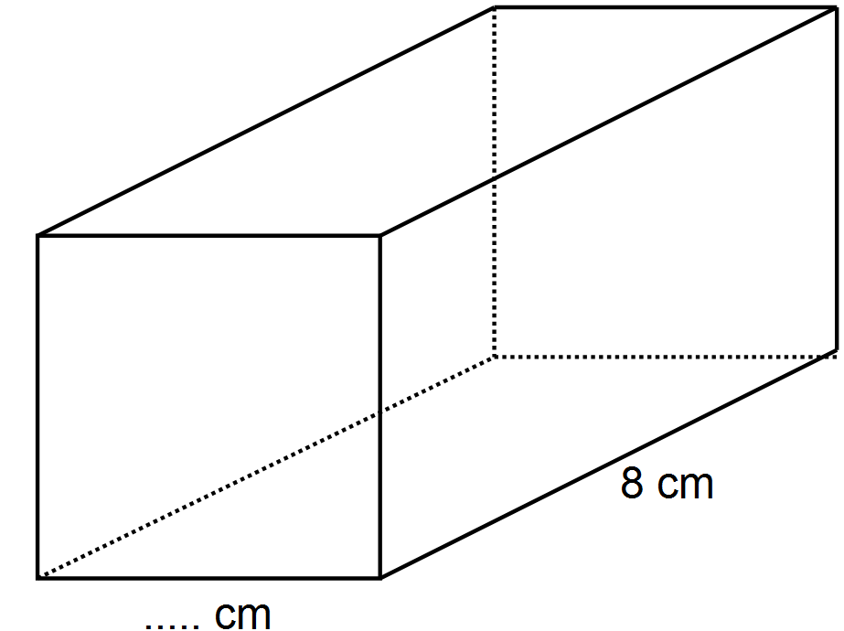  Square cross section  Volume = 200cm³  Volume = ……cm³  Then, in small groups, learners discuss how the volume of a cylinder could be calculated, for example:  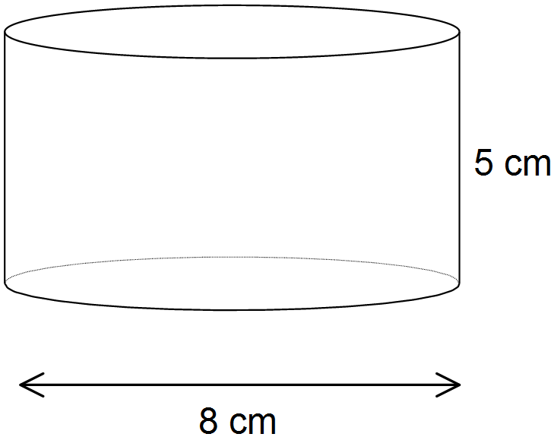  Discuss as a class, making links with the volumes of prisms. Establish the formula for the volume of a cylinder:  V = area of cross section × height  V = πr²h  Learners solve problems such as:  A cylinder has a volume of 640cm³. It has a radius of 6.5cm. What is the height of the cylinder?
9Gg.05 Use knowledge of area, and properties of cubes, cuboids, triangular prisms, pyramids and cylinders to calculate their surface area. | Ask learners to work in pairs to discuss and solve the following problem:  Ana makes paperweights in the shape of triangular prisms.  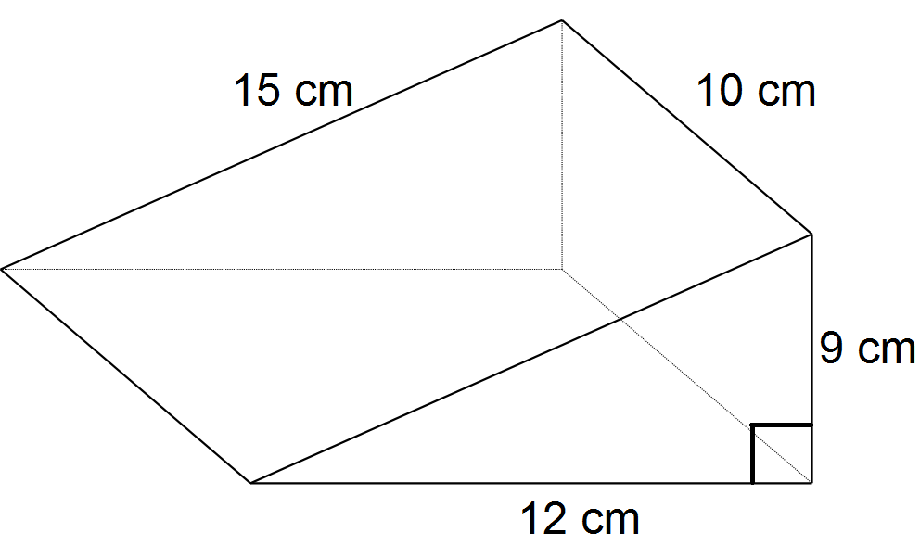  She paints each paperweight with two coats of paint. She has enough paint to cover an area of 6000cm².  How many paperweights can she paint completely?  In small groups, learners discuss how the surface area of a cylinder could be calculated, for example:  Establish that the 'unrolled' curved surface of a cylinder is a rectangle with width equal to the circumference of the cylinder's cross-section.  So, the formula for the surface area (S) of a cylinder is:  S = 2πr² + 2πrh  Ask learners solve problems such as:  The total surface area of a cylinder is 640cm². The radius of the cylinder is 7cm. What is the height of the cylinder?  This activity can be extended by asking learners to investigate the maximum volume for a prism or cylinder with a given surface area and vice versa.
9Gg.04 Use knowledge of area and volume to derive the formula for the volume of prisms and cylinders. Use the formula to calculate the volume of prisms and cylinders.  9Gg.05 Use knowledge of area, and properties of cubes, cuboids, triangular prisms, pyramids and cylinders to calculate their surface area.  9Gg.06 Identify reflective symmetry in 3D shapes. | Explain that the logos learners investigated in a previous topic (Topic 1 2D shapes and measure) are being made into pendants for a key ring:  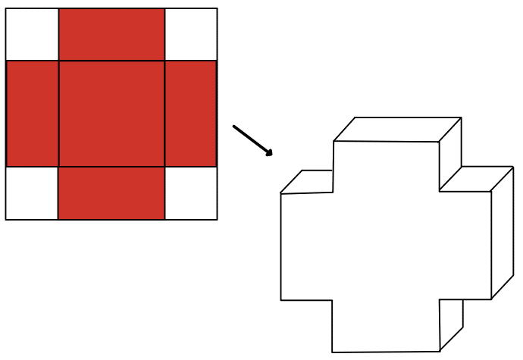  Each pendant has a thickness of 1cm and the dimensions of the cross-section (shown in red) are now halved from their original design:  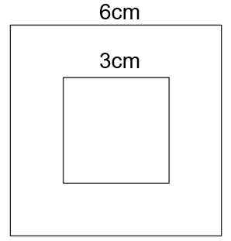  In pairs, learners should calculate the volume of the 3D pendant shape made from each logo.  Then tell learners the pendants are to be painted red and ask:  What is the total surface area that requires painting for each design?  Learners, in pairs, should calculate the surface area of the 3D pendant shape made from each logo.  Ask learners to draw the net of each 3D shape, showing relevant dimensions and identify planes of reflective symmetry in each 3D shape.  The NRICH task: Changing Areas, Changing Volumes (https://nrich.maths.org/7535) provides a challenging task, which reinforces understanding of surface area and volume.  Resources:  NRICH task | When finding the surface area of more complicated shapes, like the cross-shaped prism, that has 14 faces, drawing nets helps ensure no faces are missed during the calculations. Alternatively, learners should write each stage of their calculation, indicating which face is being calculated each time.  Learners can be supported to identify plane symmetry by asking them to imagine a mirror being sliced through the shape. For the cross shape, learners can initially focus on the front face, for which they should identify four lines of symmetry, which will translate into four planes of symmetry. Remind learners that there is also one plane of symmetry halfway along the prism’s length, perpendicular to the other planes of symmetry, as this often gets overlooked.

Unit 9.3 Topic 3 Pythagoras’ theorem

Outline of topic:
Learners will explore Pythagoras’ theorem, looking at particular cases and investigating triangles that satisfy given criteria.

Language:
Key vocabulary:
Pythagoras’ theorem
hypotenuse
right-angled

Key phrases:
The length of the hypotenuse is …

Recommended prior knowledge:
- Know various properties of triangles (e.g. angle sum)
- Find the area of a square
- Recognise square numbers and understand how to find the square and square root of a number

Learning objectives | Suggested teaching activities and resources | Mental strategies, possible misconceptions and comments
9Gg.10 Know and use Pythagoras’ theorem.  TWM.02 Generalising  Recognising an underlying pattern by identifying many examples that satisfy the same mathematical criteria | Give each pair of learners a selection of right-angled triangles with whole number side lengths with squares drawn on the sides of each triangle edge. For example:  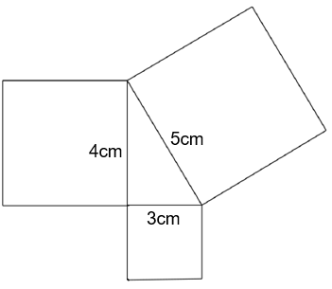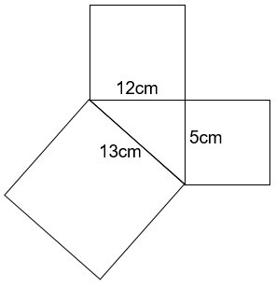  In pairs, learners investigate the areas of the squares drawn on the sides of different sizes of right-angled triangles.  Ask learners:  How will you work systematically and record your investigation?  What patterns do you notice?  Learners will show they are generalising (TWM.02) when they notice the sum of the areas of the two smaller squares is equal to the area of the larger square.  Ask learners to use their results to predict the areas of squares, for example:  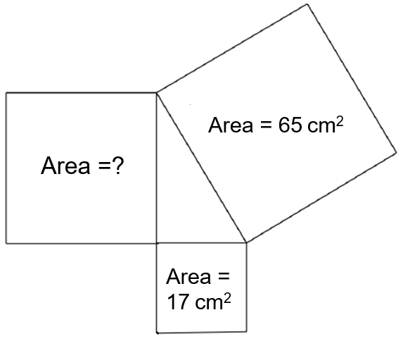  Then ask learners to find the value of x in this diagram:  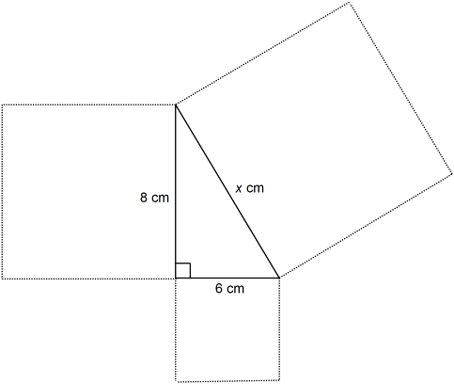  From this investigation, establish Pythagoras’ theorem:  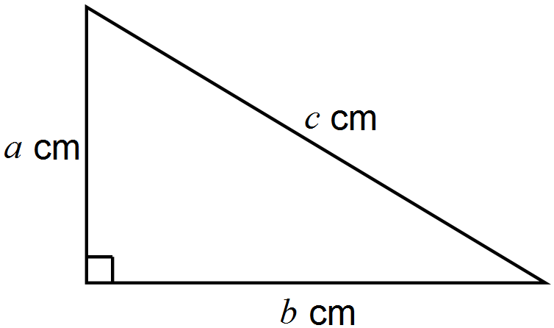  a² + b² = c²  Emphasise that the theorem only applies to right-angled triangles.  In pairs, learners find the length of missing sides of right-angled triangles in simple and then more complex examples, including word problems, such as:  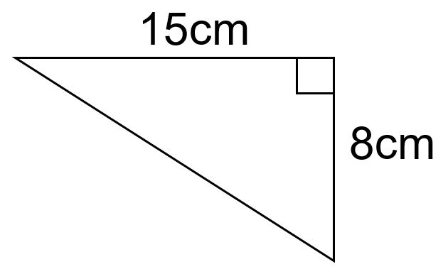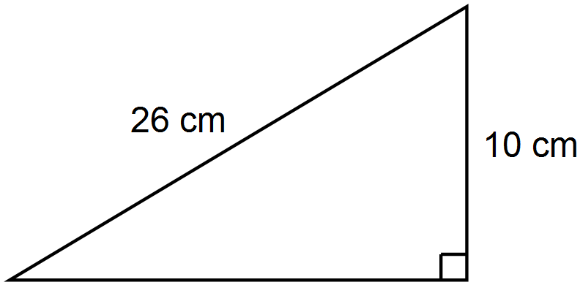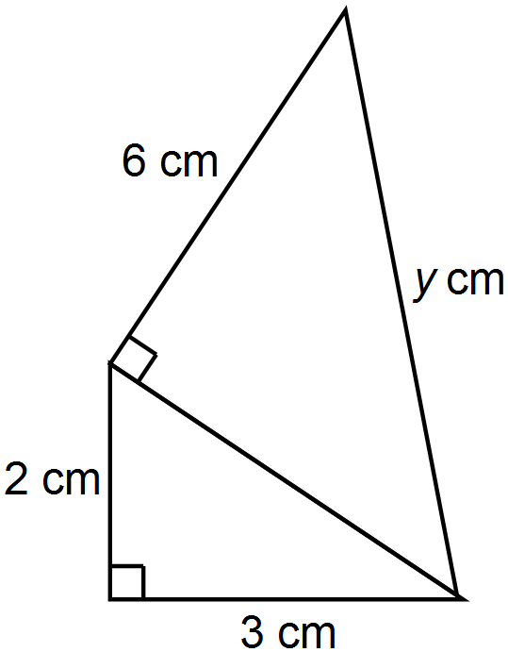  A boat sails 4km north and then 11km east. How far is the boat from the starting point? | The NRICH task: Pythagoras Proofs (https://nrich.maths.org/6553) provides three different ideas that lead to proofs of Pythagoras’ theorem.
9Gg.10 Know and use Pythagoras’ theorem.  TWM.01 Specialising  Choosing an example and checking to see if it satisfies or does not satisfy specific mathematical criteria | Show learners this right-angled triangle:  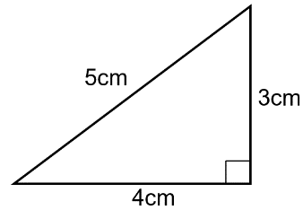  Ask learners to describe the properties of the triangle and then to verify that it is right-angled by using Pythagoras’ theorem (3² + 4² = 5² is correct).  Then ask learners to find other right-angled triangles where all three side lengths are whole numbers.  Ask learners:  Is it possible to find a right-angled triangle with whole number side lengths and also…  - …all three sides are even?  - …all three sides are odd?  - …the hypotenuse is 1 more than the next largest side?  - …the hypotenuse is 2 more than the next largest side?  Learners will show they are specialising (TWM.01) when they choose examples of triangles, check whether or not they satisfy the criteria and also verify whether or not they are right-angled by using Pythagoras’ theorem. | Possible solutions are:  - all three sides are even:  - 6cm, 8cm, 10cm  - all three sides are odd:  not possible  - the hypotenuse is 1 more than the next largest side?  - 5cm, 12cm, 13cm  - the hypotenuse is 2 more than the next largest side?  - 8cm, 15cm, 17cm

Unit 9.4 Fractions, decimals, percentages, ratio and proportion

Learning objectives covered in Unit 9.4 and topic summary: |  | 9.4 Topic 1  Calculating with fractions and decimals | 9.4 Topic 2  Percentages | 9.4 Topic 3  Ratio and proportion | Thinking and Working Mathematically
9Nf.02 | Estimate, add and subtract proper and improper fractions, and mixed numbers, using the order of operations.
9Nf.03 | Estimate, multiply and divide fractions, interpret division as a multiplicative inverse, and cancel common factors before multiplying or dividing. |  |  |  | TWM.04 Convincing
9Nf.04 | Use knowledge of the laws of arithmetic, inverse operations, equivalence and order of operations (brackets and indices) to simplify calculations containing decimals and fractions.
9Nf.05 | Understand compound percentages.
9Nf.06 | Estimate, multiply and divide decimals by integers and decimals. |  |  |  | TWM.02 Generalising
9Nf.07 | Understand the relationship between two quantities when they are in direct or inverse proportion.
9Nf.08 | Use knowledge of ratios and equivalence for a range of contexts.
9Ae.02 | Understand how to manipulate algebraic expressions including:  - expanding the product of two algebraic expressions  - applying the laws of indices  - simplifying algebraic fractions.

Unit 9.4 Topic 1 Calculating with fractions and decimals

Outline of topic:
Learners will consider different fraction and decimal calculations using the order of operations. Learners will consider the effect of multiplying and dividing by certain values, and will be able to estimate answers. Learners will understand why cancelling common factors enables them to be more efficient with calculations.

Language:
Key vocabulary:
order of operations
mixed numbers
proper and improper fractions
scientific calculators
estimate, estimation
simplify

Key phrases:
Cancelling common factors

Recommended prior knowledge:
- Use the four operations with different types of fractions
- Know the order of operations
- Simplify fractions

Learning objectives | Suggested teaching activities and resources | Mental strategies, possible misconceptions and comments
9Nf.02 Estimate, add and subtract proper and improper fractions, and mixed numbers, using the order of operations. | In pairs, ask learners to look at the two questions and discuss how the answers might be different:  $$1\frac{7}{10}-\frac{4}{5}+\frac{3}{4}$$  $$1\frac{7}{10}-\left(\frac{4}{5}+\frac{3}{4}\right)$$  Ask learners:  Which answer do you think will be bigger? Why?  Can you estimate what the answers will be? Will they be less than 1 or greater than 1? Why?  Learners should now calculate the solutions. Ask them to use calculators to check their answers.  This activity can be extended by asking learners to change one fraction in either of the calculations (e.g. change $\frac{4}{5}$ to $\frac{6}{5}$) and then estimate what will happen to the answer i.e. whether it will be bigger, smaller, negative etc. They can then check their answers using calculators. | Possible misconceptions:  Learners sometimes assume that addition must come before subtraction in the order of operations. This is not the case. Addition and subtraction must be done in the order they are written (left to right), as in the first question shown opposite.  Ensure learners know how to use the functions for fractions, including mixed numbers, on their scientific calculators.
9Nf.03 Estimate, multiply and divide fractions, interpret division as a multiplicative inverse, and cancel common factors before multiplying or dividing.  TWM.04 Convincing  Presenting evidence to justify or challenge a mathematical idea or solution | Ask learners:  Is 5 ÷ 2 the same as 5 x $\frac{1}{2}$? Explain your answer.  What about 9 ÷ 3 and 9 x $\frac{1}{3}$?  Can you write other equivalent calculations that follow this pattern? (e.g. tenths)  Establish the ‘division as a multiplicative inverse’ rule.  Ask learners:  What is half of one half?  Ask learners if they can write this in different ways (e.g. $\frac{1}{2}$ ÷ 2 and $\frac{1}{2}$ x $\frac{1}{2}$).  Learners will show that they are convincing (TWM.04) when they reason that any division can be interpreted as multiplying by the reciprocal.  As a class, explore the question:  $$\frac{3}{5} \frac{1}{5}$$  Can this be written as a multiplication?  Learners should understand that finding how many fifths are in a number is equivalent to multiplying the number by 5 (since there are five fifths in one whole).  $$\frac{3}{5} × \frac{5}{1}$$  At this stage, cancelling common factors can also be introduced:  $$\frac{3}{5×1} × \frac{5×1}{1}$$  Give learners a selection of multiplication and division questions, where common factors can be cancelled. Remind learners to change any division questions into equivalent multiplications first before calculating. | Possible misconceptions:  Learners often incorrectly think that 3 ÷ $\frac{1}{4}$ is equivalent to 3 ÷ 4 to find $\frac{3}{4}$ and think that 5 ÷ $\frac{1}{2}$ is equivalent to $\frac{1}{2}$ of 5. This activity will challenge any misconceptions in this particular area of fractional calculation.
9Ae.02 Understand how to manipulate algebraic expressions including:  - expanding the product of two algebraic expressions  - applying the laws of indices  - simplifying algebraic fractions. | Show learners this solution:  $$\frac{3a}{15a^{2}}= \frac{3×1 × a}{3×5×a×a}= \frac{1}{5a}$$  In pairs, learners should discuss how cancelling common factors helps when simplifying fractional questions and answers.  Ask learners to simplify further algebraic fractions such as$\frac{12a^{2}}{18ab}$ by cancelling common factors. | When simplifying, ensure learners have found the simplest form each time.
9Nf.04 Use knowledge of the laws of arithmetic, inverse operations, equivalence and order of operations (brackets and indices) to simplify calculations containing decimals and fractions. | Show learners this calculation:  ${\left(\frac{1}{4}+3.75\right)}^{2}$– 4 = 12  Ask learners to use only mental strategies to solve the calculation, and explain what strategies they used to calculate their answer.  Ask learners to design similar questions, with a mixture of fractions and decimals. Design some questions so that the laws of arithmetic help simplify the calculation, for example:  $$5.61+1.72+\frac{39}{100}$$  Learners swap their questions with their partners to see how they would solve them. They should agree on the most efficient method. | Mental strategies:  Encourage learners to use mental strategies where appropriate and consider whether the laws of arithmetic (associative law, commutative law and distributive law) could help them calculate the answer more efficiently.
9Nf.06 Estimate, multiply and divide decimals by integers and decimals.  TWM.02 Generalising  Recognising an underlying pattern by identifying many examples that satisfy the same mathematical criteria | Show learners these four questions and ask them to predict which will have answers smaller than 0.5 and which will have answers greater than 0.5.  0.5 × 2.5 0.5 × 0.25  0.5 ÷ 2.5 0.5 ÷ 0.25  Then ask learners to arrange the four questions from smallest to largest value. Ask them to use calculators to find the answers to all four calculations to see if they are correct.  Ask learners:  Did any of the answers surprise you? Why? Why not?  Then ask learners to create four decimal calculation questions, similar to above, and repeat the activity.  Learners will show they are generalising (TWM.02) when they begin to recognise the effects of multiplying and dividing a number by a decimal and are able to explain their answers to the following questions:  - What happens when you multiply a number by a decimal greater than 1?  - What happens when you divide a number by a decimal greater than 1?  - What happens when you multiply a number by a decimal between 0 and 1?  - What happens when you divide a number by a decimal between 0 and 1?  This activity can be extended by asking learners to also consider multiplying and dividing by decimals between 0 and -1, and by decimals smaller than -1.

Unit 9.4 Topic 2 Percentages

Outline of topic:
Learners will use compound percentages in the real-life context of money related to saving and interest, making comparisons between different types of bank accounts.

Language:
Key vocabulary:
compound percentage
simple interest, compound interest
annual

Recommended prior knowledge:
- Finding percentage increase

Learning objectives | Suggested teaching activities and resources | Mental strategies, possible misconceptions and comments
9Nf.05 Understand compound percentages. | Show learners the following problem:  $2000 will be saved in two bank accounts for a period of 5 years.  Bank A offers an annual simple interest rate of 3%.  Bank B offers a compound interest rate of 2.5%.  Which account gives the most interest at the end of the 5-year period?  (Answer: Bank A earns $£300, Bank B earns $262.82)  Then show learners the additional information:  After the first 5 years, the saver decides to leave the money, with its earned interest, in the accounts for an extra 45 years.  Will Bank A still earn more?  (Answer: Bank A will earn a total of £60 × 50 years = $3000 interest. Bank B will earn a total of ($2000 x 1.025⁵⁰) - $2000 = $4874.22 interest.)  Learners should appreciate the benefits of compound interest when the period of time is increased, due to the accumulating effect of interest being earned on the interest.  Ask learners to explore other situations, such as what would happen if you wanted to invest $60 and both banks offered the same rate of 3% over a period of 100 years, one with simple interest and one with compound interest. | Before starting this activity, ensure learners understand the difference between simple and compound interest.  Simple interest - the amount of interest is fixed over a period of time. For example if you were to save $200 at 3% simple interest you would earn $6 per year, every year.  Compound interest - interest earned over time will continue to increase as long as no money is withdrawn from the bank account. For example, if you were to save $200 at 3% compound interest you would earn $6 in the first year, in the second year you would earn 3% of $206 = £6.18 etc.

Unit 9.4 Topic 3 Ratio and proportion

Outline of topic:
Learners will explore real-life situations involving ratio and proportion. Learners will explore ratios in patterns and geometric designs.

Language:
Key vocabulary:
directly proportional, direct proportion
inversely proportional, inverse proportion
ratio
unitary form

Key phrases:
Divide in a given ratio
Express the ratio in the form 1:n

Recommended prior knowledge:
- Understand and use the relationship between ratio and direct proportion
- Divide an amount into a given ratio with two or more parts

Learning objectives | Suggested teaching activities and resources | Mental strategies, possible misconceptions and comments
9Nf.07 Understand the relationship between two quantities when they are in direct or inverse proportion. | Show learners the following information:  The Forth Bridge is approximately 2.5km long. It was once believed that the bridge’s steel structure took so long to paint, that as soon as the painting was finished, the cycle of painting needed to be started again.  Tell learners that a smaller, 500 metre long bridge took a team of 10 people 150 days to paint.  Ask learners:  How long would it take a team of 10 people to paint the Forth Bridge? (Answer: 5 × 150 = 750 days = 2 years and 20 days)  As the Forth Bridge is 5 times longer than the smaller bridge, they should make the assumption that it will take 5 times longer to paint. Establish that the length of the bridge and the time taken to paint the bridge are in direct proportion.  Show learners how to model the situation using a double number line:  Then ask learners:  If 20 people were employed instead of 10, how many days would it take to paint the smaller bridge? (Answer: 150 ÷ 2 = 75 days)  How long would it take if there were just 2 painters painting the Forth Bridge? (Answer: 750 × 5 = 3750 days, which is over 10 years)  Establish that these are examples of inverse proportionality, as learners should make the assumption that doubling the number of painters will halve the time it takes and vice versa.  Ask learners further questions where the bridge length, the number of painters or the number of days taken to paint the bridge varies. For example:  - How many days would it take 50 painters to paint the Forth Bridge?  - How many people would be needed to paint the Forth Bridge in less than a year?  - Another bridge is a third of the length of the Forth Bridge. How many people would be needed to paint this bridge in 750 days?
9Nf.08 Use knowledge of ratios and equivalence for a range of contexts. | An architect wishes to design a building façade so that different shades of brick are used. The shades are labelled A, B and C and the ratio of their quantities in the design are 2: 2.5: 3.5.  Ask learners:  - Can this ratio be written in any other way? (Answer: for example, in unitary form 1: 1.25: 1.75 or by making the ratios whole numbers 4: 5: 7)  - If 320 000 bricks are ordered. How many of each type of brick are needed?  - If the architect wants to use 139 230 bricks of shade C, how many of shade A and B should they use?  The architect is considering geometric designs for the windows. They consider the following polygons for this:  A right-angled triangle can be drawn with angles 30°, 60° and 90°. The angles are in the ratio of 1: 2: 3.  Ask learners:  Is it possible to draw a quadrilateral with angles in the ratio 1: 2: 3: 4?  What are the sizes of the angles in this quadrilateral? (Answer: 36°, 72°, 108°, 144°)  Draw a quadrilateral with these angles. What type of quadrilateral is it? (Answer: trapezium)  Then ask learners to explore whether it is possible to draw a pentagon with angles in the ratio 1: 2: 3: 4: 5. Learners should discover that the largest angle in this case is 180°. Ask learners to share their ideas with the rest of the class.  Ask learners to create other window designs in the shape of polygons and to write the ratio of the angles for each design. They should write the ratio in its simplest form and in unitary form 1: …  For more questions involving ratio, use the NRICH task: Ratio, Proportion and Rates of Change https://nrich.maths.org/9256).  Resources:  NRICH task

Unit 9.5 Probability

Learning objectives covered in Unit 9.5 and topic summary: |  | 9.5 Topic 1  Mutually exclusive and combined events | 9.5 Topic 2  Expected frequency | Thinking and Working Mathematically
9Sp.01 | Understand that the probability of multiple mutually exclusive events can be found by summation and all mutually exclusive events have a total probability of 1.
9Sp.02 | Identify when successive and combined events are independent and when they are not.
9Sp.03 | Understand how to find the theoretical probabilities of combined events. |  |  | TWM.07 Critiquing
9Sp.04 | Design and conduct chance experiments or simulations, using small and large numbers of trials. Calculate the expected frequency of occurrences and compare with observed outcomes. |  |  | TWM.03 Conjecturing  TWM.04 Convincing

Unit 9.5 Topic 1 Mutually exclusive and combined events

Outline of topic:
Learners will understand the impact of replacement and non-replacement when working with different probability situations. Learners will draw probability trees and use them to find expected probabilities of combined events.

Language:
Key vocabulary:
mutually exclusive events
dependent events, independent events
relative frequency
theoretical probability
probability tree

Recommended prior knowledge:
- Understand that the combination of mutually exclusive events results in a probability of 1

Learning objectives | Suggested teaching activities and resources | Mental strategies, possible misconceptions and comments
9Sp.01 Understand that the probability of multiple mutually exclusive events can be found by summation and all mutually exclusive events have a total probability of 1. | Review the concept of mutually exclusive outcomes. Show a spinner:  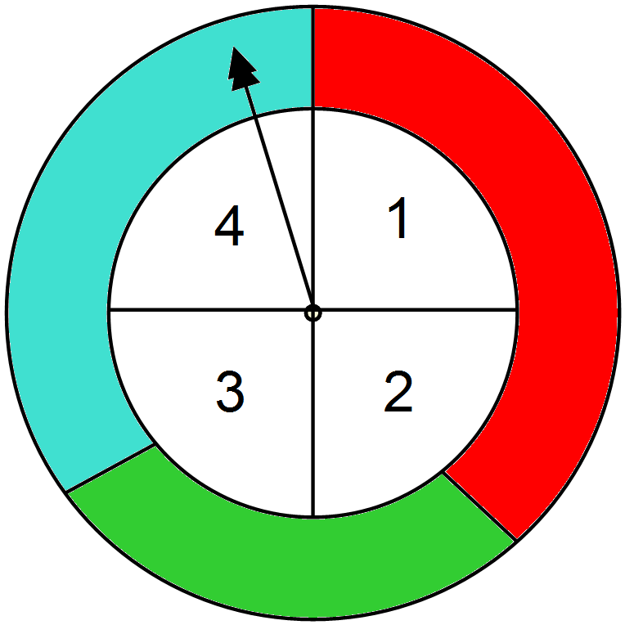  In pairs, learners list three mutually exclusive outcomes and three outcomes which are not mutually exclusive. (Getting a 1, 2, 3 or 4 on the spinner are mutually exclusive as they cannot occur at the same time. The outcomes ‘getting a red or a 1’ are not mutually exclusive as they can occur at the same time.)  In pairs, learners explore the following problem:  A spinner has four sections coloured green, red, yellow and white. The probabilities of the spinner stops on each of the sections are:  What is the probability that the spinner stops on white? Why? (Answer: 0.45, because mutually exclusive outcomes must total 1)  What is the probability that the spinner stops on green or red? (Answer: 0.3, because the probability of multiple mutually exclusive events can be found by summation)  What is the probability that the spinner does not stop on white? (Answer: 0.55)  Then ask learners to work individually to explore further problems, before comparing their answers with a partner. For example:  A bag contains balls that are either red or green or blue. The probabilities of choosing a ball of each colour are:  Find the value of x.  What is the probability that the ball is not green?
  Colour | green | red | yellow | white
  Probability | 0.2 | 0.1 | 0.25
  Colour | red | green | blue
  Probability | x | 2x | x + 0.2
9Sp.02 Identify when successive and combined events are independent and when they are not. | Explain to learners that events are ‘independent’ if the outcome of one event does not affect the outcome of the other event.  Give learners a selection of successive and combined events and ask them whether the events are independent or dependent. For example:
  Events | Independent  (the outcome of one event does not affect the outcome of the other event) | Dependent (the outcome of one event does affect the outcome of the other event)
  I throw a die and flip a coin.
  I get stopped at traffic lights and I am late to school.
  I choose a marble from a box, do not replace it and then choose a second marble from the box.
  I flip a coin and then flip the coin again.
  …
9Sp.03 Understand how to find the theoretical probabilities of combined events.  TWM.07 Critiquing  Comparing and evaluating mathematical ideas, representations or solutions to identify advantages and disadvantages | Show learners the information below:  Carlos is creating a game with a spinner and a coin.  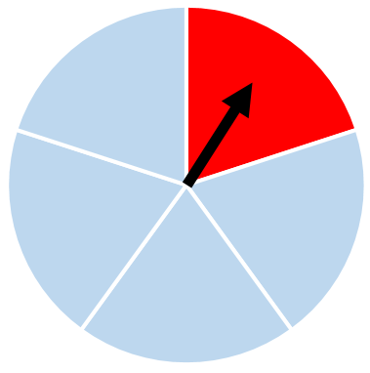  $1  He has decided that to win the game the player must flip tails on the coin and the spinner must stop on red.  Ask learners:  What is the probability that a player wins Carlos’ game?  Discuss as a class different ways to represent and solve the problem. Introduce learners to representing combined events as a tree diagram, for example:  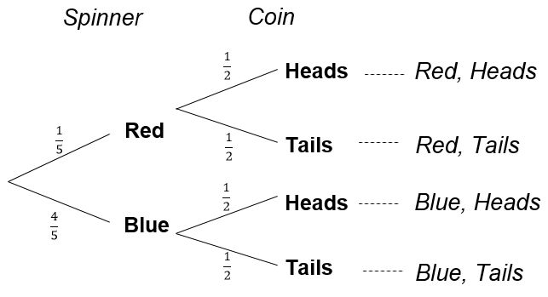  Ensure learners understand that the sums of joined branches add to 1, as these represent all mutually exclusive outcomes. To find the probability of combined events they should multiply the probabilities along the branches. For example, to calculate the probability of spinning red and flipping tails to win Carlos’ game:  $$\frac{1}{5}×\frac{1}{2}=\frac{1}{10}$$  Learners will show they are critiquing (TWM.07) when they compare the different approaches to solving probability questions.
9Sp.01 Understand that the probability of multiple mutually exclusive events can be found by summation and all mutually exclusive events have a total probability of 1.  9Sp.02 Identify when successive and combined events are independent and when they are not.  9Sp.03 Understand how to find the theoretical probabilities of combined events. | Tell learners that in a lake there are three species of fish: A, B and C. The probabilities of fish A and fish B being caught, based on the numbers of each species present in the lake, are 0.5 and 0.35 respectively.  Ask learners:  What is the probability of fish C being caught?  Then tell learners that a fisherman catches 100 fish in total and sells all the fish of species A he has caught to a local restaurant.  Ask learners:  How do you think this may affect the probability of catching each species for the next fisherman? (Answer: there will now be approximately 50 fewer fish A to catch, reducing the probability. At the same time, the probability of catching fish B and C will increase, as the total probability of all mutually exclusive events will always be equal to one.)  Tell learners that another lake has 20 fish; 8 of species A, 7 of species B and 5 of species C.  Ask learners to draw a tree diagram to show all possible outcomes where two fish are caught (and replaced) in succession.  Ask learners to find probabilities from their tree diagram such as:  What is the probability of the rarest fish being caught both times? (Answer: $\frac{5}{20}×\frac{5}{20}=\frac{25}{400}=\frac{1}{16}$ )  What is the probability of species A being caught both times?  (Answer: $\frac{8}{20}×\frac{8}{20}=\frac{64}{400}=\frac{4}{25}$ )  This task can be extended by asking learners to consider the problem above but without replacement. They should draw another tree diagram showing the probabilities of all possible outcomes where two fish are caught in succession but not replaced. | Possible misconceptions:  Learners must remember that when calculating quantities using relative frequencies, the numbers produced cannot be assumed to be exact amounts. They are estimates (hence the use of the language ‘approximately 50’ fish).

Unit 9.5 Topic 2 Expected frequency

Outline of topic:
Learners will complete experiments to determine relative frequency of events. They will use their results to make further predictions and find the expected number of outcomes.

Language:
Key vocabulary:
relative frequency
trials
experimental probability
estimate
expected outcome, observed outcome

Recommended prior knowledge:
- Use the language associated with probability and proportion to describe and compare possible outcomes

Learning objectives | Suggested teaching activities and resources | Mental strategies, possible misconceptions and comments
9Sp.04 Design and conduct chance experiments or simulations, using small and large numbers of trials. Calculate the expected frequency of occurrences and compare with observed outcomes. | Ask learners:  If you roll a die 12 times how many of each number would you expect to roll?  Learners should use the theoretical probability of rolling each number to calculate the expected probability of each:$\frac{1}{6} ×12=2$.  Then ask learners to try this experiment and compare their results with the expected frequency. Ask learners:  Did you roll the expected number of each? Discuss your results with a partner.  Then ask learners to roll the die 60 times. They should calculate the expected rolls of each number before they begin and then compare this with their results. Learners should notice their results get closer to the expected number the more trials they perform.
9Sp.04 Design and conduct chance experiments or simulations, using small and large numbers of trials. Calculate the expected frequency of occurrences and compare with observed outcomes.  TWM.03 Conjecturing  Forming mathematical questions or ideas  TWM.04 Convincing  Presenting evidence to justify or challenge a mathematical idea or solution | Show learners the following information:  Mia spread butter on one side of a piece of bread. She accidentally dropped it on the floor and it landed butter side down. Mia wondered whether bread is always more likely to fall butter side down when dropped.  Ask learners to work in small groups to design and conduct a chance experiment to investigate Mia’s idea. They should consider how many trials to use and how to record their results.  Before they begin, learners should make a prediction of the probability and of how many times they think the bread will land butter-side down. Learners will show they are conjecturing (TWM.03) when they form opinions and ideas which may or may not be correct. By conducting their own experiment they can conclude, with evidence, whether the myth is true or not, showing that they are convincing (TWM.04).  This type of experiment can be repeated with a drawing pin (thumb tack). Ask learners to predict how many times a pin will land pin-up. After a small number of trials, ask learners to calculate and record the probability of the pin landing pin-up. They should use this to estimate how many pins would land pin-up if a box of 100 were dropped onto the floor.

Unit 9.6 Angles and constructions

Learning objectives covered in Unit 9.6 and topic summary: |  | 9.6 Topic 1  Angles | 9.6 Topic 2  Bearings and constructions | Thinking and Working Mathematically
9Gg.07 | Derive and use the formula for the sum of the interior angles of any polygon. |  |  | TWM.02 Generalising  TWM.04 Convincing
9Gg.08 | Know that the sum of the exterior angles of any polygon is 360°. |  |  | TWM.01 Specialising  TWM.02 Generalising
9Gg.09 | Use properties of angles, parallel and intersecting lines, triangles and quadrilaterals to calculate missing angles.
9Gg.11 | Construct 60º, 45º and 30º angles and regular polygons. |  |  | TWM.05 Characterising
9Gp.01 | Use knowledge of bearings and scaling to interpret position on maps and plans.

Unit 9.6 Topic 1 Angles

Outline of topic:
Learners will investigate interior angles of polygons, looking for patterns and rules to derive formulae. They will also explore exterior angles of polygons and apply their knowledge to find missing interior and exterior angles in regular and irregular polygons.

Language:
Key vocabulary:
polygon
triangles, quadrilaterals
interior angle, exterior angle

Key phrases:
The sum of the interior angles of a …. is …
The angle sum of a … is …

Recommended prior knowledge:
- Know that angles in a triangle add up to 180º
- Know various angle rules and use them to find missing angles

Learning objectives | Suggested teaching activities and resources | Mental strategies, possible misconceptions and comments
9Gg.07 Derive and use the formula for the sum of the interior angles of any polygon.  TWM.02 Generalising  Recognising an underlying pattern by identifying many examples that satisfy the same mathematical criteria  TWM.04 Convincing  Presenting evidence to justify or challenge a mathematical idea or solution | Display a triangle and a quadrilateral on the board. Ask learners:  What is an interior angle?  What is the sum of the interior angles of a triangle? What about of a quadrilateral?  How can you convince me that the angles in any quadrilateral add up to 360°?  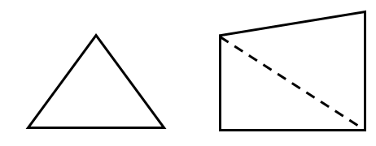  Establish that any quadrilateral can be divided into two triangles. Therefore, the sum of the interior angles of any quadrilateral is 2 × 180° = 360°.  Ask learners to draw a pentagon, a hexagon and a heptagon. In small groups, learners investigate the sum of the interior angles of pentagons, hexagons and heptagons by dividing into triangles and tabulating their results.  Establish that a pentagon can be divided into 3 triangles so the sum of the interior angles is 3 × 180° = 540°. Establish that a hexagon can be divided into 4 triangles and so the sum of the interior angles is 4 × 180° = 720°.  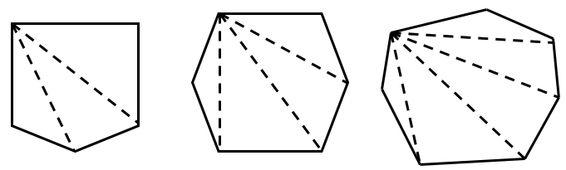  Ask learners:  What do you notice?  Can you write a formula for the sum of the interior angles for a polygon with n sides?  Can you convince a partner that your formula is correct?  Learners will show they are generalising (TWM.02) when they notice and use patterns in the table to describe the relationship between the number of sides of the polygon and the sum of interior angles with a formula such as:  S = (n - 2) × 180  They will show they are convincing (TWM.04) when they develop and explain their arguments to a partner.  Then ask learners to use the formula to find the sum of the interior angles of an octagon, nonagon and decagon and of other polygons, e.g. a 22 sided polygon.  This activity can be extended by asking learners to explore the size of each interior angle of regular polygons (e.g. an equilateral triangle has three angles of 60°, a square has four angles of 90°, etc.). Learners will observe that as the number of sides increases, so do the angles. Ask learners:  Is there a limit to the size of each angle in a regular polygon?  Is it possible that an interior angle of a regular polygon can be 180°?
  Polygon | Number of triangles | Sum of interior angles
  Triangle | 1 | 180°
  Quadrilateral | 2 | 360°
  Pentagon
  Hexagon
  Heptagon
9Gg.08 Know that the sum of the exterior angles of any polygon is 360°.  TWM.01 Specialising  Choosing an example and checking to see if it satisfies or does not satisfy specific mathematical criteria  TWM.02 Generalising  Recognising an underlying pattern by identifying many examples that satisfy the same mathematical criteria | Display an equilateral triangle on the board. Ask learners:  What is an exterior angle?  Select a learner to come to the board and draw an exterior angle on a triangle.  Demonstrate to learners that the exterior angles of an equilateral triangle add up to 360° by placing a pencil on the base of the triangle and then turning it to match each consecutive side until it has gone all the way around.  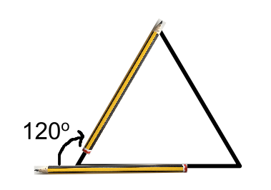  Ask learners:  How many degrees does it turn in total?  How many degrees has it turned each time?  Now ask learners to draw a square and repeat the same process. They should use their pencil to determine that the exterior angles of their square also add up to 360° and notice that each exterior angle is 90°.  They should then repeat the same process for other polygons including irregular triangles and quadrilaterals, pentagons, hexagons etc.  Learners will show they are specialising (TWM.01) when they choose different polygons, checking if the exterior angles add up to 360° each time. They will show they are generalising (TWM.02) when they notice that the sum of the exterior angles of any polygon is 360°.
9Gg.07 Derive and use the formula for the sum of the interior angles of any polygon.  9Gg.08 Know that the sum of the exterior angles of any polygon is 360°. | Give learners a selection of questions where they should find the missing interior or exterior angle in polygons, for example:  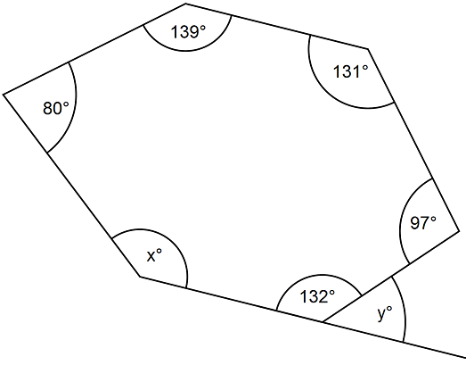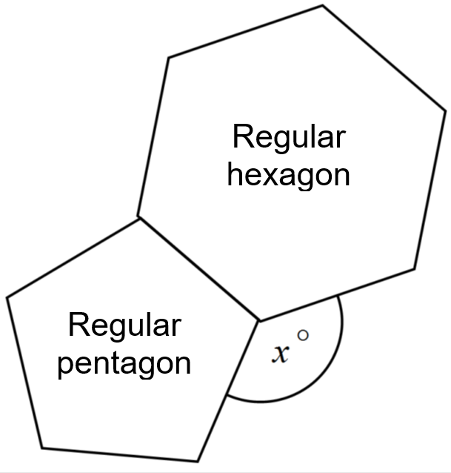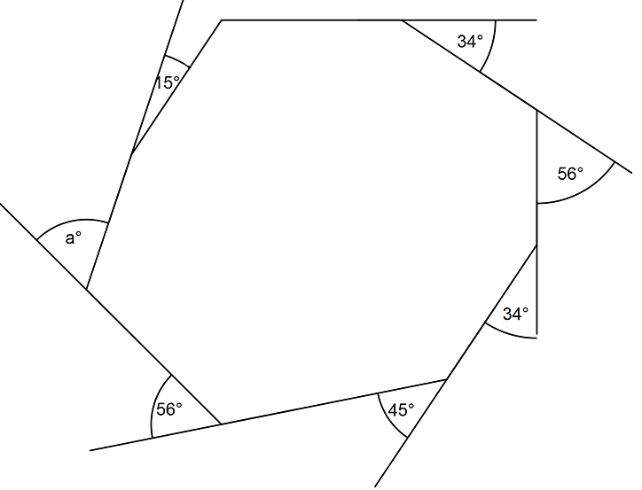
9Gg.09 Use properties of angles, parallel and intersecting lines, triangles and quadrilaterals to calculate missing angles.  9Gg.07 Derive and use the formula for the sum of the interior angles of any polygon.  9Gg.08 Know that the sum of the exterior angles of any polygon is 360°. | As a class, learners should reflect on their previous learning on properties of angles, parallel and intersecting lines and interior and exterior angles of polygons. Select learners to share an angle rule or property they know and collate the learning on a central board. Ensure all rules and properties have been covered, so that learners can refer to these as they proceed onto the next part of the activity.  In pairs, learners should design three missing angle questions, on a large sheet of paper. A small piece of paper (as a window flap) should then be glued over one of the angles in each question. The questions are exchanged with another pair for them to solve the missing angle problem, which they can check afterwards by lifting the flap. Encourage learners to write each step of their calculation on a separate piece of paper so the questions can be swapped with another pair.  For more questions involving angles, use the NRICH task: Angles, Polygons and Geometrical Proof (https://nrich.maths.org/8746).  Resources:  NRICH task

Unit 9.6 Topic 2 Bearings and constructions

Outline of topic:
Learners explore different angles that can be constructed, including the creation of regular polygons. They will also give directions, making use of bearings and scale.

Language:
Key vocabulary:
bisect, angle bisector, perpendicular bisector
circumference
regular polygons
scale map
bearing

Key phrases:
Travel on a bearing of … for …

Recommended prior knowledge:
- Construct triangles, the midpoint and perpendicular bisector of a line segment, and the bisector of an angle
- Know that the sum of the angles around a point is 360º, and use this to calculate angles in a regular polygon
- Understand and use bearings as a measure of direction

Learning objectives | Suggested teaching activities and resources | Mental strategies, possible misconceptions and comments
9Gg.11 Construct 60º, 45º and 30º angles and regular polygons. | Ask learners to construct an equilateral triangle of any side length using only their pencil, ruler and compasses.  Ask learners:  What angles have you drawn? Check your answer by measuring with your protractor.  Learners should notice that by constructing an equilateral triangle, they have also constructed a 60º angle without using a protractor.  Then ask learners:  Can you construct a 30º angle? (Answer: bisect the 60º angle of an equilateral triangle to make two angles of 30º)  Can you construct a 45º angle? (Answer: construct the perpendicular bisector of a line and then bisect it to make two 45º angles)  This activity can be extended by asking learners if they can make an angle of 15º (bisecting 30º) and 120º (joining two equilateral triangles).  Ask learners:  What other angles can you construct without using a protractor?
9Gg.11 Construct 60º, 45º and 30º angles and regular polygons.  TWM.05 Characterising  Identifying and describing the mathematical properties of an object | Display a circle on the board. Demonstrate how to mark 6 equal divisions around the edge of the circle using a compass. You can also use geometry software or an animation for this.  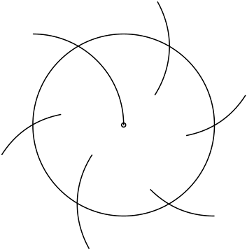  Demonstrate how an equilateral triangle and a regular hexagon can be inscribed within the circle by connecting the divisions on the circumference. Ask learners to follow this process in their books to construct a regular hexagon and an equilateral triangle.  Then ask learners to draw another circle and its diameter. Then ask them to construct a perpendicular bisector of the diameter.  Ask learners:  What happens when you join the four points where the diameter and the perpendicular meet the circumference? (Answer: it creates an inscribed square)  Once learners know how to construct an inscribed square, ask:  How could you construct an inscribed regular octagon?  Give learners time to investigate, then, establish how you can inscribe a regular octagon by first constructing an inscribed square and then bisecting the angles between its diagonals.  Learners will show they are characterising (TWM.05) when they identify properties of the constructions and how to adapt or add to the constructions to form different shapes.
9Gp.01 Use knowledge of bearings and scaling to interpret position on maps and plans. | Give learners a map of an island. For example:  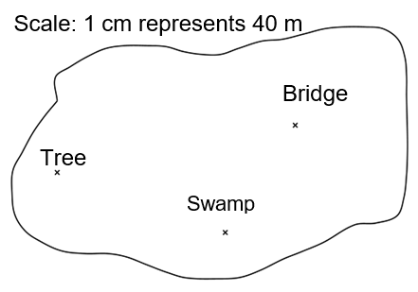  Tell learners that gold coins are buried 120m from the bridge and ask:  From this information, do know where the gold coins are buried?  What other information do you need to know?  Learners should notice that they need more information; either another distance from a different location or the bearing of the gold coins from the bridge. Tell learners the gold coins are on a bearing of 230° and ask them to mark the position “G” on the map where the gold coins are buried.  Then tell learners silver coins are buried on a bearing of 080° from the tree and on a bearing of 345° from the swamp. They should mark on the map the position “S” where the silver coins are buried.  Ask learners:  How far are the coins from the swamp?  Resources:  Island maps
9Gp.01 Use knowledge of bearings and scaling to interpret position on maps and plans. | Provide learners with a city map showing streets and places of interest. The north direction and scale should be shown on the map.  Explain that you are thinking of a secret location and will give them clues so that they can find it on the map. Give learners information such as:  The secret location is on a bearing of 050° from the hospital.  The secret location is 960 metres from the library.  Learners should write where they think the secret location is and score a point if they were correct. Repeat this several times.  Then ask learners to work in pairs. They should identify two places of interest on the map and create a route between them for a tourist to take. Instructions should be recorded giving the name of the landmarks, bearings, distances and road names. For roads with bends, a straight line can be assumed from the start of the road to its end point.  For example  Start at the primary school. Walk down High Street for a distance of 400m on a bearing of 078º. Then…  Once learners have finished their directions, they should swap with another pair of learners and see if their directions lead them to the correct end point.  Resources:  City maps

Unit 9.7 Sequences, functions and graphs

Learning objectives covered in Unit 9.7 and topic summary: |  | 9.7 Topic 1  Generating terms and finding rules of sequences | 9.7 Topic 2  Functions | 9.7 Topic 3  Graphs and coordinates | Thinking and Working Mathematically
9As.01 | Generate linear and quadratic sequences from numerical patterns and from a given term-to-term rule (any indices). |  |  |  | TWM.01 Specialising  TWM.07 Critiquing  TWM.08 Improving
9As.02 | Understand and describe $n$th term rules algebraically (in the form $an ± b,$where $a$ and $b$ are positive or negative integers or fractions, and in the form $\frac{n}{a}$, $n^{2}, n^{3}$ or $n^{2 }± a$, where a is a whole number).
9As.03 | Understand that a function is a relationship where each input has a single output. Generate outputs from a given function and identify inputs from a given output by considering inverse operations (including indices).
9As.04 | Understand that a situation can be represented either in words or as a linear function in two variables (of the form $y = mx + c$ or $ax + by = c$), and move between the two representations.
9As.05 | Use knowledge of coordinate pairs to construct tables of values and plot the graphs of linear functions, including where $y$ is given implicitly in terms of $x$ ($ax + by = c$), and quadratic functions of the form $y = x^{2} ± a$. |  |  |  | TWM.05 Characterising
9As.06 | Understand that straight-line graphs can be represented by equations. Find the equation in the form $y = mx + c$ or where $y$ is given implicitly in terms of $x$ (fractional, positive and negative gradients). |  |  |  | TWM.05 Characterising  TWM.06 Classifying
9As.07 | Read, draw and interpret graphs and use compound measures to compare graphs.
9Gp.02 | Use knowledge of coordinates to find points on a line segment.

Unit 9.7 Topic 1 Generating terms and finding rules of sequences

Outline of topic:
Learners will explore different sequences, making use of trial and correction and trying to generate specific terms.

Language:
Key vocabulary:
term-to-term rule
linear and quadratic sequences
$n$th term

Recommended prior knowledge:
- Understand term-to-term rules and generate sequences
- Understand, describe and use nth-term rules

Learning objectives | Suggested teaching activities and resources | Mental strategies, possible misconceptions and comments
9As.01 Generate linear and quadratic sequences from numerical patterns and from a given term-to-term rule (any indices).  TWM.01 Specialising  Choosing an example and checking to see if it satisfies or does not satisfy specific mathematical criteria  TWM.07 Critiquing  Comparing and evaluating mathematical ideas, representations or solutions to identify advantages and disadvantages  TWM.08 Improving  Refining mathematical ideas or representations to develop a more effective approach or solution | Give learners the task of creating a sequence using a term-to-term rule, with the first term as 1 and one of the other terms as 100. A simple example of this would be using the term-to-term rule ‘add one’:  1, 2, 3, 4 …. 100  Ask learners to compare their answers with a partner. They should establish that there are many different linear sequences, which satisfy these criteria.  Now challenge learners to use squaring, cubing or other indices as part of their term-to-term rule. For example, learners could consider the term-to-term rule ‘square and subtract 1’. However, they will notice this generates the sequence 1,0,-1,0,-1,0 …, so will not include 100 as any term.  Learners will show they are specialising (TWM.01) when they try examples of term-to-term rules to see if they reach 100 as a term. They will show they are critiquing (TWM.07) and improving (TWM.08) when they consider their previous attempts and systematically adapt the term-to-term rules in order to find a solution.  Set learners further challenges, such as changing the starting number to 2, or finding a sequence where 1000 is a term. | Spreadsheet software could be used (if it is available) to support this activity and develop appreciation of the impact of indices in term-to-term rules.
9As.02 Understand and describe $n$th term rules algebraically (in the form $an ± b,$where $a$ and $b$ are positive or negative integers or fractions, and in the form $\frac{n}{a}$, $n^{2}, n^{3}$ or $n^{2 }± a$, where a is a whole number). | Learners work in small groups with two sets of cards, showing the first four terms of arithmetic sequences and the nth term rules for these sequences. Learners match the sequences with their nth term rules. Ensure that some sequences and nth term rules do not have a matching card, so that learners must fill in the missing cards. For example:  Resources:  Sets of cards showing sequences and nth term rules
  3n + 2 | 5, 8, 11, 14, …
  -9n + 1 | -8, -17, -26, -35, …
  $$\frac{n}{7}$$ | $$\frac{1}{7}, \frac{2}{7}, \frac{3}{7}, \frac{4}{7}, …$$
  2n - 5
   | 10, 16, 22, 28, …
9As.02 Understand and describe $n$th term rules algebraically (in the form $an ± b,$where $a$ and $b$ are positive or negative integers or fractions, and in the form $\frac{n}{a}$, $n^{2}, n^{3}$ or $n^{2 }± a$, where a is a whole number). | Show learners the two sequences below:  1, 4, 9, 16, 25, …  1, 8, 27, 64, 125, …  Ask learners:  What is the next term in each sequence? How do you know?  What is the nth term of each sequence?  Learners should recognise the sequences are the sequence of square numbers (nth term n²) and cube numbers (nth term n³).  Ask learners to generate the first five terms of the following sequences: n² + 5, n² – 1, n² + 3, n² – 6.  Then ask learners to explore the patterns which occur in the difference between the terms of these sequences and the difference between these differences (second difference). For example, for the sequence n² + 5:  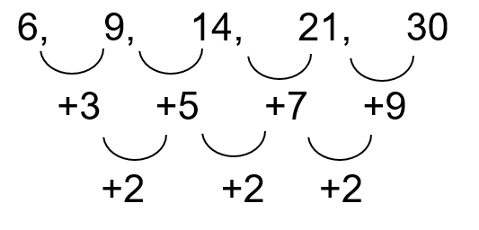  Learners should notice that the second difference of the four sequences above is +2.  Give learners some further questions on generating terms of sequences from nth term rules. For example:  What is the 200th term of the sequence with nth term rule 5$n$? (1000)  What is the 10th term of the sequence with nth term rule $n$³? (1000)  Will $\frac{n}{2}$ generate 1000 as a term? What will the value of $n$ be?  ($n$= 2000. It is the 2000th term.)  Can you find the $n$th term of other sequences that have 1000 as a term?  For another challenge involving investigating sequences and finding nth term rules, use the NRICH task: Charlie's Delightful Machine (https://nrich.maths.org/7024).  Resources:  NRICH task

Unit 9.7 Topic 2 Functions

Outline of topic:
Learners will consider linear and non-linear relationships and how inputs can be found by considering inverse operations. Learners will explore real-life applications using linear relationships with two variables.

Language:
Key vocabulary:
input, output
function
inverse operation
linear equation
non-linear equation
variables

Recommended prior knowledge:
- Understand that a function is a relationship where each input has a single output
- Recognise inverse operations

Learning objectives | Suggested teaching activities and resources | Mental strategies, possible misconceptions and comments
9As.03 Understand that a function is a relationship where each input has a single output. Generate outputs from a given function and identify inputs from a given output by considering inverse operations (including indices).  9As.04 Understand that a situation can be represented either in words or as a linear function in two variables (of the form $y = mx + c$ or $ax + by = c$), and move between the two representations. | Show learners this function machine:  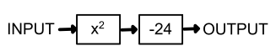  Ask learners:  If the input is 3, what is the output?  If the output is 1, what could the input have been?  Encourage learners to write this inverse function machine to solve this:  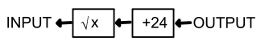  Learners should recognise that there are two possible inputs, 5 and -5, as the square root of 25 can have a positive or a negative value.  Ask learners to create function machines for other functions including indices such as $y = 2x^{2}$ and$y = x^{3}+4$.  Ask learners:  What is the output if x = 0 ….1 … 2 … 3?  Learners can record their answers in a table or mapping diagram. For example:  Then give learners some real-life situations and ask them to write a function for each.  For example:  A boat company charges an initial cost of $10 and an hourly rate of $8 to hire a boat. Write a function to represent the cost of hiring a boat. (Answer: for example, c = 10 + 8h)  What would the total cost be to hire a boat for 1 hour? …2 hours? …3 hours?  If a family has $60 to spend, what is the maximum number of hours they can hire a boat?  Encourage learners to use function machines, tables or mapping diagrams to represent the function. | Possible misconceptions:  Learners need to consider order of operations when using function machines. For example, x² + 100 could also be written as 100 + x², but this does not mean that adding 100 to the input is calculated before squaring. Similarly with the function y=2x² learners should understand the input is squared before being multiplied by 2 as the order of operations should be followed.
  Input, x | Output, y
  0
  1
  2
  3

Unit 9.7 Topic 3 Graphs and coordinates

Outline of topic:
Learners will construct tables of values for linear and quadratic functions and draw linear and quadratic graphs, considering their properties. They will develop their understanding for the real-life applications of such functions and graphs.

Language:
Key vocabulary:
function, equation
coordinate pairs
rearrange
linear, quadratic
variables

Recommended prior knowledge:
- Understand that a function is a relationship where each input has a single output
- Use knowledge of coordinate pairs to construct tables of values and plot the graphs of linear functions
- Be familiar with linear functions (in the form y = mx + c)
- Recognise that equations of the form y = mx + c correspond to straight-line graphs, where m is the gradient and c is the y-intercept

Learning objectives | Suggested teaching activities and resources | Mental strategies, possible misconceptions and comments
9As.04 Understand that a situation can be represented either in words or as a linear function in two variables (of the form $y = mx + c$ or $ax + by = c$), and move between the two representations.  9As.05 Use knowledge of coordinate pairs to construct tables of values and plot the graphs of linear functions, including where $y$ is given implicitly in terms of $x$ ($ax + by = c$), and quadratic functions of the form $y = x^{2} ± a$. | Explain that you are organising a trip for 80 people and so you need to book some transport. Each taxi can transport 4 people and each minibus can transport 10 people. Ask learners to use algebra to represent the situation. (Answer: for example, 4t + 10m = 80)  Then ask learners to construct a table of values, for example:  From these coordinate pairs, ask learners to draw a linear graph.  Resources:  Graph paper
  t | 0 | 5 | 10 | 15 | 20
  m | 8 | 6 | 4 | 2 | 0
9As.05 Use knowledge of coordinate pairs to construct tables of values and plot the graphs of linear functions, including where $y$ is given implicitly in terms of $x$ ($ax + by = c$), and quadratic functions of the form $y = x^{2} ± a$.  TWM.05 Characterising  Identifying and describing the mathematical properties of an object | Ask learners to construct a table of values for each of the following quadratic functions:  $$y = x^{2}$$  $$y = x^{2} + 3$$  $$y = x^{2} – 1$$  Ask learners:  What do you notice about the tables of values?  What are the similarities and differences between the tables of values for each of the quadratic functions?  Then, using graphing software, graphical calculators or pencil and paper, ask learners to plot and label the graphs.  Ask learners:  What do you notice?  What are the similarities and differences between the graphs of each of the quadratic functions?  Learners will show they are characterising (TWM.05) when they identify properties of quadratic functions, such as reflective symmetry of the coordinate pairs.  Resources:  Graphing software, graphical calculators or graph paper
  $$x$$ | -3 | -2 | -1 | 0 | 1 | 2 | 3
  $$y$$
9As.06 Understand that straight-line graphs can be represented by equations. Find the equation in the form $y = mx + c$ or where $y$ is given implicitly in terms of $x$ (fractional, positive and negative gradients).  TWM.05 Characterising  Identifying and describing the mathematical properties of an object  TWM.06 Classifying  Organising objects into groups according to their mathematical properties | Give learners a collection of equations, where most are an equation of a straight line, such as:  Ask learners:  - What can you say about each equation? List the properties of the graphs represented by these equations.  - Which equations correspond to straight-line graphs and which do not? How do you know?  Learners will show they are characterising (TWM.05) when they identify and describe mathematical properties of the equations in relation to their graphs. For example, learners may identify the equations of horizontal and vertical lines. They may identify the equations which do not correspond to straight-line graphs or the gradient and y-intercept of those that do.  Then ask learners to sort the equations into groups. It is their choice how they sort the equations, but they must be able to explain their reasons.  Learners will show they are classifying (TWM.06) when they organise the equations according to their mathematical properties. For example, they can consider x- and y- intercepts, the shape of the graphs, whether it has a positive, negative or fractional gradient etc. | Possible misconceptions:  Learners may incorrectly think that the number in front of x is always the gradient. For example, the graph of $4x + 2y = 10$ has a gradient of 4. Encourage learners to rearrange the equations in the form y = mx + c where possible.  Learners should see that once rearranged, some of the equations are identical to each other. For example $4x + 2y = 10$ is the same as $y = -2x + 5$.
  $$4x + 2y = 10$$ | $$2y = 5x – 4$$ | $$x = 7$$
  $$x + 3y - 8 = 2x + y – x$$ | $$y = 4$$ | $$y = -2x + 5$$
  $$\frac{y}{x}=6$$ | $$y = -2x + 2$$ | $$x + 3y = 2$$
  $$y ={ x}^{3}$$ | $$\frac{y}{x} = x$$ | $$x = 5$$
  $$2y – 5x + 4 = 0$$ | $$x = y$$ | $$x = 3y – 6$$
9As.07 Read, draw and interpret graphs and use compound measures to compare graphs. | Show learners the following information:  A ceiling fan is used to cool a room. It has three settings: Low (200 revolutions per minute), Medium (300 revolutions per minute), and High (400 revolutions per minute). An engineer wants to monitor its cooling effect over a period of one hour. The fan takes five minutes to reach each operational speed and the engineer runs the fan at each speed for a total of 15 minutes.  Ask learners to draw a graph to show the revolutions per minutes against time:  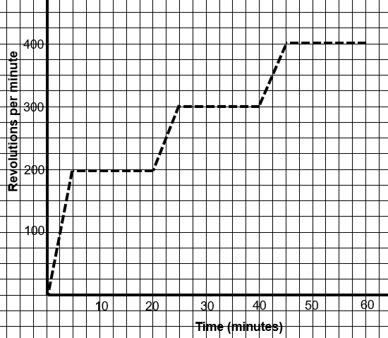  Ask learners to explain what the gradients on the graph represent. (Answer: the rate of change of revolutions per minute)  Then tell learners the temperature of the room at the start of the test is 30ºC. The temperature falls to 20ºC at the end of the test, before the fan is turned off. Ask learners to show on another graph how they predict the temperature changes over time, giving consideration to the revolutions per minute over time graph already drawn.  Learners can compare their results with other learners, giving their justifications and discussing their reasoning.  This activity can be extended by telling learners that the engineer is considering adding a fourth speed: ‘Turbo’. Ask learners to predict how the results might change, drawing further graphs to demonstrate this.  Resources:  Graph paper
9As.07 Read, draw and interpret graphs and use compound measures to compare graphs. | Show a travel graph, such as:  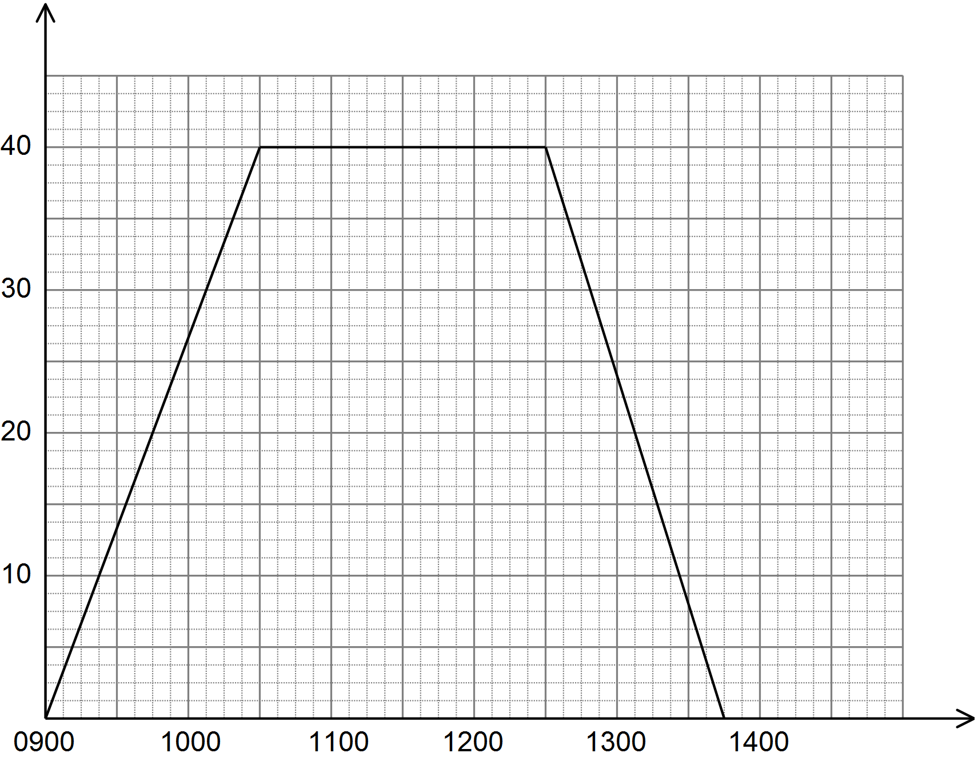  Distance from home (km)  Time  Ask learners:  How much faster was the journey back towards home compared to the journey away from home?  Discuss how the formula:  $$average speed=\frac{distance travelled}{time taken}$$  relates to the gradient of a distance-time graph.  Give learners a travel graph of a journey. Ask them to work with a partner to describe the journey. They should include speeds, for example:  Between 1 p.m. and 2.30 p.m., the car was travelling at an average speed of 50 km/h.  Between 2.30 p.m. and 2.45 p.m., the car was parked (not moving) …  Ask learners:  Do you need to include distance as well as speed in your descriptions? (Answer: No, giving speed and time allows someone to calculate the distance if they need it)  Ask learners to do the reverse activity to the one above. Give them a description of a journey and ask them to draw a travel graph that matches the description.  Resources:  Travel graphs  Graph paper
9Gp.02 Use knowledge of coordinates to find points on a line segment. | Show learners the table of coordinates below:  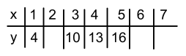  Discuss how the missing values can be found. Learners should notice a rule that connects the y to the x values (y = 3x + 1). They can also solve the problem by plotting the given values e.g. (1,4) and then using the line segment to find the missing coordinates as well as finding the equation of the line, in the form y = mx + c.  Ask learners:  What would the value of y be when x is 20? (Answer: 61)  What would the value of x be when y is 11? (Answer: 3$\frac{1}{3}$)
9Gp.02 Use knowledge of coordinates to find points on a line segment. | Tell learners that the origin O, point A, and point B are equally spaced along the same line such that the distance OA is equal to the distance AB:  Ask learners:  If A is the point (4, 3), what are the coordinates of point B?  If the points continue along the line so that each subsequent point is labelled with the next letter of the alphabet, what would be the coordinates of point C? ...point D? …point T?

Unit 9.8 Transformations

Learning objectives covered in Unit 9.8 and topic summary: |  | 9.8 Topic 1  Reflections, rotations and translations | 9.8 Topic 2  Enlargements | Thinking and Working Mathematically
9Gp.03 | Transform points and 2D shapes by combinations of reflections, translations and rotations.
9Gp.04 | Identify and describe a transformation (reflections, translations, rotations and combinations of these) given an object and its image.
9Gp.05 | Recognise and explain that after any combination of reflections, translations and rotations the image is congruent to the object.
9Gp.06 | Enlarge 2D shapes, from a centre of enlargement (outside, on or inside the shape) with a positive integer scale factor. Identify an enlargement, centre of enlargement and scale factor.
9Gp.07 | Analyse and describe changes in perimeter and area of squares and rectangles when side lengths are enlarged by a positive integer scale factor.

Unit 9.8 Topic 1 Reflections, rotations and translations

Outline of topic:
Learners will explore different types of transformation and look at alternatives that lead to the same final transformation.

Language:
Key vocabulary:
grid and coordinate scale
transform
translate
reflect
rotate
angle of rotation
vector
congruent

Recommended prior knowledge:
- Translate, reflect and rotate 2D shapes, identifying the corresponding points between the original and the translated image, on coordinate grids
- Understand that if two 2D shapes are congruent, corresponding sides and angles are equal

Learning objectives | Suggested teaching activities and resources | Mental strategies, possible misconceptions and comments
9Gp.03 Transform points and 2D shapes by combinations of reflections, translations and rotations.  9Gp.04 Identify and describe a transformation (reflections, translations, rotations and combinations of these) given an object and its image.  9Gp.05 Recognise and explain that after any combination of reflections, translations and rotations the image is congruent to the object. | Give each learner a copy of the grid shown below.  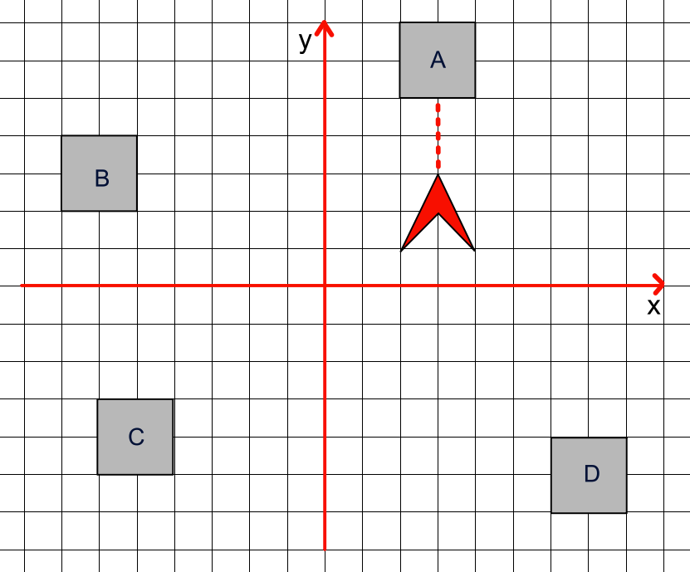  6  4  -6  -4  -6  -4  -2  -2  2  4  2  Explain to learners that the arrowhead represents a spaceship and each of the squares represents a base. Their challenge is to move the spaceship using a combination of translations, reflections and rotations to destroy each of the four bases. To destroy a base, the spaceship must be pointing at the base and also be inside the same quadrant (as shown by the example with base A above).  Ask learners how they could use transformation to move the spaceship to destroy base B. For example, they could reflect the spaceship in the y-axis and then rotate the spaceship 90° anticlockwise about the point (-3, 3).  Once base B is destroyed learners should now describe transformations which could be performed to destroy base C and then base D.  Learners should clearly record their instructions for each transformation and then swap with a partner who should perform the transformations to verify the bases have been destroyed.  Select learners to share their instructions with the class and model the transformations on the board (a cut-out spaceship will support this, or a moveable electronic version).  During the activity, encourage learners to explore different types of transformations that could be used to move the spaceship into position. They should understand that after any combination of reflections, translations and rotations the spaceship’s shape and size remain the same, i.e. it remains congruent.  For another challenge involving transformations, use the NRICH task: Combining Transformations (https://nrich.maths.org/5332) to explore the order in which transformations are combined.  Resources:  Copies of the grid with spaceship and 4 bases  NRICH task | Encourage learners to use vectors to describe a translation. They should give the equation of the mirror line when describing a reflection. They should give the centre, angle and direction when describing a rotation.

Unit 9.8 Topic 2 Enlargements

Outline of topic:
Learners will use enlargements and develop their understanding of scale factor, in particular how it affects perimeter and area.

Language:
Key vocabulary:
enlarge, enlargement
centre of enlargement
scale factor

Recommended prior knowledge:
- Understand that the image is mathematically similar to the object after enlargement
- Enlarge 2D shapes, from a centre of enlargement (outside or on the shape) with a positive integer scale factor
- Identify an enlargement and scale factor

Learning objectives | Suggested teaching activities and resources | Mental strategies, possible misconceptions and comments
9Gp.06 Enlarge 2D shapes, from a centre of enlargement (outside, on or inside the shape) with a positive integer scale factor. Identify an enlargement, centre of enlargement and scale factor.  9Gp.07 Analyse and describe changes in perimeter and area of squares and rectangles when side lengths are enlarged by a positive integer scale factor. | Continuing from the previous topic (Topic 1), because the spaceship destroyed the bases learners need to be rebuild them as shown:  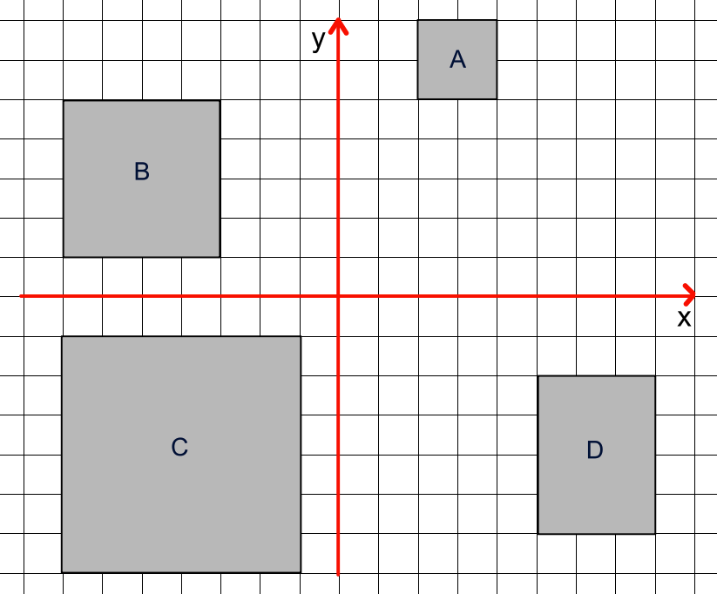  Ask learners:  Are any of these new bases congruent to the original bases? (Answer: base A, as it is exactly the same shape and size to those in the previous topic)  Are any of these new bases similar to the original bases? (Answer: base B, as it is an enlargement of scale factor 2, and base C as it is an enlargement of scale factor 3)  Learners should recognise that base D, whilst larger, is not an enlargement of the original bases. Ask learners to redesign base D so that it is an enlargement, but a different size to base A, B or C (learners may consider scale factors of 4, 0.5, 2.5, etc.).  Then ask learners to investigate the area and perimeter of each base and describe how the perimeter and area of the other bases relate to base A. Ask learners to consider how they will record their findings, for example they could use a table such as:  Ask learners:  What do you notice?  When the shape is enlarged by scale factor 2, what happens to the perimeter?  When the shape is enlarged by scale factor 2, what happens to the area?  What happens to the shape’s perimeter and area if it is enlarged by scale factor 3?  Learners should notice that for scale factor 2, the perimeter doubles but the area is multiplied by 4 (two squared). They should notice that for scale factor 3, the perimeter triples but the area is multiplied by 9 (three squared).
  Base | Scale factor | Perimeter | Area
  A (original) | 1 | 8 | 4
  B | 2 | 16 | 16
  C | 3 | 24 | 36
  D | … | … | …
9Gp.06 Enlarge 2D shapes, from a centre of enlargement (outside, on or inside the shape) with a positive integer scale factor. Identify an enlargement, centre of enlargement and scale factor. | Give learners a set of coordinates of a shape. Ask learners to enlarge the shape by scale factor 3, from centre (2, 1) and find the coordinates of the enlarged shape.  How can you check that your answer is correct?  In pairs, learners discuss how to describe the single transformation that maps triangle P onto triangle Q:  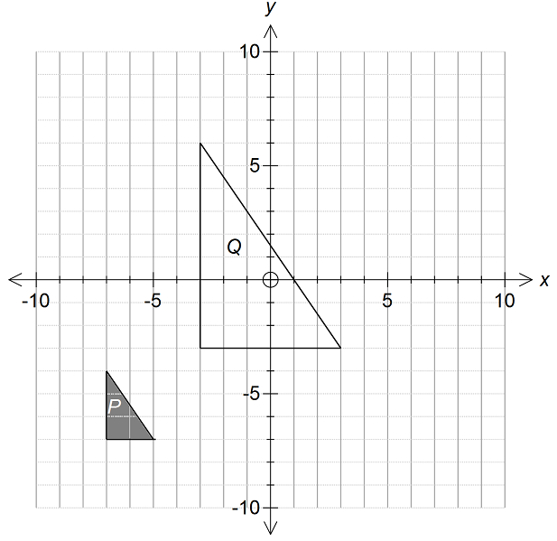  Model finding the centre of enlargement by connecting vertices in corresponding positions. Establish that the scale factor can be found by finding the ratio of two corresponding side lengths.  Give learners a selection of grids showing enlargements of shapes. Ask learners to fully describe each enlargement.  The context of the reconstruction of the bases can be used for learners to continue to practise performing and describing enlargements. Learners should consider how different enlargements affect the sizes and locations for their new bases. Two examples are given below:  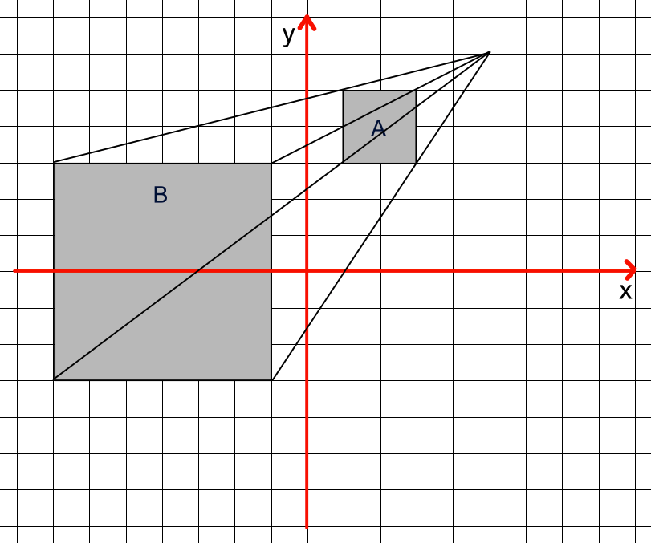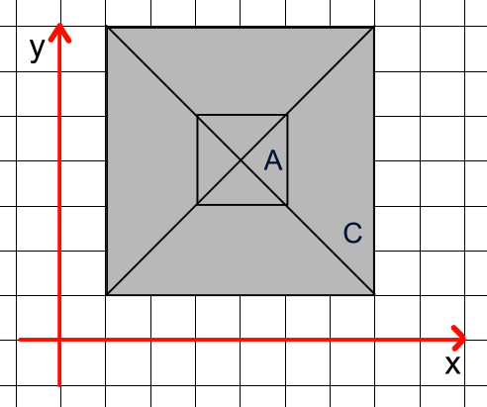  Resources:  Selection of grids showing enlargements of shapes | Encourage learners to leave construction lines (drawn lightly) in their drawings.  When describing an enlargement learners should clearly record the scale factor and centre of enlargement.

Unit 9.9 Statistics

Learning objectives covered in Unit 9.9 and topic summary: |  | 9.9 Topic 1  Collecting, presenting and interpreting data | 9.9 Topic 2  Descriptive statistics | 9.9 Topic 3  The statistical cycle | Thinking and Working Mathematically
9Ss.01 | Select, trial and justify data collection and sampling methods to investigate predictions for a set of related statistical questions, considering what data to collect, and the appropriateness of each type (qualitative or quantitative; categorical, discrete or continuous). |  |  |  | TWM.08 Improving
9Ss.02 | Explain potential issues and sources of bias with data collection and sampling methods, identifying further questions to ask. |  |  |  | TWM.08 Improving
9Ss.03 | Record, organise and represent categorical, discrete and continuous data. Choose and explain which representation to use in a given situation:  - Venn and Carroll diagrams  - tally charts, frequency tables and two-way tables  - dual and compound bar charts  - pie charts  - line graphs, time series graphs and frequency polygons  - scatter graphs  - stem-and-leaf and back-to-back stem-and-leaf diagrams  - infographics. |  |  |  | TWM.08 Improving
9Ss.04 | Use mode, median, mean and range to compare two distributions, including grouped data. |  |  |  | TWM.08 Improving
9Ss.05 | Interpret data, identifying patterns, trends and relationships, within and between data sets, to answer statistical questions. Make informal inferences and generalisations, identifying wrong or misleading information. |  |  |  | TWM.08 Improving

Unit 9.9 Topic 1 Collecting, presenting and interpreting data

Outline of topic:
Learners will consider a survey and choose the type of data to be collected and the format of its collection. They will then consider different graphical representations that best support their statistical questions.

Language:
Key vocabulary:
qualitative data, quantitative data
categorical data, discrete data, continuous data
primary data, secondary data
survey, questionnaire
census
sample
bias
grouped data
graphs, tables and diagrams:
- Venn and Carroll diagrams
- tally charts, frequency tables and two-way tables
- dual and compound bar charts
- pie charts
- line graphs, time series graphs and frequency polygons
- scatter graphs
- stem-and-leaf and back-to-back stem-and-leaf diagrams
- infographics

Recommended prior knowledge:
- Knowledge of different types of data
- Knowledge of different types of data collection methods
- Knowledge of a range of data representations and which to apply to a given situation
- Identify patterns and trends, within and between data sets

Learning objectives | Suggested teaching activities and resources | Mental strategies, possible misconceptions and comments
9Ss.01 Select, trial and justify data collection and sampling methods to investigate predictions for a set of related statistical questions, considering what data to collect, and the appropriateness of each type (qualitative or quantitative; categorical, discrete or continuous).  9Ss.02 Explain potential issues and sources of bias with data collection and sampling methods, identifying further questions to ask. | Explain that learners will be investigating the question:  What are they main characteristics of books read by Grade 9 learners?  Discuss what characteristics they might look for and what data they can collect, e.g. genre, average word lengths, average words per page, time it takes a learner to read a page etc. Learners should classify each data type (qualitative or quantitative; categorical, discrete or continuous).  Ask learners:  - If investigating the average word length, what sample of words would be appropriate (10, 100 or 1000) for this survey? Discuss why 10 is too few to be truly representative and why 1000 would be too time consuming.  - If you wanted to investigate reading differences across the school, how would you do this?  The last question above will create opportunity to discuss when and where surveys should or should not be conducted and how many people would be a good representative sample.  Ask learners:  Where might bias occur? (E.g. just selecting learners who are in the library) | Learners conduct statistics investigations as part of a four-part statistical enquiry cycle:  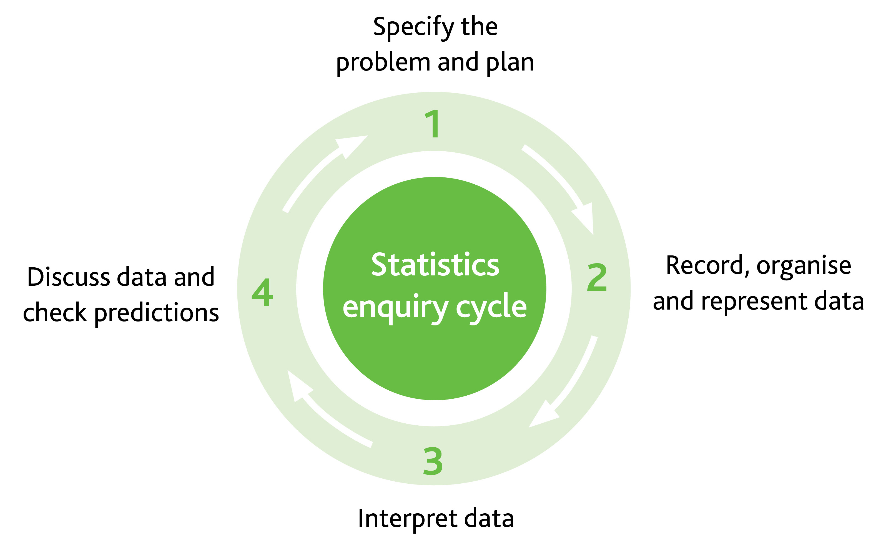
9Ss.03 Record, organise and represent categorical, discrete and continuous data. Choose and explain which representation to use in a given situation:  - Venn and Carroll diagrams  - tally charts, frequency tables and two-way tables  - dual and compound bar charts  - pie charts  - line graphs, time series graphs and frequency polygons  - scatter graphs  - stem-and-leaf and back-to-back stem-and-leaf diagrams  - infographics. | Display data suitable for displaying as a scatter graph, e.g. the heights and masses of seven people:  Model how the data can be presented on a scatter graph:  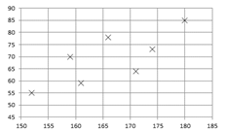  Establish that the graph shows the relationship between a person’s height and weight. Ask learners:  How could you describe this relationship? (e.g. the graph shows that taller people tend to be heavier than shorter people)  Why is a scatter graph useful to present this data?  Explain that scatter graphs are useful to present two related sets of data that you want to compare.  Show learners five scatter graphs showing relationships between variables, for example:  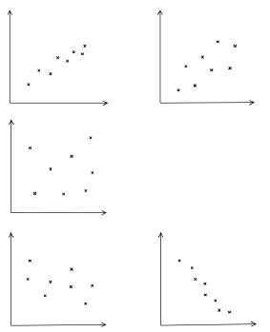  Explain that a scatter diagram shows correlation between two variables if there is a relationship between the variables. Establish that correlation can be positive (one variable tends to increase as the other increases) or negative (one variable decreases as the other increases). Establish that correlation is strong if the points lie very close to a straight line.  Establish that correlation does not imply causation. | Learners conduct statistics investigations as part of a four-part statistical enquiry cycle:
  Height (cm) | Mass (kg)
  152 | 55
  159 | 70
  161 | 59
  166 | 78
  171 | 64
  174 | 73
  180 | 85
9Ss.03 Record, organise and represent categorical, discrete and continuous data. Choose and explain which representation to use in a given situation:  - Venn and Carroll diagrams  - tally charts, frequency tables and two-way tables  - dual and compound bar charts  - pie charts  - line graphs, time series graphs and frequency polygons  - scatter graphs  - stem-and-leaf and back-to-back stem-and-leaf diagrams  - infographics.  9Ss.05 Interpret data, identifying patterns, trends and relationships, within and between data sets, to answer statistical questions. Make informal inferences and generalisations, identifying wrong or misleading information. | Review simple stem-and-leaf diagrams. Then show a back-to-back stem-and-leaf diagram, e.g.  Key: 1 | 4 | 2 represents a mark of 42% in Class 1 and a mark of 41% in Class 2  Class 2 Class 1  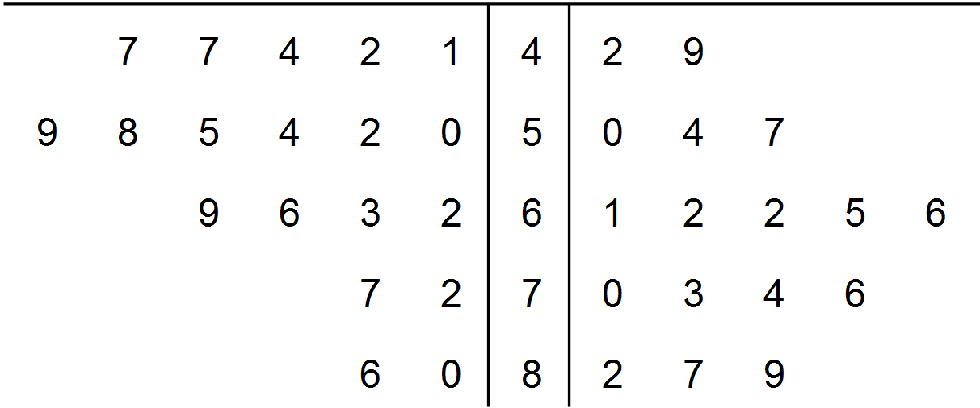  Ask learners:  How are the marks for Class 2 ordered differently from those for Class 1? (Answer: the numbers decrease from left to right – so the smallest values are still nearest to the stem)  Why is a back-to-back stem-and leaf diagram useful to present this data?  Establish that back-to-back stem-and-leaf diagrams are a useful way to compare two sets of data.  Ask learners:  How do the marks in the two classes compare? Discuss the distributions of the marks. | Learners conduct statistics investigations as part of a four-part statistical enquiry cycle:
9Ss.03 Record, organise and represent categorical, discrete and continuous data. Choose and explain which representation to use in a given situation:  - Venn and Carroll diagrams  - tally charts, frequency tables and two-way tables  - dual and compound bar charts  - pie charts  - line graphs, time series graphs and frequency polygons  - scatter graphs  - stem-and-leaf and back-to-back stem-and-leaf diagrams  - infographics.  9Ss.05 Interpret data, identifying patterns, trends and relationships, within and between data sets, to answer statistical questions. Make informal inferences and generalisations, identifying wrong or misleading information. | Model how to produce a frequency polygon from a frequency diagram for continuous data by joining the midpoints of each bar. For example:  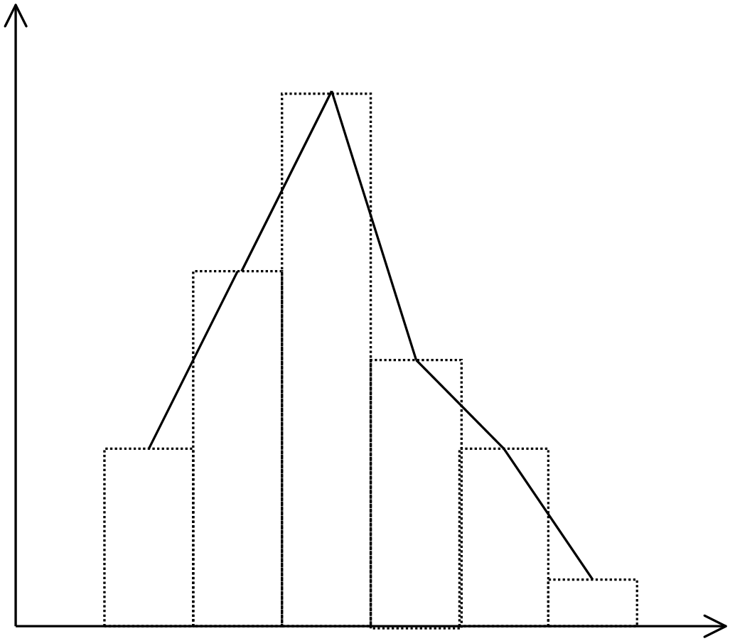  Show how frequency polygons are useful for comparing two distributions, e.g.  Frequency polygons showing the number of times the maximum temperature was reached in a month in two towns  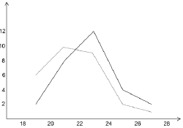  Temperature ºC  Town B  Town A  Ask learners:  How do the temperatures in the two towns compare?  Encourage learners to comment on which town is warmer on average and to compare the spread.  Give learners two sets of grouped continuous data. They draw and interpret a single frequency polygon to illustrate one set of data. They then draw a frequency polygon for the second set of data and compare the two sets of data.  Give learners opportunities to work in groups to collect and present data to test their own research questions and hypotheses. Learners should consider appropriate ways to present the data, interpret their charts, graphs and diagrams and comment on whether they support their hypotheses.  Resources:  Two sets of grouped continuous data  Graph paper | Learners conduct statistics investigations as part of a four-part statistical enquiry cycle:

Unit 9.9 Topic 2 Descriptive statistics

Outline of topic:
Learners will find averages of grouped data. They will conduct a case study to provide statistical evidence of global warming, using different types of average and range.

Language:
Key vocabulary:
average, mode, median, mean, range

Key phrases:
The mean of the data is …
The mode of the data is …
The median of the data is …
The range of the data is …

Recommended prior knowledge:
- Use knowledge of mode, median, mean and range to describe and summarise large data sets
- Interpret and summarise data

Learning objectives | Suggested teaching activities and resources | Mental strategies, possible misconceptions and comments
9Ss.04 Use mode, median, mean and range to compare two distributions, including grouped data. | Display a grouped discrete frequency table. For example:  In small groups, learners discuss the modal class, the median and the mean.  Ask learners:  What is the modal class?  In which interval does the median lie?  What problem might you encounter when you are trying to find the mean?  How can you estimate the mean?  Establish that the mean can be estimated by using the midpoints of each interval to represent that interval. Extend the information in the table to show how the this is done. For example:  Give learners some grouped frequency tables (some for discrete data and some for continuous data) and ask them to estimate the mean for each one. Learners also identify the modal interval and the interval in which the median lies. Ask learners:  What do these statistics tell you about the data?  Resources:  Grouped frequency tables | Ensure learners understand that when calculating spread and centrality of grouped data:  - the mean is an estimate  - the precise range cannot be found  - the modal class changes depending on how the data is grouped (the mode may not lie in the modal class).
  Number of marks | Frequency
  1–5 | 5
  6–10 | 7
  11–15 | 6
  16–20 | 2
  Number of marks | Frequency | Mid-point | Mid-point × frequency
  1–5 | 5 | 3 | 15
  6–10 | 7 | 8 | 56
  11–15 | 6 | 13 | 78
  16–20 | 2 | 18 | 36
  Totals | 20 | - | 185
9Ss.04 Use mode, median, mean and range to compare two distributions, including grouped data.  9Ss.05 Interpret data, identifying patterns, trends and relationships, within and between data sets, to answer statistical questions. Make informal inferences and generalisations, identifying wrong or misleading information. | Show learners the following information:  Global temperatures have risen on average by 1°C over the last 100 years due to global warming. Some areas of the world have seen more dramatic changes, for example, in Siberia, winters that used to reach -50 degrees are now a comparatively mild -30 degrees, which is causing the permafrost to melt.  Learners should choose an area of the world and collect monthly temperature data from the last year as well as from a previous period of time (e.g. 20 years ago).  By using mode, median, mean and range they should compare the two distributions. If daily temperatures are given, this data can be grouped before performing statistical analysis (e.g. by using estimated means).  Data can be compared within a set (e.g. range of temperatures for the year, etc.) as well as comparing between sets (e.g. finding how much the average temperature has changed over 20 years).  Ask learners to interpret their data and present their study and findings to a partner. Learners should ask questions and aim to identify any misleading information presented by their partner.  Resources:  Access to computers for researching temperature data | Learners need to consider which is the most appropriate measure of average and how the range can point towards consistency of data.

Unit 9.9 Topic 3 The statistical cycle

Outline of topic:
Learners will apply the statistical enquiry cycle to conduct a statistics investigation by:
- specifying the problem, planning the investigation and making predictions
- collecting, recording, and organising the data
- considering how to appropriately represent the data
- interpreting the data and discussing conclusions.

Language:
Key vocabulary:
qualitative data, quantitative data
categorical data, discrete data, continuous data
survey, questionnaire
data, statistics
tally, table, frequency
sample
diagrams, tables, graphs, charts
average, mode, median, mean, range
outlier

Key phrases:
Data collection method
Sampling method
Appropriate representation of data
The mean of the data is …
The mode of the data is …
The median of the data is …
The range of the data is …

Recommended prior knowledge:
- Knowledge of a range of data representations and which to apply to a given situation
- Use knowledge of mode, median, mean and range to describe and summarise large data sets
- Identify patterns and trends, within and between data sets, to answer statistical questions
- Interpret and summarise data

Learning objectives | Suggested teaching activities and resources | Mental strategies, possible misconceptions and comments
9Ss.01 Select, trial and justify data collection and sampling methods to investigate predictions for a set of related statistical questions, considering what data to collect, and the appropriateness of each type (qualitative or quantitative; categorical, discrete or continuous).  9Ss.02 Explain potential issues and sources of bias with data collection and sampling methods, identifying further questions to ask.  9Ss.03 Record, organise and represent categorical, discrete and continuous data. Choose and explain which representation to use in a given situation:  - Venn and Carroll diagrams  - tally charts, frequency tables and two-way tables  - dual and compound bar charts  - pie charts  - line graphs, time series graphs and frequency polygons  - scatter graphs  - stem-and-leaf and back-to-back stem-and-leaf diagrams  - infographics.  9Ss.04 Use mode, median, mean and range to compare two distributions, including grouped data.  9Ss.05 Interpret data, identifying patterns, trends and relationships, within and between data sets, to answer statistical questions. Make informal inferences and generalisations, identifying wrong or misleading information.  TWM.08 Improving  Refining mathematical ideas or representations to develop a more effective approach or solution | Learners work in pairs for this extended activity. Ask them to think of a question or statement (hypothesis) linked to how people travel to school or to work. For example: younger people are more likely to walk to school.  Explain that they will collect data related to their chosen question or statement. From the data that they collect they must show that more younger people walk to school or work than older people.  Learners need to discuss what data (qualitative or quantitative; categorical, discrete or continuous data) will be needed to answer their question or verify their statement. They also need to plan and discuss how they will collect their data (include sampling methods). They should also consider what representations and statistical analysis they will use to for their analysis.  Learners should choose at least two representations. They should present their information with their conclusions clearly stated.  Learners can also present their findings to the rest of the class, explaining where there were any difficulties and how they would refine the research if they had time to repeat the activity.  Learners will show they are improving (TWM.08) after discussing any difficulties and then agreeing on the best approach for an improved sample and data collection approach. They may also consider better representations and statistical analyses that support their hypothesis. | Learners conduct statistics investigations as part of a four-part statistical enquiry cycle:

Sample lesson 1

CLASS:

DATE:
Learning objectives | 9Sp.01 Understand that the probability of multiple mutually exclusive events can be found by summation and all mutually exclusive events have a total probability of 1.  9Sp.02 Identify when successive and combined events are independent and when they are not.  9Sp.03 Understand how to find the theoretical probabilities of combined events.
Lesson focus /  success criteria | Learners will combine knowledge of mutually exclusive and independent events to draw probability tree diagrams to represent all outcomes. They will begin to use tree diagrams to find probabilities of independent successive events.  - I can find probabilities by considering events that have a total probability of 1  - I can draw probability tree diagrams to represent outcomes of events occurring in succession  - I can use probability tree diagrams to find the probability of successive independent events
Prior knowledge / previous learning | Learners will understand that the sum of the probabilities of all mutually exclusive events will add to 1. They will understand and identify when two events are independent.
Plan
Lesson | Planned activities | Notes
Introduction | Show learners the learning objectives and lesson focus and agree the success criteria:  - I can find probabilities by considering events that have a total probability of 1  - I can draw probability tree diagrams to represent outcomes of events occurring in succession  - I can use probability tree diagrams to find the probability of successive independent events  Review previous learning on mutually exclusive events. In pairs, learners explore the following two problems:  Problem 1. A bag contains 12 cards numbered 1, 2, 3, … 12.  A card is chosen from the bag at random.  Some possible outcomes are:  A = the card shows an odd number  B = the card shows the number 8  C = the card shows a multiple of 4  D = the card shows a factor of 10  E = the card shows a prime number  Which pairs of outcomes are mutually exclusive?  Which pairs of outcomes are not mutually exclusive?  Problem 2. A bag contains cubes coloured either black, white or blue.  The probability of choosing a black cube is 0.24. The probability of choosing a white cube is three times the probability of choosing a blue cube.  What is the probability that the cube is black or blue?
Main activities | Tell learners that in a lake there are 3 species of fish: A, B and C. The probabilities of fish A and fish B being caught, based on the numbers of each species present in the lake, are 0.5 and 0.35 respectively.  Ask learners:  What is the probability of fish C being caught?  Then tell learners that a fisherman catches 100 fish in total and sells all fish of species A he has caught to a local restaurant.  Ask learners:  How do you think this may affect the probability of catching each species for the next fisherman? (Answer: there will now be approximately 50 less fish A to catch, reducing the probability. At the same time, the probability of catching fish B and C will increase, as the total probability of all mutually exclusive events will always be equal to one).  Tell learners that another lake has 20 fish; 8 of species A, 7 of species B and 5 of species C.  Ask learners to draw a tree diagram to show all possible outcomes where two fish are caught (and replaced) in succession.  Ask learners to find probabilities from their tree diagram such as:  What is the probability of the rarest fish being caught both times? (Answer: $\frac{5}{20}×\frac{5}{20}=\frac{25}{400}=\frac{1}{16}$ )  What is the probability of species A being caught both times?  (Answer: $\frac{8}{20}×\frac{8}{20}=\frac{64}{400}=\frac{4}{25}$ )  This task can be extended by asking learners to consider the problem above but without replacement. They should draw another tree diagram showing the probabilities of all possible outcomes where two fish are caught in succession but not replaced.
Summary | Give learners a partially completed tree diagram and ask them to fill in the missing probabilities.  For example:  Two different spinners are spun. The first spinner will either land on red or blue. The second spinner will either land on yellow or green.  Explain why spinning the first spinner and spinning the second spinner are independent events.  The tree diagram shows the probability of each outcome.  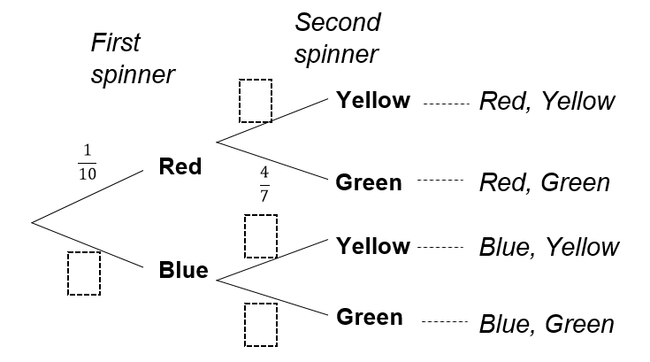  Fill in the missing probabilities.  What is the probability the spinners will land on red and green?  What is the most likely outcome of both spinners? What is the probability of this outcome?  What is the probability the spinners will not land on red and yellow?  Revisit the learning objectives and success criteria. Ask learners to explain whether they have met the success criteria and if they have any questions or comments.

Reflection
Use the space below to reflect on your lesson. Answer the most relevant questions for your lesson.
Were the learning objectives and lesson focus realistic? What did the learners learn today?
What was the learning atmosphere like?
What changes did I make from my plan and why?
If I taught this again, what would I change?
What two things really went well (consider both teaching and learning)?
What two things would have improved the lesson (consider both teaching and learning)?
What have I learned from this lesson about the class or individuals that will inform my next lesson?
Next steps
What will I teach next based on learners’ understanding of this lesson?

Sample lesson 2

CLASS:

DATE:
Learning objectives | 9As.07 Read, draw and interpret graphs and use compound measures to compare graphs.
Lesson focus /  success criteria | Learners will develop their understanding of real-life graphs, that include compound measures.  - I can draw graphs to show change over given time periods  - I can interpret gradients on graphs involving compound measures  - I can predict what happens when variables are changed
Prior knowledge / previous learning | Learners should be able to determine coordinate points that can be used to plot graphs of real-life situations. They should be able to interpret the different features of distance-time graphs.
Plan
Lesson | Planned activities | Notes
Introduction | Show learners the learning objectives and lesson focus and agree the success criteria:  - I can draw graphs to show change over given time periods  - I can interpret gradients on graphs involving compound measures  - I can predict what happens when variables are changed  Ask learners:  If a handheld fan rotates at 60 revolutions per minute, how long does it take to make one complete turn? (Answer: 1 second)  How many revolutions would it complete in 1 hour? (Answer: 3600 revolutions)  If a desk fan completes 1800 revolutions in $\frac{3}{4}$ of an hour, is this fan faster or slower than the handheld fan?
Main activities | Show learners the following information:  A ceiling fan is used to cool a room. It has 3 settings: Low (200 revolutions per minute), Medium (300 revolutions per minute), and High (400 revolutions per minute). An engineer wants to monitor its cooling effect over a period of 1 hour. The fan takes 5 minutes to reach each operational speed and the engineer runs the fan at each speed for a total of 15 minutes.  Ask learners to draw a graph to show the revolutions per minutes against time:  Ask learners to explain what the gradients on the graph represent. (Answer: the rate of change of revolutions per minute)  Then tell learners the temperature of the room at the start of the test is 30ºC. The temperature falls to 20ºC at the end of the test, before the fan is turned off. Ask learners to show on another graph how they predict the temperature changes over time, giving consideration to the revolutions per minute over time graph already drawn.  Learners can compare their results with other learners, giving their justifications and discussing their reasoning.  This activity can be extended by telling learners that the engineer is considering adding a fourth speed: ‘Turbo’. Ask learners to predict how the results might change, drawing further graphs to demonstrate this. | Resources:  Graph paper
Summary | Give learners graphs showing the revolutions per minute of the ceiling fan during different times of another day. For example:  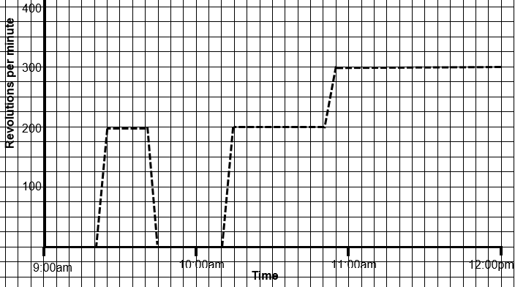  Learners should write a ‘story’ for each graph by interpreting the features.  Revisit the learning objectives and success criteria. Ask learners to explain whether they have met the success criteria and if they have any questions or comments.

Reflection
Use the space below to reflect on your lesson. Answer the most relevant questions for your lesson.
Were the learning objectives and lesson focus realistic? What did the learners learn today?
What was the learning atmosphere like?
What changes did I make from my plan and why?
If I taught this again, what would I change?
What two things really went well (consider both teaching and learning)?
What two things would have improved the lesson (consider both teaching and learning)?
What have I learned from this lesson about the class or individuals that will inform my next lesson?
Next steps
What will I teach next based on learners’ understanding of this lesson?

Changes to this Scheme of Work

This Scheme of Work has been amended. The latest Scheme of Work is version 2.0, published January 2021.

- The definition of the Thinking and Working Mathematically characteristic TWM.03 Conjecturing has been changed to: Forming mathematical questions or ideas.
- The definition of the Thinking and Working Mathematically characteristic TWM 04 Convincing has been changed to: Presenting evidence to justify or challenge a mathematical idea or solution.

There may be other minor changes that do not affect teaching and learning.

Cambridge Assessment is committed to making our documents accessible in accordance with the WCAG 2.1 Standard. We are always looking to improve the accessibility of our documents. If you find any problems or you think we are not meeting accessibility requirements, contact us at info@cambridgeinternational.org with the subject heading: Digital accessibility. If you need this document in a different format, contact us and supply your name, email address and requirements and we will respond within 15 working days.

Cambridge Assessment International Education
The Triangle Building, Shaftesbury Road, Cambridge, CB2 8EA, United Kingdom
t: +44 1223 553554 f: +44 1223 553558
e: info@cambridgeinternational.org www.cambridgeinternational.org

© UCLES September 2020

