

Scheme of Work
Cambridge Lower Secondary
Mathematics 0862
Stage 8

This Cambridge Scheme of Work is for use with the Cambridge Lower
Secondary Mathematics Curriculum Framework published in September
2020 for first teaching in September 2021.

© UCLES 2020
Cambridge Assessment International Education is part of the Cambridge Assessment Group. Cambridge Assessment is the brand name of the University of Cambridge Local Examinations Syndicate (UCLES), which itself is a department of the University of Cambridge.

UCLES retains the copyright on all its publications. Registered Centres are permitted to copy material from this booklet for their own internal use. However, we cannot give permission to Centres to photocopy any material that is acknowledged to a third party, even for internal use within a Centre.

Contents

Contents 3
Introduction 5
Unit 8.1 Number and calculation 9
Unit 8.1 Topic 1 Place value and rounding 10
Unit 8.1 Topic 2 Indices, factors and multiples 14
Unit 8.1 Topic 3 Calculating with integers and decimals 18
Unit 8.2 Algebraic representation and manipulation 22
Unit 8.2 Topic 1 Manipulating algebra, expressions and formulae 23
Unit 8.2 Topic 2 Equations and inequalities 29
Unit 8.3 2D and 3D shape 32
Unit 8.3 Topic 1 Quadrilaterals and polygons 33
Unit 8.3 Topic 2 Area, perimeter and circumference 36
Unit 8.3 Topic 3 3D shapes, surface area and volume 40
Unit 8.4 Fractions, decimals, percentages, ratio and proportion 44
Unit 8.4 Topic 1 Comparing numbers 45
Unit 8.4 Topic 2 Calculating with fractions 49
Unit 8.4 Topic 3 Percentage change, ratio and proportion 53
Unit 8.5 Probability 56
Unit 8.5 Topic 1 Complementary and combined events 57
Unit 8.5 Topic 2 Experimental probability 61
Unit 8.6 Angles and construction 64
Unit 8.6 Topic 1 Angles, bearings and measure 65
Unit 8.6 Topic 2 Construction and midpoints 69
Unit 8.7 Sequences, functions and graphs 73
Unit 8.7 Topic 1 Generating terms and finding rules of sequences 74
Unit 8.7 Topic 2 Functions 77
Unit 8.7 Topic 3 Graphs and equation of a straight line 80
Unit 8.8 Transformations 84
Unit 8.8 Topic 1 Translations and vectors 85
Unit 8.8 Topic 2 Reflections, rotations and enlargements 87
Unit 8.9 Statistics 91
Unit 8.9 Topic 1 Data types and collection methods 92
Unit 8.9 Topic 2 Recording and interpreting data 94
Unit 8.9 Topic 3 Using descriptive statistics 96
Unit 8.9 Topic 4 The statistical cycle 98
Sample lesson 1 102
Sample lesson 2 105
Changes to this Scheme of Work 108

Changes to this Scheme of Work
For information about changes to this Scheme of Work, go to page 108.
The latest Scheme of Work is version 2.0, published January 2021.

Introduction
This document is a scheme of work created by Cambridge Assessment International Education for Cambridge Lower Secondary Mathematics Stage 8.

It contains:
- suggested units showing how the learning objectives in the curriculum framework can be grouped and ordered
- at least one suggested teaching activity for each learning objective
- a list of subject-specific language that will be useful for your learners
- common misconceptions
- sample lesson plans
- links to relevant NRICH activities to enrich learners’ mathematical experiences, https://nrich.maths.org/

You do not need to use the ideas in this scheme of work to teach Cambridge Lower Secondary Mathematics Stage 8. Instead use them as a starting point for your planning and adapt them to suit the requirements of your school and the needs of your learners. The schemes of work are designed to indicate the types of activities you might use, and the intended depth and breadth of each learning objective. These activities are not designed to fill all the teaching time for this stage. You should use other activities with a similar level of difficulty, for example, those from endorsed resources.

The accompanying teacher guide for Cambridge Lower Secondary Mathematics suggests effective teaching and learning approaches. You can use this scheme of work as a starting point for your planning, adapting it to suit the requirements of your school and needs of your learners.

Long-term plan
This long-term plan shows the units in this scheme of work and a suggestion of how long to spend teaching each one. The suggested teaching time is based on learners having about 4 to 5 hours of Mathematics per week (about 120 to 150 hours per stage). The actual number of teaching hours may vary according to your context.
Unit and suggested order | Suggested teaching time
Unit 8.1 Number and calculation | 13% (20 hours)
Unit 8.2 Algebraic representation and manipulation | 13% (20 hours)
Unit 8.3 2D and 3D shape | 13% (20 hours)
Unit 8.4 Fractions, decimals, percentages, ratio and proportion | 13% (20 hours)
Unit 8.5 Probability | 7% (10 hours)
Unit 8.6 Angles and construction | 10% (15 hours)
Unit 8.7 Sequences, functions and graphs | 13% (20 hours)
Unit 8.8 Transformations | 7% (10 hours)
Unit 8.9 Statistics | 10% (15 hours)
Total | 150 hours

Sample lesson plans
You will find two sample lesson plans at the end of this scheme of work. They are designed to illustrate how the suggested activities in this document can be turned into lessons. They are written in more detail than you would use for your own lesson plans. The Cambridge Lower Secondary Mathematics Teacher Guide has information on creating lesson plans.

Other support for teaching Cambridge Lower Secondary Mathematics Stage 8
Cambridge Lower Secondary centres receive access to a range of resources when they register. The Cambridge Lower Secondary support site at https://lowersecondary.cambridgeinternational.org is a password-protected website that is the source of the majority of Cambridge-produced resources for the programme. Ask the Cambridge Coordinator or Exams Officer in your school if you do not already have a log-in for this support site.

Included on this support site are:
- the Cambridge Lower Secondary Mathematics Curriculum Framework, which contains the learning objectives that provide a structure for your teaching and learning
- grids showing the progression of learning objectives across stages
- the Cambridge Lower Secondary Mathematics Teacher Guide, which will help you to implement Cambridge Lower Secondary Mathematics in your school
- templates for planning
- worksheets for short teacher training activities that link to the teacher guide
- assessments provided by Cambridge
- a list of endorsed resources, which have been through a detailed quality assurance process to make sure they are suitable for schools teaching Cambridge Lower Secondary Mathematics worldwide
- links to online communities of Cambridge Lower Secondary teachers.

Resources for the activities in this scheme of work
We have assumed that you will have access to these resources:
- squared paper, pens and pencils for learners to use
- rulers, set squares, protractors, compasses and calculators.

Other suggested resources for individual units and/or activities are described in the rest of this document. You can swap these for other resources that are available in your school.

Websites
We recommend NRICH to support Cambridge Lower Secondary Mathematics at https://nrich.maths.org/

NRICH publishes free and challenging mathematics activities for learners of all ages. The resources assist teachers to embed thinking and working mathematically with mathematics content. NRICH is based in both the University of Cambridge's Faculty of Education and the Centre for Mathematical Sciences.

There are many excellent online resources suitable for teaching Cambridge Lower Secondary Mathematics. Since these are updated frequently, and many are only available in some countries, we recommend that you and your colleagues identify and share resources that you have found to be effective for your learners.

Approaches to teaching Cambridge Lower Secondary Mathematics Stage 8
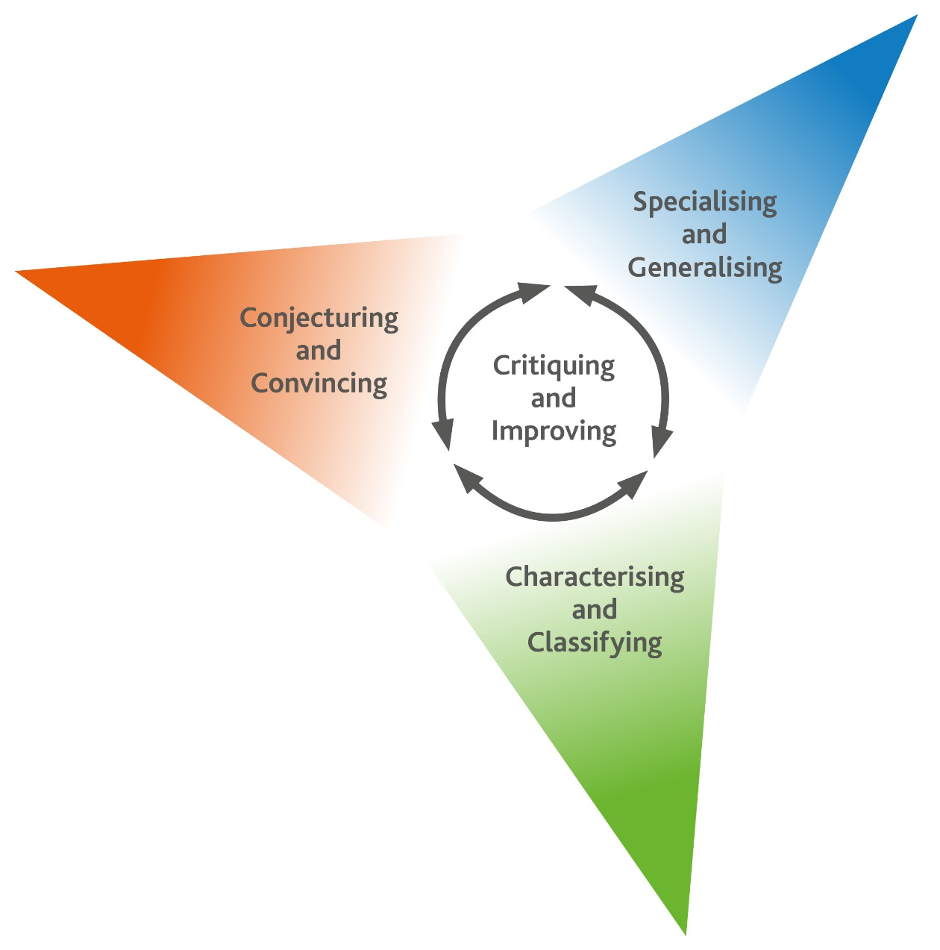
Thinking and Working Mathematically
Thinking and Working Mathematically supports the mathematical concepts and skills in all strands of the Cambridge Lower Secondary Mathematics curriculum. When learners think and work mathematically, they actively engage with their learning of mathematics. They try to make sense of ideas and build connections between different facts, procedures and concepts. Learners who do not think and work mathematically can carry out processes that their teacher has shown them, but they may not understand why the processes work or what the results mean. Noticing inconsistencies, patterns and particular representations encourages learners to think and work mathematically. Practice, reflection and questioning will help them to improve.

Thinking and Working Mathematically has eight characteristics that are presented in four pairs:

- Specialising and Generalising
- Conjecturing and Convincing
- Characterising and Classifying
- Critiquing and Improving.
The eight Thinking and Working Mathematically characteristics are all closely connected and interdependent. A high-quality mathematics task may include one or more of them. The characteristics provide learners with the language they need to think and work mathematically. Learners can then decide what mathematical knowledge, procedures and strategies to use in order to gain a deeper understanding of mathematical questions.

Throughout this scheme of work, there are examples of classroom activities that link the Thinking and Working Mathematically characteristics with content learning objectives. We recommend you use the ideas in these examples to create further classroom activities.

Thinking and Working Mathematically characteristics: |  | Unit 8.1 | Unit 8.2 | Unit 8.3 | Unit 8.4 | Unit 8.5 | Unit 8.6 | Unit 8.7 | Unit 8.8 | Unit 8.9
TWM.01 | Specialising – Choosing an example and checking to see if it satisfies or does not satisfy specific mathematical criteria
TWM.02 | Generalising – Recognising an underlying pattern by identifying many examples that satisfy the same mathematical criteria
TWM.03 | Conjecturing – Forming mathematical questions or ideas
TWM.04 | Convincing – Presenting evidence to justify or challenge a mathematical idea or solution
TWM.05 | Characterising – Identifying and describing the mathematical properties of an object
TWM.06 | Classifying – Organising objects into groups according to their mathematical properties
TWM.07 | Critiquing – Comparing and evaluating mathematical ideas, representations or solutions to identify advantages and disadvantages
TWM.08 | Improving – Refining mathematical ideas or representations to develop a more effective approach or solution

Misconceptions
Mathematical misconceptions are usually incorrect generalisations made by learners. Misconceptions should not be avoided, but instead used for teaching purposes to reveal learners’ thinking. Research suggests that asking learners open-ended questions about mathematical concepts is the most appropriate way to uncover misconceptions. Once a learner’s misconceptions have been identified, the next step is to know how to correct them. One approach is to give learners a variety of mathematical strategies to draw upon when finding solutions so that they can gain a deeper understanding of each mathematical concept.

Mental strategies and calculators
Mental calculation is a skill needed for everyday life, especially when paper or calculators are not available. Mental calculation relies on working memory, the organisation of thoughts and the use of efficient mathematical strategies when solving mathematical computations. It is important for learners to practise mental calculations and have a range of strategies as this improves understanding and recall as well as increasing confidence and proficiency.

Calculators are useful teaching aides. Although learners need to practise doing mental and written calculations, calculators can help them to notice patterns. They are also useful when learners are solving problems where non-calculator calculations would take the focus away from strategies. When well used, calculators can help learners to learn about numbers and the number system. Use calculators as a teaching aid to promote mental calculation and mental strategies and to explore mathematical patterns. Learners should understand when it is best to use calculators to help them calculate, and when to calculate mentally or using written methods.

As Cambridge International includes calculator-based assessments at Stages 7, 8 and 9, we recommend that learners develop effective use of calculators so that they are familiar with the buttons and functions of a basic calculator.

Unit 8.1 Number and calculation

Learning objectives covered in Unit 8.1 and topic summary: |  | 8.1 Topic 1  Place value and rounding | 8.1 Topic 2  Indices, factors and multiples | 8.1 Topic 3  Calculating with integers and decimals | Thinking and Working Mathematically
8Np.01 | Use knowledge of place value to multiply and divide integers and decimals by 0.1 and 0.01. |  |  |  | TWM.02 Generalising
8Np.02 | Round numbers to a given number of significant figures. |  |  |  | TWM.01 Specialising  TWM.03 Conjecturing  TWM.04 Convincing
8Ni.05 | Use positive and zero indices, and the index laws for multiplication and division. |  |  |  | TWM.02 Generalising  TWM.03 Conjecturing  TWM.04 Convincing
8Ni.06 | Recognise squares of negative and positive numbers, and corresponding square roots.
8Ni.07 | Recognise positive and negative cube numbers, and the corresponding cube roots.
8Ni.01 | Understand that brackets, indices (square and cube roots) and operations follow a particular order.
8Ni.02 | Estimate, multiply and divide integers, recognising generalisations. |  |  |  | TWM.02 Generalising  TWM.03 Conjecturing  TWM.04 Convincing
8Nf.04 | Use knowledge of the laws of arithmetic and order of operations (including brackets) to simplify calculations containing decimals or fractions.
8Nf.07 | Estimate and multiply decimals by integers and decimals.
8Nf.08 | Estimate and divide decimals by numbers with one decimal place.
8Ni.03 | Understand factors, multiples, prime factors, highest common factors and lowest common multiples. |  |  |  | TWM.01 Specialising  TWM.04 Convincing

Unit 8.1 Topic 1 Place value and rounding

Outline of topic:
Learners will use and develop their understanding of place value, considering what happens to numbers when they are multiplied and divided by 0.1 and 0.01. They will apply their understanding of place value to round to a given number of significant figures.

Key vocabulary:
figures, digits
significant figures
place value
thousands, hundreds, tens, ones, tenths, hundredths, thousandths
decimal place
decimal point

Key phrases:
Round … to … significant figures
Round … to … decimal places

Recommended prior knowledge:
- Know the place value of each digit in decimals (tenths, hundredths and thousandths)
- Multiply and divide by any positive power of 10
- Round numbers to a given number of decimal places

Learning objectives | Suggested teaching activities and resources | Mental strategies, possible misconceptions and comments
8Np.01 Use knowledge of place value to multiply and divide integers and decimals by 0.1 and 0.01.  TWM.02 Generalising  Recognising an underlying pattern by identifying many examples that satisfy the same mathematical criteria | Ask learners:  How many tenths are there in two wholes? (Answer: 20)  Select learners to share their answers and explain their strategies for finding solutions. Use diagrams to support learners understanding.  Then ask learners to calculate 2 ÷ 0.1. Learners may recognise that this is an equivalent question to the previous question, so has the same answer. By doing this, learners will appreciate that seeing 0.1 as $\frac{1}{10}$ can be helpful in understanding decimal calculations.  Ask learners a selection of similar questions, such as:  - 319 ÷ 0.1  - 2.4 ÷ 0.1  - 0.87 ÷ 0.1  Ask learners:  What do you notice? What calculation is this the same as? (Answer: dividing by 0.1 gives the same answer as multiplying by 10)    Learners should record their findings and then investigate dividing by 0.01 and can then go on to investigate multiplying by 0.1 and 0.01. Learners will show they are generalising (TWM.02) when they explain what they have noticed. For example:  - Dividing by 0.1 is the same as multiplying by 10.  - Dividing by 0.01 is the same as multiplying by 100.  - Multiplying by 0.1 is the same as dividing by 10.  - Multiplying by 0.01 is the same as dividing by 100.  Once these rules are established, learners can try a selection of decimal multiplication and division questions such as:  - 3.5 ÷ 0.01  - 89 × 0.1  - 0.9 × 0.01  - 9812 ÷ 0.1 | Mental strategies:  Encourage learners to check their answers on calculators once they have attempted the questions using a written or mental method.  Possible misconceptions:  Learners will often incorrectly assume that dividing numbers leads to an answer that is smaller.
  $$\frac{1}{10}$$ | $$\frac{1}{10}$$ | $$\frac{1}{10}$$ | $$\frac{1}{10}$$ | $$\frac{1}{10}$$ | $$\frac{1}{10}$$ | $$\frac{1}{10}$$ | $$\frac{1}{10}$$ | $$\frac{1}{10}$$ | $$\frac{1}{10}$$ |  | $$\frac{1}{10}$$ | $$\frac{1}{10}$$ | $$\frac{1}{10}$$ | $$\frac{1}{10}$$ | $$\frac{1}{10}$$ | $$\frac{1}{10}$$ | $$\frac{1}{10}$$ | $$\frac{1}{10}$$ | $$\frac{1}{10}$$ | $$\frac{1}{10}$$
8Np.02 Round numbers to a given number of significant figures. | Introduce learners to rounding integers to a given number of significant figures. Use examples such as:  - Round 8538 to 1 significant figure. (Answer: 9000 as the 5 digit rounds up and the zeros preserve place value).  - Round 404 398 to 3 significant figures. (Answer: 404 000 as the ‘trapped’ 0 acts as a significant figure)  - Round 69 563 to 2 significant figures. (Answer: 70 000. For this number, the answer is the same as rounding to 1 significant figure.)  Remind learners that rounding can be useful to help estimate answers to calculations. Learners work in pairs to use rounding to 1 significant figure to match cards showing calculations and answers. For example:  16 000  367 × 42  30  874 ÷ 32  Resources:  Sets of cards with matching questions and answers. | Ensure learners are aware that when rounding a mid-value, it always rounds up: if asked to round 3.5 to the nearest whole number, 3.5 is exactly half way between 3 and 4 (it has no ‘nearest’ number), and so by convention, we always round up.
8Np.02 Round numbers to a given number of significant figures. | Discuss rounding decimals to a given number of significant figures. Use examples such as:  - Round 0.00493 to 1 significant figure. (Answer: 0.005, as the leading zeros are not significant and the 9 digit rounds up)  - Round 0.05074 to 3 significant figures. (Answer: 0.0507 as the ‘trapped’ 0 acts as a significant figure)  Learners work in pairs and are given cards with the digits 0, 0, 0, 1, 3, 5 and a decimal point. Ask learners to design questions for each other to answer, by making a number using the digit cards and deciding how many significant figures to round it to, for example:  - What is 1.03050 to 4 significant figures?  - What is 0.01035 to 1 significant figure?  This activity can be extended by giving learners answers and asking them to create the question that would give this answer. For example, if the target answer was 100, learners could create the question:  What is 130.005 rounded to 1 significant figure?  Resources:  Sets of cards with digits 0, 0, 0, 1, 3, 5 and a decimal point.
8Np.02 Round numbers to a given number of significant figures.  TWM.03 Conjecturing  Forming mathematical questions or ideas  TWM.01 Specialising  Choosing an example and checking to see if it satisfies or does not satisfy specific mathematical criteria  TWM.04 Convincing  Presenting evidence to justify or challenge a mathematical idea or solution | Show learners the statement below:  Rounding a number to the same number of decimal places and significant figures gives the same answer.  Ask learners:  Is this always, sometimes or never true?  Learners will show they are conjecturing (TWM.03) when they decide whether they think the result will always, sometimes or never be true.  Learners will show they are specialising (TWM.01) when they check certain examples to see if they give the same or different results such as:  - rounding 0.0041035 to 3 significant figures (0.00410) and to 3 decimal places (0.004)  - rounding 0.234 to 2 significant figures (0.23) and to 2 decimal places (0.23).  Learners will show they are convincing (TWM.04) when they can explain, using examples such as those above, why this is sometimes true. | Remind learners about rounding numbers to a given number of decimal places. Check that their knowledge of the processes is secure and check that they understand the difference between rounding to a number of decimal places and to a number of significant figures.

Unit 8.1 Topic 2 Indices, factors and multiples

Outline of topic:
Learners will use and develop their understanding of indices to derive the laws of indices. They will be able to recognise cube and square numbers and understand how they are formed. Learners will explore pairs of numbers and their highest common factors and lowest common multiples.

Language:
Key vocabulary:
index, indices, power
base
index laws, laws of indices
square, squared, cube, cubed
square root, cube root
highest common factor
lowest common multiple
prime factor

Key phrases:
To the power of …

Recommended prior knowledge:
- Understand the vocabulary and notation associated with powers and indices
- Understand the relationship between squares and corresponding square roots, and cubes and corresponding cube roots
- Know square numbers to 144 (12 × 12) and cube numbers to 125 (5 × 5 × 5)
- Understand lowest common multiple and highest common factor

Learning objectives | Suggested teaching activities and resources | Mental strategies, possible misconceptions and comments
8Ni.05 Use positive and zero indices, and the index laws for multiplication and division.  TWM.03 Conjecturing  Forming mathematical questions or ideas  TWM.04 Convincing  Presenting evidence to justify or challenge a mathematical idea or solution | Ask learners:  Which is larger, 2³ or 3²?  Ensure all learners understand that 2³ = 2×2×2 = 8 and 3² = 3×3 = 9, so 2³ is smaller than 3².  Ask learners:  - What do you notice?  - What questions could you ask based on this example? What could you investigate further? Can you explain and justify your answers?  For example:  Is 4³ less than 5²? Is 11³ less than 12²? Is 0³ less than 1²?  When is n³ less than (n+1)²?  Is 2⁵ less than 3⁴? Is 2⁹ less than 3⁸? Is 2¹ less than 3⁰?  When is 2^{n+1} less than 3^{n}?  Is 3⁴ less than 4³? Is 2⁵ less than 5²? Is 0¹ less than 1⁰?  When is a^{b} less than bª?  Learners will show they are conjecturing (TWM.03) when they ask questions about the patterns in the numbers. They will show they are convincing (TWM.04) when they can explain and justify their answers.
8Ni.05 Use positive and zero indices, and the index laws for multiplication and division.  TWM.02 Generalising  Recognising an underlying pattern by identifying many examples that satisfy the same mathematical criteria  TWM.03 Conjecturing  Forming mathematical questions or ideas  TWM.04 Convincing  Presenting evidence to justify or challenge a mathematical idea or solution | Ask learners to calculate 2³ × 2² and 2⁵.  Ask learners:  - What do you notice? (The answers are the same)  - Can you explain why?  - Can you suggest a rule for multiplying numbers that have the same base (base 2 in this example)? (Answer: add the indices)  Then ask learners to calculate a selection of divisions of numbers expressed as powers, such as 2³ ÷ 2², 2⁴ ÷ 2³, 2⁴ ÷ 2², 2⁴ ÷ 2¹.  Ask learners:  - What do you notice?  - Can you suggest a rule for dividing numbers that have the same base (base 2 in this example)? (Answer: subtract the indices)  Ask learners:  What is 2³ ÷ 2³?  Select learners to share their ideas. Some learners may apply the index law for division and notice 2³ ÷ 2³ = 2⁰. Some learners may notice 2³ ÷ 2³ = 1, as any number divided by itself is 1.  Ask learners:  Can you suggest another index law based on this? (Any number to the power of zero is 1.)  Learners will show they are generalising (TWM.02), conjecturing (TWM.03) and convincing (TWM.04) as they begin to derive the laws for indices. | To demonstrate the index law for multiplication, show how the calculation can be expanded:  $$2^{3}×2^{2}=\left( 2×2×2\right) × \left(2×2\right) \\ = 2×2×2×2×2 \\ = 2^{5}$$  To demonstrate the index law for division, write the division in fractional form and cancel the common factors:  $$2^{3}÷2^{2}=\frac{2×2×2}{2×2}=2$$
8Ni.06 Recognise squares of negative and positive numbers, and corresponding square roots.  8Ni.07 Recognise positive and negative cube numbers, and the corresponding cube roots. | Ask learners what 1 × 1 equals and how we can express the same question using indices (1²). Remind learners that the square root of a number is the inverse operation of squaring. So √1 = 1.  Ask learners to show this information in a table and extend it for 2×2, 3×3, etc.  Introduce (-1)² = 1. Ask learners if this is true or false and ask for explanations. Ask learners:  Is it possible for a negative number to be a square number? Explain your answer.  Now ask learners to extend the table in the opposite direction too:  Discuss the third column. Learners should notice √1 has two possible solutions: 1 and -1.  Ask learners now to draw and complete another table showing cubing and cube roots. Learners should investigate what happens when cubing negative numbers, e.g. (-1)³. | Possible misconceptions:  Learners should recognise that normally, the square root of a number will give a positive solution when using a calculator (e.g.√9 = 3). However, for all numbers (apart from 0) there are two square roots: one positive and one negative. This is sometimes written as  √9 = ±3.  When using a calculator, learners may type -1² and get an answer of -1. Explain to learners that, because of the order of operations, brackets are needed. Typing in (-1)² will give the expected result of 1.
  1 × 1 = 1 | 1² = 1 | √1 = 1
  2 × 2 = 4 | 2² = 4 | √4 = 2
  …
  …
  -1 × -1 = 1 | (-1)² = 1 | √1 = -1
  0 × 0 = 0 | 0² = 0 | √0 = 0
  1 × 1 = 1 | 1² = 1 | √1 = 1
  2 × 2 = 4 | 2² = 4 | √4 = 2
  …
8Ni.03 Understand factors, multiples, prime factors, highest common factors and lowest common multiples.  TWM.01 Specialising  Choosing an example and checking to see if it satisfies or does not satisfy specific mathematical criteria  TWM.04 Convincing  Presenting evidence to justify or challenge a mathematical idea or solution | Write the following question on the board and ask learners to discuss in pairs:  The lowest common multiple of a pair of numbers is always a multiple of the highest common factor. Do you agree or disagree?  In pairs, ask learners to decide whether they agree or disagree and write a convincing argument for their answer.  Learners will show they are specialising (TWM.01) when they choose pairs of numbers and find the lowest common multiple and the highest common factor to show if the statement is true or false. They will show they are convincing (TWM.04) when they give evidence to show the statement is correct, perhaps using knowledge of prime factors to help them.  This activity can be extended by asking learners to consider what happens with three or more numbers, rather than just two. | If learners need support in understanding what the statement means, lead them through an example:  - Choose a pair of numbers (6 and 8).  - Find the lowest common multiple (24).  - Find the highest common factor (2).  - Decide whether the lowest common multiple (24) is a multiple of the highest common factor (2).  For this example we can see that the statement is true, as 24 is a multiple of 2, but learners should now investigate other pairs of numbers.

Unit 8.1 Topic 3 Calculating with integers and decimals

Outline of topic:
Learners will deepen their understanding of negative numbers and decimals, and recognise generalisations when calculating with integers. They will apply the order of operations in calculations involving decimals and integers and use estimation to predict answers.

Language:
Key vocabulary:
estimate, estimation
integer
order of operations
addition, subtraction, multiplication, division
negative, positive

Recommended prior knowledge:
- Estimate, add and subtract integers
- Understand that brackets, positive indices and operations follow a particular order
- Estimate, multiply and divide integers where one integer is negative

Learning objectives | Suggested teaching activities and resources | Mental strategies, possible misconceptions and comments
8Ni.02 Estimate, multiply and divide integers, recognising generalisations.  TWM.03 Conjecturing  Forming mathematical questions or ideas  TWM.02 Generalising  Recognising an underlying pattern by identifying many examples that satisfy the same mathematical criteria | Give each learner a multiplication table:  Ask learners to complete the top right section of the multiplication table first. They should then complete the blue squares and the top left and bottom right sections. Ask learners:  What do you notice about the numbers you have completed so far?  Ask learners to use the patterns they have noticed to complete the rest of the multiplication table. Learners will show they are conjecturing (TWM.03) when they suggest how to complete the bottom left section.  Then ask learners to use the multiplication table to explain what they have noticed about multiplying with negative numbers. Similarly, they should use the multiplication table to make conclusions about dividing with negative numbers.  Learners will show they are generalising (TWM.02) when they write statements to describe the rules for multiplying and dividing integers. For example, multiplying a negative number by a negative number gives a positive answer.  Resources:  Multiplication tables | Learners should identify patterns in the numbers they have completed to conjecture about the remaining empty spaces. For example, using the pattern -3, -2, -1, 0,… in the numbers highlighted yellow above, learners may conjecture that the pattern continues: …1, 2, 3. This means -1 × -1 = 1, -1 × -2 = 2 and  -1 × -3 = 3.  Learners should recognise the generalisations:  positive × positive = positive  positive × negative = negative  negative × positive = negative  negative × negative = positive  positive ÷ positive = positive  positive ÷ negative = negative  negative ÷ positive = negative  negative ÷ negative = positive
  -3 | -2 | -1 | 0 | 1 | 2 | 3 | x
   |  |  |  |  |  |  | 3
   |  |  |  |  |  |  | 2
   |  |  |  |  |  |  | 1
   |  |  |  |  |  |  | 0
   |  |  |  |  |  |  | -1
   |  |  |  |  |  |  | -2
   |  |  |  |  |  |  | -3
  -3 | -2 | -1 | 0 | 1 | 2 | 3 | x
  -9 | -6 | -3 | 0 | 3 | 6 | 9 | 3
  -6 | -4 | -2 | 0 | 2 | 4 | 6 | 2
  -3 | -2 | -1 | 0 | 1 | 2 | 3 | 1
  0 | 0 | 0 | 0 | 0 | 0 | 0 | 0
   |  | 1 | 0 | -1 | -2 | -3 | -1
   |  | 2 | 0 | -2 | -4 | -6 | -2
   |  | 3 | 0 | -3 | -6 | -9 | -3
8Ni.02 Estimate, multiply and divide integers, recognising generalisations.  TWM.04 Convincing  Presenting evidence to justify or challenge a mathematical idea or solution | Ask learners to choose two of these six numbers and divide one by the other.  3 -12 -2 15 -6 4  Ask learners:  What is the largest answer that it is possible to make by dividing one of these numbers by another? How do you know?  Then ask:  What is the smallest answer that it is possible to make by multiplying one of these numbers by another? How do you know?  Learners will need to think about which pair of numbers to choose and whether to divide or multiply by a positive or negative number. They will show they are convincing (TWM.04) when they can explain their solution and justify why they think it is the largest or smallest possible answer.  This activity can be extended by asking learners to create a similar but more challenging problem. | For this particular set of numbers, the largest possible answer when dividing is -12 ÷ -2 = 6. The smallest possible answer when multiplying is 15 × -12 = -180.
8Ni.01 Understand that brackets, indices (square and cube roots) and operations follow a particular order. | Ask learners to calculate √4 + 16 × 2. The answer is 34 (or 30 if they remember that √4 can be positive or negative). Confirm that the correct order of operations has been followed. Ask learners to insert brackets to make a different answer, e.g. √(4 + 16 × 2) or √(4 + 16) × 2. Use of calculators will support this activity.  Then challenge learners to use each of the numbers 1, 2, 3, 4 exactly once and the operations +, –, × and ÷ to try to make every number from 0 to 20. They can also use brackets, indices, square roots and cube roots. For example:  0 = √4 ÷ 2 – 1³  Ask learners:  Which numbers are you finding the most difficult to calculate?  Is there more than one possible way of calculating each number?  Learners should discuss and compare their answers with a partner.
8Nf.07 Estimate and multiply decimals by integers and decimals.  8Nf.08 Estimate and divide decimals by numbers with one decimal place. | Ask learners to create a table with three columns: Calculation, Estimate and Answer. Give them a selection of questions that will provide opportunities for them to consider patterns in the questions and their answers (see example below). Use examples with positive decimals and positive and negative integers:  Encourage learners to use calculators to check their final answers, and discuss and compare their estimates with a partner. Learners may use previous questions to inform their estimates (for the first example above, they may say they rounded 3.2 to 3 as they knew 3 × 20 is 60, whereas for the next question, they may recognise their answer will be 10 times smaller than their previous answer).
  Calculation | Estimate | Answer
  3.2 × 20 | 60 | 64
  3.2 × 2
  3.2 × -2
  2.6 ÷ 2
  2.6 ÷ -2
  2.6 ÷ 0.2
  1.5 × 6
  1.5 × 0.6
  0.15 × 0.6
  …
8Nf.04 Use knowledge of the laws of arithmetic and order of operations (including brackets) to simplify calculations containing decimals or fractions. | Ask learners to calculate (0.3 + 0.1) × 1.2. The answer is 0.48. Confirm that they followed the correct order of operations. Ask learners to remove the brackets to create a different answer, 0.3 + 0.1 × 1.2 = 0.42.  Then ask learners to calculate 4.7 × 9.9. Select learners to explain their method of calculation. Some learners may notice the distributive law could help simplify the calculation, e.g. 4.7 × (10 – 0.1) = 47 – 0.47 = 46.53.  Ask learners to create four more decimal questions of varying complexity that involve using the order of operations or might be simplified using the laws of arithmetic. They must be able to solve the questions without a calculator. They then swap their questions with a partner and discuss their answers to see if they agree.

Unit 8.2 Algebraic representation and manipulation

Learning objectives covered in Unit 8.2 and topic summary: |  | 8.2 Topic 1  Manipulating algebra, expressions and formulae | 8.2 Topic 2  Equations and inequalities | Thinking and Working Mathematically
8Ae.01 | Understand that letters have different meanings in expressions, formulae and equations.
8Ae.02 | Understand that the laws of arithmetic and order of operations apply to algebraic terms and expressions (four operations, squares and cubes).
8Ae.03 | Understand how to manipulate algebraic expressions including:  - applying the distributive law with a single term (squares and cubes)  - identifying the highest common factor to factorise. |  |  | TWM.07 Critiquing  TWM.08 Improving
8Ae.04 | Understand that a situation can be represented either in words or as an algebraic expression, and move between the two representations (linear with integer or fractional coefficients).
8Ae.05 | Understand that a situation can be represented either in words or as a formula (mixed operations), and manipulate using knowledge of inverse operations to change the subject of a formula.
8Ae.06 | Understand that a situation can be represented either in words or as an equation. Move between the two representations and solve the equation (integer or fractional coefficients, unknown on either or both sides).
8Ae.07 | Understand that letters can represent open and closed intervals (two terms).

Unit 8.2 Topic 1 Manipulating algebra, expressions and formulae

Outline of topic:
Learners will understand how letters can be used to represent numbers, variables or constants. They will understand the difference between an expression, a formula and an equation. Using their knowledge of the distributive law and by collecting like terms, they will understand how to simplify expressions and use the correct conventions for writing algebra.

Language:
Key vocabulary:
expression, formula, formulae, equation
unknown, variable, coefficient, term
factorise
highest common factor
subject of the formula

Recommended prior knowledge:
- Understand the distributive law and order of operations
- Collect like terms and simplify expressions

Learning objectives | Suggested teaching activities and resources | Mental strategies, possible misconceptions and comments
8Ae.01 Understand that letters have different meanings in expressions, formulae and equations.  8Ae.02 Understand that the laws of arithmetic and order of operations apply to algebraic terms and expressions (four operations, squares and cubes). | Show learners the following three statements:  3b + 9  C = 3b + 9  3b + 9 = 24  As learners to discuss what the letters represent in each individual statement and ask learners to give reasons for their answers. For example, b is an unknown number in the third statement, as the value of b can be found, whereas in the first and second statements b is a variable as it can represent any number. In the second statement, C is a variable and it is also the subject of the formula.  Establish that the first statement is an algebraic expression, as it does not contain an equals sign. The second statement is a formula, as it shows the relationship between C and b, but C and b can have multiple different values (e.g. C=12 and b=1, or C=39 and b=10 etc.). The third statement is an equation, as it shows the two sides are equal. This particular equation can be solved to show b=5.  Then give learners a set of cards each showing an expression, a formula or an equation. For example:  Ask learners to sort the cards into expressions, formulae and equations.  Then ask learners to choose a value for the variable e, and to find the value of each of the expressions by considering the order of operations.  For example, when e=3:  4e² + 1 = 4 × 3² + 1 = 37  This activity can be extended by asking learners to choose a negative or decimal value for e, and to find the value of each expression.  Resources:  Sets of cards with expressions, formulae and equations | Remind learners that the multiplication symbol is not normally used with algebra, so 3 × b is written as 3b.
  8e - 10 | C=πd | Q = P+8 | 67 – y = 4
  11z + 12 = 1 | 55e | 9e + 21 | V = W² × (9 + r)
  6 + w = 10 | 100s + 60 = J | 10m – 17 = 83 | 9L=B
  4e² + 1 | 10e³ | L = 7u² - 44 | e²
8Ae.03 Understand how to manipulate algebraic expressions including:  - applying the distributive law with a single term (squares and cubes)  - identifying the highest common factor to factorise. | Show learners the following expressions:  6 × (2a + 4), 12a + 4, 6 × 2a + 6 × 4, 12a + 24, 6(2a + 4)  Ask learners:  Which is the odd one out?  Establish that when writing 6 x (2a + 4), the multiplication sign is not necessary and it is convention to write 6(2a + 4) instead. Learners should notice, by applying the distributive law, that 6 × (2a + 4) is 6 × 2a plus 6 × 4 which equals 12a + 24. Therefore, all expressions are equivalent except 12a + 4.  Show learners some more sets of expressions, including some with squares and cubes, for them to choose the odd one out. For example:  3b × (4b² – 2b), 3b×4b² – 3b×2, 12b³ – 6b², 3b(4b² – 2b), 3b×4b² – 3b×2b  8a²(a + 2b), 8a²×a + 8a²×2b, 8a³ + 16ab², 8a³ + 16a²b  Then ask learners to write some of their own ‘odd one out’ examples for a partner to answer.
8Ae.03 Understand how to manipulate algebraic expressions including:  - applying the distributive law with a single term (squares and cubes)  - identifying the highest common factor to factorise.  TWM.07 Critiquing  Comparing and evaluating mathematical ideas, representations or solutions to identify advantages and disadvantages  TWM.08 Improving  Refining mathematical ideas or representations to develop a more effective approach or solution | Show learners the following table and tell them that each row shows a pair of equivalent expressions:  Ask learners to complete the table. They should apply the distributive law to complete the second row and attempt to reverse the process to complete the third row. Establish that the reverse process, of writing an expression with brackets, is called factorising.  Select learners to share their solutions. Write a selection of possible factorisations of 36c + 24 on the board, for example:  2(18c + 12), 4(9c + 6), 12(3c + 2), 6(6c + 4), 1(36c + 24)  Ask learners:  Which of these expressions are equivalent to 36c + 24? (Answer: all of them)  Which are correct factorisations of 36c + 24? Are any “better” than others? (Answer: 12(3c + 2) is the full factorisation as the highest common factor is on the outside of the brackets.)  Learners will show they are critiquing (TWM.07) when they consider and evaluate the different representations of the same expression.  Give learners further expressions without brackets such as 30d – 18,  3ab + 12a and 9a² – 21 and ask them to write equivalent expressions with brackets in as many different ways as they can. Learners should then recognise and identify which of the expressions is factorised fully.  Learners will show they are improving (TWM.08) when they find the highest common factor and use it to factorise. | Possible misconceptions:  Some learners may have written a correct equivalent expression in brackets but not factorised fully, for example:  36c + 24 = 2(18c + 12), rather than  36c + 24 = 12(3c + 2).  Ensure learners understand that to factorise fully, the highest common factor must be identified and written outside of the brackets.
  With brackets | Without brackets
  6(3a + 4) | 18a + 24
  10(b + 5)
   | 36c + 24
8Ae.05 Understand that a situation can be represented either in words or as a formula (mixed operations), and manipulate using knowledge of inverse operations to change the subject of a formula. | Tell learners that the size of a potato crop can be modelled by the formula  C = 3s + 9, where C is number of potatoes in the potato crop and s is the number of seed potatoes planted.  Ask learners:  Explain the relationship between the number of seed potatoes planted and the number of potatoes in the crop. (Answer: the size of the crop is 9 more than 3 times the number of seed potatoes planted)  If 10 potato seeds are planted, how many potatoes can be expected once the crop is harvested? (Answer: 3 × 10 + 9 = 39 potatoes)  Then ask learners:  How many seed potatoes would need to be planted to produce a crop of 26 potatoes?  What about 99 potatoes?  What about 999 potatoes?  What about C potatoes?  When considering C potatoes, learners will be required to change the subject of the formula to s, for example s = (C – 9) ÷ 3.  Explain to learners that on another field, the number of potatoes in the crop is nine more than half the number of seed potatoes planted. Ask learners to write a formula for the size of the crop, for example C = $\frac{1}{2}$s + 9, where C is the number of potatoes in the crop and s is the number of seed potatoes planted.  Then ask learners:  If 10 potato seeds are planted, how many potatoes can be expected once the crop is harvested? (Answer: $\frac{1}{2}$ × 10 + 9 = 14 potatoes; a net gain of just 4 potatoes).  What if he planted 100 potato seeds in this field? (Answer: $\frac{1}{2}$ × 100 + 9 = 59 potatoes; less potatoes than he started with). | Possible misconceptions:  Learners may not consider the order of operations when changing the subject of a formula, e.g. for this example writing  s = P – 9 ÷ 3, rather than s = (P – 9) ÷ 3.
8Ae.04 Understand that a situation can be represented either in words or as an algebraic expression, and move between the two representations (linear with integer or fractional coefficients). | Show learners the following information:  A rectangle has width w. The rectangle’s width is three times its height.  Ask learners to write expressions for:  - the height of the rectangle (Answer: $\frac{1}{3}w$)  - the perimeter of the rectangle (Answer: $2\frac{2}{3}w$)  - the area of the rectangle (Answer: $\frac{1}{3}w^{2}$)  Then show learners the following diagram:  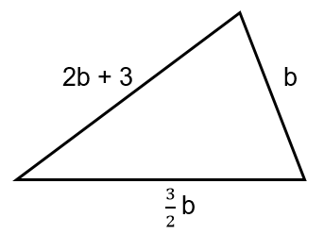  Ask learners to describe in words how the side lengths of the triangle are related and then to find an expression for the perimeter of the triangle.

Unit 8.2 Topic 2 Equations and inequalities

Outline of topic:
Learners will form and solve equations. Learners will also investigate the different types of inequalities to find all possible integer solutions.

Language:
Key vocabulary:
equation
solve, solution
inequalities
integers

Recommended prior knowledge:
- Collect like terms and simplify expressions
- Solve simple equations with integer coefficients and with the unknown on one side
- Use and interpret the symbols < and >

Learning objectives | Suggested teaching activities and resources | Mental strategies, possible misconceptions and comments
8Ae.06 Understand that a situation can be represented either in words or as an equation. Move between the two representations and solve the equation (integer or fractional coefficients, unknown on either or both sides). | Show learners the following information:  Two straight lines intersect so that the larger angle formed is tº. The larger angle is three times the size of the smaller angle.  Ask learners:  Is this possible? Write an expression for the smaller angle.  What are the sizes of the angles? Write an equation to represent the problem.  Encourage learners to draw a diagram to represent the problem, for example:  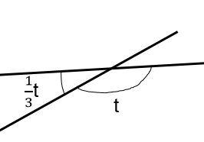  Using their knowledge of angles at a point, or angles on a straight line, learners should form and solve an equation, such as:  t + $\frac{1}{3}$t = 180º  $1\frac{1}{3}$t = 180º  t = 135º  So, the larger angle is 135º and the smaller angle is $\frac{1}{3}$ × 135º = 45º
8Ae.06 Understand that a situation can be represented either in words or as an equation. Move between the two representations and solve the equation (integer or fractional coefficients, unknown on either or both sides). | Ask learners to calculate the perimeter of the following shape, from the information given:  Learners should first write an equation to find x. They should notice the horizontal length of the top edge is equal to the horizontal length of the bottom edge. An equation with the unknown x on both sides can be written and solved:  x – 3 + 10 = 2x  x + 7 = 2x  7 = x  Learners should then use substitution of x = 7 to find the perimeter of the shape is 52.
8Ae.07 Understand that letters can represent open and closed intervals (two terms). | Present learners with the following inequalities:  x > 0  x $≥$ 0  0 $≤$ x $≤$ 4  0 < x < 4  Ask learners to represent each inequality on a number line and then explore which integers satisfy each inequality. For example, for 0 < x < 4, the integer values of x could be 1, 2 or 3:  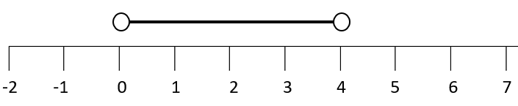  x  Ask learners:  Which inequality has the fewest integer solutions? (Answer: 0 < x < 4 only has 3 integer solutions)  Which inequality has the most integer solutions? (Answer: x $≥$ 0)  Then ask learners to write inequalities which satisfy the criteria below:  - has 2 integer solutions  - has no integer solutions  - has only negative solutions.

Unit 8.3 2D and 3D shape

Learning objectives covered in Unit 8.3 and topic summary: |  | 8.3 Topic 1  Quadrilaterals and polygons | 8.3 Topic 2  Area, perimeter and circumference | 8.3 Topic 3  3D shapes, surface area and volume | Thinking and Working Mathematically
8Gg.01 | Identify and describe the hierarchy of quadrilaterals. |  |  |  | TWM.05 Characterising  TWM.06 Classifying
8Gg.02 | Understand π as the ratio between a circumference and a diameter. Know and use the formula for the circumference of a circle.
8Gg.04 | Use knowledge of rectangles, squares and triangles to derive the formulae for the area of parallelograms and trapezia. Use the formulae to calculate the area of parallelograms and trapezia. |  |  |  | TWM.02 Generalising
8Gg.05 | Understand and use Euler’s formula to connect number of vertices, faces and edges of 3D shapes.
8Gg.06 | Use knowledge of area and volume to derive the formula for the volume of a triangular prism. Use the formula to calculate the volume of triangular prisms. |  |  |  | TWM.02 Generalising
8Gg.07 | Represent front, side and top view of 3D shapes to scale.
8Gg.08 | Use knowledge of area, and properties of cubes, cuboids, triangular prisms and pyramids to calculate their surface area. |  |  |  | TWM.02 Generalising
8Gg.09 | Understand that the number of sides of a regular polygon is equal to the number of lines of symmetry and the order of rotation. |  |  |  | TWM.02 Generalising

Unit 8.3 Topic 1 Quadrilaterals and polygons

Outline of topic:
Learners will investigate the necessary and sufficient properties to define each specific type of quadrilateral and explore the symmetrical properties of regular polygons.

Language:
Key vocabulary:
quadrilateral, square, rectangle, parallelogram, trapezium, rhombus, kite
regular, irregular
line of symmetry
rotational symmetry
polygon

Key phrases:
The … has an order of rotational symmetry of …
The … has … lines of symmetry

Recommended prior knowledge:
- Identify and describe quadrilaterals and regular polygons, including reference to sides, angles and symmetrical properties

Learning objectives | Suggested teaching activities and resources | Mental strategies, possible misconceptions and comments
8Gg.01 Identify and describe the hierarchy of quadrilaterals.  TWM.05 Characterising  Identifying and describing the mathematical properties of an object  TWM.06 Classifying  Organising objects into groups according to their mathematical properties | Give each pair of learners several pieces of blank paper. Ask each pair of learners to write the names of as many quadrilaterals as they can think of on separate pieces of paper. Learners should also sketch each quadrilateral and label or list its properties. For example, for a parallelogram:  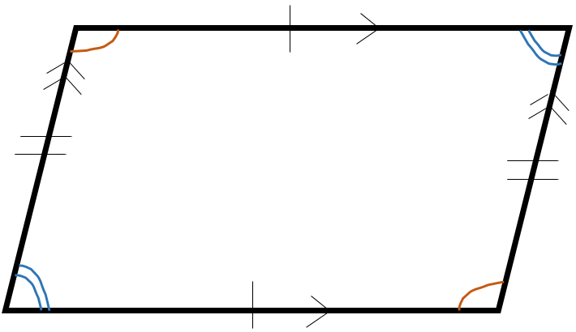  - opposite sides are parallel  - opposite sides are equal length  - opposite angles are equal  Ask learners to sort, organise or group the quadrilaterals by their properties and then ask them to share their ideas with the class. Learners should be able to justify how they have organised the quadrilaterals.  Learners will show they are characterising (TWM.05) when they identify associated properties of the quadrilaterals. They will show they are classifying (TWM.06) when they organise the quadrilaterals by like properties.  Establish the hierarchy of quadrilaterals and the definition of each quadrilateral, discussing the necessary and sufficient properties. For example, learners should recognise that any rectangle is also a parallelogram, although not all parallelograms are rectangles.
8Gg.09 Understand that the number of sides of a regular polygon is equal to the number of lines of symmetry and the order of rotation.  TWM.02 Generalising  Recognising an underlying pattern by identifying many examples that satisfy the same mathematical criteria | Give each learner an equilateral triangle drawn on a piece of paper. Ask learners to cut out the equilateral triangle. Then ask learners to fold the triangle to show the three lines of symmetry. The lines of symmetry should meet to show the centre of the triangle. Ask learners to use a sharp pencil or compass point placed firmly on the centre of the triangle, and turn the triangle to show the rotational symmetry.  Ask learners:  How many lines of symmetry does an equilateral triangle have?  What is the order of rotational symmetry of an equilateral triangle?  Then provide learners with other regular polygons such as a regular quadrilateral (square), a regular pentagon and a regular hexagon and ask them to repeat this activity.  Ask learners:  What do you notice about the relationship between the number of sides of the polygon, the number of lines of symmetry and the order of rotational symmetry?  Is this true for a rectangle? Why not?  How many lines of symmetry would a regular decagon (10 sides) have and what is its order of rotational symmetry?  Learners will show they are generalising (TWM.02) when they notice that regular shapes always have the same number of lines of symmetry and the same order of rotational symmetry as the number of sides.  Resources:  Regular polygons drawn on paper  Scissors | Triangles have numerous centres, defined in different ways such as centroid, circumcentre and orthocentre. The centre of the triangle found in this activity is called the incentre.  Possible misconceptions:  Learners may incorrectly state that a shape has an order of rotational symmetry of zero. All shapes will look identical after having completed one complete turn.

Unit 8.3 Topic 2 Area, perimeter and circumference

Outline of topic:
Learners will investigate pi (π) by considering the ratio of circumference to diameter. They will also derive the formula for the area of parallelograms and the formula for the area of trapezia.

Language:
Key vocabulary:
circumference, diameter, radius
pi (π)
formula, formulae
parallelogram, trapezium
congruent

Recommended prior knowledge:
- Identify and describe quadrilaterals and regular polygons, including reference to sides, angles and symmetrical properties
- Know the parts of a circle, including centre, radius, diameter, circumference, chord and tangent

Learning objectives | Suggested teaching activities and resources | Mental strategies, possible misconceptions and comments
8Gg.02 Understand π as the ratio between a circumference and a diameter. Know and use the formula for the circumference of a circle. | Learners work in pairs for this activity. Give each pair of learners several circular objects (e.g. tins, lids, cups) and ask them to measure the circumference and diameter of each circle.  Select learners to share one of their results with the class and tabulate the results on the board:  Once several results have been recorded ask learners:  Is there a relationship between the diameter and the circumference?  If learners cannot see a relationship, extend the table to create a third column, where learners should calculate circumference ÷ diameter. Learners should notice that the circumference is approximately three times the length of the diameter.  Introduce learners to the constant pi (π). Explain that pi is the exact ratio of the circumference of a circle to its diameter. Learners should understand that pi is approximately 3.14, but that the exact value of pi cannot be written in numeric form, as it is a decimal with infinitely many decimal places, and hence we use the symbol π to represent this number.  From this, learners should derive the formula for the circumference of a circle, C = πd. Give learners a selection of questions where they are required to use the formula to find the circumference, diameter or radius of a circle. For example:  - Find the circumference of a circle with diameter 12.4cm.  - Find the circumference of a circle with radius 79mm.  - Find the diameter of a circle with circumference 178m.  - Find the radius of a circle with circumference 2km.  Resources:  Circular objects (e.g. tins, lids, cups)  String or tape measures for the circumference measurement
  Diameter | Circumference
  … | …
8Gg.04 Use knowledge of rectangles, squares and triangles to derive the formulae for the area of parallelograms and trapezia. Use the formulae to calculate the area of parallelograms and trapezia.  TWM.02 Generalising  Recognising an underlying pattern by identifying many examples that satisfy the same mathematical criteria | Give each learner a sheet of centimetre squared paper. Ask learners to draw a parallelogram, ensuring horizontal edges are in line with the squared paper, e.g.  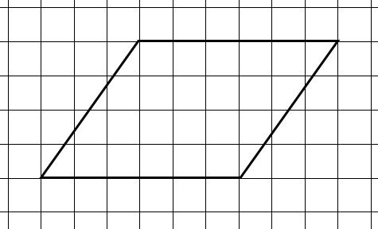  Ask learners to find the area of the parallelogram by dividing it into a rectangle and two congruent triangles. Support learners to see that they can turn their shape into a rectangle by moving one of the triangles, e.g.  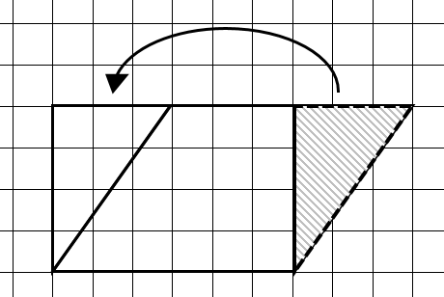  Ask learners:  Can you use this diagram to write the formula for finding the area of a parallelogram?  Learners will show they are generalising (TWM.02) when they notice the area of a parallelogram can be found in the same way as a rectangle, by multiplying the base by the perpendicular height. They should use this to derive the formula for the area of a parallelogram: A = b × h, where b is the base and h is the perpendicular height.  Learners should then use the formula to find the area of parallelograms which are not drawn on a square grid.  Resources:  Centimetre squared paper | Possible misconceptions:  Although this task is set out so that the parallel lines are horizontal, learners need to recognise that parallel lines can go in any direction (e.g. vertical or with a diagonal slope).
8Gg.04 Use knowledge of rectangles, squares and triangles to derive the formulae for the area of parallelograms and trapezia. Use the formulae to calculate the area of parallelograms and trapezia. | Give each learner an isosceles trapezium drawn on centimetre squared paper with horizontal base 10cm and parallel edge 6cm:  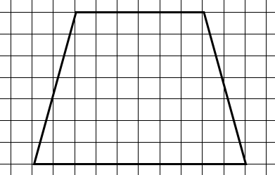  Ask learners to find the area of the trapezium by dividing it into a rectangle and two congruent triangles. Support learners to see that they can turn their shape into a rectangle by moving and reflecting one of the triangles, e.g.  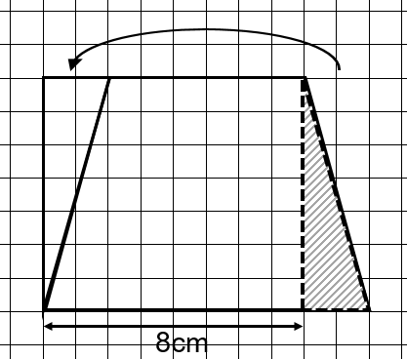  Learners should notice that this rectangle has the same height as the original trapezium, but now has horizontal width 8cm. Show learners the formula for the area of a trapezium: A = $\frac{1}{2}$ (a + b) × h, where a and b are the parallel sides of the trapezium and h is the perpendicular height. Ask learners to discuss with a partner and explain how the formula is derived. They should recognise that the $\frac{1}{2}$ (a + b) is the mean of the two parallel sides of the trapezium.  Ask learners to draw other trapezia on centimetre squared paper (including non-isosceles trapezia). They should find the area of each by dividing them into a rectangle and two triangles and then confirm that using the formula for the area gives the same result.  Learners should then use the formula to find the area of trapezia which are not drawn on a square grid.  Resources:  Centimetre squared paper

Unit 8.3 Topic 3 3D shapes, surface area and volume

Outline of topic:
Learners will study the properties of 3D shapes and the relationships between them. They will apply their understanding of 3D shapes and area to derive the formula for the volume and surface area of triangular prisms and to calculate the surface areas of pyramids.

Language:
Key vocabulary:
polyhedron, polyhedra
vertex, vertices, edges, faces
Euler
prism
net
perpendicular
scale
surface area, volume

Recommended prior knowledge:
- Identify and describe the combination of properties that determine a specific 3D shape
- Use knowledge of area, and properties of cubes and cuboids to calculate their surface area

Learning objectives | Suggested teaching activities and resources | Mental strategies, possible misconceptions and comments
8Gg.05 Understand and use Euler’s formula to connect number of vertices, faces and edges of 3D shapes. | Give learners a selection of polyhedra (e.g. solid shapes, boxes, or pictures of a cube, triangular prism, etc.). They should identify the number of vertices, faces and edges for each shape and record their results in a table:  Select learners to share their results and write these on the board. Once several results have been recorded, ask learners to discuss with a partner what they notice about the results.  Introduce learners to Euler’s formula V + F – E = 2 and ask learners to confirm that this formula is true for the polyhedra in their table.  Then ask learners to use Euler’s formula to find missing information about polyhedral, such as:  How many edges does a polyhedron with eight vertices and six faces have?  What 3D shapes could this be?  How many faces does a polyhedron with eight edges and five vertices have?  What 3D shape could this be?  Resources:  Models or pictures of polyhedra | Possible misconceptions:  Learners may incorrectly think that Euler’s formula applies to all 3D shapes. Ensure learners know that Euler’s formula applies only to polyhedra (3D shapes with plane faces). It does not apply to, for example, a cylinder.
  Shape | Vertices | Faces | Edges
  Cube | 8 | 6 | 12
  …
8Gg.06 Use knowledge of area and volume to derive the formula for the volume of a triangular prism. Use the formula to calculate the volume of triangular prisms.  TWM.02 Generalising  Recognising an underlying pattern by identifying many examples that satisfy the same mathematical criteria | In pairs, learners discuss and recall how to find the volume of cubes and cuboids. Then show learners the right-angled triangular prism below:  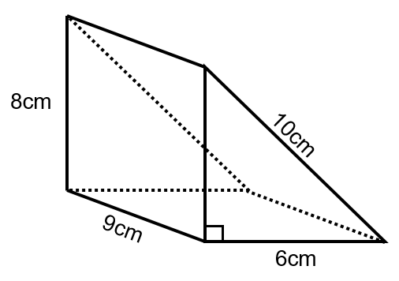  Ask learners:  What is the volume of this triangular prism?  What is your method?  Write a formula for the volume of any triangular prism.  Learners will show they are generalising (TWM.02) when they derive the formulae for the volume of a triangular prism.  volume of triangular prism = length × width × perpendicular height  2  Show learners that the volumes of cubes, cuboids and triangular prisms can be found by finding the area of the cross-section and then multiplying by the length of the prism:  volume of prism = area of cross section × length
8Gg.08 Use knowledge of area, and properties of cubes, cuboids, triangular prisms and pyramids to calculate their surface area.  TWM.02 Generalising  Recognising an underlying pattern by identifying many examples that satisfy the same mathematical criteria | Learners work in small groups with cuboid-shaped boxes. They discuss, using their previous knowledge, how to find the surface area of a cuboid by measuring lengths and calculating.  Invite a learner to use a cuboid net to model the derivation of the surface area to the class:  Total surface area = sum of surface area of all six faces  = (2 × width × length) + (2 × width × height) + (2 × length x height)  = 2 (wl + wh + lh)  Then repeat this activity with triangular prism-shaped and pyramid-shaped boxes.  Learners will show they are generalising (TWM.02) when they derive the formulae for the surface area of 3D shapes.  Resources:  Cuboid-shaped boxes  Cuboid nets
8Gg.06 Use knowledge of area and volume to derive the formula for the volume of a triangular prism. Use the formula to calculate the volume of triangular prisms.  8Gg.07 Represent front, side and top view of 3D shapes to scale.  8Gg.08 Use knowledge of area, and properties of cubes, cuboids, triangular prisms and pyramids to calculate their surface area. | Give learners the net of a triangular prism drawn with the following dimensions:  Ask learners to fold the net to make the triangular prism. Explain that this will be a model of a roof for a building, using a scale of 1cm: 1m. The roof has a perpendicular height of 3m.  Ask learners to use the same scale to draw front, side and top views of the roof.  Then explain that the roof will be filled with insulation material. Learners should find the volume of the roof by using the formula they derived previously.  Every surface of the roof, including its base, will need to be treated with a waterproof paint. Using the net, learners should calculate the total surface area.  This activity can be extended by providing learners with some additional information and asking them further questions about the roof. For example:  Insulation costs $39.99 per cubic metre, and one tin of paint covers 45m² and costs $24.99. How much will the insulation material and paint cost altogether?  Resources:  Centimetre squared paper  Pre-drawn triangular prism nets

Unit 8.4 Fractions, decimals, percentages, ratio and proportion

Learning objectives covered in Unit 8.4 and topic summary: |  | 8.4 Topic 1  Comparing numbers | 8.4 Topic 2  Calculating with fractions | 8.4 Topic 3  Percentage change, ratio and proportion | Thinking and Working Mathematically
8Ni.04 | Understand the hierarchy of natural numbers, integers and rational numbers. |  |  |  | TWM.01 Specialising  TWM.04 Convincing  TWM.06 Classifying
8Nf.01 | Recognise fractions that are equivalent to recurring decimals.
8Nf.06 | Understand the relative size of quantities to compare and order decimals and fractions (positive and negative), using the symbols =, ≠, >, <, ≤ and ≥.
8Nf.02 | Estimate and subtract mixed numbers, and write the answer as a mixed number in its simplest form.
8Nf.03 | Estimate and multiply an integer by a mixed number, and divide an integer by a proper fraction. |  |  |  | TWM.08 Improving
8Nf.04 | Use knowledge of the laws of arithmetic and order of operations (including brackets) to simplify calculations containing decimals or fractions.
8Nf.05 | Understand percentage increase and decrease, and absolute change.
8Nf.09 | Understand and use the relationship between ratio and direct proportion.
8Nf.10 | Use knowledge of equivalence to simplify and compare ratios (different units).
8Nf.11 | Understand how ratios are used to compare quantities to divide an amount into a given ratio with two or more parts.

Unit 8.4 Topic 1 Comparing numbers

Outline of topic:
Learners will learn about the different types of numbers and how they relate to each other. They will be able to convert fractions to recurring and terminating decimals and use these skills to compare and order values.

Language:
Key vocabulary:
natural number, integer, rational number
Venn diagram
recurring decimals, terminating decimals
equivalent

Recommended prior knowledge:
- Recognise that fractions, decimals (terminating) and percentages have equivalent values
- Understand and use Venn diagrams
- Familiarity with inequality signs

Learning objectives | Suggested teaching activities and resources | Mental strategies, possible misconceptions and comments
8Ni.04 Understand the hierarchy of natural numbers, integers and rational numbers.  TWM.06 Classifying  Organising objects into groups according to their mathematical properties  TWM.01 Specialising  Choosing an example and checking to see if it satisfies or does not satisfy specific mathematical criteria  TWM.04 Convincing  Presenting evidence to justify or challenge a mathematical idea or solution | Discuss the meanings of the terms natural number, integer and rational number.  Ask learners to think of a number. Then show learners the diagram below and ask them to decide in which region their number belongs.  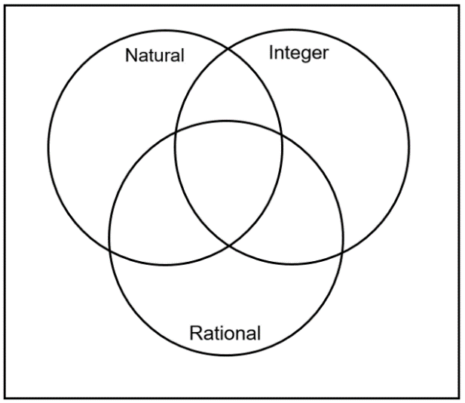  Learners will show they are classifying (TWM.06) when they organise numbers according to their properties into the correct regions of the Venn diagram.  Then ask learners to find examples of numbers that belong in each of the eight regions, if possible. If they think it is not possible, they should explain why.  Learners will show they are specialising (TWM.01) when they find examples of numbers which belong in each region. They will show they are convincing (TWM.04) when they justify why it is impossible to complete certain regions of the Venn diagram.  This activity can be extended by asking learners to suggest a different diagram to represent the three sets of numbers. | The regions which cannot be completed are marked by an “X” in the diagram below. Possible numbers for the other regions are also shown:  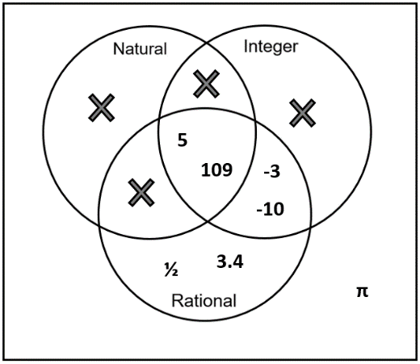  For this activity a Venn diagram is used to allow learners an opportunity to think and work mathematically. However, a more suitable diagram which represents the hierarchy of natural numbers, integers and rational numbers is shown below:  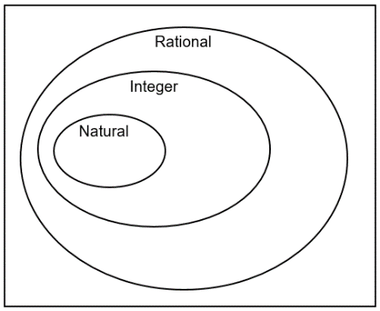
8Nf.01 Recognise fractions that are equivalent to recurring decimals. | Ask learners to convert the fractions$\frac{1}{4}$, $\frac{1}{5}$ and $\frac{1}{8}$ into decimals by dividing the numerator by the denominator using a short division method. Then ask learners to convert $\frac{1}{3}$ in the same way. They should discover that the answer will be a recurring decimal (0.33333…). Establish that this decimal can be written as$0.\dot{3}$. Ask learners to use their answer to write $\frac{2}{3}$ as a decimal.  Using calculators, learners should investigate different unit fractions to see which ones give recurring answers and record their results in a table:  Learners should recognise that if a unit fraction, such as$\frac{1}{11}$ , is equivalent to a recurring decimal, then proper fractions that are multiples of this unit fraction will also be equivalent to recurring decimals, i.e. $\frac{2}{11}, \frac{3}{11}, \frac{4}{11}, …,\frac{9}{11}$ are also equivalent to recurring decimals. | Learners should check their answers to their short division calculations using a calculator.  Possible misconceptions:  Learners may incorrectly interpret a calculator display, leading them to believe that some recurring decimals terminate. For example, for$\frac{2}{3}$, when calculating 2 ÷ 3 the calculator may display 0.6666666667, as the result has been rounded.
  Fraction | Equivalent decimal | Recurring or terminating?
  $$\frac{1}{2}$$ | 0.5 | Terminating
  $$\frac{1}{3}$$ | $$0.\dot{3}$$ | Recurring
  $$\frac{1}{4}$$ | 0.25 | Terminating
  …
8Nf.06 Understand the relative size of quantities to compare and order decimals and fractions (positive and negative), using the symbols =, ≠, >, <, ≤ and ≥. | Show learners the inequality 0.5 $<x≤$ 1. Ask them to write on individual pieces of card, five decimals and five fractions that satisfy the inequality.  Ask learners to work in small groups and collect all of their fraction and decimal cards and place them face down in a pile. Learners take it in turns to reveal two quantities to compare, make a verbal statement to their group and then record it in their books. For example, if they reveal 0.56 and $\frac{3}{5}$ the learner might say, “$\frac{3}{5}$ is greater than 0.56” and write in their books $\frac{3}{5}$ > 0.56. This is repeated several times, until the pile of cards is finished.  Then ask each group of learners to order all of their fractions and decimals from smallest to largest.  This activity can be extended by repeating the activity for values that satisfy 0.3$<x≤$ 1.3.  Resources:  Pieces of card | A number line can be used to support learners’ thinking. This establishes the context of fractions and decimals being used on a continuous scale as opposed to being part of a whole.

Unit 8.4 Topic 2 Calculating with fractions

Outline of topic:
Learners will estimate answers to fraction calculations and consider the most efficient method of calculation. They will apply the laws of arithmetic and the order of operations to calculations involving fractions.

Language:
Key vocabulary:
mixed number
proper and improper fractions
estimate
simplify

Recommended prior knowledge:
- Multiply and divide two proper fractions
- Simplify fractions
- The order of operations

Learning objectives | Suggested teaching activities and resources | Mental strategies, possible misconceptions and comments
8Nf.02 Estimate and subtract mixed numbers, and write the answer as a mixed number in its simplest form. | Ask learners:  Which value is easier to visualise: $\frac{22}{7}$ or 3$\frac{1}{7}$ ?  Establish that although both values are equivalent, simplifying an answer and changing an improper fraction to a mixed number can make it easier to understand. Learners should now create ten of their own improper fractions with single digit denominators and swap with another learner to see if they can write the improper fractions as mixed numbers in their simplest form.  Then show learners the following four calculations:  $4\frac{4}{5}-2\frac{3}{5}$, $4\frac{1}{5}-2\frac{3}{5}$, $4\frac{4}{5}-2\frac{3}{7}$, $4\frac{1}{5}-2\frac{3}{7}$  Ask learners to discuss the questions in pairs and determine which they think are the easiest and which are more difficult. Encourage learners to explain their reasons. For example, learners should notice that for calculations 2 and 4 it is necessary to regroup or convert to improper fractions, e.g. writing $4\frac{1}{5}-2\frac{3}{5}$ as 3$\frac{6}{5}-2\frac{3}{5}$ or $\frac{21}{5}-\frac{13}{5}$. They should also notice that for questions 3 and 4 it is easier to find equivalent fractions with the same denominators, e.g. writing $4\frac{4}{5}-2\frac{3}{7}$ as $4\frac{28}{35}-2\frac{15}{35}$ and writing their answers in their simplest form.  Learners should consider the most efficient method for each calculation and use these to find answers. | Learners should check their answers using estimation. If an answer is incorrect, ask:  Does this answer look correct?  What would your estimate for the answer be?
8Nf.03 Estimate and multiply an integer by a mixed number, and divide an integer by a proper fraction.  TWM.08 Improving  Refining mathematical ideas or representations to develop a more effective approach or solution | Give learners a set of questions where they are asked to multiply integers by mixed numbers such as:  - 8 × 2 $\frac{1}{2}$  - 5 × 3 $\frac{1}{4}$  - 10 × 5 $\frac{2}{3}$  - 7 × 6 $\frac{7}{8}$  Ask learners to answer them and clearly write their method each time. Then, ask learners to compare and discuss their methods with other learners.  For example, for 8 × 2 $\frac{1}{2}$, some learners may have used a mental strategy ($\frac{1}{2}$ of 8 added to 2 × 8), some may have used a diagram to represent the problem and other learners may have converted 2 $\frac{1}{2}$ to an equivalent decimal and used a written multiplication method for 8 × 2.5.  Did you both use the same method?  Which method is most efficient?  Does the most efficient method change depending on the question?  Select learners to share their ideas with the class.  Then repeat the activity for questions where learners divide integers by proper fractions, such as:  - 4 ÷ $\frac{1}{2}$  - 3 ÷ $\frac{1}{5}$  - 6 ÷ $\frac{3}{7}$  - 7 ÷ $\frac{8}{9}$  Learners will show they are improving (TWM.08) when they reflect on their previous methods and develop more effective approaches for finding answers, depending on the questions. | Learners should check their answers using estimation. If an answer is incorrect, ask:  Does this answer look correct?  What would your estimate for the answer be?  Possible misconceptions:  Learners will often incorrectly see dividing by $\frac{1}{2}$ as ‘half of …’ rather than ‘how many halves are there in …’. For example, learners may think  4 ÷ $\frac{1}{2}$ is 2, rather than 8. Using diagrams, ask learners how many halves there are in one whole as this with help them to visualise the answer.
8Nf.04 Use knowledge of the laws of arithmetic and order of operations (including brackets) to simplify calculations containing decimals or fractions. | Ask learners to find the answer to the following calculation:  $$\frac{2}{3}+ \frac{2}{3} × \frac{1}{2}$$  Ask learners to discuss their method in pairs. If learners followed the correct order of operations, they should have found the answer is 1.  Give learners other calculations involving fractions, which require the order of operations to be followed correctly, for them to discuss and answer in pairs. For example:  $$\frac{4+5×1}{6}-\frac{1}{3} ÷2$$  Then ask learners to find the answer to the following calculation:  $$\frac{4}{5}×\frac{16}{17}+ \frac{1}{5}×\frac{16}{17}$$  Ask learners:  Can you simplify this calculation?  Which law of arithmetic could you apply?  Learners should notice the distributive law could help simplify the calculation to$$\frac{16}{17}\left(\frac{4}{5}+\frac{1}{5}\right)=\frac{16}{17}$$  Give learners further calculations involving fractions, which could be simplified using their knowledge of the laws of arithmetic.

Unit 8.4 Topic 3 Percentage change, ratio and proportion

Outline of topic:
Learners will use and apply knowledge of percentage to consider how values can be increased or decreased as a proportion of their original amount and understand absolute change.

Learners will investigate the relationship between ratio and proportion. They will apply their knowledge to different skills relating to ratios, such as simplifying ratios with different units and sharing quantities in a given ratio.

Language:
Key vocabulary:
percentage increase, percentage decrease
sale
percentage of
percentage off
decimal equivalence
ratio
parts
direct proportion
equivalence
simplify

Key phrases:
The ratio of … to …

Recommended prior knowledge:
- Recognise percentages, including those less than 1 or greater than 100, of shapes and whole numbers
- Simplify ratios and identify equivalent ratios
- Divide an amount into a given ratio with two parts

Learning objectives | Suggested teaching activities and resources | Mental strategies, possible misconceptions and comments
8Nf.05 Understand percentage increase and decrease, and absolute change. | Ask learners what typical sales or advertisements involving percentages they see in real life, for example, “10% off selected items” or “50% extra free” etc.  Introduce learners to the multiplier method for calculating percentage increase and decrease.  Ask learners:  If there is an offer for 15% extra free, what percentage of the original amount is for sale? (Answer: 115%)  What is this as a decimal? (Answer: 1.15)  If there is sale with 2% off items, what percentage of the original amount is the sale price? (Answer: 98%)  What is this as a decimal? (Answer: 0.98)  Establish that multiplying the original amount by the multiplier 1.15 will increase the amount by 15%. Similarly, using the multiplier 0.98 will decrease the original amount by 2%.  Give learners a selection of offers where they should decide which they would rather accept. For example:  Would you rather buy a game from shop A, where the original price was $30 with 15% off, or from shop B where the original price was $32 with 20% off?  For the same price, would you rather buy a box of cereal that was originally 350g with 20% extra free, or a box of cereal that was originally 400g with 10% extra free?  For each offer, learners should compare the final offers before making a decision and also find the absolute change. For example:  Shop A  0.85 × $30 = $25.50  Absolute change = $30 - $25.50 = $4.50  Shop B  0.8 × $32 = $25.60  Absolute change = $32 - $25.60 = $6.40  Learners should then create their own ‘would you rather’ sales and offers and swap their questions with a partner to answer. | For this activity learners need to appreciate equivalent percentages and decimals (e.g. 50% is 0.5 and 100% is 1.0, etc.).  Possible misconceptions:  Learners often incorrectly think you cannot have 110% because percentages cannot be greater than 100%.
8Nf.09 Understand and use the relationship between ratio and direct proportion.  8Nf.10 Use knowledge of equivalence to simplify and compare ratios (different units). | Ask learners to measure and cut pieces of paper using a length to width ratio of 1:2. They should place these over each other as shown:  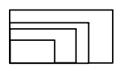  Ask learners:  What happens to the length as the width increases?  What is the relationship between the width and length of the rectangles?  Can you write this as a formula? (Answer: W = 2L, or L = $\frac{1}{2}$W)  Explain that the lengths and widths of the rectangles are in direct proportion and show learners that if you connect the corners of the rectangles they should lie on a straight line.  Then draw a sketch of a rectangle on the board and label the width 1.2m and the length 60cm. Ask learners to express the length to width ratio of the rectangle in its simplest form. Learners should understand that in order to simplify the ratio, the same units are required, so should convert 1.2m to 120cm or 60cm to 0.6m. Learners should notice the rectangle is in the same proportion as the rectangles they previously drew.  This activity can be extended by asking learners to investigate rectangles where the width and length are in a different ratio, such as 1:3, or 2:3.  Resources:  Scissors
8Nf.11 Understand how ratios are used to compare quantities to divide an amount into a given ratio with two or more parts. | Give learners the following problems and ask them to discuss and solve them in pairs:  A triangle with perimeter of 36cm has sides in the ratio 3:4:5. What is the length of each side?  A rectangle has perimeter 90cm. The rectangle has width and length in the ratio 7:2. What is the length and the width of the rectangle? | A bar model or other diagrams can be used to help learners visualise ratio questions.

Unit 8.5 Probability

Learning objectives covered in Unit 8.5 and topic summary: |  | 8.5 Topic 1  Complementary and combined events | 8.5 Topic 2  Experimental probability | Thinking and Working Mathematically
8Sp.01 | Understand that complementary events are two events that have a total probability of 1. |  |  | TWM.02 Generalising
8Sp.02 | Understand that tables, diagrams and lists can be used to identify all mutually exclusive outcomes of combined events (independent events only). |  |  | TWM.03 Conjecturing  TWM.04 Convincing  TWM.07 Critiquing
8Sp.03 | Understand how to find the theoretical probabilities of equally likely combined events. |  |  | TWM.03 Conjecturing  TWM.04 Convincing
8Sp.04 | Design and conduct chance experiments or simulations, using small and large numbers of trials. Compare the experimental probabilities with theoretical outcomes.

Unit 8.5 Topic 1 Complementary and combined events

Outline of topic:
Learners will find theoretical probabilities of equally likely combined events using tables, diagrams and lists to identify all mutually exclusive outcomes. They will understand and generalise a rule for complementary events.

Language:
Key vocabulary:
dice (plural), die (singular)
theoretical probability, experimental probability
outcomes, events
mutually exclusive outcomes
complementary events
tree diagram

Key phrases:
The probability of … is …

Recommended prior knowledge:
- Use the language associated with probability and proportion to describe and compare possible outcomes
- Identify when two events can happen at the same time and when they cannot, and know that the latter are called mutually exclusive

Learning objectives | Suggested teaching activities and resources | Mental strategies, possible misconceptions and comments
8Sp.01 Understand that complementary events are two events that have a total probability of 1.  TWM.02 Generalising  Recognising an underlying pattern by identifying many examples that satisfy the same mathematical criteria | Give each learner a die and ask them to roll it and record their result.  Ask learners:  What would the theoretical probability of getting the same result again be? (Answer: $\frac{1}{6}$, no matter what number they rolled)  What would the theoretical probability of not getting the same result again be? (Answer: $\frac{5}{6}$)  Select learners to explain how they found their answer to the second question. Some learners may have considered how many results are not the same as the original roll (5 × $\frac{1}{6}$) and some may have calculated 1 – $\frac{1}{6}$.  Then explain that for a biased die, the probability of rolling a ‘6’ is 0.7.  Ask learners:  What would the probability of not getting a ‘6’ be? (Answer: 0.3)  Explain your method.  Select learners to explain their method to the class. This time it is not possible to consider the probabilities of rolling a ‘1’, ‘2’, ‘3’, ‘4’, or ‘5’, as these are unknown, so learners must use the calculation 1 – 0.7.  Ask learners:  Can you generalise this rule?  Learners will show they are generalising (TWM.02) when they can explain that if the probability of an event occurring is p, then the probability of it not occurring is 1 – p.  Resources:  Dice | Explain that the complement of event A is the event not A.  Introduce the notation P(A) + P(A’) = 1, which can be read as “the sum of the probability of A and the probability of not A is 1”.  Ensure learners also understand that, for example, flipping a coin and getting heads and flipping a coin and getting tails are complementary events, as P(not tails) = P(heads) and P(tails) + P(heads) = 1.
8Sp.02 Understand that tables, diagrams and lists can be used to identify all mutually exclusive outcomes of combined events (independent events only).  TWM.07 Critiquing  Comparing and evaluating mathematical ideas, representations or solutions to identify advantages and disadvantages | Show learners the following problem:  Chen is in a restaurant and wants to order a main course and dessert from the menu. His choices for the main course are pasta, salad, curry or tagine. His choices for the dessert are fruit or ice cream. Show Chen all of the possible combinations he could choose from.  Learners should use lists, tables or diagrams to systematically identify all menu combinations.  Show learners several different ways they can represent the information. For example:  In a table:  As a list:  Pasta and fruit  Pasta and ice cream  Salad and fruit  Salad and ice cream  Curry and fruit  Curry and ice cream  Tagine and fruit  Tagine and ice cream  In a tree diagram:  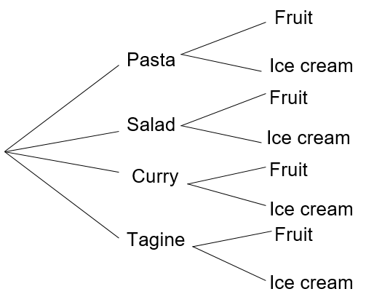  Ask learners to comment on each representation. Learners will show they are critiquing (TWM.07) when they identify advantages and disadvantages of the representations and recognise there are different methodical listing strategies for combined events.
   | Pasta | Salad | Curry | Tagine
  Fruit | P, F | S, F | C, F | T, F
  Ice cream | P, I | S, I | C, I | T, I
8Sp.02 Understand that tables, diagrams and lists can be used to identify all mutually exclusive outcomes of combined events (independent events only).  8Sp.03 Understand how to find the theoretical probabilities of equally likely combined events.  TWM.03 Conjecturing  Forming mathematical questions or ideas  TWM.04 Convincing  Presenting evidence to justify or challenge a mathematical idea or solution | Show learners the following information:  Oliver is playing a dice game. He has three options on his turn:  - roll one die  - roll two dice and add up the numbers  - roll two dice and multiply the numbers.  Oliver needs to roll a score of exactly six to win the game.  Ask learners:  Which option should Oliver choose to have the most chance of winning the game?  How can you convince Oliver that you are correct?  Learners will show they are conjecturing (TWM.03) when they suggest ideas about which option would be best. They will show they are convincing (TWM.04) when they present their reasoning clearly and show all possible mutually exclusive outcomes using tables, diagrams or lists.  This activity can be extended by asking learners further questions about Oliver’s options. For example:  - Oliver needs to roll an odd number to win the game. Which option should Oliver choose?  - Oliver needs to roll a prime number to win the game. Which option should Oliver choose?  - Oliver needs to roll a multiple of 3 to win the game. Which option should Oliver choose? | Learners should realise Oliver has the most chance if he rolls one die ($\frac{6}{36}$ is the highest probability). Possible solutions and diagrams are shown below.  Roll one die: $\frac{1}{6}$ = $\frac{6}{36}$  Roll two dice and add: $\frac{5}{36}$  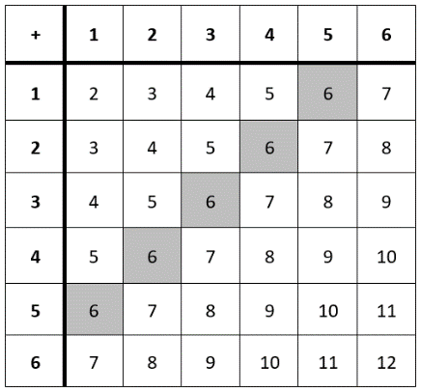  Roll two dice and multiply: $\frac{4}{36}$  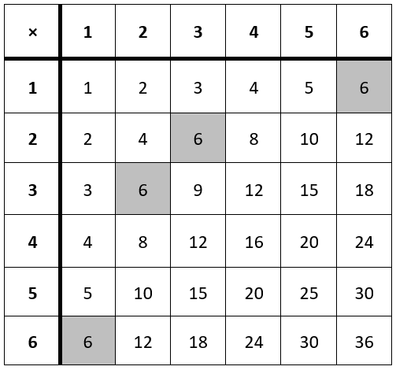

Unit 8.5 Topic 2 Experimental probability

Outline of topic:
Learners will explore theoretical and experimental probability and make comparisons between them. They will discover that with more trials, the accuracy of their probabilities will improve. Learners will use simulations and experimental probability to model a given situation.

Language:
Key vocabulary:
theoretical probability, experimental probability
trials
outcome, event
simulation

Key phrases:
The probability of … is …

Recommended prior knowledge:
- Conduct chance experiments or simulations, with small and large numbers of trials. Predict, analyse and describe the frequency of outcomes using the language of probability

Learning objectives | Suggested teaching activities and resources | Mental strategies, possible misconceptions and comments
8Sp.04 Design and conduct chance experiments or simulations, using small and large numbers of trials. Compare the experimental probabilities with theoretical outcomes. | Give each learner a die and ask them to roll it.  Ask the class:  Did anyone roll a 6?  What is the theoretical probability of rolling a 6?  How many learners would you have expected to roll a 6?  Do you think the dice I gave you are fair dice? Why or why not?  How could you gather more evidence to support your assumption?  Discuss the results as a class. Learners should compare the results of the experiment to the theoretical probabilities. They should understand that conducting more trials should lead to an experimental probability that is closer to the theoretical probability.  Ask learners to conduct 20 trials each and record the results of the whole class on the board. Discuss the results of using a larger number of trials and compare the experimental probability with the theoretical probability.  Then ask learners:  If I roll three dice and multiply the results, what is the probability of the product being an even number?  Ask learners to work in pairs design a chance experiment that will allow them to make an estimate for this probability. They should consider how many trials they will carry out and how to record their results. Learners should be encouraged to compare their findings with other pairs of learners.  This activity can be extended by asking learners to calculate the theoretical probability of the product of three dice rolls being an even number. Learners could then compare their experimental probability with the theoretical probability.  Resources:  Dice | Learners will discover the advantages of using decimals for probability with this activity. It will allow direct comparisons between experimental and theoretical probability. Fractions in an un-simplified form, however, are also useful as the denominator will indicate how many possible outcomes there are (when considering theoretical probability) and the number of trials conducted (when considering experimental probability).  If simulation software is available then use this can be used to roll dice.
8Sp.04 Design and conduct chance experiments or simulations, using small and large numbers of trials. Compare the experimental probabilities with theoretical outcomes.  8Sp.02 Understand that tables, diagrams and lists can be used to identify all mutually exclusive outcomes of combined events (independent events only). | The NRICH tasks: Which Team Will Win? (https://nrich.maths.org/9546) and The Dog Ate My Homework! (https://nrich.maths.org/9525) provide learners with a context to investigate simulations and experimental probability. The second task also informally introduces learners to using tree diagrams to represent combined events.  Resources:  NRICH tasks  Dice  Red, blue, green and yellow multi-link cubes (or use the online interactive environment)

Unit 8.6 Angles and construction

Learning objectives covered in Unit 8.6 and topic summary: |  | 8.6 Topic 1  Angles, bearings and measure | 8.6 Topic 2  Construction and midpoints | Thinking and Working Mathematically
8Gg.03 | Know that distances can be measured in miles or kilometres, and that a kilometre is approximately $\frac{5}{8}$ of a mile or a mile is 1.6 kilometres.
8Gg.10 | Derive and use the fact that the exterior angle of a triangle is equal to the sum of the two interior opposite angles.
8Gg.11 | Recognise and describe the properties of angles on parallel and intersecting lines, using geometric vocabulary such as alternate, corresponding and vertically opposite.
8Gg.12 | Construct triangles, midpoint and perpendicular bisector of a line segment, and the bisector of an angle.
8Gp.01 | Understand and use bearings as a measure of direction.
8Gp.02 | Use knowledge of coordinates to find the midpoint of a line segment. |  |  | TWM.07 Critiquing  TWM.08 Improving

Unit 8.6 Topic 1 Angles, bearings and measure

Outline of topic:
Learners will develop their skills of measuring distances and bearings in the context of looking at a map. They will also explore and derive the rules relating to exterior angles of triangles and those relating to transversals on parallel lines.

Language:
Key vocabulary:
parallel lines
transversal
alternate, corresponding, vertically opposite
exterior angle, interior angle
metric
scale map
bearing

Key phrases:
On a bearing of …
The bearing of … from …
The bearing from … to …

Recommended prior knowledge:
- Know that angles in a triangle add up to 180º and that angles on a straight line add up to 180º
- Measure and draw angles using a protractor
- Construct circles of a specified radius or diameter
- Recognise the properties of angles on:
- parallel lines and transversals
- perpendicular lines
- intersecting lines

Learning objectives | Suggested teaching activities and resources | Mental strategies, possible misconceptions and comments
8Gg.03 Know that distances can be measured in miles or kilometres, and that a kilometre is approximately $\frac{5}{8}$of a mile or a mile is 1.6 kilometres.  8Gp.01 Understand and use bearings as a measure of direction. | Give learners a scale map, preferably of the local area and ask them to identify two points on the map (e.g. the train station and the school) and connect these two points with a straight line. Ask learners to find the direct distance between the points, making use of the scale to write their answer in kilometres. Then ask learners to use an approximation of 1 km to $\frac{5}{8}$ of a mile to find the distance in miles. Learners should then choose more locations and find the distances between them in kilometres and miles.  Tell learners a new shop is being built exactly 4.5 miles from the school. Ask learners to find a possible location for the new shop on the map. Learners should then discuss their methods and answers with a partner to check they agree with their conversion from miles to kilometres and that their reasoning for the location of the shop is correct.  Ask learners to identify which direction is north on the map. This is usually detailed in the top right-hand corner of the map and all lines parallel to this also point north.  Ask learners to look at the line they drew previously to show the distance from the school to the train station. Ask learners:  What is the bearing of the station from the school?  What is the bearing of the school from the station?  Ask learners other questions about the map such as:  List three things that are on a bearing of 035° from the school.  A new café is being built on a bearing of 120° from the station. Find a suitable location for the café on the map.  Resources:  Scale maps of the local area | Learners could use calculators for this activity. Using the decimal equivalent of $\frac{5}{8}$ of a mile (0.625 miles) may be easier to work with.  Explain to learners that bearings are angles measured clockwise from north and are recorded using three digits.

Learning objectives | Suggested teaching activities and resources | Mental strategies, possible misconceptions and comments
8Gg.10 Derive and use the fact that the exterior angle of a triangle is equal to the sum of the two interior opposite angles. | Show learners the diagram below:  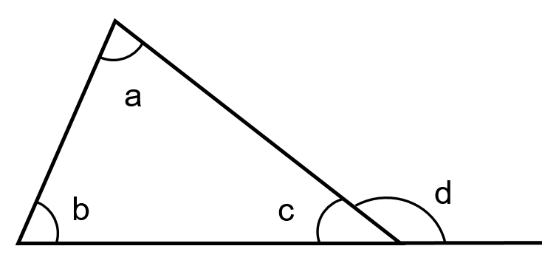  Ask learners:  What information can you determine from the diagram?  Can you use the diagram to derive two equations?  Learners should recall that angles in a triangle add up to 180° and angles on a straight line add up to 180°. They should write the equations:  a + b + c = 180 and d + c = 180  Show learners that a new equation can be created by equating the two above:  a + b + c = d + c  Subtracting c from both sides gives:  a + b = d  Ask learners to explain what this new formula shows in words (the exterior angle of a triangle is equal to the sum of the two interior opposite angles).  Give learners a selection of diagrams with missing angles, where they should apply the angle rule they derived for exterior angles of a triangle. Also, include examples of isosceles or equilateral triangles. For example:  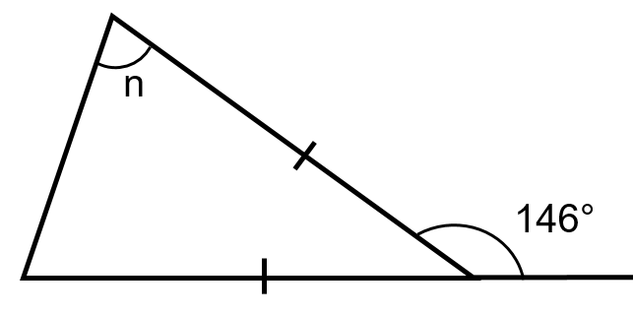

Learning objectives | Suggested teaching activities and resources | Mental strategies, possible misconceptions and comments
8Gg.11 Recognise and describe the properties of angles on parallel and intersecting lines, using geometric vocabulary such as alternate, corresponding and vertically opposite. | Give learners the diagram below:  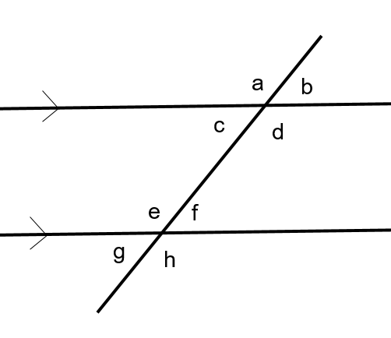  Ask learners to identify as many pairs of angles, which are the same size, as they can in one minute. For example, a=d, e=h, f=g, etc.  Select a learner to share one of their pairs of equal angles with the class. Introduce learners to the geometric vocabulary for this particular pair of angles, i.e. for the example a=d this would be “vertically opposite”. Discuss the properties of vertically opposite angles and how to identify them. Then ask learners to identify other pairs of vertically opposite angles in the diagram.  Then select another learner to give a different pair of equal angles, which are not vertically opposite. Repeat the steps above to cover the geometric vocabulary “alternate angles and corresponding angles”.  The NRICH task: Parallel Base (https://nrich.maths.org/10194) provides learners with further opportunity to identify alternate, corresponding and vertically opposite angles. Encourage learners to use the geometric vocabulary when giving reasons why two angles on parallel lines are the same.  Resources:  NRICH task | Possible misconceptions:  Learners sometimes incorrectly think ‘vertically opposite’ means that the angles have to be directly above and below each other. Any two opposite angles (when two straight lines cross) are equal and by changing the orientation, they can be shown to be vertically opposite.

Unit 8.6 Topic 2 Construction and midpoints

Outline of topic:
Learners will develop their construction skills, looking at mid-points, angle and line bisectors and the different types of triangles.

Language:
Key vocabulary:
construction
midpoint
bisector, perpendicular bisector
line segment
hypotenuse

Recommended prior knowledge:
- Know that angles in a triangle add up to 180º and that angles on a straight line add up to 180º
- Read and plot coordinates

Learning objectives | Suggested teaching activities and resources | Mental strategies, possible misconceptions and comments
8Gg.12 Construct triangles, midpoint and perpendicular bisector of a line segment, and the bisector of an angle. | 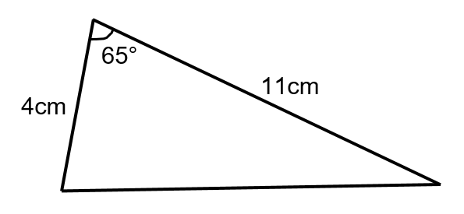  Ask learners to construct, using a ruler and protractor, the following types of triangles:  - given two sides and the included angle (SAS), e.g.  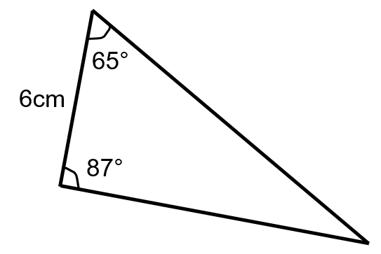  - two angles and the included side (ASA), e.g.  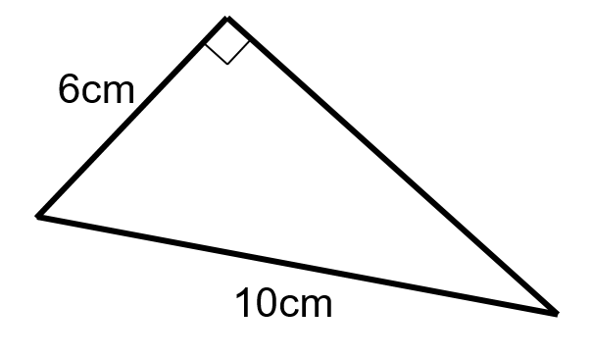  - given a right angle, hypotenuse and one side (RHS), e.g.  Learners should label and show the method they used for construction, including written instructions. Then ask learners to construct a triangle given three sides (SSS), e.g.  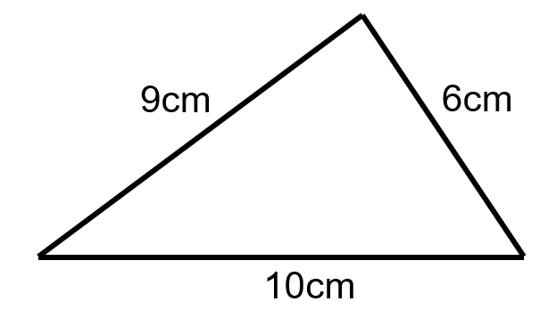  Use the video from the NRICH task: Constructing Triangles (https://nrich.maths.org/8098) to support learners with methods for constructing a triangle when given three sides. This NRICH task also provides further opportunity for learners to practise constructing these types of triangles and extends the activity by allowing learners to consider when it is and is not possible to draw a given triangle.  Resources:  NRICH task | When constructing triangles using a ruler and protractor, encourage learners to use light construction lines and not to rub them out. The final designed shape can be made more prominent by drawing the specific lines that form the triangle in a different colour.
8Gg.12 Construct triangles, midpoint and perpendicular bisector of a line segment, and the bisector of an angle. | Ask learners:  What does the word bisect mean?  Learners should understand that to bisect means to divide something (e.g. a line, angle or shape) into two equal pieces.  Instruct learners to draw a 70° angle and ask:  What would you expect to get if you bisect this angle? (Answer: two 35° angles)  How could you do this?  How could you do this if you did not have a protractor?  Demonstrate to learners the construction lines required to bisect an angle with a straight edge and compass. Learners should repeat the steps on their 70° angle and make notes of each step in their books.  Then instruct learners to draw a 7cm line and ask:  What would you expect to get if you bisect this line? (Answer: two 3.5cm lines)  How could you do this?  How could you do this if you did not have a ruler with centimetres marked?  Demonstrate to learners the construction lines required to bisect a line with a straight edge and compass. Explain that the point where the line is bisected is called the midpoint. Learners should repeat the steps on their 7cm line and make notes of each step in their books.  This activity can be extended by asking learners to draw a triangle (allowing space around it for construction lines) and then to draw the perpendicular bisectors of each side.  What do you notice about the three lines you have drawn?  Inform them that the point where the lines meet is called the circumcentre of the triangle.  Then ask learners to repeat this but to draw the angle bisectors of each angle instead. Inform learners that this is called the incentre of the triangle. | Encourage learners to check their constructions by measuring the lengths either side of the perpendicular bisector or the angles either side of the angle bisector to check they are equal.  For example, this triangle shows the perpendicular bisectors and bisectors of an angle. Point M is the circumcentre and the incentre because it is an equilateral triangle.  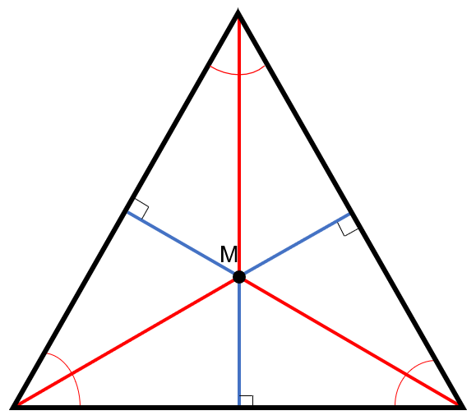

Learning objectives | Suggested teaching activities and resources | Mental strategies, possible misconceptions and comments
8Gp.02 Use knowledge of coordinates to find the midpoint of a line segment.  TWM.07 Critiquing  Comparing and evaluating mathematical ideas, representations or solutions to identify advantages and disadvantages  TWM.08 Improving  Refining mathematical ideas or representations to develop a more effective approach or solution | Ask learners to find the midpoint of the line segment between (1, 3) and (15, 7). Ask learners to compare their solution and the method they used with another learner.  - Did you both use the same method or different methods?  - Can you think of another method you could use?  - What are the advantages and disadvantages of each method?  Learners will show they are critiquing (TWM.07) when they compare different methods and representations of the problem, and discuss the possible advantages and disadvantages of each.  Give learners more questions to find the midpoint of a line segment so that they can try different methods. Ask learners to consider which they think is the most efficient method for each question and why.  Learners will show they are improving (TWM.08) when they reflect on their previous methods and develop a more effective approach for finding the midpoint. | Some possible methods learners may use are:  Method 1: Drawing and measuring on a grid  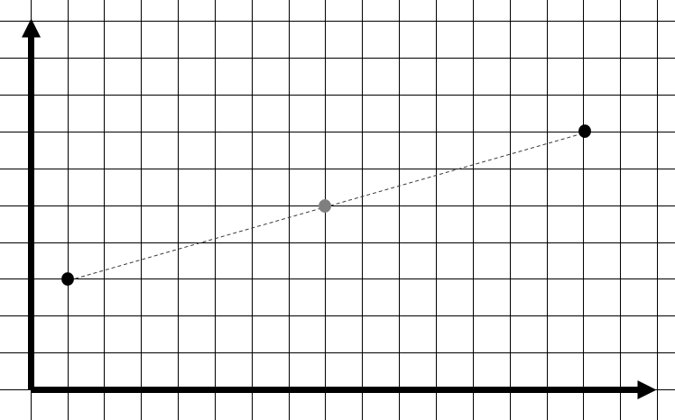  (8, 5)  Method 2: Finding the middle values  x-coordinate:  1, 2, 3, 4, 5, 6, 7, 8, 9, 10, 11, 12, 13, 14, 15  y-coordinate:  3, 4, 5, 6, 7  Method 3: Calculation  x-coordinate: (1 + 15) ÷ 2 = 8  y-coordinate: (3 + 7) ÷ 2 = 5  If learners do not discover these methods for themselves, demonstrate each to the class so that they have at least three methods to compare.

Unit 8.7 Sequences, functions and graphs

Learning objectives covered in Unit 8.7 and topic summary: |  | 8.7 Topic 1  Generating terms and finding rules of sequences | 8.7 Topic 2  Functions | 8.7 Topic 3  Graphs and equation of a straight line | Thinking and Working Mathematically
8As.01 | Understand term-to-term rules, and generate sequences from numerical and spatial patterns (including fractions).
8As.02 | Understand and describe $n$th term rules algebraically (in the form $n ± a$, $a × n,$or $an ± b,$where $a$ and $b$ are positive or negative integers or fractions). |  |  |  | TWM.02 Generalising
8As.03 | Understand that a function is a relationship where each input has a single output. Generate outputs from a given function and identify inputs from a given output by considering inverse operations (including fractions).
8As.04 | Understand that a situation can be represented either in words or as a linear function in two variables (of the form $y = mx + c$), and move between the two representations. |  |  |  | TWM.05 Characterising
8As.05 | Use knowledge of coordinate pairs to construct tables of values and plot the graphs of linear functions, where $y$ is given explicitly in terms of $x$ ($y = mx + c$). |  |  |  | TWM.05 Characterising
8As.06 | Recognise that equations of the form $y = mx + c$ correspond to straight-line graphs, where $m$ is the gradient and $c$ is the $y$-intercept (integer values of $m$). |  |  |  | TWM.05 Characterising
8As.07 | Read and interpret graphs with more than one component. Explain why they have a specific shape and the significance of intersections of the graphs. |  |  |  | TWM.05 Characterising

Unit 8.7 Topic 1 Generating terms and finding rules of sequences

Outline of topic:
Learners will explore spatial and numerical sequences looking at term-to-term rules as well as $n$th term rules. They will consider a real-life context and analyse their results.

Language:
Key vocabulary:
sequence, pattern, term, position
term-to-term rule, nth term rule

Recommended prior knowledge:
- Understand term-to-term rules, and generate sequences from numerical and spatial patterns
- Understand and describe$n$th term rules algebraically

Learning objectives | Suggested teaching activities and resources | Mental strategies, possible misconceptions and comments
8As.01 Understand term-to-term rules, and generate sequences from numerical and spatial patterns (including fractions). | Show learners the sequence of patterns below:  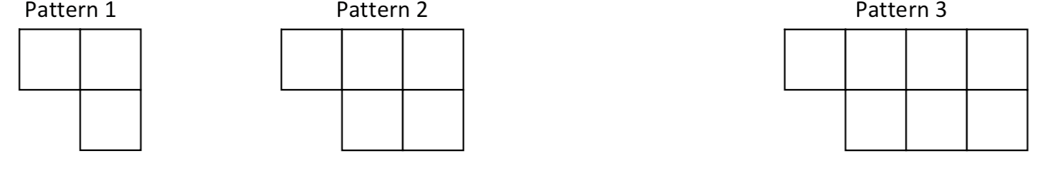  Ask learners:  What would the fourth pattern look like?  How do you know?  What is the term-to-term rule for the number of squares in each pattern?  Can you predict how many squares would be in pattern 6?  Which pattern would have 27 squares? | The NRICH task: Go Forth and Generalise (https://nrich.maths.org/2338) provides some useful teaching notes and further ideas for this topic.
8As.01 Understand term-to-term rules, and generate sequences from numerical and spatial patterns (including fractions). | Show learners the following information:  A pizza making machine produces one pizza every minute but is currently faulty. Each pizza produced is missing one slice, so that it only produces ⁴/₅ of a pizza.  Ask learners:  How many pizzas in total are produced after 2 minutes?  How many pizzas in total are produced after 3 minutes?  Write the sequence of the first ten terms representing the first ten minutes of production.  Encourage learners to draw what the pizza looks like and then to produce a sequence to show the fractions of total pizzas produced.  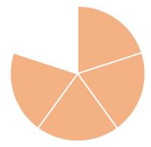, 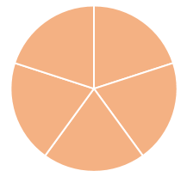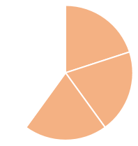, 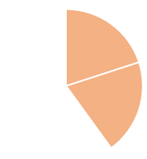  4/5, 1 3/5, 2 2/5, …  Ask learners:  After how many minutes can 4 whole pizzas be made using all the slices?  What is the term-to-term rule?
8As.02 Understand and describe $n$th term rules algebraically (in the form $n ± a$, $a × n,$or $an ± b,$where $a$ and $b$ are positive or negative integers or fractions).  TWM.02 Generalising  Recognising an underlying pattern by identifying many examples that satisfy the same mathematical criteria | Ask learners to choose two positive, single-digit numbers, such as 3 and 5.  Then ask learners to use these two numbers to define two rules for the n^{th} term, in this case: 3n + 5 and 5n + 3.  Ask learners to write at least the first 15 terms of each sequence.  Ask learners:  What do your sequences have in common and what are the differences?  Now ask learners to create a new sequence by writing the numbers (if any) which appear in both of their previous sequences.  For example,  3n + 5: 8, 11, 14, 17, 20, 23, 26, 29, 32, 35, 38, 41, 44, 47, 50, 53, …  5n + 3: 8, 13, 18, 23, 28, 33, 38, 43, 48, 53, 58, 63, 68, 73, 78, …  New sequence: 8, 23, 38, 53, … (15n – 7)  Ask learners:  - What do you notice about the numbers that appear in both sequences?  - What is the n^{th} term of the new sequence?  - Investigate by choosing some other examples. Can you notice a pattern?  Learners will show they are generalising (TWM.02) when they notice underlying patterns in the common terms of their original sequences and in the n^{th} term of their new sequences. For example, they may notice their original sequences always begin with the same number. Some learners may also notice that the coefficient of n in their new sequence is the lowest common multiple of the coefficients of n in their original sequences.

Unit 8.7 Topic 2 Functions

Outline of topic:
Learners will learn about linear relationships and functions. They will consider real life contexts in which they can be used.

Language:
Key vocabulary:
input, output
function
inverse operation
linear equation
variables

Recommended prior knowledge:
- Understand that a function is a relationship where each input has a single output

Learning objectives | Suggested teaching activities and resources | Mental strategies, possible misconceptions and comments
8As.03 Understand that a function is a relationship where each input has a single output. Generate outputs from a given function and identify inputs from a given output by considering inverse operations (including fractions).  8As.04 Understand that a situation can be represented either in words or as a linear function in two variables (of the form $y = mx + c$), and move between the two representations. | Show learners the following information:  In a factory, machines make bars of soap. The soap bars come in packs of five. Each machine makes one pack of soap bars every minute.  Ask learners:  How many packs of soap does a machine make in 10 minutes? How many bars of soap is this?  How many packs of soap does a machine make in 1 hour? How many bars of soap is this?  How long does it take a machine to make 235 bars of soap?  Can you write a function to relate the time taken in minutes and the number of bars of soap?  Discuss different representations of the function such as functions machines, mapping diagrams, tables and linear functions in two variables. For example, (where b is the number of bars of soap and t is the time in minutes):  b = 5t  t = $\frac{1}{5}$b  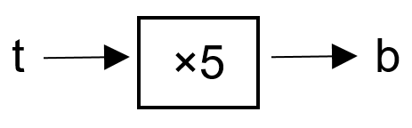  Ask learners:  How long does it take a machine to make 32 bars of soap? (Answer: 32 ÷ 5 = 6.4 minutes = 6 minutes and 24 seconds)  How many bars of soap does a machine make in 75 seconds? (Answer: learners should convert 75 seconds to 1.25 minutes before calculating 1.25 × 5 = 6.25 bars of soap, which should be rounded to 6 full bars of soap)
  Input (t) | 1 | 2 | 3 | 4 | 5
  Output (b) | 5 | 10 | 15 | 20 | 25

Learning objectives | Suggested teaching activities and resources | Mental strategies, possible misconceptions and comments
8As.03 Understand that a function is a relationship where each input has a single output. Generate outputs from a given function and identify inputs from a given output by considering inverse operations (including fractions).  8As.04 Understand that a situation can be represented either in words or as a linear function in two variables (of the form $y = mx + c$), and move between the two representations. | Explain that that a local sports team would like to get some t-shirts printed with their team logo. You have the following information:  - the team need at least 10 t-shirts printed, but possibly more  - printing company A charges $11 per t-shirt  - printing company B charges a set-up fee of $27 and then $9 per t-shirt  Ask learners to use functions to model the cost of printing t-shirts at company A and company B. Discuss different representations of the function such as functions machines, mapping diagrams, tables and linear functions in two variables. For example:  Ask learners:  Would you recommend the sports team use company A or company B?  Why?  For another challenge involving functions representing real life situations try the NRICH task: Which is Cheaper? (https://nrich.maths.org/7342).  Resources:  NRICH task
  Company A: | Company B:
  C = 11t | C = 27 + 9t
    Number of t-shirts (t) | Cost in $ (C)
    5 | 55
    10 | 110
    15 | 165
    Number of t-shirts (t) | Cost in $ (C)
    5 | 72
    10 | 117
    15 | 162

Unit 8.7 Topic 3 Graphs and equation of a straight line

Outline of topic:
Learners will use graphical representations of linear relationships, making sense of y = mx + c and relating them to real life context.

Language:
Key vocabulary:
function
inverse operation
linear equation
variables

Recommended prior knowledge:
- Understand term-to-term rules, and generate sequences from numerical and spatial patterns
- Understand that a function is a relationship where each input has a single output
- Use knowledge of coordinate pairs to construct tables of values and plot the graphs of linear functions

Learning objectives | Suggested teaching activities and resources | Mental strategies, possible misconceptions and comments
8As.05 Use knowledge of coordinate pairs to construct tables of values and plot the graphs of linear functions, where $y$ is given explicitly in terms of $x$ ($y = mx + c$). | Ask learners to give you instructions to draw a set of axes from -10 to +10.  Ask learners:  What key features should appear on all sets of axes?  Make sure all the key features are identified (e.g. x-axis, y-axis, origin, scales).  Using the function y = 2x, ask learners for the value of y if x = 1, x = 2, x = -2, etc. Learners should then construct a table of values for x = -5 to x = 5, plot the coordinate pairs on the Cartesian plane and join the points to make a graph.  Ask learners to repeat this for y = 2x + 1 and y = 2x + 2.  Ask learners:  What is the same about all of the lines? What is different?  How can you describe the coordinates of any point on the line?  What is the equation of the line?
8As.06 Recognise that equations of the form $y = mx + c$ correspond to straight-line graphs, where $m$ is the gradient and $c$ is the $y$-intercept (integer values of $m$). | Learners work in pairs to explore graphs (graphs on a set of axes, or equations or coordinate pairs) for a range of linear functions. Some should have the same gradient and some the same intercept. Learners represent each graph as a table of values and deduce the equations for the lines.  Ask learners:  What patterns do you notice in the tables?  What patterns do you notice in their graphs?  Discuss learners' findings and establish that all straight-line graphs can be written in the form y = mx + c, where m is the gradient and c is the y-intercept.  The NRICH task: Parallel lines (https://nrich.maths.org/5609) provides some interactive investigation into the effects of changing the position and gradient of straight lines on m and c.  Ask learners:  Can you predict what will happen to the equation if the red point is moved to 2?  Where should you put the blue point so that you get a gradient of 3?  Can you predict where the equation y = 2x + 6 will cross the y-axis?  Can you write the equation of a straight line that is parallel to y = 2x + 6?  Resources:  NRICH task
8As.04 Understand that a situation can be represented either in words or as a linear function in two variables (of the form $y = mx + c$), and move between the two representations.  8As.05 Use knowledge of coordinate pairs to construct tables of values and plot the graphs of linear functions, where $y$ is given explicitly in terms of $x$ ($y = mx + c$).  8As.06 Recognise that equations of the form $y = mx + c$ correspond to straight-line graphs, where $m$ is the gradient and $c$ is the $y$-intercept (integer values of $m$).  TWM.05 Characterising  Identifying and describing the mathematical properties of an object | Show learners the following information:  A machine takes 2 minutes to warm up and then makes one product every 3 minutes.  Ask learners:  How much time does it take from switching on the machine to make 4 products? (Answer: 3 × 4 + 2 = 14 minutes)  If the machine is running for 100 minutes, how many products will it have made? (Answer: (100 – 2) ÷ 3 = $32.\dot{6}$ products, which should round to 32, as the 33rd product will not quite be finished)  Ask learners to write a linear function in two variables, where p is the number of products made and m is the number of minutes, to represent the situation. Learners should compare their answer with a partner to see if they have written the same function. For example, m = 3p + 2, m = 2 + 3p, m - 2 = 3p, etc. are all correct representations.  Then ask learners to complete a table of values for their function. Ask learners:  What values of p and m should we consider when completing a table of values for the function?  Learners should suggest it is not possible to have a negative amount of products or minutes, so starting the table of values at zero is appropriate for this situation.  Ask learners to plot the graph of the linear function, using the coordinate pairs from the table of values to help.  Ask learners:  What is the gradient of your graph? What does the gradient represent in this situation? (Answer: the gradient is 3 because the rate of production is 3 per minute)  What is the y-intercept of your graph? What does the y-intercept represent in this situation? (Answer: the y-intercept is 2 because the machine takes two minutes to warm up before it produces any products)  Learners will show they are characterising (TWM.05) when they interpret the features of the graph they have drawn.  This activity can be extended by giving learners functions that represent other machines and asking them to describe how the machine works. For example, for the function p = 4m + 11, the machine takes 11 minutes to warm up and produces products at a rate of 4 every minute. Ask learners to consider the graphs of these functions and how the gradient and y-intercept differ from the graph of the original machine. | Possible misconceptions:  Learners may incorrectly think the variables x and y must be used when plotting graphs of linear functions. Establish that in this case the variables p and m have been used instead.
  p | 0 | 1 | 2 | 3 | 4 | 5 | 6 | 7
  m | 2 | 5 | 8 | 11 | 14 | 17 | 20 | 23
8As.07 Read and interpret graphs with more than one component. Explain why they have a specific shape and the significance of intersections of the graphs.  TWM.05 Characterising  Identifying and describing the mathematical properties of an object | Show learners the graph below and explain that the blue and orange lines represent two runners in a race.  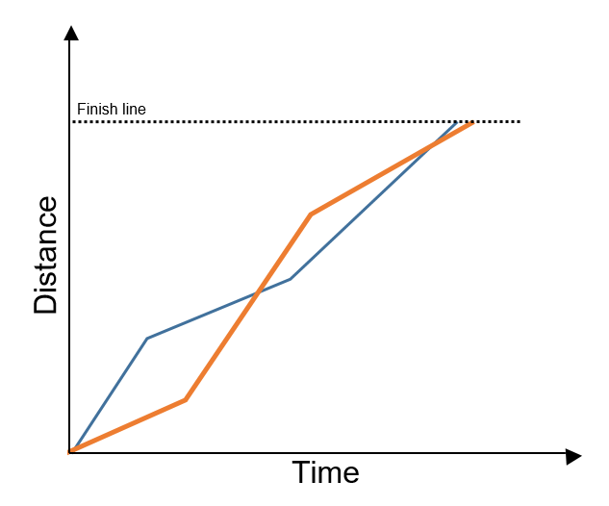  Ask learners to work in pairs to discuss and describe the properties of the graphs in as much detail as possible. Learners should also consider how the properties of the graphs show what happens in the race.  Ask learners questions such as:  - Which runner is in the lead at which points on the graph?  - Which runner wins?  - Which do you think is the most exciting point in the race and why?  - What advice would you give to the runners afterwards and why?  - What information is not given in the graphs?  Learners will show they are characterising (TWM.05) when they identify certain properties of the graphs, for example the points of intersection or change in gradient, and explain the significance of these properties in the context of a running race.

Unit 8.8 Transformations

Learning objectives covered in Unit 8.8 and topic summary: |  | 8.8 Topic 1  Translations and vectors | 8.8 Topic 2  Reflections, rotations and enlargements | Thinking and Working Mathematically
8Gp.03 | Translate points and 2D shapes using vectors, recognising that the image is congruent to the object after a translation.
8Gp.04 | Reflect 2D shapes and points in a given mirror line on or parallel to the $x$- or $y$-axis, or $y = ± x$ on coordinate grids. Identify a reflection and its mirror line.
8Gp.05 | Understand that the centre of rotation, direction of rotation and angle are needed to identify and perform rotations.
8Gp.06 | Enlarge 2D shapes, from a centre of enlargement (outside or on the shape) with a positive integer scale factor. Identify an enlargement and scale factor. |  |  | TWM.05 Characterising

Unit 8.8 Topic 1 Translations and vectors

Outline of topic:
Learners will learn how to translate shapes using vectors. They will recognise that a translated shape will always be congruent to its original shape.

Language:
Key vocabulary:
congruent
translate
vector
object, image

Recommended prior knowledge:
- Translate 2D shapes, identifying the corresponding points between the original and the translated image, on coordinate grids
- Understand that if two 2D shapes are congruent, corresponding sides and angles are equal

Learning objectives | Suggested teaching activities and resources | Mental strategies, possible misconceptions and comments
8Gp.03 Translate points and 2D shapes using vectors, recognising that the image is congruent to the object after a translation. | Give learners a copy of the diagram below:  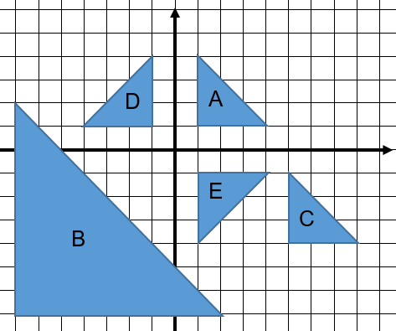  Ask learners:  Which shapes are congruent? How do you know?  Explain why shapes A and B are not congruent. (Answer: the corresponding sides are not equal in length)  Then ask learners:  Which shapes could have been transformed by a translation? How do you know? (Answer: shapes A and C are congruent and the same orientation)  Describe the translation from shape A to shape C. (Answer: 4 right and 5 down)  Can you write this as a vector? (Answer: $\left({4 \atop -5}\right)$)  Describe the translation from shape C to shape A. (Answer: 4 left and 5 up)  Can you write this as a vector? (Answer:$\left({-4 \atop 5}\right)$)  Learners now need to find available space on the grid and perform three translations for shape D, describing the translations each time using vectors. For example:  Translate shape D by the vector $\left({-2 \atop 3}\right)$.  Resources:  Tracing paper  Copies of the diagram | Tracing paper can be used to support this activity. It is also advisable for learners to mark one corner of the shape to be translated and focus on just moving that point, before establishing the new position of the whole shape.  Possible misconceptions:  Learners often confuse coordinates and vectors. Explain to learners that coordinates locate points and vectors describe movement. They can often be shown together, for example, a point at (2, 3) is translated using the vector$\left(\begin{matrix}6 \\ 1\end{matrix}\right)$.

Unit 8.8 Topic 2 Reflections, rotations and enlargements

Outline of topic:
Learners will learn how to reflect, rotate and enlarge shapes. They will recognise that rotated and reflected shapes will always be congruent to their original shape, whereas enlargements result in similar shapes.

Language:
Key vocabulary:
congruent, similar
object, image
transformations
reflection
mirror line
rotation
centre of rotation
clockwise, anti-clockwise
enlarge, enlargement
centre of enlargement
scale factor

Recommended prior knowledge:
- Reflect 2D shapes on coordinate grids, in a given mirror line (x- or y-axes), recognising that the image is congruent to the object after a reflection
- Rotate shapes 90º and 180º around a centre of rotation, recognising that the image is congruent to the object after a rotation
- Understand that the image is mathematically similar to the object after enlargement

Learning objectives | Suggested teaching activities and resources | Mental strategies, possible misconceptions and comments
8Gp.04 Reflect 2D shapes and points in a given mirror line on or parallel to the $x$- or $y$-axis, or $y = ± x$ on coordinate grids. Identify a reflection and its mirror line. | Give learners a copy of the diagram below:  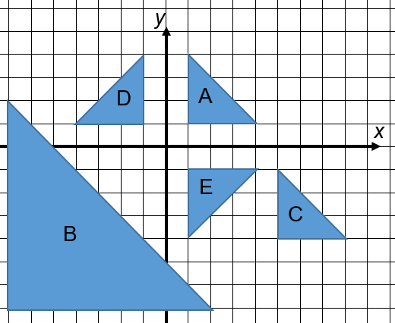  Ask learners to identify as many reflections as they can. (Answers: shapes A and E; shapes D and A; and shapes D and E.) Then ask learners to identify the mirror lines. Explain that the mirror line for shape A and D is the y-axis but could also be stated as the equation x = 0. Similarly, the mirror line for shapes A and E is the x-axis, which can also be stated as y = 0. The mirror line for shapes D and E is the line with equation y = x.  Then ask learners to draw their own grid on square paper and draw one shape anywhere on the grid. Ask learners to reflect the shape in the mirror lines:  - x = 1  - y = -4  - y = x  - y = -x  They should then share their reflections with another learner, explaining how they did the reflection and confirming each other’s answers.  Resources:  Copies of the diagram
8Gp.05 Understand that the centre of rotation, direction of rotation and angle are needed to identify and perform rotations. | Give learners a copy of the same diagram as used in the previous activity.  Ask learners:  Is it possible to transform shape A onto shape E without reflecting? Explain your answer.  What information is needed to fully describe this rotation?  Is there more than one possible way of describing this rotation?  Establish that to describe a rotation the angle, direction and centre of rotation are needed. Demonstrate to learners how to find the centre of rotation using tracing paper and a trial and error method. Discuss that a 90º rotation clockwise is the same as a 270º rotation anticlockwise and that for a rotation of 180º the direction is not needed.  Ask learners to identify some other rotations on the diagram and to fully describe them by writing the angle, direction and centre of rotation for each. For example: shape D is rotated 180º about the point (0, 0) onto shape E.  Then ask learners to draw their own grid on square paper and draw one shape anywhere on the grid. Ask learners to rotate the shape in different ways, for example:  - 180º about the centre of rotation (2, 3)  - 90º anticlockwise about the centre of rotation (1, -1)  This activity can be extended by encouraging learners to explore rotations other than 90º and 180º (e.g. 45 º or 100 º).  Resources:  Tracing paper  Copies of the diagram | Tracing paper can be used to support this activity.
8Gp.06 Enlarge 2D shapes, from a centre of enlargement (outside or on the shape) with a positive integer scale factor. Identify an enlargement and scale factor.  TWM.05 Characterising  Identifying and describing the mathematical properties of an object | Give learners a copy of the same diagram as used in the previous activities.  Ask learners:  Is shape B congruent to the other shapes? Why? (Answer: no, as corresponding sides are not the same)  Explain that as the angles are the same and corresponding sides are in the same ratio, the shapes are similar. Review how to find the scale factor for the enlargement and how it relates to ratio.  Then demonstrate to learners how to enlarge a shape from a centre of enlargement. Explain that in the diagram, shape A has been enlarged by scale factor 3 from the centre (5, 5). Establish that the distances from the centre to each point are multiplied by the scale factor of 3.  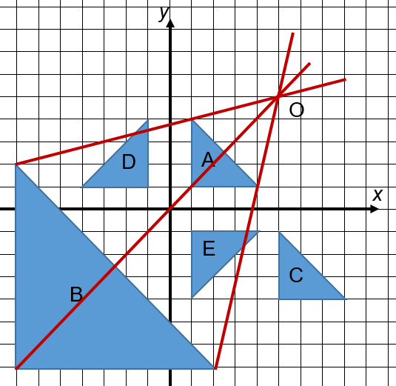  Then ask learners to draw their own grid on square paper and draw one shape anywhere on the grid. They should choose a scale factor and centre of enlargement and draw the enlarged shape. Learners should swap with a partner and describe the enlargement to check they agree.  This activity can be extended by asking learners to do several enlargements of the same shape, using different centres of enlargement, to see the effect of the centre of enlargement moving.  On completing all four transformations in this unit, ask learners to summarise their work, describing each type of transformation as fully as they can. Learners will show they are characterising (TWM.05) when they identify the key features of each type of transformation.  Resources:  Copies of the diagram

Unit 8.9 Statistics

Learning objectives covered in Unit 8.9 and topic summary: |  | 8.9 Topic 1  Data types and collection methods | 8.9 Topic 2  Recording and interpreting data | 8.9 Topic 3  Using descriptive statistics | 8.9 Topic 4  The statistical cycle | Thinking and Working Mathematically
8Ss.01 | Select, trial and justify data collection and sampling methods to investigate predictions for a set of related statistical questions, considering what data to collect (categorical, discrete and continuous data). |  |  |  |  | TWM.04 Convincing  TWM.07 Critiquing  TWM.08 Improving
8Ss.02 | Understand the advantages and disadvantages of different sampling methods. |  |  |  |  | TWM.04 Convincing  TWM.07 Critiquing  TWM.08 Improving
8Ss.03 | Record, organise and represent categorical, discrete and continuous data. Choose and explain which representation to use in a given situation:  - Venn and Carroll diagrams  - tally charts, frequency tables and two-way tables  - dual and compound bar charts  - pie charts  - frequency diagrams for continuous data  - line graphs and time series graphs  - scatter graphs  - stem-and-leaf diagrams  - infographics.
8Ss.04 | Use knowledge of mode, median, mean and range to compare two distributions, considering the interrelationship between centrality and spread.
8Ss.05 | Interpret data, identifying patterns, trends and relationships, within and between data sets, to answer statistical questions. Discuss conclusions, considering the sources of variation, including sampling, and check predictions.

Unit 8.9 Topic 1 Data types and collection methods

Outline of topic:
Learners will justify their data collection methods and investigate predictions for a set of statistical questions. They will explore the advantages and disadvantages of different sampling techniques.

Language:
Key vocabulary:
categorical data, discrete data, continuous data
primary data, secondary data
prediction
survey, questionnaire

Key phrases:
Data collection method
Sampling method

Recommended prior knowledge:
- Knowledge of different types of data
- Knowledge of different types of data collection methods

Learning objectives | Suggested teaching activities and resources | Mental strategies, possible misconceptions and comments
8Ss.01 Select, trial and justify data collection and sampling methods to investigate predictions for a set of related statistical questions, considering what data to collect (categorical, discrete and continuous data).  8Ss.02 Understand the advantages and disadvantages of different sampling methods.  TWM.07 Critiquing  Comparing and evaluating mathematical ideas, representations or solutions to identify advantages and disadvantages  TWM.08 Improving  Refining mathematical ideas or representations to develop a more effective approach or solution  TWM.04 Convincing  Presenting evidence to justify or challenge a mathematical idea or solution | Learners work in small groups. Explain that they need to investigate the quality and effectiveness of a primary school in their area.  Ask learners:  What could you consider as part of your investigation? (For example, academic results, attendance records, sporting achievements, number of clubs, student, teacher and parent satisfaction etc.)  Select learners to share their group’s ideas. Record the suggestions on the board and ask learners to use these to identify the set of related questions they plan to investigate. Learners should also make predictions for their chosen questions, for example:  ‘We believe the school has better academic results than other primary schools in the area’.  Then ask learners to discuss and justify which methods of data collection are appropriate. For example, they might be able to collect secondary data for the academic results from a public website, whereas they will need to conduct interviews or produce a questionnaire to gather opinions.  Learners should also consider sampling. Ask learners:  Do you need to collect data for every … (learner/parent/teacher/subject etc.)?  How could you ensure your sample is representative of the population?  Which sampling methods could you use?  What would be the advantages or disadvantages for each?  Learners will show they are critiquing (TWM.07) when they evaluate different sampling and data collection methods. They will show they are improving (TWM.08) and convincing (TWM.04) when they decide on the most appropriate approach and justify the reasons for their data selection and sampling method and sample sizes. | Reliable sources for data collection are an important consideration in this activity. Learners need to think carefully about their sources, comparing primary and secondary data sources and bias.  Learners conduct statistics investigations as part of a four-part statistical enquiry cycle:  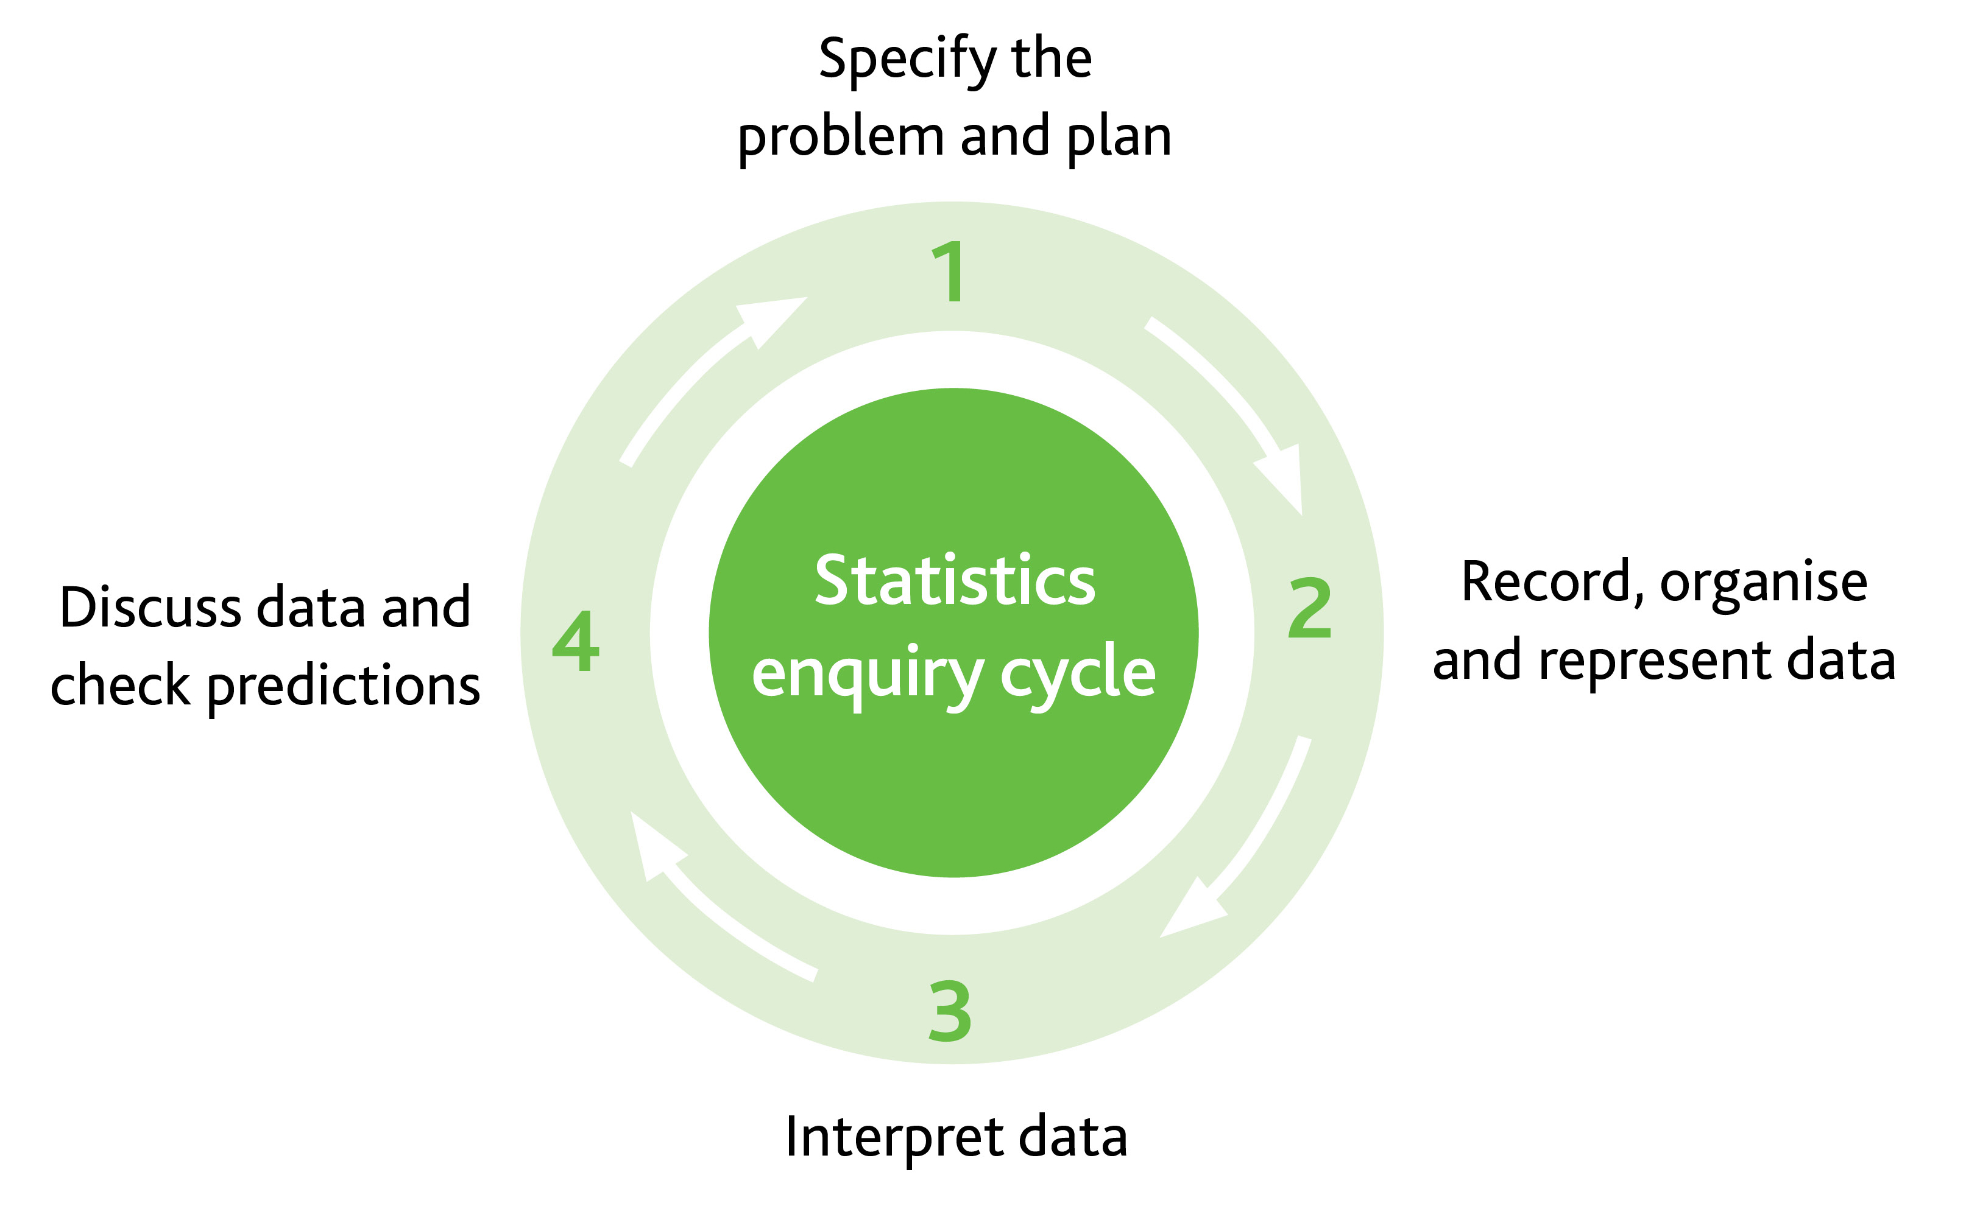

Unit 8.9 Topic 2 Recording and interpreting data

Outline of topic:
Learners select data relating to a given criteria and explore ways of representing it, considering appropriateness and effectiveness of each type of representation. The graphs and tables will be interpreted to draw conclusions.

Language:
Key vocabulary:
data, statistics
graphs, tables and diagrams:
- Venn and Carroll diagrams
- tally charts, frequency tables and two-way tables
- dual and compound bar charts
- pie charts
- line graphs and time series graphs
- scatter graphs
- stem-and-leaf diagrams
- infographics

Key phrases:
appropriate presentation of data
sources of variation

Recommended prior knowledge:
- Knowledge of a range of data representations and which to apply to a given situation
- Identify patterns and trends, within and between data sets, to answer statistical questions

Learning objectives | Suggested teaching activities and resources | Mental strategies, possible misconceptions and comments
8Ss.03 Record, organise and represent categorical, discrete and continuous data. Choose and explain which representation to use in a given situation:  - Venn and Carroll diagrams  - tally charts, frequency tables and two-way tables  - dual and compound bar charts  - pie charts  - frequency diagrams for continuous data  - line graphs and time series graphs  - scatter graphs  - stem-and-leaf diagrams  - infographics.  8Ss.05 Interpret data, identifying patterns, trends and relationships, within and between data sets, to answer statistical questions. Discuss conclusions, considering the sources of variation, including sampling, and check predictions. | Give learners a selection of local property information or access to the internet for them to search properties for sale in a given area. They should identify possible data they could collect from these sources (e.g. property prices, number of bedrooms, square footage, distance from the nearest train station etc.). If they are using the internet, learners could also consider collecting historic data, about property prices for example, to show a trend over time.  Ask learners to select two or more variables, and collect at least twenty sets of data. Learners should understand how to correctly tabulate data using the symbols < and ≤. For example:  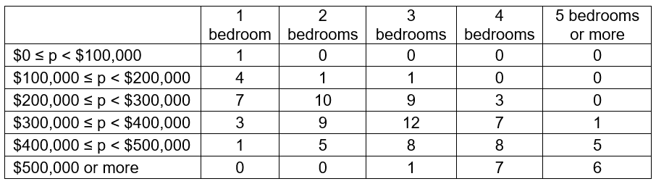  They should then present the data using appropriate graphs or charts to provide information for people wanting to buy property in the area. For example, learners may choose to represent their data using pie charts to compare proportions:  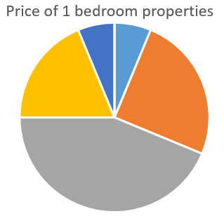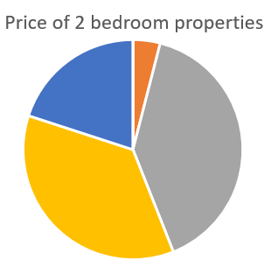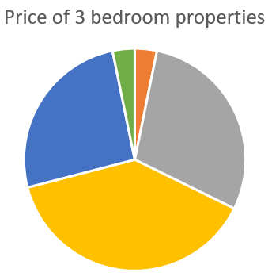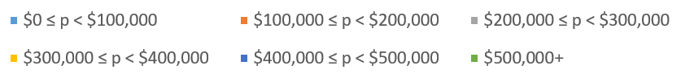  Learners should make conclusions based on what the graphs and charts show.  They should use their data to make comparisons and establish relationships. For example, a scatter graph could be used to show the relationship between house prices and the number of bedrooms.  Resources:  Data on property prices in the local or another given area | Learners conduct statistics investigations as part of a four-part statistical enquiry cycle:

Unit 8.9 Topic 3 Using descriptive statistics

Outline of topic:
Learners will compare sets of data using statistical analysis, including measures of centrality and spread.

Language:
Key vocabulary:
average, mode, median, mean, range

Key phrases:
The mean of the data is …
The mode of the data is …
The median of the data is …
The range of the data is …

Recommended prior knowledge:
- Use knowledge of mode, median, mean and range to describe and summarise large data sets
- Interpret and summarise data

Learning objectives | Suggested teaching activities and resources | Mental strategies, possible misconceptions and comments
8Ss.04 Use knowledge of mode, median, mean and range to compare two distributions, considering the interrelationship between centrality and spread.  8Ss.05 Interpret data, identifying patterns, trends and relationships, within and between data sets, to answer statistical questions. Discuss conclusions, considering the sources of variation, including sampling, and check predictions. | Show learners the Carroll diagram below, showing the prices, number of bedrooms and distance from the train station of 32 properties:  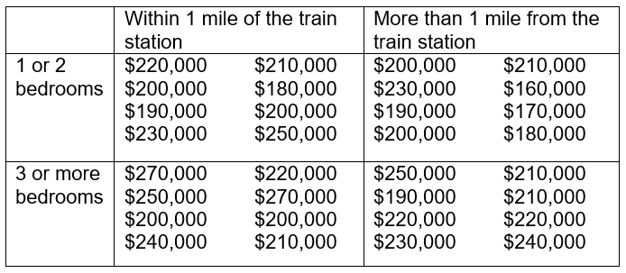  Ask learners to compare the house prices using measures of centrality and spread. They could compare:  - prices of properties inside and outside a 1 mile zone  - prices of 1 and 2 bedroom houses with those that have 3 or more  - all four groups of properties shown in the Carroll diagram.  Ask learners to interpret their results. Ask questions such as:  What does the range of a distribution show? Why might there be a greater range for … (e.g. properties with 1 or 2 bedrooms) than for … (e.g. properties with 3 or more bedrooms)?  What is the mean of each set of data? Why might the mean be higher for … than for …?  Then give learners further data provided in frequency tables, for them to compare using averages and interpret the results. For example:  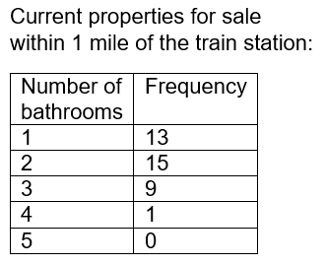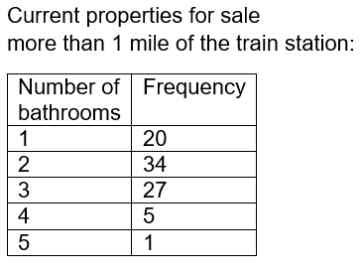  Resources:  Copies of the Carroll diagram  Data in frequency tables | Possible misconceptions:  If asked to find the mean of a data set using calculators, learners sometimes forget to enter the calculations using the correct order of operations; i.e., entering 2 + 3 + 4 + 5 + 6 ÷ 5 in one line so that only the last number entered is divided by 5. The use of brackets can solve this problem.  Learners sometimes believe that average only implies the use of the mean. It can also be the median or the mode. Range is not a type of average. It is a measure of spread.  Learners conduct statistics investigations as part of a four-part statistical enquiry cycle:

Unit 8.9 Topic 4 The statistical cycle

Outline of topic:
Learners will apply the statistical enquiry cycle to conduct a statistics investigation by:
- specifying the problem, planning the investigation and making predictions
- collecting, recording, and organising the data
- considering how to appropriately represent the data
- interpreting the data and discussing conclusions.

Language:
Key vocabulary:
categorical data, discrete data, continuous data
primary data, secondary data
survey, questionnaire, experiment
data, statistics
tally, frequency
sample
diagrams, tables, graphs, charts
average, mode, median, mean, range
outlier

Key phrases:
Data collection method
Sampling method
Appropriate presentation of data
The mean of the data is …
The mode of the data is …
The median of the data is …
The range of the data is …

Recommended prior knowledge:
- Knowledge of a range of data representations and which to apply to a given situation
- Use knowledge of mode, median, mean and range to describe and summarise large data sets
- Identify patterns and trends, within and between data sets, to answer statistical questions
- Interpret and summarise data

Learning objectives | Suggested teaching activities and resources | Mental strategies, possible misconceptions and comments
8Ss.01 Select, trial and justify data collection and sampling methods to investigate predictions for a set of related statistical questions, considering what data to collect (categorical, discrete and continuous data).  8Ss.02 Understand the advantages and disadvantages of different sampling methods.  TWM.07 Critiquing  Comparing and evaluating mathematical ideas, representations or solutions to identify advantages and disadvantages  TWM.08 Improving  Refining mathematical ideas or representations to develop a more effective approach or solution  8Ss.03 Record, organise and represent categorical, discrete and continuous data. Choose and explain which representation to use in a given situation:  - Venn and Carroll diagrams  - tally charts, frequency tables and two-way tables  - dual and compound bar charts  - pie charts  - frequency diagrams for continuous data  - line graphs and time series graphs  - scatter graphs  - stem-and-leaf diagrams  - infographics.  8Ss.04 Use knowledge of mode, median, mean and range to compare two distributions, considering the interrelationship between centrality and spread.  8Ss.05 Interpret data, identifying patterns, trends and relationships, within and between data sets, to answer statistical questions. Discuss conclusions, considering the sources of variation, including sampling, and check predictions. | Explain to learners that a new brand of clothing is being designed for teenagers and the production team needs their help to make decisions about the designs and marketing of the new brand.  Ask learners:  - What data would be helpful for the production team to have?  - How will you collect this data?  - What will your sample size be?  - Which sampling method will you use?  - How will you ensure your sample is representative of the population?  Learners should discuss what data (categorical, discrete and continuous data) will be needed. This might include sizing and measurements, types of clothing, colour preferences, cost of items etc. They also need to decide on how they will collect their data (primary or secondary data) and suggest sampling methods they could use, identifying advantages and disadvantages of each suggestion. Learners will show they are critiquing (TWM.07) when they evaluate different sampling and data collection methods. They will show they are improving (TWM.08) when, after discussing the advantages and disadvantages, they then agree on the best approach for sampling and collecting data for this task.  Learners should suggest some predictions, before then collecting the data. The data should be tabulated appropriately. Learners should consider the advantages and disadvantages of various methods of recording the data, which should be shared with the whole class and discussed.  Learners should then organise and create representations of the data to be presented to the clothing production team e.g. frequency tables, frequency diagrams for continuous data, dual bar charts, pie charts, stem and leaf diagrams etc., considering which representation is best, e.g.  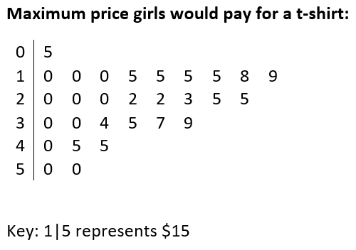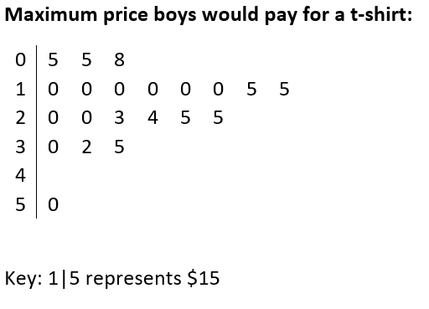  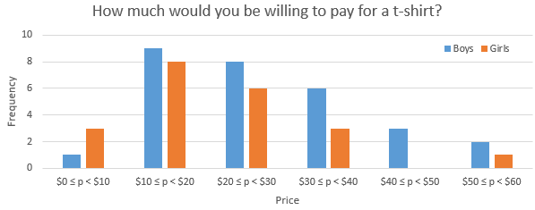  Learners could also decide to calculate the mean, median or mode for their data, including data presented in a frequency table. They should analyse and summarise each data set, making comparisons between data sets. Learners should consider which average is most appropriate and how well the average represents the data, e.g. they might note that most values were a long way from the mean, so it does not represent the data very well.  Learners should then interpret their data and identify patterns within and between data sets. For example, in the scatter graph below, learners should notice that as the age of the teenager increases, the more money they are willing to spend on a t-shirt.  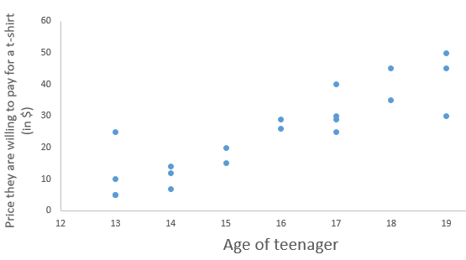  Learners should discuss conclusions, identifying reasons for these, and check their predictions. They should also consider possible sources of variation, including data sampling. For example, they might notice the girls in their sample were all 18 or 19 years old, whereas the boys they asked were all younger teenagers.  Resources:  Access to computers, graphing software and the internet | Learners conduct statistics investigations as part of a four-part statistical enquiry cycle:  Use of technology will support this stage of data representation.

Sample lesson 1

CLASS:

DATE:
Learning objectives | 8Gg.03 Know that distances can be measured in miles or kilometres, and that a kilometre is approximately $\frac{5}{8}$ of a mile or a mile is 1.6 kilometres.  TWM.07 Critiquing  TWM.08 Improving
Lesson focus /  success criteria | Learners will develop their measuring skills, with the use of a scale map, and consider metric to imperial conversions.  - I can measure lengths accurately  - I can use map scales  - I can convert between metric and imperial units of measure
Prior knowledge /  previous learning | Learners should know how to use scale maps to find actual distance. They should be able to draw a circle to a given radius and understand that a circle is a set of points that are the same distance from the centre.
Plan
Lesson | Planned activities | Notes
Introduction | Show learners the learning objectives and lesson focus and agree the success criteria:  - I can use measure lengths accurately  - I can use map scales  - I can convert between metric and imperial units of measure  Ask learners:  How far do you think it is to the local train station (or other significant location)?  What methods could you use to estimate this distance?  How accurate do you think your estimate is?  What units would be appropriate to measure this distance in?  Use a map or online distance finder to establish the actual distance. Discuss the units that learners chose to use. Ensure learners are aware that in some countries distance is typically measured in kilometres, whereas other countries typically use miles.  Learners will show they are critiquing (TWM.07) and improving (TWM.08) when they consider different methods of estimating distance, the accuracy of their estimates and how they could make a better estimate of distance in future.
Main activities | Ask learners:  Which is farther: 1 mile or 1 kilometre?  What is the relationship between miles and kilometres?  Establish the relationship between miles and kilometres from learners’ suggestions, for example:  - 5 kilometres is approximately 3 miles  - 1 kilometre is approximately equal to $\frac{5}{8}$ of a mile  - 1 mile is approximately equal to 1.6 kilometres.  Demonstrate how to use this relationship to convert between miles and kilometres and then give learners some ‘would you rather’ questions for them to practice this method.  For example:  - Would you rather run 17 miles or 20 kilometres?  - Would you rather swim 0.3 miles or $\frac{2}{3}$ of a kilometre?  Encourage learners to give reasons for their answers, e.g.  I do not like swimming, so I would rather swim 0.3 miles, as $\frac{2}{3}$ of a km is farther than 0.3 miles.  Then give learners a scale map, preferably of the local area and ask them to identify two points on the map (e.g. the train station and the school) and connect these two points with a straight line. Ask learners to find the direct distance between the points, making use of the scale to write their answer in kilometres. Then ask learners to use an approximation of 1 km to $\frac{5}{8}$ of a mile to find the distance in miles. Learners should then choose more locations and find the distances between them in kilometres and miles.  Tell learners a new shop is being built exactly 4.5 miles from the school. Ask learners to find a possible location for the new shop on the map. Learners should then discuss their methods and answers with a partner to check they agree with their conversion from miles to kilometres and that their reasoning for the location of the shop is correct.  Ask learners to work in pairs. Learners should take it in turns to choose a secret location on their map and give clues to the other learner who should guess the location. For example:  My secret location is 4 miles from the town hall. It is also 3 km from the supermarket. It is less than 1 mile from our school.  This activity can be extended by asking learners to investigate and compare the direct distance between two points (measuring in a straight line on the map) with the travelling distance calculated between the two points by an online route calculator (using roads and paths).  Ask learners:  How much further is the travelling distance than the direct distance?  Can this be expressed as a percentage?  How does this compare with other journeys?  Why might some travelling distances be much further than the direct distances? (e.g. restrictions to the route, like railway lines and rivers) | Resources:  Physical copies of a local map, showing a scale  Access to an online route calculator
Summary | Give learners some quick questions about miles and kilometres for them to answer and display on mini whiteboards. For example:  - Which is farther: 18 miles or 18 km?  - 5 miles is approximately the same as 3 km. True or false?  - 10 km is approximately the same as 6 miles. True or false?  - How many km is equivalent to 33 miles?  - How many miles is equivalent to 19 km?  Revisit the learning objectives and success criteria. Ask learners to explain whether they have met the success criteria and if they have any questions or comments. | If mini whiteboards are not available then ask learners to calculate their answers mentally.

Reflection
Use the space below to reflect on your lesson. Answer the most relevant questions for your lesson.
Were the learning objectives and lesson focus realistic? What did the learners learn today?
What was the learning atmosphere like?
What changes did I make from my plan and why?
If I taught this again, what would I change?
What two things really went well (consider both teaching and learning)?
What two things would have improved the lesson (consider both teaching and learning)?
What have I learned from this lesson about the class or individuals that will inform my next lesson?
Next steps
What will I teach next based on learners’ understanding of this lesson?

Sample lesson 2

CLASS:

DATE:
Learning objectives | 8Gp.03 Translate points and 2D shapes using vectors, recognising that the image is congruent to the object after a translation.
Lesson focus /  success criteria | Learners are introduced to vectors and how they can be used to translate shapes.  - I can interpret vectors, describing both the horizontal and vertical movements.  - I can move shapes using vectors.  - I know what congruent shapes are and that translations always give images that are congruent to the original shape.
Prior knowledge /  previous learning | Learners should already know how to translate shapes on coordinate grids using vocabulary of right, left, up and down. They should know that if two 2D shapes are congruent, corresponding sides and angles are equal.
Plan
Lesson | Planned activities | Notes
Introduction | Show learners the learning objectives and lesson focus and agree the success criteria:  - I can interpret vectors, describing both the horizontal and vertical movements.  - I can move shapes using vectors.  - I know what congruent shapes are and that translations always give images that are congruent to the original shape.  Give learners the coordinate alphabet grid below:  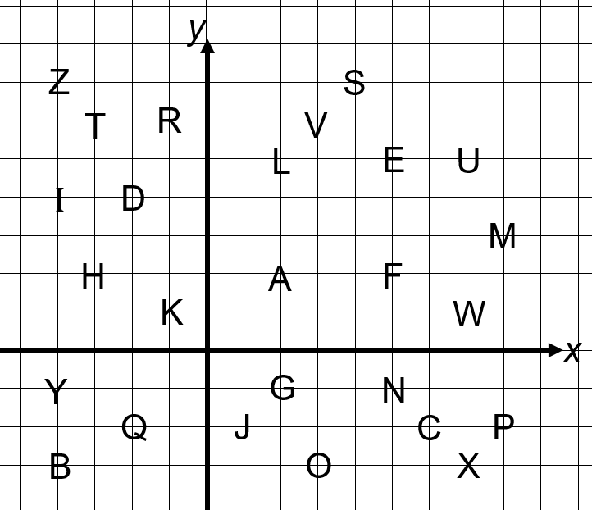  Give learners the following message to decode. They should write the letters they finish at after each step:  Start at V. (V)  Move 2 right and 1 down. (E)  Then move 1 right and 7 down. (C)  Then move 9 left and 8 up. (T)  Then move 6 right and 9 down. (O)  Then move 4 left and 9 up. (R)  Ask learners:  What is a vector?  Discuss this as a class and establish how to write and use vectors. | Resources:  Copies of the coordinate alphabet grid  Copies of the coordinate grid with shaded triangles A-E  Centimetre squared paper  Tracing paper can also be used to support these activities
Main activities | Using the alphabet grid from the introduction, learners should make their own coded message using vectors. For example:  Start at C. (C)  Move by the vector$\left({-4 \atop 4}\right)$ . (A)  Then move by the vector$\left({-5 \atop 4}\right)$ . (T)  Learners should swap with a partner and follow the vector instructions to decode their message.  Give learners a copy of the diagram below:  Ask learners:  Which shapes are congruent? How do you know?  Explain why shapes A and B are not congruent. (Answer: the corresponding sides are not equal in length)  Then ask learners:  Which shapes could have been transformed by a translation? How do you know? (Answer: shapes A and C are congruent and the same orientation)  Describe the translation from shape A to shape C. (Answer: 4 right and 5 down)  Can you write this as a vector? (Answer: $\left({4 \atop -5}\right)$)  Describe the translation from shape C to shape A. (Answer: 4 left and 5 up)  Can you write this as a vector? (Answer:$\left({-4 \atop 5}\right)$)  Learners now need to find available space on the grid and perform three translations for shape D, describing the translations each time using vectors. For example:  Translate shape D by the vector $\left({-2 \atop 3}\right)$.
Summary | To assess learners’ ability to translate shapes, ask them to draw the following isosceles triangle on a coordinate grid (x and y axes both from  -10 to 10):  (-5, 7), (-2, 1) and (-8, 1).  Tell learners that the triangle is translated and one of the vertices translates to (2, -2).  Ask learners:  Draw one possible position for the triangle. What vector gives this translation?  Can you find any other possible positions (there are two more)? What are the translations for these? (Answers: in any order: $\left(\begin{matrix} 7 \\ -9\end{matrix}\right),\left(\begin{matrix} 4 \\ -3\end{matrix}\right),\left(\begin{matrix}10 \\ -3\end{matrix}\right)$)  Revisit the learning objectives and success criteria. Ask learners to explain whether they have met the success criteria and if they have any questions or comments.

Reflection
Use the space below to reflect on your lesson. Answer the most relevant questions for your lesson.
Were the learning objectives and lesson focus realistic? What did the learners learn today?
What was the learning atmosphere like?
What changes did I make from my plan and why?
If I taught this again, what would I change?
What two things really went well (consider both teaching and learning)?
What two things would have improved the lesson (consider both teaching and learning)?
What have I learned from this lesson about the class or individuals that will inform my next lesson?
Next steps
What will I teach next based on learners’ understanding of this lesson?

Changes to this Scheme of Work

This Scheme of Work has been amended. The latest Scheme of Work is version 2.0, published January 2021.

- The definition of the Thinking and Working Mathematically characteristic TWM.03 Conjecturing has been changed to: Forming mathematical questions or ideas.
- The definition of the Thinking and Working Mathematically characteristic TWM 04 Convincing has been changed to: Presenting evidence to justify or challenge a mathematical idea or solution.
- On page 91, ‘frequency diagrams for continuous data’ has been added to 8Ss.03.

There may be other minor changes that do not affect teaching and learning.

Cambridge Assessment is committed to making our documents accessible in accordance with the WCAG 2.1 Standard. We are always looking to improve the accessibility of our documents. If you find any problems or you think we are not meeting accessibility requirements, contact us at info@cambridgeinternational.org with the subject heading: Digital accessibility. If you need this document in a different format, contact us and supply your name, email address and requirements and we will respond within 15 working days.

Cambridge Assessment International Education
The Triangle Building, Shaftesbury Road, Cambridge, CB2 8EA, United Kingdom
t: +44 1223 553554 f: +44 1223 553558
e: info@cambridgeinternational.org www.cambridgeinternational.org

© UCLES September 2020

